**marxan.io user guide**

**A web app for systematic conservation planning**

Matthew E. Watts

[m.watts@uq.edu.au](mailto:m.watts@uq.edu.au)

25th March 2016

For marxan.io revision 25

**Table of contents**

About marxan.io 3

What is marxan.io? 3

Get an account 3

The open source project 3

Preparing your data 3

Introduction to Marxan course materials 4

Qmarxan plugin for Quantum GIS 4

Marxan workflow in R 4

Other ways to create a Marxan dataset 4

Creating a zip file 4

Sample datasets 5

Login to marxan.io 5

Upload a dataset 6

Choose File 6

Database Name 7

Accept Database 8

Run Marxan 8

User Interface 9

Database 9

BLM 10

Run 10

Display output: Map 11

Best solution 11

Solution M 12

Selection frequency 12

Display output: Cluster 13

NMDS of solutions 14

Bray-Curtis dissimilarity of solutions 14

Edit Species 15

Edit “prop” and “spf” 16

Save 17

Parameter Testing 17

BLM Calibration 18

SPF Calibration 19

Target Sensitivity 19

Run 20

Output table 21

Output graph 21

Output map 22

Value to display 23

Map to display 24

Plot Parameter Values 24

Acknowledgements 24

References 24

# About marxan.io

Marxan is the most widely used decision support software for conservation planning globally. It’s used in over 180 countries to build marine and terrestrial conservation plans and national parks systems. It’s the global leader in conservation land-use planning software and new extensions are making it even more popular. URL <http://marxan.org>

## What is marxan.io?

The marxan.io web app is a graphical user interface for Marxan users that runs on the Nectar research cloud. You can upload your own Marxan datasets, edit targets, SPF and BLM, conduct parameter testing and analysis, and visualise output maps, figures, and tables in an easy to use web interface.

The instructions relate to revision 25 of the marxan.io web app.

## Get an account

We don’t yet have an automated account management system. It is planned to integrate the app with Australian Access Federation (AAF) so you can use your federated access credentials from Australian Universities and research institutions.

Currently, you need to send an email to [m.watts@uq.edu.au](mailto:m.watts@uq.edu.au) to receive your access credentials. It’s not an automated process so please be patient and we’ll endeavor to get back to you as quickly as we can.

## The open source project

The app is written in R. It’s open source software that you can freely use and modify subject to the conditions of the AGPLv3 open source software license.

You can access the source code on Github here:

<https://github.com/mattwatts/marxan.io>

You’re welcome to participate in the evolution of the software by contributing changes to the Github repository. Lots more changes and improvements are planned.

# Preparing your data

To use your own data with marxan.io, you first need to prepare your dataset and ensure Marxan is running ok on your local computer. If Marxan doesn’t run ok, there is likely something wrong with your data. That is, one or more files malformed and not in compliance with the specification as detailed in the Marxan user manuals and course manuals.

There are functions in marxan.io that check for common mistakes in data creation and attempt to fix them, although some mistakes might stop your data from importing. More improvements to the error checking and correction code are planned.

## Introduction to Marxan course materials

Day 1 of the Introduction to Marxan course materials describes in detail how to create a Marxan dataset from your own GIS layers. Handbooks are provided with the materials explaining this procedure using an open source GIS (Quantum GIS) and a commercial GIS (ESRI ArcMap). URL <http://marxan.net> , click “Teaching and Learning”, “Course Materials”.

## Qmarxan plugin for Quantum GIS

An easy way to create a Marxan dataset is to use the Qmarxan plugin for Quantum GIS, described in the introduction to Marxan day 1 course materials.

## Marxan workflow in R

We’ve created an entire workflow in R to create Marxan datasets that is available here:

<https://github.com/mattwatts/CoESRA-Marxan>

## Other ways to create a Marxan dataset

There are many ways users create Marxan datasets and the methods multiply as time goes by. GRASS is a great way to intersect raster layers to create input files. Similarly PostGIS is a great way to intersect vector layers to create input files. You should choose the method that works best for you.

## Creating a zip file

Once you have a Marxan dataset, assemble all the required files to prepare them for upload. You need these files:

* The input.dat input parameter file,
* The input folder with all the input files,
* The planning unit layer shapefile files.

Put all the files in a directory with the name you want for your Marxan database then zip up the directory. This zip file is your Marxan dataset.

## Sample datasets

A sample dataset “Tasmania” is included in your account by default. Several additional sample datasets are provided for download from <http://marxan.net>

# Login to marxan.io

We recommend Google Chrome web browser if other browsers don’t work as expected with the apps. Using your browser, visit <http://marxan.io>

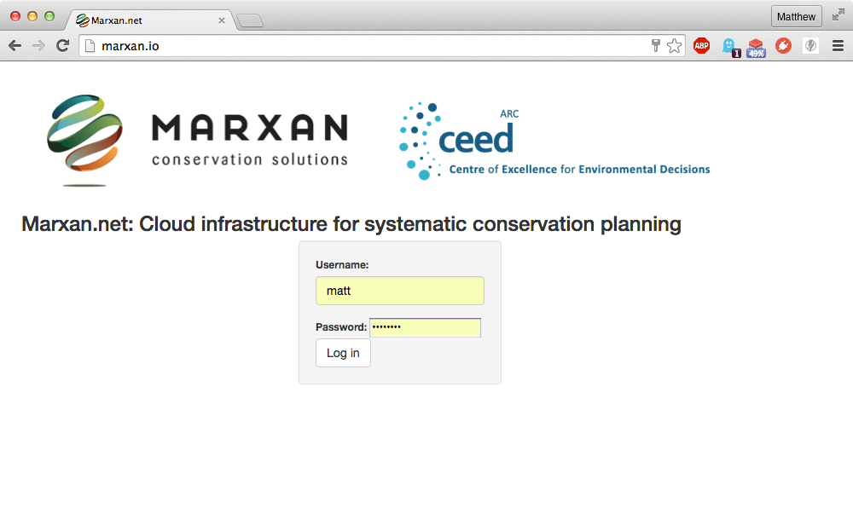

Enter the username and password provided. Then click the “Log in” button to be authenticated on the system. Once you’re authenticated, you’ll see this screen:

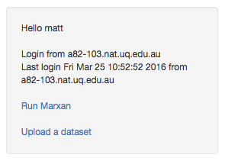

Click the blue “Run Marxan” link to do parameter testing and analysis, and visualise output maps, figures, and tables. A new tab will open in your browser with this app leaving the authentication tab open where you can launch other apps.

Similarily, click the blue “Upload a dataset” link to upload your own Marxan datasets. Again, a new tab will open in your browser with this app leaving the authentication tab open where you can launch other apps.

# Upload a dataset

The “Upload a dataset” screen looks like this:

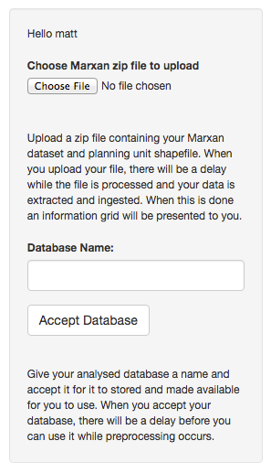

## Choose File

Click the “Choose File” button to select and upload the zip file containing your dataset. When you upload your file, there will be a delay while the file is processed and your data is extracted and ingested.

For large datasets, the delay might be a minute or even several minutes while the files are analysed. Large and complex polygon sets can take a while to process. When this is done, an information grid is presented to you like the screen below:

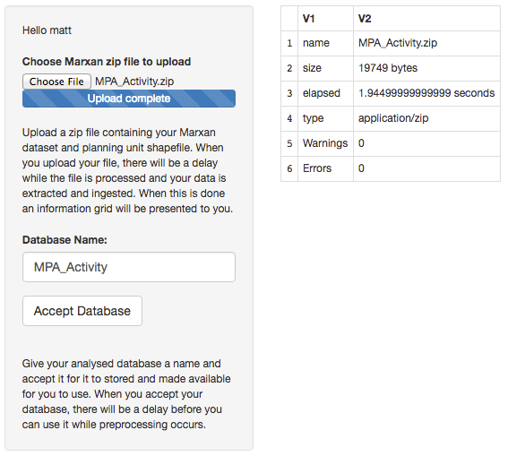

If the app hangs and does not display the grid, an error might have occurred in the processing of your dataset. You can email [m.watts@uq.edu.au](mailto:m.watts@uq.edu.au) to check your data that is logged in the system.

If an error is listed in the “Errors” box, it will contain diagnostic information that might help you correct the error and upload a corrected zip file. If you get stuck you can email [m.watts@uq.edu.au](mailto:m.watts@uq.edu.au) to check your data that is logged in the system.

Diagnosis of errors will allow us to improve the service over time for all users, so your patience and help is appreciated.

## Database Name

If the information grid is displayed with summary information on the examination of your dataset, and no errors are displayed, then you can specify a name for your dataset.

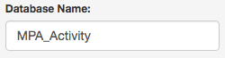

Please only use alphabetic and numeric characters with underscores and no spaces, as this becomes the directory name for your dataset. If you already have accepted a dataset with the same name, you will be asked to enter a new unique name for the dataset.

## Accept Database

To accept a dataset that has been successfully analysed, click the “Accept Database” button.

Macintosh HD:Users:matt:Downloads:figure7.png

Your dataset will then be imported into your account for use. A label will appear on the screen saying “Accepted”.

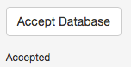

# Run Marxan

The web app is a graphical user interface that allows users to run Marxan, display maps, tables and graphs, edit key parameters, and do parameter testing. It has a control panel on the left, and an output panel on the right.

The “Run Marxan” screen looks like this:

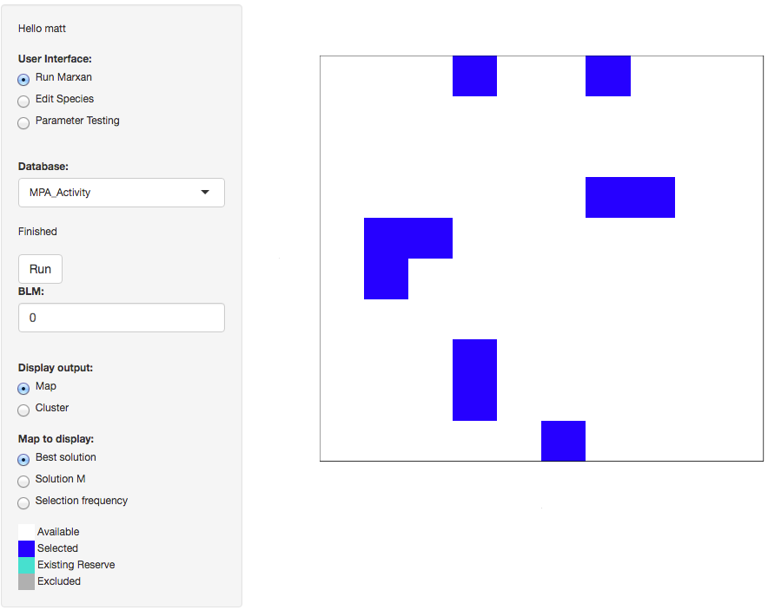

## User Interface

The app has a “User Interface” control:

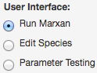

Select “Run Marxan” to set the BLM (boundary length modifier), display output maps and cluster analysis graphs, and run Marxan.

Select “Edit Species” to set the feature prop (proportional target) and SPF (species penalty factor) for each of your species.

Select “Parameter Testing” to run BLM calibration, SPF calibration, Target sensitivity analysis, and to display output tables, graphs, and maps for parameter testing.

## Database

The app has a “Database” control:

Macintosh HD:Users:matt:Downloads:figure11.png

Click the drop down arrow on the right of the control to select the dataset you want to work with.

The first time you select a dataset you have uploaded, there will be a delay while the Marxan and parameter testing outputs are rendered for you.

This delay is a minute or so for small datasets and several minutes for large and complex datasets.

Please be patient after selecting a dataset while the output renders. The display will refresh with output from your dataset once it’s rendered.

## BLM

The app has a “BLM” control:

Macintosh HD:Users:matt:Downloads:figure27.png

To edit the boundary length modifier (BLM), enter a new value in this control.

## Run

The app has a run button:

Macintosh HD:Users:matt:Downloads:figure12.png

When you’ve changed BLM, SPF, or targets, click this button to run Marxan with the new parameters.

A delay of a few seconds for small datasets and longer for larger datasets occurs during which the “Finished” label greys out. After the results are rendered, the “Finished” label appears black again and the display refreshes with new output.

Macintosh HD:Users:matt:Downloads:figure13.png

## Display output: Map

The app has a “Display output” control:

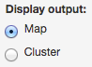

Select “Map” to display output maps.

When “Map” is selected, a “Map to display” control appears:

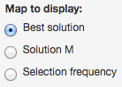

### Best solution

Selecting “Best solution” displays the Marxan solution with the lowest objective function score. A map and map legend appears:

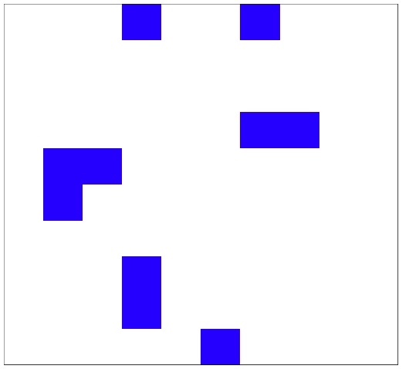

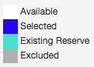

### Solution M

Selecting “Solution M” displays a slider to select any of the 100 solutions:

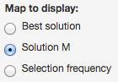 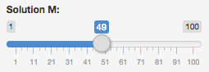

When you drag the slider, the map display is refreshed with the solution selected in the slider.

### Selection frequency

Selecting “Selection frequency” displays a selection frequency map of 100 solutions and a map legend:

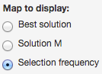

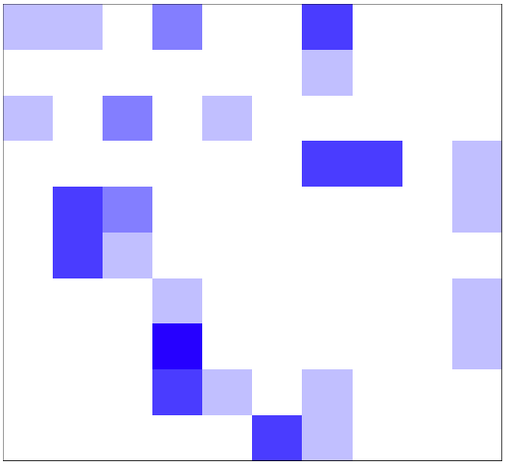

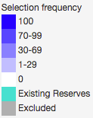

## Display output: Cluster

Selecting “Cluster” with the “Display output” control causes the “Cluster to display” control to appear:

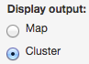 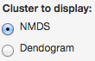

### NMDS of solutions

Selecting “NMDS” with the “Cluster to display” control displays the 2 dimensional scaling of the dissimilarity of the 100 solutions:

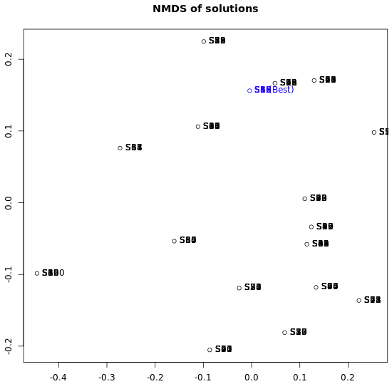

The 100 solutions are labeled on the graph, and the solution with the lowest objective function score is labeled in blue.

### Bray-Curtis dissimilarity of solutions

Selecting “Dendogram” with the “Cluster to display” control displays a dendogram of the 100 solutions:

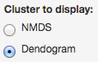

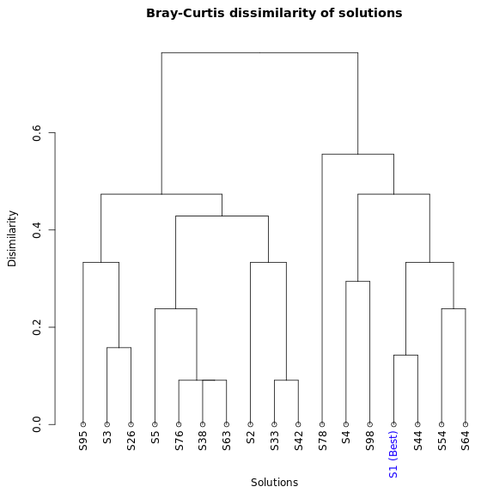

Only unique solutions are displayed, and again each solution is labeled and the solution with the lowest objective function score is labeled in blue.

# Edit Species

Selecting “Edit Species” in the “User Interface” control causes the species table editor to appear:

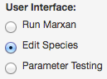

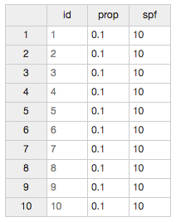

## Edit “prop” and “spf”

Here you can edit prop (proportional target) and SPF (species penalty factor) for each species.

To edit prop or SPF for a species, click the cell you want to edit and type in a new value. Here we have changed the prop for species 2 from 0.1 to 0.4:

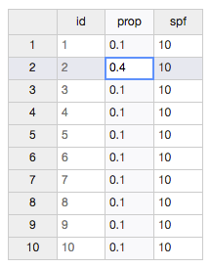

## Save

When you have entered the prop and SPF values for the species you want to change, click the “Save” button to save the changes to your dataset:

Macintosh HD:Users:matt:Downloads:figure31.png

# Parameter Testing

Selecting “Parameter Testing” in the “User Interface” control causes the parameter testing interface to appear:

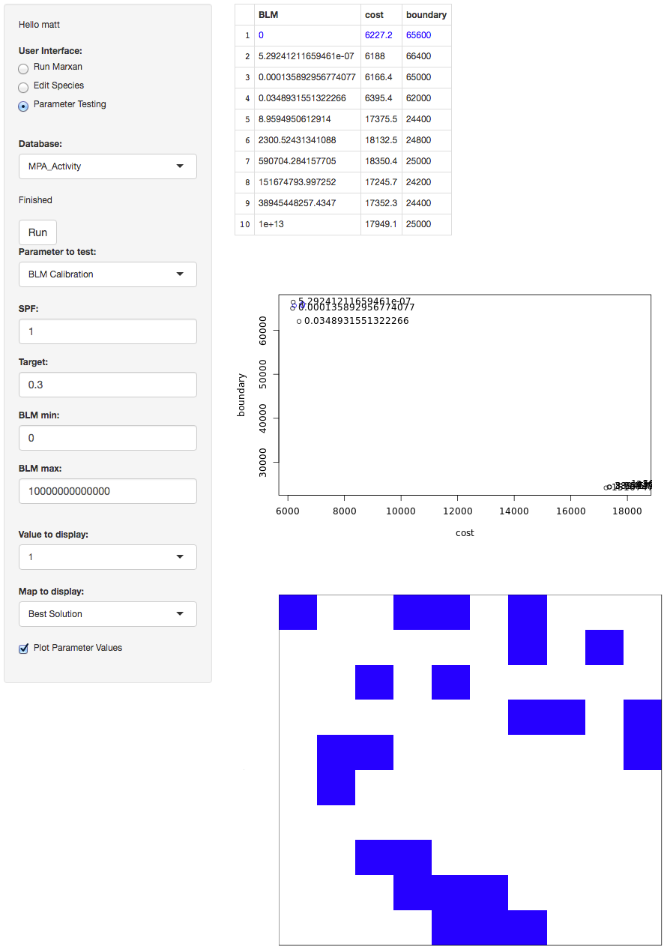

Here you can do calibration and sensitivity analysis of key parameters.

You can iteratively run tests for parameters of interest, changing parameters each time, to interactively explore the response of variables of interest. This allows the dynamics of a problem to be systematically explored in a structured way.

Appropriate values for the key parameters can thus be rapidly and efficiently determined.

## BLM Calibration

Click the drop down arrow on the right of the “Parameter to test” control and select “BLM Calibration” to calibrate the boundary length modifier (BLM):

Macintosh HD:Users:matt:Downloads:figure33.png

These controls appear for you to enter parameter values for the calibration:

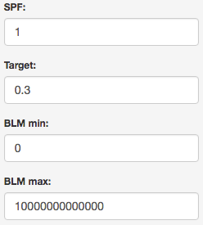

In the “SPF” control, enter the SPF value you want to use.

In the “Target” control, enter the proportional target value to use.

In the “BLM min” control, enter the minimum BLM value to use.

In the “BLM max” control, enter the maximum BLM value to use.

## SPF Calibration

Click the drop down arrow on the right of the “Parameter to test” control and select “SPF Calibration” to calibrate the species penalty factor (SPF):

Macintosh HD:Users:matt:Downloads:figure35.png

These controls appear for you to enter parameter values for the calibration:

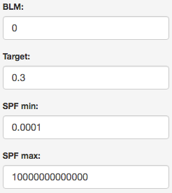

In the “BLM” control, enter the BLM value you want to use.

In the “Target” control, enter the proportional target value to use.

In the “SPF min” control, enter the minimum SPF value to use.

In the “SPF max” control, enter the maximum SPF value to use.

## Target Sensitivity

Click the drop down arrow on the right of the “Parameter to test” control and select “Target Sensitivity” to analyse the sensitivity of the species targets:

Macintosh HD:Users:matt:Downloads:figure37.png

These controls appear for you to enter parameter values for the calibration:

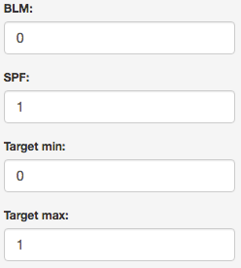

In the “BLM” control, enter the BLM value you want to use.

In the “SPF” control, enter the proportional SPF value to use.

In the “Target min” control, enter the minimum Target value to use.

In the “Target max” control, enter the maximum Target value to use.

## Run

Click the run button to execute the selected parameter test with the parameters you have entered:

Macintosh HD:Users:matt:Downloads:figure39.png

A delay of a few seconds for small datasets and longer for larger datasets occurs during which the “Finished” label greys out. After the results are rendered, the “Finished” label appears black again and the display refreshes with new output.

Macintosh HD:Users:matt:Downloads:figure13.png

A set of 10 values is tried for the parameter you are testing.

A set of 10 solutions are generated for each value you are testing for a total of 100 solutions.

For BLM and SPF calibration, the values are ramped exponentially between the min and max entered.

For Target sensitivity analysis, the values are ramped linearly between the min and max entered.

## Output table

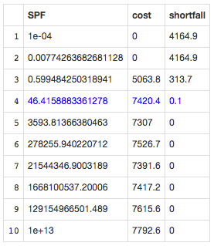

The output table displays the parameter values tried, the average cost of solutions, and the average value for the response variable of the solutions.

For SPF, the response variable is “shortfall” (the total amount by which our features miss meeting their targets).

For BLM, the response variable is “boundary” (the total boundary length of the reserve network configuration).

For target, the response variable is simply “target” (the target level we are testing).

Our aim with SPF and BLM calibration is to discover a parameter value that gives an appropriate response in the response variable.

Our aim with target sensitivity analysis is to discover how much it costs to protect different proportions of our species.

## Output graph

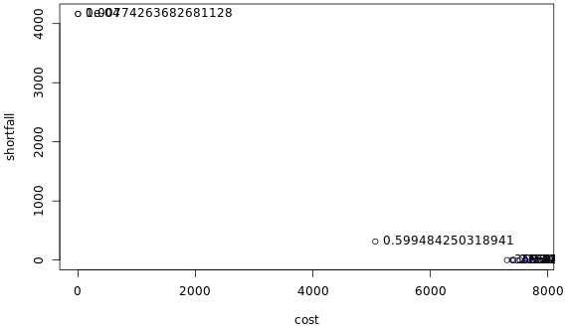

The output graph for BLM and SPF displays the response variable on the Y axis, and the cost on the X axis.

The output graph for target displays target on the Y axis and cost on the X axis.

As a test is rerun with different values of “min” and “max”, results are cumulatively added to the graph so the problem dynamics can gradually be revealed.

This iterative process allows rapid and efficient determination of appropriate values for the key parameters.

## Output map

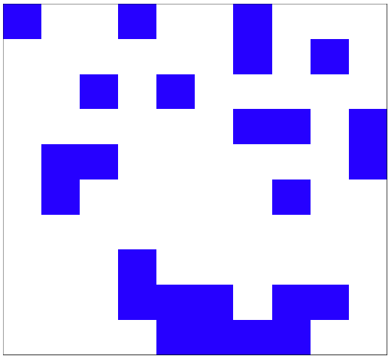

The output map displays selected areas or selection frequency for the value selected in the “Values to display” control (see below).

The “Map to display” control also determines which map is displayed (see below).

## Value to display

Macintosh HD:Users:matt:Downloads:figure43.png

The “values to display” control allows you to select which input parameter value to interrogate.

Choosing “1” selects the “min” value specified. Choosing “10” selects the “max” value specified. Choosing a value between 1 and 10 selects one of the values ramped between the “min” and “max” values.

The selected value is highlighted in blue on the output table and graph, and results from testing the selected value are displayed on the output map.

## Map to display

Macintosh HD:Users:matt:Downloads:figure44.png

The “Map to display” control allows you to select which map to display.

10 solutions are generated for each input parameter value tried, and selecting “Run 1” to “Run 10” displays that solution on the map.

Selecting “Best Solution” displays the solution with the lowest objective function score on the map.

Selecting “Selection Frequency” displays selection frequency on the map.

## Plot Parameter Values

Macintosh HD:Users:matt:Downloads:figure45.png

The “Plot Parameter Values” control selects if parameter values will or will not be displayed next to their relevant points on the graph.

# Acknowledgements

Marxan acknowledges funding from Nectar. Nectar is supported by the Australian Government through the National Collaborative Research Infrastructure Strategy (NCRIS).

# References

Ball, I.R., H.P. Possingham, and M. Watts. 2009. Marxan and relatives: Software for spatial conservation prioritisation. Chapter 14: Pages 185-195 in Spatial conservation prioritisation: Quantitative methods and computational tools. Eds Moilanen, A., K.A. Wilson, and H.P. Possingham. Oxford University Press, Oxford, UK.

R Development Core Team (2008). R: A language and environment for

statistical computing. R Foundation for Statistical Computing, Vienna, Austria. ISBN 3-900051-07-0, URL <http://www.R-project.org>.

Shiny server, by the RStudio Team (2015). RStudio: Integrated Development for R. RStudio, Inc., Boston, MA URL http://www.rstudio.com/.

Watts, M.E. and Possingham, H.P. 2013. Marxan.net: Cloud infrastructure for systematic conservation planning. URL <http://marxan.net>

Watts, M.E, I.R. Ball, R.R. Stewart, C.J. Klein, K. Wilson, C. Steinback, R. Lourival, L. Kircher, and H.P. Possingham. 2009. Marxan with Zones: software for optimal conservation based land- and sea-use zoning, Environmental Modelling & Software (2009), doi:10.1016/j.envsoft.2009.06.005

**--------------------------------------------------------------**