FLY TO THE MOON MUSIC STUDIO 🌙🎹
Logo
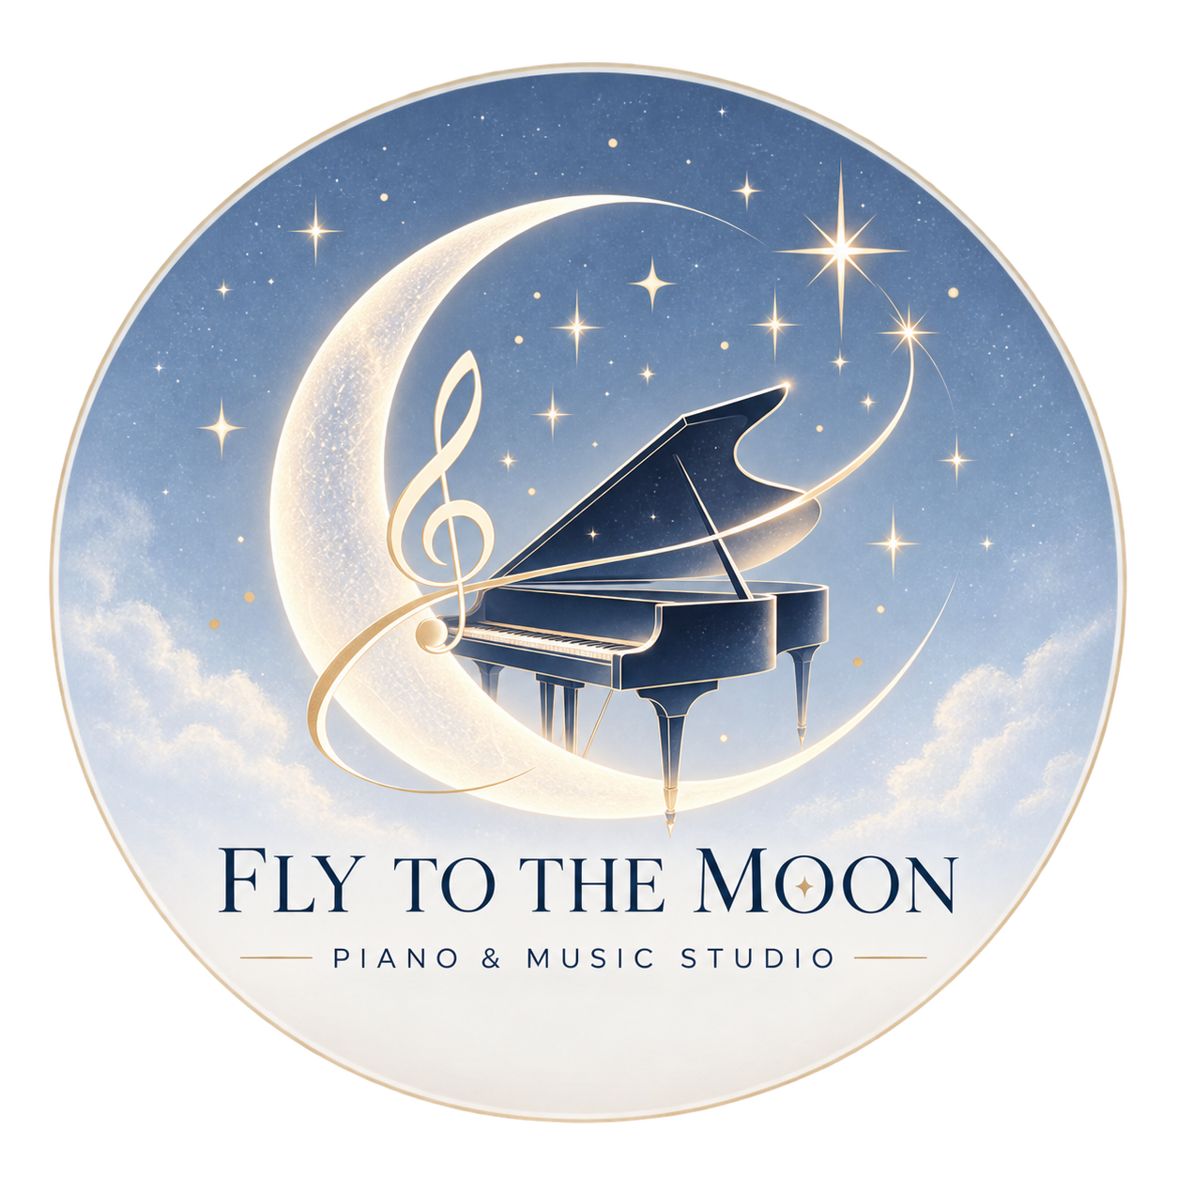
参考排版
参考排版2
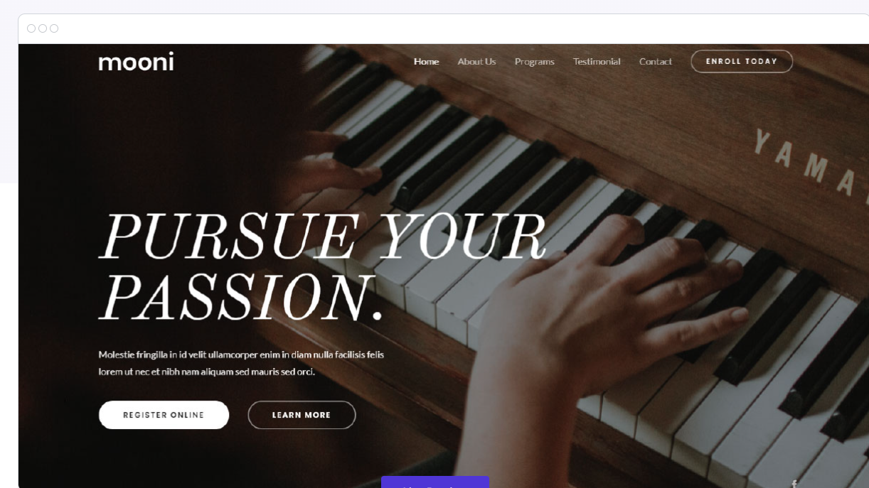
第一页 Homepage：
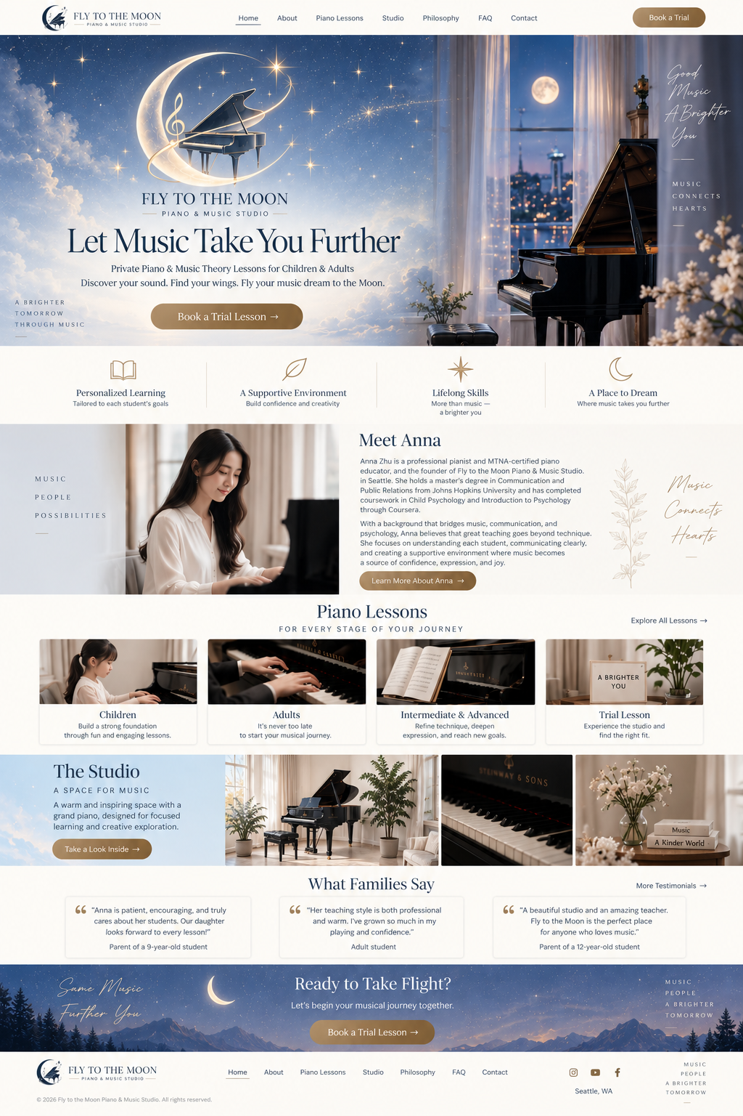

Title：FLY TO THE MOON PIANO & MUSIC STUDIO
顶部导航 横着排列
Home
（About）Meet Anna
Piano Lessons
Studio
Philosophy
FAQ
Contact
Book a Trial

🎹 HERO / 第一屏
这是整个网站最重要的地方。

这张我和三角钢琴照片作为背景，在照片上放文字。照片如下， file里面编号1

参考上面那张图
大标题写--Let Music Take You Further
subtitle：
Private Piano & Music Theory Lessons for Children & Adults
Discover your sound. Find your wings. Fly your music dream to the Moon
然后按钮
Contact
然后 Home 往下怎么排？
第一页可以向下滑动，同时到达下一个界面
↓
01Meet Anna （可展开到详细页面）
Anna Zhu is a pianist, MTNA-certified piano educator, and the founder of Fly to the Moon Piano & Music Studio. She holds a master’s degree in Communication and Public Relations from Johns Hopkins University and has completed additional coursework in Child Psychology and Introduction to Psychology through Coursera, as well as online coursework focused on children with autism through the University of British Columbia.
Her teaching experience includes working with children and adults of different ages, learning styles, and musical goals, including children on the autism spectrum and older adults living with dementia. These experiences have shaped her belief that there is no single “right” way to learn music. Patience, communication, trust, and an understanding of each student are at the heart of her teaching.
Anna continues her own advanced piano studies with Victoria Bogdashevskaya, former principal pianist of the Seattle Symphony, bringing an active connection to professional musicianship into her teaching.
At Fly to the Moon, Anna hopes to create more than piano lessons. She wants each student to feel heard, supported, challenged, and inspired—to develop strong musical foundations while discovering a personal and lasting connection with music.
这里放我的证书和获奖照片 （file里面编号2-7）按顺序放
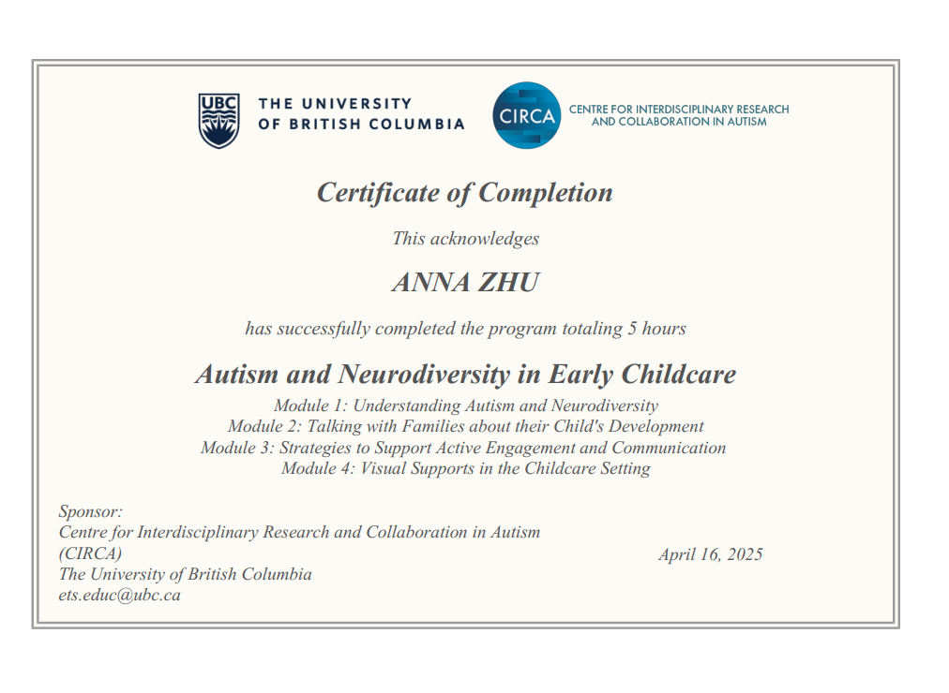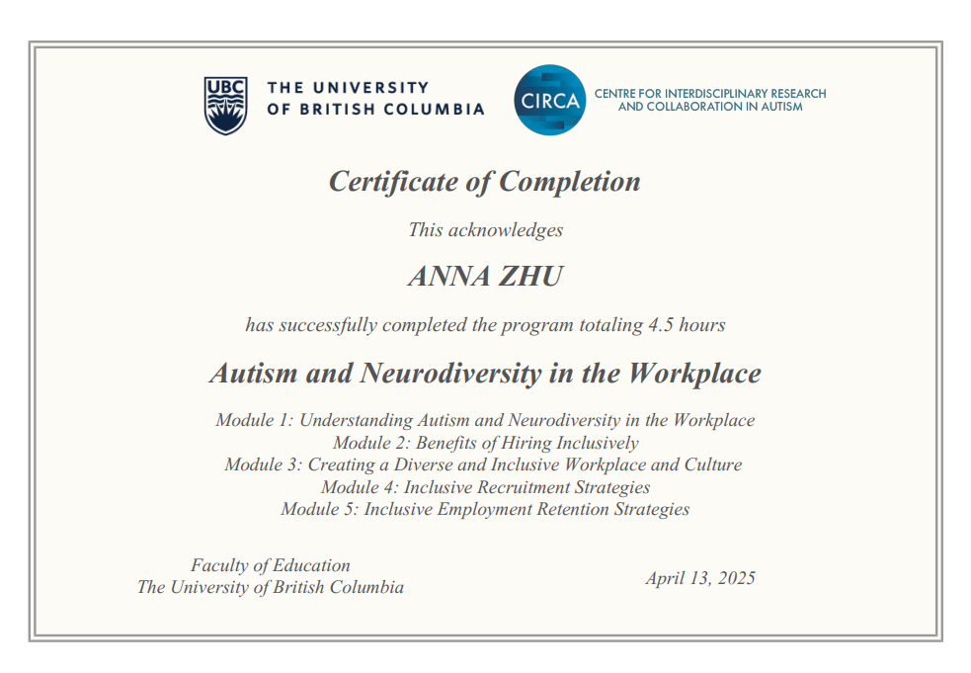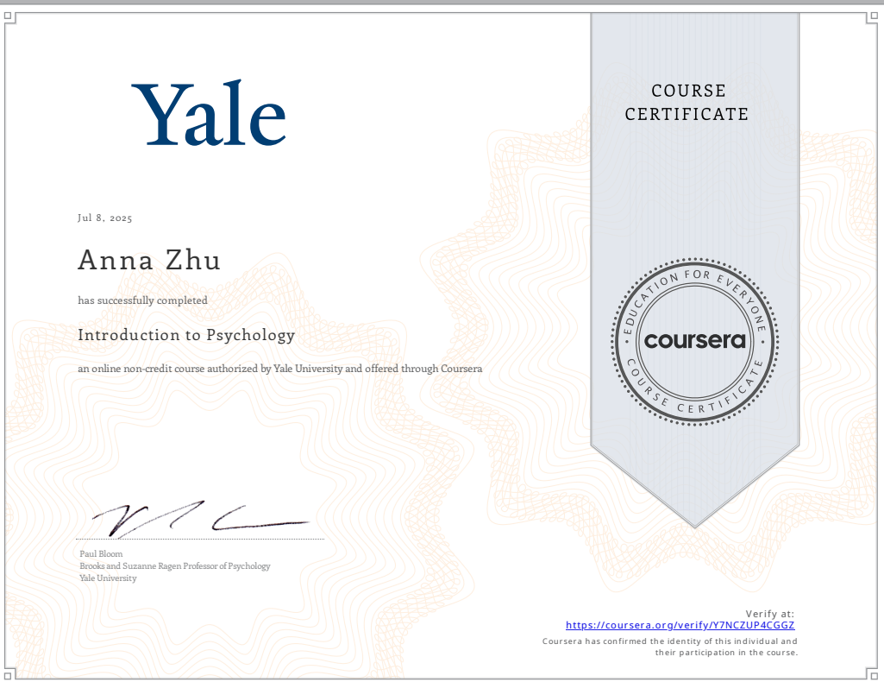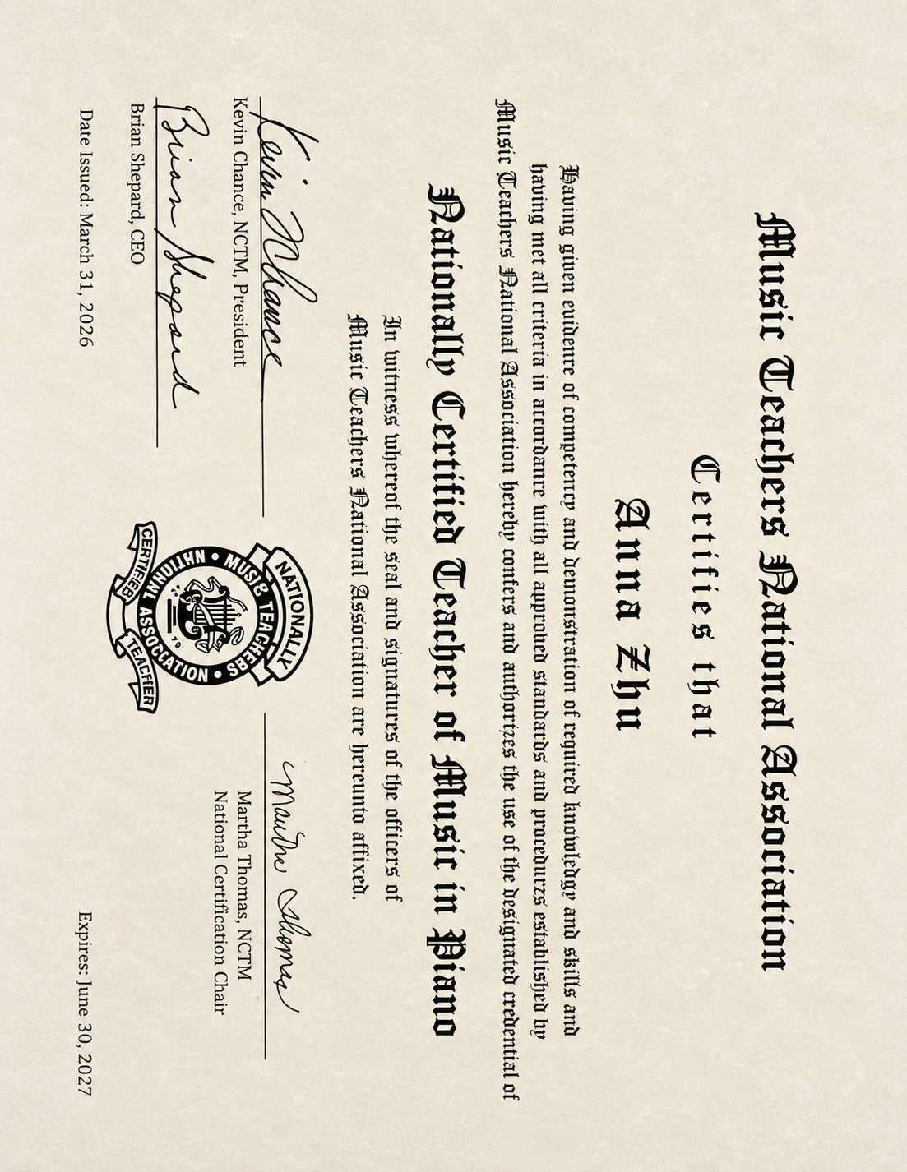
Music · Communication · Understanding · Growth

02 — PIANO LESSONS
图片用 8-11， 按照模板里面的横着排列

Children | Adults | Beginners | Advanced
Learn at Your Own Pace. Grow in Your Own Way.
Every student comes to music with a different goal. Some want to play their favorite songs for fun, some dream of performing on stage, and others are preparing for examinations or competitions. Lessons are personalized around each student's age, experience, learning style, and musical interests.
Private Piano Lessons
30-Minute Lessons
Ideal for young beginners and students who benefit from shorter, focused weekly lessons.
60-Minute Lessons
Recommended for intermediate and advanced students, exam or competition preparation, and students who would like more time for technique, repertoire, theory, and musicianship.
Areas of Study
Play for Joy
Learn the music you love while developing strong foundations, confidence, and musical expression.
RCM & ABRSM Exam Preparation
Structured preparation in repertoire, technique, musicianship, and music theory for students pursuing RCM or ABRSM examinations.
Competition & Performance Preparation
Individualized coaching for students preparing for competitions, recitals, auditions, and other performance opportunities.
Early Childhood Music Education
An engaging introduction to rhythm, listening, keyboard exploration, musical stories, and foundational skills designed for young learners.
Music Theory & Musicianship
Theory can be incorporated into piano lessons or studied more intensively depending on each student's goals.
Whether your goal is your first song, your first recital, an examination, or a competition stage, there is a place for you here.
↓
03 Studio
A Space to Learn, Create & Grow
Fly to the Moon Piano & Music Studio is a private teaching studio located in the 98059 area of Newcastle/Bellevue, Washington, serving students from Renton and surrounding communities.
Centered around a grand piano, the studio is designed to provide a calm, welcoming, and focused environment where students can step away from everyday distractions and connect deply with music.
Whether a student is playing their very first note or preparing for an advanced performance, the studio is a place where curiosity is encouraged, mistakes are part of learning, and every musical milestone deserves to be celebrated.
Detailed studio directions are provided upon lesson confirmation.
04 — TEACHING PHILOSOPHY
Music is more than notes.
Technique · Creativity · Expression · Confidence
Teaching Philosophy
Happy Learning. Meaningful Progress.
I believe students learn best when they feel safe, curious, understood, and excited to return to the piano.
Joy Comes First
Music should be something students look forward to—not another source of pressure.
Lessons encourage curiosity, creativity, and a genuine love of music while gradually building strong technique and musicianship.
Every Student Is Different
No single teaching method works for everyone.
Some students learn by listening. Some learn visually. Some need to move, imagine, tell stories, or understand the “why” behind what they are playing.
My job is not simply to teach the lesson. It is to discover how each student learns best.
Communication Is Essential
I want my students to know that their ideas matter.
They are always encouraged to tell me:
“I don't understand.”
“Can we try this another way?”
“I really love this piece.”
“This is difficult for me.”
These conversations are not interruptions to learning—they are part of learning.
A strong teacher-student relationship is built on trust, respect, and communication.
Little Missions, Big Progress
Joyful learning does not mean learning without goals.
Students may receive small weekly Music Missions—a technique challenge, a listening activity, a practice goal, a creative exercise, or a musical discovery to bring back to the next lesson.
The goal is not perfection.
The goal is to build curiosity, independence, consistency, and the confidence to keep moving forward.
More Than Piano
Ultimately, I hope students leave the studio with more than the ability to play an instrument.
I hope they learn how to listen, express themselves, overcome challenges, stay curious, and find confidence in their own voice.
Good music begins with good communication.

↓
05 FAQ
Q: How does tuition payment work?
A: Tuition is accepted via Zelle or cash and is due at the beginning of each month. Monthly tuition reserves the student's regular weekly lesson time.
Q: What is the cancellation policy?
A: Please provide at least 24 hours' notice if you need to cancel or reschedule a lesson.
When sufficient notice is provided, a make-up lesson may be arranged based on studio availability.
Q: Do you offer make-up lessons?
A: Yes. Make-up lessons are available for eligible cancellations with at least 24 hours' notice and are scheduled according to teacher and studio availability.

Q: Are recitals offered?
A: Yes! Studio recitals are offered twice each year, giving students the opportunity to share their progress, build confidence, and celebrate music with family and fellow students.
Participation is encouraged but not required.

Q: Do you prepare students for competitions?
A: Absolutely. Students interested in competitions, auditions, examinations, or other performance opportunities are always welcome to discuss their goals with the teacher.
Preparation plans can be developed according to the student's level, timeline, and individual goals.

Q: Do you offer RCM or ABRSM preparation?
A:Yes. Lessons can include preparation for RCM and ABRSM examinations, including repertoire, technique, musicianship, and music theory.

Q: Are master lessons available?
A: For selected students seeking advanced musical development, opportunities for master lessons with university music professors and professional musicians may be available when appropriate.
Please contact the studio to discuss whether this would be a good fit for the student's current level and goals.

Q: What happens when the teacher is on vacation?
A: Planned studio vacations will generally be communicated at least one month in advance so families have plenty of time to plan accordingly.

Q:What if I have a question about lessons or my child's progress?
A: Please reach out anytime.
Communication between students, families, and the teacher is an important part of the learning process. Questions about practice, repertoire, progress, motivation, scheduling, or lesson goals are always welcome.

06— STUDENT STORIES
★★★★★
家长 testimonials
↓
07 — FINAL CTA
Ready to Take Flight?
Book a Trial Lesson →

