Dzanga-Sangha Simulation
Program Flow & Logic Summary
Based on dzanga_sim(1).py | Python port of large_scale_sim_FINAL_ver_5_REAL.m

Purpose and architecture
The program models elephant movement, poacher activity, acoustic-microphone detection, and ranger intervention inside a mapped park boundary. DzangaSimulation owns the model and all simulation state; DzangaApp provides a Tkinter dashboard. An alternative command-line headless mode runs a fixed number of time steps and prints results.

Model setup
Initialization builds the park occupancy grid, five village avoidance zones, the Bai attractor/protected zone, 20 elephants, 10 poachers, position-sampling pools, and microphones. Defaults are 80 microphones using Strategy 1. Optional random seed enables reproducible stochastic runs.
Stage | What the code does
1 · Uniform spread | Farthest-point placement across candidate park locations.
2 · Targeted fortress | Put most microphones around village rings, then spatially fill remaining sites.
3 · Perimeter defense | Space microphones along park-boundary segments.
4 · Combination | Combine village-ring and perimeter positions, then fill any remainder.

Sequence of one simulation step
Stage | What the code does
1 · Advance time | Multiply elapsed real time by the chosen acceleration, then compute per-agent travel distances.
2 · Move poachers | Travel toward roaming targets; avoid the Bai region; turn back or retarget at park boundary.
3 · Move elephants | Transition through ROAMING, SEEKING, and WAITING; move toward Bai when appropriate; avoid village zones and boundaries.
4 · Scan microphones | At most one scan per microphone per simulated second; evaluate nearby elephants and poachers, missed detections, and elephant memory.
5 · Dispatch/move rangers | When microphone evidence identifies a threat, target poachers and send a ranger from the nearest village; catch them within 500 m.
6 · Evaluate encounters | Check proximity outside Bai, apply one stochastic poaching roll per continuous encounter, update alert flags and counters.
Important execution detail: within step(), the source calls _move_poachers(), _move_elephants(), _scan_mics(), _move_rangers(), then _poaching_check(), in exactly that order.

Figure 1 · Overall program flow
Orthogonal connectors show command-line mode selection, model construction, the Tkinter timer loop, and headless execution. The GUI updates the model only when it is not paused.
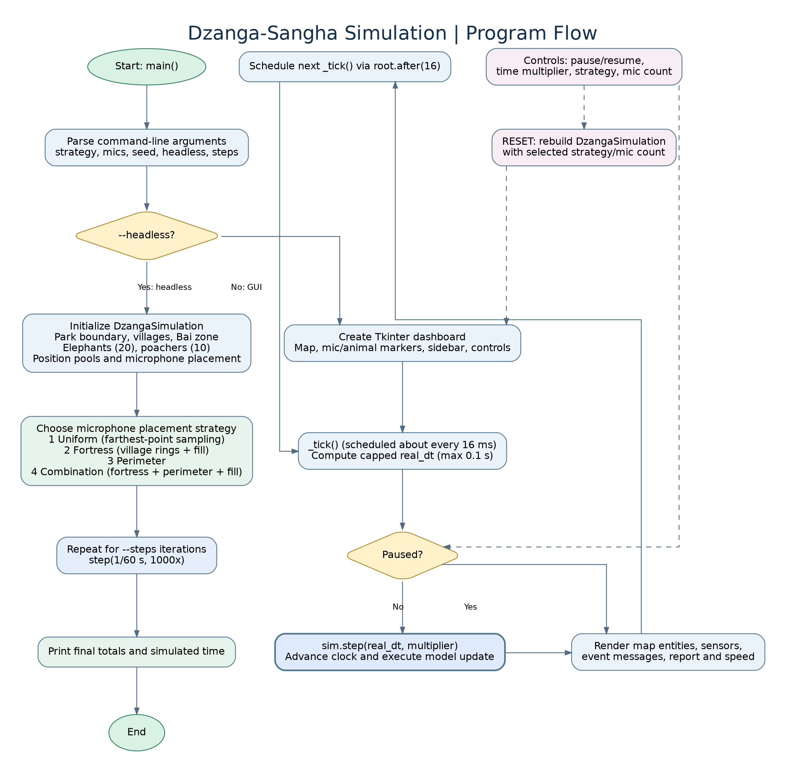

Figure 2 · Per-step model decisions
This diagram follows DzangaSimulation.step(), with branches for invalid time input, threat detection, ranger dispatch, and elephant–poacher encounters.
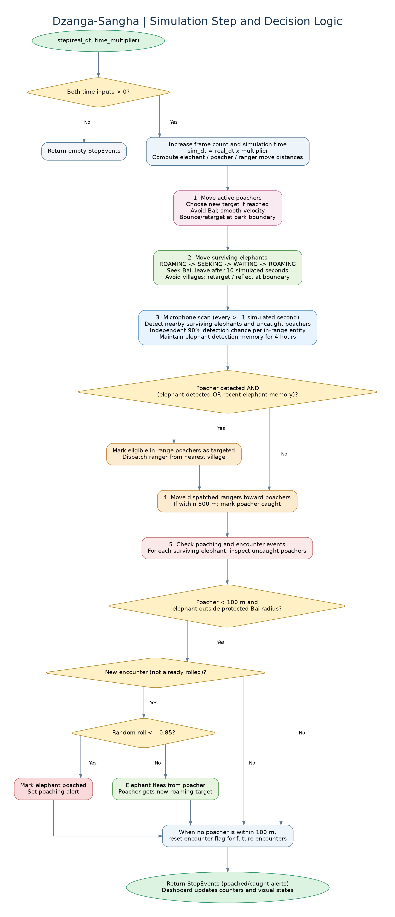

Key parameters and interpretation
Stage | What the code does
Detection | 90% independent random chance when an eligible entity is within a microphone’s applicable detection radius.
Sensor ranges | Elephant: 3,950 m; poacher: 200 m.
Sensor timing | Each microphone scans after ≥1 simulated second since its last scan; elephant memory lasts 14,400 s (4 h).
Poaching event | Poacher within 100 m of a living elephant outside the Bai protected radius; 85% chance on a new eligible encounter.
Ranger interception | Ranger is sent from nearest village when an in-range poacher is detected together with an elephant detection or recent memory; capture threshold is 500 m.
Model speeds | Elephant 1.11 m/s; poacher 0.55 m/s; ranger 5.55 m/s.
GUI / headless | GUI _tick() scheduled at approximately 16 ms; headless defaults to 500 iterations at 1/60 s real time and 1000× multiplier.

Behavioral nuances
A microphone alone does not automatically dispatch a ranger: a detected poacher must coincide with a current elephant detection or valid elephant memory at that microphone. Ranger targets remain targeted once set. Poaching trials are not repeated on every frame during a continuous close encounter; the encounter flag resets when no uncaught poacher is within 100 m.
The Bai is protected from the poaching event check, but it is not a universal safety guarantee against all interactions or movement. The simulation models stochastic outcomes, not measured real-world intervention effectiveness.

Source and scope
Source: uploaded dzanga_sim(1).py, especially DzangaSimulation.__init__, _place_mics, step, _scan_mics, _move_rangers, _poaching_check, DzangaApp._tick, run_headless, and main. Flowcharts are simplified conceptual depictions of these control paths; this report does not claim to validate model realism or predictions.

