Project Jerusalem
Architectural Blueprint

Author: Duncan Mee
Version: 0.7
Date: 12/12/2008

Table of Contents

Sign-off and Review 1
Document History 2
Audience 2
Introduction 2
Application Architecture 2
Overview 2
Services 3
User Interface 3
Users 5
Network Architecture 5
Platforms 5
Network Topology 6
Data 6

Sign-off and Review
Name | Role | Task | Date
Liam O'Brien | Director – UK Sales | Sign-off
Wendy Davison | Chief Architect – UK Retail Systems | Sign-off
Patrick Wolfenden | Business Partner – UK Retail Systems | Sign-off
Charndeet Amray | Senior Infrastructure Architect | Review
Sandra Stewart | Senior Systems Analyst | Review
Keith Davies | Principal Data Analyst | Review
Alessandro DiSilva | Project Manager – Jerusalem Project | Review
Chris Morris | Senior Designer – CGWI | Review
Anna Constantine | Lead Engineer – Services and Platforms | Review

Document History
Version | Changes | Who | Date
0.6 | Version retrieved from coolbox. Tidied up for review. | Duncan Mee | 11/9/2008
0.7 | Incorporated review feedback. Added audience and document history sections. | Duncan Mee | 12/12/2008

Audience
The document is intended for IT executives of Contoso Ltd, business sponsors, domain analysts, project managers, architects, designers, developers and users of the Jerusalem system.

Introduction
The Jerusalem system is a replacement for the legacy RT platform. Jerusalem is a next-generation platform based around Microsoft .NET 3.5, Windows Server 2008, and the Intel Xeon processor which brings 64-bit processor power and native support for virtualization to the retail tills platform. By deploying this platform and upgrading store connectivity to 4MB, Jerusalem will bring unparalleled performance and proven reliability to the Contoso till systems which will keep us ahead of the competition for years to come.
Jerusalem will replace RT on all retail till systems over the course of 2007.

Application Architecture

Overview
Each Jerusalem installation is based around a Retail Store Host System (RSHS or 'Mothership'). The mothership acts as a local cache for data flowing to and from the Pricing and USS enterprise systems. This is a Windows Server 2008 system.

Services
The Jerusalem system takes advantage of the following enterprise services:
Service | Description | Implementation
Pricing | Provides current prices from central stock system. | Mainframe fronted by Web Services
Authentication | Provides authorization and authentication for clients. | LDAP
Local Pricing | Store-specific prices based on weekly promotions | Windows NT 3.51 in-store
Payment | The Athena Payments System ® is a universal payments system suitable for large enterprises. It incorporates many features including credit card processing, debit card processing, cash management and reconciliation. Almost 53% of retailers in the Fortune 500 employ the Athena Payments System ® to gain competitive advantage in a challenging market.
Chip + PIN | Support for CHIP + PIN payments at till. Payments encoded in 256-bit encryption and passed to clearing house. | ChipSafe CardCaddy
Card Swipe | TBA
Logon | Manages user logon to till system | COM linking to LDAP bridge
Promotions | Delivers promotional suggestions to till user as items are scanned, e.g. if cat food is scanned, suggest pet insurance to customer. | Contoso custom module for till system
Barcode scanner | In-unit barcode scanner for till system. Linked to main till system via USB. Can be used in holder or uncliupped to scan large items. | RedBar CodeBest mark 3

User Interface
The till user interface will use a thin-client Browser interface to take advantage of the latest AJAX technology. Application modules will run under the Microsoft Cassino web server on the till system which supports ASP.NET 3.5 and Silverlight to provide AJAX support. Each of the main user interface elements will be implemented as a separate ASP.NET Web Application using Web Forms and Silverlight and will connect to the primary business modules over Web Service calls.
The primary business modules will interface with the enterprise services providing a clean layering and conforming to the Layers pattern as described by the Microsoft Prescriptive Architecture Group. Figure 1 shows the principal elements of the till user interface.

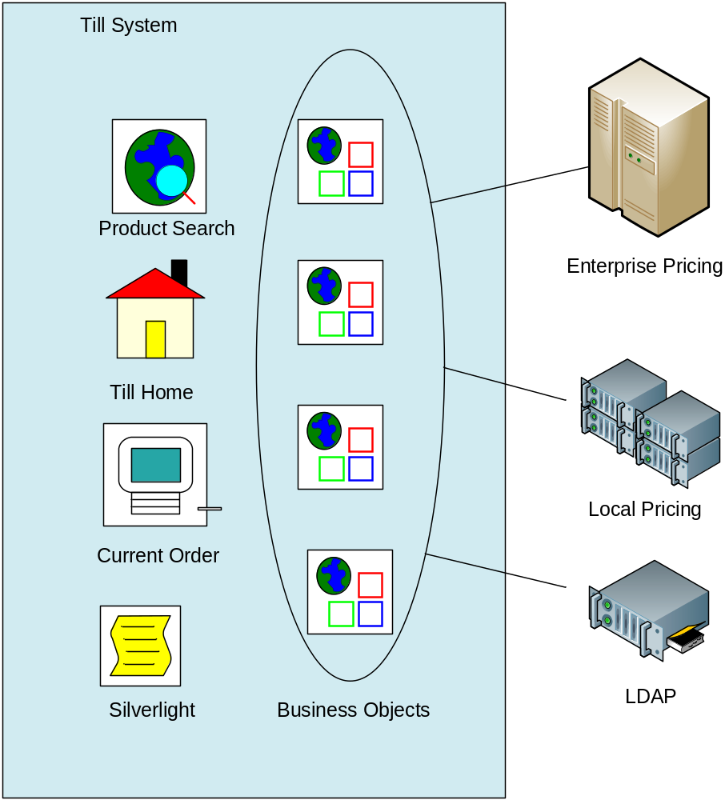
Figure 1 Jerusalem Architecture

Users
There are two primary groups of users:
- Till staff – including work experience and temporary users
- Administrators – including lane supervisors, this group will have elevated privileges

Network Architecture
Platforms
The primary platforms in the Jerusalem system are:
- Till System – Based on Windows NT 3.51. This also runs specialist till software created for Contoso by NCR. Systems are locked down and limited to a custom login sequence which integrates with LDAP.
- Store Server (“Mothership”) - this AIX system provides caching between the central pricing servers and the local till systems. It also provides local pricing and promotions.
- Mainframe – the Contoso mainframe system is running in the West Bromwich datacentre with disaster recovery in Cardiff.
- LDAP and security. The security servers run on hardened AIX servers using IBM WebSecure technology.

Network Topology
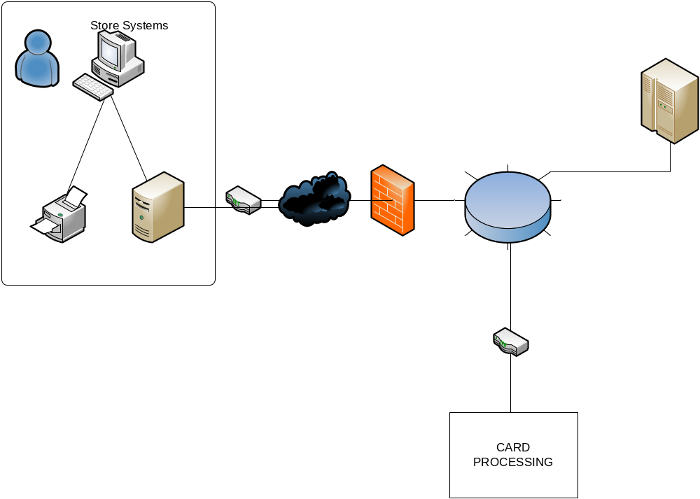

Data
There are two principal databases in the Jerusalem system:
- Central pricing. This is held on the mainframe in DB2. Some pricing feeds are delivered via Connect : Direct from 3rd party suppliers while other prices are updated manually by the pricing team in Watford.
- Local pricing and promotions. This is held on the Mothership and can be updated by the store manager. The data is held in a clustered SQL Server installation for resillience. Data is accessed via ADO.NET and delivered to the till user interface in the form of DataSets.
Data must be encrypted using SSL when it is travelling between the corporate datacentre and the store (and vice versa).
Credit card data must not be retained by any of the Contoso systems but all other order data must be retained for 7 years after the point of sale. This data will be maintained in the Contoso Data Warehouse in Cardiff.

