Hallo Anna,
just a quick answer bevor going on holiday to London for one week.

Decomposition Mode:
in x11 the mode is needed if you have no preprocessing.
If you would like to use LogAdditve od Pseudo additive it is only possible with this Option.

Some further explanation including PreProcessor and x11
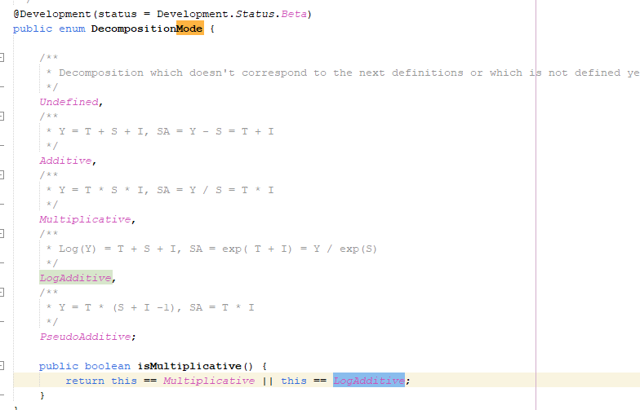
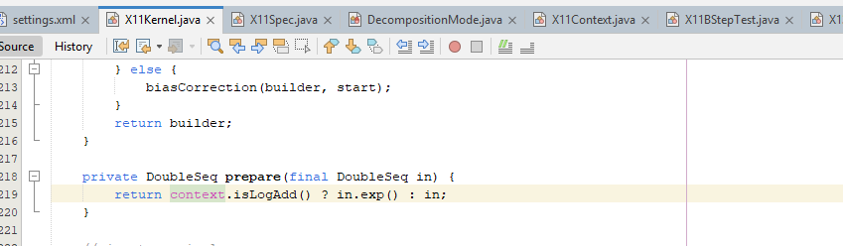
X11 Spec DecompositionMode

X13 Spec contains RegArimaSpec and this contains TransformSep with TransformationType
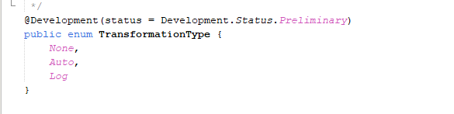
Logic für die Zusammenführung von Transformation Typ und DecompositionMode
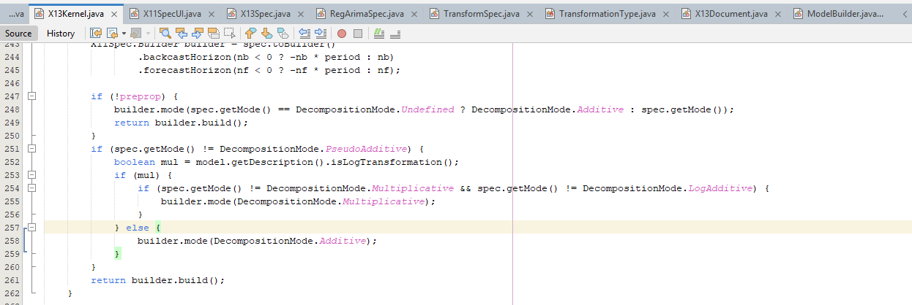

BiasCorrection
Starts in X11Kernel line 223
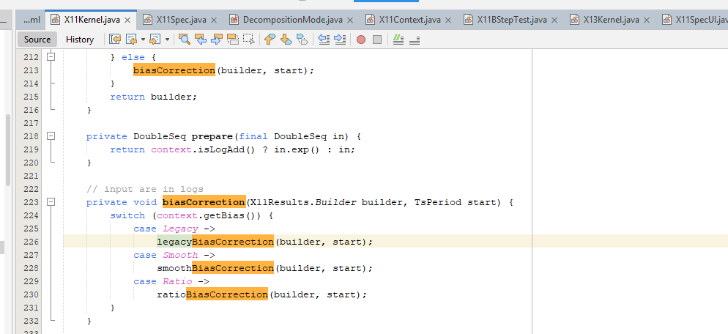

Methods are in jdplus-main/jdplus-main-base/jdplus-x13-base-parent/jdplus-x13-base-core/src/main/java/jdplus/x13/base/core/x11/X11Kernel.java at develop · jdemetra/jdplus-main starting in line 244.

Bias SUITE, from code
// fill D10, d11, d12, d13
private X11Results.Builder finalResults(X11Results.Builder builder, TsPeriod start, X11Spec spec) {
if (spec.getMode() != DecompositionMode.LogAdditive || !spec.isSeasonal() || spec.getBias() == BiasCorrection.None) {
QQ !spec.isSeasonal() ??
builder.d10(TsData.of(start, prepare(dstep.getD10())))
.d11(TsData.of(start, prepare(dstep.getD11())))
.d12(TsData.of(start, prepare(dstep.getD12())))
.d13(TsData.of(start, prepare(dstep.getD13())));
} else {
biasCorrection(builder, start);
}
return builder;
}

private DoubleSeq prepare(final DoubleSeq in) {
return context.isLogAdd() ? in.exp() : in;
}

// input are in logs
private void biasCorrection(X11Results.Builder builder, TsPeriod start) {
switch (context.getBias()) {
case Legacy ->
legacyBiasCorrection(builder, start);
case Smooth ->
smoothBiasCorrection(builder, start);
case Ratio ->
ratioBiasCorrection(builder, start);
}
}

private void fill(X11Results.Builder builder, TsPeriod start, DoubleSeq d10, DoubleSeq d12) {
d12 = X11Context.makePositivity(d12);
DoubleSeq d11 = DoublesMath.divide(input.getValues(), d10);
DoubleSeq d13 = DoublesMath.divide(d11, d12);
builder.d10(TsData.of(start, d10))
.d11(TsData.of(start, d11))
.d12(TsData.of(start, d12))
.d13(TsData.of(start, d13));
}

private void smoothBiasCorrection(X11Results.Builder builder, TsPeriod start) {
DoubleSeq d13 = dstep.getD13(), d10 = dstep.getD10(), d12 = dstep.getD12();
double issq = d13.ssq();
double sig = Math.exp(issq / (2 * d13.length()));
int ifreq = context.getPeriod();
SymmetricFilter filter = X11TrendCycleFilterFactory.makeTrendFilter(ifreq);
int ndrop = filter.length() / 2;
double[] x = new double[d10.length()];
DataBlock out = DataBlock.of(x, ndrop, x.length - ndrop);
d10 = d10.exp();
filter.apply(d10, out);
CopyEndPoints cp = new CopyEndPoints(ndrop);
DataBlock X = DataBlock.of(x);
cp.process(d10, X);
d12 = d12.fn(X, (a, b) -> Math.exp(a) * b * sig).commit();

fill(builder, start, d10, d12);
}

private void ratioBiasCorrection(X11Results.Builder builder, TsPeriod start) {
DoubleSeq d10 = dstep.getD10().exp();
DoubleSeq d12 = dstep.getD12().exp();
DoubleSeq d13 = dstep.getD13().exp();

int ifreq = context.getPeriod();
int s0 = start.annualPosition(), ny = (d10.length() - s0) / ifreq;

double sbias = d10.range(s0, s0 + ny * ifreq).average(), ibias = d13.average();
d10 = d10.fn(x -> x / sbias);
double tbias = sbias * ibias;
d12 = d12.fn(x -> x * tbias);
fill(builder, start, d10, d12);
}

private void legacyBiasCorrection(X11Results.Builder builder, TsPeriod start) {
DoubleSeq d13 = cstep.getC13(), d10 = dstep.getD10(), d12 = dstep.getD12();
double issq = d13.ssq();
double sig = Math.exp(issq / (2 * d13.length()));
int ifreq = context.getPeriod();
int length = (ifreq == 2) ? 5 : 2 * ifreq - 1;
double[] x = table(d10.length(), Double.NaN);
int ndrop = length / 2;
DataBlock out = DataBlock.of(x, ndrop, x.length - ndrop);
d10 = d10.exp();
SymmetricFilter smoother = context.trendFilter(length);
smoother.apply(d10, out);
FiniteFilter[] musgraveFilters = MusgraveFilterFactory.makeFilters(smoother, 4.5);
AsymmetricEndPoints aepFilter = new AsymmetricEndPoints(musgraveFilters, 0);
DataBlock hs = out.extend(ndrop, ndrop);
aepFilter.process(d10, hs);
d12 = d12.fn(hs, (a, b) -> Math.exp(a) * b * sig).commit();

fill(builder, start, d10, d12);
}

TRAMO SEATS
La correction est ecrite là , uniquement ?
https://github.com/jdemetra/jdplus-main/blob/develop/jdplus-main-base/jdplus-tramoseats-base-parent/jdplus-tramoseats-base-core/src/main/java/jdplus/tramoseats/base/core/seats/DefaultBiasCorrector.java

l’appel dans seats est là

https://github.com/jdemetra/jdplus-main/blob/develop/jdplus-main-base/jdplus-tramoseats-base-parent/jdplus-tramoseats-base-core/src/main/java/jdplus/tramoseats/base/core/seats/SeatsKernel.java

et la methode appelée est celle-ci IBiasCorrector bias = toolkit.getBiasCorrector()

si si c’est pareil marqué au dessus du fichier….

