**Quality Machine**

Based on the results in *Quality Minus Junk*1 by Asness, Frazzini and Pedersen. Their methodology includes long/short portfolios and in-sample estimated predictors of a company's future default probability. Furthermore, ad hoc choices are made regarding weighting of quality measures and stocks in the actual portfolio. These choices make it virtually impossible to replicate the portfolio in reality.

The empirical finance literature often employs averaging methods uses in-sample estimated factors and unrealistic assumptions when creating sample portfolios. These objections call into question the quantitative results.

All these objections are handled by creating a factor that is a long-only portfolio assembled by a Random Forest. This machine learning mechanism is fed with balance sheet and stock return data of companies that existed in the last 5 years. In-sample estimated series are not included. The random forest learns from this data and applies the resulting decision rules to current book data. This approach gives similar results as the original paper, so it appears that the existence of the quality premium is robust to the author's methodology.

Based on empirical results Asness et al. [2014] suggest the existence of a quality premium. They argue that investors should be willing to pay more for stocks that are: safe, profitable, growing, and well managed.

These four properties of a company can be translated to more or less quantifiable characteristics. While diverse profitability measures exist in the accounting literature, measuring how well a company is managed is hardly possible. However, five characteristics that relate the basic principles above to balance sheet data emerge:

* Profitability
* Growth
* Safety
* Payout
* Book-to-Market

**Benchmark - Long Only**

The benchmark portfolio mimics the portfolio constructed in Asness et al. [2014] in almost all characteristics. The only differences are that it is long only as opposed to long/short, and it weights stocks equally as opposed to linearly. In Asness et al. [2014] the top 30 percent quality stocks are bought and the worst 30 percent quality stocks are shorted. Their portfolio weights are linear in quality. E.g. the top-quality stock has large share in the portfolio, the lowest quality stock that is still bought has a tiny fraction. Since very small and very large positions are infeasible for a real portfolio manager, the benchmark portfolio weights bought stocks equally.

Shorting stocks is also too often infeasible in reality, therefore the benchmark portfolio is long-only.

**Random Forest**

The random forest portfolio is created on the basis of predicted return. The companies with the top 10 percent predicted return are bought into the portfolio with equal weights. The return prediction is done using the same balance sheet data in two set ups. At first Altmann's Z and Ohlson's O score are still included, then they are not used as predictors.

At each portfolio decision point a forest with 1000 decision trees is grown. Each tree tries to explain annualized returns in the past 5 years as a function of balance sheet data from 5 years ago. For prediction purposes each tree generates a forecast, the final prediction is the mean over the individual ones.

**Results**

It can be obtained that the development of the random forest portfolio is rather good, with some kind of break after 2008, most certainly caused by the financial crisis.

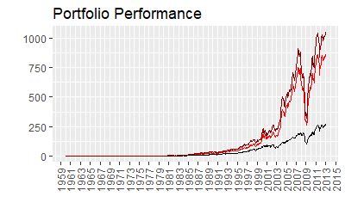

The results show that the benchmark portfolio (black) has similar results than the factor in Asness et al. [2014]. The random forest portfolio in the first set up does so even more, indicating that the existence of a quality premium is not dependent on the standardization of measures of characteristics or linear weighting of portfolio positions. The second random forest portfolio without Z and O score (dark red) performs as well, even a bit better, than the random forest portfolio utilizing the two predictors (red).

Annualized results are:

|  |  |  |  |
| --- | --- | --- | --- |
| Results | Benchmark | Random Forest | without Z and O |
| Annualized Return | 0.1493 | 0.1808 | 0.1875 |
| Annualized Std Dev | 0.1755 | 0.2140 | 0.2107 |
| Annualized Sharpe | 0.5408 | 0.5840 | 0.6237 |

**Robustness**

Let's take a look at the uncertainty of the forest. The variance within the trees for every single stock was determined after which the difference between the maximum and the minimum variance was chosen as the measurement of uncertainty. It would be interesting to know, whether or not the performance of the random forest portfolio is sensitive to the forest's uncertainty.

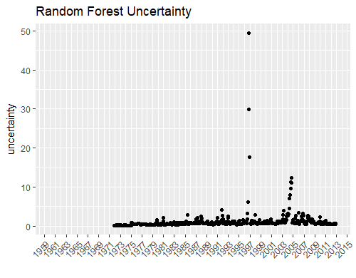

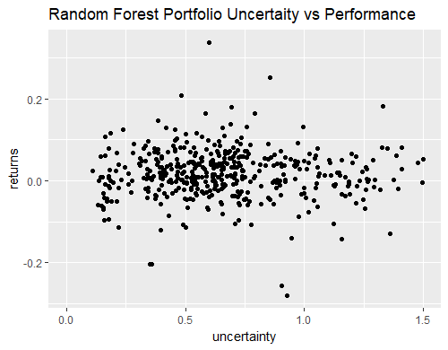

There seems to be no high correlation and no distinctive relationship between the performance and the uncertainty.

**Conclusion**

In conclusion, the results in Asness et al. [2014] seem to be robust to the objections raised. Abandoning the ad hoc choices of long/short portfolios, linearly weighted portfolio positions, and standardization and equal weighting of measures and characteristics does not change the results to the worse. Both Altmann's Z score and Ohlson's O score, which are estimated in-sample, can be left out without weakening the claim of the existence of the quality premium.