## Tensile Properties analysis

A code was implemented with the Matlab software to analyse the experimental data and study the mechanical properties of biological tissues through relevant parameters extraction from the stress-strain(σ-ε) curve.

The code takes as inputs the force and displacement vectors directly extracted from the tensile machine and converted them to stress (MPa, y-axis) and strain (%, x-axis) vectors using the equations 1 and 2.

The stress σ is calculated as the ratio between the load F (N) and the cross section A (mm²):

σ = $\frac{F}{A}$ (1).

The strain ε is calculated using the following equation:

ε = $\frac{l-l_{0}}{l_{0}}$ (2)

where l-l0 (mm) is the change in length obtained directly from the experimental data, l0 is the gauge length (mm). The result obtained by (2) is multiplied by 100 to obtain the value of deformation in percentage.

Then the code fits stress and strain data with a curve. The curve that best interpolates the data was found using a Matlab tool called *“Curve fitting tool”*. This tool allows comparing different functions to fit the experimental data and choose the best one using some parameters to assess the goodness of different fittings as shown in fig.2.6.

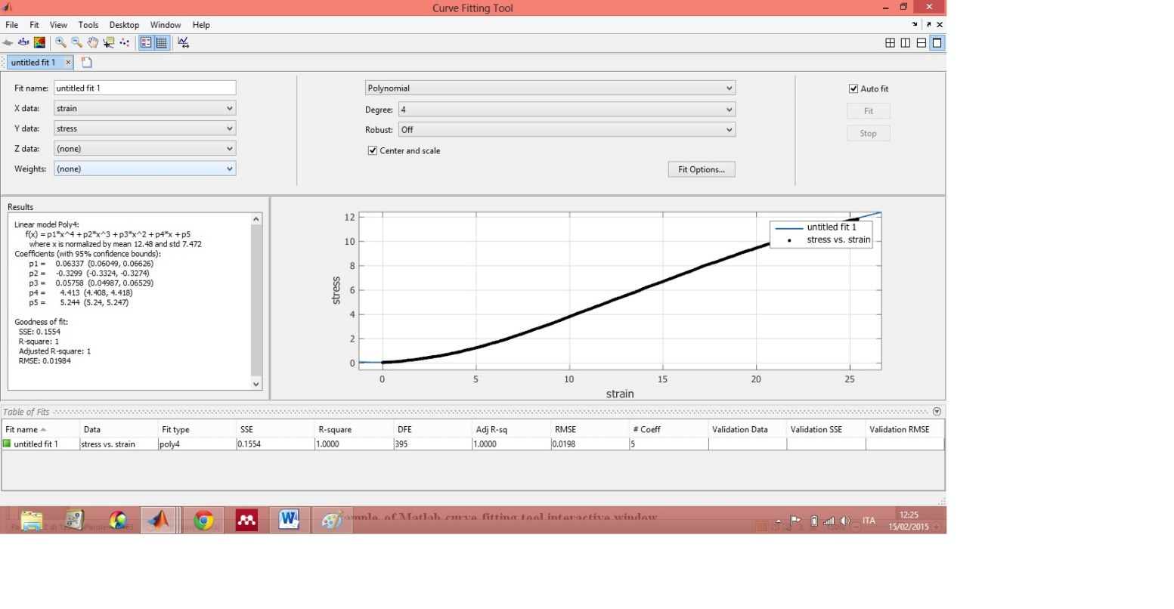

Figure 2.6: Example of Matlab curve fitting tool interactive window

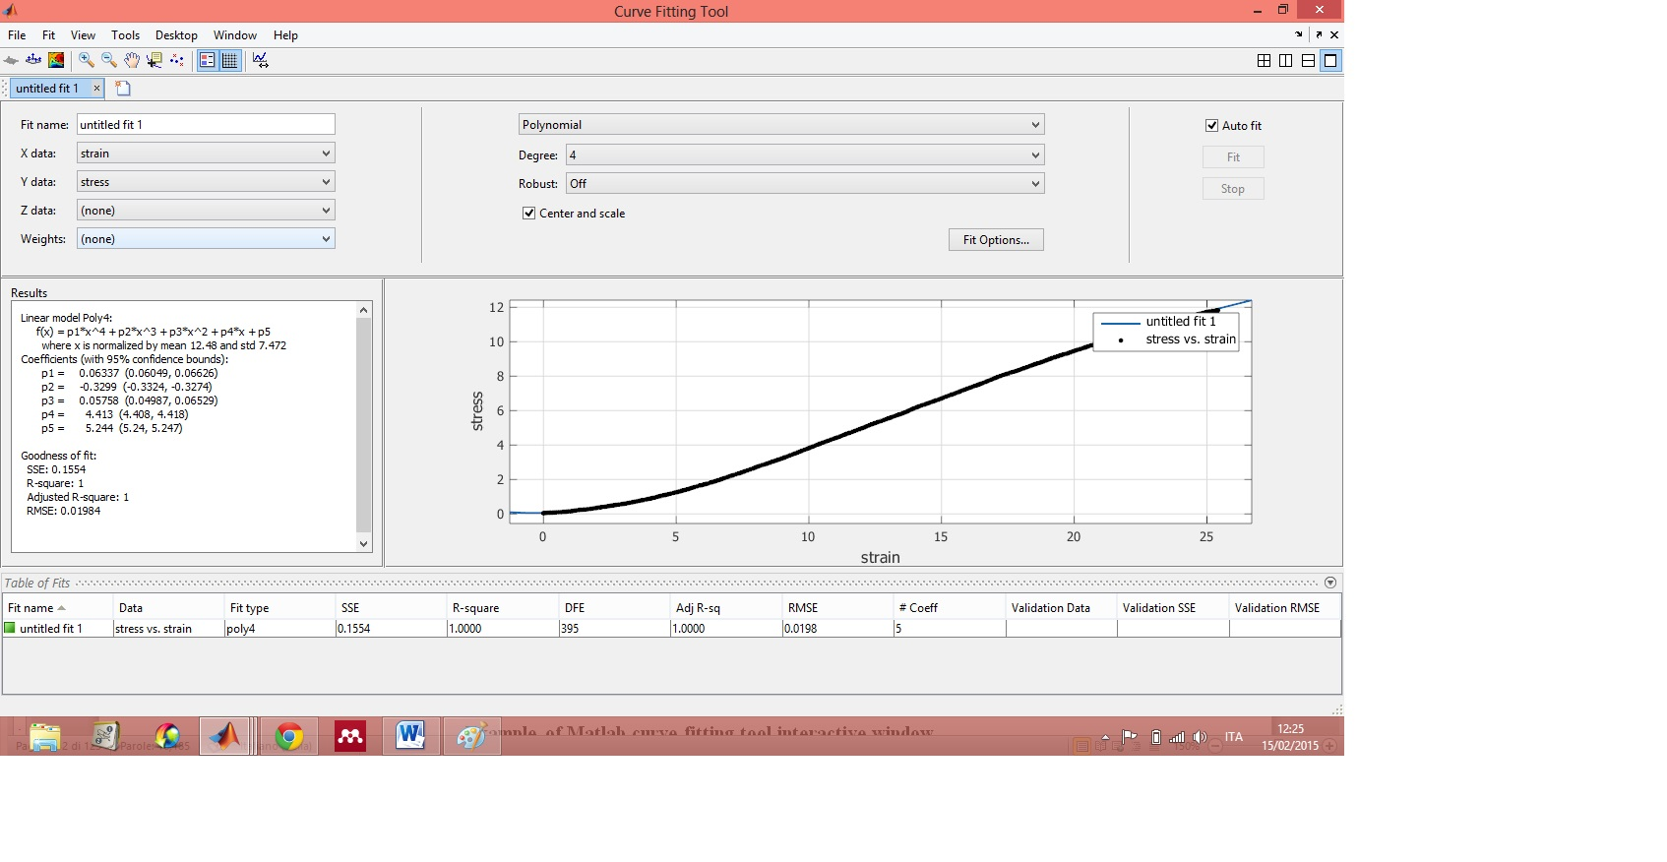

Figure 2.7: Zoom of the curve fitting tool window that show the parameters to assess the goodness of the fit

Hence, a polynomial function of fourth degree was chosen to fit the data.

To perform this, it was employed the Matlab function “*Fit*”, that takes as inputs the stress and strain vectors and the chosen polynomial function to interpolate the data, and gives back the fitting curve. The polynomial coefficients were calculated with a Matlab function called “*Coeffvalues*”.

Once obtained the curve that best fits the data, it could be calculated the first derivative of the same in order to get the Young modulus of the sample.

The function used to compute the first and second derivative of the curve is the function “*Differentiate*”. The Young’s modulus is exactly the first derivative and it could be plotted to know the values of Young’s modulus point by point.

The implemented code uses these information to get some results that are relevant parameters to analyse the σ-ε (stress-strain) curve.

The tensile test results usually are analysed exporting the force and displacement data in an excel worksheet and calculating the corresponding stress and strain getting as results the ultimate tensile stress and the strain at the ultimate tensile stress.

Using the implemented code it was possible to get the Young modulus for a set of points in a given region of the curve; it would not have been possible to do this employing the traditional formula used to calculate the Young modulus(3) because it affords to calculated the Young modulus between two points only.

E= $\frac{σ_{2 }-σ_{1}}{ε_{2 }-ε_{1}}$ (3)

Thus, the firsts parameters obtained were: the Young modulus in a range of points according to setting of a first derivative percent variation (${Δy}_{1}$) compared with the minimum value of Young modulus, and the force strain ratio in the same range (range1)(elastic region).

So once calculated the percent variation (${Δy}_{1}$) based on a number that can be chosen (P1), the value corresponding to this variation($y_{1}$) is given from the minimum of the first derivative with the addition of the percent variation. This value represents the last element of the range 1 where the Young modulus is calculated as shown in fig.2.8.

For example:

P1 = 5% ${Δy}_{1}$ = (5*min)/100 $y_{1}$ = min + ${Δy}_{1}$



Figure 2.8: First derivative and range 1 (red dots)

The other values calculated are the stress and strain coordinates corresponding to the end of the elastic region that is when the second derivative reaches the maximum (Transition point).

Then it was computed the Young modulus in a set of points around the maximum of the first derivative; this range was chosen setting a first derivative percent variation $({Δy}_{2})$ but compared with the maximum value of Young modulus. In this range (range2) it wasalso calculated the force strain ratio. For the range 2 the value corresponding to the percent variation was calculated using the maximum of the first derivative and then it was subtracted to this the percent variation.

This value identifies two points around the maximum that define the set because the curve trend of the biological tissue’s first derivative should be like this (Fig.2.9):



Figure 2.9: Biological tissue's first derivative and range 2 (red dots)

For example:

P2 = 5% ${Δy}_{2}$ = (5*max)/100 $y_{2}$ = max - ${Δy}_{2}$

For both the range1 and the range 2 the calculation of the Young modulus is based on the average of the values included in that set.

Other important results are the calculation of the Young’s modulus maximum and the coordinates of stress and strain related to it.

It was obtained also the second derivative of the curve and it was computed the Young modulus and the force strain ratio where the second derivative is zero that should be the same value of maximum Young modulus.

So it is possible verify if the strain coordinate (x axis) related to the maximum of the first derivative and the strain coordinate (x axis) related to the zero of the second derivative have the same value, otherwise it is displayed a “warning” in the maximum Rigidity Modulus box within realised Matlab GUI.

This is a useful tool to check if there are calculation errors.

Finally it were calculated the Tensile strength, that is the maximum amount of tensile stress that a material can withstand while being stretched. It was calculated using the maximum applied force divided by the thicknesses’ average.

Other calculations were the strain at Tensile strength, the maximum applied Force and the ultimate Tensile stress’ average and standard deviation obtained from the three different stresses values corresponding to the three thicknesses’ values.

### 2.4.1 Graphical user interface realisation

In order to make easier the use of this code, it was designed a graphical user interface (GUI) in the Matlab environment.

The GUI can import data directly from the tensile machine (TRA file extension), to get the stress and strain vectors. It is made up of two panels: “**Test input**”, the panel which includes the test parameters like the sample’s thicknesses in the three measurements sites, their average and standard deviation, the specimen’s width and gauge length, the temperature, the P1 and P2 parameters, the Tensile test speed and load cell used; and “**Results**”, the panel that shows the results explained before.

The thicknesses’ average and standard deviation are calculated automatically while the width and gauge length are set choosing between two specimen standard based on ISO 37:2011 or can be set manually.

The GUI has a toolbar with some buttons to perform different functions: to open the TRA files, to save the test inputs and the results in a Excel file ,to have a GUI screen shot, to zoom the graphs and to identify a specific point on the graph with a cursor.

This is an example that demonstrates how the GUI works (Fig. 2.10).

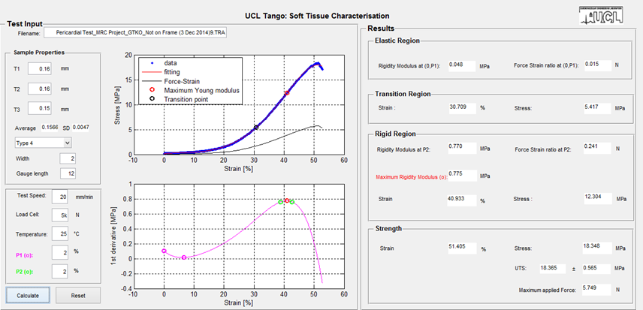

Figure 2.10: Matlab GUI

The magenta dots shown in the first derivative plot represent the range 1, while the green dots represent the range 2 where the Young modulus was calculated.

The GUI’s input and output parameters are explained in the tables below:

Table 2: Tensile test inputs and outputs meaning

|  |  |
| --- | --- |
| **Input parameters** | **Description** |
| Filename | File’s name of the TRA file(file given from the tensile machine) to import the data |
| Sample thicknesses | Sample thicknesses at three measurements sites |
| Thicknesses’ mean and standard deviation | Mean and standard deviation of the three thicknesses values ( these values are calculated automatically) |
| Specimen’s width and gauge length | Specimen standards. They are chosen setting a specimen standard based on ISO 37:2011 or can be set manually |
| Test speed | Tensile Test speed |
| Load cell | Load cell used from the Tensile machine. |
| Temperature | Test Temperature |
| P1 | Number to set a percent variation of the first derivative compared with the minimum of the same. It is important because defines the range of points where the Young modulus is calculated(range1) |
| P2 | Number to set a percent variation of the first derivative compared with the maximum of the same. It is important because defines the range of points where the Young modulus is calculated (range2) |

|  |  |
| --- | --- |
| **Output Parameters** | **Description** |
| Rigidity Modulus at (0,P1)  ** | Young modulus in a range of points according to setting of P1. This range includes the points between the first value of the first derivative and another value of the first derivative set choosing a percent variation of the first derivative compared with the minimum of the same |
| Force-strain ratio at (0,P1)  ** | Force-strain ratio in a range of points according to the setting of P1. This range includes the points between the first value of the first derivative and another value of the first derivative set choosing a percent variation of the first derivative compared with the minimum of the same |
| Stress at knee (transition region) | Stress coordinate at the end of the elastic region(when the second derivative reaches the maximum) |
| Strain at knee (transition region) | Strain coordinate at the end of the elastic region(when the second derivative reaches the maximum) |
| Rigidity modulus at P2** | Young’s modulus calculated in range 2 setting P2.  This range is a set of points between two values of the first derivative around the maximum of the same. The Young’s modulus is calculated between these two values, the first one before the maximum and the other one after the maximum |
| Force-strain ratio at P2** | Force-strain ratio calculated setting P2, a first derivative percent variation compared with the maximum value of Young modulus.  This range is a set of points between two values of the first derivative around the maximum of the first derivative chosen setting P2 |
| Maximum Rigidity Modulus | Maximum value of the Young modulus |
| Stress at maximum Rigidity modulus | Stress coordinate when the Young modulus reaches the maximum |
| Strain at maximum Rigidity modulus | Strain coordinate when the Young modulus reaches the maximum |
| Rigidity modulus at D2=0 | Young modulus calculated where the second derivative is zero |
| Force-strain ratio when D2=0 | Force-strain ratio when the second derivative is zero |
| Tensile strength | Stress value calculated using the maximum applied force divided by the thicknesses’ mean |
| Strain at Tensile strength | Strain value at Tensile strength |
| UTS ultimate Tensile stress mean and standard deviation | UTS mean is a mean calculated between three different stresses’ values obtained from the maximum applied force divided by every thicknesses’ values.  UTS standard deviation is the standard deviation between three stresses values obtained from the maximum applied force divided by every thicknesses’ values. |
| Maximum applied Force | Maximum applied Force from the Tensile machine |

**For the calculation of the Young modulus in a range of values the code makes the average of the points included in the specific set.

In this paragraph the Young modulus is also called Rigidity Modulus.

In the appendix B is attached a copy of codes used to analyse the data and to realise the GUI.