Problem #1

A Cat, a Parrot, and a Bag of Seed:

A man finds himself on a riverbank with a cat, a parrot and a bag of seed. He needs to transport all three to the other side of the river in his boat. However, the boat has room for only the man himself and one other item (either the cat, parrot or seed). In his absence, the cat could eat the parrot, and the parrot would eat the bag of seed. Show how he can get all the passengers to the other side, without leaving the wrong ones alone together.

1)

Define the problem: to figure out how can a man transport three items (cat, parrot and a bag of seed) to the other side of the river one item at a time and making sure that nothing gets eaten without his presence.

What is not obvious from reading the problem is that the man not only can transfer an item to the other side of the river, but he could also bring that item back to its original place when traveling back for the other items.

The overall goal is to think abstract in order to figure out the plan for transporting every item safely.

2) Break the problem apart

Constraints: 1) A man can only transport one item at a time in the boat.

2) Some items can get eaten if left together unattended.

Sub-goals: 1) To make sure that the items that can get eaten don’t stay alone with items that can eat them.

3) Identify potential solutions

1. Parrot should never stay alone with cat
2. Parrot should never stay alone with a bag of seed.
3. Since parrot can not stay alone with all items, it should be transferred first.
4. After transferring parrot, it does not matter whether a cat or a bag of seed is transferred next to the other side. Nevertheless, after placing a cat or a bag of seed on the shore the parrot should be taken back on the boat to transfer it to the original shore to avoid something being eaten.
5. After placing the parrot on the original shore the third item should be taken and transferred to the other side.
6. Last step, would be to travel back to get the parrot.

4) Evaluation of solutions:

1. All solutions work for each case and are goal oriented. It is consistent throughout that the parrot does not stay alone with a cat or bag of seed unattended and each item is being transferred one at a time.

5) Plan to implement the solution:

1. A man should transfer a parrot to the other side of the river.
2. A man should travel back to the original shore.
3. A man should take a cat to the board and transfer it to the other side.
4. A man should travel back to the original shore together with parrot to avoid cat eating it.
5. A man should leave a parrot on the original shore and take a bag of seed with him on the boat. This will prevent parrot from eating seeds.
6. A man should transfer the seeds to the other side and leave them with a cat. This combination is safe, so he can travel alone back to the original shore to get a parrot.
7. A man should transfer a parrot to the other side.
8. Every item has been transferred safely.

Below is a visual illustration of the solution.

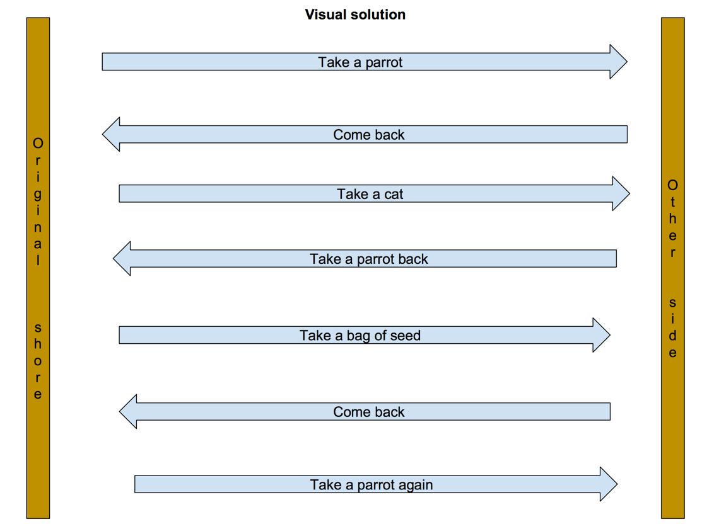

Problem #2

Socks in the Dark:

There are 20 socks in a drawer: 5 pairs of black socks, 3 pairs of brown and 2 pairs of white. You select the socks in the dark and can check them only after a selection has been made. What is the smallest number of socks you need to select to guarantee getting the following: a) At least one matching pair b) At least one matching pair of each color.

1)

Define the problem: to select a number of socks in the dark in a way that there is at least one color matching pair and at least one matching pair of each color of socks.

The overall goal is to figure out the the smallest number of socks one should pick in order to have at least one matching pair and at least one matching pair of each color.

2) Break the problem apart:

Constraints: You can check the socks only after the selection has been made.

Sub-goals: to calculate how many socks to pick in both scenarios, so the selections have proper matching pairs.

3) Identify potential solutions:

1. For the one matching pair, I would pick out 4 socks. There are 3 colors and if we pick that amount plus an extra sock, one of the colors would definitely match.
2. For all the colors matching pairs, I would pick 18 socks. There are 10 black socks, 6 brown socks and 4 white socks, making total of 20 socks. Picking 18 socks, will ensure that only one pair or two pairs are missing, but all the colors having at least one matching pair.

4) Evaluate solutions

All solutions are goal oriented and include the smallest number of socks that should be picked up in order to get matching pairs.

5) Plan to implement the solution:

1) Pick out 4 socks. One pair at least should be matched, because there are only 3 colors and we have 4 socks.

2) Pick out 18 socks. All three colors should have at least one matching pair, because we only left two socks remaining and without them all colors of socks are still covered.

Problem #3

A little girl counts using the fingers of her left hand as follows:

She starts by calling her thumb 1, the first finger 2, middle finder 3, ring finger 4, and little finger 5. Then she reverses direction, calling the ring finger 6, middle finger 7, first finger 8 and thumb 9, after which she calls her first finger 10 and so on. If she continues to count in this manner, on which finger will she stop? a) What if the girl counts from 1 to 10 b) What if the girl counts from 1 to 100 c) What if the girl counts from 1 to 1000

1)

Define the problem: to figure out on which finger a girl will stop on the count of number 10, 100 and 10000 after counting on fingers following a specific pattern.

The overall goal is to figure out the girl’s pattern of counting and thus find out the answer to the problem.

2) Break the problem apart:

Constraints: there is a specific counting pattern that the girl follows.

Sub-goals: to figure out the consistencies and rules of the pattern in order to calculate where will the count stop at 10, 100 and 1000.

3)

Identify potential solutions:

1. Perform the counting till 10 myself.
2. Continue counting beyond 10 and noting which numbers does the first finger get. Look if there is any specific rule to predict which number will the first finger get.
3. If the pattern rule is discovered, then make calculations to predict where the number 100 and 1000 will be.
4. If no pattern is discovered, then the counting could be done manually with fingers.

4)

Evaluate potential solutions:

To count everything manually would require a lot of time. Therefore, I am hoping to see a pattern rule in the counting. Nevertheless, to see this pattern I would have to try counting with my fingers initially for quiet some time until I find some consistent rule. I am not sure that by evaluating numbers of one finger I will reach the answer. I guess in the beginning it would be better to look at all fingers and see if there is anything interesting happening in the number sequence. To understand whether this solution works one needs to try it in practice.

5)

Develop a plan for solution implementation:

1. Perform finger counting in the girl’s style until number 10. Record the finger.
2. Continue counting beyond 10, examining what kind of values does the recorded finger in the previous step would get.
3. Write down anything interesting.
4. Figure out what is the pattern.
5. Apply it to find out what finger will get 100 and a 1000 as a result.

Here is a pattern that was found during the counting:

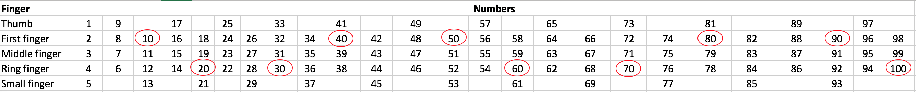

One can see that only first and ring fingers get numbers that are devisable by 10. Additionally, there is also a consistency in how often the fingers would get a number devisable by 10. A first finger would be get 0 and 10, the ring finger would get 20 and 30, then the first finger would get 40 and 50, after the ring finger would get 60 and 70 and so on. It is apparent that one finger would get two numbers devisable by 10 in a row and after the other finger would get two numbers devisable by 10 in a row. Applying this understanding I could calculate that number 10 would terminate at the ring finger.

In order to figure out further where would a number 1000 be, this should be repeated 10 times aka multiplied by 10. This will lead us to the same finger, meaning that a girl will reach a number of 1000 on her ring finger.