**DEC-2019-0043R2  
A zero attraction effect in naturalistic choice  
*Decision*  
  
Dear Miss Trendl,**

**I have received now reviews of this revision from the original three reviewers.  The consensus is that you have successfully addressed most of their concerns. The reviewers think that this is an improved presentation and that this is a very good paper.  Thus, I am happy to accept the paper tentatively.  I highlight this term because all the reviewers made some suggestions that could further improve the presentation of the results and their interpretation, and I want to give you an opportunity to polish the final version by addressing them.  To be clear, I am not insisting that you accept and implement all their recommendations, but I hope you will consider them seriously.**

**In the system, I will mark this as requiring a minor revision, but when you upload the next version (and the relevant cover letter) I will not re-send it for another round of reviews.**

**This is a very nice and original paper (I learned a lot from reading it), and I believe it will make a nice contribution to the literature.  I hope that the final version will be even better.**

**To submit a revision, go to** [**https://www.editorialmanager.com/dec/**](https://www.editorialmanager.com/dec/) **and log in as an Author. You will see a menu item call Submission Needing Revision. You will find your submission record there.  
  
Sincerely,  
David Budescu  
Editor  
Decision  
  
Reviewers' comments:  
  
Reviewer #1: With the revisions it is clear that this is an important paper. The attraction effect was important when it came out almost 40 years ago because it showed that human choice could not be simply characterized by a utility score for each object in a choice set, but depends on the relationships among the alternatives in the set. The attraction effect also violated the similarity effect, where similar items take disproportionate share from each other. The attraction idea was surprising because Duncan Luce said that regularity was one of the few choice axioms that has not been violated. Because attraction was multiply determined many future studies examined the sources and boundaries of the effect.  
  
The authors have clearly demonstrated that the attraction effect is negligible with complex, natural objects. The choices are among movies, a category in which it is a very difficult to test asymmetric dominance because the movie titles and images have many components whose values differ strongly across people. This study elegantly resolved that indeterminacy by measuring the preferences for movies at the individual level. Then, an elaborate sorting process defines individual asymmetrically dominating choice sets and shows that there is negligible evidence for the attraction effect. Notice that even if there was an attraction effect in some of the tested choice sets, the fact that it only worked for such a small fraction of possible choice sets indicates that the attraction effect is extremely rare. I suggest the following changes.  
  
It is important for the authors to not overstate their finding. Claiming a zero effect asks other researchers to find cases where the attraction effect is not binding. For that reason, it would be valuable to feature the findings currently in the appendix in the main paper, even if they were not specified in the pre-registration.**

We do report all findings in the Appendix in the main text in the “Further analyses” section, which is part of the main body of the manuscript. Since our core analysis was planned in advance, we prefer to keep the current simpler structure of the manuscript, where we keep the distinction between the planned and unplanned analyses, such that tables and figures relating to the presentation of the main results are included in the main body, and all additional results are reported in the main texts, but additional tables and figures (which are not core to the paper’s argument) are presented in the Appendix.  
 **Drop or revise Figure 5. This is a confusing figure. It appears that randomly choosing subsets of choices stratified by participant results in choices around 50% which have high variance with smaller samples but converge to a very narrow boundary. When 91% of observations have exactly zero attraction are merged with 9% that may not, it is not surprising that such an unreasonable confidence interval could arise. The bottom line is better given by Models 3-5 which show that the average positive and negative attraction effects are simply not significantly different from zero for the first choice.**

We added a sentence to clarify the funnel pattern seen on Figure 5.

*“The proportion of trials where the target was chosen shows greater variation for participants who were presented with relatively fewer choice trials, whereas it is more narrowly concentrated around .5 for participants with a higher number of trials.” (page 12)*

**The analysis in tables 3-5 has fixed effects for each individual. What proportion are significantly different from zero? Indeed a histogram of the individual effects would be a good replacement for Figure 5. Alternatively, within a random effects model for individuals, consider examining the distribution of the individual tests of attraction to provide an estimate of how many have significant positive or negative attraction effects.**

Our original analysis plan did not aim to estimate the attraction effect on the individual level, and therefore our experimental design does not have enough statistical power for a precise estimation of these effects. Nevertheless, to give a sense of the variation in the attraction effect on the individual level, we include a version of Figure 5, where we include bootstrapped confidence intervals (CIs) for the proportion of trials where the target was chosen. We excluded participants for whom this proportion was exactly 0.5 (and therefore could not have had a significant negative or positive attraction effect; about 57% of participants). From the remaining 58 participants, only one had CIs with the upper limit below 0.5 and no participant had CIs with a lower limit higher than 0.5.

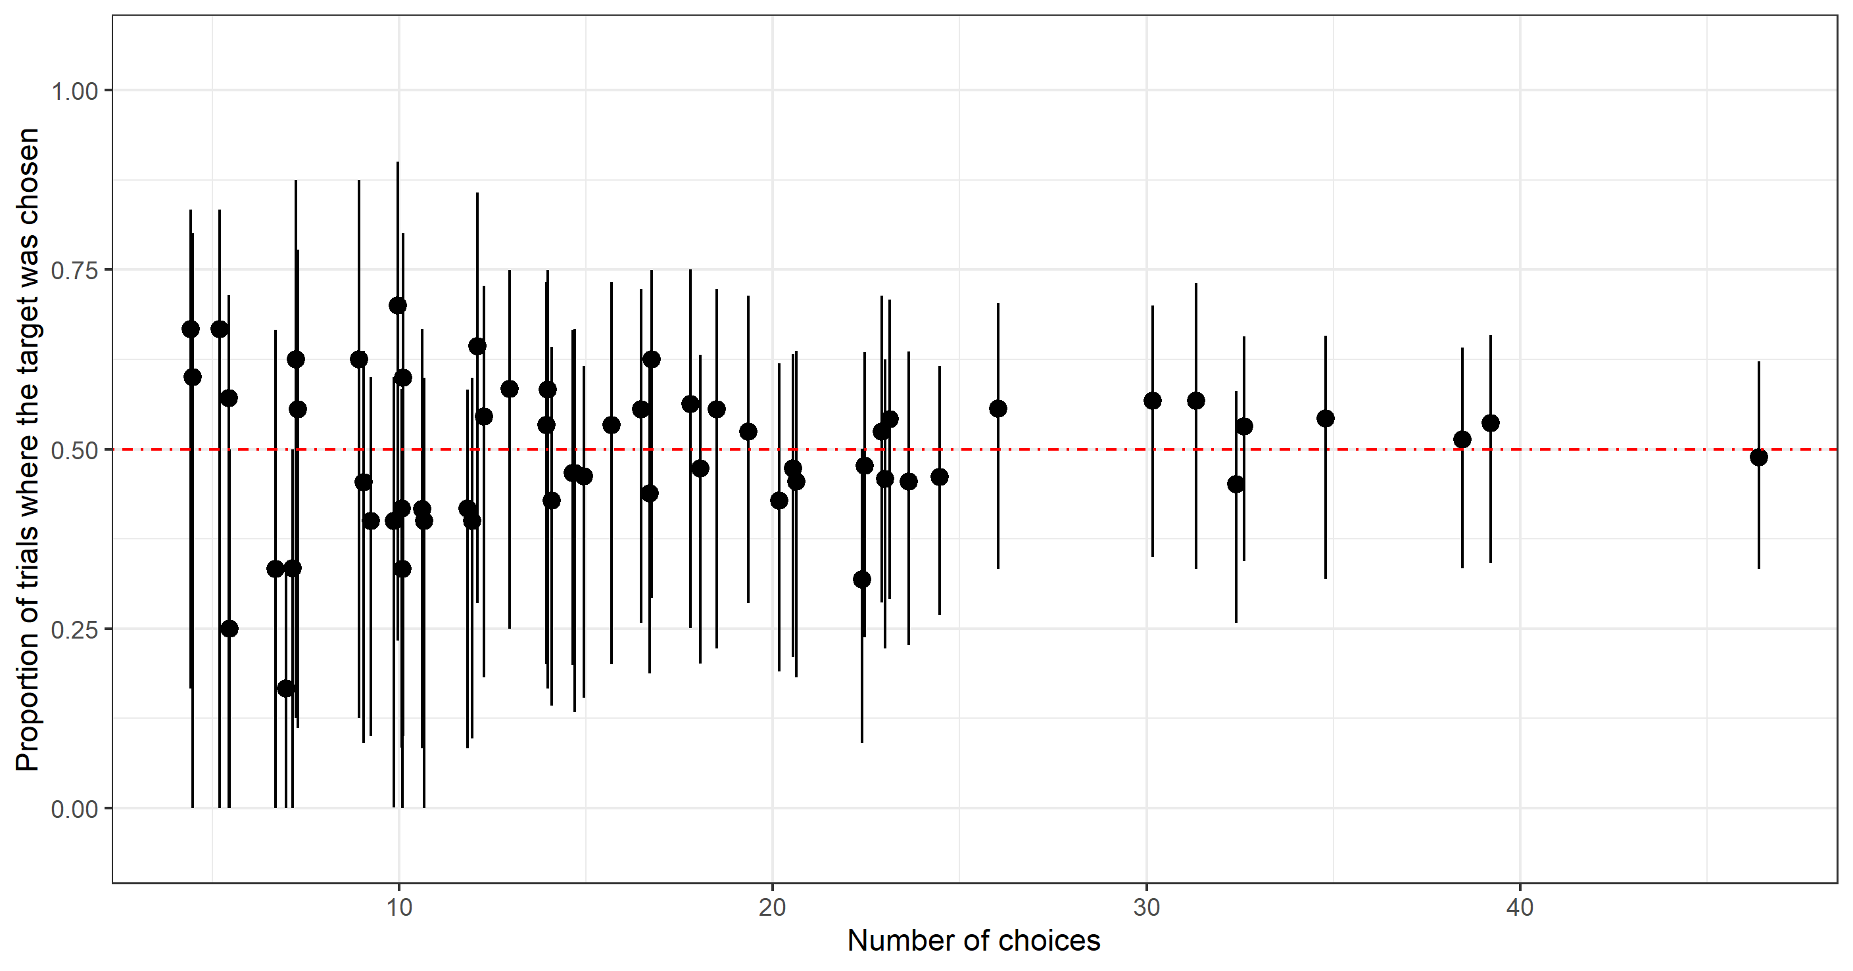

**Additionally, report the significance of the covariance factors. For example, test to see there is a significant positive association between TD rating difference and the measure of the attraction effect.**

This is exactly what we have done in Model 2, 4, 5, and 7 to explore what factors influence the strength of the attraction effect. We found no evidence for an association between TD rating difference and our measure of the attraction effect.

**Negative attraction effects are certainly possible if generated by a negative similarity effect, as the authors note in their reference to the Spektor et al (2018). A reading of the Figure A1 suggests that greater target-decoy similarity and smaller rating differences may result in fewer choices for the target over the competitor This could arise if the TD are close in ratings or similarity so that the decoy chosen takes disproportionate share from the target. It is important to refute that possibility by testing whether decoy choice increases for TD pairs that are more similar or have more equal ratings.**

To explore this, using the subset of first choices, we ran a logistic model where the outcome variable was the decoy being chosen and the explanatory variables were the target-decoy similarity ratings and rating difference. Here we include a plot of the predicted probability of choosing the decoy for each level of the explanatory variables. Altogether the decoy was chosen in less than 5% of trials. However, the decoy was more likely to be chosen when the rating difference between the target and the decoy was low, and when the decoy and target were perceived as more similar. Nonetheless, this pattern could not have affected our measure of the attraction effect, since we measured the attraction effect by calculating the proportion of trials where the target was chosen after excluding all trials where the decoy was chosen.

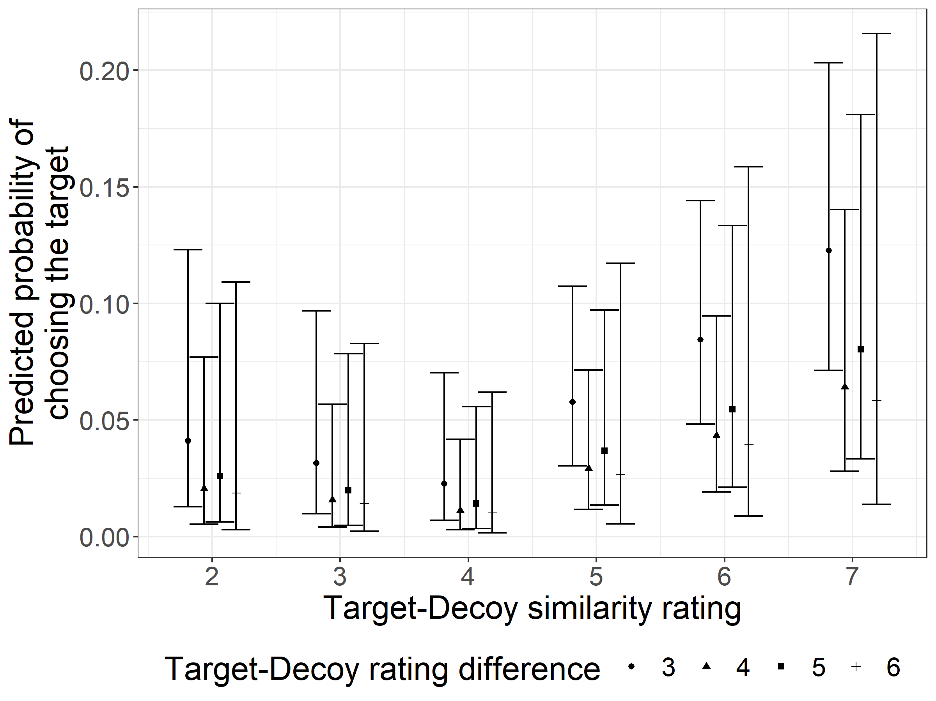

**Finally, Table A2 is confusing. Given the 2000 observations it clearly includes both the first and second choices. Thus except for including a genre rating difference, it has the same problems as Table 1 where that 91% of the observations must be exactly zero. Further, it is not clear from the text, but the results in figure A1 certainly should come from the first choice in each AB dyad.**

We reran the regression in Table A2 with first choices only (see Table A3). We also updated the two figures to only include the first choices.

**The paper importantly shows that the attraction effect in negligible for complex and natural objects. It does so using a laborious method that is both clever and innovative. However, the authors need to be careful not to overstate their case by building a statistical argument around a questionable methodology.  
  
  
Reviewer #2: I like the changes that have been made. My comments are now very minor.**

**page 2). I think it is very odd not to cite Frederick et al. here, along with Specktor et al & Cataldo and Cohen. Showing that the attraction effect is "highly dependent on the exact presentation format" was the central point of our paper, as you correctly note on page 19.**

We agree and added this reference. **page 3). I may be wrong here, but I don't think it is quite right to say that Yang and Lynn reported difficulties replicating the attraction effect in experiments where the stimuli were pictorial. That is true in their data, but I don't think they "reported difficulties." I actually don't think they made that distinction at all.**

We changed the sentence to “*who demonstrated difficulties replicating the attraction effect in experiments where the stimuli had qualitative-verbal or pictorial depictions*”.

**page 4) I actually think the attraction effect is limited to choice tasks in which options are FULLY represented with numerical attributes; where the only presentation format is numeric. I think that is a more accurate statement than (at least partly).**

We removed the word “partly”. **page 4) The paragraph preceding the "Testing the attraction effect" section is somewhat awkwardly written to me. You have a counterfactual result that actually obtains (no effect) and then a counterfactual result that does not (an effect) and then a factual result (no effect). There is nothing "wrong" exactly, but I find the structure confusing and I think someone reading fast might miss the key point: no effect with naturalistic stimuli.**

We shortened the paragraph as follows:

*“In this article, we describe a rigorous test of the attraction effect with complex, naturalistic choice options, using a carefully developed experimental methodology that addresses all of the critical conditions discussed by Huber et al. (2014). Our results show a precisely zero attraction effect. Taken together with earlier results from Frederick et al. (2014) and Yang and Lynn (2014), we see this as strong evidence for the claim that the attraction effect is limited to choice tasks where options are represented with numerical attributes.”* **page 12) I find this sentence confusing "This indicates that participants were able to identify the lowest rated option in the choice stage" The word "identify" indicates that that was their GOAL, as opposed to simply indicating their preference from which one can INFER that one or more of the options was dispreferred.**

Thank you, we changed the sentence to:*“The fact that participants only chose the lowest-rated option very rarely in the choice stage suggests that they reported their preferences truthfully in the rating stage.”* **page 16) Typo at bottom of page. "We we have not find any" Replace find with found.**

Thank you, we corrected this. **page 17) I recognize your geographical provenance, but I think most readers will prefer while to whilst. ; )**

Thank you, we updated the manuscript. **Nice paper!  
  
  
Reviewer #3: I recommended acceptance of the first revision.  
I maintain this recommendation after reading second revision and the replies to the other two reviewers. I am, however, less enthusiastic about the authors placing emphasis on "numeric vs. non-numeric" stimuli. The reason is that Trueblood et al (2013) have demonstrated the attraction effect using rectangles. This finding has been replicated by Trueblood et al in subsequent publications. I think it is more appropriate to draw a distinction between stylised vs. non-stylised stimuli (or stimuli with externally and objectively defined attributes vs. naturalistic stimuli).**replace with stylised.

**A few more remarks that might be helpful to the authors:  
  
1) Huber et al., described 5 properties that inhibit the occurrence of the attraction effect. Logically, avoiding designs that have these properties does not guarantee the occurrence of the attraction effect. There is a myriad of other reasons in an experimental design that can lead to a null attraction effect result (e.g. lack of motivation from the participants, lack of understanding of the task etc). It is great that the authors took these properties into account but I do not think that this is the central take away from this paper.  
  
2) The within-subjects design the authors employed together with the type of stimuli is, in my opinion, the important contribution of this paper.Previous replication failures in the literature have employed between-subjects designs, which are by definition less powerful (see also the work by Michael Regenweter and colleagues). This is also why I believe that the within-subjects experiments by Trueblood et al (using non-numerical stimuli) should weigh more heavily in any debate pertaining to the robustness of the attraction effect.**