# 27-03-20. Test single voxel CSH carbonation

1 μm3 solid voxel with CSH and 4 water voxels next to it. Reaction for 10 seconds

Initial equilibrium concentrations with calcite (mlvl – eq with portlandite – *need to update)*

## Mineral phases

Calcite precipitates next to mlvl voxel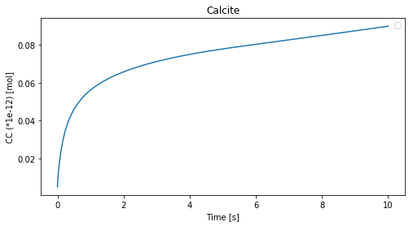

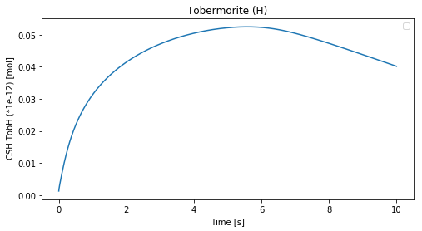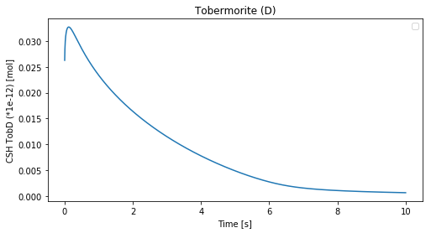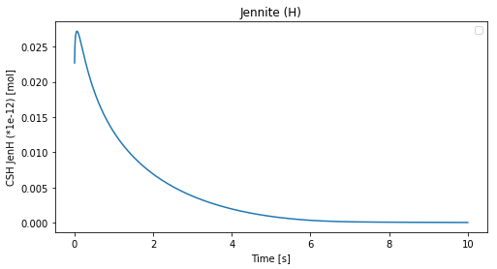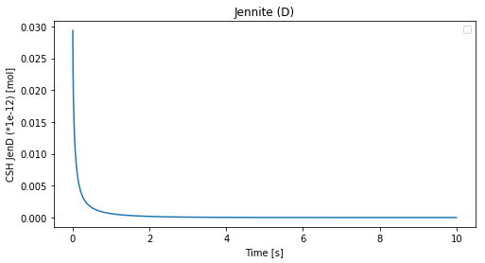

## Liquid concentrations

## Solid concentrations

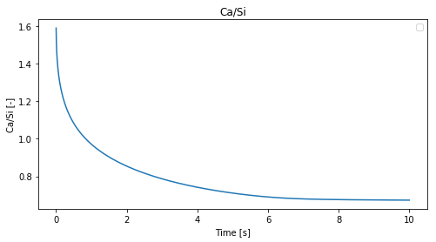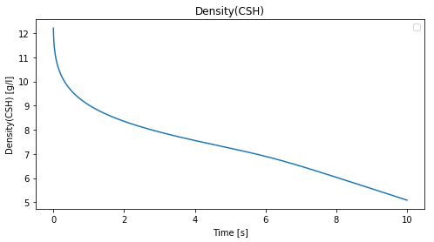

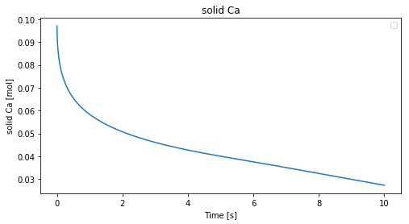

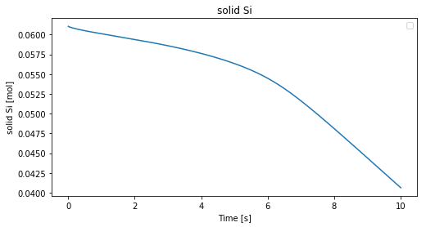

## Properties

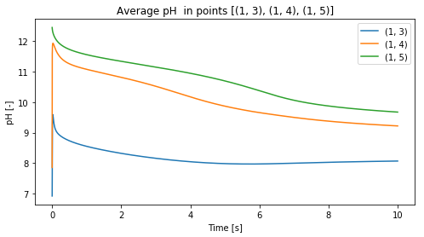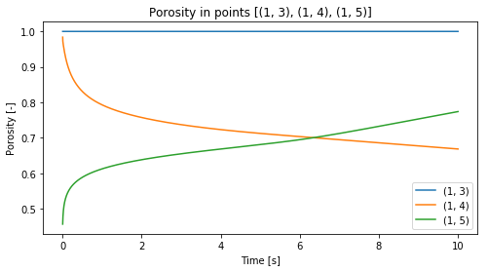

# 03-04-2020. Geometry and partial pressure

## Geometry examples:

### 1D:

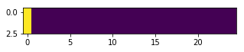

### 2D (plain crack):

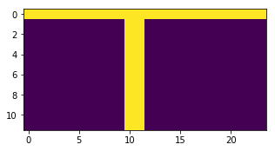

↓

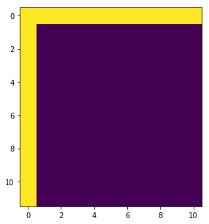

Boundary conditions:

1. Either void space is filled with water (CO2 (g) is applied from the upper boundary)
2. Void space is air and CO2 (g) boundary is applied in each C-S-H-air border

Initial conditions:

* CSH only or combination with CH/clinker/pore
* w/c (0.4-05) -> different CSH molarity
* CO2(g): 0.03%, 1%, 10%, 100%

### 2D (rough surface):

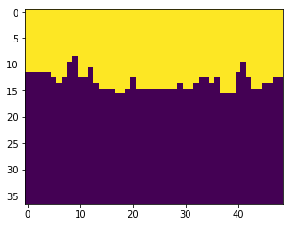

* CSH geometry should not change
* Geometry may consist of different phases (CSH, CH, clinker) + different initial CSH stoichiometry depending on w/c

## Test different partial pressure

|  |  |  |
| --- | --- | --- |
| 0.03% | 1% | 10% |
|  |  |  |
|  |  |  |
|  |  |  |
|  |  |  |
|  |  |  |
|  |  |  |
|  |  |  |

* Add phase SIO2?
* Check Si boundary