**SMA observations of AT2018cow:**

**A prototype for millimeter time-domain astronomy**

Anna Y. Q. Ho (Caltech)

Recent discoveries by optical time-domain surveys challenge our understanding of how energy is deposited and transported in stellar explosions. Commonly-invoked mechanisms for depositing energy include radioactive decay (Colgate & McKee 1969) and shock heating (Grassberg 1971, Chevalier 1976). Together, these explain the locations of most optical transients in the parameter space of rise time *(should ‘rise-time’ be have a hyphen?)* and luminosity. However, the faster cadence and wider areal coverage of modern surveys have unlocked new regions of parameter space -- for example, the region of short rise (rising?) times and high peak luminosities (Drout et al. 2014; Arcavi et al. 2016; Tanaka et al. 2016; Whitesides et al. 2017; Pursiainen et al. 2018; Rest et al. 2018). To explain these “fast-luminous” transients, model parameters must be taken to extremes, or entirely new power sources must be considered; see Kasen (2017) for a review.

Most of the approximately 100 fast-luminous transients were found in archival searches at cosmological distances, so could not be studied in detail. As a result, the ATLAS survey’s discovery on 16 June 2018 of the young, nearby, rapidly rising, and luminous optical transient AT2018cow (Smartt et al. 2018; Prentice et al. 2018) generated considerable excitement. Over the following few months, AT2018cow became one of the most intensely observed cosmic explosions in history (Rivera Sandoval et al 2018; Kuin et al. 2018; Perley et al. 2018; Margutti et al. 2018; Ho et al. 2018).

Our observations of AT2018cow using the SMA, recently published in the Astrophysical Journal (Ho et al. 2018), represent a milestone in millimeter time-domain astronomy. Although it has become common to follow-up *(add hyphen)* optical transient discoveries with centimeter-wavelength (low-frequency) facilities like the Very Large Array, successful follow-up at millimeter wavelengths (high-frequencies) *(add hyphen)* has been rare (see Figure 1). This is because after a few days, for most known classes of transients, the peak of the synchrotron spectrum lies at centimeter wavelengths.

We began observing AT2018cow with the SMA four days after the optical discovery, and the millimeter light curves are shown in the top panel of Figure 2. To our great surprise, the transient exhibit millimeter emission that was more luminous than any known supernova, *(remove comma)* rivaled only by a handful of relativistic jetted explosions (gamma-ray bursts and Swift J1644+57). Over the next few nights, the millimeter emission increased in brightness, representing the first time any cosmic explosion has been caught rising at high frequencies. The light curve reached a plateau of 50 mJy at 230 GHz which lasted from 8 days after the explosion to 30 days after. The millimeter emission then faded, marking a sudden decrease or end to interaction with the surrounding medium. Around this same time, there is an abrupt change to the X-ray light curve, shown in the bottom panel of Figure 2. The X-ray emission begins to diminish, to exhibit significant temporal variability, and to soften (as reflected in the NuSTAR data). We refer to these two phases as the “plateau phase” and the “decline phase,” and suggest that the transition (indicated by a shaded region in the bottom panel of Figure 2) represents the unveiling of the central engine of the explosion, likely an accreting black hole or a newborn magnetar.

In our paper, we show that this luminous millimeter emission is a consequence of two factors: the large energy released in the event, and the high density of the surrounding medium. Motivated by the bright SMA detection, we acquired broad-band ALMA observations at 22 days post-explosion. Constraining the peak of the SED enabled us to model the properties of the shockwave driven into the surrounding medium, assuming a population of electrons with a power-law number distribution in Lorentz factor (a typical assumption in modeling synchrotron spectra, and expected in well-tested theories of acceleration of electrons in supernova shocks). Following the framework in Chevalier (1998), we infer a forward-shock radius of R ~ 7 x 1015 cm (and a corresponding mean velocity of 0.13*c*), a magnetic field strength B ~ 6 G, and a total energy in the shock of U >~ 4 x 1048 erg. From conservation of momentum, we infer an electron number density in the surrounding medium of 3 x 105 cm-3. We show in Figure 3 that the high radio luminosity is a consequence of the large energy swept up at this blastwave radius, and the high peak frequency is a consequence of the high density. Finally, as the peak of the synchrotron SED is at high-frequencies *(add hyphen)*, the entire observed spectrum lies above the cooling frequency, the first time (as far as we are aware) that this has been reported. The powerful X-ray emission from AT2018cow also Compton-heated the surrounding medium to such a high temperature as to wipe out free-free absorption (commonly invoked to absorb early low-frequency *(add hyphen)* radio emission from supernovae). In the case of AT2018cow, the cm-wavelength spectrum is set just by synchrotron self-absorption.

Extraordinarily, despite intense multiwavelength examination, AT2018cow only deepened the mystery surrounding fast-luminous transients. Its rapid evolution and location in the spiral arm of a star-forming galaxy suggests a massive-star origin. However, the UVOIR spectra resemble those predicted for a tidal disruption event: the disruption of a main sequence star or a white dwarf by an intermediate-mass black hole (Kuin et al. 2018; Perley et al. 2018). The luminous radio and millimeter emission, together with luminous and highly-variable X-ray emission, suggest continuous energy injection by an accreting black hole or a highly-magnetized neutron star (Margutti et al. 2018; Ho et al. 2018). This could happen both in a supernova, *(remove comma)* and in a tidal disruption event.

Although AT2018cow is a singular transient, the millimeter properties may not be so unusual. In fact, a key result of our study is that the circumstances that gave rise to long-lived luminous millimeter emission in AT2018cow were also seen in other classes of explosions: in particular, there have been supernovae with large energies and high ambient densities, but which were only observed at centimeter wavelengths (e.g., SN 2007bg, SN 2003bg, and SN 2003L). As shown in the right panel of Figure 1, their late-time centimeter-wavelength behavior is very similar to that of AT2018cow. Another promising class for future millimeter study is that of energetic supernovae observed to accompany low-luminosity gamma-ray bursts. Only one member of this class (the archetype, SN 1998bw) was observed at millimeter wavelengths, and this yielded a luminous detection (see left panel of Figure 1). Thus, there are at least two classes of supernovae that may be luminous millimeter transients if they are observed by millimeter telescopes at early times. In the next few years, optical wide-field surveys will uncover new members of these classes, and (as for AT2018cow) millimeter observations will be essential for measuring the early evolution of the explosion, *(remove comma)* and tracing the structure of the ambient medium. Thus motivated, we urge systematic millimeter observations dedicated to the pursuit of optical transients.

**References**

Arcavi 2016: <http://adsabs.harvard.edu/abs/2016ApJ...819...35A>

Arnett 1979: <http://adsabs.harvard.edu/abs/1979ApJ...230L..37A>

Chevalier 1976: <http://adsabs.harvard.edu/doi/10.1086/154557>

Chevalier 1998: <http://adsabs.harvard.edu/abs/1998ApJ...499..810C>

Colgate & McKee 1969: <http://adsabs.harvard.edu/abs/1969ApJ...157..623C>

Drout 2014: <http://adsabs.harvard.edu/abs/2014ApJ...794...23D>

Grassberg1971: <http://adsabs.harvard.edu/abs/1971Ap%26SS..10...28G>

Ho 2018: <http://adsabs.harvard.edu/cgi-bin/bib_query?arXiv:1810.10880>

Kasen 2017: <http://adsabs.harvard.edu/abs/2017hsn..book..939K>

Kuin 2018: <http://adsabs.harvard.edu/abs/2018arXiv180808492K>

Margutti 2018: <http://adsabs.harvard.edu/abs/2018arXiv181010720M>

Nakar & Sari 2010: <http://adsabs.harvard.edu/abs/2010ApJ...725..904N>

Perley 2018: <http://adsabs.harvard.edu/abs/2018arXiv180800969P>

Prentice 2018: <http://adsabs.harvard.edu/abs/2018ApJ...865L...3P>

Pursiainen 2018: <http://adsabs.harvard.edu/abs/2018MNRAS.481..894P>

Rest 2018: <http://adsabs.harvard.edu/abs/2018NatAs...2..307R>

Rivera Sandoval 2018: <http://adsabs.harvard.edu/abs/2018MNRAS.480L.146R>

Smartt 2018: <http://adsabs.harvard.edu/abs/2018ATel11727....1S>

Tanaka 2016: <http://adsabs.harvard.edu/abs/2016ApJ...819....5T>

Whitesides 2017: <http://adsabs.harvard.edu/abs/2017ApJ...851..107W>

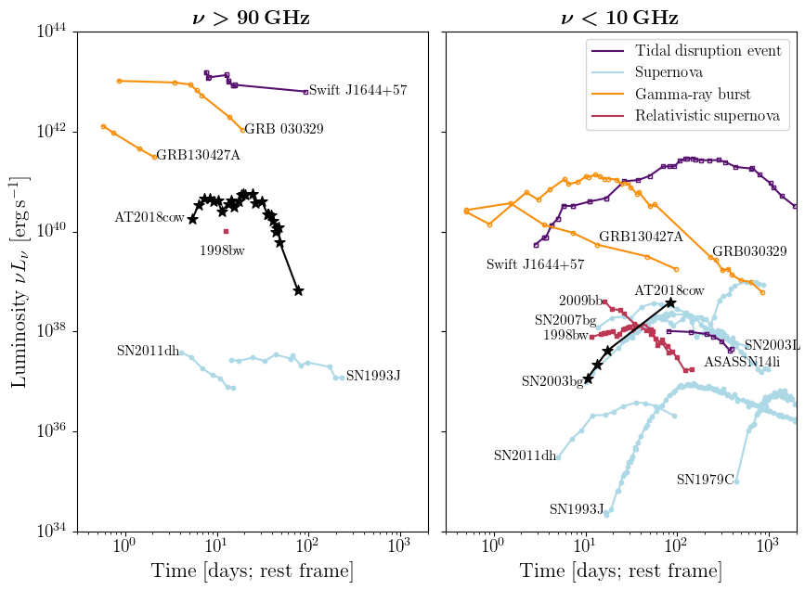

**Figure 1:** Millimeter- (left panel) and centimeter-wavelength (right panel) light curves for several classes of extragalactic transients. The millimeter transient sky remains poorly explored. A number of other explosions (SN2007bg, SN2003L, SN2009bb) have similar low-frequency light curves to AT2018cow, and would likely have been luminous millimeter transients at early times, had they been observed by millimeter observatories (promisingly, SN1998bw, a relative of SN2009bb, was observed by SCUBA and had a single detection).

*Qizhou suggesed that you spell out the acronyms for Figure 1. Maybe TDE = …. SN = …*

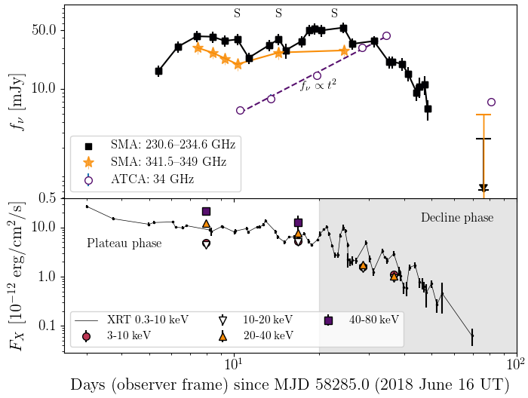

**Figure 2:** Millimeter (SMA), centimeter (ATCA), and X-ray (Swift/XRT and NuSTAR) light curves for AT2018cow. SMA observations of AT2018cow represent the first detection of a transient rising at millimeter wavelengths. By 50 days after the optical discovery, the interaction has diminished, shown by a rapid fall-off in millimeter emission. The smooth (t2) rise at 34 GHz reflects the fact that emission is self-absorbed at these frequencies, meaning that the peak of the SED would be hidden to the low-frequency facilities (like the VLA) that are typically used to observe extragalactic transients.

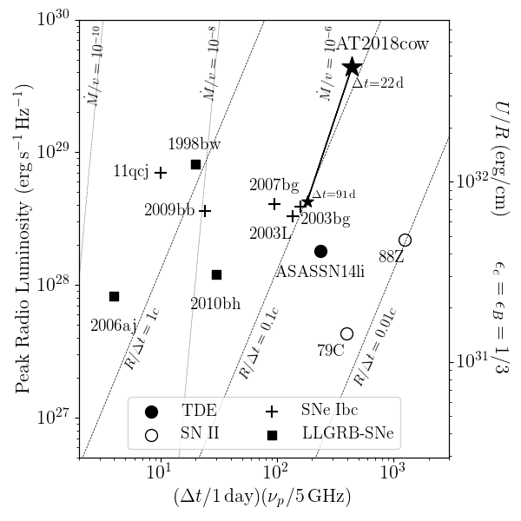

**Figure 3:** Peak time and frequency (x-axis) vs. peak radio luminosity (y-axis) inferred from the synchrotron self-absorption frequency and peak flux constrained by ALMA at ∆t=22 days. The product of peak time and peak frequency roughly traces the mass-loss rate, shown (scaled by velocity) as nearly vertical lines. As shown on the right-hand axis, the peak radio luminosity reflects U/R, the amount of energy processed by the shock into pressure divided by the radius of the shockwave. AT2018cow is unusual in having such a luminous peak at high frequencies, and this reflects ~~the~~ a *(use ‘a’)* large amount of energy propagating into a dense medium.