General information
The aim of ontology comparison tool is to provide methods and metrics for comparing and merging ontologies. Comparison not only to supports URI-equivalence (which is quite fast and convenient for comparing different versions of the same ontology) or lexical similarity (which may lead to homonym mismatch: for example, java as a programming language could be mapped to java as coffee), but also semantic similarity and similarity of ontology restrictions.

Comparing classes
The comparison algorithm is based on comparing ontology concepts to each other.
Comparing a pair of ontology classes is done in 3 steps:
- URIs are compared
- If URIs are different, but the semantics are determined, it's being compared
- If the semantic context was not found for at least one of the classes, their labels are compared lexically
- Axioms (properties, restrictions) defined for the classes in each of the ontologies are also compared: larger number of similar properties stands for closer similarity of classes. If all axioms are different (or there are contradictory ones), the classes are deemed different.
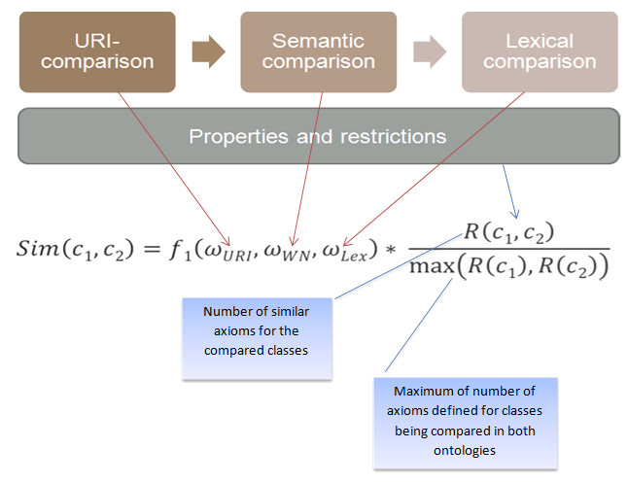
Combining several comparing approaches makes the tool more flexible and universal. URI-comparison works well for different versions of the same ontology, semantic comparison helps to map synonyms, while taking axioms and restrictions into account helps to distinguish homonyms that can be found during the lexical comparison.

Search of semantics
We use WordNet to determine the semantic context of ontology classes. It groups English words into sets of synonyms called synsets, provides short, general definitions, and also records various semantic relations between these synonym sets (such as is_a and part_of relations).
When looking for the appropriate context of ontology class, we search synsets for the class label. (For example, for class “java”, 3 synsets will be found (see figure 1)) Then the rdfs:subClassOf and owl:partOf relations in the ontology are compared with the corresponding relations in WordNet so the best synset is chosen.
Example of such an analogous relations is shown on figure 2: “java rdfs:subClassOf object-oriented_programming_language” relation in ontology is similar to hypernym relation for the java and object- oriented programming language in WordNet.
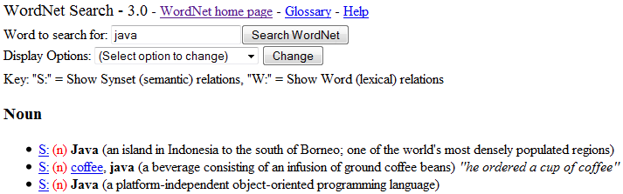Рисунок 1: WordNet synsets for "java"
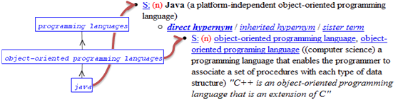Рисунок 2: Mapping ontology classes to WordNet synsets
Merging ontologies | (1)
The merged ontology is constructed of the axioms of the initial ontologies supplemented by owl:equivalentClass axioms for the pairs of similar classes found during the comparison.

http://code.google.com/p/ontologycomparision/
http://wordnet.princeton.edu/

