Whitney Humecky WJH190000

Ann Biju AXB1900042

CS 4372 HW 4

You are tasked with comparing two investment strategies that are described below:

1. Buy and Hold: In this strategy, you invest $1,000 every month into a stock of your

choice and hold the investment till the expiry of the test period (30 years by

default). You do not care whether the market is going up or down but invest

consistently the same fixed amount.

**number of stocks owned 48871.39390593173**

**Sell price after 30 years $387,471.00956132065**

2. Active Trading: In this strategy, you check the market signal before investing. The

strategy can be summarized as:

For every month:

If (technical signal is buy)

Invest $1,000 in the stock market

Else if (technical signal is sell)

Put $1,000 in a savings account with 0% APR i.e. no interest

**SMA(30) used for signals**

**Value at end of 30 years : $216,202.3220629575**

You can assume that you start with a zero equity and follow the strategies

mentioned above by checking on your stock on the first trading day of every month. You

should output the following metrics for both strategies:

• The total equity at the end of 30 years

Strat 1: **$387,471.00956132065**

Strat 2: **$216,202.3220629575**

• The annual percent return

Average Annual return (strategy 1): **1.4989077030171223 %**

Average Annual return (strategy 2): **0.7516317369299741 %**

• A plot showing the growth of your money using both the strategies

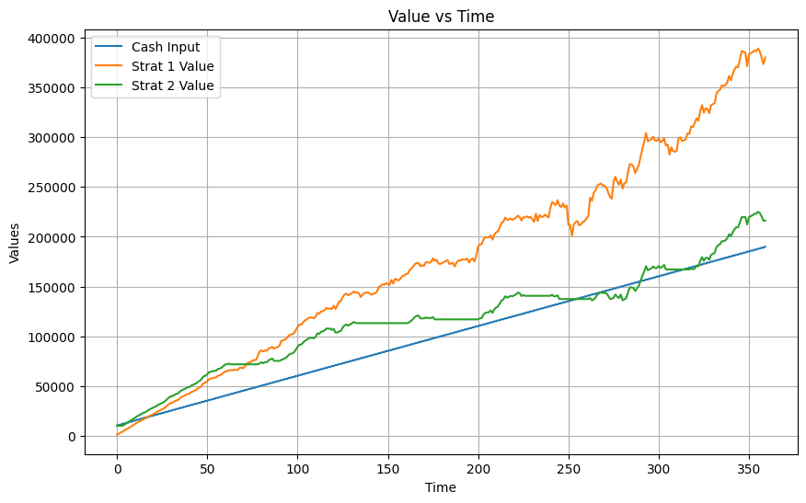

From this chart we can conclude that Strategy 1 (Buy and Hold) amounts to a higher net value (~$375000), than Strategy 2 (Active Trading). Additionally, the sell price of a Buy and Hold stock amounts to a greater value after 30 years ($387,471) than a stock that has been actively traded ($$216,202).