Ann-Jelikka B. Calumba December 18, 2018

BSEMCDA - Y01 CCS0007L

**LABORATORY EXERCISE 2**

* Item One

#include <iostream>

using namespace std;

int main()

{

int x, y, z;

cout<< "Enter Two Numbers: ";

cin>>y;

cin>>z;

int max = x;

if (y > max)

{

max = y;

}

if (z > max)

{

max = z;

}

cout<<"Highest Number: "<<max<<endl;

return 0;

}

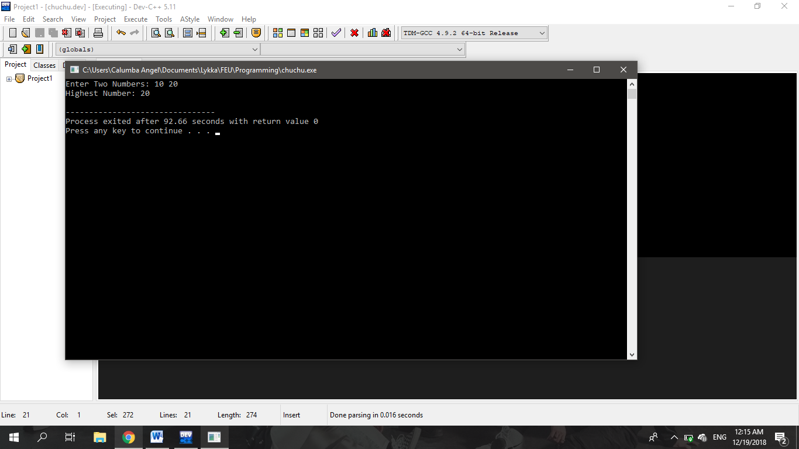

* Item Two

#include <iostream>

using namespace std;

int main()

{

int c, n, fact = 1;

cout << "Enter Number: ";

cin >> n;

for (c = 1; c <= n; c++)

fact = fact * c;

cout << "Factorial: " << fact;

return 0;

}

