Prerequisite:

Create an s3 bucket and upload the training and validation data set.

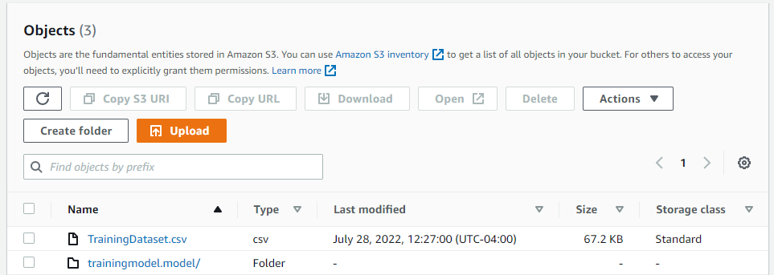

**Task1: Parallel training on 4 ec2 Instances**

* 1. Lauch an EMR cluster.

General Configuration:

Launch Mode : Cluster

Software Configuration:

Applications: Spark: Spark 2.4.8 on Hadoop 2.10.1 YARN and Zeppelin 0.10.0

Hardware configuration

Number of instances:4

Security and access

EC2 key pair: Select an existing Key pair or create a new pair if you don’t have one

Change a new rule in inbound rules of master node’s security group and add new rule with SSH and custom TC as the masters public IP address in order to enable sshing.

* 1. Copy the IP and login to master from terminal

* 1. Create a py new file

$ nano winetrain.py

Write your code ,save and close

Install all necessary libraries using pip install

Eg: pip install findspark

* 1. Run your code using ‘spark-submit winetrain.py
  2. Go to application interface and select spark history server and check status of your job.

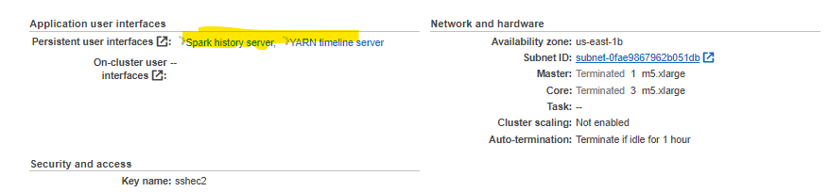

**Task2: Single machine prediction application**

2.1 Launch an ec2 instance.

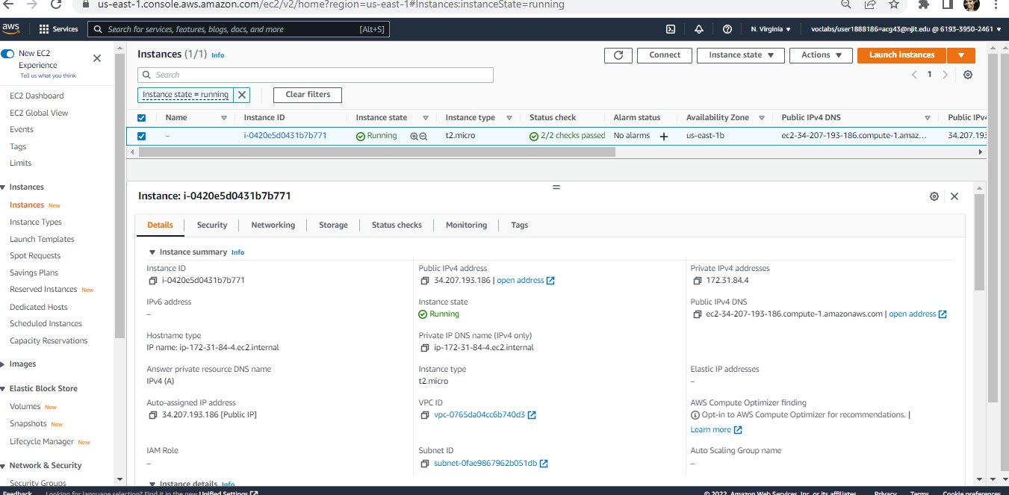

2.2 ssh to new instance from your local terminal

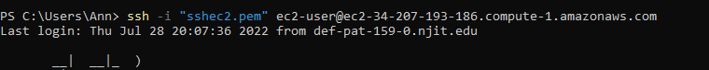

2.3Install scala.

* wget http://downloads.typesafe.com/scala/2.11.6/scala-2.11.6.tgz
* tar -xzvf scala-2.11.6.tgz
* Update PATH environment variable:
  + - vim ~/.bashrc
    - copy following lines into file and then save it
      * export SCALA_HOME=/home/ec2-user/scala-2.11.6
      * export PATH=$PATH:/home/ec2-user/scala-2.11.6/bin
    - source ~/.bashrc

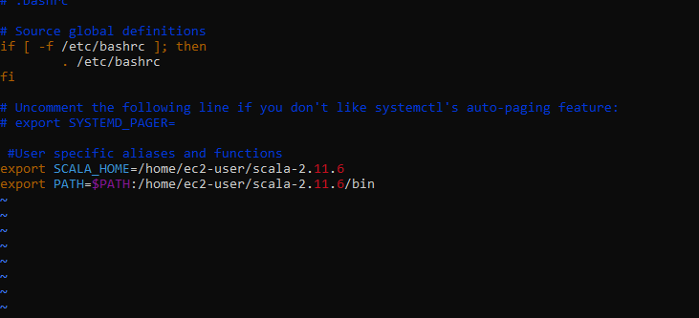

* 1. Install Spark

1. wget <https://archive.apache.org/dist/spark/spark-2.4.5/spark-2.4.5-bin-hadoop2.7.tgz>
2. sudo tar xvf spark-2.4.5-bin-hadoop2.7.tgz -C /opt
3. sudo chown -R ec2-user:ec2-user /opt/spark-2.4.5-bin-hadoop2.7
4. sudo ln -fs spark-2.4.5-bin-hadoop2.7 /opt/spark
5. Update PATH Environment

$ vim ~/.bash_profile

copy following lines into file and then save it

export SPARK_HOME=/opt/spark

PATH=$PATH:$SPARK_HOME/bin

export PATH

$ source ~/.bash_profile

2.5Check java –version

Install if not its not there. Steps in below link

https://techviewleo.com/install-java-openjdk-on-amazon-linux-system/

2.5 check python version



If not available install python

2.6Install all necessary libraries using pip install. If pip fails run below command

$ sudo yum -y install python-pip

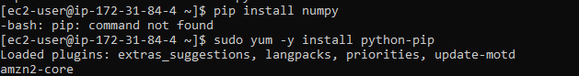

2.7 Open a new .py file with command nano winepredict.py

Insert python code.

2.8 spark-submit winepred.py run your code in ec2.

**Task 3: Prediction by using docker image.**

Install docker in ec2.

3.1 Install docker

$sudo amazon-linux-extras install docker -y

$ sudo service docker start

$ sudo chmod 666 /var/run/docker.sock

$docker login

$ docker pull ann3010/wine-qualitytrain:tag

$ docker run -p 4000:80 ann3010/wine-qualitytrain:tag