Test Description: sanity-std to web Issta-מלונות בחו"ל
<Describe shortly what are you going to test>
Test Purpose: <Describe shortly what is the purpose of this test>
Test Run Instructions: <Describe any special instructions needed to execute this test>
Test Run Information:  Tester Name: Anne azvelos  Date of Test: 9/11/2023 | Prerequisites for this testמלונות בחו"ל
Software Versions:2.0
Application: issta
Browser:
Operating System:
Required Configuration: [ browser setup, security or user ID roles]
No special setup needed
NOTES and RESULTS:

TEST SCRIPT STEPS/RESULTS
STEP | TEST STEP/INPUT | EXPECTED RESULTS | ACTUAL RESULTS |  | PASS/FAIL
<Optional> <Headline>מלונות בחו"ל
functionality
 | Click on  https://www.issta.co.il/ | Click on  https://www.issta.co.il/ | There is web is up |  | pass
 | In the search bar on the right click on-מלונות בחו"ל | The page opens | The page opens |  | pass
 | Write a search bar יעד | Registers-NY ניו יורק | Registers- NY ניו יורק |  | pass
 | In the date line a calendar will be opened to mark the departure date | I chose the date 15/11/23 | The date is marked |  | pass
 | In the date line a calendar will be opened to mark the return date | I chose the date 30/11/23 | The date is marked |  | pass
 | Select number of guests | I chose 2 guests | Marked 2 guests |  | pass
 | Click on the button-מצאו לי דיל בחו"ל | A number of search results will open | A number of search results will open |  | pass
 | I checked the data in dev tools -payload | The data I entered will appear. | 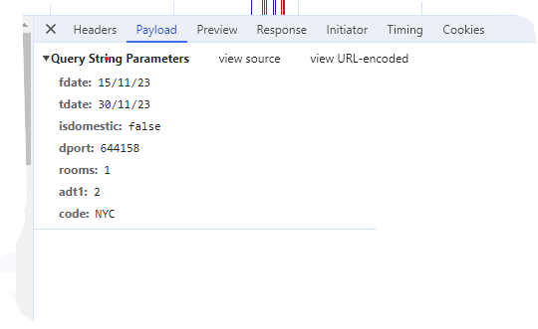
 | I checked the data in dev tools- Headers | The data I entered will appear. | I got-  method-GET  Status code-200 OK
 | Selects a hotel | presses a button- הזמן עכשיו | presses a button- הזמן עכשיו |  | pass
 | Choose a room type- standard room | Presses a button- רכישה | Presses a button- רכישה |  | pass
 | A page will open for entering the orders details | Enter first name (Lior)  , last name (dan),  email (test232@gmail.com)  , and phone number (052-8884444) | The details have been recorded |  | pass
 | Presses a button- המשיכו | A page will open to write down the passenger details | The page opens |  | pass
 | Enter passenger details in English and date of birth | Lior dan 12/09/2000 | The details have been recorded |  | pass
 | Choose a type of suitcase | I chose- מזוודת יד | The selection is checked |  | pass
 | Presses a button- המשיכו | Another page will open- שירותים נוספים | שירות איתור מזוודה, שירות נהג עם שלט, שירות flexy |  | pass
 | Presses a button- המשיכו | A page will open with a summary of payer details and payment details | Check that the details correct |  | pass
 | Presses a button- אישור ומעבר לתשלום | Approval and agreement to terms of use must be checked | Ok is marked |  | pass
 | A page will open for ordering payment details | Presses a button- אישור וביצוע תשלום | A payment confirmation is received |  | pass
 | Purchase confirmation was received by email | I received an email confirmation | I received an email confirmation |  | pass
Negative testing-יעד
 | In the box -יעד, enter the numbers | Entering more than 20 numbers | The numbers are typed
 | In the box- יעד- numbers | A pop-up message will pop up where you can type only letters and not numbers | I got- לא נמצאו תוצאות |  | fail
 | In the box- יעד, type full letters,40 letters | That a message pop up for maximum letters | I got- לא נמצאו תוצאות |  | fail
 | In the box- יעד , writes in English | Will find the place in English | Find the place in Hebrew.  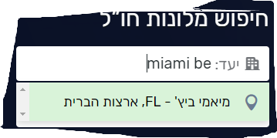 |  | fail
 | in the box-- יעד lists dangerous destinations | Registers-  לבנון, איראן, סוריה | I got-לא נמצאו תוצאות |  | pass
 | in the box-- יעדregisters- ישראל | No results will appear regarding hotels abroad | I got-לא נמצאו תוצאות |  | pass
Recovery testing-יעד
 | You press a lot of keys at the destination | From pressing full numbers, over 50 numbers | The numbers are typed |  | pass
 | Click on the button- חיפוש | The system will crash | The system hangs for a few seconds,10 seconds. |  | fail
 | The state that the system returns | The system will return to the main page | The system returns to the last search of the country I searched for, before entering all the numbers |  | pass
Functionality-choose a room and add a flight
 | Write a search bar יעד | Registers-ברלין, גרמניה | Registers-ברלין, גרמניה |  | pass
 | In the date line a calendar | I chose the date -20/12/23-31/12/23 | I chose the date -20/12/23-31/12/23 |  | pass
 | Select number of guests | I chose 2 guests | I chose 2 guests |  | pass
 | Click on the button-מצאו לי דיל בחו"ל | A number of search results will open | A number of search results will open |  | pass
 | Selects a hotel | presses a button- הזמן עכשיו | presses a button- הזמן עכשיו |  | pass
 | Next to the room selection button an option opens to click on a button including flight.  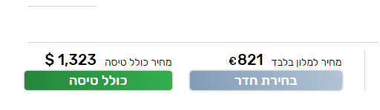 | click on a button כולל טיסה | click on a button-כולל טיסה |  | pass
 | Open a row below to add a flight. | Click on the -להוספת טיסה  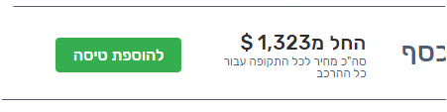 | Click on the-להוספת טיסה . |  | pass
 | We will open 2 option-  1.החלפת טיסה  2.פרטי הטיסה | Click on -החלפת טיסה | Several options will open |  | pass
 | Click on the button- בחירת טיסה זו | Adds a flight to the deal | Adds a flight to the deal |  | pass
 | Choose a room | Receive a price for the deal including flight and room | Total price appears |  | pass
 | Presses a button- המשך | A page for entering details will open | A page for entering details will open |  | pass
 | A page will open for entering the orders details | Enter the details-פרטי המזמין.  פרטי הנוסעים  שירותים נוספים  תשלום | The details are entered |  | pass
 | A page will open for ordering payment details | Presses a button- אישור וביצוע תשלום | A payment confirmation is received |  | pass
Boundary testing-מחיר המלון
 | A number of search results will open-there is a bar on the right side where you can choose a price from minimum to maximum.  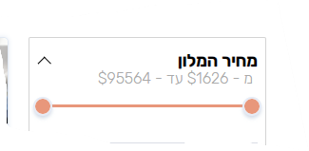 | In the bar appears from the price 1626$ until 95564$ | In the bar appears from the price 1626$ until 95564$ |  | pass
 | I checked the minimum price | I will accept 1626$ | I got 1626$ |  | pass
 | I checked the maximum price | I will accept 95564$ | I got 95564$ |  | pass
Boundary testing-calendar
 | Click on the calendar choose -ניו יורק - and a date today | Choose date 13/11/23-18/11/23 | Choose date 13/11/23-18/11/23 |  | pass
 | Click on button- חיפוש | Several options open | Several options open |  | pass
 | Click on the calendar choose-ניו יורק - a date the last one in diary | Choose date 1/11/24-12/11/24 | Choose date 1/11/24-12/11/24 |  | pass
 | Click on button- חיפוש | Several options open | No results have been found |  | fail
Error handling-calendar
- 2 | Click on the calendar choose one day | Choose date 12/11/23-12/11/23 | Choose date 12/11/23-12/11/23 |  | pass
 | Click on button- מצאו לי מלון בחו"ל | Several options open | A pop-up message pops up- לא ניתן לבצע חיפוש ליום אחד בלבד |  | fail
 | Click on the calendar choose over a month | Choose date-13/11/23- 20/12/23 | Choose date-13/11/23- 20/12/23 |  | pass
 | Click on the button- חיפוש | Several options open | A pop-up message pops up- לא ניתן לבצע הזמנה של מעל 30 יום |  | fail
Boundary testing-guests
 | Minimum number of adults | Aduit choice 1 | Aduit choice 1 |  | pass
 | Maximum number of adults | Aduit choice 4 | Aduit choice 4 |  | pass
 | Minimum selection of children | Must choose 1 adult, 1 child | choose 1 adult, 1 child |  | pass
 | Maximum selection of children | Must choose 1 adult, 6 child | choose 1 adult, 6 child |  | pass
 | Chooses the maximum | Aduit choice 4 ,  6 child | Not possible. You choose 4 adult, 'you can only choose 5 children  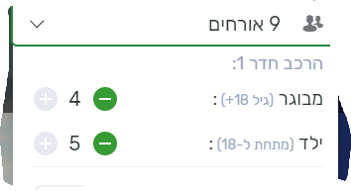
 | I choose 1 adult  2 babies  1 child | I choose-1 adult  2 babies (0-1) (0-1), child (4) | The selection has been typed |  | fail
 | Click on button- מצאו לי מלון בחו"ל | Several options open | A pop-up message pops up-  מספר התינוקות חייב להיות קטן או שווה למספר המבוגרים |  | fail
Error handling-חיפוש לפי שם מלון
 | There is search box where you can search for hotel by name.  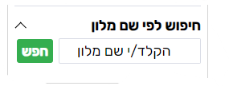 | I typed a hotel in Hebrew in the box- הילטון | I typed a hotel in Hebrew in the box- הילטון |  | pass
 | Click on the button- חפש | Several options open | No results have been found |  | fail
 | I typed a hotel in the box-1. | Click on the button- חפש | No results have been found
Functionality-marking favorites
 | I chose a destination, date, number of guests | Miami  17/11/23-24/11/23  One gest | The details have been recorded
 | Click on the button- חיפוש | Several options open | Several options open
 | On the picture of the hotel on the lower right, you can mark an excess  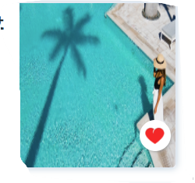 | The heart is painted red | The heart is painted red
 | Pop up massage pops up | In the message-  מוצר חדש התווסף לרשימת מעודפים | A pop-up message |  | pass
 | above where it says entry to the personal area.  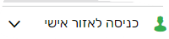 | The arrow appears in my favorites.  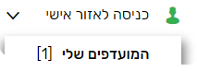 | See my favorites |  | pass
 | Pressing in my favorites | I see the hotel I chose | The hotel is marked with a red heart |  | pass
Removal from my favorites
 | Entered to my favorites | The hotel I selected appears | hotel is marked with a red heart |  | pass
 | On the top left is a drawing of a tin  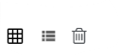 | Click on the bin | The button was pressed |  | pass
 | A message pop up | In the message-  האם אתה בטוח שברצונך לבצע פעולה זו? | The message appears |  | pass
 | A message pop up -2 options | Click on-  כן, בצע פעולה | Deletes all the favorites |  | pass
 | Going out from my favorites | Entered again to my favorites check that it has been removed | Delete everything all the favorites |  | pass
 | Another possibility to remove from the favorites-  In the list of hotels | Marking the red heart in the picture | The heart is painted red
 | Click on the heart again the red marking has been removed.   | A message pop up-  מוצר הוסר מרשימת המועדפים | You receive a message that it has been removed |  | pass
 | Entered my favorites | Checking that it was really removed | Has been removed |  | pass
usability- favorites selection
 | In selecting favorites-choose 10 favorites | See 10 favorites in my favorites | Appears 6 favorites |  | fail
 | In selecting favorites | Expect a message to pop up that you can select a maximum of 6 favorites | There is no message,  and 4 hotels the marking of the favorites has been deleted. |  | fail
Functionality- תנאי הזמנה גמישים
 | Which will open several options for hotels | Appears on the right- תנאי הזמנה גמישים.  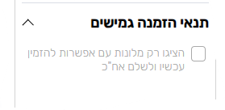 | Appears on the right- תנאי הזמנה גמישים.
 | Are marking v in a square | Filters hotels and display only-  מלונות עם אפשרות להזמין עכשיו ולשלם אח"כ | Filters hotels and display only |  | pass
 | Are marking v in a square | Checks that there is filtering and a message pop up-  אפשרות הזמן עכשיו ושלם אח"כ זמינה בחלק מהחדרים  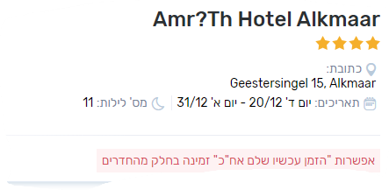 | Checks that there is filtering and a message pop up-  אפשרות הזמן עכשיו ושלם אח"כ זמינה בחלק מהחדרים
 | Clicks again on the square to download the v | The filter has been canceled and all hotels appear | The filter has been canceled and all hotels appear |  | pass
Functionality-דירוג כוכבים
 | I chose a destination, date, number of guests | Mexico  18/11/23-2/12/23  2 guests | The details have been recorded |  | pass
 | Click on the button- חיפוש | Several options open | Several options open |  | pass
 | On the right, an option for star rating of the hotels opens 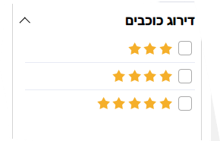 | 3 option-  3 stars/ 4 stars /5 stars | 3 options
 | I chose 4 stars | The selection is checked in v green | The selection is checked |  | pass
 | The site automatically calculates for 1-2 seconds | We will open option of hotels with 4 stars | Showing hotels |  | pass
 | I marked 2 option-  3 stars and 5 stars | The selection is checked in v green | Checking that hotel with 3 star and 5 stars |  | pass
 | I have not marked any star rating option | Show all options | Show all options |  | pass
Functionality-איפוס סינון
 | I chose a destination, date, number of guests | Mexico  20/12/23-27/12/23  2 guests | The details have been recorded |  | pass
 | Click on button- מצאו לי מלון בחו"ל | Several options open | Several options open |  | pass
 | On the right there are filter options-  מחיר המלון  תנאי הזמנה גמישים  דירוג כוכבים  חיפוש לפי שם מלון | Options can be filtered and below there is a filter reset button-  איפוס סינון  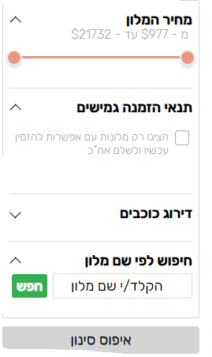הכפתור הזה -> | Button down-  איפוס סינון |  | pass
 | Indicates the lowest price in-מחיר המלון  977$ | Find hotels with price 977$ | Found some hotels |  | pass
 | Click on-  איפוס סינון | Returned all hotels | The data has been reset |  | pass
 | Are marking v in a square- תנאי הזמנה גמישים | Filters hotels and display only-  מלונות עם אפשרות להזמין עכשיו ולשלם אח"כ | Found some hotels |  | pass
 | Click on-  איפוס סינון | Returned all hotels | The data has been reset |  | pass
 | In the star rating I marked 4 stars | We will open option of hotels with 4 stars | Found some hotels |  | pass
 | Click on-  איפוס סינון | Returned all hotels | The data has been reset |  | pass
 | In the box- חיפוש לפי שם מלון  I typed center | Find all the hotels where the word appears- center | Found some hotels |  | pass
 | Click on-  איפוס סינון | Returned all hotels | The data has been reset |  | pass
GUI
 | Check that there are no spelling errors.
 | The box you press has a contrast in colors stands out-written in white on a green box
 | The pictures of the hotels are clear and straight
 | That the buttons of the images can be moved to the next image | The screen buttons work  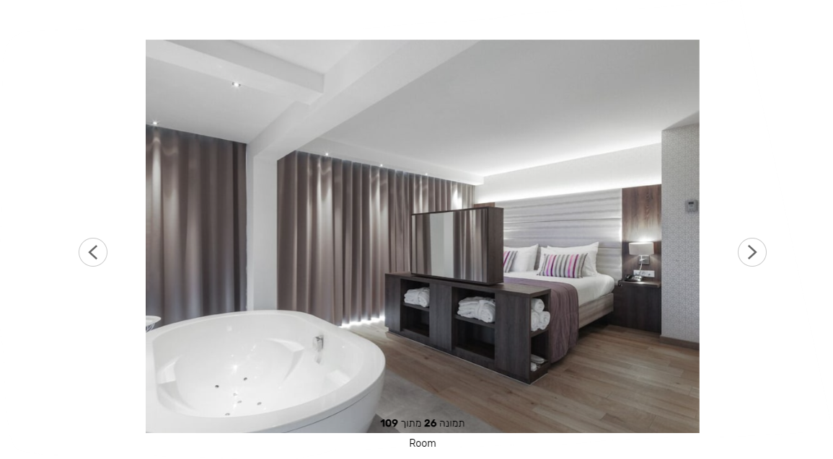 | The screen buttons work
 | The buttons of the computer | Images can be browsed through computer buttons | It is not possible scroll through the seat, the buttons do not respond |  | fail
 | Scrollable satellite maps | You can scroll sideways, froward, and backward
 | Which receives several hotel options | Choose a hotel | Choose a hotel |  | pass
 | When you enter the hotel selection , | Details about the hotel appear adove  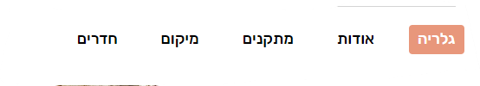 | Details about the hotel appear adove |  | pass
 | That click on-אודות | That the page appears exactly at the beginning of -אודות | The link skips about and appears-מתקנים  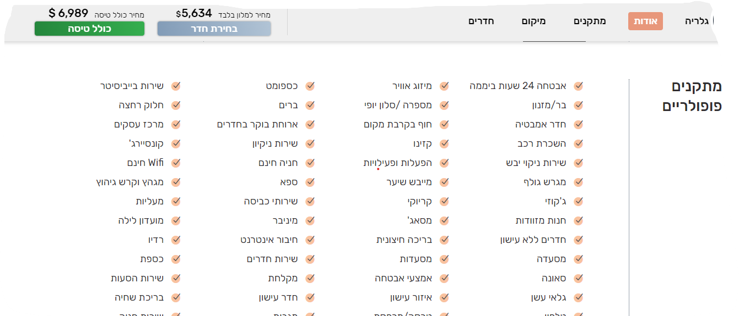 |  | fail
 | That click on- מתקנים | That the page appears exactly at the beginning of -מתקנים | The page goes down too much and not exactly on facilities  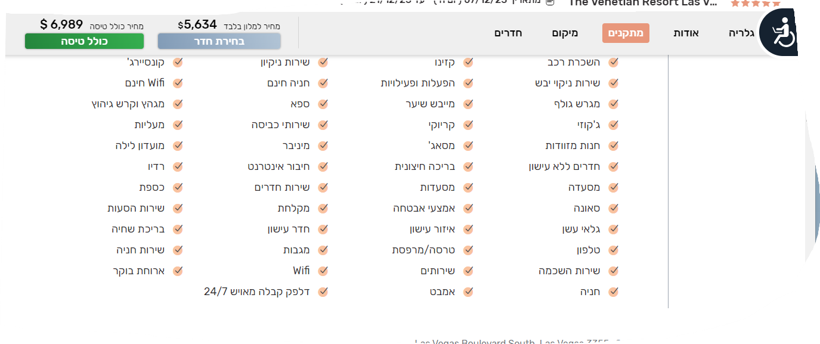 |  | fail
 | That click on-מיקום | That the page appears exactly at the beginning of -מיקום | The page goes down too much and not exactly on facilities  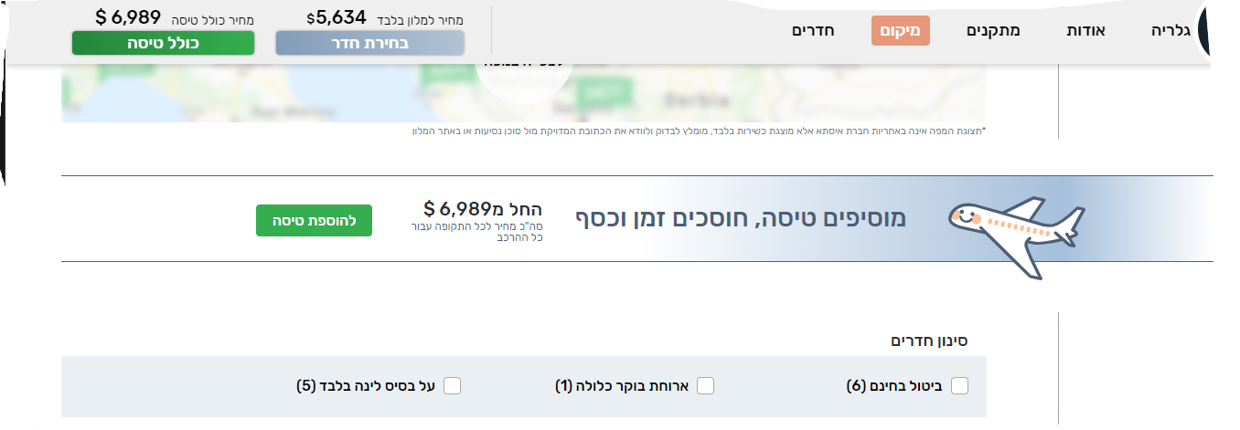 |  | fail
Integration
 | Interaction between issta and credit companies
 | Interaction between issta and PayPal
 | Interaction between issta and hotels abroad
 | Interaction between issta and airlines
 | Interaction between issta and google maps
Interaction between issta and mate
YouTube
Instagram

localization
At the order-
The price appears in shekels
 | The time zone corresponds to Israel
 | the web in Hebrew is suitable for Israel
 | Places that Israelis do not travel does not show results
Compatibility
 | Checking the web works on iPhone-13 pro max  On google chrome | Click on  https://www.issta.co.il | The web opened |  | pass
 | Press on- מלונות בחו"ל | Registers- בודפשט, הונגריה | Registers- בודפשט, הונגריה |  | pass
 | Chooses a date | 20/11/23-30/11/23 | 20/11/23-30/11/23 |  | pass
 | Select number of guests | 2 guests | 2 guests |  | pass
 | Click on the button- מצאו לי מלון בחו"ל | Several options open | Several options open |  | pass
 | Choose a hotel, by clicking on the picture | Details about the hotel | Details about the hotel |  | pass
 | There is a room filter icon | There are 2 option-  ארוחת בוקר כלולה  על בסיס לינה בלבד | There are 2 options |  | pass
 | Select the room | Select the room- superior twin room | Click on the button- רכישה |  | pass
 | A page will open for entering the orders details | Enter first name (orya)  , last name (ban),  email (test232@gmail.com)  , and phone number (052-1113000) | The details have been recorded.  Click the button- המשיכו |  | pass
 | Enter passenger details in English and date of birth | Orya ban 15/02/2000 | The details have been recorded.  Click the button- המשיכו |  | pass
 | Choose a type of suitcase | I chose- מזוודת יד | The details have been recorded.  Click the button- המשיכו |  | pass
 | Another page will open- שירותים נוספים | שירות איתור מזוודה, שירות נהג | The details have been recorded.  Click the button- המשיכו |  | pass
 | A page will open for ordering payment details | Presses a button- אישור וביצוע תשלום | A payment confirmation is received |  | pass
 | Receive a purchase confirmation by email | I received an email confirmation | I received an email confirmation |  | pass

