Bi-Weekly Status Report     Name: Anne George     Project Title: Andx Entertainment Score: 100

# Overall Status

(On schedule, behind schedule, or ahead of schedule.

Provide current suggestions or action plans.)

* Behind

We realized that many of the functionalities we thought were working on the back-end actually were not working. Our plan is to scale back our goals.

# Summary of Project Tasking

## List meetings attended – minutes and meeting minutes taken

* *First Week Meetings:* 
  + **Tuesday, May 31 – One-on-ones**
    - Philip – 13min
      * Main points: Learn what is needed for his card. Work on setting up his environments.
      * Notes submitted with this report.
    - Jarom – 15min
      * Main points: Get 50% of his shared card with Kenyon done. Work on setting up his environment. Help Philip with his environment.
      * Notes submitted with this report.
    - Carol – 15min
      * Main points: Learn what is needed for her card. Work on setting up her environments.
      * Notes submitted with this report.
    - Guillermo – 20min
      * Main points: Create a decomposing of the authentication and registration process.
      * Notes submitted with this report.
    - Aaron – 15min
      * Main points: Learn how to commit. Work on setting up environments. Learn what is needed for his card.
      * Notes submitted with this report.
    - Kenyon – 15min
      * Main points: Get 50% of his shared card with Jarom done.
      * Notes submitted with this report.
    - Mark – 11min
      * Main points: Learn what is needed for his card. Work on setting up his environments.
      * Notes submitted with this report.
  + **Thursday, June 02 – One-on-ones**
    - Philip – 16min
      * Main points: Goals status report.
      * Notes submitted with this report.
    - Jarom – 23min
      * Main points: Goals status report. Environments set up.
      * Notes submitted with this report.
    - Carol – 13min
      * Main points: Set up environment.
      * Notes submitted with this report.
    - Guillermo – 17min
      * Main points: I requested that he works on the back-end and leave the decomposition for later time.
      * Notes submitted with this report.
    - Aaron – 0 min
      * Main points: Canceled meeting. Reported to be done with goals.
      * Notes submitted with this report.
    - Kenyon – 31min
      * Main points: Goals status report.
      * Notes submitted with this report.
    - Mark – 15min
      * Main points: Goals status report.
      * Notes submitted with this report.
  + **Friday, June 3 – Meetings**
    - Professor – 45min
      * Main points: Risk Analysis. Software Development Folders.
    - Team – 1h
      * Main points: Discuss VDD. Refine our backlogs.
      * Notes submitted with this report.
* *Second Week Meetings:* 
  + **Tuesday, June 07 – One-on-ones**
    - Philip – 16min
      * Main points: Finished registration button. We went through how to fork the repo and commit.
      * Notes submitted with this report.
    - Jarom – 0min
      * Main points: Canceled meeting.
      * No notes.
    - Carol – 15min
      * Main points: Get help from lab. Work on set up environments.
      * Notes submitted with this report.
    - Guillermo – 0min
      * Main points: canceled meeting.
      * No notes
    - Aaron – 19min
      * Main points: Made cosmetic changes. Learn to connect back and front end.
      * Notes submitted with this report.
    - Kenyon – 6min
      * Main points: Done with shared card. Working on refactoring.
      * Notes submitted with this report.
    - Mark – 25min
      * Main points: we went through forking the repo and committing.
      * Notes submitted with this report.
  + **Thursday, June 09 – One-on-ones**
    - Philip – 9min
      * Main points: Goals status report.
      * Notes submitted with this report.
    - Jarom – 15min
      * Main points: Figure out deployment to use instead of Swagger (since the results from Swagger did not seem to be accurate).
      * Notes submitted with this report.
    - Carol – 18min
      * Main points: Missed the lab. Struggling with setting up the environment.
      * Notes submitted with this report.
    - Carol – 22min
      * Main points: I tried to help her set up her environment.
      * Notes submitted with this report.
    - Guillermo – 6min
      * Main points: We changed the direction of his goals.
      * Notes submitted with this report.
    - Aaron – 15min
      * Main points: Learn how to set up the ports.
      * Notes submitted with this report.
    - Kenyon – 11min
      * Main points: Finished connecting the routes.
      * Notes submitted with this report.
    - Mark – 15min
      * Main points: more adjustments to be made on architectural design.
      * Notes submitted with this report.
  + **Friday, June 10 – Meetings**
    - Client – 0min
      * Main points: meeting missed.
      * No notes.
    - Team – 3h 19min
      * Main points: Group programing instead of meeting (since we got stuck, we decided to program together. It helped us make progress).
      * No notes
  + **Friday, June 10 – One-on-one**
    - Jarom – 30min
      * Main points: Figuring out deployment.
      * No notes.

## Training notes

* Risk Analysis and Software Development Folders

## Stories assigned

## Project artifacts and notes identified in project tasking

# Number of Hours

* Number of Hours worked this week (expectation: 7-9 hours): 15h
* Total Number of Hours this semester (anticipated 120/semester): 65h 50min

# Accomplishments

(Since last status report)

* Number of Story Points completed: 17
* Number of Stories completed: 2
* Personal Velocity (Points/Stories): 8.5
* Project Velocity (Teams Points/Teams Stories): 8
* Earned Value (*Actual* Points/Hour - *Estimated* Points/Hour): 0.13

# Performance

* Last Week’s Performance Average (Actual Total Points/ Total Hours): 1
* This Week’s Performance (Actual Points/Hours): 1.13

## Challenges

(Challenges encountered / resolutions found since the last status report)

* Getting people to finish their goals.
  + One-on-ones are definitely making a difference, but I am not being successful at helping everyone to get involved.
* Organizing my time in order to do my tasks.
  + One-on-ones are extremely necessary, but they do add up. And I am only maintaining a record of actual meetings. My team and I also communicate through text.

## Plans/Goals/Tasking

(For the coming week/sprint.)

* Currently stories assigned and deadline:

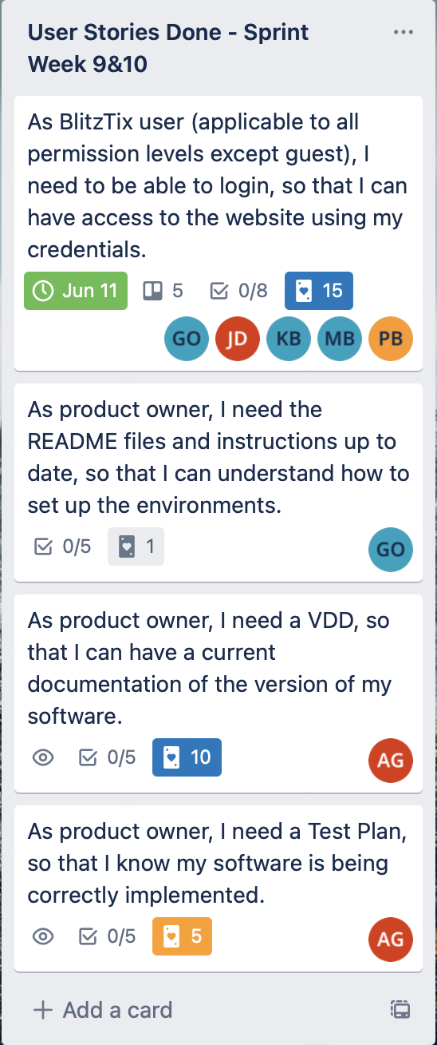

* + - Deadline: June 25.
* Stories for next sprint:

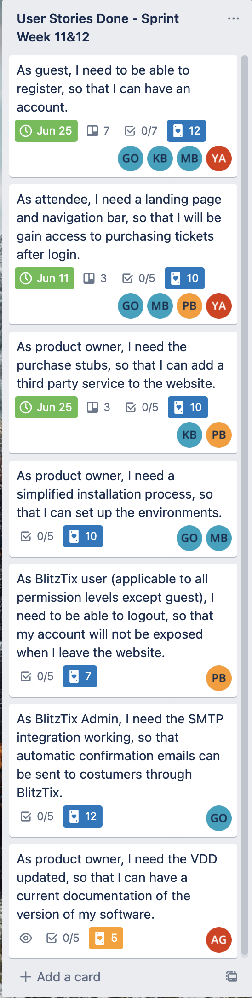

* + - Deadline: the end of next sprint
* Reflection goals and status:
  + Status from last report: Have not able to balance the workload of this class just yet, so next sprint goal is the same as last sprint goal. And talk holds accurate still.
  + Goals for next sprint: spend less hours per week involved with this class (9h instead of 10 - 20h).

## Follow-up/Reporting

(Describe who will help you follow through with your goals.)

* My instructor and my husband.

## Other Comments

* No comments

# Rubric

30% All questions answered

40% All Project tasks were completed

30% Performance Average from this week and last week