Bi-Weekly Status Report     Name: Anne George     Project Title: Andx Entertainment Score: 100

# Overall Status

(On schedule, behind schedule, or ahead of schedule.

Provide current suggestions or action plans.)

* On schedule

Since we scaled back our goals, we are now on schedule. We are now ready to take on more.

# Summary of Project Tasking

## List meetings attended – minutes and meeting minutes taken

* *First Week Meetings:* 
  + **Saturday, June 11 – One-on-one**
    - Guillermo – 15min
      * Main points: We went over the progress he made which involved implementing JWT correctly and the user API calls being made correctly.
      * Notes submitted with this report.
  + **Tuesday, May 14 – One-on-ones**
    - Philip – 0min
      * Main points: No meeting.
      * No notes.
    - Jarom – 28min
      * Main points: checked on his progress.
      * Notes submitted with this report.
    - Carol – 13min
      * Main points: She reported on her progress concerning getting her environments working.
      * Notes submitted with this report.
    - Guillermo – 29min
      * Main points: Cookies were implemented.
      * Notes submitted with this report.
    - Aaron – 9min
      * Main points: Went over his progress.
      * Notes submitted with this report.
    - Kenyon – 15min
      * Main points: he reported on his progress.
      * Notes submitted with this report.
    - Mark – 51min
      * Main points: he was able to connect the front and the back end.
      * Notes submitted with this report.
  + **Thursday, June 16 – One-on-ones**
    - Philip – 41min
      * Main points: Troubleshot sending pull requests. Went over his progress.
      * Notes submitted with this report.
    - Jarom – 28min
      * Main points: trying to help Carol. Working on the login.
      * Notes submitted with this report.
    - Carol – 14min
      * Main points: Having problems with docker. We agreed on her working on the front end.
      * Notes submitted with this report.
    - Guillermo – 0min
      * Main points: No meeting.
      * No notes.
    - Aaron – 42min
      * Main points: having issues with the database. Fixed the CORS.
      * Notes submitted with this report.
    - Kenyon – 18min
      * Main points: Goals status report.
      * No notes.
    - Mark – 52min
      * Main points: Goals status report.
      * Notes submitted with this report.
  + **Friday, June 17 – Meetings**
    - Professor – 45min
      * Main points: Keeping track of our tests and the results.
    - Team – 1h
      * Main points: Guillermo demo the changes he made. We added tasks to Trello. Group programimg.
      * Notes submitted with this report.
* *Second Week Meetings:* 
  + **Tuesday, June 21 – One-on-ones**
    - Philip – 15min
      * Main points: he is going to work on purchases stubs.
      * Notes submitted with this report.
    - Jarom – 15min
      * Main points: having problems with docker. He is going to review some of the finished cards.
      * Notes submitted with this report.
    - Carol – 21min
      * Main points: her computer can’t support running the environments.
      * Notes submitted with this report.
    - Guillermo – 15min
      * Main points: enable authentication.
      * Notes submitted with this report.
    - Aaron – 0min
      * Main points: no meeting.
      * No notes.
    - Kenyon – 23min
      * Main points: we troubleshot pull requests. He is working on the routes.
      * Notes submitted with this report.
    - Mark – 0min
      * Main points: no meeting.
      * No notes.
  + **Friday, June 24 – Meetings**
    - Professor – 45min
      * Main points: DevOps.
    - Team – 3h 19min
      * Main points: we talked about design problems.
      * Notes submitted with this report.

## Training notes

* Tracking test results and bugs:
  + It is a process of recording and monitoring errors during software testing.
  + It helps with prioritization of the bugs to be fixed since the number of bugs gets multiplied over a period of time on large systems.
* DevOps
  + It’s the union of development and operations.
  + The cycle of SW development is expanded, so that monitoring and troubleshooting is included in addition to writing the and testing the software.

## Task Submission

* Bug I found through review:

* + This bug has already been fixed.
* DevOps
  + <https://docs.microsoft.com/en-us/devops/what-is-devops>
  + <https://www.ibm.com/cloud/learn/devops-a-complete-guide>
  + <https://aws.amazon.com/devops/what-is-devops/>
  + <https://www.atlassian.com/devops>
  + Stages:

* + 1. Plan
       - Scrum
       - Kanban boards
    2. Develop (Build & Test)
       - Version control
       - Automated testing
    3. Release (Deliver)
       - Infrastructure as Code (IaC)
       - Containers
       - Microservices
    4. Monitor (Operate)
       - Synthetic Monitoring
       - Telemetry

*Telemetry* is the mechanism for collecting data from monitoring. Telemetry can use agents that are installed in the deployment environments, an SDK that relies on markers inserted into source code, server logging, or a combination of these. Typically, telemetry will distinguish between the data pipeline optimized for real-time alerting and dashboards and higher-volume data needed for troubleshooting or usage analytics.

## Stories assigned

https://github.com/ANDX-Entertainment/Software-Development-Repository.git

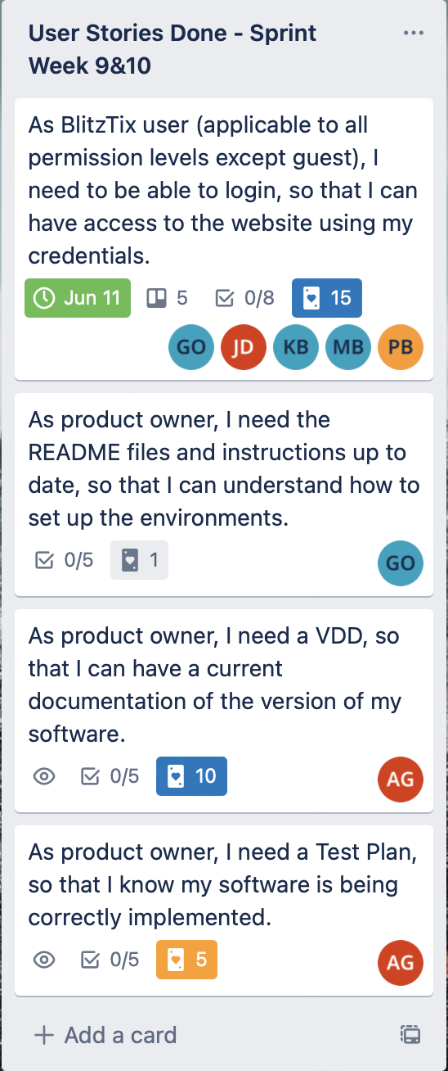



## Project artifacts and notes identified in project tasking

# Number of Hours

* Number of Hours worked this week (expectation: 7-9 hours): 15h
* Total Number of Hours this semester (anticipated 120/semester): 70h 50min

# Accomplishments

(Since last status report)

* Number of Story Points completed: 15
* Number of Stories completed: 2
* Personal Velocity (Points/Stories): 7.5
* Project Velocity (Teams Points/Teams Stories): 7.75
* Earned Value (*Actual* Points/Hour - *Estimated* Points/Hour): 0

# Performance

* Last Week’s Performance Average (Actual Total Points/ Total Hours): 1
* This Week’s Performance (Actual Points/Hours): 1

## Challenges

(Challenges encountered / resolutions found since the last status report)

* Getting people to finish their goals.
  + Some people just needed different goals that were more alined with what they wanted to do.

## Plans/Goals/Tasking

(For the coming week/sprint.)

* Currently stories assigned and deadline:

* + - Deadline: July 9
* Stories for next sprint:

* + - Deadline: the end of next sprint.
* Reflection goals and status:
  + Status from last report: Have not able to balance the workload of this class just yet, so next sprint goal is the same as last sprint goal.
  + Goals for next sprint: spend less hours per week involved with this class (9h instead of 10 - 20h).

## Follow-up/Reporting

(Describe who will help you follow through with your goals.)

* My instructor and my husband.

## Other Comments

* No comments

# Rubric

30% All questions answered

40% All Project tasks were completed

30% Performance Average from this week and last week