IM.090 Installation Instructions

Catalog Migration Release1A

Author: Krishna Pangath

Creation Date: Jan 27, 2016

Last Updated: Jan 27, 2016

Version: 1.1

1. **Title, Subject, Last Updated Date, Reference Number**, **and** **Version** are marked by a Word Bookmark so that they can be easily reproduced in the header and footer of documents. When you change any of these values, be careful not to accidentally delete the bookmark. **You can make bookmarks visible by selecting the Office Button>Word Options>Advanced> and checking the Show bookmarks option in the Show document content region.**

**Approvals:**

|  |  |
| --- | --- |
| <Approver 1> | Vinay Pachika |
| <Approver 2> | Viswam Nair |

1. To add additional approval lines, press [Tab] from the last cell in the table above.
2. You can delete any elements of this cover page that you do not need for your document.

# Document Control

## Change Record

3

| Date | Author | Version | Change Reference |
| --- | --- | --- | --- |
| Jan 27, 2016 | Krishna Pangath | 1.0 | No Previous Document |
| Jan 29, 2016 | Krishna Pangath | 1.1 | Updated comment to add screenshots from production to be shared with Dev team. |

## Reviewers

| Name | Position |
| --- | --- |
| Siva Balakrishnan | TCS |
|  |  |
|  |  |
|  |  |

Contents

1 Document Control ii

1.1 Change Record ii

1.2 Reviewers ii

2 Installation Instructions for BI System Setups Migration 4

2.1 Pre-Migration Steps 4

2.2 Catalog Migration Steps 4

2.3 Catalog Migration Verification Checklist 12

3 Open and Closed Issues 13

3.1 Open Issues 13

3.2 Closed Issues 13

1. To update the table of contents, put the cursor anywhere in the table and press [F9]. To change the number of levels displayed, select the menu option Insert‑>Index and Tables, make sure the Table of Contents tab is active, and change the Number of Levels to a new value.

# Installation Instructions for BI System Setups Migration

|  |  |
| --- | --- |
| **Source Environment Name:** UAT | **Machine:** TCGI13 |

|  |  |
| --- | --- |
| **Target Environment Name**: PROD | **Machine:** PCGIT3 |

## Pre-Migration Steps

* Ensure that the RPD and Configuration Migration has been completed
* **Ensure that the ‘Cigna Custom Financials’ and ‘Cigna Real Time Financials’ Folders are archived from UAT and put into SVN (<Target>\Catalog). The corresponding catalog files will be subsequently used for migration to Production instance in Section 2.2.**

## Catalog Migration Steps

* Copy below catalog from Source SVN repository to target repository
* SVN Base Path: http://subversion.sys.cigna.com/svn/ORACLE_BI_REPO
* Source Location: <Source> \Catalog
* Target Location : <Target>\Catalog

| S.No | Version # | File Name |
| --- | --- | --- |
| 1 | **<Cigna will update from UAT>** | Cigna Custom Financials.catalog |
| 2 | **<Cigna will update from UAT>** | Cigna Real Time Financials.catalog |
| 3 | **<Cigna will update from UAT>** | Cigna Business Development.catalog |
| 4 | **<Cigna will update from UAT>** | Cigna CMG Reporting.catalog |
| 5 | **<Cigna will update from UAT>** | Cigna Controller Reporting.catalog |
| 6 | **<Cigna will update from UAT>** | Cigna Expense Accounting Reporting.catalog |
| 7 | **<Cigna will update from UAT>** | Cigna Finance - Shared.catalog |
| 8 | **<Cigna will update from UAT>** | Cigna IT Finance Reporting.catalog |
| 9 | **<Cigna will update from UAT>** | Cigna Tax Reporting.catalog |

* Open the <Target> OBIEE Anwers url using the following URL with a user having admin privileges (preferably ‘custadmin’ user)

< https://<Targetserver>.oracleoutsourcing.com/analytics>

Ex: <https://OBIEEcgitprod.oracleoutsourcing.com/analytics>

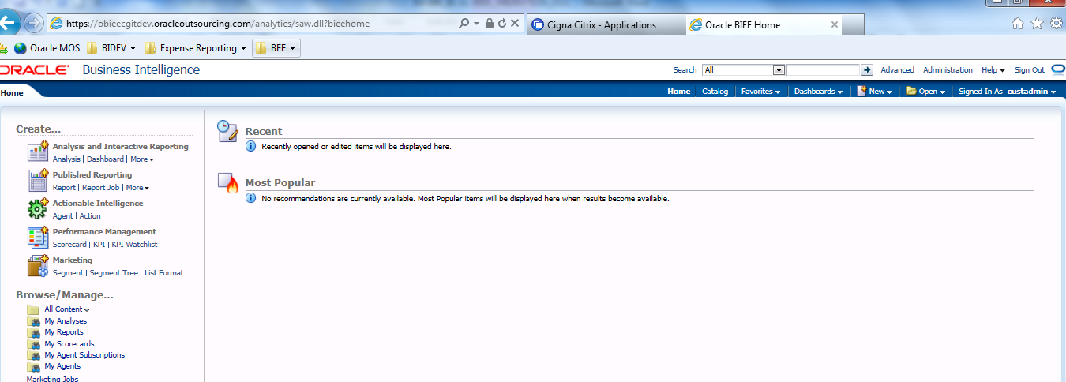

* Go to catalog and click on Shared Folders

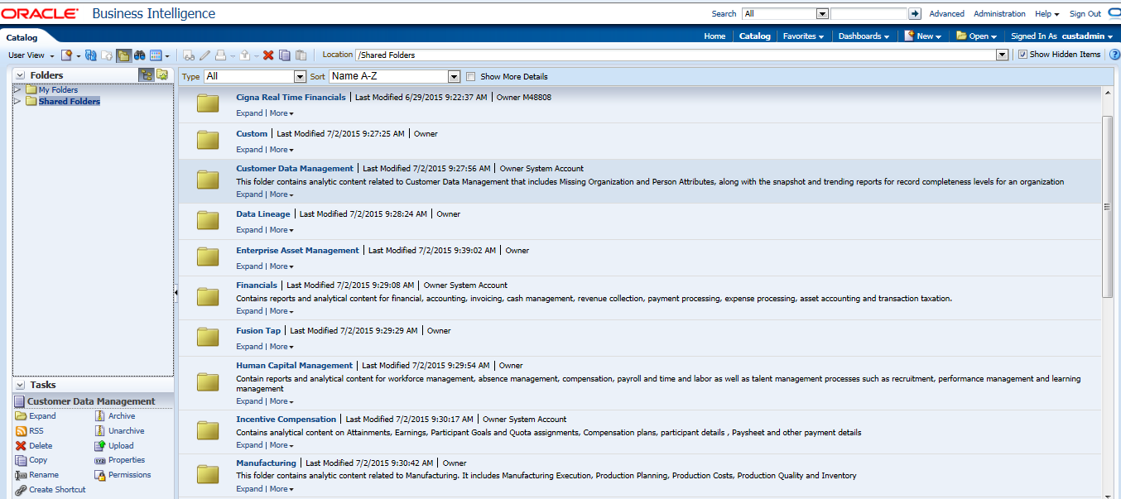

Delete the below mentioned Sub-Folders.

1. Cigna Custom Financials
2. Cigna Real Time Financials

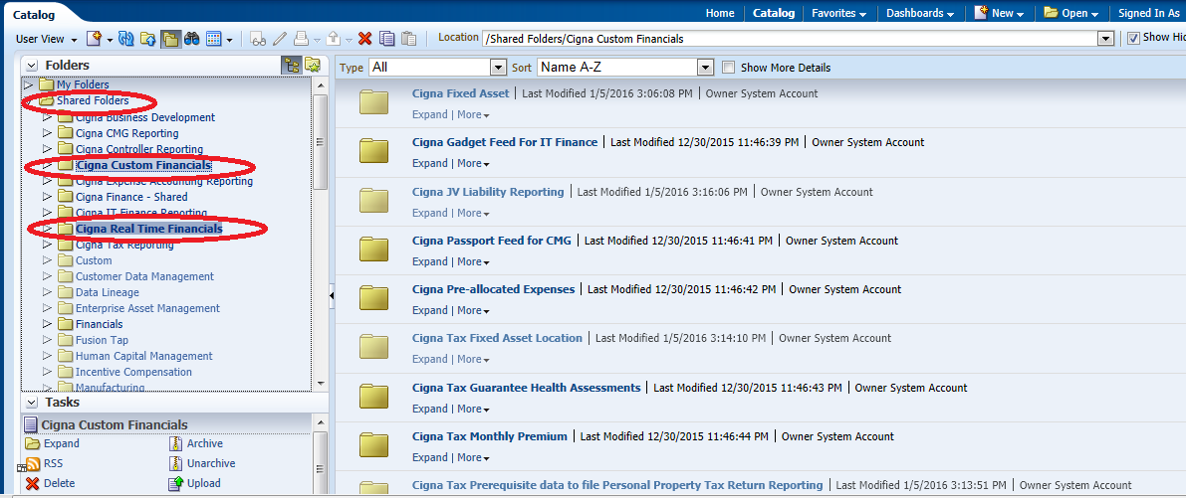

* Browse to the first catalog file(Cigna Real Time Financials)downloaded from the SVN in the first step.
* Select NONE for Replace from the Drop Down
* Select Inherit for ACL from the Drop Down.
* Click OK

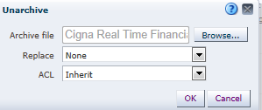

* Browse to the first catalog file(Cigna Custom Financials)downloaded from the SVN in the first step.
* Select NONE for Replace from the Drop Down
* Select Inherit for ACL from the Drop Down.
* Click OK

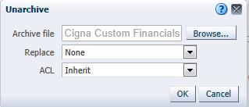

* For catalogs file 3-9 (Cigna Business Development.catalog,Cigna CMG Reporting.catalog,Cigna Controller Reporting.catalog,Cigna Expense Accounting Reporting.catalog,Cigna Finance - Shared.catalog,Cigna IT Finance Reporting.catalog,Cigna Tax Reporting.catalog), follow the following steps.
* Select NONE for Replace from the Drop Down
* Select **Preserve** for ACL from the Drop Down.
* Click OK

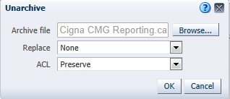

* Refresh the Answers(url) to get the changes reflected.
* Please ensure/modify the folders to have the following privilege  
    
  **Cigna Business Development**

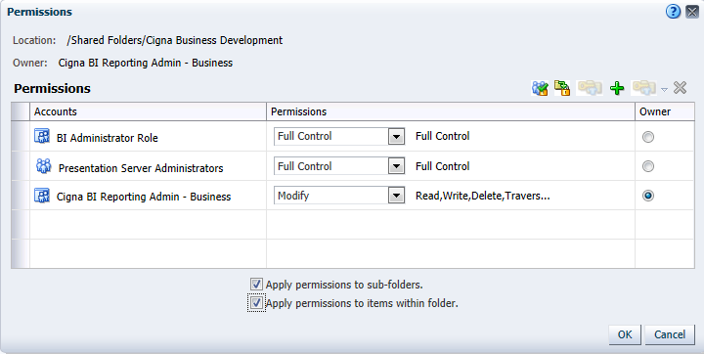

**Cigna CMG Reporting**

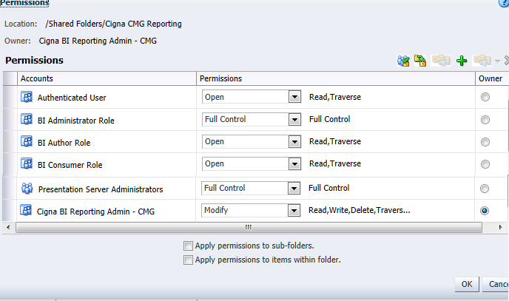

**Cigna Controller Reporting**

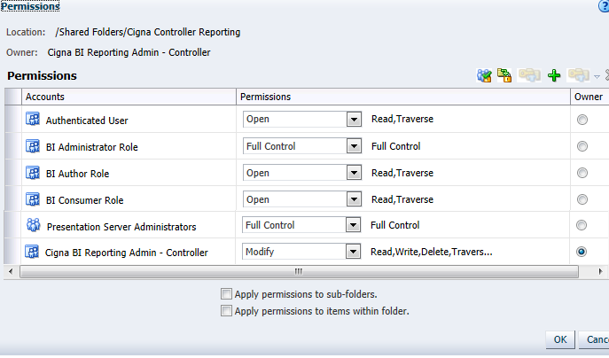

**Cigna Expense Accounting Report**

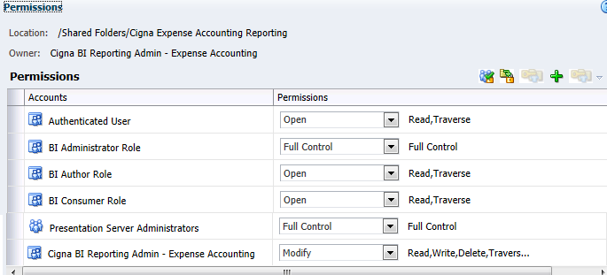

**Cigna Finance – Shared**

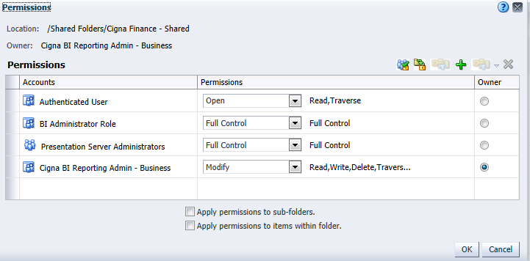

**Cigna IT Finance Reporting**

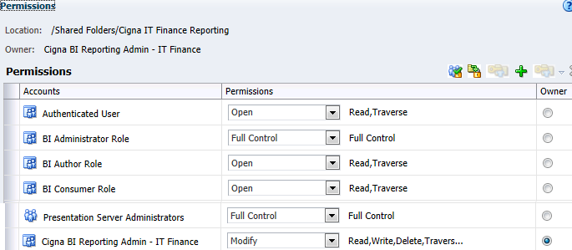

**Cigna Tax Reporting**

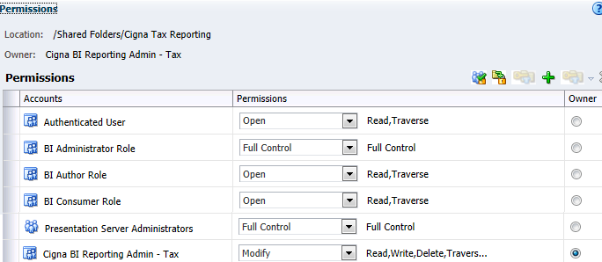

* Open the calatog and cross verify the presence of the new Sub-Folders under the Shared Folder.

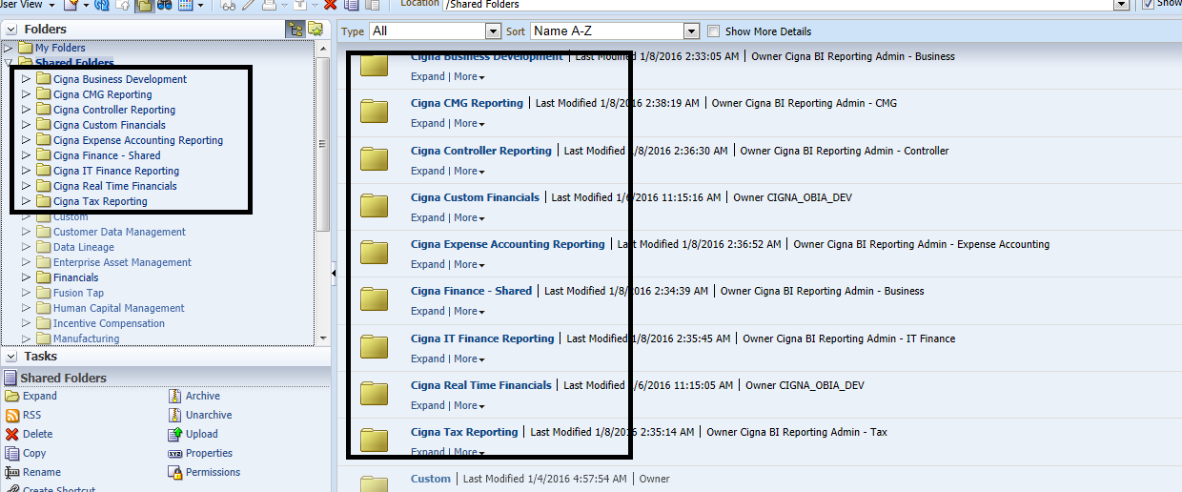

***Note: In case of any errors faced, Notify the developer team.***

## Catalog Migration Verification Checklist

1. Include a subset of test steps that will confirm that the customization has been installed properly.

Verify that the deployment has been completed successfully by following these steps:

* Make sure that the Catalog migration has been successful by verifying the below folder structure in the catalog manager. **Please take a screenshot of the contents of ‘Shared Folder’ as show below and share it with the Dev team.**



* Goto Dashboards Dropdown and verify the presence of below folders. **Please take a screenshot of the dashboard dropdown as show below and share it with the Dev team.**

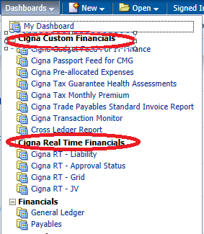

# **Open and Closed Issues**

1. Add open issues that you identify while writing or reviewing this document to the open issues section. As you resolve issues, move them to the closed issues section and keep the issue ID the same. Include an explanation of the resolution.  
     
   When this work product is complete, any open issues should be transferred to the project- or process-level Issue Log (Manage focus area) and managed using a project level Issue Form (Manage focus area). In addition, the open items should remain in the open issues section of this work product, but flagged in the resolution column as being transferred.

## Open Issues

| ID | Issue | Resolution | Responsibility | Target Date | Impact Date |
| --- | --- | --- | --- | --- | --- |
|  |  |  |  |  |  |
|  |  |  |  |  |  |
|  |  |  |  |  |  |
|  |  |  |  |  |  |

## Closed Issues

| ID | Issue | Resolution | Responsibility | Target Date | Impact Date |
| --- | --- | --- | --- | --- | --- |
|  |  |  |  |  |  |
|  |  |  |  |  |  |
|  |  |  |  |  |  |
|  |  |  |  |  |  |