OUM

DS.140 Design Specification

Cigna Corporation

BI-RPD-0008 Cigna AP Unpaid Invoice Subject Area

Author: Aditya Krishna Rao

Creation Date: August 22, 2016

Last Updated: September 13, 2016

Document Ref: BI-RPD-0008

Version: 1.0

1. **Title, Subject, Last Updated Date, Reference Number**, **and** **Version** are marked by a Word Bookmark so that they can be easily reproduced in the header and footer of documents. When you change any of these values, be careful not to accidentally delete the bookmark. **You can make bookmarks visible by selecting the Office Button>Word Options>Advanced> and checking the Show bookmarks option in the Show document content region.**

**Approvals:**

|  |  |
| --- | --- |
| Christine Park |  |
| Viswam Nair |  |

1. To add additional approval lines, press [Tab] from the last cell in the table above.



1. You can delete any elements of this cover page that you do not need for your document.

# Document Control

## Change Record

5

| Date | Author | Version | Change Reference |
| --- | --- | --- | --- |
| 22-Aug-16 | Aditya Krishna Rao | 1.0 | No Previous Document |

## Reviewers

| Name | Position |
| --- | --- |
| Hari Kishore Araveti | TCS |

## Distribution

| Name | Position |
| --- | --- |
|  |  |
|  |  |
|  |  |
|  |  |

Contents

1 Document Control 2

1.1 Change Record 2

1.2 Reviewers 2

1.3 Distribution 2

2 Business Overview 5

2.1 Assumptions 5

2.2 Risks & Issues 6

2.3 Referential Documents 6

2.4 Definitions and Acronyms 6

2.5 Block Diagram 7

3 Technical Overview 8

3.1 Technical Approach 8

3.2 Data Lineage/Mapping 10

4 Custom Components list 11

5 ELT Overview 14

5.1 Data Flow Model 14

5.2 Source System 14

5.3 Target System 14

5.4 SQL Statements 14

5.5 Indexes 14

5.6 Data Mapping 14

5.7 Load plans 15

6 RPD Design 16

6.1 Physical Layer 16

6.2 Database Objects 16

6.3 Physical diagram 17

7 BMM Layer 19

7.1 Logical Layer 21

8 Presentation layer 22

9 Report Design 23

9.1 Report Details 23

9.2 User Prompts 23

9.3 Header 23

9.4 Data Fields 23

9.5 Report Filters 23

9.6 Interfaces- External 24

9.7 Security 32

10 Performance 28

10.1 Performance Considerations/Requirements 28

10.2 Stress Test 28

10.3 Loading Timing/Benchmarking 28

11 Open and Closed Issues 29

11.1 Open Issues 29

11.2 Closed Issues 29

1. To update the table of contents, put the cursor anywhere in the table and press [F9]. To change the number of levels displayed, select the menu option Insert‑>Index and Tables, make sure the Table of Contents tab is active, and change the Number of Levels to a new value.

# Business Overview

**Upon AP Close, Controllers must identify transactions that have been recorded but, as of the day of close, have not yet been posted. These records have a Posted Indicator of N and therefore are not brought into the BI Data Warehouse via any out of the box or existing ETL processes, which all only bring in data with a Posted Indicator of Y.**

**Controllers look at these records in order to record liability for those amounts for the period in which they were recorded. Prior to BI R2, this report is generated manually via a process where a SQL statement is run against EBS to retrieve these records, and then a manual process was done to match each of these records up to Controller. This consolidated report is then distributed to the controllers who perform the tasks to record the associated liability.**

**This process must be made possible via BI. This document outlines the ETL component of taking a snapshot of this data from EBS at the time of AP Close and loading into a new table in BI for controllers to run for access.**

## Business Requirements

* Subject area naming and contents should match the contents of the table in data field requirements section below
* End user should be able to pull any field from the list into adhoc analysis and be able to view the data on the screen
* User should be able to export the retrieved data via adhoc analysis into any standard format including but not limited to excel, html, pdf.
* Last date and timestamp when the Unpaid invoices data were loaded into the data warehouse need to be displayed on the top when the end user selects the Unpaid invoices subject area.
* Single unified view of all Unpaid invoices data need to be presented in the BI presentation layer regardless of the type of transaction or source.
* Adhoc analyses created by end user should execute in optimal manner. Results should retrieve within 20 minutes time frame as long as some key prompt values are entered.
* Most frequently used and primarily used prompts / parameter would be Expense Center Parent i.e AOR, period name etc
* AOR security needs to be implemented. Data need to be secured by expense center parent /child hierarchy values configured at the source system. RPD should be designed to read the profiles and limit the data to the respective user according to the rules defined in EBS.

## Assumptions

* Custom Unpaid Invoices ETL (BI-ETL-0007) should have been successfully executed and should have brought the Unpaid Invoices data should have successfully loaded into BI DW prior.
* Out of the box load plans full load and incremental load must have been successfully executed and data should have been loaded successfully in standard BI DW tables.
* Data will not be available in real time. Latency of data will directly depend on when the last data refresh (standard and custom) happened. Normal schedule of data refresh is once a month, on the night of AP Close.
* No analysis or dashboard will be built as part of this requirement. Only subject area structure will be available for end users to perform adhoc reporting.
* Any addition to fields that are not listed in the Data Field Requirements section will require RPD design changes
* Any numeric column in a fact table should have a default aggregation of SUM, unless otherwise noted

## Risks & Issues

|  |  |  |  |
| --- | --- | --- | --- |
| **ID** | **Risk/Issue** | **Probability**  **(H/M/L)** | **Mitigation** |
| R&I-1 | Any change in source table structure | L | Data acquisition ETLs have to be modified accordingly. |
| R&I-2 | Incorporation of more than one Summary table and frequent changes in column structures | H | Re-work needs to be done with change in delivery timeline. |
| R&I-3 | Any modification in the requirement with regards to the user interaction of Parent-child value hierarchy would involve further customization of the hierarchy tables. | H | Re-work needs to be done with change in delivery timeline. |
| R&I-4 | Any change in ETL flow/logic will have impact on the design of CS | L | The RPD has to be modified to accommodate the data elements. |

## Referential Documents

The following documents serve as references for the content within this technical design

Document.

|  |  |
| --- | --- |
| **Name** | **Locations/Attachments** |
| AP Unpaid Invoice Functional Specification | [BI-RPD-0008_FS_RD-140_UNPAID_INVOICES_SUBJECT_AREA](https://centralhub.cigna.com/project/epms13058/Expense%20Reporting/Design/Reporting/Functional%20Specs/RPD/BI-RPD-0008_FS_RD-140_UNPAID_INVOICES_SUBJECT_AREA.docx) |
| ETL Functional Specification | [BI-ETL-0007_FS_RD-140_Unpaid_Invoices_ETL](https://centralhub.cigna.com/project/epms13058/Expense%20Reporting/Design/Reporting/Functional%20Specs/ETL/BI-ETL-0007_FS_RD-140_Unpaid_Invoices_ETL.docx) |
| ETL Technical Design Document | [TD_DS_140_ETL_007_ODI_UnPaid_Invoices.docx](https://centralhub.cigna.com/project/epms13058/Expense%20Reporting/Release%202/TCS-Development/05-DS-140%20Technical%20Design%20TD/TD_DS_140_ETL_007_ODI_UnPaid_Invoices.docx) |
| Security Functional Specification | [BI-FAH-0006_FS_RD-140_PREALLOC_EXP_SUBJECT_AREA](https://centralhub.cigna.com/project/epms13058/Expense%20Reporting/Design/Reporting/Functional%20Specs/RPD/BI-FAH-0006_FS_RD-140_PREALLOC_EXP_SUBJECT_AREA.DOCX) |

## Definitions and Acronyms

|  |  |
| --- | --- |
| **Key Word** | **Meaning** |
| OBIEE | Oracle Business Intelligence Enterprise Edition |
| OOB | Out Of The Box |
| RPD | Repository File |
| ETL | Extract, Transform and Load |
| BI | Business Intelligence |
| DW | Data warehouse |

## Block Diagram

DW

OBIEE

EBS

**Cigna AP Unpaid Invoice Subject Area**

**OOB Dimensions**

**Custom**

**Unpaid Invoice**

**Staging**

**R12 EBS Accounts Payables**

**OOB AP Unpaid Invoice Detail**

# Technical Overview

## Technical Approach

The high level approach for the requirement independently is as follows:

The ETL design for this requirement has already been defined in a separate document dedicated exclusively for the custom ETL flow to bring custom data into the DW. The following sections broadly outline the design at the OBIEE side, based on the backend database objects already created by ETL.

The AP Unpaid Invoice subject area data model is a star schema with a central fact populated by custom designed ETL bringing in all the metrics and attributes required for reporting.



Translated to OBIEE RPD design, the physical data model looks as follows:

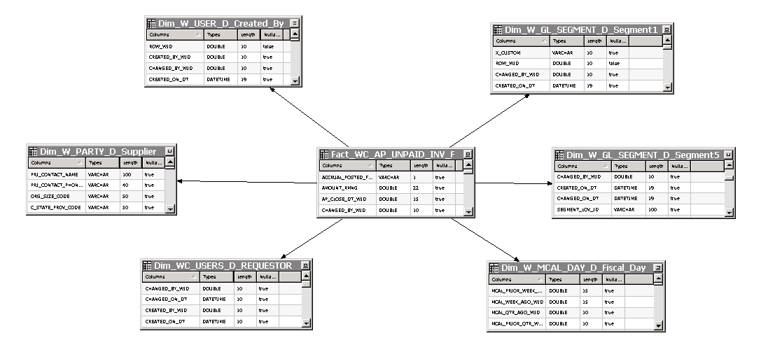

As mentioned, the Fact is joined to User, Segment1, Segment5, Fiscal Day, Requestor and Supplier dimensions through the relevant surrogate keys. The fact table i.e. Fact- AP Unpaid Invoice is divided into two parts i.e. Fact – AP Unpaid Invoice which contains only measure columns and Dim – AP Unpaid Invoice Detail which contains non-measure columns. These two tables are internally connected through a join.

The design gets replicated for the Logical Model:

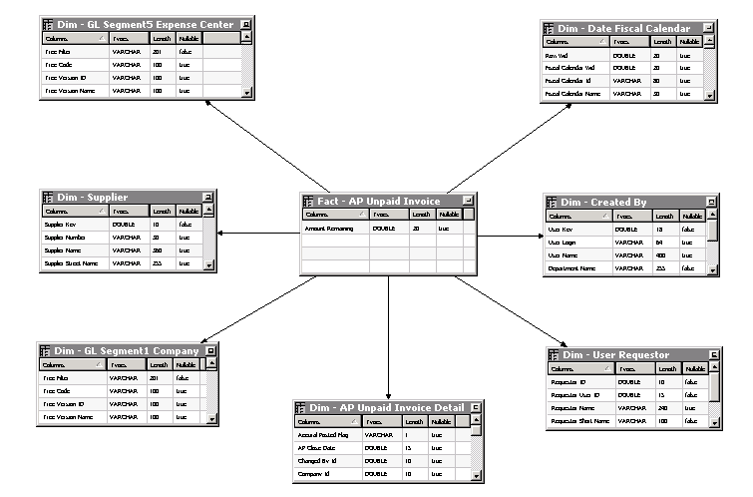

The design for data level security involves creation of an initialization block to pull up the responsibility setup related to the user and use that value as parameter to the customized GL segment hierarchy stored in the DW. This pulls up all the child nodes below of a specific Expense Center and which could further be used as a filter to limit the records. The filter is applied whenever the Logical Pre Allocation fact is queries by the requests generated by the user.

## Data Lineage/Mapping

The data mapping for all the columns showing up in the CSA presentation layer is as attached:



The ETL Lineage is handled in the ETL Technical Document ([DS-140_ETL_TECH_DESIGN_DOCUMENT](https://centralhub.cigna.com/project/epms13058/Expense%20Reporting/IT%20Delivery/TCS/04-MD70%20Technical%20Design%20Documents%20(TD)/DS-140_BI-ETL-0001_ETL_TECH_DESIGN_DOCUMENT.docx))

# Custom Components list

**ETL/DB objects are out of scope in this list**

|  |  |  |  |  |  |  |  |  |
| --- | --- | --- | --- | --- | --- | --- | --- | --- |
| **S.No** | **Area** | **Type** | **New /Change?** | **Name** | | **Description** | **Purpose** | **Schema** |
| 1 | RPD | Alias | New | | Dim_W_USER_D_Created_By |  | Loads the Cost Pool Dimension |  |
| 2 | RPD | Alias | New | | Dim_W_GL_SEGMENT_D_Segment1 |  | Loads the Company Dimension |  |
| 3 | RPD | Alias | New | | Dim_W_PARTY_D_Supplier |  | Loads the Supplier Dimension |  |
| 4 | RPD | Alias | New | | Dim_WC_USERS_D_REQUESTOR |  | Loads the Requestor Dimension |  |
| 5 | RPD | Alias | New | | Dim_W_MCAL_DAY_D_Fiscal_Day |  | Loads the date Dimension |  |
| 6 | RPD | Alias | New | | Dim_W_GL_SEGMENT_D_Segment5 |  | Loads the Expense Center Dimension |  |
| 7 | RPD | Alias | New | | Fact_WC_AP_UNPAID_INV_F |  | Unpaid Invoice Fact |  |
| 8 | RPD | Logical Table | New | | Dim - Created By |  |  |  |
| 9 | RPD | Logical Table | New | | Dim - GL Segment1 Company |  |  |  |
| 10 | RPD | Logical Table | New | | Dim - Supplier |  |  |  |
| 11 | RPD | Logical Table | New | | Dim - User Requestor |  |  |  |
| 12 | RPD | Logical Table | New | | Dim - Date Fiscal Calendar |  |  |  |
| 13 | RPD | Logical Table | New | | Dim - GL Segment5 Expense Center |  |  |  |
| 14 | RPD | Logical Table | New | | Dim - AP Unpaid Invoice Detail | OOB Dimension | OOB Dimension |  |
| 15 | RPD | Logical Table | New | | Fact - AP Unpaid Invoice |  |  |  |
| 16 | RPD | Presentation Table | New | | AP Close Calendar |  |  |  |
| 17 | RPD | Presentation Table | New | | Company |  |  |  |
| 18 | RPD | Presentation Table | New | | Expense Center |  |  |  |
| 19 | RPD | Presentation Table | New | | Vendor |  |  |  |
| 20 | RPD | Presentation Table | New | | Requestor |  |  |  |
| 21 | RPD | Presentation Table | New | | Document Details |  |  |  |
| 22 | RPD | Presentation Table | New | | Fact - AP Unpaid Invoice |  |  |  |
| 23 | RPD | Initialization Block | New | | Cigna AOR Hierarchy Based Security |  | Pulls the expense center child values for use in AOR based security |  |
| 24 | RPD | Session Variable | New | | WC_AOR_EC_SECURITY_DW |  | Stores the values returned from the Initialization block “Cigna AOR Hierarchy Based Security” |  |
| 25 | Weblogic/RPD | Application Role | New | | Cigna Pre-Allocated Expense Analyst role | A new row had been added to Object Permissions and Data Filters tabs. | Role created for security setting w.r.t Pre Allocated Expense and AP Unpaid Invoice CSA |  |
| 26 | Weblogic | Group | New | | Cigna Pre-Allocated Expense Analyst |  | Group assigned to “Cigna Pre-Allocated Expense Analyst Role” Application Role |  |
| 27 | RPD | Dimensional Hierarchy | New | | Dim - Created ByDim | One Total and One detail Level with all attributes set at detail level. |  |  |
| 28 | RPD | Dimensional Hierarchy | New | | Dim - GL Segment1 CompanyDim | Level set in sync with the OOB Fiscal CalendarDim |  |  |
| 29 | RPD | Dimensional Hierarchy | New | | Dim - SupplierDim | One Total and One detail Level with all attributes set at detail level. |  |  |
| 30 | RPD | Dimensional Hierarchy | New | | Dim - User RequestorDim | One Total and One detail Level with all attributes set at detail level. |  |  |
| 31 | RPD | Dimensional Hierarchy | New | | Dim - Date Fiscal CalendarDim | One Total and One detail Level with all attributes set at detail level. |  |  |
| 32 | RPD | Dimensional Hierarchy | New | | Dim - GL Segment5 Expense CenterDim | One Total and One detail Level with all attributes set at detail level. |  |  |
| 33 | RPD | Dimensional Hierarchy | New | | Dim - AP Unpaid Invoice DetailDim | One Total and One detail Level with all attributes set at detail level. |  |  |

# ELT Overview

All the information related to the ELT flow of this component is covered in the Technical document ([DS-140_ETL_TECH_DESIGN_DOCUMENT](https://centralhub.cigna.com/project/epms13058/Expense%20Reporting/IT%20Delivery/TCS/04-MD70%20Technical%20Design%20Documents%20(TD)/DS-140_BI-ETL-0001_ETL_TECH_DESIGN_DOCUMENT.docx))

## Data Flow Model

.

## Source System

### Data objects

|  |  |  |
| --- | --- | --- |
| **Source(Table/View)** | **Column** | **Description** |
| N/A | N/A | N/A |

### Data Model

## Target System

### Data objects

|  |  |  |
| --- | --- | --- |
| **Source(Table/View)** | **Column** | **Description** |
| N/A | N/A | N/A |

### Data Model

N/A

## SQL Statements

N/A

## Indexes

N/A

|  |  |  |
| --- | --- | --- |
| **Name** | **Columns** | **Description** |
| N/A | N/A | N/A |

## Data Mapping

## Load plans

The following new components were created to execute a scheduled procedure that runs at a predetermine schedule.

|  |  |  |
| --- | --- | --- |
| **Name** | **Type** | **Description** |
| N/A | N/A | N/A |
| N/A | N/A | N/A |
| N/A | N/A | N/A |

# RPD Design

## Physical Layer

**Connection Pool**

The existing connection pool for DW is used to connect to the OOB as well as custom tables, since they reside on the same schema.

|  |  |
| --- | --- |
| **Item** | **Specification** |
| Call Interface | *OCI 10G/11G* |
| Maximum Connections | *100* |
| Fully Qualified Table Names | *YES* |
| Data Source Name | *(DESCRIPTION=(ADDRESS_LIST=(ADDRESS=(PROTOCOL=TCP)(HOST=vmsodcgit001.oracleoutsourcing.com)(PORT=30711)))(CONNECT_DATA=(SERVICE_NAME=DCGIT3))) (Connection string for the relevant instance)* |
| Shared Login | *Yes* |
| User Name | *DCGIT3_DW (Datawarehouse Schema for the relevant instance)* |
| Enable Connection Pooling | *Yes* |
| Timeout | *5 min* |
| Asynchronous Queries | *No* |
| Execute on Connect | *no* |
| Parameters Supported | *yes* |
| Isolation Level | *Dirty read* |

## Database Objects

### Tables/Views

|  |  |  |
| --- | --- | --- |
| **RPD Object Name** | **WH Object Name** | **Description** |
| Dim_W_USER_D_Created_By | W_USER_D | Stores the user dimension |
| Dim_W_GL_SEGMENT_D_Segment1 | W_GL_SEGMENT_D | Stores Company dimension |
| Dim_W_PARTY_D_Supplier | W_PARTY_D | Stores Supplier Type Dimension |
| Dim_W_GL_SEGMENT_D_Segment5 | W_GL_SEGMENT_D | Stores Expense Center Dimension |
| Dim_W_MCAL_DAY_D_Fiscal_Day | W_MCAL_DAY_D | Stores Calendar Dimension |
| Dim_WC_USERS_D_REQUESTOR | WC_PREALLOC_USERS_D | Users dimension that stores the requestor information |
| Fact_WC_AP_UNPAID_INV_F | WC_AP_UNPAID_INV_F | AP Unpaid Invoice Fact table. |

### Data Validations

No extra validations required since all the aliases, DB objects for this component are based on already existing DW objects.

|  |  |  |
| --- | --- | --- |
| **ID** | **Validation** | **Description** |
| N/A | N/A | N/A |

## Physical diagram



**The joins are as follows:**

|  |  |  |  |
| --- | --- | --- | --- |
| **Source Table Name** | **Target Table Name** | **Join Type (Physical Key/Complex)** | **Joins Specification** |
| Fact_WC_AP_UNPAID_INV_F | Dim_W_USER_D_Created_By | Physical Key | "Oracle Data Warehouse"."Catalog"."dbo"."Dim_W_USER_D_Created_By"."ROW_WID" = "Oracle Data Warehouse".""."DCGIT3_DW"."Fact_WC_AP_UNPAID_INV_F"."CREATED_BY_WID" |
| Fact_WC_AP_UNPAID_INV_F | Dim_W_GL_SEGMENT_D_Segment1 | Physical Key | "Oracle Data Warehouse"."Catalog"."dbo"."Dim_W_GL_SEGMENT_D_Segment1"."SCD1_WID" = "Oracle Data Warehouse".""."DCGIT3_DW"."Fact_WC_AP_UNPAID_INV_F"."COMPANY_WID" |
| Fact_WC_AP_UNPAID_INV_F | Dim_W_PARTY_D_Supplier | Physical Key | "Oracle Data Warehouse"."Catalog"."dbo"."Dim_W_PARTY_D_Supplier"."ROW_WID" = "Oracle Data Warehouse".""."DCGIT3_DW"."Fact_WC_AP_UNPAID_INV_F"."VENDOR_WID" |
| Fact_WC_AP_UNPAID_INV_F | Dim_W_GL_SEGMENT_D_Segment5 | Physical Key | "Oracle Data Warehouse"."Catalog"."dbo"."Dim_W_GL_SEGMENT_D_Segment5"."SCD1_WID" = "Oracle Data Warehouse".""."DCGIT3_DW"."Fact_WC_AP_UNPAID_INV_F"."EXPENSE_CENTER_WID" |
| Fact_WC_AP_UNPAID_INV_F | Dim_WC_USERS_D_REQUESTOR | Physical Key | "Oracle Data Warehouse".""."DCGIT3_DW"."Dim_WC_USERS_D_REQUESTOR"."ROW_WID" = "Oracle Data Warehouse".""."DCGIT3_DW"."Fact_WC_AP_UNPAID_INV_F"."REQUESTOR_WID" |
| Fact_WC_AP_UNPAID_INV_F | Dim_W_MCAL_DAY_D_Fiscal_Day | Physical Key | "Oracle Data Warehouse"."Catalog"."dbo"."Dim_W_MCAL_DAY_D_Fiscal_Day"."ROW_WID" = "Oracle Data Warehouse".""."DCGIT3_DW"."Fact_WC_AP_UNPAID_INV_F"."AP_CLOSE_DT_WID" |

# BMM Layer

## Logical Layer

The design in the BMM layer is mostly straightforward with the model being almost an exact copy of physical layer with no additional complex joins or any aggregate navigation. The fact is set at the Detail level for all the dimensions to which it is linked.

### Logical Tables

**The following new Logical Tables were created:**

|  |  |
| --- | --- |
| **Logical Table** | **Dim – Created By** |
| **Logical Table Type** | **Dimension** |
| **Primary Key** | **User Key** |

|  |  |  |  |  |
| --- | --- | --- | --- | --- |
| **Logical Table Source** | **Active** | **List of Physical Tables Mapped** | **WHERE Clause in LTS** | **LTS Join Type** |
| Dim_W_USER_D_Created_By | Y | Dim_W_USER_D_Created_By |  |  |

|  |  |
| --- | --- |
| **Logical Table** | **Dim - GL Segment1 Company** |
| **Logical Table Type** | **Dimension** |
| **Primary Key** | **Tree Filter, Segment Value Set Code and Segment Code** |

|  |  |  |  |  |
| --- | --- | --- | --- | --- |
| **Logical Table**  **Source** | **Active** | **List of Physical Tables Mapped** | **WHERE Clause in LTS** | **LTS Join Type** |
| Dim_W_GL_SEGMENT_DH_Segment1 | Y | Dim_W_GL_SEGMENT_DH_Segment1 | "Oracle Data Warehouse"."Catalog"."dbo"."Dim_W_GL_SEGMENT_D_Segment1"."SEGMENT_LOV_ID" IN (1015156,0) |  |

|  |  |
| --- | --- |
| **Logical Table** | **Dim - GL Segment5 Expense Center** |
| **Logical Table Type** | **Dimension** |
| **Primary Key** | **Tree Filter, Segment Value Set Code and Segment Code** |

|  |  |  |  |  |
| --- | --- | --- | --- | --- |
| **Logical Table**  **Source** | **Active** | **List of Physical Tables Mapped** | **WHERE Clause in LTS** | **LTS Join Type** |
| Dim_W_GL_SEGMENT_DH_Segment5 | Y | Dim_W_GL_SEGMENT_DH_Segment5 | "Oracle Data Warehouse"."Catalog"."dbo"."Dim_W_GL_SEGMENT_D_Segment5"."SEGMENT_LOV_ID" IN (1015160,0) |  |

|  |  |
| --- | --- |
| **Logical Table** | **Dim - User Requestor** |
| **Logical Table Type** | **Dimension** |
| **Primary Key** | **Requestor ID** |

|  |  |  |  |  |
| --- | --- | --- | --- | --- |
| **Logical Table Source** | **Active** | **List of Physical Tables Mapped** | **WHERE Clause in LTS** | **LTS Join Type** |
| Dim_WC_USERS_D_REQUESTOR | Y | Dim_WC_USERS_D_REQUESTOR |  |  |

|  |  |
| --- | --- |
| **Logical Table** | **Dim - Supplier** |
| **Logical Table Type** | **Dimension** |
| **Primary Key** | **Supplier Key** |

|  |  |  |  |  |
| --- | --- | --- | --- | --- |
| **Logical Table Source** | **Active** | **List of Physical Tables Mapped** | **WHERE Clause in LTS** | **LTS Join Type** |
| Dim_W_PARTY_D_Supplier | Y | Dim_W_PARTY_D_Supplier |  |  |

|  |  |
| --- | --- |
| **Logical Table** | **Dim - Date Fiscal Calendar** |
| **Logical Table Type** | **Dimension** |
| **Primary Key** | **Row Wid** |

|  |  |  |  |  |
| --- | --- | --- | --- | --- |
| **Logical Table Source** | **Active** | **List of Physical Tables Mapped** | **WHERE Clause in LTS** | **LTS Join Type** |
| Dim_W_MCAL_DAY_D_Fiscal_Day | Y | Dim_W_MCAL_DAY_D_Fiscal_Day |  |  |

|  |  |
| --- | --- |
| **Logical Table** | **Dim - AP Unpaid Invoice Detail** |
| **Logical Table Type** | **Dimension** |
| **Primary Key** | **Invoice Number** |

|  |  |  |  |  |
| --- | --- | --- | --- | --- |
| **Logical Table Source** | **Active** | **List of Physical Tables Mapped** | **WHERE Clause in LTS** | **LTS Join Type** |
| Dim_WC_JE_CATEGORY_D | Y | Dim_WC_JE_CATEGORY_D |  |  |

### Joins

Each New Logical Dimension table created in the above step has to be joined to the following Logical tables with the dimension being at the 1 end of the 1:N relationship:

|  |
| --- |
| Dim - Created By |
| Dim - Supplier |
| Dim – GL Segment1 Company |
| Dim – AP Unpaid Invoice Details |
| Dim – Date Fiscal Calendar |
| Dim - GL Segment5 Expense Center |
| Dim – User Requestor |

### Business Rules

|  |  |  |
| --- | --- | --- |
| **ID** | **Business Rule** | **Description** |
| N/A | N/A | N/A |

# Presentation layer

The newly created presentation table have been added in section 5 for the custom components. The presentation columns have been created based on the data field document mentioned as per the document.

**SUBJECT AREA**: **Cigna Unpaid Invoices**

|  |  |  |
| --- | --- | --- |
| **Source Column Name** | **Presentation Folder Name** | **Presentation Column Name** |
| AP_Close_Date | AP Close Calendar | AP Close Date |
| Vendor_Name | Vendor | Vendor Name |
| Expense_Center | Expense Center | Expense Center |
| Segment_Name | Company | Company Name |
| Invoice_Num | Document Details | Invoice Number |
| Line_Num |  | Line Number |
| Dist_Line_Num |  | Distribution Line Number |
| Inv_Date |  | Invoice Date |
| Due_Dt |  | Due Date |
| PO_Number |  | PO Number |
| Voucher_Num |  | Voucher Number |
| accrual_posted_flag |  | Accrual Posted Flag |
| Creation_Date |  | Creation Date |
| Requestor | Requestor | Requestor |

No other customizations were added at the presentation layer.

# Report Design

## Report Details

No specific reports have been created for this component.

|  |  |  |  |  |  |
| --- | --- | --- | --- | --- | --- |
| **Report Name** | **Report Location** | **Subject Area** | **Dashboard** | **Dashboard Page** | **Description** |
| N/A | N/A | N/A | N/A | N/A | N/A |

## User Prompts

|  |  |  |  |  |  |
| --- | --- | --- | --- | --- | --- |
| **Dashboard Prompt Name** | **Prompt Label** | **Prompt Expression** | **Prompt Type** | **Default To** | **Set Variable** |
| N/A | N/A | N/A | N/A | N/A | N/A |

## Header

|  |  |
| --- | --- |
| **Report Name** | **Report Location** |
| Report Title | N/A |
| Report Sub-Title | N/A |

## Data Fields

|  |  |  |  |  |  |
| --- | --- | --- | --- | --- | --- |
| **Column Name** | **Column Description** | **Calculated?** | **BMM Expression** | **Variable Name** | **Comment** |
| N/A | N/A | N/A | N/A | N/A | N/A |
| N/A | N/A | N/A | N/A | N/A | N/A |

## Report Filters

|  |  |
| --- | --- |
| **Column Name** | **Filter Condition** |
| N/A | N/A |
| N/A | N/A |

## Interfaces- External

|  |  |  |  |
| --- | --- | --- | --- |
| **Drilldown From Column** | **Drilldown To Column** | **Underlying Hierarchy** | **Display Characteristics** |
| N/A | N/A | N/A | N/A |

|  |  |  |  |
| --- | --- | --- | --- |
| **Navigate From Column** | **Navigate To** | **Pass-through Parameters** | **Display Characteristics** |
| N/A | N/A | N/A | N/A |

## Security

**Object Level Security**

This also involves setting up the User level security at the rpd level. Any user who is part of group or is assigned can access this dashboard. No other user assigned to any other group or any other application role can access Pre Allocation and AP Unpaid Invoice Subject Areas.

|  |  |
| --- | --- |
| **Group** | **Application Role** |
| Cigna Pre-Allocated Expense Analyst | Cigna Pre-Allocated Expense Analyst role |

**Row Level (Data)Security**

This involves changes at both BI and EBS setups.

**EBS Level Changes:**

A new profile ‘XXC_BI_AOR_SECURITY’ was created at the EBS side with values limited to AOR verticals.

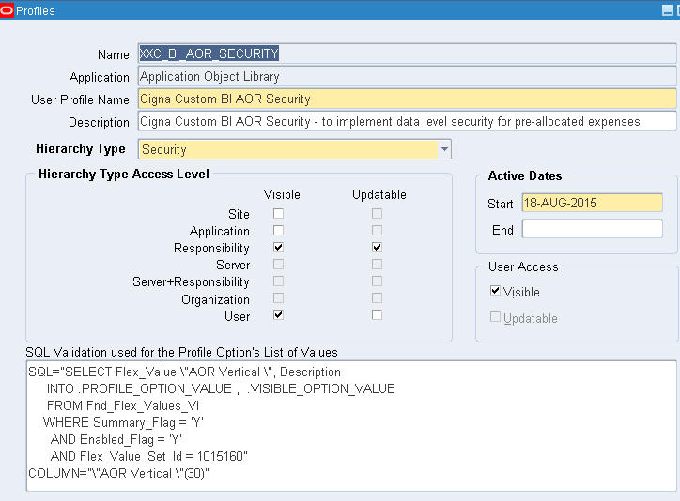

Custom BI responsibility is created and the above custom profile set at the responsibility level with an expense center parent value from the pick list. Example shown below t

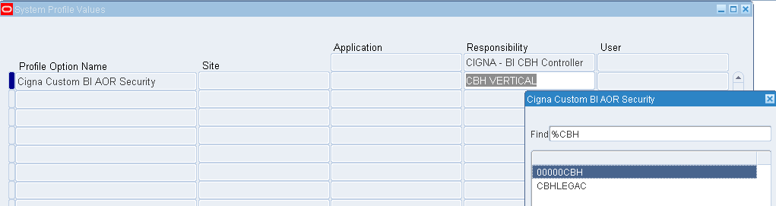

Users are assigned one or more BI AOR Security responsibilities created above thereby defining access rules for a user to expense center parents and the entire children expense center values associated with that hierarchy

**BI Security Setup:**

Involves an IB which pulls the Expense Center Wids related to the child Expense Centers that are pulled as per the Parent values set up in the EBS profiles. This is then applied as a data filter , whenever any user queries the Preallocation Logical fact table in the BMM layer.

**Initialization Block:**

**Name:** Cigna AOR Hierarchy Based Security

|  |  |
| --- | --- |
| **Properties** | **Values** |
| Disabled | Unchecked |
| Allow Deferred Execution | Checked |
| Connection Pool | Oracle Data Warehouse."Oracle Data Warehouse Repository Initblocks Connection Pool" |
| Query | SELECT DISTINCT 'WC_AOR_EC_SECURITY_DW', Wg5.Gl_Segment_Wid  FROM Applsys.Fnd_Profile_Option_Values@Ebs1213.World@Dsn_1 Fpov, Wc_Gl_Segment5_Dh_Mv_Dist Wg5  WHERE Fpov.Application_Id = 0  AND Fpov.Level_Id = 10003 -- responsibility level  AND EXISTS  ( SELECT 1  FROM Apps.Fnd_User_Resp_Groups_all@Ebs1213.World@Dsn_1 Fur, Applsys.Fnd_User@Ebs1213.World@Dsn_1 Fu, Applsys.Fnd_Profile_Options@Ebs1213.World@Dsn_1 Fpo  WHERE Fur.Start_Date <= TRUNC (SYSDATE)  AND NVL (Fur.End_Date, SYSDATE) >= TRUNC (SYSDATE)  AND Fur.User_Id = Fu.User_Id  AND Fu.User_name ='VALUEOF(NQ_SESSION.USER)'  AND Fpov.Level_Value = Fur.Responsibility_Id  AND Fpov.Profile_Option_Id = Fpo.Profile_Option_Id  AND Fpo.Profile_Option_Name = 'XXC_BI_AOR_SECURITY')  AND Fpov.Profile_Option_Value = Wg5.X_Parent_Code |
| Target | Row Wise Initialization |
| Execution Precedence | EBS Security Context, EBS Single Sign-On Integration |

**Variable:**

|  |  |
| --- | --- |
| Name | WC_AOR_EC_SECURITY_DW |
| Default Value | ‘-4’ |

**Data Filter:**

|  |  |
| --- | --- |
| Application Role | Cigna Pre-Allocated Expense Analyst role |
| Layer | Business Model and Mapping |
| Name | "Core"."Fact - AP Unpaid Invoice" |
| Status | Enabled |
| Data Filter | "Core"."Fact - AP Unpaid Invoice"."Expense Center Wid" = VALUEOF(NQ_SESSION."WC_AOR_EC_SECURITY_DW") |

|  |  |
| --- | --- |
| Application Role | Cigna Pre-Allocated Expense Analyst role |
| Layer | Business Model and Mapping |
| Name | "Core"."Dim - AP Unpaid Invoice Detail" |
| Status | Enabled |
| Data Filter | "Core"."Dim - AP Unpaid Invoice Detail"."Expense Center Wid" = VALUEOF(NQ_SESSION."WC_AOR_EC_SECURITY_DW") |

**Object Permissions**

|  |  |
| --- | --- |
| Application Role | Cigna Pre-Allocated Expense Analyst role |
| Type | Presentation Layer |
| Name | “Cigna Financials – AP Unpaid Invoice” |
| Read | Enabled (Select Radio Button) |

# Performance

## Performance Considerations/Requirements

Any request created using this subject area is supposed to run within 20 minutes. A timeout limit has been set for the Application role ‘Cigna Pre-Allocated Expense Analyst’ for a maximum of 20 minutes.

## Stress Test

N/A

## Loading Timing/Benchmarking

# Open and Closed Issues

1. Add open issues that you identify while writing or reviewing this document to the open issues section. As you resolve issues, move them to the closed issues section and keep the issue ID the same. Include an explanation of the resolution.  
     
   When this work product is complete, any open issues should be transferred to the project- or process-level Issue Log (Manage focus area) and managed using a project level Issue Form (Manage focus area). In addition, the open items should remain in the open issues section of this work product, but flagged in the resolution column as being transferred.

## Open Issues

| **ID** | **Issue** | **Resolution** | **Responsibility** | **Target Date** | **Impact Date** |
| --- | --- | --- | --- | --- | --- |
| 1 | N/A | N/A | N/A | N/A | N/A |

## Closed Issues

| **ID** | **Issue** | **Resolution** | **Responsibility** | **Target Date** | **Impact Date** |
| --- | --- | --- | --- | --- | --- |
| N/A | N/A | N/A | N/A | N/A | N/A |