OUM

DS.140 Design Specification

Cigna Corporation

BI-ETL-0007 ODI Unpaid Invoices ETL Technical Requirements

Author: Venkat Jaligama

Creation Date: July 27,2016

Last Updated: July 27,2016

Document Ref: Unpaid Invoices

Version: 1.0

1. **Title, Subject, Last Updated Date, Reference Number**, **and** **Version** are marked by a Word Bookmark so that they can be easily reproduced in the header and footer of documents. When you change any of these values, be careful not to accidentally delete the bookmark. **You can make bookmarks visible by selecting the Office Button>Word Options>Advanced> and checking the Show bookmarks option in the Show document content region.**

**Approvals:**

|  |  |
| --- | --- |
| Vinay Pachika |  |

1. To add additional approval lines, press [Tab] from the last cell in the table above.



1. You can delete any elements of this cover page that you do not need for your document.

# Document Control

## Change Record

5

| Date | Author | Version | Change Reference |
| --- | --- | --- | --- |
| 27-July-16 | Venkat J | 1.0 | ODI Unpaid Invoices Components |

## Reviewers

| Name | Position |
| --- | --- |
| Jagan Devara | Onsite |
|  |  |
|  |  |
|  |  |

## Distribution

| Name | Position |
| --- | --- |
| Vinay Pachika | Cigna |
| Viswam Nair | Cigna |
|  |  |
|  |  |

Contents

1 Document Control 2

1.1 Change Record 2

1.2 Reviewers 2

1.3 Distribution 2

2 Business Overview 4

2.1 Assumptions 4

2.2 Risks & Issues 5

2.3 Referential Documents 5

2.4 Definitions and Acronyms 5

3 Functional Requirements 6

4 Technical Overview 7

5 ELT Overview 8

5.1 Database Tables & Models in ODI: 8

5.2 Data Lineage/Mapping 8

5.3 Custom Components 9

5.4 ODI Code Changes: 9

5.4 Data Model 10

6 Open and Closed Issues 11

6.1 Open Issues 11

6.2 Closed Issues 11

1. To update the table of contents, put the cursor anywhere in the table and press [F9]. To change the number of levels displayed, select the menu option Insert‑>Index and Tables, make sure the Table of Contents tab is active, and change the Number of Levels to a new value.

# Business Overview

As part of the Building Financial Foundations project, Oracle Enterprise Business Suite (EBS) R12 was implemented / upgraded in an effort to modernize the overall accounting and financial reporting process. Reporting for the General Ledger (GL), Accounts Payable (AP), Fixed Assets (FA) and Accounts Receivable (AR) were developed in Discoverer.

To build upon the current reporting, the Expense Redesign projects plans to implement Business Intelligence (BI) to:

* Integrated systems and reporting tools to automate business processes and better insight into data resulting in time and cost savings
* Self-Service Business Intelligence to aid timely and intelligent business decisions by providing trustworthy and relevant and timely access to data
* Build a solid foundation for future reporting needs, including management reporting and analytics. Replace older reporting tools with modern and more effective integrated reporting technologies
* Provide a platform for analytical and operational reporting
* Adhoc reporting with drilldown and dashboard capabilities
* Extend the current operational reporting capabilities
* Enhance analytical, real time, metadata reporting capabilities

Business Intelligence reporting will be standardized on the Oracle Business Intelligence Enterprise Edition (OBIEE) platform. Oracle Business Intelligence Application (OBIA) will be implemented to provide GAAP, STAT, MLR reporting, extend analysis capabilities, and provide operating expense reporting to various areas in the Finance community.

Pre-allocation expenses transactions reside in the custom area of Oracle EBS. Out of the box OBIA ETL do not bring them into OBIA data warehouse or BI. So custom extract transform, load procedures need to be designed and built to bring these data into OBIA data warehouse, to enable further BI analytical reporting on pre-allocated expenses data.

This document describes the functional requirements, source of data elements, logic and flow of the Extract, Transform and Load (ETL) process.

Unpaid Invoices:

* + **Upon AP Close, Controllers must identify transactions that have been recorded but, as of the day of close, have not yet been posted. These records have a Posted Indicator of N and therefore are not brought into the BI Data Warehouse via any out of the box or existing ETL processes, which all only bring in data with a Posted Indicator of Y.**
  + ETL should pick transactions that are Unpaid as of the day of AP Close

## Assumptions

* If we do a full load on OOB, then all the historical data in Unpaid Invoices Fact table will be truncated and after the full load Fact table will have snapshot of latest AP close period(as on Full load date).

Please see below for the confirmation email from John on the same:

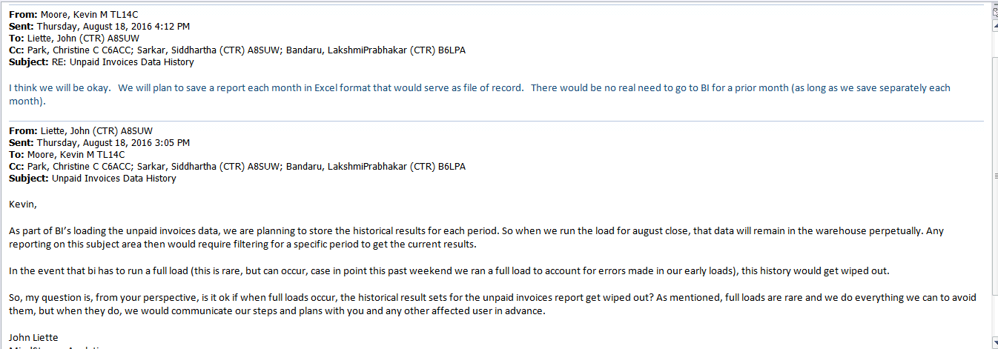

* Below are the few exceptions that we have considered during the dev phase and see John’s reply for the same.
  + - * 1. If AP close gets delayed. Lets say, AP closed on the night of July 28th after 11:30PM, but by that time ETL load started.
        2. If the ODI Job failed on July 28th run and load resumed only on 29th after noon. Unpaid invoices will have a snapshot of that day.

John’s Reply for the above exceptions:

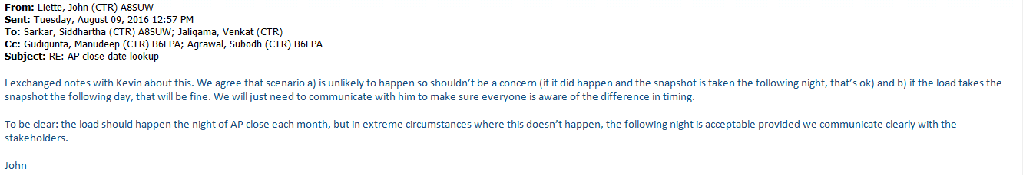

* In case of above case-b scenario, Production support team has to communicate the same to the business.
* Data quality issues if any will be handled by the source system (EBS).

## Risks & Issues

|  |  |  |  |
| --- | --- | --- | --- |
| **ID** | **Risk/Issue** | **Probability**  **(H/M/L)** | **Mitigation** |
|  |  |  |  |
|  |  |  |  |

## Referential Documents

The following document is the Functional document and requirements:

Unpaid Invoices:

https://centralhub.cigna.com/project/epms13058/Expense%20Reporting/Design/Reporting/Functional%20Specs/ETL/BI-ETL-0007_FS_RD-140_Unpaid_Invoices_ETL.docx

## Definitions and Acronyms

|  |  |
| --- | --- |
| **Key Word** | **Meaning** |
| OBIEE | Oracle Business Intelligence Enterprise Edition |
| OOB | Out Of The Box |
| RPD | Repository File |
| ETL | Extract, Transform and Load |
| BI | Business Intelligence |
| OBAW / DW | OBIA Data warehouse |
| EBS R12 | Oracle E-Business Suite Release 12 |
| OBIA | Oracle Business Intelligence Applications |

# Functional Requirements

* Unpaid Transactions must be made available for reporting via BI in their own subject area, not within any existing subject area.
* This load must only be ran on the night of AP Close and not any other day.
* This data should be appended to the table. Records should not be updated in following loads, but a user must be able to view records that were Unpaid as of AP Close of each month.
* Any failures in ETL need to be alerted via email to the support team and fixed as soon as possible. Partial load is not acceptable.
* Business user friendly and configurable value sets and lookups on the source system side need to be implemented as needed to avoid hard coding of filter criteria and conditions during extract.
* Custom ETL code should strictly follow and mimic out of the box ETL coding standards and best practices.

# Technical Overview

* ETL should pick transactions that are Unpaid as of the day of AP Close.
* This load must only be ran on the night of AP Close and not any other day.This data should be appended to the table. Records should not be updated in following loads, but a user must be able to view records that were Unpaid as of AP Close of each month

|  |  |
| --- | --- |
| Folder Name | CUSTOM_SDE_Adaptor |
| Sub Folder | SDE_WC_Stage_UnPaid_InvoiceFact |
| Package Name | SDE_WC_Stage_Unpaid_Invoices |
| Scenario Name | SDE_WC_STAGE_UNPAID_INVOICES |
| Procedure | Prc_Load_Unpaid_Invoices |
| Variables | GET_PERIOD_CLOSE_DATE, GET_AP_CLOSING_PERIOD, CHECK_UNPAID_INV_LOADED |

|  |  |
| --- | --- |
| Folder Name | CUSTOM_SILOS |
| Sub Folder | SIL_WC_AP_UnPaid_Invoices_F |
| Package Name | SIL_WC_AP_UNPAID_INVOICES_F |
| Scenario Name | SIL_WC_AP_UNPAID_INVOICES_F |
| Interfaces | SIL_WC_AP_UNPAID_INVOICES_F |
| Variables |  |

# ELT Overview

## Database Tables & Models in ODI:

Create the new table WC_AP_UNPAID_INV_FS, WC_AP_UNPAID_INV_F db.

List of tables or view created for this change as below:

|  |  |  |
| --- | --- | --- |
| Script Name | Description | Schema |
| Wc_unpaid_inv.sql | This script is used to create wc_ap_unpaid_inv_fs and wc_ap_unpaid_inv_f tables | <DW_SCHEMA> |

**Model Changes:**

Reverse engineer the below tables

|  |  |
| --- | --- |
| Folder Name | Oracle BI Applications |
| Sub Folder | Dimension, Dimension Stage |
| Table | Wc_ap_unpaid_inv_fs,wc_ap_unpaid_inv_f |
| Change Description | Add new tables to the ODI repository |

## Data Lineage/Mapping

Please refer to the following Paths Excel document for the EBS Data Sources, Staging table Mappings for both Fact and Dimensions, and final Target table mappings:



## Custom Components

Please refer the list of the custom objects used for this change(DB tables, and ODI components).



## ODI Code Changes:

**SDE code changes:**

Step-1: Get the AP Period close date, Closing Period and check if the Data is already loaded into w_ap_unpaid_inv_f table. If data is already loaded into Fact, then don’t proceed with the Data load. If data is not loaded into the Fact then proceed with the below procedure, which loads the data into FS.

Step-2: In SDE step, by using a procedure, use the given SQL(Attached in FD) and load the Staging table(FS).

**SIL Code changes:**

Create a new Interface WC_AP_UNPAID_INV_F which loads the data from WC_AP_UNPAID_INV_FS into fact.

**Lookup Condition:**

WC_AP_UNPAID_INV_FS.AP_CLOSE_DATE=to_char(W_MCAL_DAY_D.MCAL_DAY_DT,'MM/DD/YYYY')

AND W_MCAL_DAY_D.MCAL_CAL_NAME ='CIGNA_CORPORATE'

WC_AP_UNPAID_INV_FS.REQUESTOR=WC_PREALLOC_USERS_D.PERSON_FULL_NAME

WC_AP_UNPAID_INV_FS.VENDOR_NUMBER=W_PARTY_D.SUPPLIER_NUM

AND WC_AP_UNPAID_INV_FS.DATASOURCE_NUM_ID=W_PARTY_D.DATASOURCE_NUM_ID

WC_AP_UNPAID_INV_FS.EXPENSE_CENTER=W_GL_SEGMENT_D1.SEGMENT_VAL_CODE

AND WC_AP_UNPAID_INV_FS.DATASOURCE_NUM_ID=W_GL_SEGMENT_D1.DATASOURCE_NUM_ID

AND W_GL_SEGMENT_D1.SEGMENT_LOV_ID='#GL_Segment5_Lov_Id'

WC_AP_UNPAID_INV_FS.CREATED_BY=W_USER_D.INTEGRATION_ID

AND WC_AP_UNPAID_INV_FS.CREATION_DATE>=TO_CHAR(W_USER_D.EFFECTIVE_FROM_DT,'mm/dd/yyyy')

AND WC_AP_UNPAID_INV_FS.CREATION_DATE<TO_CHAR(W_USER_D.EFFECTIVE_TO_DT,'mm/dd/yyyy')

WC_AP_UNPAID_INV_FS.COMPANY=W_GL_SEGMENT_D.SEGMENT_VAL_CODE

AND SEGMENT_LOV_ID = '#GL_Segment1_Lov_Id' AND WC_AP_UNPAID_INV_FS.DATASOURCE_NUM_ID=W_GL_SEGMENT_D.DATASOURCE_NUM_ID

## Data Model

The following diagram represents the Star Schema Diagram for the entire process:



# Open and Closed Issues

1. Add open issues that you identify while writing or reviewing this document to the open issues section. As you resolve issues, move them to the closed issues section and keep the issue ID the same. Include an explanation of the resolution.  
     
   When this work product is complete, any open issues should be transferred to the project- or process-level Issue Log (Manage focus area) and managed using a project level Issue Form (Manage focus area). In addition, the open items should remain in the open issues section of this work product, but flagged in the resolution column as being transferred.

## Open Issues

| **ID** | **Issue** | **Resolution** | **Responsibility** | **Target Date** | **Impact Date** |
| --- | --- | --- | --- | --- | --- |
|  |  |  |  |  |  |
|  |  |  |  |  |  |
|  |  |  |  |  |  |
|  |  |  |  |  |  |

## Closed Issues

| **ID** | **Issue** | **Resolution** | **Responsibility** | **Target Date** | **Impact Date** |
| --- | --- | --- | --- | --- | --- |
|  |  |  |  |  |  |
|  |  |  |  |  |  |
|  |  |  |  |  |  |
|  |  |  |  |  |  |