Prod Support - Transition
Architecture

Document Control

Change Record
3
Date | Author | Version | Change Reference

Reviewers

Name | Position

Distribution
Name | Position

Table of Contents
Contents
1 Summary & scope 4
1.1 Audience 4
1.2 Related Documentation 4
2 Business Function 5
2.1 Business Functionality Overview 5
3 BI Requirements 6
3.1 Master Data and Hierarchies 6
3.2 Real Time Needs 6
4 BI APPS Architecture- Real Time and ETL 6
4.1 BI Architecture 6
4.2 Database Link For Real Time, Views and Materialized Views 7
4.3 DRM and BI Integration 7
4.4 Real Time 8
5 OBIA Configurations Functional (BI OOB 0001) 8
5.1 EBS Source System Tasks 8
5.2 BI Configuration Manager Tasks 9
6 OBIA Configurations Technical ETL (BI OOB 0002) 11
7 OOB Presentation Layer Changes(BI OOB 0004) 12
7.1 Block Diagram 12
7.2 Functional Description 12
7.3 Technical Approach 13
8 Conclusion 14

Summary & scope

Audience
Operations Support Resources
Onshore
- Naveen.Anabothula
- Abhishek.chattopadhyay
Offshore
- Lakshmi.supriya
- Sitharaghava.reddy

Service Delivery Manager: vinay.pachika

Related Documentation
Below link consists of all technical design documents (MD 70)

https://centralhub.cigna.com/project/epms13058/Expense%20Reporting/Forms/AllItems.aspx?RootFolder=%2Fproject%2Fepms13058%2FExpense%20Reporting%2FIT%20Delivery%2FTCS%2F04%2DMD70%20Technical%20Design%20Documents%20%28TD%29&FolderCTID=0x01200027EA7DA673F2F84DAC7482C3AB3767CF&View={FA61A862-B7FA-4A1C-A0E5-AFF744F4FC86}

Below link consists of all Functional design documents (MD 50)
https://centralhub.cigna.com/project/epms13058/Expense%20Reporting/Forms/AllItems.aspx?RootFolder=%2Fproject%2Fepms13058%2FExpense%20Reporting%2FDesign%2FReporting%2FFunctional%20Specs&FolderCTID=0x01200027EA7DA673F2F84DAC7482C3AB3767CF&View={FA61A862-B7FA-4A1C-A0E5-AFF744F4FC86}

Business Function

Business Functionality Overview
Business Intelligence reporting will be standardized on the Oracle Business Intelligence Enterprise Edition (OBIEE) platform. Oracle Business Intelligence Application (OBIA) will be implemented to support GAAP, STAT, MLR reporting, extend analysis capabilities, and provide operating expense reporting to various areas in the Finance community.
Replace order reporting tools with modern and more effective integrated reporting technologies, analytical and operational reporting & Adhoc, drill and dashboard capabilities.

Reporting – Current State
Oracle Discoverer is used as reporting tool by Oracle EBS it is all Real time, no ETL or other is involved as it is directly hitting transactional system where it is having limited flexibility and tuning capabilities and the same for CES and Hyperion Planning
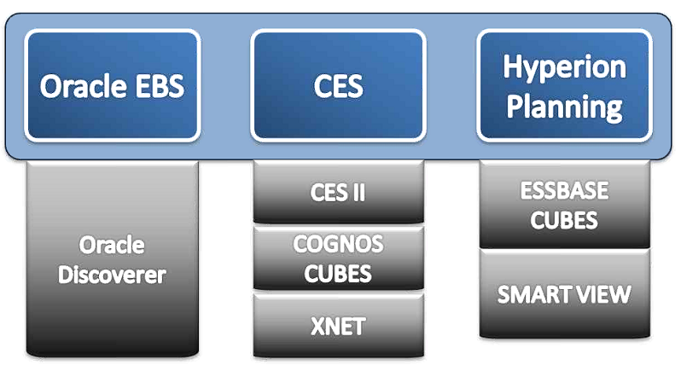

Reporting – Future State
All these various system would have a unified reporting tool which would be OBIEE/OBIA, ESSBASE/SMARTVIEW.
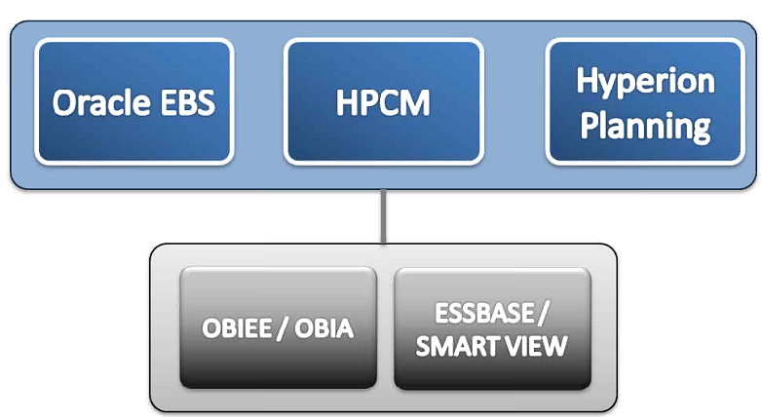

BI Requirements

Master Data and Hierarchies
- Key Dimensions in BI Reporting will include both GL and non-GL master data and hierarchies
- Oracle DRM (Data Relationship Management) helps in maintaining management data proactively across the enterprise with very less effort.
- At Cigna, DRM is the single version of truth for financial master data such as GL chart of accounts segments and GL hierarchies and other non-GL hierarchies. Pre-built adaptors between DRM => EBS and EBS => BI are available out of the box. But there is no out of the box integration option available between DRM => BI with the current release of DRM
- Hierarchies is used for Flexibility to have varied depth and contents of reporting hierarchy which may be different from the ones used for operations

Real Time Needs
- BI must meet both analytical data (day delay acceptable) and day- to-day operational reporting needs(real time/near real time)
- During period closing, real time access to relevant data is needed to prevent delays where
as other times day old snapshot of data is acceptable. So flexible refresh schedule would
be ideal.

BI APPS Architecture- Real Time and ETL

BI Architecture
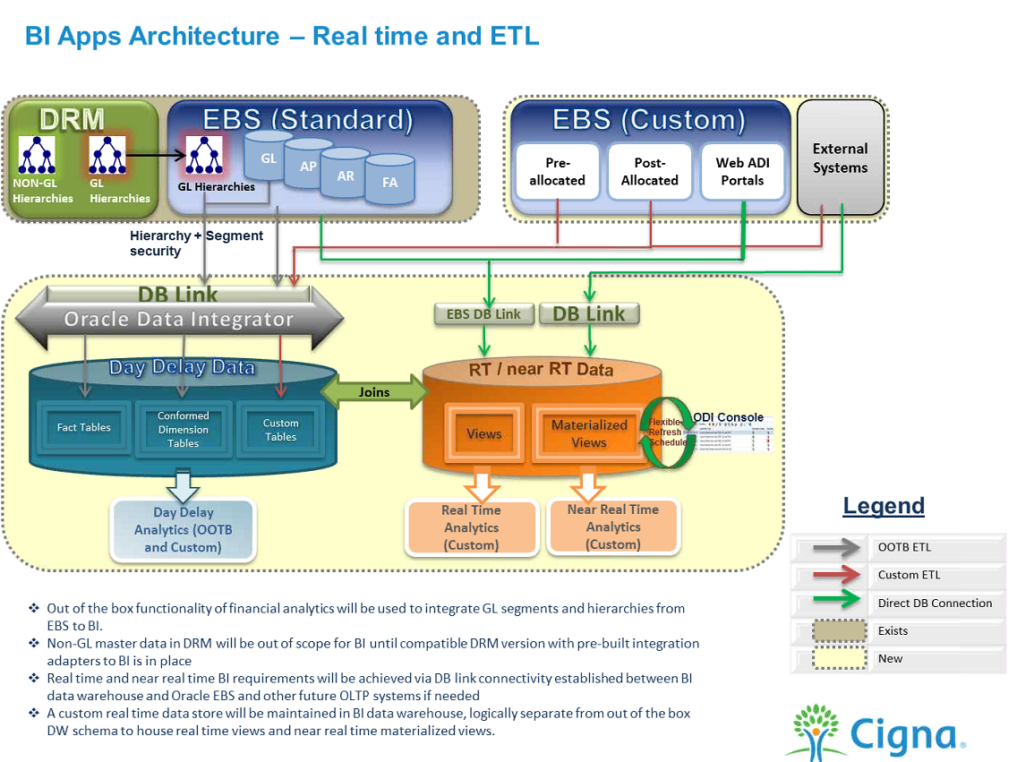

DRM
Is used as Master Data management tool, it is currently holding GL Segments that is needed by EBS.
Note: Currently we have only EBS as source system

EBS (Standard)
Holds GL hierarchies, GL, AP, AR, AP&FA

EBS (Custom)
Any custom created tables

External Scope
Out of scope (future use

DWH-DB Link
Both EBS system and OBIA infrastructure are hosted by Oracle Manage Cloud Services in the same datacenter and same network, so DB Link is the preferred way to use which would give better results like improving performance.
Note: DB Link is used for both EBS and Real Time Views and Materialized views. But Real Time will always have an impact on Transactional System so the data is limited for users to see to 3+1(quarter + one month)

Database Link for Real Time, Views and Materialized Views
- Database links offer accessing data in the remote database via direct sql statement similar to accessing DB objects in its own schema.
- With DB links, materialized views (replica /snapshot of source data such as Oracle EBS from a single point in time) can be physically stored in the BI apps data warehouse rather than the source database.BI reports then access data warehouse copy rather than the EBS source directly thereby relieving reports’ query load and network load off the source system.
- Materialized views over DB link connection to source systems offer merging and consolidating data from various systems In consistent point of time fashion for reliable reporting.
- Similarly creation of views in BI apps data warehouse over DB link help real time source system to be joined with other source system data or day delay data within the data warehouse and also relieve physical space needed in the source systems database.

DRM and BI Integration
- Integrate GL segments and hierarchies from EBS to BI Apps via out the box solution
- As there are no immediate business requirements around non-GL master data wait till next release of DRM and align DRM upgrade project timelines to take advantage of the pre-built adapter from oracle.

Real Time
- Establish database links between source systems and BI data warehouse database.
- Maintain real time data store at BI data warehouse database rather than at source systems’ database.

OBIA Configurations Functional (BI OOB 0001)
As part of the Building Financial Foundations project, Oracle Enterprise Business Suite (EBS) R12 was implemented / upgraded in an effort to modernize the overall accounting and financial reporting process. Reporting for the General Ledger (GL), Accounts Payable (AP), Fixed Assets (FA) and Accounts Receivable (AR).

EBS Source System Tasks

File Used to Configure ETL Setup
Oracle GL Accounts to Group Account Numbers
- The Data in this file is used to Map the Oracle EBS Natural accounts to BI Group accounts which help in reconciling sub-ledger transactions and this transactions are used by BI Reports to display financial statements.
File Used: file_group_acct_codes_ora.csv
- Configure GL Account and GL Segments
Code-combinations and segments which are used in EBS are handled in this file. Cigna maintains 3 types of ledgers (GAAP, STAT & MLR) and 19 segments in which 10 segments are default and the remaining 9 segments are built as per the standard procedure given by Oracle.
File Used: file_glacct_segment_config_ora.csv
- Configure Asset Category Dimension
Key setup’s like major and minor category used for Assets has been used in this file
File Used: file_fa_category_segment_config_ora.csv
- Configure the Asset Location
In Detail data like value set ID for the segments has been used in this file
File Used: file_fa_location_segment_config_ora.csv
- Configure GL Account hierarchy based on FSG Row Sets
Value set based Hierarchy is used in CIGNA, which describes how we define natural accounts/every segment
File Used: file_gl_hierarchy_assignment_ora.csv
Note:
- Mainly all Cigna accounts are run by Parent values which are used in reporting to pull the child values.
- All these files we have custom ETL path location newly created and registered with BICM (there is standard ETL path location but oracle recommends custom path)
- Mostly the changes are made to mapping file (file_group_acct_codes_ora.csv) whenever natural accounts are created, so that should be taken backup and the replace it in configuration manager.

BI Configuration Manager Tasks

Register Source System (TCGI3I)
The below screenshot explains what is the source system, Target system used for extracting & loading with environment configuration details.
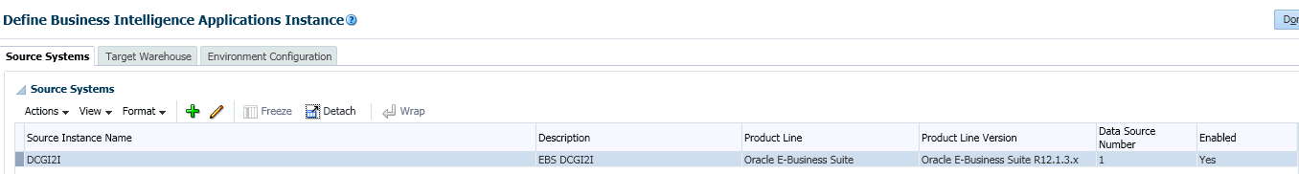

Enable OBIA Offerings (Financial Analytics)
Below screenshot explains what all the offerings that are enabled for CIGNA in Oracle Financial Analytics
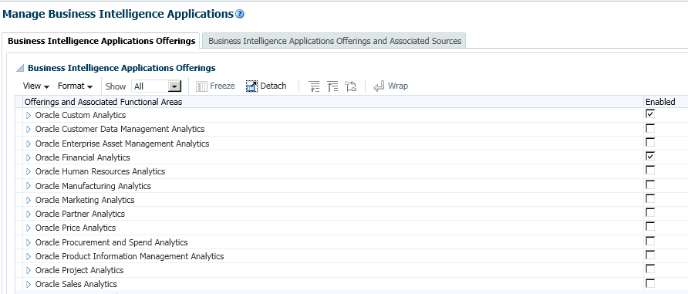
In Oracle Financial Analytics total 8 offereings are enabled ( Accounts Payable, Accounts Receivable, Employee Expense(EBS not uses EE so it not actively used), Fixed assets, General Ledger, Profitablity, Subledger Accounting and Custome Functional Area for Custom Content are enabled)
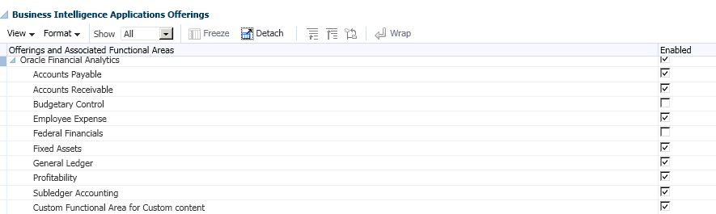

Currencies
In the below screen shot we can see only Document currency code has been modified to Entered Currency.
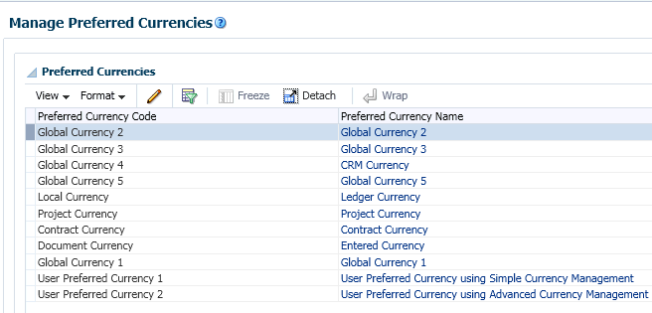

Languages
Language that is enabled for CIGNA is American English
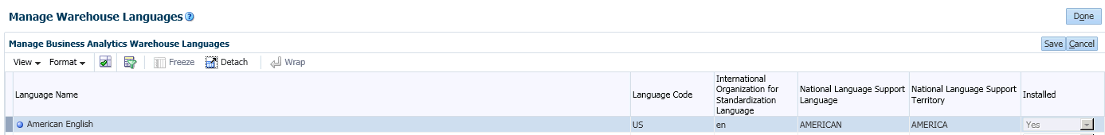

OBIA Configurations Technical ETL (BI OOB 0002)
Most of the configurations are default, below are the minimal changes that are done from ETL
- Configure Slowly changing Dimension is set to YES(Y)
- ETL extract Date is set to 01-01-2015
- Prune Days is set to 1
- DB Link is also set in DEV(not in production)
- Initial extract date set to 01-MAR-2014 (same as UAT)
Note:
- Can’t be changed, if needs to be changed it should be done from EBS side with full load.
- Two patches has been applied to ODI (ODI Patch for Bug 17530431& ODI Patch for Bug 1998808.1)

OOB Presentation Layer Changes (BI OOB 0004)
Reporting for the General Ledger (GL), Accounts Payable (AP), Fixed Assets (FA) and Accounts Receivable (AR) were developed in OBIEE applications as part of the Financial Analytics. Oracle Business Intelligence Application (OBIA) will be implemented to support GAAP, STAT, MLR reporting, extend analysis capabilities, and provide operating expense reporting to various areas in the Finance community.
The OOB capability in OBIEE applications supports 10 GL segments which are generic. This need to be customized to Cigna’s set of GL segments to enable a more user friendly interface. The number of segments also needs to be extended to 19 GL segments in total, spanning the 3 Ledgers

Block Diagram
Oracle R12
General Ledger
GAAP
STAT
MLR
Oracle BI / OBIA
Analysis/Dashboard

OOB GL Segments (1-10)
New GL Segments Created (11-19)
Parent Node Column for GL Segments (1-5)
Posted
Transactional Source Systems,
CES/HPCM
Oracle Sub-Ledgers
Summary

Functional Description
Cigna has three primary ledgers namely GAAP(Generally Accepted Accounting Principles), STAT(Statutory) and MLR (Medical Loss Ratio). Each ledger is associated with a different Chart of Accounts with some common segments and common value sets. This report must leverage the R12 CoA values to publish the result.

Table Chart of Accounts by Ledger
Segment Name | Length | Description/Usage | GAAP/ MGT | Stat | MLR
Company | 5 | Represents a CIGNA defined entity; includes legal entities | ✓ | ✓ | ✓
Product | 5 | Represents the various products and services CIGNA sold and the external division or branch of business that business is reported as | ✓ | ✓ | ✓
Prime | 5 | Represents accounts to meet summary GAAP or STAT (including MLR) requirements | ✓ | ✓ | ✓
Sub-Prime | 5 | Distinguishes certain activity within a prime account; provides further detail of what activity is within a prime account; includes Bank accounts | ✓ | ✓ | ✓
Expense Center | 8 | Represents source system identifier, as well as categorizes all the enterprise expense data | ✓ | ✓ | ✓
Affiliate | 5 | Represents another CIGNA entity’s Company Code; the trading partner with the Company | ✓ | ✓ | ✓
Reinsurance Indicator | 2 | Designates if there is reinsurance activity, and if so what kind of contract was entered into | ✓ | ✓ | ✓
Funding Type | 2 | Represents the combination of funding and rating arrangement type; identifies the funding mechanism chosen by a customer for each product sold | ✓ | ✓ | ✓
Business Segment | 3 | Represents the combination of client size and sales geography, as defined by the business | ✓
Lead Medical Funding | 2 | Represents the funding type of the largest population of membership associated with all medical products sold to a client | ✓
Stat LOB | 4 | Values represent different product groupings as defined by STAT reporting |  | ✓ | ✓
MLR Segment | 4 | Identifies ranges of client size for MLR reporting. |  | ✓ | ✓
Residence Location | 5 | Residence identifier of the customer |  | ✓ | ✓
Contract Situs | 5 | State identifier of the contract |  | ✓ | ✓
MLR Filing Type | 2 | Categorizes data for various regulatory reporting to support MLR. |  |  | ✓
MLR Service Year | 4 | Represents the service year or coverage period for MLR reporting |  |  | ✓
MLR QI Indicator | 2 | Indicator to identify non-medical expenses that improve health outcomes |  |  | ✓
Future 1 | 6 | Reserved for future use | ✓ | ✓ | ✓
Future 2 | 4 | Reserved for future use | ✓ | ✓ | ✓

Technical Approach
The high level approach for each of the requirement independently is as follows:
- GL Segment 1-10: This involves renaming the Logical Tables as well as the Presentation tables to reflect the functional requirement in RPD. LTS for the respective logical table would also need to have a filter added on the SEGMENT LOV ID (Value set ID in EBS).
- GL Segment 11-19: Creation of totally new GL segment components spanning all the 3 layers in the RPD. For every GL segment, 6 new aliases will be created for two DW tables in the physical layer and subsequently mapped to the corresponding Logical dimension table in BMM layer. One hierarchy will be created for each Logical Table and the hierarchy table columns pegged to the corresponding level in the hierarchy. This will subsequently be brought into the presentation layer and the layout of the presentation tables modified to conform to the GL segments 1-10 as already described in point 1 above.
- Parent GL Code Columns: Creation of a new presentation column which returns only the parent values within a GL segment hierarchy. When used with the respective GL segment values (Eg: Using ‘Company Parent Code’ along with ‘Company’) in Answers, this column will hold the relevant parent node. This is accomplished in the backend by creating a new materialized view on top of the existing W_GL_SEGMENT_DH hierarchy table in DW. This view pivots the flattened hierarchy stored in the OOB hierarchy table and makes it easy for OBIEE to map a 1:1 relationship between a GL segment value and all the child nodes below it in the hierarchy for different hierarchy versions. 5 such views were created for the segments: Company, Product, Prime, Sub Prime and Expense Center. These were then pulled into the RPD and added as an additional table to the corresponding LTS for the dimension in BMM layer. The parent column was then exposed in the Presentation layer for use in analysis/dashboard.

Conclusion

