Oracle BI Applications –
Financials Analytics Fixed Asset
Open Period Support for EBS

In current Oracle BI Application (OBIA) release, Fixed Asset EBS adaptor extracts transactions from closed periods once all the depreciation process and adjustments are completed. OBIA Fixed Asset does not extract transactions from open period when the transactions are not finalized or the deprecation rollback may occur, etc. This is based on the original requirements and by design.

Design Details – Data Model Changes

New Primary Extract Table W_FA_XACT_F_PE

This new table will be used during the Soft Delete process to store the primary key from OLTP source table. The data will then be used by ODI Soft Delete KM to compares with the key loaded in warehouse fact table (W_FA_XACT_F) in order to figure out which records have been deleted from OLTP source table.

Go to ODI > Models > Oracle BI Applications > Oracle BI Applications > Primary Extract folder

Create the a new PE table as below

New Table Name | New Column | Date Type | Logical Length
W_FA_XACT_F_PE | DATASOURCE_NUM_ID | NUMBER | 10
 | INTEGRATION_ID | VARCHAR2 | 80

Expand “Constraints” under this new table, and create the following constraints:

Constraint / Key Name | Key or Index Type | Columns | Flexfields tab > OBI Index Type
W_FA_XACT_F_PE | Primary Key | INTEGRATION_ID  DATASOURCE_NUM_ID | QUERY
W_FA_XACT_F_PE_U1 | Alternate Key | INTEGRATION_ID  DATASOURCE_NUM_ID | ETL

Note: you can refer to the existing AP Primary Extract table (i.e. W_AP_XACT_F_PE) as example

New Delete Table W_FA_XACT_F_DEL

This table will be used during the Soft Delete process to stores the key of the records which have been deleted from the OLTP source table.

Go to ODI > Models > Oracle BI Applications > Oracle BI Applications > Delete folder

Create the a new Delete table as below

New Table Name | New Column | Date Type | Logical Length
W_FA_XACT_F_DEL | DATASOURCE_NUM_ID | NUMBER | 10
 | INTEGRATION_ID | VARCHAR2 | 80

Expand “Constraints” under this new table, and create the following constraints:

Constraint / Key Name | Key or Index Type | Columns | Flexfields tab > OBI Index Type
W_FA_XACT_F_DEL | Primary Key | INTEGRATION_ID  DATASOURCE_NUM_ID | QUERY

Note: you can refer to the existing AP Delete table as reference (i.e. W_AP_XACT_F_DEL)

New Primary Extract Table W_FA_BALANCE_F_PE

This table will be used during the Soft Delete process to store the primary key from OLTP source table. The data will then be used to compares with the key loaded in warehouse balance fact table (W_FA_BALANCE_F) in order to figure out which records have been deleted from OLTP source table.

Go to ODI > Models > Oracle BI Applications > Oracle BI Applications > Primary Extract

Create the a new PE table as below

New Table Name | New Column | Date Type | Logical Length
W_FA_BALANCE_F_PE | DATASOURCE_NUM_ID | NUMBER | 10
 | INTEGRATION_ID | VARCHAR2 | 80

Expand “Constraints” under this new table, and create the following constraints:

Constraint / Key Name | Key or Index Type | Columns | Flexfields tab > OBI Index Type
W_FA_BALANCE_F_PE | Primary Key | INTEGRATION_ID  DATASOURCE_NUM_ID | QUERY
W_FA_BALANCE_F_PE_U1 | Alternate Key | INTEGRATION_ID  DATASOURCE_NUM_ID | ETL

Note: you can refer to the existing AP Primary Extract table (i.e. W_AP_XACT_F_PE) as example

New Delete Table W_FA_BALANCE_F_DEL

This table will be used during the Soft Delete process to stores the key of the records which have been deleted from the OLTP source table.

Go to ODI > Models > Oracle BI Applications > Oracle BI Applications > Delete

Create the a new Delete table as below

New Table Name | New Column | Date Type | Logical Length
W_FA_BALANCE_F_DEL | DATASOURCE_NUM_ID | NUMBER | 10
 | INTEGRATION_ID | VARCHAR2 | 80

Expand “Constraints” under this new table, and create the following constraints:

Constraint / Key Name | Key or Index Type | Columns | Flexfields tab > OBI Index Type
W_FA_BALANCE_F_DEL | Primary Key | INTEGRATION_ID  DATASOURCE_NUM_ID | QUERY

Note: you can refer to the existing AP Delete table as reference (i.e. W_AP_XACT_F_DEL)

Add New Column to Existing Balance Fact Staging Table W_FA_BALANCE_FS

Add the following new DELETE_FLG column in balance fact staging table in order to support Soft Delete.

Go to ODI > Models > Oracle BI Applications > Oracle BI Applications > Fact Stage folder

Open table W_FA_BALANCE_FS and add the following column

Existing Table Name | New Column | Date Type | Logical Length
W_FA_BALANCE_FS | DELETE_FLG | CHAR | 1

Add New Column to Existing Balance Fact Table W_FA_BALANCE_F

Add the following new DELETE_FLG column in balance fact table in order to support Soft Delete.

Go to ODI > Models > Oracle BI Applications > Fact folder

Open table W_FA_BALANCE_F and add the following column

Existing Table Name | New Column | Date Type | Logical Length
W_FA_BALANCE_F | DELETE_FLG | CHAR | 1

Design Details – Transaction Fact Changes

This section covers the changes in ODI mapping, load plan, RPD that are required to support the open period exaction for transaction base fact W_FA_XACT_F and the transaction aggregate fact W_FA_XACT_GRPACCT_FSCLPRD_A.

ODI Mapping Change: Remove the Close Period Filter

To extract the open period transactions, remove the “close period” filter in the existing EBS Fixed Asset SDEs.

- SDE_ORA_FixedAssetTransactionFact_Depreciation
Go to ODI > Projects > BI Apps Project > Mappings > SDE_ORA11510_Adaptor (or the corresponding OLTP Adaptor you are using)
Expand mapping SDE_ORA_FixedAssetTransactonFact_Depreciation
Open the temp interface SDE_ORA_FixedAssetTransactionFact_Depreciation.W_FA_XACT_FS_SQ_EXTRACT, go to Quick-Edit > Filters, remove the existing filter
- FA_DEPRN_PERIODS.PERIOD_CLOSE_DATE IS NOT NULL

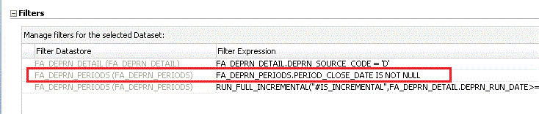

Save the change, and go to Package > Scenarios to regenerate scenario

- SDE_ORA_FixedAssetTransactionFact_Retirement
Go to ODI > Projects > BI Apps Project > Mappings > SDE_ORA11510_Adaptor (or the corresponding OLTP Adaptor you are using)
Expand mapping SDE_ORA_FixedAssetTransactonFact_Retirement
Open the temp interface SDE_ORA_FixedAssetTransactionFact_Retirement.W_FA_XACT_FS_SQ_EXTRACT, go to Quick-Edit > Joins
Open the join of FA_ADJUSTMENTS and FA_DEPRN_PERIODS
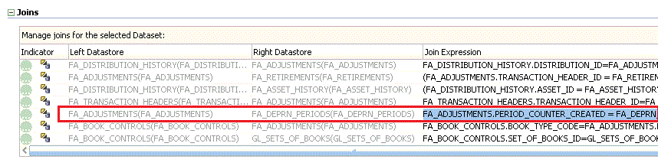
Remove the join condition
- AND FA_DEPRN_PERIODS.PERIOD_CLOSE_DATE IS NOT NULL
i.e.
Current Join
FA_ADJUSTMENTS.PERIOD_COUNTER_CREATED = FA_DEPRN_PERIODS.PERIOD_COUNTER AND
FA_ADJUSTMENTS.BOOK_TYPE_CODE = FA_DEPRN_PERIODS.BOOK_TYPE_CODE AND
FA_DEPRN_PERIODS.PERIOD_CLOSE_DATE IS NOT NULL

New Join
FA_ADJUSTMENTS.PERIOD_COUNTER_CREATED = FA_DEPRN_PERIODS.PERIOD_COUNTER AND
FA_ADJUSTMENTS.BOOK_TYPE_CODE = FA_DEPRN_PERIODS.BOOK_TYPE_CODE

Save the change, and go to Package > Scenarios to regenerate scenario

- SDE_ORA_FixedAssetTransactionFact_Utilization
Go to ODI > Projects > BI Apps Project > Mappings > SDE_ORA11510_Adaptor (or the corresponding Adaptor you are using)
Expand mapping SDE_ORA_FixedAssetTransactonFact_Utilization
Open the temp interface SDE_ORA_FixedAssetTransactionFact_Utilization.W_FA_XACT_FS_SQ_EXTRACT, go to Quick-Edit > Joins
Open the join of FA_DEPRN_PERIODS and FA_ADJUSTMENTS

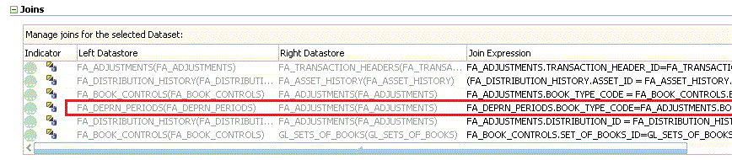

Remove the join condition
  - AND FA_DEPRN_PERIODS.PERIOD_CLOSE_DATE IS NOT NULL
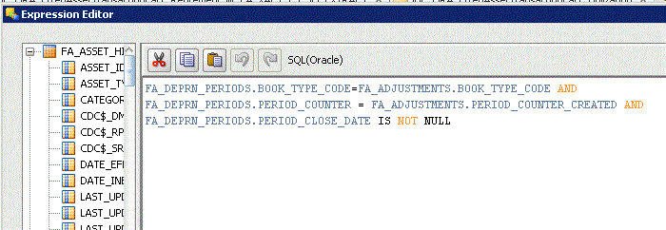
i.e.
Current Join
FA_DEPRN_PERIODS.BOOK_TYPE_CODE = FA_ADJUSTMENTS.BOOK_TYPE_CODE AND
FA_DEPRN_PERIODS.PERIOD_COUNTER = FA_ADJUSTMENTS.PERIOD_COUNTER_CREATED AND
FA_DEPRN_PERIODS.PERIOD_CLOSE_DATE IS NOT NULL

New Join
FA_DEPRN_PERIODS.BOOK_TYPE_CODE = FA_ADJUSTMENTS.BOOK_TYPE_CODE AND
FA_DEPRN_PERIODS.PERIOD_COUNTER = FA_ADJUSTMENTS.PERIOD_COUNTER_CREATED

Save the change, and go to Package > Scenarios to regenerate scenario

ODI Mapping Change: New Primary Extract SDE_ORA_FixedAssetTransactionFact_Deprn_Primary

- New Mapping SDE_ORA_FixedAssetTransactionFact_Deprn_Primary
Create a new Primary Extract (PE) Mapping SDE_ORA_FixedAssetTransactionFact_Deprn_Primary. This PE mapping will perform a full extract of the primary key (i.e. INTEGRATION_ID) and the source identifier (i.e. DATASOURCE_NUM_ID) into the primary extract table W_FA_XACT_F_PE.
Subsequently ODI SoftDelete KM will use this information to compare with the records which have been loaded into fact table, and figure out the records which have been deleted in OLTP source side.

Go to ODI > Projects > BI Apps Project > Mappings > SDE_ORA11510_Adaptor (or the corresponding OLTP Adaptor that you are using)
Create a new mapping called SDE_ORA_FixedAssetTransactionFact_Deprn_Primary
Create temp interface SDE_ORA_FixedAssetTransactionFact_Deprn_Primary.W_FA_XACT_F_PE_SQ_FA_DEPRN_DETAIL
Source: FA_DEPRN_DETAIL, FA_PERIODS, FA_BOOK_CONTROLS
Join:
Source Table to Join | Join Expression | Execute On | Join Type
FA_DEPRN_DETAIL and  FA_BOOK_CONTROLS | FA_BOOK_CONTROLS.BOOK_TYPE_CODE = FA_DEPRN_DETAIL.BOOK_TYPE_CODE | Source | Inner Join
FA_DEPRN_DETAIL and  FA_DEPRN_PERIODS | FA_DEPRN_DETAIL.BOOK_TYPE_CODE = FA_DEPRN_PERIODS.BOOK_TYPE_CODE AND  FA_DEPRN_DETAIL.PERIOD_COUNTER = FA_DEPRN_PERIODS.PERIOD_COUNTER | Source | Inner Join

In the Mappings tab, create the following column mappings:
Target Column Name | Data Type | Length | Mapping Expression
SET_OF_BOOKS_ID | NUMBER | 15 | FA_BOOK_CONTROLS.SET_OF_BOOKS_ID
ASSET_ID | NUMBER | 15 | FA_DEPRN_DETAIL.ASSET_ID
PERIOD_COUNTER | NUMBER | 15 | FA_DEPRN_PERIODS.PERIOD_COUNTER
BOOK_TYPE_CODE | VARCHAR2 | 15 | FA_DEPRN_DETAIL.BOOK_TYPE_CODE
DISTRIBUTION_ID | NUMBER | 15 | FA_DEPRN_DETAIL.DISTRIBUTION_ID

In the Flow tab, use the “IKM BIAPPS Oracle Control Append”.

Create a main interface
SDE_ORA_FixedAssetTransactionFact_Deprn_Primary.W_FA_XACT_F_PE
Target Datastore: W_FA_XACT_F_PE
Go to Quick-Edit
In the Sources tab, use above temp interface as source and use alias SQ_FA_DEPRN_DETAIL
In the Mappings tab, create the following column mappings:

Target Column Name | Data Type | Length | Mapping Expression
DATASOURCE_NUM_ID | NUMBER | 10 | #DATASOURCE_NUM_ID
INTEGRATION_ID | VARCHAR2 | 80 | 'DEPRN~'||  TO_CHAR(SQ_FA_DEPRN_DETAIL.SET_OF_BOOKS_ID)||'~'||  TO_CHAR(SQ_FA_DEPRN_DETAIL.ASSET_ID)||'~'||  TO_CHAR(SQ_FA_DEPRN_DETAIL.PERIOD_COUNTER)||'~'||  TO_CHAR(SQ_FA_DEPRN_DETAIL.BOOK_TYPE_CODE)||'~'||  TO_CHAR(SQ_FA_DEPRN_DETAIL.DISTRIBUTION_ID)

In the Flow tab, use IKM BIAPPS Oracle Control Append

- Create a new Package SDE_ORA_FixedAssetTransactionFact_Deprn_Primary. The package should have Evaluate variable steps to incorporate the following logic.

If #IS_INCREMENTAL = 'Y' AND #IS_SDS_DEPLOYED
If
(
#SOFT_DELETE_FEATURE_ENABLED = 'Y' AND
#SOFT_DELETE_PREPROCESS = 'Y'
)
RUN PE interface (i.e. SDE_ORA_FixedAssetTransactionFact_Deprn_Primary.W_FA_XACT_F_PE)
Else
Skip PE interface
End If
Else
Run "Simulate Full Load" Procedure
End If

In the Package > Diagram, create the following flow based on the above logic:

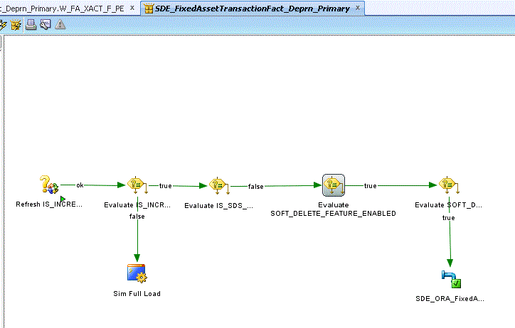

Note:
- IS_INCREMENTAL is a Package specific variable. There is no need to execute the primary extract delete process during a full load - we evaluate this variable to ensure this process only executes during initial loads.
- IS_SDS_DEPLOYED is a Fact Group specific variable. If enabled, there is no need to perform the Primary Extract part of the delete process.
- SOFT_DELETE_FEATURE_ENABLED is a load plan parameter that can be set at a per load plan run basis. Its value will not change during the Load Plan execution. If set to 'No', delete processing is not performed.
- SOFT_DELETE_PREPROCESS is a Fact Group specific variable. This variable indicates that the Primary Extract delete process should be executed. This process extracts all records from the OLTP (created after the Initial Extract Date) which can have a significant impact on the OLTP system. Due to this impact, the customer may implement an alternate system to identify deleted records and populate the _DEL table used by the delete process and thus wants to disable the Primary Extract part of the process. This variable is evaluated by both the Primary Extract process and the SIL process for processing deletes.

Save the package and generate the scenario. Named it by following the naming convention: [Adaptor Name]_[Package Name]
In this case for EBS 11.5.10 adaptor, the scenario name should be
SDE_ORA11510_ADAPTOR_SDE_ORA_FIXEDASSETTRANSACTIONFACT_DEPRN_PRIMARY
Note: every time you make changes in the interface or package, make sure you re-generate the scenario.

ODI Mapping Change: New Primary Extract SDE_ORA_FixedAssetTransactionFact_Adj_Primary

1. New Mapping SDE_ORA_FixedAssetTransactionFact_Adj_Primary
Similar to above section, here we create another new Primary Extract (PE) Mapping SDE_ORA_FixedAssetTransactionFact_Adj_Primary. This PE mapping will perform a full extract of the primary key (i.e. INTEGRATION_ID) and the source identifier (i.e. DATASOURCE_NUM_ID) into the primary extract table W_FA_XACT_F_PE.
Subsequently ODI SoftDelete KM will use this information to compare with the records which have been loaded into fact table, and figure out the records which have been deleted in OLTP source side.

Go to Go to ODI > Projects > BI Apps Project > Mappings > SDE_ORA11510_Adaptor (or the corresponding Adaptor you are using)
Create a new mapping called SDE_ORA_FixedAssetTransactionFact_Adj_Primary
Create temp interface
SDE_ORA_FixedAssetTransactionFact_Adj_Primary.W_FA_XACT_F_PE_SQ_FA_ADJUSTMENTS
Source: FA_ADJUSTMENTS
In the Mappings tab, create the following column mappings:
Target Column Name | Data Type | Length | Mapping Expression
ADJUSTMENT_LINE_ID | NUMBER | 15 | FA_ADJUSTMENTS. ADJUSTMENT_LINE_ID
TRANSACTION_HEADER_ID | NUMBER | 15 | FA_ADJUSTMENTS.TRANSACTION_HEADER_ID

In the Flow tab, use the “IKM BIAPPS Oracle Control Append”.

Create a main interface
SDE_ORA_FixedAssetTransactionFact_Adj_Primary.W_FA_XACT_F_PE
Target Datastore: W_FA_XACT_F_PE
Go to Quick-Edit
In the Sources tab, use above temp interface as source and use alias SQ_FA_ADJUSTMENTS
In the Mappings tab, create the following column mappings:

Target Column Name | Data Type | Length | Mapping Expression
DATASOURCE_NUM_ID | NUMBER | 10 | #DATASOURCE_NUM_ID
INTEGRATION_ID | VARCHAR2 | 80 | 'ADJ~'||  SQ_FA_ADJUSTMENTS.TRANSACTION_HEADER_ID||'~'||  SQ_FA_ADJUSTMENTS.ADJUSTMENT_LINE_ID

In the Flow tab, use IKM BIAPPS Oracle Control Append

2. Create a new Package SDE_ORA_FixedAssetTransactionFact_Adj_Primary. The package should have Evaluate variable steps to incorporate the following logic.

If #IS_INCREMENTAL = 'Y' AND #IS_SDS_DEPLOYED
If
(
#SOFT_DELETE_FEATURE_ENABLED = 'Y' AND
#SOFT_DELETE_PREPROCESS = 'Y'
)
RUN PE interface (i.e. SDE_ORA_FixedAssetTransactionFact_Adj_Primary.W_FA_XACT_F_PE)
Else
Skip PE interface
End If
Else
Run "Simulate Full Load" Procedure
End If

In the Package > Diagram, create the flow based on the above logic. (Same as the page in previous section for _Deprn_Primary)
Save the package and generate the scenario. Named it by following the naming convention: [Adaptor Name]_[Package Name]
In this case for EBS 11.5.10 adaptor, the scenario name should be
SDE_ORA11510_ADAPTOR_SDE_ORA_FIXEDASSETTRANSACTIONFACT_ADJ_PRIMARY
Note: every time you make changes in the interface or package, make sure you re-generate the scenario.

ODI Mapping Change: Existing Fixed Asset SIL Change

This section contains the steps to enable the Soft Delete KM Option in the SIL.
Go to ODI > Projects > BI Apps Project > Mappings > SILOS folder
Open Fixed Asset SIL mapping SIL_FixedAssetTransactionFact
Open the main interface SIL_FixedAssetTransactionFact.W_FA_XACT_F
Go to Flow tab, and in the Target Properties, set the OBI_SOFT_DELETE to true as shown in the figure below:
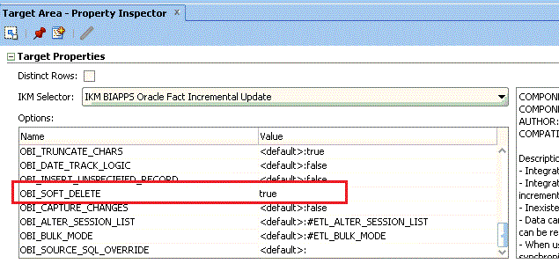
Save the change
Go to Package > Scenarios, and regenerate the scenario SILOS_SIL_FIXEDASSETTRANSACTIONFACT

ODI Mapping Change: DELETE_FLG in Existing Fixed Asset SDEs
Ensure the DELETE_FLG in the existing Fixed Asset SDEs has the right column mapping.

- SDE_ORA_FixedAssetTransactionFact_Depreciation

Open the existing SDE_ORA_FixedAssetTransactionFact_Depreciation, open to the temp interface and go to Quick-Edit.
In the Mappings section, review and make sure the DELETE_FLG has the following mapping expression

RUN_REPLICATED_TRANSACTIONAL('#IS_SDS_DEPLOYED',
'N',
CASE WHEN FA_DEPRN_DETAIL.CDC$_DML_CODE = 'D' THEN 'Y' ELSE 'N' END
)

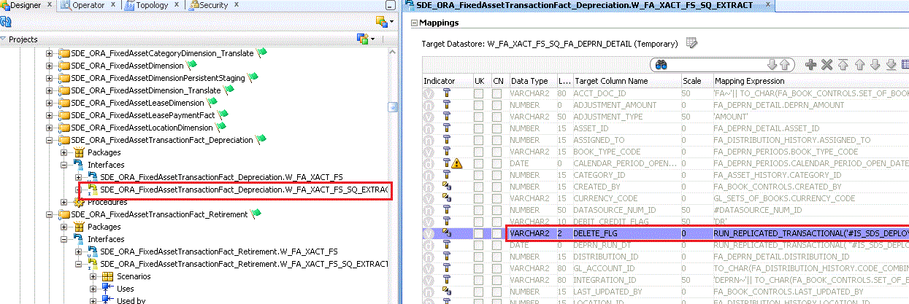

- SDE_ORA_FixedAssetTransactionFact_Retirement

Open the existing SDE_ORA_FixedAssetTransactionFact_Retirement, open to the temp interface and go to Quick-Edit.
In the Mappings section, review and make sure the DELETE_FLG has the following mapping expression

RUN_REPLICATED_TRANSACTIONAL('#IS_SDS_DEPLOYED',
'N',
CASE WHEN FA_ADJUSTMENTS.CDC$_DML_CODE = 'D' OR FA_RETIREMENTS.CDC$_DML_CODE = 'D' THEN 'Y' ELSE 'N' END
)

- SDE_ORA_FixedAssetTransactionFact_Utilization

Open the existing SDE_ORA_FixedAssetTransactionFact_Utilization, open to the temp interface and go to Quick-Edit.
In the Mappings section, review and make sure the DELETE_FLG has the following mapping expression

RUN_REPLICATED_TRANSACTIONAL('#IS_SDS_DEPLOYED',
'N',
CASE WHEN FA_ADJUSTMENTS.CDC$_DML_CODE = 'D' THEN 'Y' ELSE 'N' END
)

ODI Mapping Change: Existing Fixed Asset PLP

Make sure the existing Fixed Asset PLP has the DELETE_FLG = ‘N’ filter. This will ensure only the records with DELETE_FLG=’N’ will be aggregated into Fixed Asset Aggregation table W_FA_XACT_GRPACCT_FSCLPRD_A.

Go to ODI > Projects > BI Apps Project > Mappings > PLP folder

Open the existing Fixed Asset PLP mapping i.e. PLP_FAXactPeriod_A_Load, open to the temp interface and go to Quick-Edit.
In the Filters section, review and make sure the following filter is there:
W_FA_XACT_F.DELETE_FLG = ‘N’

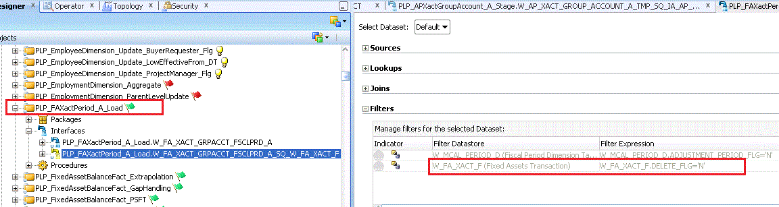

ODI Load Plan Change
This section contains the steps to add the two new Primary Extract (PE) scenarios into the existing Fixed Asset SDE load plan component. It can be set to run in parallel to the main set of scenarios for that entity.
- Go to Load Plans and Scenarios > BIAPPS Load Plan > Load Plan Dev Components > SDE > EBS_11_5_10 > Open “3 SDE Fact ASXACT_FG EBS_11_5_10” (or the corresponding Adaptor Load Plan Component you are using)
- In the “Steps”, append the two new PE scenarios at the end.

- SDE_ORA11510_ADAPTOR_SDE_ORA_FIXEDASSETTRANSACTIONFACT_DEPRN_PRIMARY
- SDE_ORA11510_ADAPTOR_SDE_ORA_FIXEDASSETTRANSACTIONFACT_ADJ_PRIMARY

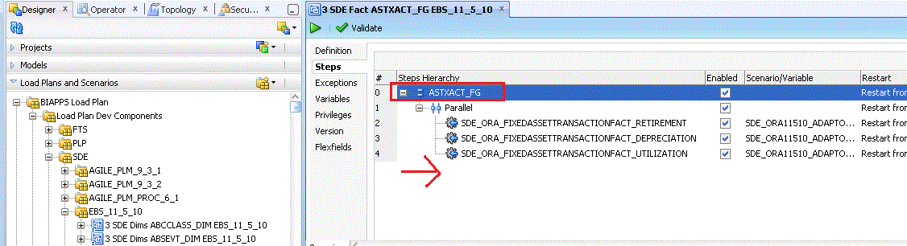

- Go to the Root Step “ASTXACT_FG” (i.e. step 0 as shown above) and make sure to refresh the variable SOFT_DELETE_PREPROCESS, i.e. check the “Refresh” checkbox as shown below.

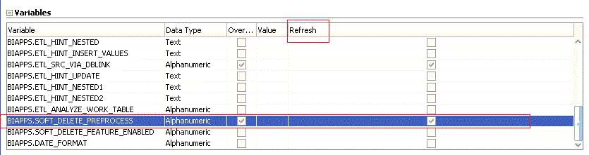
Note: you can refer to the existing SoftDelete in AP load plan component “SDE Fact APTRANS_FG EBS_11_5_10” as an example (see fig below)
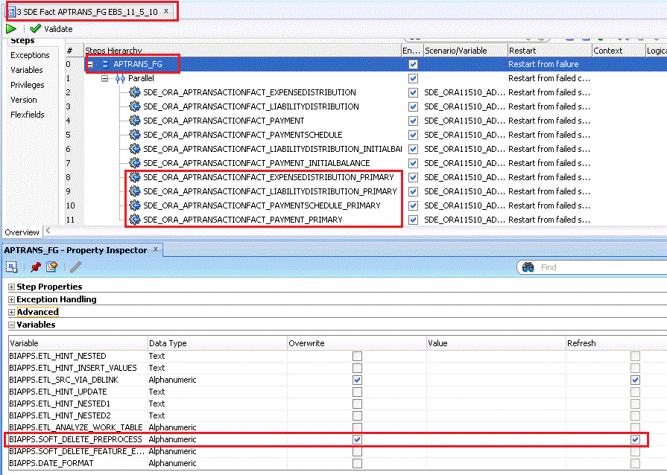

RPD Change: Logical Layer Filter DELETE_FLG = ‘N’

Make sure the RPD Logical Table Source of all Fixed Asset logical facts has the delete flag filter:
- Open your RPD using OBIEE Administration Tool.
- Go to Business Model and Mapping and open the “Fact – Fins – Asset Depreciation”
- Go to Sources, and open the logical table source “Fact_W_FA_XACT_F”
- Under Content tab, review and ensure the following filter is there
- "Oracle Data Warehouse"."Catalog"."dbo"."Fact_W_FA_XACT_F"."DELETE_FLG" = 'N'
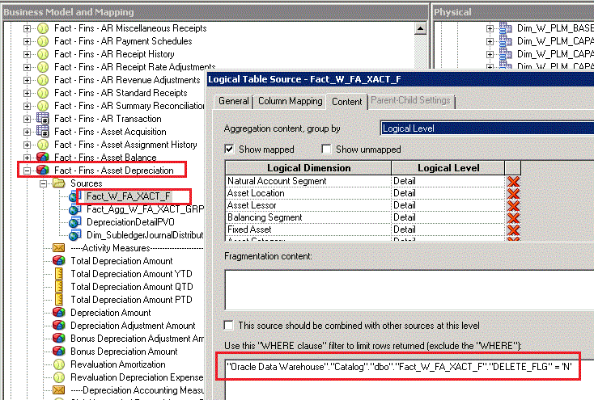

- Do the same thing above for the other Fixed Asset fact in the logical layer
- Fact - Fins - Asset Acquisition
- Fact - Fins - Asset Utilization
- Fact - Fins - Asset Retirement
- Save the RPD changes
Note: since no records with DELETE_FLG=’Y’ will be loaded into aggregate table W_FA_XACT_GRPACCT_FSCLPRD_A, there is no need to put any filter for the Aggregate Logical Table Source “Fact_Agg_W_FA_XACT_GRPACCT_FSCLPRD_A”

Design Details – Balance Fact Changes

This section covers the changes in ODI mappings, load plan, and RPD that are required to support the open period exaction for balance fact W_FA_BALANCE_F

ODI Mapping Change: Remove the Close Period Filter

To extract the open period balance information, remove the “close period” filter in the existing EBS Fixed Asset Balance SDE.

- SDE_ORA_FixedAssetBalanceFact
Go to ODI > Projects > BI Apps Project > Mappings > SDE_ORA11510_Adaptor (or the corresponding OLTP Adaptor that you are using)
Expand mapping SDE_ORA_FixedAssetBalanceFact
Open the temp interface SDE_ORA_FixedAssetBalanceFact.W_FA_BALANCE_FS_SQ_EXTRACT
Go to Quick-Edit > Filters, remove the filter
- FA_DEPRN_PERIODS.PERIOD_CLOSE_DATE IS NOT NULL

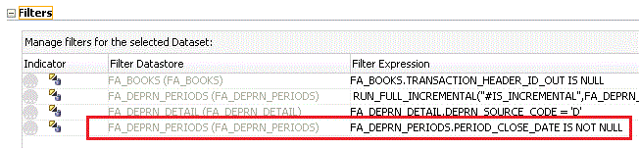

Save the change, and go to Package > Scenarios to regenerate scenario

ODI Mapping Change: New Primary Extract SDE_ORA_FixedAssetBalanceFact_Primary

New Mapping SDE_ORA_FixedAssetBalanceFact_Primary
Create a Primary Extract Mapping SDE_ORA_FixedAssetBalanceFact_Primary. This PE mapping will perform a full extract of the primary key (i.e. INTEGRATION_ID) and the source identifier (i.e. DATASOURCE_NUM_ID) into the primary extract table W_FA_BALANCE_F_PE.
Subsequently this information will be used to compare with the records which have been loaded into balance fact table (W_FA_BALANCE_F), and figure out the balance records which have been deleted in EBS OLTP source side.

Go to ODI > Projects > BI Apps Project > Mappings > SDE_ORA11510_Adaptor (or the corresponding OLTP Adaptor that you are using)
Create a new mapping called SDE_ORA_FixedAssetBalanceFact_Primary
Create temp interface SDE_ORA_FixedAssetBalanceFact_Primary.W_FA_BALANCE_F_PE_SQ_FA_DEPRN_DETAIL
Source: FA_DEPRN_DETAIL, FA_PERIODS
Join:
Source Table to Join | Join Expression | Execute On | Join Type
FA_DEPRN_DETAIL and  FA_DEPRN_PERIODS | FA_DEPRN_DETAIL.BOOK_TYPE_CODE = FA_DEPRN_PERIODS.BOOK_TYPE_CODE AND  FA_DEPRN_DETAIL.PERIOD_COUNTER = FA_DEPRN_PERIODS.PERIOD_COUNTER | Source | Inner Join

In the Mappings tab, create the following column mappings:
Target Column Name | Data Type | Length | Mapping Expression
PERIOD_NAME | VARCHAR2 | 15 | FA_DEPRN_PERIODS.PERIOD_NAME
BOOK_TYPE_CODE | VARCHAR2 | 15 | FA_DEPRN_DETAIL.BOOK_TYPE_CODE
DISTRIBUTION_ID | NUMBER | 15 | FA_DEPRN_DETAIL.DISTRIBUTION_ID

In the Flow tab, use the “IKM BIAPPS Oracle Control Append”.

Create a main interface SDE_ORA_FixedAssetBalanceFact_Deprn_Primary.W_FA_BALANCE_F_PE
Target Datastore: W_FA_BALANCE_F_PE
Go to Quick-Edit
In the Sources tab, use above temp interface as source and use alias SQ_FA_DEPRN_DETAIL
In the Mappings tab, create the following column mappings:

Target Column Name | Data Type | Length | Mapping Expression
DATASOURCE_NUM_ID | NUMBER | 10 | #DATASOURCE_NUM_ID
INTEGRATION_ID | VARCHAR2 | 80 | 'FA~'  || SQ_FA_DEPRN_DETAIL.BOOK_TYPE_CODE ||'~'  || TO_CHAR(SQ_FA_DEPRN_DETAIL.DISTRIBUTION_ID) || '~'  || SQ_FA_DEPRN_DETAIL.PERIOD_NAME

In the Flow tab, use IKM BIAPPS Oracle Control Append

- Create a new Package SDE_ORA_FixedAssetBalanceFact_Primary. The package should have Evaluate variable steps to incorporate the following logic.

If #IS_INCREMENTAL = 'Y' AND #IS_SDS_DEPLOYED
If
(
#SOFT_DELETE_FEATURE_ENABLED = 'Y' AND
#SOFT_DELETE_PREPROCESS = 'Y'
)
RUN PE interface (i.e. SDE_ORA_FixedAssetBalanceFact_Primary.W_FA_BALANCE_F_PE)
Else
Skip PE interface
End If
Else
Run "Simulate Full Load" Procedure
End If

In the Package > Diagram, create the following flow based on the above logic:

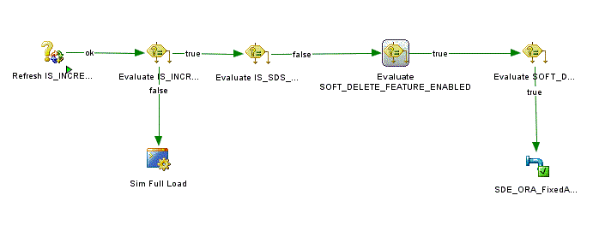

Note:
- IS_INCREMENTAL is a Package specific variable. There is no need to execute the primary extract delete process during a full load - we evaluate this variable to ensure this process only executes during initial loads.
- IS_SDS_DEPLOYED is a Fact Group specific variable. If enabled, there is no need to perform the Primary Extract part of the delete process.
- SOFT_DELETE_FEATURE_ENABLED is a load plan parameter that can be set at a per load plan run basis. Its value will not change during the Load Plan execution. If set to 'No', delete processing is not performed.
- SOFT_DELETE_PREPROCESS is a Fact Group specific variable. This variable indicates that the Primary Extract delete process should be executed. This process extracts all records from the OLTP (created after the Initial Extract Date) which can have a significant impact on the OLTP system. Due to this impact, the customer may implement an alternate system to identify deleted records and populate the _DEL table used by the delete process and thus wants to disable the Primary Extract part of the process. This variable is evaluated by both the Primary Extract process and the SIL process for processing deletes.

Save the package and generate the scenario. Named it by following the naming convention : [Adaptor Name]_[Package Name]
In this case for EBS 11.5.10 adaptor, the scenario name should be
SDE_ORA11510_ADAPTOR_SDE_ORA_FIXEDASSETBALANCEFACT_PRIMARY
Note: every time you make changes in the interface or package, make sure you re-generate the scenario.

ODI Mapping Change: New Identify Delete Mapping SIL_FixedAssetBalanceFact_IdentifyDelete

New Mapping SIL_FixedAssetBalanceFact_IdentifyDelete
Create a new IdentifyDelete Mapping SIL_FixedAssetBalanceFact_IdentifyDelete. This _IdentifyDelete mapping compares the keys in the primary extract table (W_FA_BALANCE_F_PE) with the keys in the balance fact table (W_FA_BALANCE_F). It looks for the records that exist in the balance fact W_FA_BALANCE_F but do not exist in the primary extract table W_FA_BALANCE_F_PE. Those records are then loaded into the W_FA_BALANCE_F_DEL table.
Subsequently, the other soft delete mapping _SoftDelete will take the info in this _DEL table and mark these records as deleted in the balance fact i.e. set the DELETE_FLG of these records in the balance fact W_FA_BALANCE_F to ‘Y’.

Go to ODI > Projects > BI Apps Project > Mappings > SILOS
Create a new mapping called SIL_FixedAssetBalanceFact_IdentifyDelete
1. Under this mapping, create a Temp interface
SIL_FixedAssetBalanceFact_IdentifyDelete.W_FA_BALANCE_F_DEL_SQ_W_FA_BALANCE_F_PE

Target Datastore: SQ_W_FA_BALANCE_F_PE
Sources:
- W_FA_BALANCE_F: use alias TARGET_TABLE
- W_FA_BALANCE_F_PE: use alias PE_STAGE_TABLE
Joins:
- Left Datastore: TARGET_TABLE (i.e. W_FA_BALANCE_F)
- Right Datastore: PE_STAGE_TABLE (i.e. W_FA_BALANCE_F_PE)
- Join Expression:
TARGET_TABLE.INTEGRATION_ID=PE_STAGE_TABLE.INTEGRATION_ID AND TARGET_TABLE.DATASOURCE_NUM_ID=PE_STAGE_TABLE.DATASOURCE_NUM_ID
- Join Type: Left Outer Join

Filters:

Filter Datastore | Filter Expression
TARGET_TABLE | TARGET_TABLE.DELETE_FLG='N'
TARGET_TABLE | TARGET_TABLE.CREATED_ON_DT>TO_DATE_VAR('#LAST_ARCHIVE_DATE')
TARGET_TABLE | TARGET_TABLE.X_CUSTOM = '0' (**)
(**) Customer like Google, Inc. has implemented additional logic to create additional balance records in w_fa_balance_f. And these custom records (i.e. Extrapolation and Gap filling records are having x_custom populated as NEW or GAP). SoftDelete process should exclude these additional NEW/GAP records.

Mappings:
Create the following column mappings:
Target Column Name | Data Type | Length |  | Mapping Expression
DATASOURCE_NUM_ID | NUMBER | 10 |  | TARGET_TABLE.DATASOURCE_NUM_ID
INTEGRATION_ID | VARCHAR2 | 80 |  | TARGET_TABLE.INTEGRATION_ID
PE_DATASOURCE_NUM_ID | NUMBER | 10 |  | PE_STAGE_TABLE.DATASOURCE_NUM_ID
PE_ INTEGRATION_ID | VARCHAR2 |  | 80 | PE_STAGE_TABLE.INTEGRATION_ID
In the Flow tab, use the “IKM BIAPPS Oracle Control Append”.

- Now, create a main interface SIL_FixedAssetBalanceFact_IdentifyDelete.W_FA_BALANCE_F_DEL
Target Datastore: W_FA_BALANCE_F_DEL
Sources: SQ_W_FA_BALANCE_F_PE
Go to Quick edit, expand Sources , Check Sub-select check box
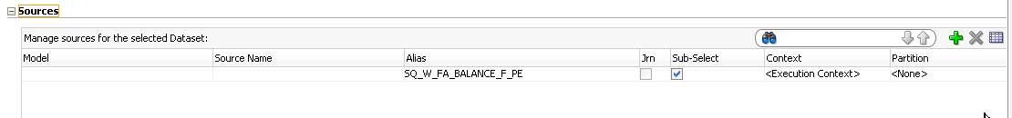

Filters:

Filter Datastore | Filter Expression
PE_STAGE_TABLE | SQ_W_FA_BALANCE_F_PE.PE_INTEGRATION_ID IS NULL
PE_STAGE_TABLE | SQ_W_FA_BALANCE_F_PE.PE_DATASOURCE_NUM_ID IS NULL

Mappings:
Create the following column mappings:
Target Column Name | Data Type | Length | Mapping Expression
DATASOURCE_NUM_ID | NUMBER | 10 | SQ_W_FA_BALANCE_F_PE.DATASOURCE_NUM_ID
INTEGRATION_ID | VARCHAR2 | 80 | SQ_W_FA_BALANCE_F_PE.INTEGRATION_ID

In the Flow tab, use the “IKM BIAPPS Oracle Control Append”.

- Create a new Package SIL_FixedAssetBalanceFact_IdentifyDelete. The package should have Evaluate variable steps to incorporate the following logic.

If #IS_INCREMENTAL = 'Y'
RUN Delete interface (i.e. SIL_FixedAssetBalanceFact_IdentifyDelete.W_FA_BALANCE_F_DEL)
Else
Run "Simulate Full Load" Procedure
End If

In the Package > Diagram, create the following flow based on the above logic:
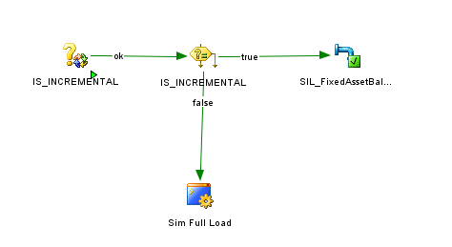
Save the package and generate the scenario. Named it by following the naming convention: [Adaptor Name]_[Package Name]
SILOS_SIL_FIXEDASSETBALANCEFACT_IDENTIFYDELETE
Note: every time you make changes in the interface or package, make sure you re-generate the scenario.

ODI Mapping Change: New SoftDelete Mapping SIL_FixedAssetBalanceFact_SoftDelete

New Mapping SIL_FixedAssetBalanceFact_SoftDelete
Create a new SoftDelete Mapping SIL_FixedAssetBalanceFact_SoftDelete. This mapping refers to W_FA_BALANCE_F_DEL table and mark the corresponding records in W_FA_BALANCE_F as deleted i.e. set the DELETE_FLG of the records in balance fact to ‘Y’

Go to ODI > Projects > BI Apps Project > Mappings > SILOS
- Create a new mapping called SIL_FixedAssetBalanceFact_SoftDelete
- Under this mapping, create a temporary interface SIL_FixedAssetBalanceFact_SoftDelete.W_FA_BALANCE_F_SQ_W_FA_BALANCE_F_DEL
Target Datastore: SQ_W_FA_BALANCE_F_DEL
Sources: W_FA_BALANCE_F_DEL
Mappings:
Map the following columns:
Target Column Name | Mapping Expression
DELETE_FLG | ‘Y’
DATASOURCE_NUM_ID | W_FA_BALANCE_F_DEL.DATASOURCE_NUM_ID
INTEGRATION_ID | W_FA_BALANCE_F_DEL.INTEGRATION_ID

In the Flow tab, use the “IKM BIAPPS Oracle Control Append”.

- Now, create a main interface SIL_FixedAssetBalanceFact_SoftDelete.W_FA_BALANCE_F
Target : W_FA_BALANCE_F
Source: SQ_W_FA_BALANCE_F_DEL
Go to Quick edit, expand Sources , Check Sub-select check box
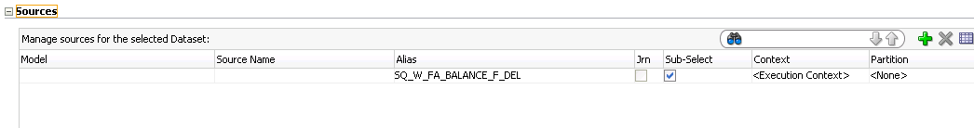
Mappings:
Map the following columns:
Target Column Name | Mapping Expression
DELETE_FLG | SQ_W_FA_BALANCE_F_DEL.DELETE_FLG
W_UPDATE_DT | SESSSTARTTIME
DATASOURCE_NUM_ID | SQ_W_FA_BALANCE_F_DEL.DATASOURCE_NUM_ID
ETL_PROC_WID | #ETL_PROC_WID
INTEGRATION_ID | SQ_W_FA_BALANCE_F_DEL.INTEGRATION_ID
Check “Unique Key” & “Check Not Null” for INTEGRATION_ID, DATASOURCE_NUM_ID
In the Flow tab, use the “IKM BIAPPS Oracle Incremental Append”.
Insert=False

- Create a new Package SIL_FixedAssetBalanceFact_SoftDelete. The package should have Evaluate variable steps to incorporate the following logic.

If #IS_INCREMENTAL = 'Y'
RUN Delete interface (i.e. SIL_FixedAssetBalanceFact_SoftDelete.W_FA_BALANCE_F)
Else
Run "Simulate Full Load" Procedure
End If

In the Package > Diagram, create the following flow based on the above logic:
Save the package and generate the scenario. Named it by following the naming convention: [Adaptor Name]_[Package Name]
In this case for EBS 11.5.10 adaptor, the scenario name should be
SILOS_SIL_FIXEDASSETBALANCEFACT_SOFTELETE
Note: every time you make changes in the interface or package, make sure you re-generate the scenario.

ODI Mapping Change: DELETE_FLG in Existing Fixed Asset SDE / SIL
Include and set the DELETE_FLG in the existing Fixed Asset Balance SDE / SIL

- Open the existing SDE_ORA_FixedAssetBalanceFact, open to the temp interface(SDE_ORA_FixedAssetBalanceFact.W_FA_BALANCE_FS_SQ_EXTRACT) and go to Quick-Edit.
In the Mappings section, add the new column DELETE_FLG, and set the following mapping expression

RUN_REPLICATED_TRANSACTIONAL('#IS_SDS_DEPLOYED',
'N',
CASE WHEN FA_DEPRN_DETAIL.CDC$_DML_CODE = 'D' THEN 'Y' ELSE 'N' END
)

Open main interface (SDE_ORA_FixedAssetBalanceFact.W_FA_BALANCE_FS) and go to Quick-Edit
In the Mappings section, set the following mapping expression for DELETE_FLG column

SQ_FA_DEPRN_DETAIL.DELETE_FLG
- Open the existing SIL_FixedAssetBalanceFact, Open to the temp interface and go to Quick-Edit.
In the Mappings section, add the new column DELETE_FLG, and set the following mapping expression
W_FA_BALANCE_FS.DELETE_FLG

open the main interface and go to Quick-Edit.
In the Mappings section, set the following mapping expression for DELETE_FLG column

SQ_FA_BALANCE_FS.DELETE_FLG

ODI Load Plan Change
This section contains the steps to add the new Balance Primary Extract scenarios into the existing Fixed Asset Balance SDE load plan component. It can be set to run in parallel to the main set of scenarios for that entity.
- Go to Load Plans and Scenarios > BIAPPS Load Plan > Load Plan Dev Components > SDE > EBS_11_5_10 > Open “3 SDE Fact ASTBAL_FG EBS_11_5_10” (or the corresponding Adaptor Load Plan Component you are using)
- In the “Steps”, append the new Balance Primary Extract scenarios at the end.
- SDE_ORA11510_ADAPTOR_SDE_ORA_FIXEDASSETBALANCEFACT_PRIMARY

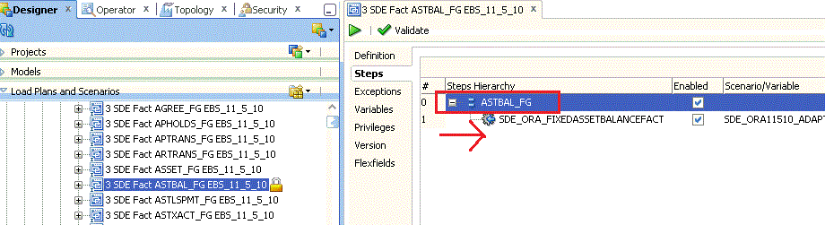

- Go to the Root Step “ASTBAL_FG” (i.e. step 0 as shown above) and make sure to refresh the variable SOFT_DELETE_PREPROCESS, i.e. check the “Refresh” checkbox as shown below.

Note: you can refer to the existing SoftDelete in AP load plan component “SDE Fact APTRANS_FG EBS_11_5_10” as an example (see fig below)

Now add the new Balance IdentifyDelete and SoftDelete scenarios into the existing Fixed Asset Balance SIL load plan component. They should be set to run in serial
Go to Load Plans and Scenarios > BIAPPS Load Plan > Load Plan Dev Components > SIL > Open “3 SIL Fact ASTBAL_FG”
- In the “Steps”, append the new Balance IdentifyDelete and SoftDelete scenarios in serial at the end.
- SILOS_SIL_FIXEDASSETBALANCEFACT_IDENTIFYDELETE
- SILOS_SIL_FIXEDASSETBALANCEFACT_SOFTELETE

- Make sure to specify version as -1 for the new scenario steps. And specify ‘Restart from failed step’ for the Restart.

RPD Change: Logical Layer Filter DELETE_FLG = ‘N’

This section covers the steps of RPD changes
- Open your RPD using OBIEE Administration Tool.
- In the Physical layer, open the balance fact W_FA_BALANCE_F
- Add the new column DELETE_FLG in W_FA_BALANCE_F. Type = CHAR / Length = 1
- Once done you should see this DELETE_FLG column appear on the corresponding Fact Alias Fact_W_FA_BALANCE_F
- Go to the Business Model and Mapping layer, and open the logical table “Fact – Fins Asset Balance
- Open the Logical Table Source “Fact_W_FA_BALANCE_F”
- Under Content tab, add the following new filter
"Oracle Data Warehouse"."Catalog"."dbo"."Fact_W_FA_BALANCE_F"."DELETE_FLG" = 'N'

- Save the RPD changes.

