Ticket:- IM8711501
Cross Ledger Report
Login into OBIEE Analytics
GOTO→Catalog →Shared Folders →Cigna Custom financials folder →“Multi Ledger dashboard”
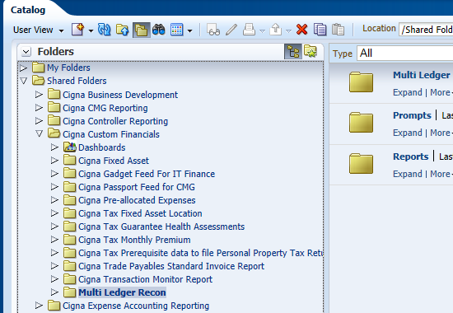

Click on the Multi Ledger Recon Folder and click on expand
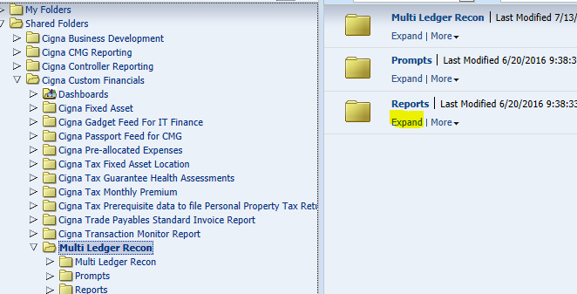

Click on EDIT Prime Drill Down Report
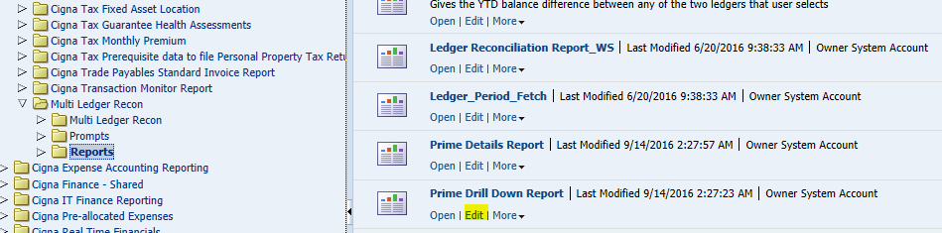

Goto Criteria tab Add Filter Condition
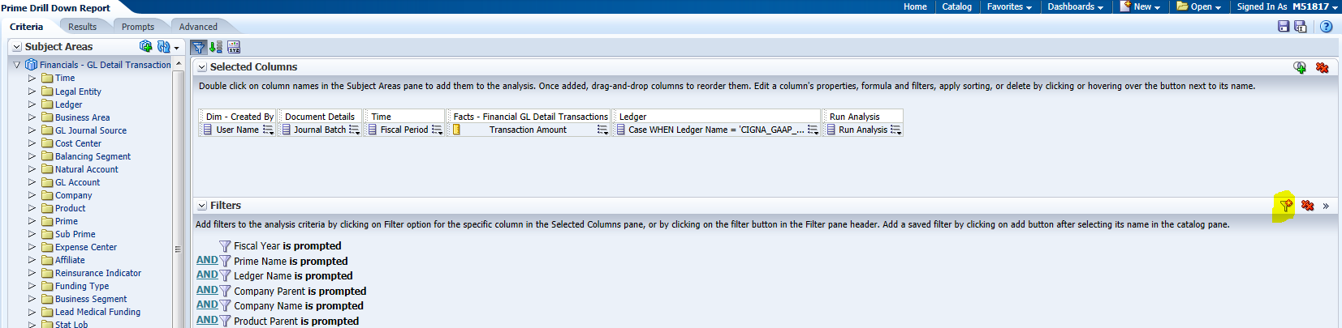
Click on More Columns as shown below screen
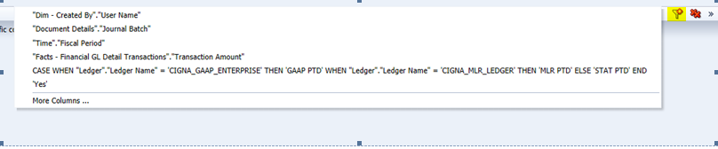
Expand Document details Folder and select Posted status column and click on OK button
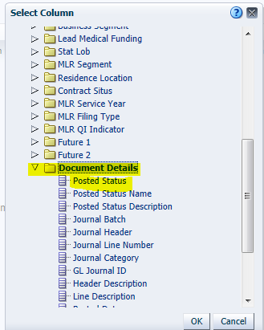
Select filter value as Posted from drop down list
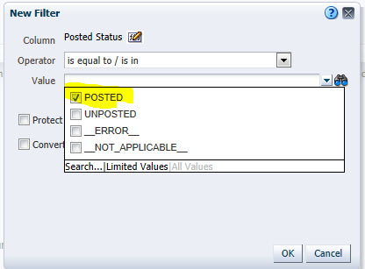
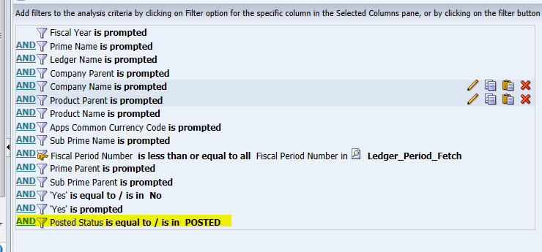
Save report and Goto dashboard click on Cigna Ledger report check the results
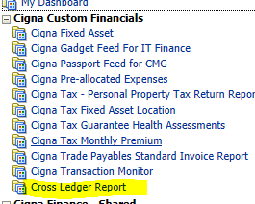

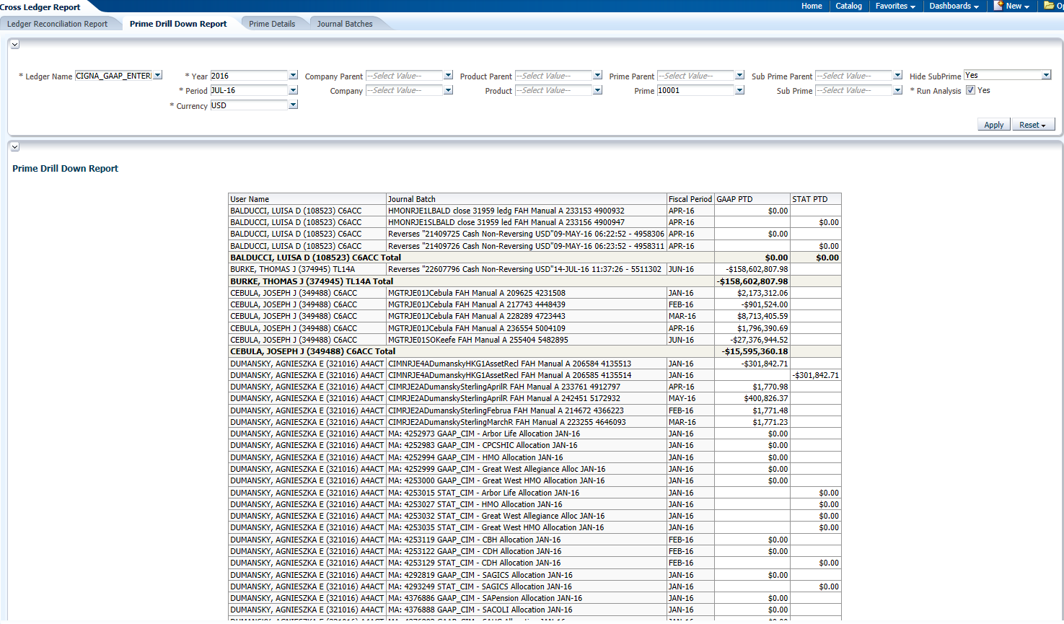

PRIME DETAILS:
GOTO→Catalog →Shared Folders →Cigna Custom financials folder →“Multi Ledger dashboard”
Click on EDIT Prime details Report
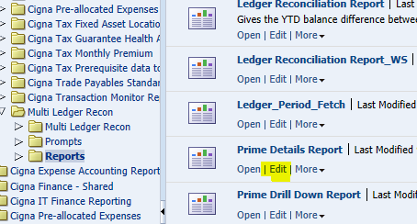
Goto Criteria tab Add Filter Condition
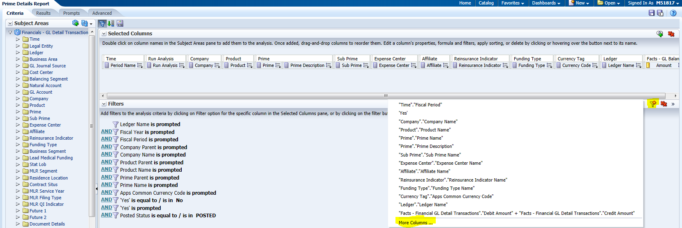
Click on More Columns as shown below screen
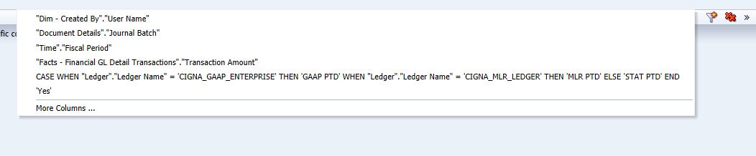
Expand Document details Folder and select Posted status column and click on OK button
Select filter value as Posted from drop down list and clieck on OK
Save report and Goto dashboard click on Cigna Ledger report check the results
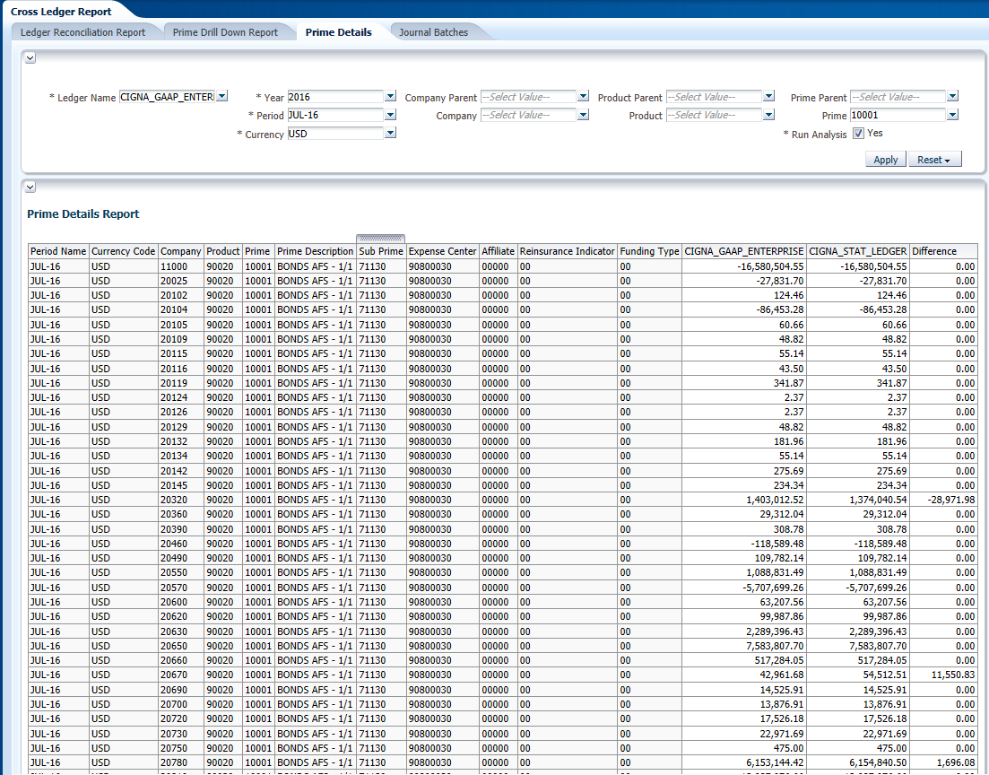
Journal Batches Report:
GOTO→Catalog →Shared Folders →Cigna Custom financials folder →“Multi Ledger dashboard”
Click on EDIT Journal Batches report
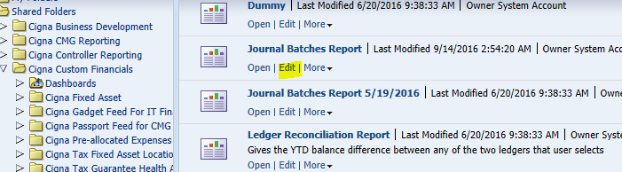
Goto Criteria tab Add Filter Condition
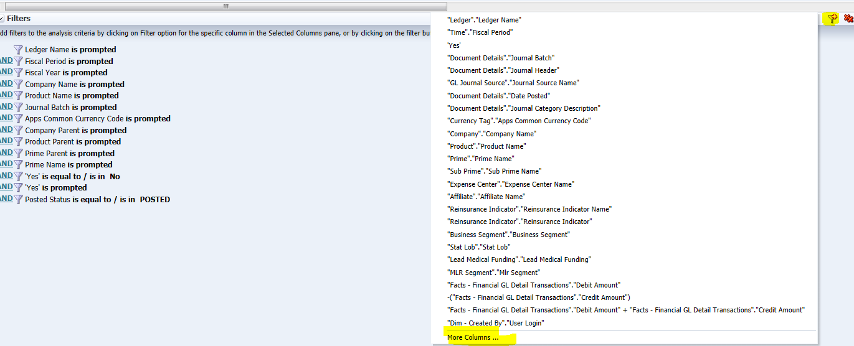
Click on More Columns as shown below screen
Expand Document details Folder and select Posted status column and click on OK button
Select filter value as Posted from drop down list and click on OK

Save report and Goto dashboard click on Cigna Ledger report check the results

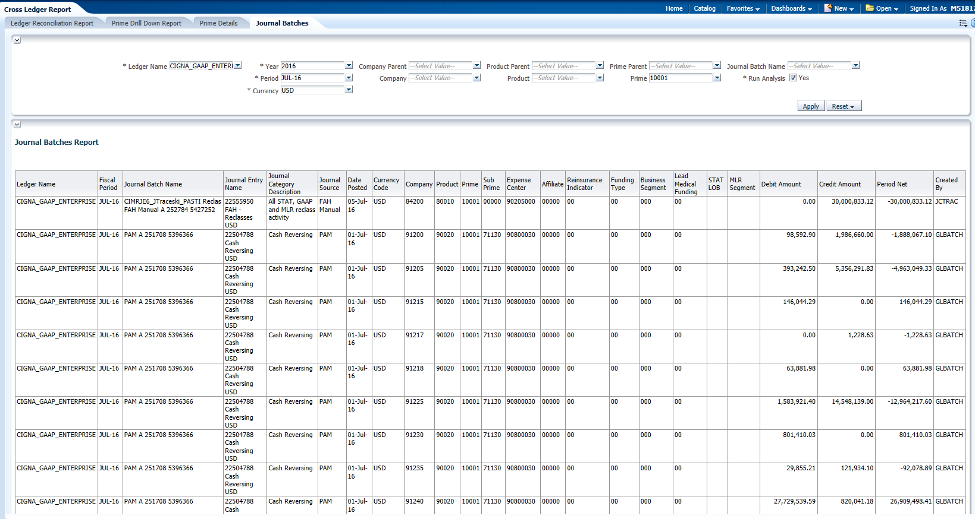

Ticket: IM8735113
Gadget Feed report:
Login into OBIEE Analytics
GOTO→Catalog →Shared Folders →Cigna Custom financials folder → Gadget Feed report
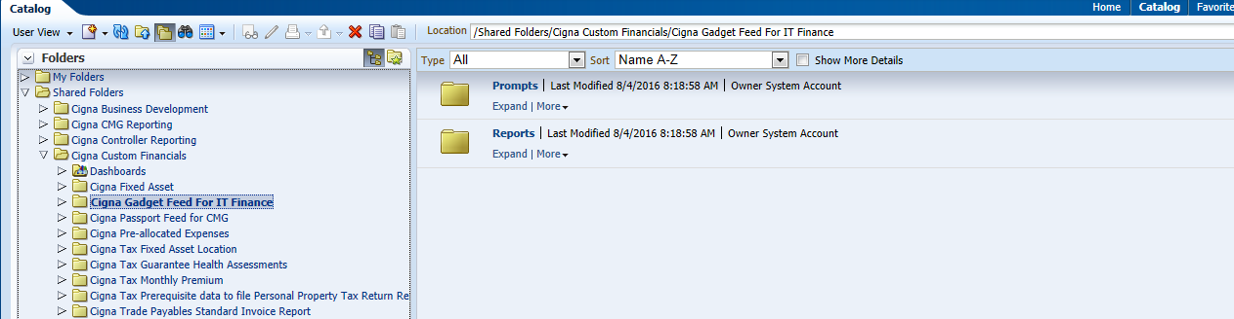
Click on the Gadget Feed report Folder and click on expand
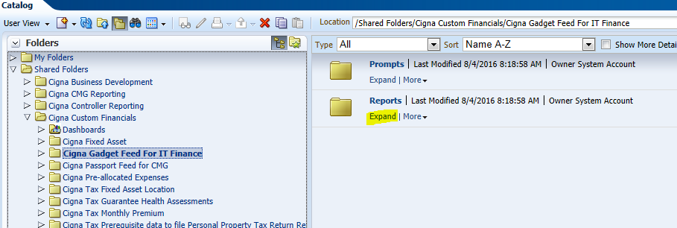

And click on EDIT
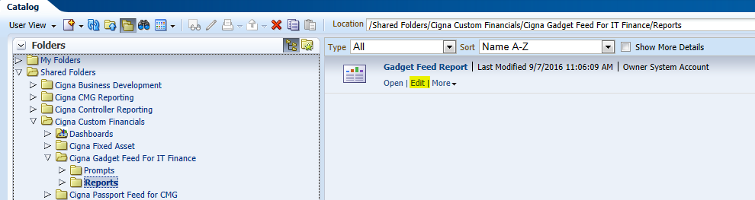

Go to criteria tab ,From FACTS-Transaction Details Add stage rec id
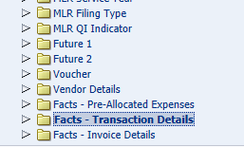
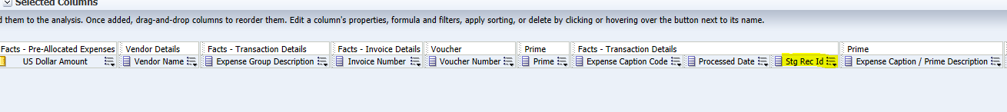
Trim the Expense Group Desc to 25 chars:
Edit Expense Group Desc column formula from Critiria
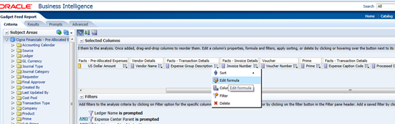

Change with bleow formula And Save Analysis
SUBSTRING("Facts - Transaction Details"."Expense Group Description" FROM 1 FOR 25)
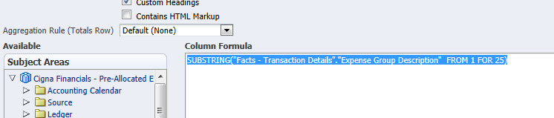
Goto dashboard click on Cigna Gadget Feed For IT Finance check the results
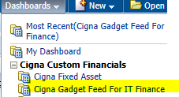

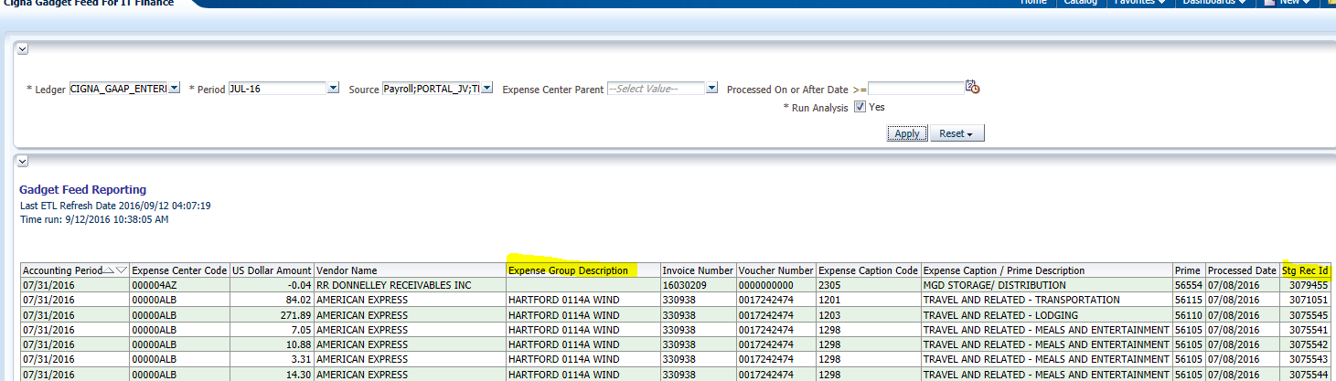

Ticket :- IM8735117
Cigna Passport Feed for CMG:
Login into OBIEE Analytics
GOTO→Catalog →Shared Folders →Cigna Custom financials folder →“Cigna Passport Feed for CMG dashboard”
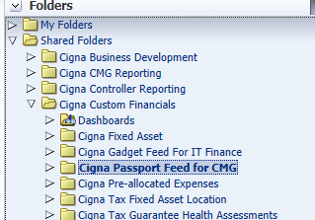

Click on the Cigna Passport Feed for CMG Folder and click on expand
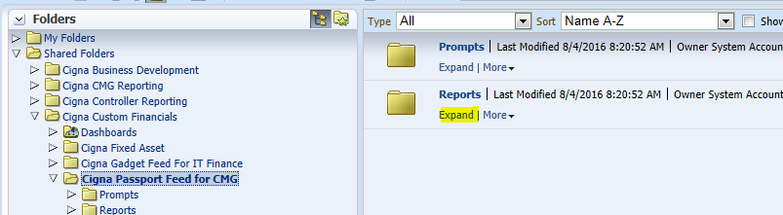
And click on EDIT
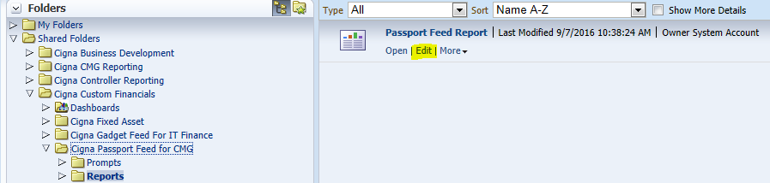

Go to criteria tab ,From FACTS-Transaction Details Add Process date Column
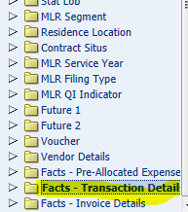
Save report
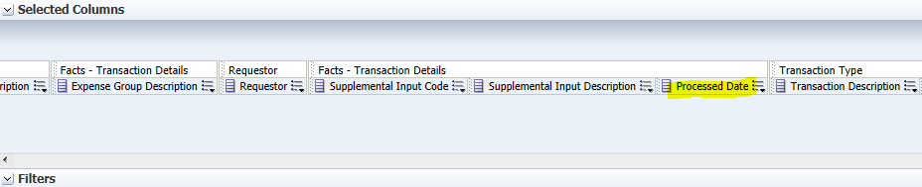
Goto dashboard click on Cigna Passport Feed for CMG check the results
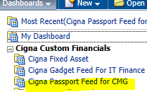

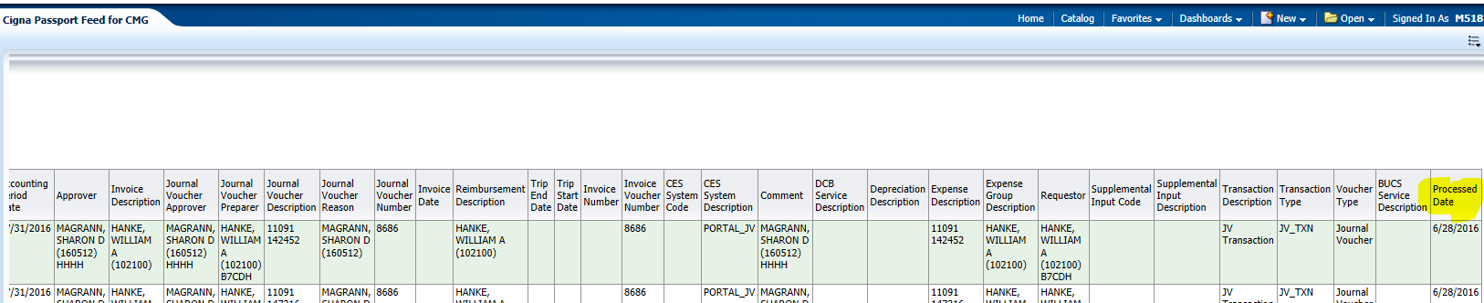

Ticket :- IM8735111
Excel found unreadable content in 'Passport Feed Report Paid and Liab.xlsx
Login into OBIEE Analytics
GOTO→Catalog →Shared Folders →Cigna Custom financials folder → Cigna Passport Feed for CMG

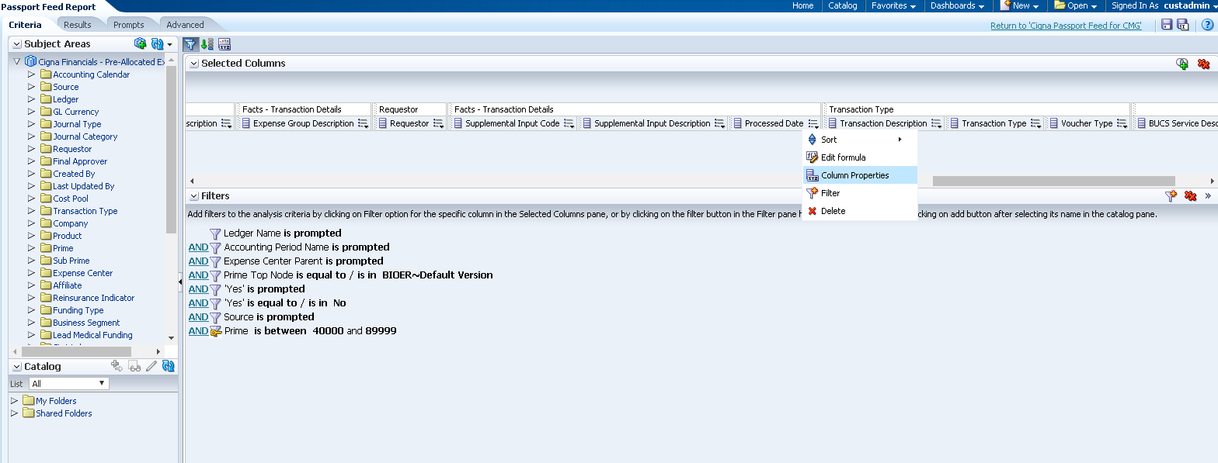

Click on Column Properties -> Data format
Click on Override data format and write MM/dd/yy custom date format.
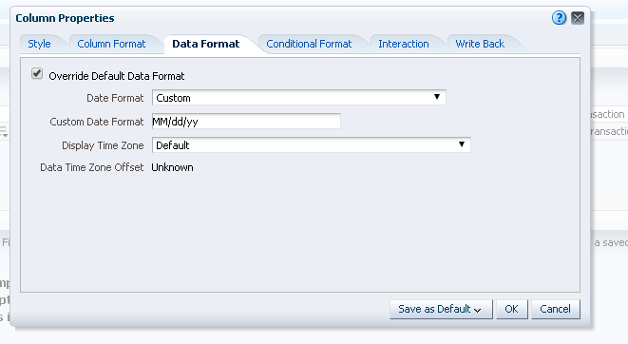
Click on save as default and click on Save as the system-wide default.

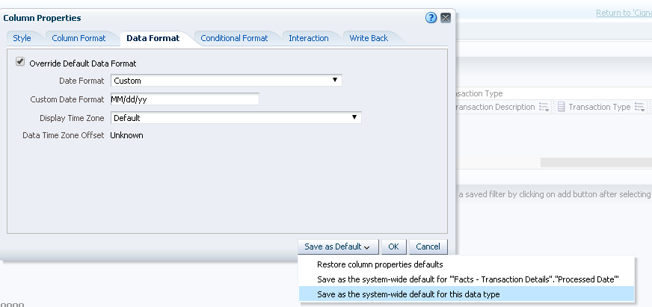

Save the report and go to dashboard,

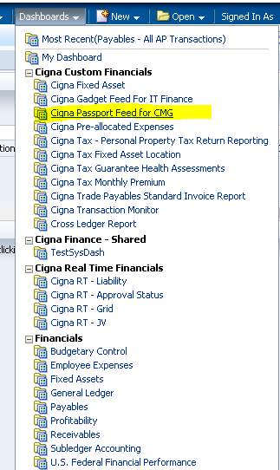

Run the report and download the report in excel and check the date format in excel for process date.
