Gadget Feed report:
Login into OBIEE Analytics
GOTO→Catalog →Shared Folders →Cigna Custom financials folder → Gadget Feed report
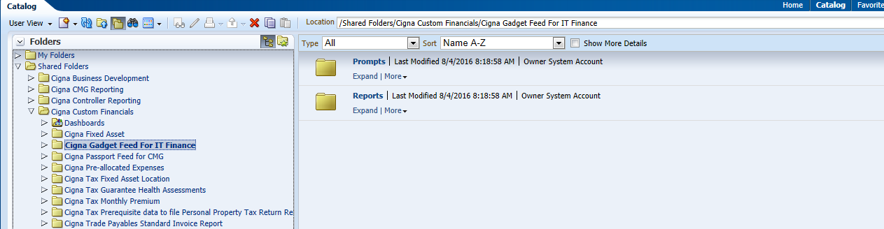
Click on the Gadget Feed report Folder and click on expand
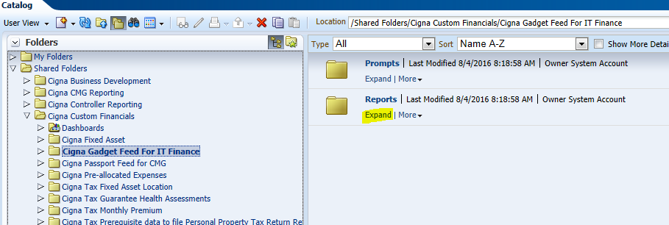

And click on EDIT
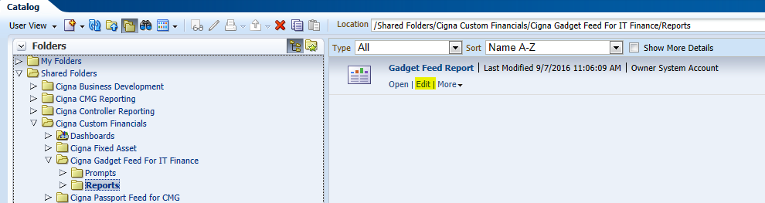

Add stage rec id column in Critiria tab from FACTS-Transaction Details
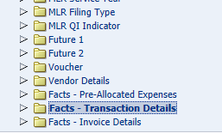
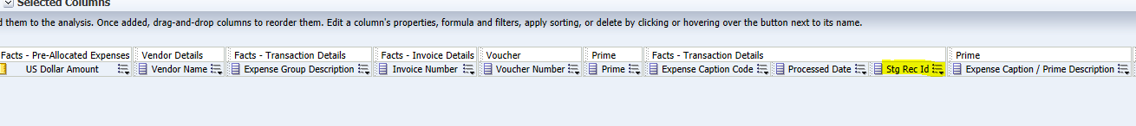
Trim the Expense Group Desc to 25 chars:
Edit Expense Group Desc column formula from Critiria
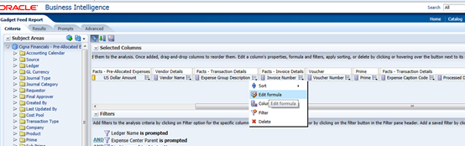

Change with bleow formula And Save Analysis
SUBSTRING("Facts - Transaction Details"."Expense Group Description" FROM 1 FOR 25)
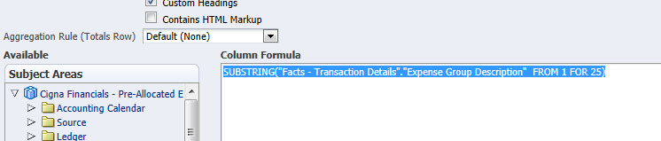
Goto dashboard click on Cigna Gadget Feed For IT Finance check the results
