Cigna Passport Feed for CMG:

Login into OBIEE Analytics
GOTO→Catalog →Shared Folders →Cigna Custom financials folder →“Cigna Passport Feed for CMG dashboard”
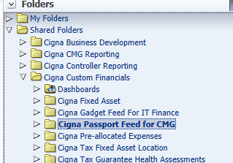

Click on the Cigna Passport Feed for CMG Folder and click on expand
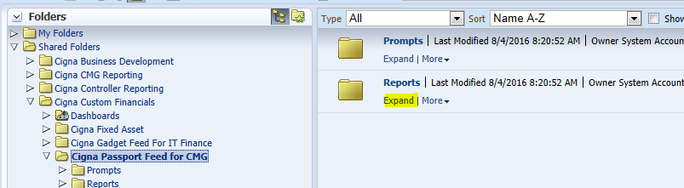
And click on EDIT
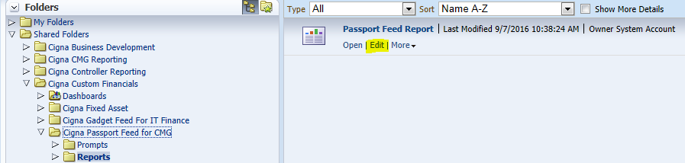

Add Process date column in Critiria tab from FACTS-Transaction Details
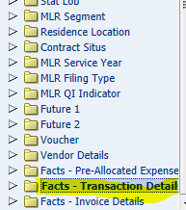

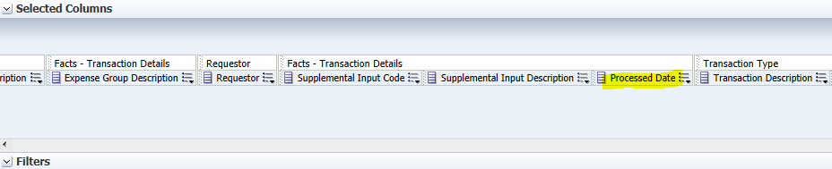
Goto dashboard click on Cigna Passport Feed for CMG check the results
