Ticket: IM9922607
Description: Please Add last refreshed date for Post allocation Dashboard

Last refreshed date for Post allocation Dashboard:

Before changes Report:
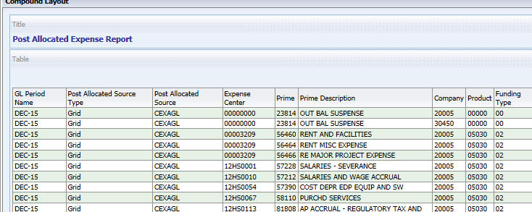

After changes in Report:
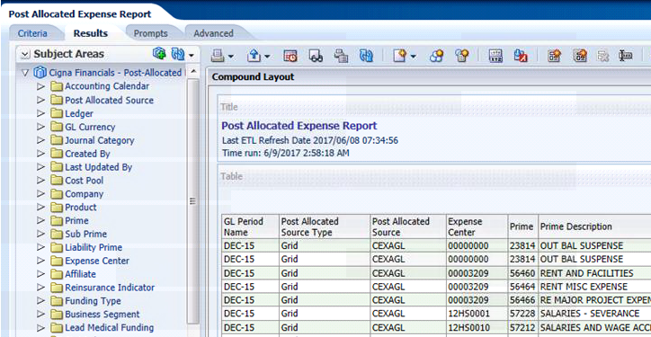
Before Changes in Dashboard:
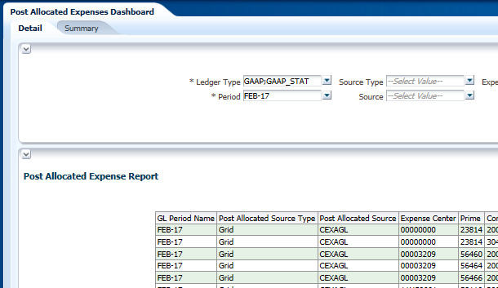
After Changes in Dashboard:
Detail page in Dashboard:

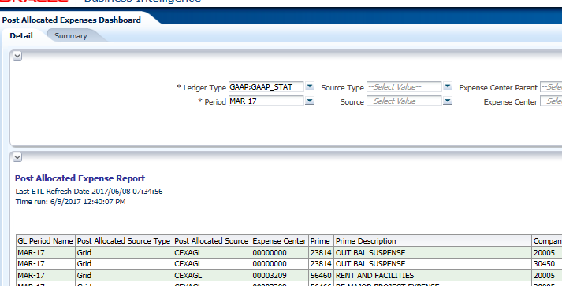

Summary Page in Dashboard:
