Before Merge:
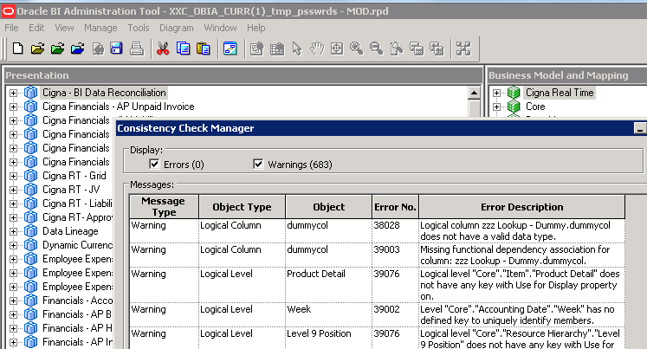

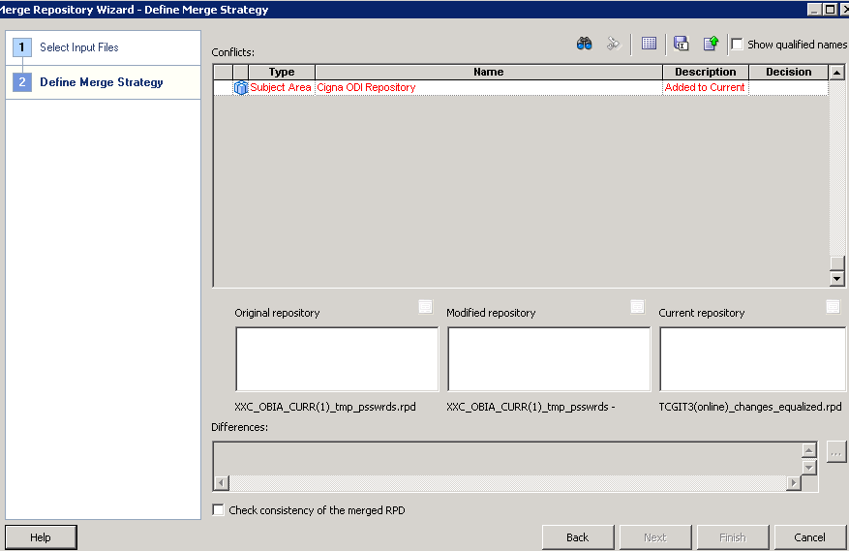

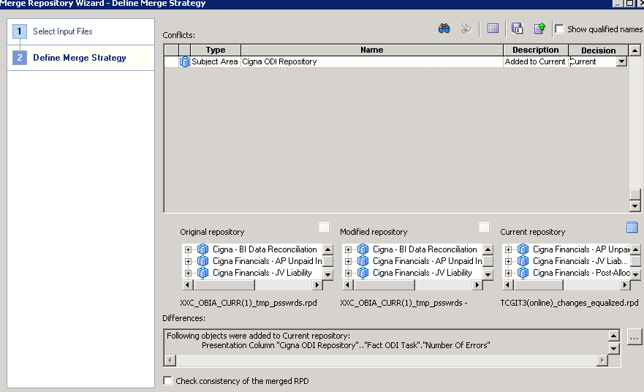

After Merged:
Warnings:605
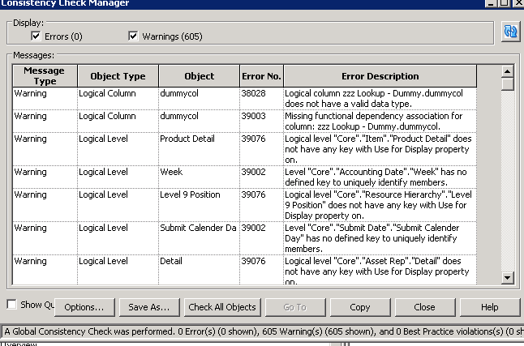

Report Testing:
Subject area :Asset Depreciation
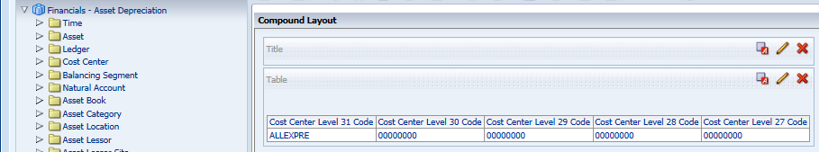
Subject Area:AP Balance
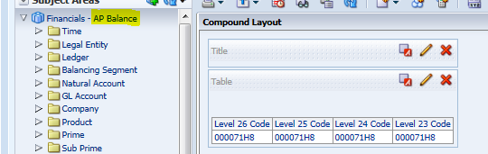
000071H8
After Chnages:
Subject area:Asset Depreciation
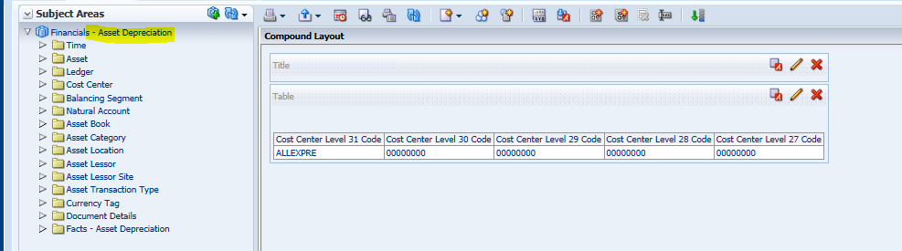
Subject area :AP Balance
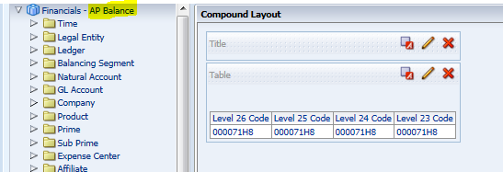
END.

