Projects for
Murach’s ASP.NET 3.5 Web Programming
with C# 2008
The projects in this document let you apply the programming skills you learn in Murach’s ASP.NET 3.5 Web Programming with C# 2008 by developing an application called SportsPro. This application is designed for the technical support department of a hypothetical software company that develops software for sports leagues. The purpose of the application is to track technical support service calls (referred to as incidents) in a database that also stores information about the company’s customers, software products, and technicians. The application uses a database called TechSupport. Before you do any of the projects, you should read the introductory information that follows.

An introduction to the projects 2
The design of the SportsPro application 2
The design of the TechSupport database 3
How to prepare for using the TechSupport database 4
How to restore the original database files 4
How to prepare for developing the SportsPro application 5
How to develop the projects 5

The Projects 6
Project 1-A: Display customers 6
Project 1-B: Create a contact list 7
Project 2-A: Survey customers 9
Project 2-B: Create a master page and content pages 12
Project 2-C: Add site navigation 14
Project 3-A: Display customer incidents 15
Project 3-B: Maintain products 16
Project 3-C: Maintain customers 18
Project 3-D: Maintain technicians 20
Project 3-E: Display incidents 22
Project 3-F: Create incidents 24
Project 3-G: Update incidents 26
Project 3-H: Display technician incidents by product 29
Project 4-A: Add user authentication 31
Project 4-B: Assign incidents 33
Project 4-C: Register products 36
Project 4-D: Add custom error handling 38

An introduction to the projects
This introduction describes the design of the SportsPro application and the TechSupport database. In addition, it explains how to make the TechSupport database available to your applications, how to restore the database so it contains its original data, and how to prepare for developing the application. Finally, it provides some general information about developing the projects.

The design of the SportsPro application
The SportsPro application consists of several pages that provide functions for three types of users. First, it lets administrators perform functions such as maintaining the Products, Customers, and Technicians tables of the TechSupport database. Second, it lets technicians perform functions such as displaying and updating incidents. And third, it lets customers perform functions such as registering products.
Each project has you add one or more new pages to the SportsPro application. For example, project 3-A has you add a page that displays incidents by customer, and project 3-B has you add a page that maintains the data in the Products table of the TechSupport database. If you complete all of these projects, you’ll have a relatively realistic web application.
Note that the project numbers refer to the sections in the book. So, for example, you can complete projects 2-A, 2-B, and so on after reading section 2, and you can complete projects 3-A, 3-B, and so on after reading section 3. Because some of the projects don’t require that you have all of the skills presented in a section, though, you may be able to complete a project before you’ve read all of the chapters in that section. In fact, many of the projects require just the skills presented in a specific chapter. For example, project 2-B requires the skills you’ll learn in chapter 9, and project 2-C requires the skills you’ll learn in chapter 10.

The design of the TechSupport database
The TechSupport database is used to track technical support incidents for a small software company named SportsPro. It consists of the five tables shown in the diagram that follows. The main table is the Incidents table, which contains one row for each technical support incident. Each row in the Incidents table is related to one row in the Customers table, which contains information about the company’s customers; one row in the Products table, which contains information about the company’s products; and one row in the Technicians table, which contains information about the company’s technical support staff members. In addition, a table called Registrations keeps track of the products that are registered to each customer.
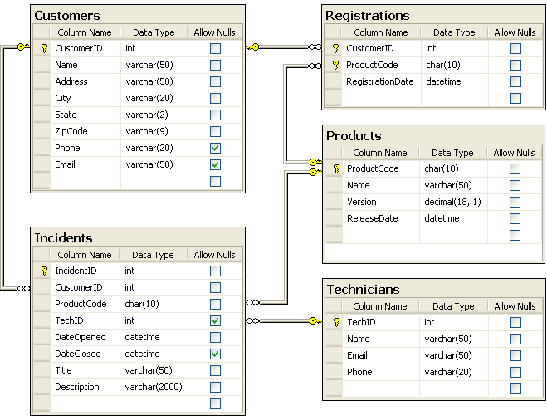
In addition to the column properties shown above, you should know that the CustomerID, IncidentID, and TechID columns in the Customers, Incidents, and Technicians tables are identity columns. So the values of these columns are set automatically when new rows are added to these tables.

How to prepare for using the TechSupport database
The projects for sections 1 and 2 use an Access version of the TechSupport database. To do these projects, you can simply copy the TechSupport.mdb file your instructor gives you to the App_Data folder of the application.
The projects for sections 3 and 4 use a SQL Server version of the TechSupport database. If this database is installed on a server at your company or school, you’ll need to get the information for establishing a connection to that database before you do these projects. On the other hand, if you’re going to use SQL Server Express on your own PC to do these projects, you’ll need to start by attaching the TechSupport database to this server.
To install the TechSupport database on your own PC, copy the TechSupport.exe file that your instructor gives you to your C drive, and double-click on this file in the Windows Explorer to execute it. Then, navigate to the C:\Murach\ASP.NET 3.5 C#\Project database directory and double-click on the db_attach.bat file to execute it. This batch file runs a SQL Server script named db_attach.sql that attaches the database to the copy of SQL Server running on your computer.
Note that if the database server on your system has a name other than the computer name appended with \SQLEXPRESS, the batch file we provide won’t work. But you can easily change it so it will work. To do that, just open the file in a text editor such as NotePad. When you do, you’ll see a single command with this server specification:
sqlcmd -S localhost\SQLExpress -E /i db_attach.sql
Then, you can just change this specification to the name of your server.
Another problem can arise if you try to attach the database by running the db_attach.bat file under the Windows Vista operating system. This is due to the fact that under Vista, you aren’t automatically given administrator privileges even if you’re logged on as an administrator, and you need to have administrator privileges to attach the database. Normally, Vista will notify you when administrator privileges are required to perform a task, but this doesn’t happen when you run a batch file.
To get around this problem, you’ll need to turn off a feature of Vista called User Account Control as described in this figure. Then, after you restart your system, you should be able to attach the database without any problem. Be sure to turn User Account Control back on when you’re done as it provides added security for your system.
If you’re using Windows XP, you’ll also need to grant ASP.NET access to the TechSupport database after you attach it to SQL Server Express. To do that, you can run the db_grant_access.bat file in the Project database directory. But first, you must modify the db_grant_access.sql file that this batch file runs so it uses the name of your computer. To do that, open the file in a text editor, and replace each occurrence of [machineName] with the name of your computer. Then, save and close this file, and run the db_grant_access.bat file to grant ASP.NET access to the TechSupport database.

How to restore the original database files
As you test some of the projects that you develop, you’ll need to add, modify, and delete rows in the database. Then, at some point, if you’re using SQL Server Express on your own PC, you may want to restore the original data. To make that easy to do, we’ve provided you with two copies of the database files. The ones that are attached to SQL Server Express when you run the db_attach.bat file are in the C:\Murach\ASP.NET 3.5 C#\ Project database directory. The others are in the C:\Murach\ASP.NET 3.5 C#\Project database backup directory.
To restore the original files, you can double-click on the db_restore.bat file in the C:\Murach\ASP.NET 3.5 C#\Project database directory to execute it. This batch file runs a SQL Server script named db_detach.sql that detaches the database from SQL Server. Then, it copies the files in the Project database backup directory over the files in the Project database directory. Finally, it runs the db_attach.sql script to reattach the database using the original files.
Note that you can run into the same problems using the batch file that restores the database as you can using the batch file that attaches the database. Specifically, this batch file won’t work if your database server has a name other than the computer name appended with \SQLEXPRESS. In addition, Windows Vista won’t let you run this batch file unless User Account Control is turned off. For information on how to resolve these problems, please see the previous topic.

How to prepare for developing the SportsPro application
Unless you’re asked to do otherwise, you can develop the SportsPro application as a file-system web site, and you can test it using your default browser and the built-in development server. If you’re asked to develop and test the application under IIS, however, you will need to have IIS installed. You will also need to have IIS installed if you’re assigned project 4-C, which uses IIS as the SMTP server for sending and receiving email. You can learn how to install IIS in figure A-2 (Windows XP) or A-3 (Windows Vista) of appendix A in the book. Note that if you’re using Windows Vista, you may need to add permissions to the directory that contains the web site. For more information on that, please see page 966 in the book.

How to develop the projects
The description of each project includes the general operation of the project’s pages, an image of how the pages should appear in a browser, and specifications for the processing the pages should do. This information is detailed enough for you to complete the project. However, you’ll occasionally need to determine minor details on your own, such as what error messages to display when the user enters invalid data.
The names of the forms you’ll create for each project are also given in the project description. To avoid conflicts with later projects, you should use the indicated names. You should also use the names specified in the project descriptions for any other classes you’re asked to create.
Unless you’re instructed otherwise, you are free to implement each project using any programming techniques you wish. In some cases, however, the project’s specifications will direct you to use a specific programming technique. For example, a project may direct you to use session state or cross-page posting. In that case, you should implement the project as directed.

Project 1-A: Display customers
For this project, you’ll create a page named Default.aspx that displays information for a selected customer. To do that, you’ll use an Access data source. (Required reading: chapters 1, 2, and 3)
The design of the Customer Display page
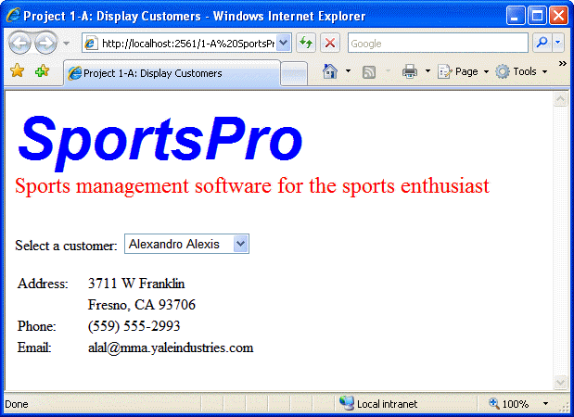
Operation
- When the page is first displayed, the information for the first customer in the drop-down list is displayed on the page. After that, the information for the customer that the user selects from the drop-down list is displayed.
Specifications
- Create a class named Customer that contains a public field for each column in the Customers table. Then, use this class to create a Customer object that contains the information for the selected customer.
- Add an Access data source to the default page for the project. This data source should retrieve all the rows and columns from the Customers table, sorted by the Name column. Bind the drop-down list to this data source so the Name column is displayed for each item in the list and the CustomerID column is stored as the value of each item.
- To get the data for a selected customer, create a data view from the data source and then filter the data view so it consists of just the row for the selected customer.
- Use a table to align the address, phone, and email information.
- Use any fonts, colors, and sizes you like for the two headings.
Project 1-B: Create a contact list
For this project, you’ll enhance the SportsPro application by adding a page named ContactDisplay.aspx that displays a list of customers to be contacted. Customers are added to this page from the Customer Display page you created in project 1-A. (Required reading: chapter 3)
The design of the enhanced Customer Display page
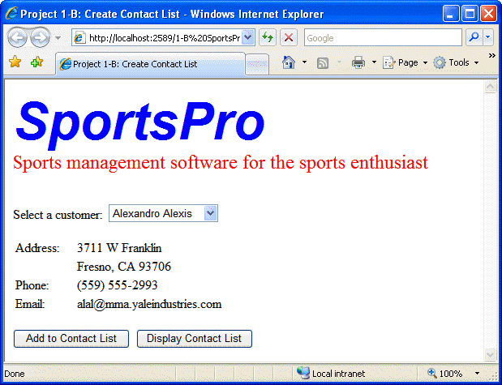
The design of the Contact Display page
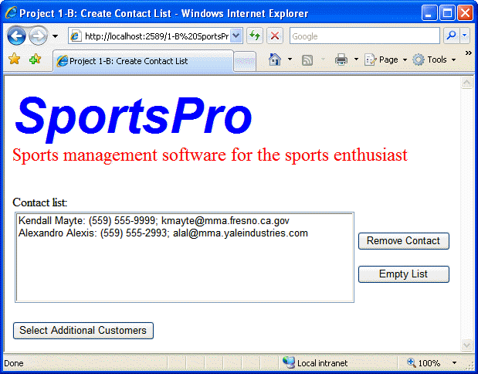
Operation of the Customer Display page
- When the user clicks the Add to Contact List button on the Customer Display page, the selected customer is added to a sorted list of contacts and the Contact Display page is displayed with the contacts listed in a list box. If the customer is already in the list, an error message is displayed in a label below the Add to Contact List button.
- When the user clicks the Display Contact List button, the Contact Display page is displayed.
Operation of the Contact Display page
- When the user selects a contact in the list and clicks the Remove Contact button, the contact is removed from the list and from the sorted list.
- When the user clicks the Empty List button, all the contacts are removed from the list and from the sorted list.
- When the user clicks the Select Additional Customers button, the Customer Display page is redisplayed.
Specifications
- Rename the Default.aspx page you created in project 1-A to CustomerDisplay.aspx.
- Store the customers that are added to the contact list in a sorted list whose key is CustomerID.
- Save the sorted list that contains the customer contacts in session state so that it’s available from both forms.
- To format the customer data that’s displayed in the list box, add a method named ContactDisplay to the Customer class that returns the customer data in the correct format.
- Use cross-page posting to display the Contact Display page when the user clicks the Display Contact List button on the Customer Display page and to display the Customer Display page when the user clicks the Select Additional Customers button on the Contact Display page.
Project 2-A: Survey customers
For this project, you’ll create a page named CustomerSurvey.aspx that surveys customers regarding recent incidents and a page named SurveyComplete.aspx that displays a message when the survey is submitted. These pages use a variety of standard and validation controls. (Required reading: chapters 6 and 7)
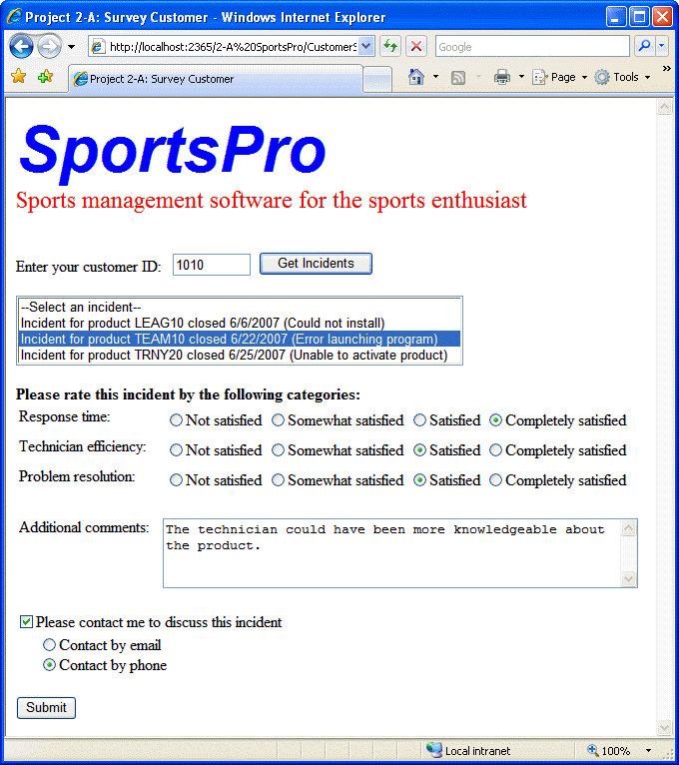
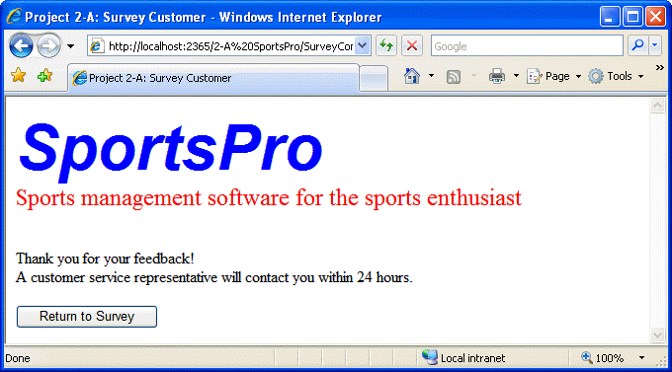
The design of the Customer Survey and Survey Complete pages

Operation
- When the Customer Survey page is first displayed, all of the controls except for the Customer ID text box and the Get Incidents button are disabled.
- When the user enters a customer ID and clicks the Get Incidents button, any closed incidents for that customer are displayed in the list box and all of the controls on the page are enabled. If there aren’t any closed incidents, the controls are not enabled and an appropriate message is displayed below the customer ID.
- To complete the survey, the user selects an incident, makes the appropriate selections and entries, and then clicks the Submit button. Then, the Survey Complete page is displayed with a message that depends on whether or not the user has asked to be contacted. The user can close this page or complete another survey by clicking the Return to Survey button.
Specifications
- Create a class named Incident that consists of one public field for each column in the Incidents table and a method named CustomerIncidentDisplay that formats an incident for display on the Customer Survey page.
- Create a class named Survey that consists of the following public fields that represent the data for a survey:
public int CustomerID;
public int IncidentID;
public int ResponseTime;
public int TechEfficiency;
public int Resolution;
public string Comments;
public bool Contact;
public string ContactBy;
- Use labels instead of text within the survey so you can enable and disable them along with the other controls.
- Use radio button lists to implement the ratings for the three categories in the survey. The Text properties for the list items in these lists should be set as shown on the page, and the Value properties should be set to 1, 2, 3, and 4.
- Use a radio button group for the last two radio buttons on the page.
- Use required field validators for the Customer ID text box and the Incidents list box, and use a compare validator for the Customer ID text box that checks for an integer value. In addition, use validation groups so that the validators for the Customer ID text box are executed only when the user clicks the Get Incidents button, and the validator for the Incidents list box is executed only when the user clicks the Submit button.
- When the Customer Survey page is first displayed, set the focus to the customer ID text box. Then, if the user clicks the Get Incidents button and there are incidents for the specified customer, move the focus to the Incidents list box.
- To get the data that’s displayed in the Incidents list box, use an Access data source that retrieves all the rows and all the columns except the Description column from the Incidents table, sorted by the DateClosed column. Then, use a data view to filter the rows so that only the closed incidents for the specified customer are displayed. To do that, you’ll need to set the RowFilter property of the data view to a compound condition where the CustomerID column is equal to the customer ID the user enters and the DateClosed column is not null.
- When populating the Incidents list box, create list items whose Text property is set to the value of the CustomerIncidentDisplay method of the incident and whose Value property is set to the incident ID. In addition, the Text property of the first item in the list box should be set as shown on the Customer Survey page, and the Value property of this item should be set to “None.”
- When the survey is submitted, the application should create a Survey object and set its properties appropriately. Then, it should save a Boolean value in session state that indicates if the user requested to be contacted. The Survey Complete page can then use that value to determine the message that’s displayed on the page. (Although a complete application would also perform some processing on the Survey object, this project doesn’t include that processing.)
Project 2-B: Create a master page and content pages
For this project, you’ll create a master page for the SportsPro application. In addition, you’ll create a new content page named ContactUs.aspx that displays contact information, and you’ll convert the other pages you’ve created to content pages. (Required reading: chapter 9)
The design of the master page and the Contact Us page
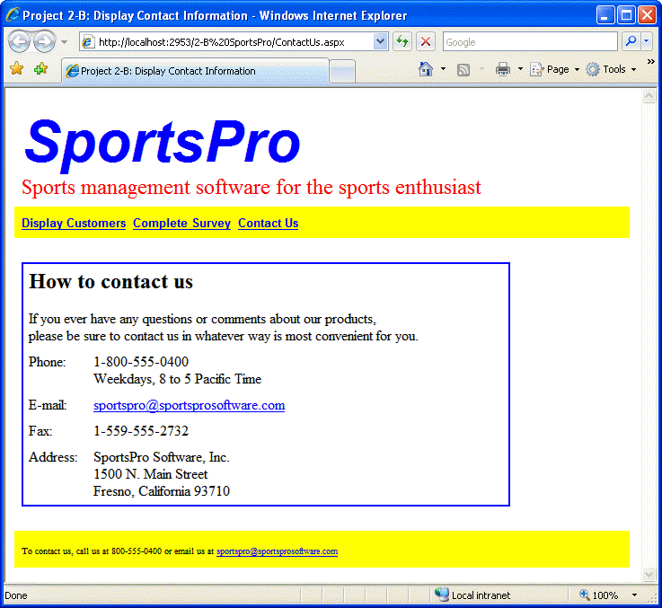
Operation
- When the user clicks one of the links at the top of the page, the appropriate page is displayed.
- When the user clicks the E-mail link in the “How to contact us” box or at the bottom of the page, the user’s email client starts a new email for the specified address.
Specifications
- The master page consists of the two titles and three links at the top of the page and the contact information at the bottom of the page. You can use any fonts, colors, and sizes you want for these elements. If you format the elements on the master page using style rules in an internal style sheet, be sure to use custom names for the style rules so the names don’t conflict with the names of style rules used in the content pages.
- After you create the master page, you can create the Contact Us page as a content page that will be displayed within the master page. In addition, you can convert the pages you created in previous projects to content pages. When you do that, don’t forget to set the titles for the master and content pages the way you want them.
- To create the two email links, you can use an Anchor element with its href attribute set to “mailto:sportspro@sportsprosoftware.com.”
Project 2-C: Add site navigation
For this project, you’ll add navigation to the SportsPro application. That includes a menu and a page that contains a tree view of the site. (Required reading: chapter 10)
The design of the Map page
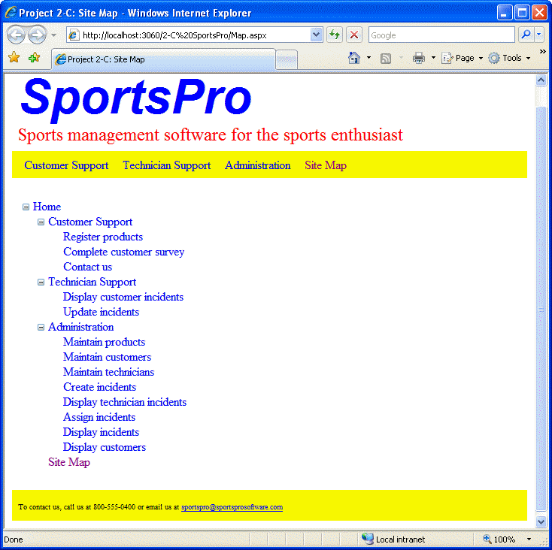
Specifications
- To implement this project, you’ll need to add several forms to the application. You should give these forms the following names: Default.aspx, CustomerSupport.aspx, ProductRegistration.aspx, TechnicianSupport.aspx, CustomerIncidentDisplay.aspx, IncidentUpdate.aspx, Administration.aspx, ProductMaintenance.aspx, CustomerMaintenance.aspx, TechnicianMaintenance.aspx, IncidentCreation.aspx, TechnicianIncidentSummary.aspx, IncidentAssignment.aspx, IncidentDisplay.aspx, and Map.aspx. The only page you’ll implement in this project is the Map page.
- After you create the necessary pages, you can create a web.sitemap file with the structure shown in the tree view above. Then, you can replace the links at the top of the master page with a Menu control, and you can add a TreeView control to the Map page.
Project 3-A: Display customer incidents
For this project, you’ll create a page named CustomerIncidentDisplay.aspx that displays the incidents for a selected customer in a data list. This page will require two SQL data sources. (Required reading: chapter 13)
The design of the Customer Incident Display page
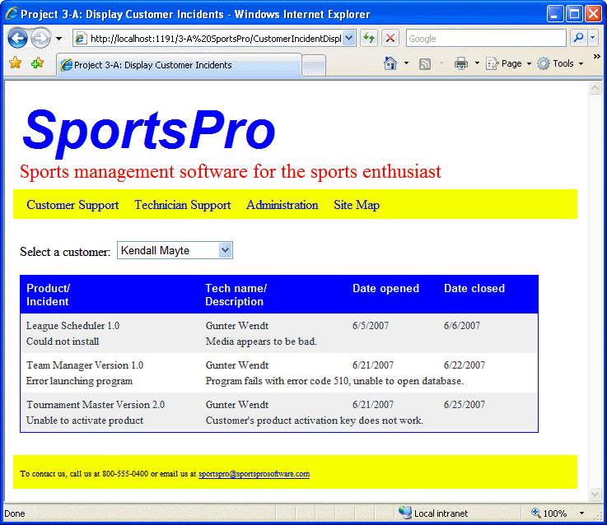
Operation
- When the user selects a customer from the drop-down list, all the incidents for that customer are displayed in a data list.
Specifications
- The Customers drop-down list is bound to a SQL data source that retrieves the CustomerID and Name columns from the Customers table and sorts the rows by the Name column. When you create the connection for this data source, you should save it in the web.config file.
- The SQL data source for the data list joins data from three tables (Incidents, Technicians, and Products) and includes only the incidents for the selected customer.
- Format the data list any way you like.
Project 3-B: Maintain products
For this project, you’ll create a page named ProductMaintenance.aspx that lets the user modify and delete existing products using a GridView control. This page will also let the user add new products by entering the product information into text boxes. (Required reading: chapters 13 and 14)
The design of the Product Maintenance page
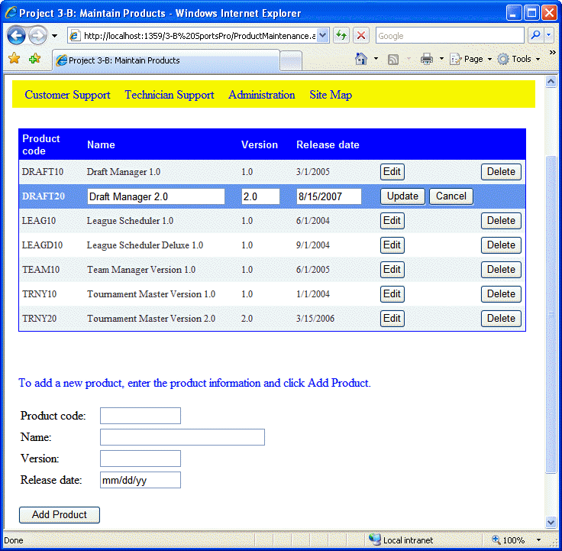
Operation
- When the user clicks the Edit button for a product, the product data is displayed in edit mode. Then, the user can modify the data and click the Update button to update the database. The user can also click the Cancel button to cancel the edit operation.
- When the user clicks the Delete button for a product, the product is deleted from the database.
- When the user enters the data for a new product into the text boxes and clicks the Add Product button, the product is added to the database.
Specifications
- The SQL data source for this project should retrieve all the columns and rows from the Products table, and it should sort the rows by the ProductCode column. It should generate Insert, Update, and Delete statements and use optimistic concurrency.
- The products should be displayed in a GridView control that provides for modifying all the columns except for the ProductCode column. You can format this control any way you like.
- Validate the data the user enters into the grid to be sure that a product name, version, and release date are provided and that the date is in a valid format. To do that, you’ll need to use templates. Display an indicator next to any field that has an error, and display the error messages in a validation summary control below the grid.
- Validate the data the user enters for a new product to be sure that a value is entered for each field and that the date is in a valid format. Display error messages to the right of any fields in error.
- When a product is updated or deleted, display an error message if an exception occurs or if the operation could not be performed.
- When a product is added, display an error message if an exception occurs. Otherwise, initialize the text boxes to prepare for the next entry.
- Be sure to set the EnableViewState property of the label you use to display error messages to False so it’s reset to its initial value each time the page is loaded.
Project 3-C: Maintain customers
For this project, you’ll create a page named CustomerMaintenance.aspx that lets the user maintain a selected customer using a DetailsView control. (Required reading: chapters 13, 14, and 15)
The design of the Customer Maintenance page
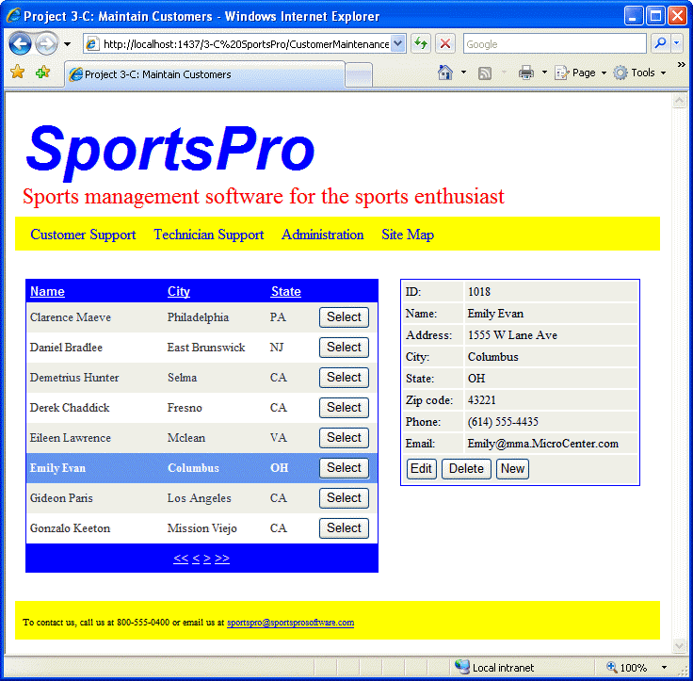
Operation
- When the user clicks the Select button for a customer in the GridView control, the data for that customer is displayed in the DetailsView control. To locate a customer, the user can use the page controls at the bottom of the GridView control or click on a column heading to sort the customers by that column.
- When the user clicks the Edit button for a customer, the customer data is displayed in edit mode. Then, the user can modify that data and click the Update button to update the database. The user can also click the Cancel button to cancel the edit operation.
- When the user clicks the Delete button for a customer, the customer is deleted from the database.
- When the user clicks the New button, the DetailsView control is placed in insert mode. Then, the user can enter the data for the customer into the text boxes that are provided and click the Insert button to add the customer to the database. The user can also click the Cancel button to cancel the insert operation.
Specifications
- The SQL data source for the GridView control should retrieve the three columns shown in the grid from the Customers table plus the CustomerID column, and it should sort the rows by the Name column.
- The SQL data source for the DetailsView control should retrieve all the columns for the customer that’s selected in the GridView control. It should generate Insert, Update, and Delete statements, and it should provide for optimistic concurrency.
- This project does not require validation controls. However, it should check for exceptions and concurrency errors and display an appropriate message if one occurs. Be sure to set the EnableViewState property of the label you use to display messages to False so it’s reset to its initial value each time the page is loaded.
- Format the GridView and DetailsView controls any way you like, but be sure to provide for sorting and paging in the GridView control.
Instructor note
- If you want to make this project more difficult, you can have your students use templates with the DetailsView control. In particular, you can have them replace the text box for the state with a drop-down list that’s bound to a SQL data source that retrieves all the states from the States table.
Project 3-D: Maintain technicians
For this project, you’ll create a page named TechnicianMaintenance.aspx that lets the user maintain a selected technician using a FormView control. (Required reading: chapters 13 and 15)
The design of the Technician Maintenance page
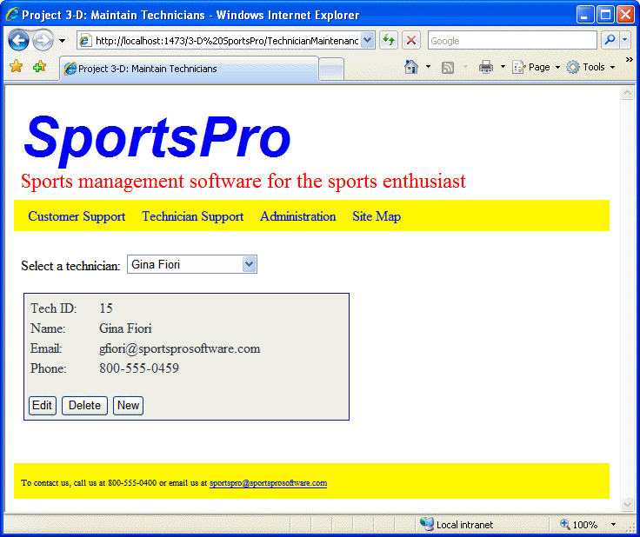
Operation
- When the user selects a technician from the drop-down list, the data for that technician is displayed in the FormView control.
- When the user clicks the Edit button for a technician, the technician data is displayed in edit mode. Then, the user can modify that data and click the Update button to update the database. The user can also click the Cancel button to cancel the edit operation.
- When the user clicks the Delete button for a technician, the technician is deleted from the database.
- When the user clicks the New button, the FormView control is placed in insert mode. Then, the user can enter the data for the technician into the text boxes that are provided and click the Insert button to add the technician to the database. The user can also click the Cancel button to cancel the insert operation.
Specifications
- The SQL data source for the drop-down list should retrieve the TechID and Name columns from the Technicians table and sort the rows by the Name column.
- The SQL data source for the FormView control should retrieve all the columns for the technician that’s selected in the drop-down list. It should generate Insert, Update, and Delete statements, and it should provide for optimistic concurrency.
- Validate the data the user enters into the FormView control to be sure that a technician name, email, and phone number are provided. Display an indicator next to any field that has an error, and display the error messages in a validation summary control to the right of the FormView control.
- Check for exceptions and concurrency errors, and display an appropriate message below the FormView control if one occurs.
- Format the FormView control any way you like.
Project 3-E: Display incidents

For this project, you’ll create a page named IncidentDisplay.aspx that displays all the incidents in a ListView control. (Required reading: chapters 13 and 16)
The design of the Incident Display page
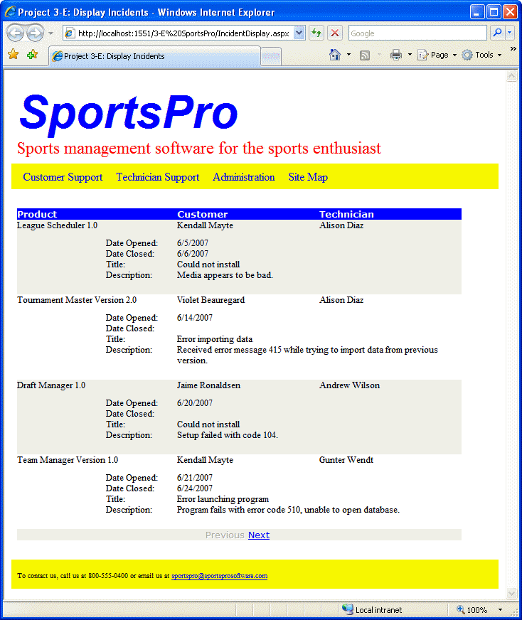
Operation
- When the page is first displayed, information for the first four incidents is displayed in the ListView control. Then, the user can click the Next and Previous link buttons in the DataPager control to display additional incidents.
Specifications
- The SQL data source for the ListView control should retrieve the DateOpened, DateClosed, Title, and Description columns from the Incidents. This table should be joined with the Products, Customers, and Technicians tables so the Name column from each of these tables can be retrieved. You will need to assign an alias to at least two of the name columns since the column names are the same.
- Format the ListView and DataPager controls as shown above. To make that easier to do, you can remove the outer table from the Layout template and then place the DataPager control in a separate table. Then, within the table row for the Item and Alternating Item templates, you can code a single table cell that spans all three columns of the table in the Layout template. Within that cell, you can code a table that defines the format of the data.
Project 3-F: Create incidents
For this project, you’ll create a page named IncidentCreation.aspx that lets the user enter new incidents. To do that, you’ll use three object data sources. (Required reading: chapters 13, 14, and 17).
The design of the Incident Creation page
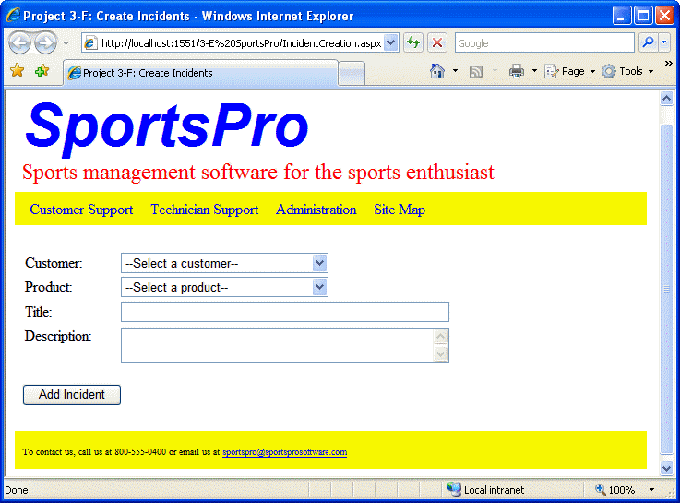
Operation
- When the user selects a customer from the Customers drop-down list, the products for that customer are displayed in the Products drop-down list. Then, the user can select a product, enter a title and description in the text boxes, and click the Add Incident button to add a new incident to the Incidents table.
Classes and methods used by this page
Class Method type Signature
IncidentDB Select public static IEnumerable GetIncidents()
Insert public static void InsertIncident(
int CustomerID,
string ProductCode,
string Title,
string Description)
CustomerDB Select public static IEnumerable GetCustomerList()
ProductDB Select public static IEnumerable
GetCustomerProducts(int CustomerID)
Specifications
- The Customers drop-down list is bound to an object data source that’s associated with a CustomerDB business object. The select method in this business object should retrieve the CustomerID and Name columns from the Customers table and sort them by the Name column.
- The Products drop-down list is bound to an object data source that’s associated with a ProductDB business object. The select method in this business object should retrieve all the ProductCode and Name columns for the selected customer and sort them by the Name column. (To get the products for a customer, you can join the Registrations and Products table and retrieve only the rows in the Registrations table with the specified CustomerID value.)
- The first item in each drop-down list should be a static item that includes instructions like the ones shown on the previous page. You should give these list items values that don’t conflict with the customer ID and product code values. To include these items in the lists along with the data bound items, you will need to set the AppendDataBoundItems property of the drop-down lists to True.
- When the user clicks the Add Incident button, the insert method in an object data source that’s associated with an IncidentDB business object should be used to add the new incident. To do that, you’ll need to create and execute a command object with the appropriate Insert statement and parameters. (Note that the DateOpened column of a new incident is set to the current date, so the insert method doesn’t accept this parameter.)
- Validate the data on the page to be sure that a customer and product are selected and that values are entered for the title and description.
- Check for exceptions when a new incident is added, and display an appropriate message if one occurs.
Instructor note
- If you prefer, you can have your students implement the insert method of the IncidentDB class so it receives an Incident object. You can also have your students implement the select methods of the IncidentDB, CustomerDB, and ProductDB classes so they return Incident, Customer, and Product objects.
Project 3-G: Update incidents
For this project, you’ll create a page named IncidentUpdate.aspx that lets the user update the rows in the Incidents table. To do that, you’ll use two object data sources. (Required reading: chapters 13, 14, and 17)
The design of the Incident Update page
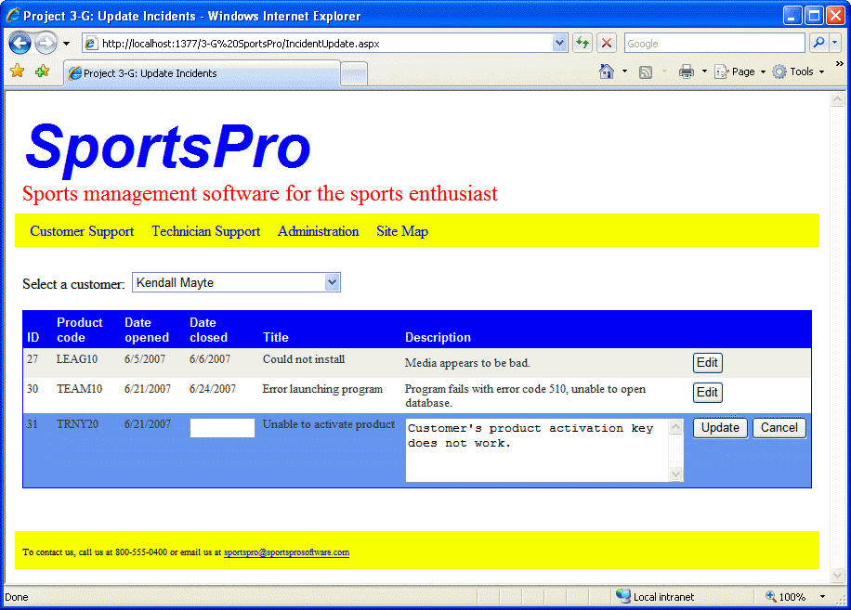
Operation
- When the user selects a customer from the drop-down list, all the incidents for that customer are displayed in a GridView control.
- When the user clicks the Edit button for one of the Incidents, the incident is displayed in edit mode. Then, the user can change the date closed or the description for the incident and click the Update button to update the database. The user can also click the Cancel button to cancel the edit operation.
Classes and methods used by this page
Class Method type Signature
CustomerDB Select public static IEnumerable
GetCustomersWithIncidents()
IncidentDB Select public static IEnumerable
GetCustomerIncidents(int CustomerID)
Class Method type Signature
IncidentDB Update public static int UpdateIncident(
DateTime DateClosed,
string Description,
int original_IncidentID,
string original_ProductCode,
DateTime original_DateOpened,
DateTime original_DateClosed,
string original_Title,
string original_Description)
Specifications
- The Customers drop-down list is bound to an object data source that’s associated with a CustomerDB business object. The select method in this business object should retrieve only the customers who have incidents that have been assigned to a technician and sort them by the Name column. To select these customers, you can use a subquery in the Select statement like this:
SELECT CustomerID, Name
FROM Customers
WHERE CustomerID IN
(SELECT DISTINCT CustomerID FROM Incidents
WHERE TechID IS NOT NULL)
ORDER BY Name
- The GridView control is bound to an object data source that’s associated with an IncidentDB business object. The select method in this business object should retrieve only the incidents for the selected customer that have been assigned to a technician.
- When the user clicks the Update button, the update method in the IncidentDB business object should be used to update the incident. To do that, you’ll need to create and execute a command object with the appropriate Update statement. Be sure the Update statement implements optimistic concurrency and that it provides for null values in the DateClosed column.
- Because the Description column can contain up to 2000 characters, you’ll want to display it in a multiline text box. To do that, you need to convert the Description field in the GridView control to a template field and then set the properties of the text box appropriately.
- If you want to change the width of the text box that’s displayed for the DateClosed field, change the Width property of the ControlStyle element for that field.
- Because the DateClosed column of an incident can contain a null value, you’ll need to include some additional code in the update method of the IncidentDB class to get this method to work correctly. That’s because the value “01/01/0001 12:00:00 AM” is passed to the method if the column is null, and that is not the value you want to store in the database. So your method will need to set the DateClosed parameter like this:
if (DateClosed == Convert.ToDateTime("01/01/0001 12:00:00 AM"))
cmd.Parameters.AddWithValue("DateClosed", DBNull.Value);
else
cmd.Parameters.AddWithValue("DateClosed", DateClosed);
You’ll need to use similar code for the original_DateClosed parameter.
- Check for exceptions and concurrency errors when an incident is updated, and display an appropriate message if one occurs.
Instructor note
- If you prefer, you can have your students implement the update method of the IncidentDB class so it receives Incident objects. You can also have your students implement the select methods of the CustomerDB and IncidentDB classes so they return Customer and Incident objects.
Project 3-H: Display technician incidents by product
For this project, you’ll create a page named TechnicianIncidentSummary.aspx that lets the user display the count of incidents for a technician by product. To do that, you’ll use two LINQ data sources. (Required reading: chapters 13, 14, and 18)
The design of the Technician Incident Summary page
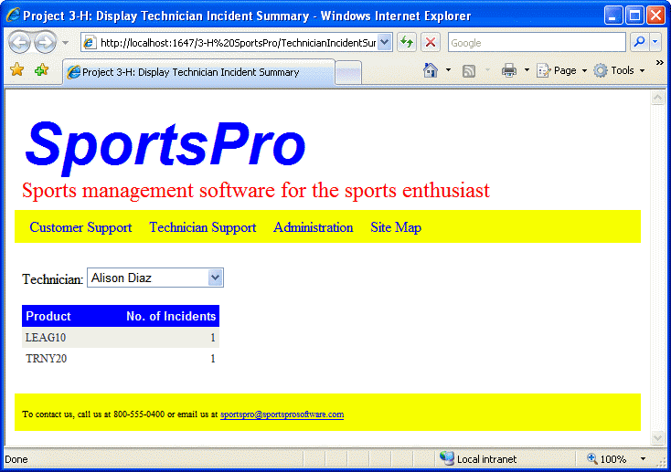
Operation
- When the page is first displayed, the incident information for the first technician in the drop-down list is displayed in a GridView control. After that, the information for the technician that the user selects from the drop-down list is displayed.
Specifications
- The object model for this page should include two entity classes. The first entity class should retrieve the TechID and Name columns from the Technicians table, and the second entity class should retrieve the ProductCode and TechID columns from the Incidents table.
- Because the SportsPro application already contains a class named Incident, you will have to use a different name for the entity class you create from the Incidents table. To maintain the pluralization of the names for both the Incidents and Technicians tables, you can change the appropriate pluralization option. Or, after you create an entity class, you can select it in the designer and then change its name in the Properties window.
- The LINQ data source for the drop-down list should retrieve both columns defined in the entity class for the Technicians table and all the rows in this table, sorted by the Name column.
- The LINQ data source for the GridView control should retrieve all the rows from the Incidents table for the technician that’s selected in the drop-down list. It should group and sort the incidents by the ProductCode column, and it should include a count of the incidents for each product.
Project 4-A: Add user authentication
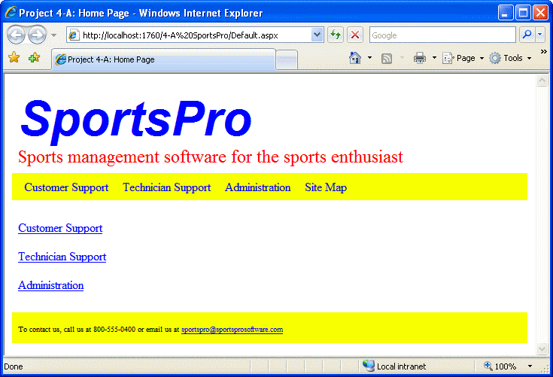
For this project, you will add roles, users, and access rules to the web site, you’ll create a login page, and you’ll implement pages named Default.aspx, CustomerSupport.aspx, TechnicianSupport.aspx, and Administration.aspx that let users access various parts of the web site. If you have not already enabled forms-based authentication, you will need to do that before beginning this project. (Required reading: chapter 20)
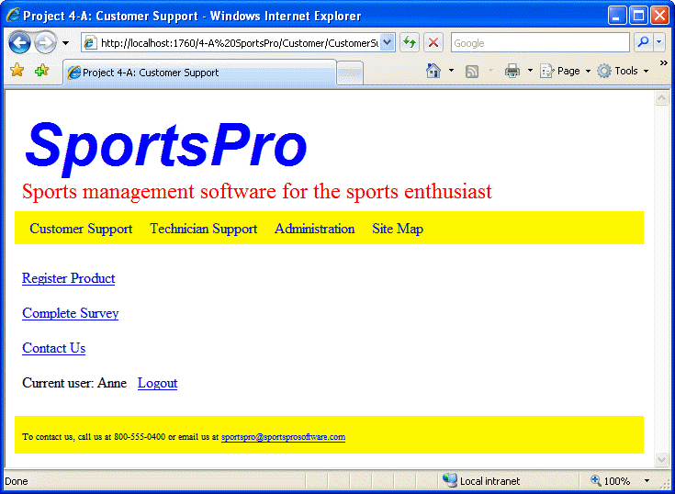
The design of the Default and Customer Support pages
Operation
- When the user clicks a hyperlink on the Default page, a login page is displayed. Then, if the user enters a valid user name and password and that user is authorized to view the selected page, that page is displayed.
- When the user clicks a hyperlink on the Administration, Technician Support, or Customer Support page, the appropriate page is displayed. The user can also click the Logout link on any of these pages to log out and redisplay the login page.
Specifications
- Add roles named Admin, Tech, and Customer. Then, add yourself as a user to the Admin role, add the five technicians in the Technicians table as users to the Tech role, and add at least a couple of customers from the Customers table to the Customer role. When you add the users, you’ll want to develop a simple scheme for the passwords and security questions and answers so you can remember them.
- Add three new folders named Admin, Tech, and Customer to the web site. Then, use the web.sitemap file to determine which pages to move to these folders, and update the URLs for these pages in the web.sitemap file so they point to the correct locations. When you’re done, all of the pages except for Default and Map should be in a folder. If any of the pages you move contain a button with a PostBackUrl attribute, you’ll need to update that attribute as well so it points to the correct location.
- Add access rules that only allow users in the Admin role access to the pages in the Admin folder, that allow users in the Admin and Tech roles access to the pages in the Tech folder, and that allow users in the Admin and Customer roles access to the pages in the Customer folder.
- The Login page should consist of just a Login control. You can format this control any way you like.
- Add the appropriate hyperlinks to the Default, Administration, Technician Support, and Customer Support pages. In addition, include LoginName and LoginStatus controls on the Administration, Technician Support, and Customer Support pages.
Instructor note
- The users currently in the TechSupport web site are as follows:
Role Name Password
Admin Anne Anne$Boehm
Tech Alison Alison$Diaz
Jason Jason$Lee
Andrew Andrew$Wilson
Gunter Gunter$Wendt
Gina Gina$Fiori
Customer Kenzie Kenzie$Quinn
Kendall Kendall$Mayte
The password for each user is the user’s first and last names, separated by a dollar sign. The security question for each user is “What is your last name?” And the security answer for each user is the user’s last name starting with a capital letter. You may want to add yourself as a user in the Admin role if you plan on demonstrating this project to your students.
Project 4-B: Assign incidents
For this project, you’ll create a page named IncidentAssignment.aspx that uses a MultiView control with three views to assign an incident to a technician. Unless you’re instructed otherwise, you should use SQL data sources for this project. (Required reading: chapters 13, 14, and 22)
The first view of the Incident Assignment page
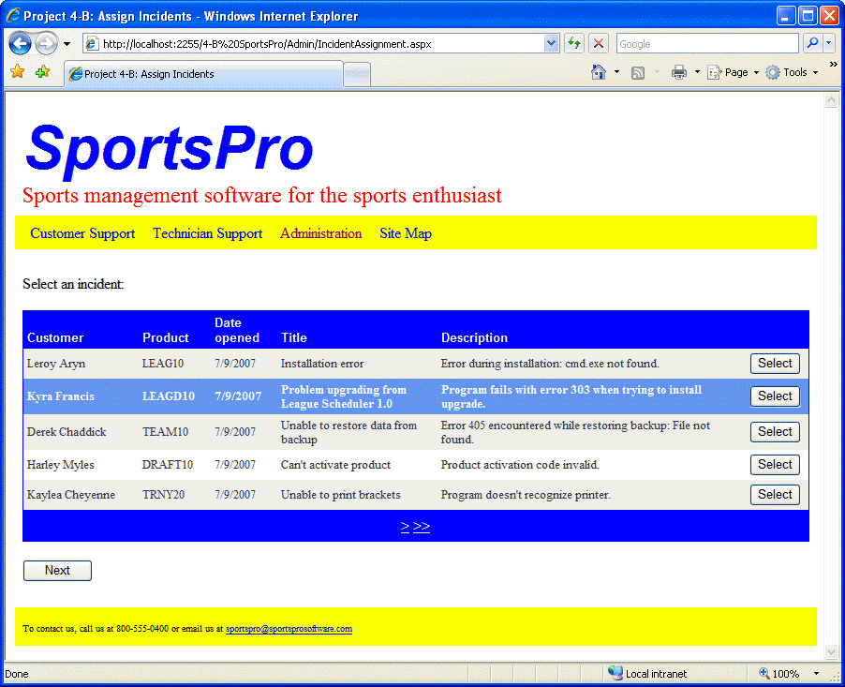
Operation
- When this application first starts, all of the incidents that have not been assigned to a technician (TechID IS NULL) are displayed in a GridView control in the first view of a MultiView control.
- When the user clicks the Select button for an incident and then clicks the Next button, the second view of the MultiView control is displayed. If the user clicks the Next button without selecting an incident, an error message is displayed.
Specifications
- The Select statement that retrieves the data for the GridView control joins data from the Incidents and Customers tables. It should retrieve the IncidentID in addition to the columns shown above.
- To prevent the next view from being displayed if the user clicks the Next button without selecting an incident, you’ll need to code a Click event handler for this button.
The second view of the Incident Assignment page
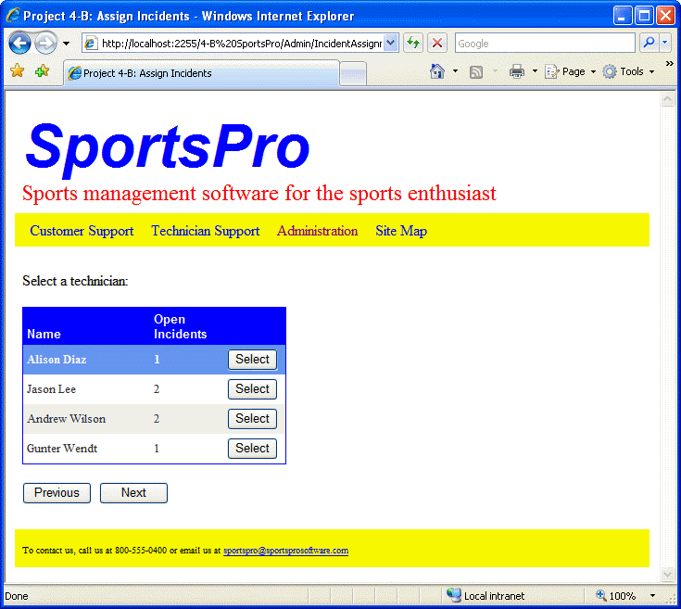
Operation
- The second view of the MultiView control displays the number of open incidents for each technician.
- When the user clicks the Select button for a technician and then clicks the Next button, the third view of the MultiView control is displayed. If the user clicks the Next button without selecting a technician, an error message is displayed.
- When the user clicks the Previous button, the previous view is displayed.
Specifications
- To get the number of open incidents for each technician, you can use a Select statement like this:
SELECT Technicians.TechID, Technicians.Name,
COUNT(*) AS OpenIncidents
FROM Incidents INNER JOIN Technicians
ON Incidents.TechID = Technicians.TechID
WHERE (Incidents.DateClosed IS NULL)
GROUP BY Technicians.Name, Technicians.TechID
Note that the TechID column is included but not displayed in the GridView control.
- Before displaying the next view, the data for that view should be retrieved and assigned to the appropriate controls. To retrieve the necessary data, you’ll need to create data views from the data sources for the two GridView controls, and you’ll need to create data row views for the selected rows. You should save the data row views in session state so they can be used to get the data that’s needed to update an incident.
The third view of the Incident Assignment page
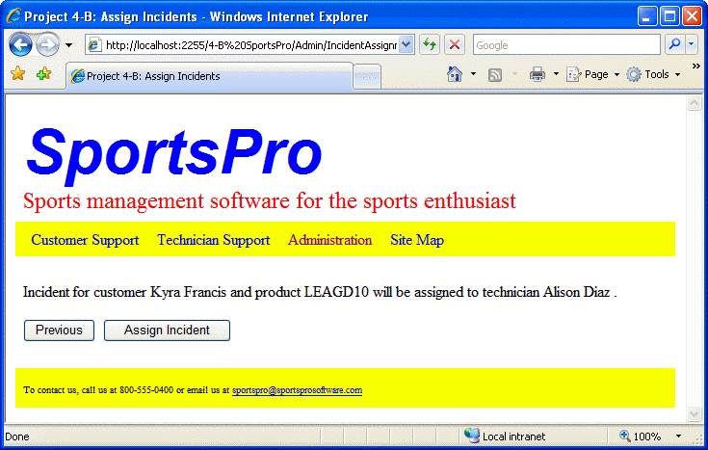
Operation
- The third view of the MultiView control displays a summary of the selections made in the first two views.
- When the user clicks the Assign Incident button, the selected incident is updated with the ID for the selected technician. If an error occurs, an appropriate message is displayed. Otherwise, the selections are cleared from the two GridView controls, the two GridView controls are updated so they display the current data, and the first view is redisplayed.
- When the user clicks the Previous button, the previous view is displayed.
Specifications
- The third view should include a data source that can be used to update the selected incident. This data source should retrieve just the IncidentID and TechID columns for the selected incident. Be sure to generate Insert, Update, and Delete statements, but don’t use optimistic concurrency.
- To update an incident, you’ll need to set the values of the update parameters for the data source and then execute the Update statement. You can use the data row views that were saved in session state to get the values that are needed for the parameters.
Project 4-C: Register products
For this project, you’ll create a page named ProductRegistration.aspx that lets the user register a product. When a product is registered, an email confirmation will be sent to the user. For this to work under Windows XP, you will need to configure the SMTP service in IIS. For this to work under Windows Vista, you will need to have access to a separate SMTP server. (Required reading: chapters 13, 14, and 23)
The design of the Product Registration page
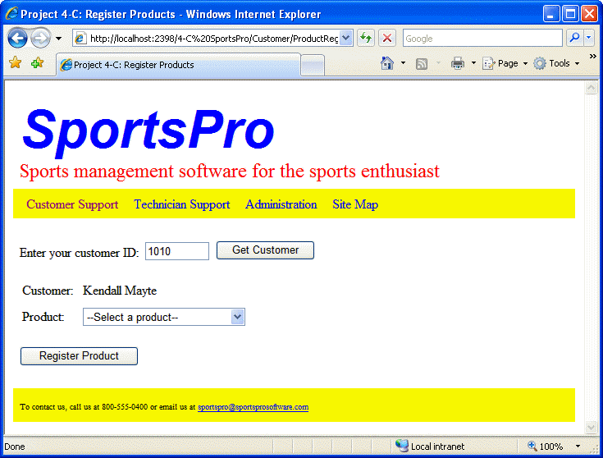
An email sent by this page
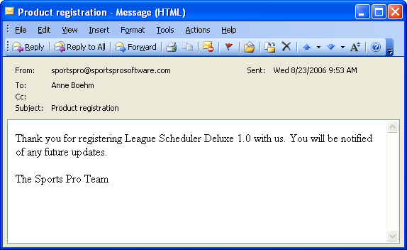
Operation
- When the user enters a valid customer ID and clicks the Get Customer button, the customer name is displayed and the Register Product button is enabled. (This button is disabled when the page is first displayed.)
- When the user selects a product and clicks the Register Product button, a row is added to the Registrations table, an email message is sent to confirm the registration, and the controls on the page are reinitialized. If an error occurs, an appropriate message is displayed.
Specifications
- This page requires three data sources: one that gets the row for the specified customer from the Customers table, one that gets a list of products from the Products table, and one that can be used to insert rows into the Registrations table. Don’t worry about displaying just the products that the customer hasn’t already registered. Instead, display an error message if a duplicate key or any other exception occurs.
- Validate the Customer ID text box to be sure the user enters an integer value that exists in the Customers table. To do that, you’ll need to use three validators, including a custom validator. Validate this text box only when the user clicks the Get Customer button.
- Validate the Products drop-down list to be sure the user has selected a value before clicking the Register Product button.
- To confirm that the email message is sent correctly, you’ll want to send it to your own email address.
Project 4-D: Add custom error handling
For this project, you’ll add custom error handling to one or more pages of the web site, and you’ll modify the web.config file to handle HTTP errors.
The design of the custom error page
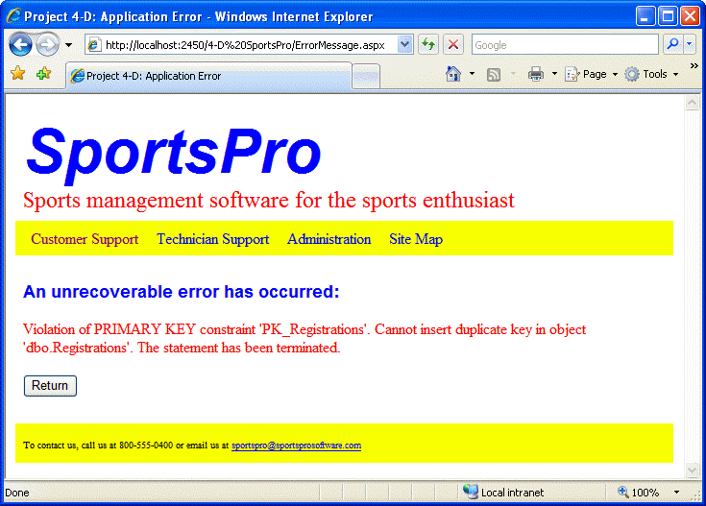
Operation
- Any time an exception is caught by a try-catch statement, the application is redirected to the error page shown above and the message associated with the exception is displayed.
- When the user clicks the Return button, the page that caused the exception is redisplayed.
Specifications
- Error handling should be added to one or more of the following pages: Incident Creation, Incident Assignment, Product Maintenance, and Product Registration.
- You should create one page named ErrorMessage.aspx to display any application errors.
- Be sure to include the appropriate path in the statements that redirect to another page.
The design of a page that displays a message for an HTTP error
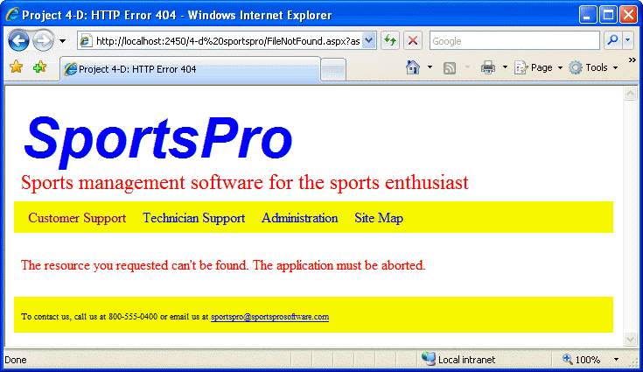
Operation
- Any time an HTTP error occurs, a page similar to the one shown above is displayed. Then, the user must end the application
Specifications
- You should create three separate pages to handle HTTP errors. The first page, named FileNotFound.aspx (shown above), should handle HTTP error 404. The second page, named NoAccess.aspx, should handle HTTP error 403. And the third page, named HttpError.aspx, should handle any other HTTP error. Each of these pages should display appropriate messages.

