**DISTRIBUTED EFFECTIVE IMPERVIOUS AREAS (EIA) TOOLBOX USER MANUAL**

User Manual for the ArcGIS 10.7 EIA Toolbox

Prepared by

Anneliese Sytsma

UC Berkeley

# Background

The method presented herein refers to hydrologically connected impervious areas as ‘effective impervious areas’, or EIA. The conceptual model presented Sytsma et al., 2019 considers three types of impervious surface, described below and shown inFigure 1**.** First, impervious surfaces which are physically connected to the storm drainage system are considered ‘physically contributing impervious’ *A*phys. Second, the impervious surfaces which are not physically connected to the storm drainage network but rather produce run-on which is routed to pervious areas, are considered ‘variably contributing impervious’ *A*var. Under the traditional definition of DCIA, such impervious surfaces would be thought of as ‘disconnected impervious areas’; however, as discussed above, the hydrologic contribution of these surfaces depends on soil conditions, slopes, and rainfall. Third, roofs are designated as ‘roof areas’ *A*roof.

These impervious surface categories can be extracted using remote sensing and geospatial data; however, estimating the degree to which each of these surfaces contributes to storm runoff is more challenging. The EIA along the flow path shown inFigure 1can therefore be described using mass balance as:

; (1)

wherephys, var, and roofrefer to the fraction of incident rainfall that contributes to runoff response. Because *A*physis directly connected to the stormwater network, we assume phys is a constant value of 1. Hydrologic connectivity of rooftops roof presents a challenge; not even the physical connectivity of rooftops can be discerned from remote sensing or GIS datasets alone (Han and Burian, 2009; Redfern et al., 2016). Thus, determining the value of roof for roof area may require site-specific surveys and field investigations. Connectivity of *A*var surfaces var, however, presents a separate challenge. The relative areas of impervious and downslope pervious, soil conditions, slope, and rainfall intensity can all affect the degree to which *A*var is hydrologically connected.

The methods for developing the EIA ArcGIS tool proceeded in three main steps, shown schematically in Figure 2 and described below. The first step was to develop generalized relationship for var as a function of the downslope pervious area, soil conditions, slopes, and rainfall. This step utilized the Python API for Stormwater Management Model (SWMM) (PySWMM), to generate infiltration and runoff data. In the second step we trained and tested a regression tree to estimate connectivity fractions based on the PySWMM model outcomes. In the third step, we developed an ArcGIS tool to implement the proposed conceptual framework and apply connectivity fractions to determine EIA at the watershed scale.

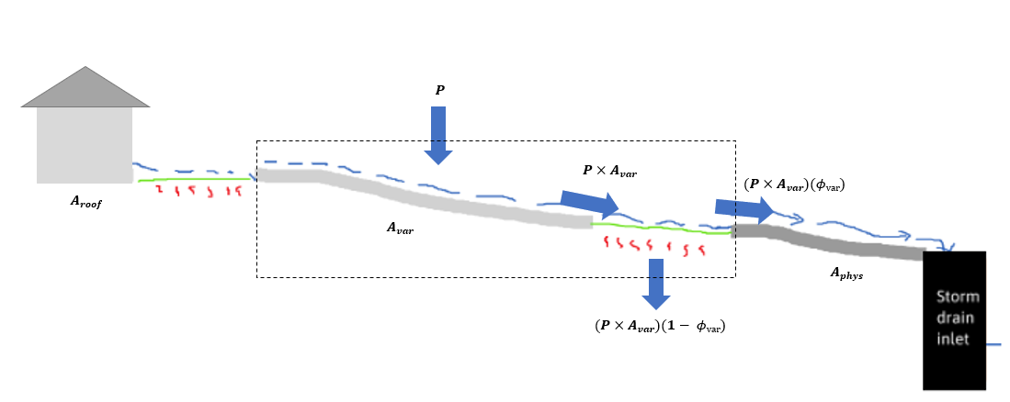

Figure 1. Conceptual model separates impervious surfaces into three categories: directly or physically connected (A**phys**), variably connected (Avar) (impervious that drains to pervious) and fractionally connected (Aroof) (rooftops).

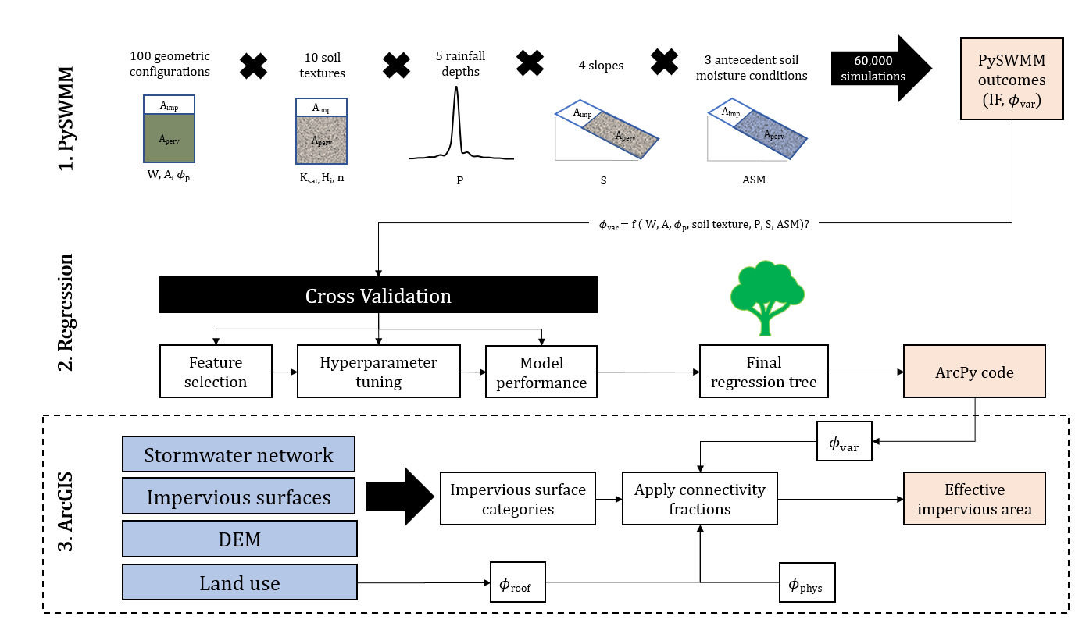

Figure 2. Schematic overview of methods used to determine relationship that relates landscape features to var (PySWMM and Regression) and coupling with methods for extracting EIA at the watershed scale (ArcGIS).

# System Requirements

The tool was developed in ArcGIS 10.7 and requires the Spatial Analyst extension and ArcHydro tools. ArcHydro is available for download at the following link: <http://downloads.esri.com/archydro/archydro/>

# DCIA Toolbox Installation

## **Installation steps**

## **Preparing ArcMap for Toolbox Use**

1. File structure
   1. Create a new folder to house inputs and outputs
   2. Create a new file geodatabase to hold input data (‘In.gbd’)
   3. Create a new file geodatabase to hold output data (‘Out.gbd’)
2. Set default workspace
   1. Geoprocessing🡪Environments🡪Workspace
   2. Set Current Workspace to your ‘Out.gbd’ path
3. Pathnames
   1. File🡪 Map Document Properties
   2. Select ‘store relative pathnames to data sources’

# Using the DCIA Toolbox

## **Input data**

The following input data are required for using the DCIA toolbox:

|  |  |  |
| --- | --- | --- |
| **Data** | **Data type** | **Requirements** |
| Digital elevation model (DEM) | Raster | Sufficient resolution for urban areas (< 3 m recommended) |
| Impervious surfaces | Polygon | A field designating each polygon into one of three impervious classes: (1) Roof, (2) Roads, (3) Other. |
| Area of interest | Polygon | Can be a watershed or city boundary, etc. |
| Drainage points | Point | Manholes, catch basins, etc. |
| Land use | Polygon | A field designating each land use type of each polygon. Up to 3 land use types are supported. |
| NRCS Ksat soil data | Polygon | Download NRCS soil data [here](https://websoilsurvey.sc.egov.usda.gov/App/WebSoilSurvey.aspx).  - import area of interest  - select ‘soil data explorer’ tab  - select’ soil properties and qualities’ tab  - expand ‘soil physical properties’  - select ‘saturated hydraulic conductivity (Ksat)’  - select ‘view rating’, then ‘add to shopping cart’  - click on ‘shopping cart’ and click the download link. |

**Limitations**

The EIA ArcGIS tool was developed for a finite number of scenarios. These parameters for which the EIA ArcGIS tool is accurate are summarized in the following table:

|  |  |  |  |  |
| --- | --- | --- | --- | --- |
| Parameter | Description | Units | Values | Count |
| Constants | | | | 1 |
| *N*imperv | Manning’s n - impervious | -- | 0.01 | 1 |
| *N*perv | Manning’s n - pervious | -- | 0.1 |
| *D*store-imperv | Storage - impervious | mm | 1.27 |
| *D*store-perv | Storage - pervious | mm | 2.54 |
| Soil/rainfall scenarios | | | | 600 |
| Soil texture | Sand - clay | -- | See Table 2 | 10 |
| *ASM* | Antecedent soil moisture condition | -- | SAT, FC, WP1 | 3 |
| *P* | 24-hr precipitation depth | cm | 1.5, 2.5, 5, 7.6, 10.2 | 5 |
| *S* | Slope | % | 1, 2, 3, 4 | 4 |
| Subcatchment configurations | | | | 100 |
| *A* | Total subcatchment area | hectare | [0 to 1] | 100 |
| *Φ*p | Pervious fraction | -- | [0 to 1] |
| *L* | Flow path length | m | [1 to 152] |
| *W* | Width of overland flow path | m | A/L |

1 SAT = saturated, FC = field capacity, WP = wilting point

Of particular importance to note are the precipitation and soil scenarios, which are limited to five precipitation depths across a SCS Type II, 24-hr storm duration, and 10 different soil textures.

## **Step 1: DEM Processing and Subcatchments**

### **Step 1a: Recondition DEM**

The purpose of this step is to adjust the DEM values to enforce initial flow direction according to the stormwater network. This forces flowpaths along stormwater networks by decreasing the elevation at these points. This function is an implementation of the AGREE method developed by Ferri Hellweger at the University of Texas in 1997.

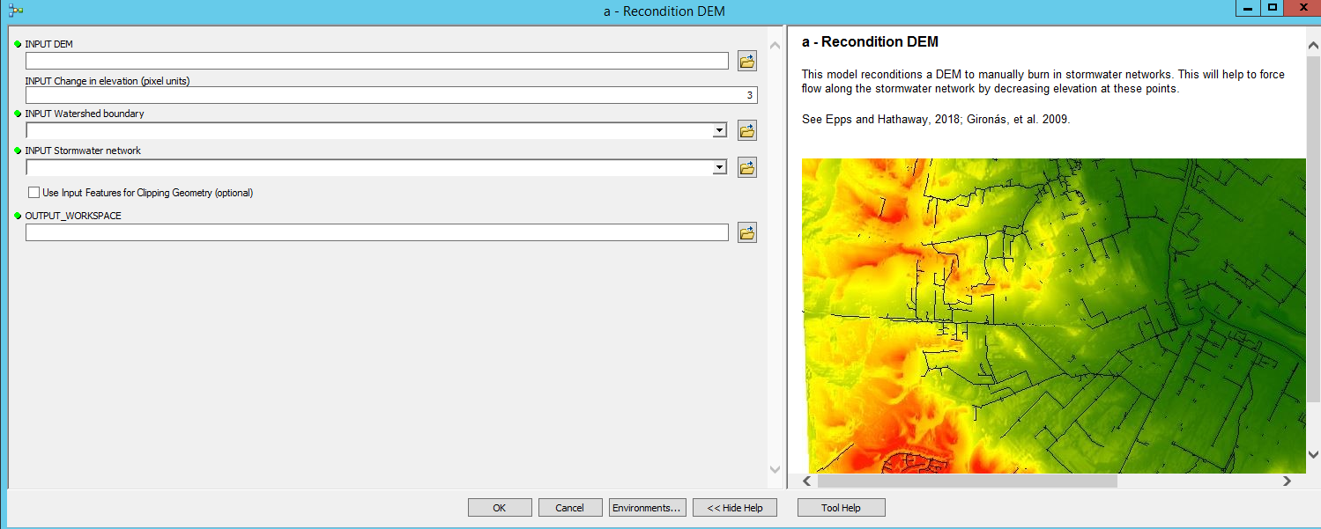

Input data:

1. DEM (raster)
2. Area of interest clip the DEM to (polygon)
3. Stormwater network (polyline)
4. Sharp drop in Z units (value)
5. Output workspace (geodatabase)

Outputs:

1. Reconditioned DEM (%OUTPUT_WORKSPACE%/dem_agree) (raster)
2. Filled DEM (%OUTPUT_WORKSPACE%/dem_fill) (raster)

The tool proceeds in the following steps:

1. *Clip* *raster*
   1. Input raster: DEM
   2. Output extent: area of interest
   3. Output raster: DEM_clip
2. *Resample* 
   1. Input raster: DEM_clip
   2. Output cell size: 1 x 1 (ft)
   3. Output raster: DEM_resample
3. *Clip*
   1. Input features: stormwater network
   2. Clip features: area of interest
   3. Output feature class: SW_clip
4. *Fill sinks*
   1. Input DEM: DEM_clip
   2. Output hydro DEM: dem_fill
5. *DEM reconditioning*
   1. Input raw DEM: dem_fill
   2. Input AGREE stream: sw_clip
   3. Number of cells for stream buffer: 5
   4. Smooth Drop in Z Units: 10
   5. Sharp drop in Z Units: user defined (1-3 recommended)
   6. Output AGREE DEM: dem_agree
   7. Raise negative values: false

### **Step 1b: Flowpath delineation**

The purpose of this step is to delineate flowpaths using the reconditioned DEM from Step 1a. Flow direction (D8) algorithm is used to generate flow direction grid where each cell indicates the direction of the steepest descent from that cell. Flow accumulation uses the flow direction grid to compute a flow accumulation grid that contains the number of accumulated cells upstream of each input cell. Stream are then defined based on a flow accumulation threshold value, which is entered by the user. Note the subsequent steps are highly sensitive to this threshold value, so the user should select this value carefully.

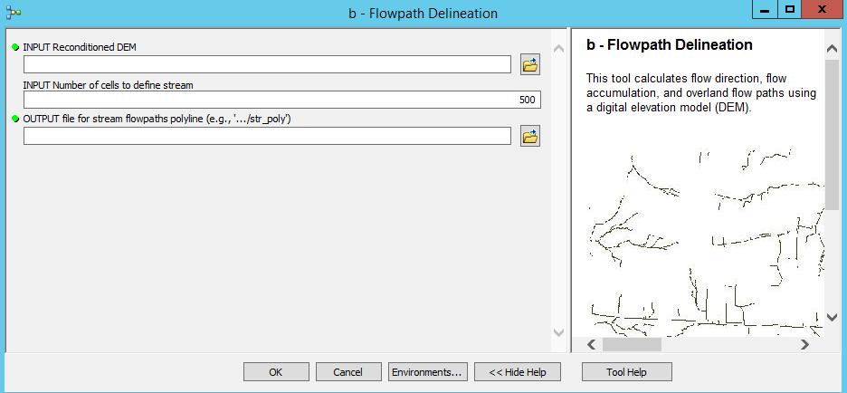

Input data:

1. Number of cells to define a stream (value)
2. Output workspace (geodatabase)

Outputs:

1. Flow direction (%OUTPUT_WORKSPACE%/fdr) (raster)
2. Flow paths (%OUTPUT_WORKSPACE%/str_poly)(polyline)
3. Stream links (%OUTPUT_WORKSPACE%/str_lnk) (raster)

The tool proceeds in the following steps:

1. *Flow direction*
   1. Input hydro DEM: dem_agree (from Step 1a)
   2. Output flow direction grid: fdr
2. *Flow accumulation*
   1. Input flow direction grid: fdr
   2. Output flow accumulation grid: fac
3. *Stream definition*
   1. Input flow accumulation grid: fac
   2. Number of cells to define a stream (user defined)
   3. Output stream grid: strm
4. *Stream segmentation*
   1. Input stream grid: strm
   2. Input flow direction grid: fdr
   3. Output stream link grid: str_lnk
5. *Drainage line processing*
   1. Input stream link grid: str_lnk
   2. Input flow direction grid: fdr
   3. Output drainage line: str_poly

### **Step 1c: Subcatchments (sink drainage points)**

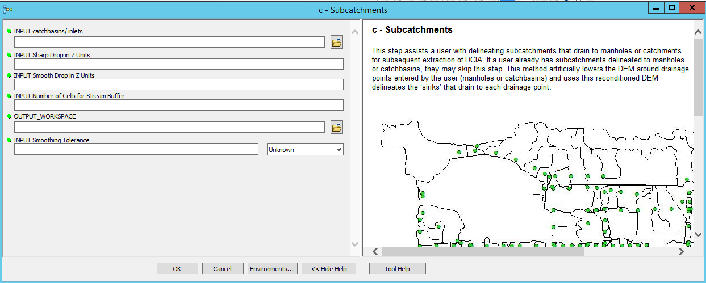This step assists a user with delineating subcatchments that drain to manholes or catchments for subsequent extraction of EIA. If a user already has subcatchments delineated to manholes or catchbasins, they may skip this step. This method artificially lowers the DEM around drainage points entered by the user (manholes or catchbasins) and uses this reconditioned DEM delineates the ‘sinks’ that drain to each drainage point.

Input data:

1. Manholes or catchbasins (points)
2. Sharp drop in Z units (value)
3. Smooth drop in Z units (value)
4. Number of cells for buffer (value)
5. Smoothing tolerance (value)
6. Output workspace (geodatabase)

Outputs:

1. Subcatchments (%OUTPUT_WORKSPACE%/subcatchments) (shapefile)

The tool proceeds in the following steps:

1. *Assign hydroID*
   1. Input manholes or catchbasins: CBs (user defined)
   2. Output modified input
2. *Buffer*
   1. Input modified manholes or catchbasins: CBs
   2. Distance = 10 feet
   3. Output: cbs_buff
3. *Polygon to Raster*
   1. Input: cbs_buff
   2. Value field: HydroID
   3. Output: cbs_ras
4. *DEM Reconditioning*
   1. Inputs:
      1. Filled DEM: dem_fill (from Step 1a)
      2. Smooth drop in Z units (user defined)
      3. Sharp drop in Z units (user defined)
      4. Number of cells for stream buffer (user defined)
   2. Outputs:
      1. Reconditioned DEM (raster)
5. Sink Evaluation
   1. Input: Reconditioned DEM (raster)
   2. Output:
      1. Sink polygon (sink_poly) (polygon)
      2. Sink drainage area (sink_da) (polygon)
   3. NOTE: This process will result in an error if the projections in the map are not consistent.
6. Smooth Polygon
   1. Input: sink_da
   2. Smoothing algorithm: PAEK
   3. Smoothing tolerance (user defined) (value, ft)
   4. Output: subcatchments

## **Step 2: Impervious Area Classification**

This group of tools uses inputs for impervious surfaces and land use to designate impervious surface polygons as one of three types on impervious area: Aroof (roof top areas), Avar, and Aphys.

### **Step 2a: Aroof**

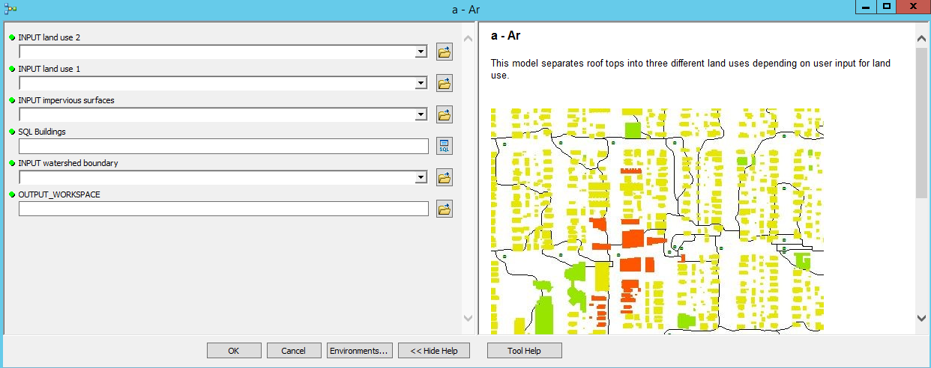This step uses inputs for impervious surface (with pre-defined classifications as roof/road/other), along with land use polygons, to classify roof areas by land use.

Input data:

1. Impervious surfaces (shapefile)
2. Land use 1 (shapefile)
3. Land use 2 (shapefile)
4. SQL Buildings (user defined)
5. Subcatchments (from step 1c)
6. Output workspace (geodatabase)

Outputs:

1. A_roof (%OUTPUT_WORKSPACE%/A_roof) (shapefile)
2. A_roof_1 (%OUTPUT_WORKSPACE%/A_roof_1) (shapefile)
3. A_roof_2 (%OUTPUT_WORKSPACE%/A_roof_2) (shapefile)
4. A_roof_other (%OUTPUT_WORKSPACE%/A_roof_other) (shapefile)

The tool proceeds in the following steps:

1. *Clip*
   1. Input features: impervious surfaces (shapefile)
   2. Clip features: subcatchments (user defined)
   3. Output: imp_clip (shapefile)
2. *Dissolve*
   1. Input: imp_clip
   2. Output: imp_diss
3. *Select Layer by Attribute*
   1. Input: imp_clip (shapefile)
   2. Selection Type: NEW_SELECTION
   3. Expression: user defined (select buildings)
   4. Output: A_roof (shapefile)
4. *Select Layer by Location*
   1. Input feature layer: A_roof (shapefile)
   2. Relationship: HAVE_THEIR_CENTER_IN
   3. Selecting features: Land use 1 (user defined)
   4. Selection type: NEW_SELECTION
   5. Output: A_roof_1
5. *Select Layer by Location*
   1. Input feature layer: A_roof (shapefile)
   2. Relationship: HAVE_THEIR_CENTER_IN
   3. Selecting features: Land use 2 (user defined)
   4. Selection type: NEW_SELECTION
   5. Output: A_roof_2
6. *Erase*
   1. Input: A_roof (shapefile)
   2. Erase features: A_roof_1 (shapefile)
   3. Output: A_roof_erase (shapefile)
7. *Erase*
   1. Input: A_roof_erase (shapefile)
   2. Erase features: A_roof_2 (shapefile)
   3. Output: A_roof_other (shapefile)

### **Step 2b: Avar**

This step identifies the Avar surfaces. This is achieved through the use of the cost distance allocation and cost path functions in ArcGIS. The process consists of six main steps: (1) first guess at A_phys (A_phys_temp; impervious that intersects with flowpaths) and A_var (A_var_temp; all other impervious that is not a roof) surfaces; (2) centroid point to represent first guess at A_var_temp; (3) pervious flow path length between from A_phys_temp to A_var_temp; (4) association of pervious flow path length with A_var_temp centroid point; (5) association of A_var_temp centroid point with A_var; and (6) exporting final A_var surfaces (A_var_temp with pervious flow length > 0) and A_phys_temp2 (A_var_temp with pervious flowpath = 0). The functions and 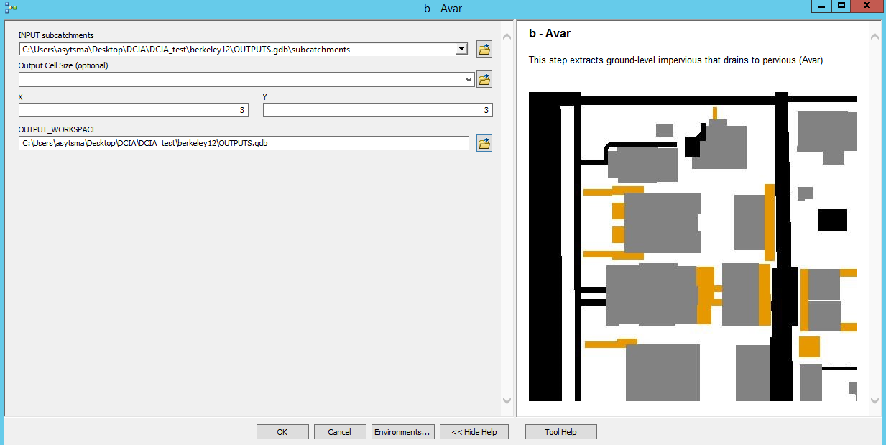tools used in each step are described in more detail below.

Input data:

1. Subcatchments (from step 1c)
2. Output workspace (geodatabase)

Outputs:

1. A_var_final (%OUTPUT_WORKSPACE%/A_var_final) (shapefile)

The tool proceeds in the following steps:

1. **First guess at A_phys**
   1. *Erase* 
      1. Input features: subcatchments (shapefile)
      2. Erase features: imp_diss (shapefile)
      3. Output: perv (shapefile)
   2. *Clip*
      1. Input features: imp_diss
      2. Clip features: subcatchments
      3. Output: imp_urban
   3. *Erase*
      1. Input features: subcatchments (shapefile)
      2. Erase features: A_roof (shapefile)
      3. Output: subcat_erase (shapefile)
   4. *Erase*
      1. Input features: imp_urban (shapefile)
      2. Erase features: subcat_erase (shapefile)
      3. Output: noroofs (shapefile)
   5. *Multipart to single part*
      1. Input: noroofs
      2. Output: groundlevel_imp
   6. *Add geometry attributes*
      1. Input: groundlevel_imp
      2. Geometry parameters: AREA
      3. Length: feet
      4. Area: square feet
   7. *Select layer by location*
      1. Input: groundlevel_imp
      2. Relationship: Intersect
      3. Selecting features: str_poly
      4. Selection type: NEW_SELECTION
   8. *Copy features*
      1. Input features: groundlevel_imp
      2. Output: A_phys_temp (see Fig 3)
   9. *Add field*
      1. Input features: A_phys_temp
      2. Field: f_phys
      3. Type: FLOAT
2. **Point to represent A_var**
   1. *Erase*
      1. Input: subcat_erase
      2. Erase: A_phys_temp
      3. Output: cost_path_diss
   2. *Erase*
      1. Input: cost_path_diss
      2. Erase: perv
      3. Output: cost_path_diss_erase
   3. 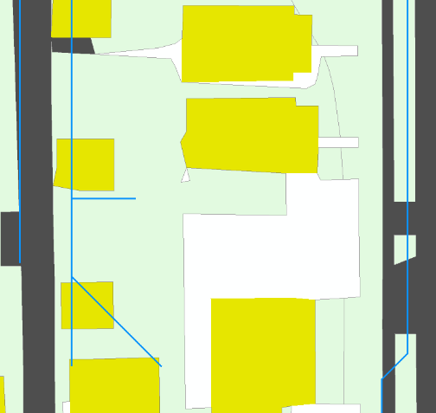*Multipart to single part*
      1. Input: cost_path_diss_erase
      2. Output: single3
   4. *Select layer by attribute*
      1. Input: single3
      2. Selection type: NEW_SELECTION
      3. Expression: OBJECTID >=0
   5. *Eliminate*
      1. Input layer: single3
      2. Eliminating polygon by border (YES)
      3. Output feature class: A_var_temp (see Figure 3)
   6. *Add field*

Figure . First guess at A_phys; impervious surfaces that intersect with flowpath

* + 1. Input table: A_var_temp
    2. Field name: join
    3. Field type: FLOAT
  1. *Calculate Field*
     1. Input table: A_var_temp
     2. 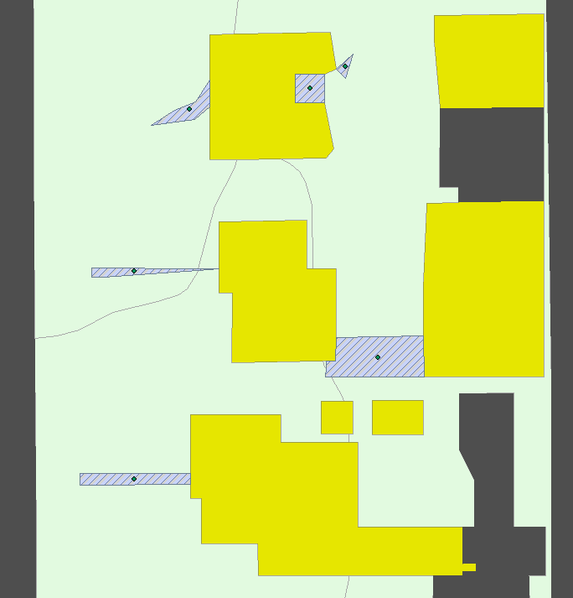Field name: join
     3. Expression: [OBJECTID]
  2. *Feature to point*
     1. Input features: A_var_temp
     2. Output feature class: A_var_pt (see Fig 4)

1. **Path distance from A_phys to A_var point**
   1. *Resample*
      1. Input:
         1. dem_clip (from Step 1a)
         2. Output cell size: 1 x 1 (ft)
      2. Output: dem_resample
   2. *Raster calculator*
      1. Expression: Float("%dem_resample%") * - 1

Figure . A_var_temp (grey hashing) and A_var_pt centroids (green)

* + 1. Output raster: dem_inverse
  1. 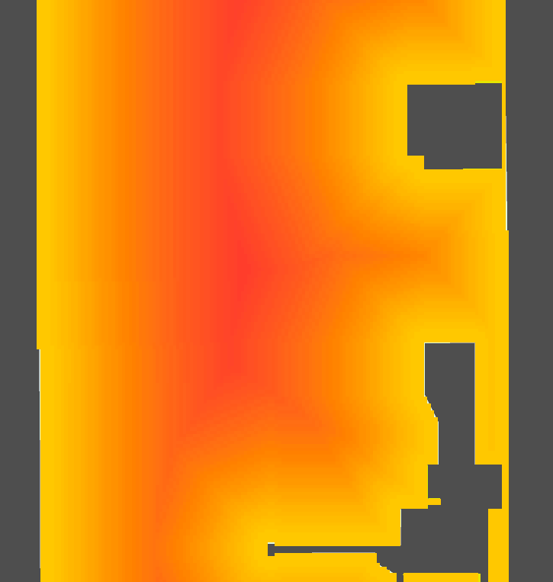*Path distance allocation*
     1. Input
        1. Input raster or feature source data: A_phys_temp
        2. Input surface raster: dem_inverse
     2. Output
        1. Output allocation raster: allocation
        2. Output distance raster: dist (see Fig 5)
        3. Output backlink raster: backlink
  2. *Cost path*
     1. Input
        1. Input raster or feature destination data: A_var_pt

Figure . Cost path distance from A_phys_temp (darker = further distance from A_phys_temp)

* + - 1. Destination field: OBJECTID
      2. Input cost distance raster: dist
      3. 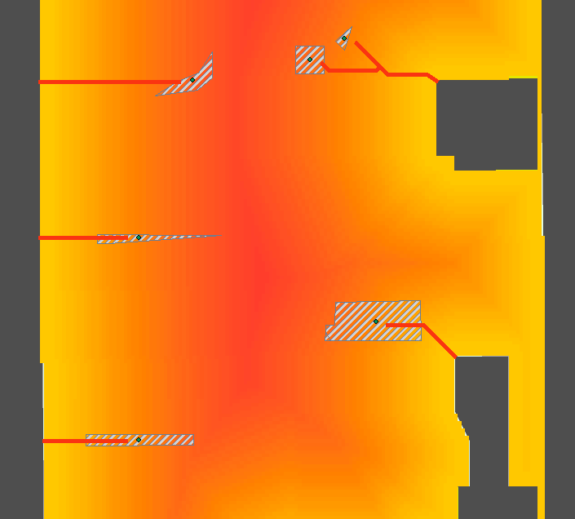Input cost backlink raster: backlink
    1. Output
       1. Output raster: cost_path_single
       2. Path type: EACH_CELL
  1. *Thin*
     1. Input raster: cost_path_single
     2. Background value: NODATA
     3. Shape for corners: “ROUND”
     4. Maximum thickness of input linear features: 1
     5. Output raster: thin
  2. *Raster to polyline*
     1. Input raster: thin

Figure . Cost path distance from A_phys_temp to centroid of A_var

* + 1. Field: Value
    2. Background value: 0
    3. Minimum dangle length: 0
    4. Simplify polylines: ‘yes’
    5. Output polyline features: cost_path_poly (see Fig 6)

1. **Associate path distance with A_var**
   1. *Dissolve*
      1. Input Features: cost_path_poly
      2. Output feature class: cost_path_poly_diss
   2. *Buffer*
      1. Input features: A_var_pt
      2. Distance: linear unit = 3 ft
      3. Side type: FULL
      4. End type: ROUND
      5. Method: PLANAR
      6. Dissolve type: NONE
      7. Output feature class: A_var_pt_buff
   3. *Erase*
      1. Input features: cost_path_poly_diss
      2. Erase features: A_var_pt_buff
      3. Output feature class: cost_path_poly_diss_erase
   4. *Add geometry attributes*
      1. Input features: cost_path_poly_diss_erase
      2. Geometry properties: LENGTH
      3. Length unit: FEET_US
   5. *Feature vertices to points*
      1. Input: cost_path_poly_diss_erase
      2. Point type: DANGLE
      3. Output feature class: cost_points
   6. *Buffer*
      1. Input
         1. Input features: cost_points
         2. Distance: linear unit = 3 ft
         3. Side type: FULL
         4. End type: ROUND
         5. 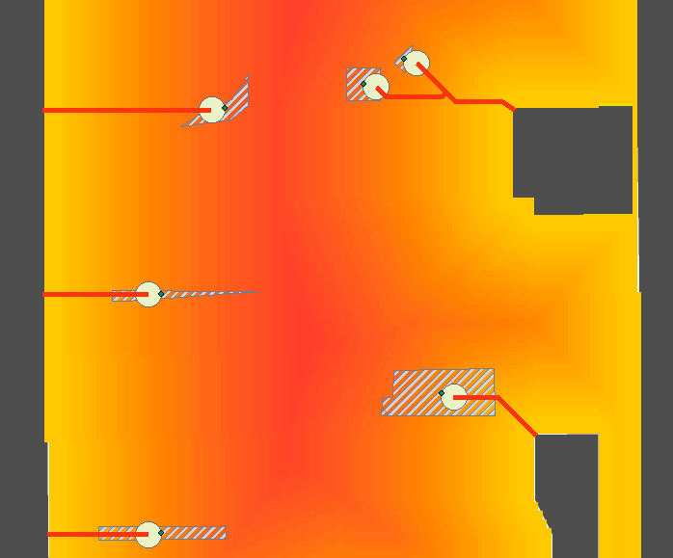Method: PLANAR
         6. Dissolve type: NONE
      2. Output feature class: cost_points_buffer
   7. *Select layer by location*
      1. Input feature: cost_points_buffer
      2. Relationship: INTERSECT
      3. Selecting features: A_var_pt
      4. Selection type: NEW SELECTION
   8. *Copy*
      1. Input: cost_points_buffer

Figure . Endpoint of cost path converted to point then buffered

* + 1. Output: cost_points_int (see Fig 7)
  1. *Add field*
     1. Input: cost_points_int
     2. Field name: ‘path_len’
     3. Field type: FLOAT
  2. *Calculate field*
     1. Input: cost_points_int
     2. Field name: “path_len”
     3. Expression: [LENGTH]

1. **Spatial join cost path points to A_var_temp**
   1. *Spatial join*
      1. Target features: cost_points_int
      2. Join features: A_var_pt
      3. Join operation: JOIN_ONE_TO_ONE
      4. Keep all target features: YES
      5. Output feature class: cost_point_int
   2. *Join field*
      1. Input table: A_var_temp
      2. Input join field: join
      3. Join table: cost_point_int
      4. Output join field: ORIG_FID_1
      5. Join fields: ‘OBJECTID’, ‘path_len’
2. **Export A_var_final and additional A_phys**
   1. *Select layer by attribute*
      1. Input: A_var_temp
      2. Select type: NEW_SELECTION
      3. Expression: LENGTH IS NULL
      4. Output: A_phys_temp2
   2. *Select layer by attribute*
      1. Input: A_var_temp
      2. Select type: NEW_SELECTION
      3. Expression: LENGTH IS NOT NULL
      4. Output: A_var_final

### **Step 2c: Aphys**

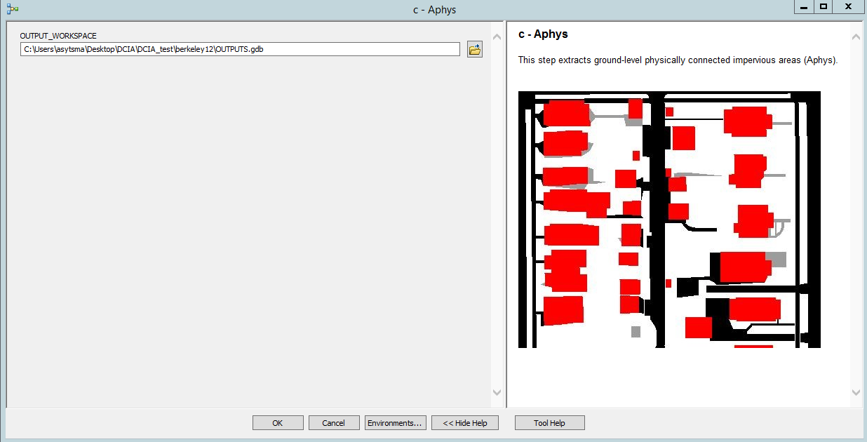This step merges the two temporary A_phys files generated in Step 2b.

Input data:

1. Output workspace (geodatabase)

Outputs:

1. A_phys_final (%OUTPUT_WORKSPACE%/A_phys_final) (shapefile)

The tool proceeds in the following steps:

1. *Merge*
   1. Input datasets:
      1. A_phys_temp (from step 2b)
      2. A_phys_temp2 (from step 2b)
   2. Output dataset: A_phys_final

## **Step 3: Connectivity fractions**

This step assigns connectivity values to each impervious area. A constant connectivity fraction is assigned to each group of rooftops (as determined in Step 2a). The connectivity fraction for f_var is based on inputs for soil characteristics, precipitation, initial moisture deficit (IMD), and computed values of slope, pervious fraction, and total area. The connectivity fraction of f_phys is assumed to be a constant value.

### **Step 3a: f_roof**

This step applies user defined connectivity fractions to each rooftop group as defined in Step 2a.

Input data:

1. Output workspace (geodatabase)
2. Roof 1 connectivity value (0-1)
3. Roof 2 connectivity value (0-1)
4. Other roofs connectivity value (0-1)

Outputs:

1. A_roof_final(%OUTPUT_WORKSPACE%/ A_roof_final) (shapefile)

The tool proceeds in the following steps:

1. Add field
   1. Input table: A_roof_1
   2. Field name: f_r
   3. Field type: FLOAT
2. Add field
   1. Input table: A_roof_2
   2. Field name: f_r
   3. Field type: FLOAT
3. Add field
   1. Input table: A_roof_other
   2. Field name: f_r
   3. Field type: FLOAT
4. Calculate field
   1. Input table: A_roof_1
   2. Field name: f_r
   3. Expression: Roof 1 connectivity value (0-1)
5. Calculate field
   1. Input table: A_roof_2
   2. Field name: f_r
   3. Expression: Roof 2 connectivity value (0-1)
6. Calculate field
   1. Input table: A_roof_other
   2. Field name: f_r
   3. Expression: Roof other connectivity value (0-1)
7. Merge
   1. Input datasets: A_roof_1, A_roof_2, A_roof_other
   2. Output dataset: %OUTPUT_WORKSPACE%\A_roof_final

### **Step 3b: f_var**

#### **Step 3b.1: Geometry**

This step computes the pervious fraction of the total subarea (A_var and downslope pervious). This is achieved by using the pervious flow path length from Step 2b and computing (1) a characteristic width of A_var surface, and (2) computing the downslope previous area and pervious fraction:

(1) Computing the characteristic width is achieved by computing the flow direction and flow length within each A_var surface, then dividing the A_var area by the flow length to get the characteristic width.

(2) The pervious area is approximated as pervious flow path length x width A_var; pervious fraction is then computed as pervious area/ total area, where total area = pervious area + A_var.

Input data:

1. Output workspace (geodatabase)

Outputs:

1. A_var_geom (%OUTPUT_WORKSPACE%/ A_var_geom) (shapefile)

The tool proceeds in the following steps:

1. Dissolve
   1. Input features: A_var_final
   2. Output: A_var_final_diss
2. Flow direction
   1. Input raster: dem_resample
   2. Output flow direction raster: fdr_resample
3. Clip
   1. Input raster: fdr_resample
   2. Output extent: A_var_final_diss
   3. Use input features for clipping = TRUE
   4. Output raster: fdr_resample_clip
4. Flow length
   1. Input flow direction raster: fdr_resample_clip
   2. Output raster: flow_len_avar
   3. Direction of measurement: DOWNSTREAM
5. Zonal statistics
   1. Input raster: A_var_final
   2. Zone field: objectID
   3. Input value raster: flow_len_avar
   4. Output raster: A_var_len_max
   5. Statistics type: MAXIMUM
6. Raster calculator
   1. Expression: “CON(%A_var_len_max% ==0, 1000000, %A_var_len_max% * 1000000)
   2. Output raster: A_var_fl_
7. Int
   1. Input raster: A_var_fl_
   2. Output raster: A_var_fl_int
8. Raster to polygon
   1. Input raster: A_var_fl_int
   2. Field: VALUE
   3. Output polygon features: A_var_fl_poly
9. Identity
   1. Input features: A_var_final
   2. Identity features: A_var_fl_poly
   3. Output feature class: A_var_id
10. Dissolve
    1. Input features: A_var_id
    2. Output feature class: A_var_width
    3. Dissolve_Fields:
       1. FID_A_var_final
    4. Statistics Fields:
       1. gridcode, MAX
11. Add field
    1. Input table: A_var_width
    2. Field name: flow_len
    3. Field type: FLOAT
12. Calculate field
    1. Input table: A_var_width
    2. Field name: flow_len
    3. Expression: [MAX_gridcode]/1000000
13. Add geometry attributes
    1. Input features: A_var_width
    2. Geometry properties: AREA
    3. Area unit: SQUARE FEET
14. Add field
    1. Input table: A_var_width
    2. Field name: “W”
    3. Field type: FLOAT
15. Calculate field
    1. Input table: A_var_width
    2. Field name: W
    3. Expression: [POLY_AREA]/[flow_len]
16. Join field
    1. Input table: A_var_final
    2. Input join field: OBJECTID
    3. Join table: A_var_ksp
    4. Output join field: OBJECT ID
    5. Join fields: HydroID, P, S, K, H_i, IMD
17. Join field
    1. Input table: A_var_final
    2. Input join field: OBJECTID
    3. Join table: A_var_width
    4. Output join field: OBJECT ID
    5. Join fields: Shape_Area, flow_len, POLY_AREA, W
18. Add field
    1. Input table: A_var_final
    2. Field name: “Perv_area”
    3. Field type: FLOAT
19. Calculate Field
    1. Input table: A_var_final
    2. Field name: Perv_area
    3. Expression: [path_len]*[W]
20. Add field
    1. Input table: A_var_final
    2. Field name: “fV”
    3. Field type: FLOAT
21. Add field
    1. Input table: A_var_final
    2. Field name: “A”
    3. Field type: FLOAT
22. Add geometry attributes
    1. Input features: A_var_final
    2. Geometry properties: AREA
    3. Area Unit: SQUARE_FEET_US
23. Calculate field
    1. Input table: A_var_final
    2. Field name: A
    3. Expression: [POLY_AREA] + [Perv_area]
24. Calculate field
    1. Input table: A_var_width
    2. Field name: fV
    3. Expression: [Perv_area]/[A]

#### **Step 3b.2: Soil and precipitation scenario**

This step allows for user definition of soil parameters (Ksat, suction, and IMD) and precipitation depth. The following soil texture classes and values are supported by this tool.

|  |  |  |  |  |  |  |  |  |  |  |
| --- | --- | --- | --- | --- | --- | --- | --- | --- | --- | --- |
| **Soil texture class & abbreviation** | | ***K*s** | ***Ψ*f** | ***n*** | ***θ*i** | | | ***IMD*** | | |
| **mm/hr** | **mm** | **-** | **SAT** | **FC** | **WP** | **SAT** | **FC** | **WP** |
| Sand | S | 120.4 | 49.0 | 0.437 | 0.437 | 0.062 | 0.024 | 0 | 0.375 | 0.413 |
| Loamy Sand | LS | 30.0 | 61.0 | 0.437 | 0.437 | 0.105 | 0.047 | 0 | 0.332 | 0.39 |
| Sandy Loam | SL | 10.9 | 110.0 | 0.453 | 0.453 | 0.19 | 0.085 | 0 | 0.263 | 0.368 |
| Silt Loam | SiL | 6.6 | 169.9 | 0.501 | 0.501 | 0.284 | 0.135 | 0 | 0.217 | 0.366 |
| Loam | L | 3.3 | 88.9 | 0.463 | 0.463 | 0.232 | 0.116 | 0 | 0.231 | 0.347 |
| Sandy Clay Loam | SCL | 1.5 | 220.0 | 0.398 | 0.398 | 0.244 | 0.136 | 0 | 0.154 | 0.262 |
| Silty Clay Loam | SiCL | 1.0 | 270.0 | 0.471 | 0.471 | 0.342 | 0.21 | 0 | 0.129 | 0.261 |
| Sandy Clay | SC | 0.6 | 240.0 | 0.43 | 0.43 | 0.321 | 0.221 | 0 | 0.109 | 0.209 |
| Silty Clay | SiC | 0.5 | 290.1 | 0.479 | 0.479 | 0.371 | 0.251 | 0 | 0.108 | 0.228 |
| Clay | C | 0.3 | 320.0 | 0.475 | 0.475 | 0.378 | 0.265 | 0 | 0.097 | 0.21 |

Input data:

1. Rainfall scenario (P) (inches) (value)
2. Ksat (in/hr) (value)
3. ASM (value)
4. Output workspace (geodatabase)

Outputs:

1. A_var_params (%OUTPUT_WORKSPACE%/ A_var_params) (shapefile)

The tool proceeds in the following steps:

1. *Slope*
   1. Input raster: dem_resample
   2. Output measurement: PERCENT_RISE
   3. Method: PLANAR
   4. Output raster: slope_pct
2. Zonal statistics
   1. Input raster: A_var_final
   2. Zone field: OBJECTID
   3. Input value raster: slope_pct
   4. Output raster: A_var_slope
   5. Statistics type: MEAN
3. Raster calculator
   1. Map algebra expression: “%A_var_slope%*100
   2. Output raster: A_var_slope2
4. Int
   1. Input raster: A_var_slope2
   2. Output raster: A_var_slopeint
5. Raster to polygon
   1. Input raster: A_var_slopeint
   2. Field: VALUE
   3. Output polygon: A_var_slope_poly
6. Spatial join
   1. Target features: A_var_final
   2. Join features: A_var_slope_poly
   3. Output feature class: A_var_sp
   4. Join operation: ONE_TO_ONE
   5. Match option: CLOSEST
7. Add field
   1. Input table: A_var_sp
   2. Field name: “P”
   3. Field type: FLOAT
8. Calculate field
   1. Input table: A_var_sp
   2. Field name: P
   3. Expression: rainfall (P) in inches (user defined)
9. Add field
   1. Input table: A_var_sp
   2. Field name: “S”
   3. Field type: FLOAT
10. Calculate field
    1. Input table: A_var_sp
    2. Field name: S
    3. Expression: [gridcode/100]
11. Add field
    1. Input able: A_var_SP
    2. Field name: Ksat (in/hr)
    3. Field type: FLOAT
12. Calculate field
    1. Input table: A_var_sp
    2. Field name: K
    3. Expression: Ksat (in/hr) (user defined)
13. Add field
    1. Input able: A_var_SP
    2. Field name: H_i (in)
    3. Field type: FLOAT
14. Calculate field
    1. Input table: A_var_sp
    2. Field name: H_i (in)
    3. Expression: H_i (in) (user defined)
15. Add field
    1. Input able: A_var_SP
    2. Field name: IMD
    3. Field type: FLOAT
16. Calculate field
    1. Input table: A_var_sp
    2. Field name: IMD
    3. Expression: IMD (user defined)
17. Copy features
    1. Input features: A_var_SP
    2. Output features: A_var_ksp

#### **Step 3b.3: Apply f_var regression**

This step applies the regression tree to predict f_var from user defined and computed features. See Sytsma et al. 2020 for detail on regression tree development.

Input data:

1. Output workspace (geodatabase)

Outputs:

1. A_var_final(%OUTPUT_WORKSPACE%/A_var_final) (shapefile)

The tool proceeds in the following steps:

1. Add field
   1. Input table: A_var_params
   2. Field name: f_var
   3. Field type: FLOAT
2. Apply regression tree (arcpy script)

### **Step 3c: f_phys**

This step applies a constant connectivity fraction to the A_phys surfaces.

Input data:

1. Output workspace (geodatabase)

Outputs:

1. A_phys_final (%OUTPUT_WORKSPACE%/A_phys_final) (shapefile)

The tool proceeds in the following steps:

1. Add field
   1. Input table: A_phys_final
   2. Field name: f_phys
   3. Field type: FLOAT
2. Calculate field
   1. Input table: A_phys_final
   2. Field name: f_phys
   3. Expression: f_phys connectivity value (0-1)

## **Step 4: Calculate EIA**

This step combines A_roof, A_var, and A_phys and computes EIA contributions from each surface, total EIA and percent EIA within each subcatchment.

Input data:

1. Output workspace (geodatabase)
2. Subcatchments (shapefile)

Outputs:

1. DCIA summarized by subcatchment (shapefile) (user defined)

The tool proceeds in the following steps:

1. Intersect
   1. Input features: A_phys_final, subcatchments
   2. Output feature class: A_phys_int
2. Intersect
   1. Input features: A_var_final, subcatchments
   2. Output feature class: A_var_int
3. Intersect
   1. Input features: A_roof_final, subcatchments
   2. Output feature class: A_roof_int
4. Add field
   1. Input table: A_phys_int
   2. Field name: DCIA_phys
   3. Field type: FLOAT
5. Add field
   1. Input table: A_var_int
   2. Field name: DCIA_var
   3. Field type: FLOAT
6. Add field
   1. Input table: A_roof_int
   2. Field name: DCIA_roof
   3. Field type: FLOAT
7. Add geometry attributes
   1. Input features: A_phys_int
   2. Geometry properties: AREA
   3. Area Unit: SQAURE_FEET_US
8. Add geometry attributes
   1. Input features: A_var_int
   2. Geometry properties: AREA
   3. Area Unit: SQAURE_FEET_US
9. Add geometry attributes
   1. Input features: A_roof_int
   2. Geometry properties: AREA
   3. Area Unit: SQAURE_FEET_US
10. Calculate field
    1. Input table: A_phys_int
    2. Field name: DCIA_phys
    3. Expression: [f_phys] * [POLY_AREA]
11. Calculate field
    1. Input table: A_var_int
    2. Field name: DCIA_var
    3. Expression: [f_var] * [POLY_AREA]
12. Calculate field
    1. Input table: A_roof_int
    2. Field name: DCIA_roof
    3. Expression: [f_roof] * [POLY_AREA]
13. Merge
    1. Input datasets: A_phys_int, A_var_int, A_roof_int
    2. Output dataset: A_merge
14. Add geometry attributes
    1. Input features: A_merge
    2. Geometry properties: AREA
    3. Area Unit: SQAURE_FEET_US
15. Add field
    1. Input table: A_merge
    2. Field name: Imperv_sf
    3. Field type: FLOAT
16. Calculate field
    1. Input table: A_merge
    2. Field name: Imperv_sf
    3. Expression: [POLY_AREA]
17. Identity
    1. Input features: subcatchments
    2. Identity features: A_merge
    3. Output features: DCIA
18. Dissolve
    1. Input features: DCIA
    2. Output feature class: dcia_diss (user defined)
    3. Dissolve fields: HydroID
    4. Statistics fields:
       1. SUM(Imperv_sf)
       2. SUM(DCIA_roof)
       3. SUM(DCIA_phys)
       4. SUM(DCIA_var)
19. Add field
    1. Input table: dcia_diss
    2. Field name: DCIA
    3. Field type: FLOAT
20. Calculate field
    1. Input table: dcia_diss
    2. Field name: DCIA
    3. Expression: [SUM_DCIA_phys] + [SUM_DCIA_var] + [SUM_DCIA_roof]
21. Add geometry attributes
    1. Input features: dcia_diss
    2. Geometry properties: AREA
    3. Area Unit: SQAURE_FEET_US
22. Add field
    1. Input table: dcia_diss
    2. Field name: area_sf
    3. Field type: FLOAT
23. Calculate field
    1. Input table: dcia_diss
    2. Field name: area_sf
    3. Expression: [POLY_AREA]
24. Add field
    1. Input table: dcia_diss
    2. Field name: nDCIA
    3. Field type: FLOAT
25. Calculate field
    1. Input table: dcia_diss
    2. Field name: nDCIA
    3. Expression: [SUM_Imperv_SF] – [SUM_SCIA]
26. Add field
    1. Input table: dcia_diss
    2. Field name: nDCIA
    3. Field type: FLOAT
27. Calculate field
    1. Input table: dcia_diss
    2. Field name: pct_routed
    3. Expression: [nDCIA]/ [SUM_Imperv_sf] *100
28. Add field
    1. Input table: dcia_diss
    2. Field name: pct_DCIA_tot
    3. Field type: FLOAT
29. Calculate field
    1. Input table: dcia_diss
    2. Field name: pct_DCIA_tot
    3. Expression: [SUM_DCIA]/ [area_sf] *100
30. Add field
    1. Input table: dcia_diss
    2. Field name: pct_DCIA_imp
    3. Field type: FLOAT
31. Calculate field
    1. Input table: dcia_diss
    2. Field name: pct_DCIA_imp
    3. Expression: [SUM_DCIA]/ [SUM_Imperv_sf] *100