# Project Name:

#### The predictive effect of measures of mental health and emotional response on presence of gastrointestinal *Bifidobacterium*

# Project Team

*Annemarie Krug* [*arkrug2 @illinois*](mailto:hpriest@bensonhillbio.com)*.edu*

*Elhan Ersoz* [*ese@illinois.edu*](mailto:ese@illinois.edu)

*CPSC541 -Fall 2019 Class*

Contents

Project Name: 1

Project Team 1

Objectives 1

Milestones 1

Background 2

Methodology and Technical Approach 2

Files 3

Results & Discussion 3

Conclusions 9

References 9

# Objectives

1. **Visualize the target variables:** 
   1. Define the variables of interest
   2. Create boxplots for depression, anxiety, and stress
   3. Create density plots for event-related potentials (ERPs)
2. **Fit logistic regression models and visualize distributions by binary response:**
   1. Use presence of *Bifidobacterium* as the binary response variable
   2. Use each of the measures of mental health as predictors
3. **Analyze logistic model fits:**
   1. Do any of the predictor variables have significant effects?
   2. Which model has the highest AIC value?
   3. Which model has the lowest AIC value?

# Milestones

1. Download and store the raw data into a github repository
2. Format data sets for input into R
3. Generate exploratory analysis graphs
4. Test logistic regression models
5. Reporting the results: Due 12/13/2019

# Background

Chronic stress is recognized to play a key role in many facets of human health. These range from mental health in anxiety, depression, and stress to physical health including gastrointestinal composition. Emotional response to different stimuli and situations could also be impacted. Prebiotic consumption, which changes the gastrointestinal microbiota in a way that benefits host health, is one potential treatment being explored to alleviate conditions related to these aspects of mental and physical health.

Prebiotics are the substrates which feed the microbes in the gastrointestinal tract. Therefore, prebiotic dietary fiber can be utilized to influence microbial populations. In humans, *Bifidobacterium longum* 1714 decreased self-reported anxiety (F(1, 21) = 6.39, p = 0.02) and stress (t(18) = 2.32, p = 0.03) compared to the control [1]. In addition, when participants consumed a probiotic treatment consisting of *Lactobacillus helveticus* R0052 and *Bifidobacterium longum* R017, they had a decrease in psychological distress compared to the control in the Hopkins Symptom Checklist-90 scale (p < 0.05), the Hospital Anxiety and Depression Scale (global score, p < 0.05), and urinary free-cortisol concentration (p < 0.05) [2]. Moreover, consumption of 100 mL of fermented milk with *Lactobacillus casei* strain Shirota each day for 11 weeks was shown to decrease sleep disturbances in students caused by academic stress [3].

One limitation of many of these human studies on probiotics and prebiotics is reliance on participant surveys to measure outcomes such as subjective stress and mood. Therefore, a gap that needs to be filled in this field of research includes increased incorporation of objective markers of cognition and stress. The current study is valuable in adding an additional clinical trial to the emerging field of prebiotics and mental health in humans. Moreover, it is innovative by examining quantitative measures of stress and cognitive processing in response to prebiotic consumption. The objective of the study was to determine the effect of prebiotic dietary fiber consumption of fructooligosaccharides (FOS) and galactooligosaccharides (GOS) on the gastrointestinal microbiota and behavioral and biological measures of cognition and stress among healthy adults in a randomized, controlled, crossover trial. For this particular project, it was hypothesized that measures of mental health and emotional response could predict presence or absence of *Bifidobacterium*, which is a genus known to be increased by consumption of certain types of prebiotic dietary fiber.

# Methodology and Technical Approach

**Participants.** Healthy adults (n = 24) 25-45 years of age

**Experimental design and treatments.** The study had a randomized, placebo-controlled, double-blinded, crossover design. It included two 4-week treatment periods of dairy-based beverages separated by at least a 4-week washout period. Administration of treatments was conducted in a counterbalanced order. The prebiotic (PRE) treatment consisted of 8 oz of commercially available Lactaid low-fat 1% milk, 5 g of FOS, and 5 g of GOS. The control (CON) treatment consisted of 8 oz of Lactaid low-fat 1% milk with no added dietary prebiotic fiber. The soluble nature of the FOS and GOS prebiotic fibers enabled subject blinding. Data collection occurred prior to beginning each treatment (baseline) and immediately following each treatment. Therefore, data were collected on four total occasions after the initial screening visit. A schematic of the study design is displayed below.

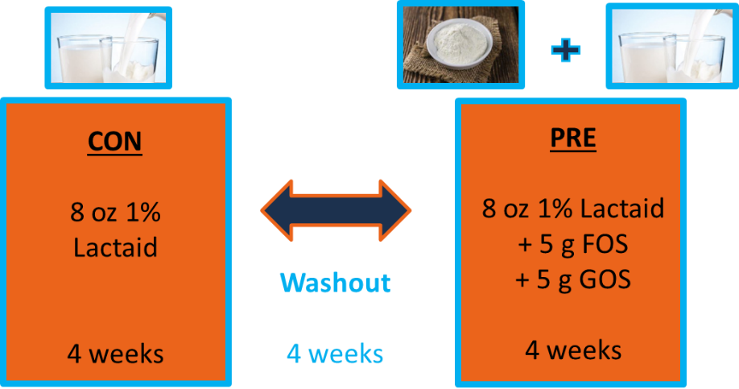

**Mental health.** The methodology for this study included self-reported measures of mental health using the Depression, Anxiety, Stress Scales (DASS-42) questionnaire. This questionnaire was comprised of 42 items separated into subscales to examine different areas of mental health.

**Emotion.** Electroencephalography (EEG) was used to measure brain activity response to neutral, positive, and negative image stimuli during the Emotional Image Task. Participants wore a 60-electrode cap and event-related potentials (ERPs) were determined. The analysis was focused on the ERPs of the midline electrodes.

**Microbiota.** Gastrointestinal microbiota were measured using relative abundance. Fecal samples were collected before and after each treatment period. Fecal microbial DNA was extracted utilizing the PowerLyzer PowerSoil DNA Isolation Kit (MO BIO Laboratories, Inc., Carlsbad, CA, USA). After extraction, the V4 region of the 16S bacterial rRNA gene was amplified using a Fluidigm Access Array system prior to high-throughput sequencing on an Illumina HiSeq. Sequencing was performed at the W. M. Keck Center for Biotechnology at the University of Illinois at Urbana-Champaign. QIIME2.0 and DADA2 software were used to analyze the high-quality sequence data following the sequencing process. Taxonomy was assigned with the GreenGenes 13_8 99% OTU reference database.

**Statistical Analysis.** Logistic regression models were utilized with *Bifidobacterium* presence or absence as the binary response variable and stress, depression to anxiety ratio, and response to neutral, positive, or negative images as the predictor variables. The family used in the models was binomial. The identity link function and probit link function were compared for each predictor and treatment group.

# Files

<https://github.com/annemarie5/prebiotic>

Once open the above link, download all files with the commit message “BYOD Final Project - use these files.”

The main R markdown document is “Krug_BYOD_final.Rmd.”

# Results & Discussion

1. **Visualize the target variables:**

The outcome variable for this experiment is presence of Bifidobacterium. The predictor variables are stress, ratio of depression to anxiety, and ERPs in responsive to neutral, positive, and negative image stimuli. Depression, anxiety, and stress are visualized by boxplots in **Figure 1**, **Figure 2**, and **Figure 3**, respectively.

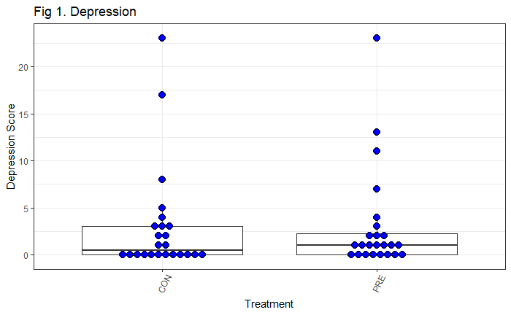

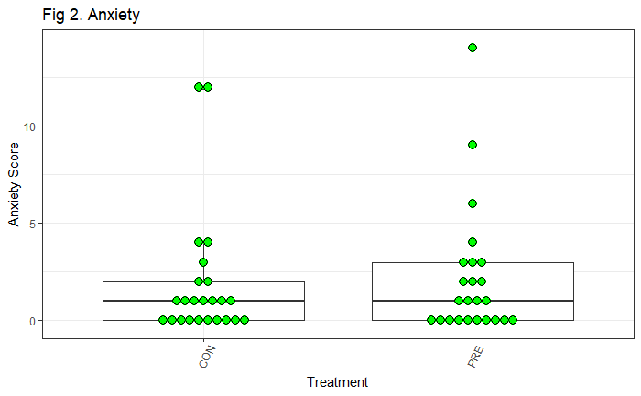

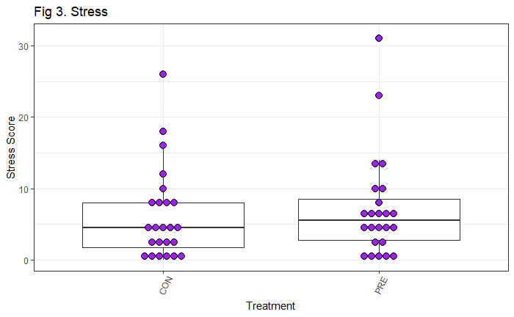

The ERPs are displayed by density plots for each of the image categories, which are neutral, positive, and negative. Response to neutral image stimuli by treatment group is displayed in **Figure 4**.

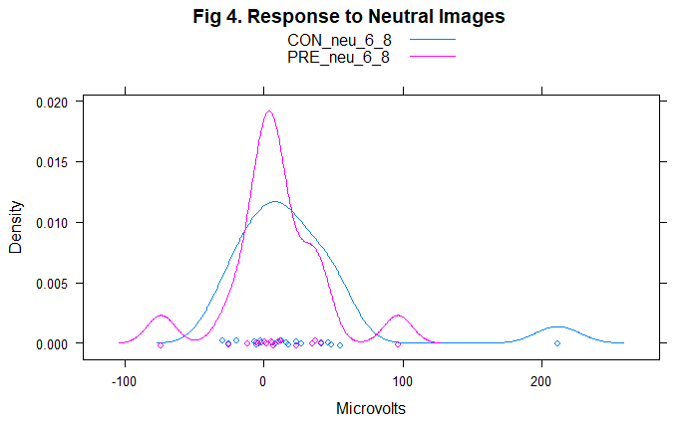

Response to positive images by treatment group is displayed in **Figure 5**.

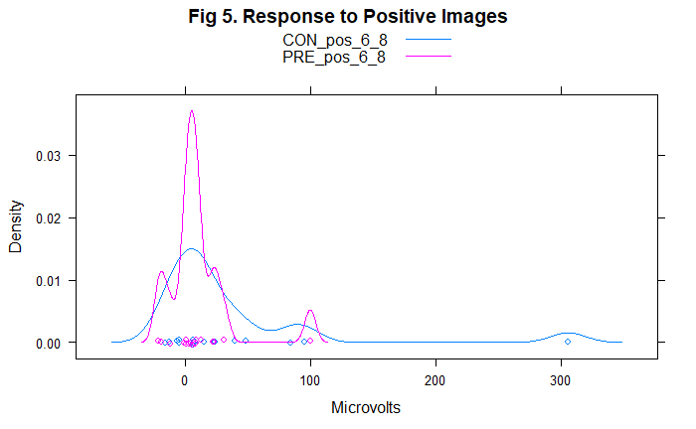

Response to negative images by treatment group is displayed in **Figure 6**.

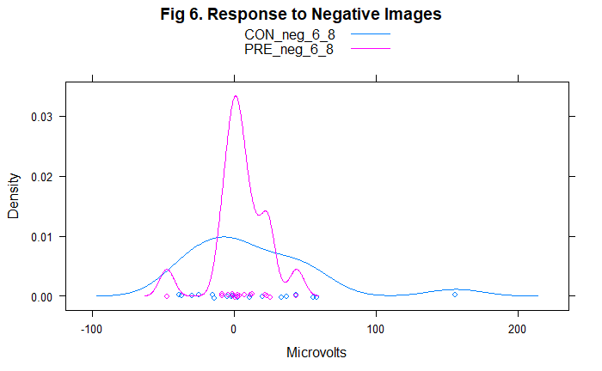

Overall, the density plots for the three image categories show that there is increased variance in ERP microvolt response in the CON group compared to the PRE group. Also, there is a greater clustering of responses near zero microvolts in the PRE group compared to the CON group. This could indicate a normalizing effect of response to emotional images with prebiotic consumption.

1. **Fit logistic regression models and visualize distributions by binary response:**

A logistic regression model summary is presented **Table 1** of the next objective (Obj 3). The current objective focuses on visualization by the binary response variable *Bifidobacterium*. The continuous variable *Bifidobacterium* relative abundance was created into a new binary response variable representing presence (1) or absence (0) of *Bifidobacterium*. The following figures visualize plots of the binary response on the x-axis and distribution of continuous predictor variable on the y-axis. **Figure 7** displays stress in the CON group and **Figure 8** displays stress in the PRE group.

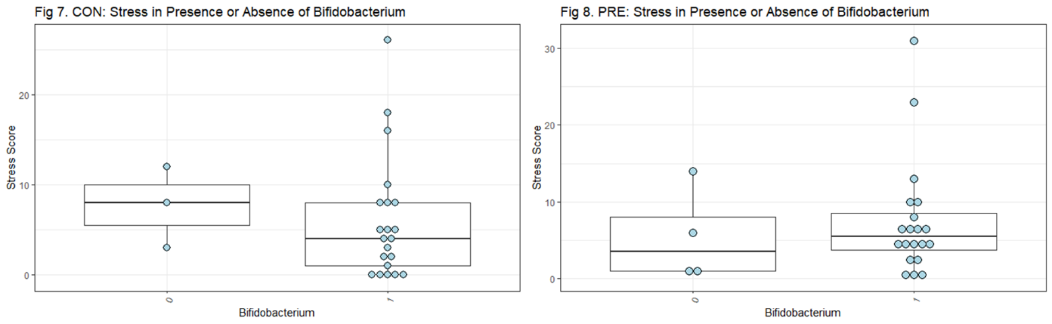

**Figure 9** and **Figure 10** display the ratio of depression to anxiety in the CON group and PRE group, respectively.

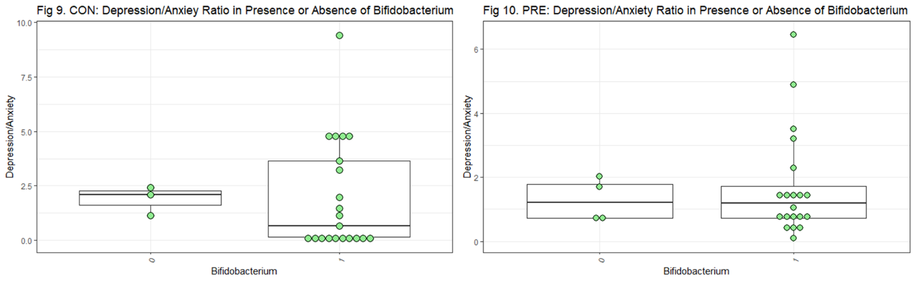

**Figure 11** and **Figure 12** display response to neutral images in the CON group and PRE group, respectively.

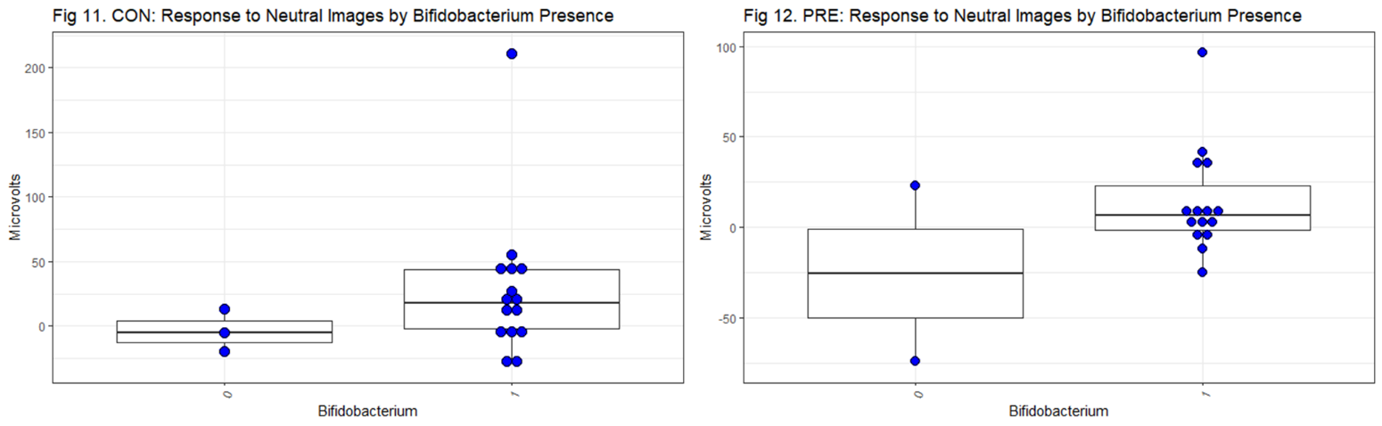

**Figure 13** and **Figure 14** display response to positive images in the CON group and PRE group, respectively.

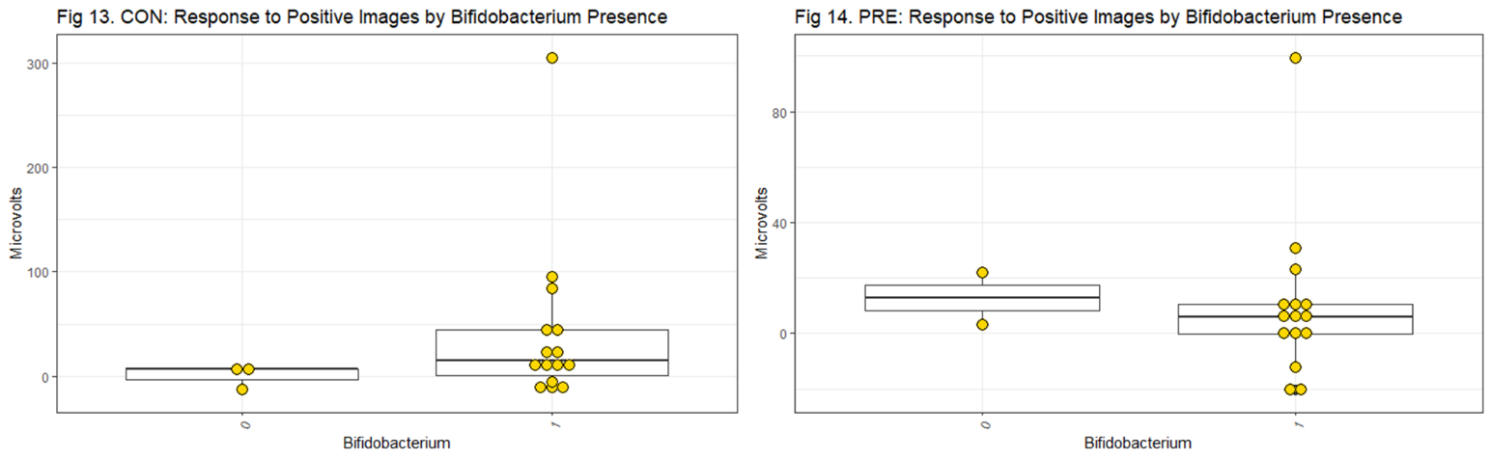

**Figure 15** and **Figure 16** display response to negative images in the CON group and PRE group, respectively.

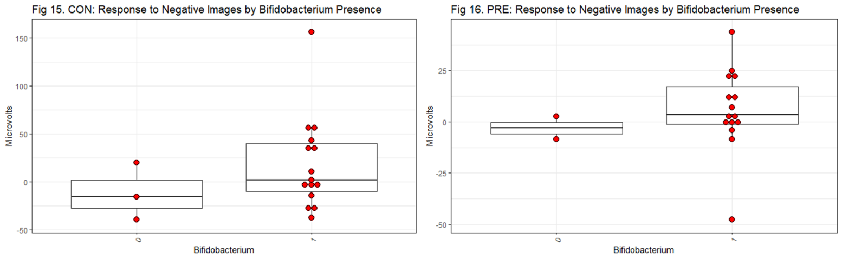

Overall, these plots show that there are more data points in both the PRE group and CON group that have *Bifidobacterium* present. Also, there is quite a bit of variance in the y-axis variable when *Bifidobacterium* is present. These factors make it difficult to make inferences on the data from visual inspection. Actual coefficient estimates from the logistic regression models are presented in Obj 3 below.

1. **Analyze logistic regression model fits:**

None of the predictor variables tested have significant effects on presence of *Bifidobacterium*. The model with the highest AIC value, which means the least good fit, used the identity link function with the predictor the ratio of depression to anxiety in the prebiotic group. This model has an AIC of 25.377. The model with the lowest AIC value, which means the best fit, used the identity link function with the predictor the ERP response to neutral images in the prebiotic group. The model has an AIC of 13.781. The predictor from this model also has the lowest p-value at p = 0.1550. However, this is still not a significant effect. **Table 1** on the following page summarizes the logistic regression models by predictor and treatment group.

|  |  |  |  |  |  |  |
| --- | --- | --- | --- | --- | --- | --- |
| **Table 1.** Logistic regression model summaries of *Bifidobacterium* presence by treatment and predictor variable | | | | | | |
|  | **Family = binomial()** | | | **Family = binomial(link = "probit")** | | |
| **Predictor: Trt** | **Estimate ± SE** | **p-value** | **AIC** | **Estimate ± SE** | **p-value** | **AIC** |
| Stress: CON | -0.04 ± 0.09 | 0.6665 | 21.911 | -0.02 ± 0.05 | 0.63028 | 21.885 |
| Stress: PRE | 0.05 ± 0.10 | 0.605 | 25.299 | 0.03 ± 0.05 | 0.5877 | 25.298 |
| Dep/Anx:CON | 0.02 ± 0.27 | 0.9375 | 22.079 | 0.01 ± 0.14 | 0.92656 | 22.078 |
| Dep/Anx: PRE | 0.21 ± 0.46 | 0.645 | 25.377 | 0.13 ± 0.24 | 0.5992 | 25.35 |
| Neutral: CON | 0.04 ± 0.03 | 0.2481 | 18.248 | 0.02 ± 0.02 | 0.2093 | 18.121 |
| Neutral: PRE | 0.04 ± 0.03 | 0.1550 | 13.781 | 0.02 ± 0.01 | 0.1889 | 14.078 |
| Positive: CON | 0.05 ± 0.04 | 0.2970 | 17.945 | 0.03 ± 0.03 | 0.2783 | 17.85 |
| Positive: PRE | -0.004 ± 0.03 | 0.8875 | 16.296 | -0.002 ± 0.01 | 0.86969 | 16.293 |
| Negative:CON | 0.03 ± 0.03 | 0.2936 | 18.616 | 0.01 ± 0.01 | 0.2780 | 18.596 |
| Negative: PRE | 0.02 ± 0.04 | 0.53722 | 15.949 | 0.01 ± 0.02 | 0.48283 | 15.88 |

# Conclusions

The goal of this study was to determine whether *Bifidobacterium* presence or absence could be predicted from different measures of mental health and emotional response to images. Mental health was measured using the DASS-42 questionnaire. Due to literature in the field often finding that these self-report surveys are not sufficiently sensitive or objective to detect differences, responses to neutral, positive, and negative images were collected using EEG to serve as an objective measure of mental health. *Bifidobacterium* DNA was collected from fecal samples and sequenced to determine relative abundance. Logistic regression was conducted with *Bifidobacterium* presence or absence as the binary response variable. From these models, it was concluded that ratio of depression to anxiety, stress, and response to neutral, positive, and negative images did not have a significant effect on presence of *Bifidobacterium*. The predictor closest to significance was response to neutral images in the prebiotic group in the model using the identity link function (p = 0.1550). A limitation of the study was small sample size due to rejection of some EEG trials due to equipment recording errors. In the future, a similar emotional image task will be utilized that has greater trial number and a greater number of total participants in the study. This research is important in helping to standardize objective methods of measuring mental health, and may help to develop future treatment for people with conditions such as depression, anxiety disorders, and autism.

# References

[1] Allen, A. P. *et al.* Bifidobacterium longum 1714 as a translational psychobiotic: modulation of stress, electrophysiology and neurocognition in healthy volunteers. *Transl. Psychiatry* **6**, e939–e939 (2016).

[2] Messaoudi, M. *et al.* Assessment of psychotropic-like properties of a probiotic formulation (Lactobacillus helveticus R0052 and Bifidobacterium longum R0175) in rats and human subjects . *Br. J. Nutr.* **105**, 755–764 (2011).

[3] Takada, M. *et al.* Beneficial effects of Lactobacillus casei strain Shirota on academic stress-induced sleep disturbance in healthy adults: A double-blind, randomised, placebo-controlled trial. *Benef. Microbes* **8**, 153–162 (2017).