PROJECT INNOVATION

SMART WATER MANAGEMENT

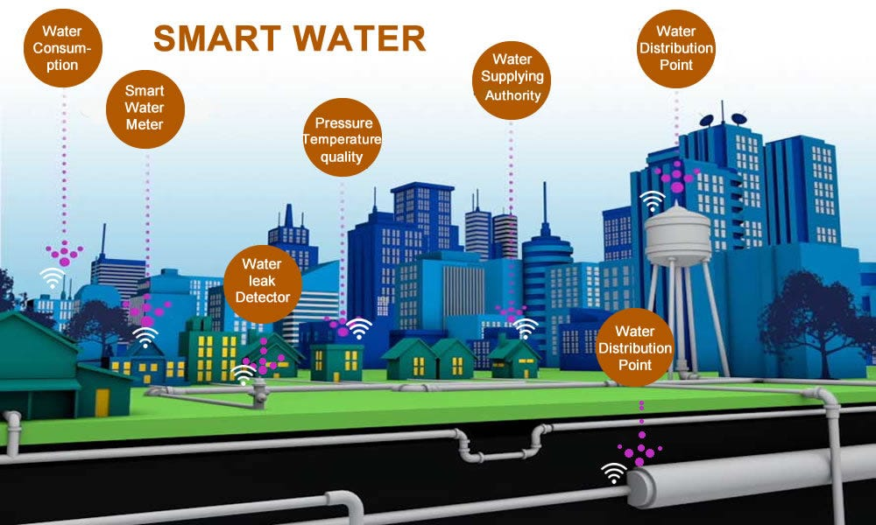

## TEAM DETAILS

|  |  |
| --- | --- |
| Mentor: | Mrs.M.Maheswari |
| Leader: | Gayathri. B |
| Members: | Anne PS  Boomika N  Danis Swetha A  Induja S |
| Problem Description: | In this project we are going to use different sensors to manage the use of water and quality of the water.All the data from the sensors will be sent to local server using iot technology |
| Phase: | Phase 2: Design the innovation to solve a problem |

ABSTRACT:

This project presents an IoT system which helps to manage and plan the usage of water. This system can be easily installed and maintained for long run. The Ultrasonic sensor is placed on the tank which continuously monitors the water level in real time. This information will be updated in the cloud and user can analyze the amount of water. We have some more sensor like pH, Temperature Sensor, Ultrasonic module, and Turbidity Sensor. By using this sensor value, we calculate the continually and taking the data, analyze after any problem in the sensor value we will calculate to the water purity and sent the alert to the authorized person by using the IOT Technologies. We have the turbidity sensor and pH sensor by using this we got the sensor values, at last, we get the message

PROJECT DESCRIPTION:

* The project uses different sensors like pH,Turbidity to

detect the quality of the water

* The ultrasonic sensor is used to detect the quantity of

Water in the tank.

* System also measures the temprature of the water.
* All these values are sent to the local server using iot technology

HARDWARE

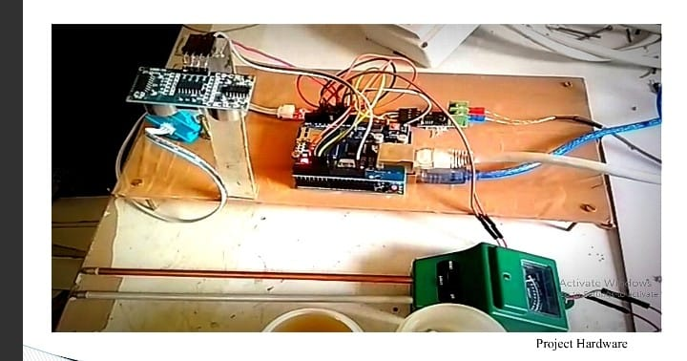

COMPONENTS:

1.Arduino Mega

2.Ethernet Shield

3.Ultrasonic sensor

4.Turbidity Sensor

5.Themocouple Max6675

6.pH Sensor/Meter

7.A LAN Connection

**1.ARDUINO MEGA**

The Arduino Mega is based on ATmega2560 Microcontroller. The ATmega2560 is an 8-bit microcontroller. We need a simple USB cable to connect to the computer and the AC to DC adapter or battery to get started with it.

The Arduino Mega is organized using the Arduino (IDE), which can run on various platforms. Here, IDE stands for **Integrated Development Environment.**

The functioning of the Arduino Mega is similar to other Arduino Boards. We need not require extra components for its working.

The ATmega2560 Microcontroller is consistent with most of the shields of Arduino UNO.

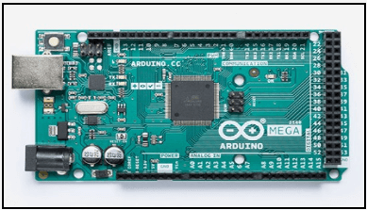

2.ETHERNET SHIELD

The **Arduino Ethernet Shield** allows an Arduino board to connect to the internet using the [Ethernet library](https://www.arduino.cc/reference/en/libraries/ethernet/) and to read and write an SD card using the [SD library](https://www.arduino.cc/reference/en/libraries/sd/). This shield is fully compatible with the former version but relies on the newer W5500 chip.

### **Connecting the field**

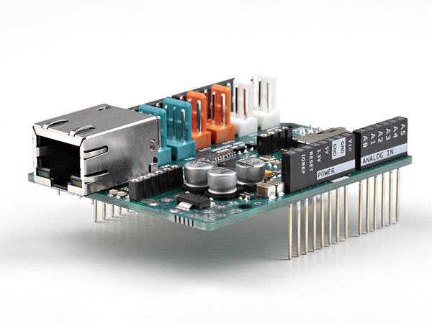

To use the shield, mount it on top of an Arduino board (e.g. the Uno). To upload sketches to the board, connect it to your computer with a USB cable as you normally would. Once the sketch has been uploaded, you can disconnect the board from your computer and power it with an external power supply.

Connect the shield to your computer or a network hub or router using a standard ethernet cable (CAT5 or CAT6 with RJ45 connectors). Connecting to a computer may require the use of a cross-over cable (although many computers, including [all recent Macs](https://web.archive.org/web/20191015221518/https://support.apple.com/en-us/HT2274) can do the cross-over internally).

3.ULTRASONIC SENSOR

Ultrasonic sensing is one of the best ways to sense proximity and detect levels with high reliability.

Our technical support gets emails all of the time about how our sensors work and what environments our sensors work (or don’t work) in.

This guide was created as an introduction to ultrasonic sensing, its principles, and how ultrasonic sensors work in your applications.  
  
At a top level, you need to know what an ultrasonic sensor is.

## **What is an Ultrasonic Sensor?**

An ultrasonic sensor is an instrument that measures the distance to an object using ultrasonic sound waves.  
  
An ultrasonic sensor uses a transducer to send and receive ultrasonic pulses that relay back information about an object’s proximity.  
  
High-frequency sound waves reflect from boundaries to produce distinct echo patterns.

## **How Ultrasonic Sensors Work**

Ultrasonic sensors work by sending out a sound wave at a frequency above the range of human hearing. The transducer of the sensor acts as a microphone to receive and send the ultrasonic sound. Our [ultrasonic sensors](https://maxbotix.com/collections/all), like many others, use a single transducer to send a pulse and to receive the echo. The sensor determines the distance to a target by measuring time lapses between the sending and receiving of the ultrasonic pulse.



4.TURBIDITY SENSOR

Turbidity sensors measure the amount of light that is scattered by suspended solids in a liquid, such as water. When the concentration of total suspended solids (TSS) and total dissolved solids (TDS) in a liquid increase, the turbidity also increases.

Turbidity sensors are used to measure the cloudiness or haziness (turbidity) of a liquid, usually to determine [water quality](https://atlas-scientific.com/blog/what-are-the-main-indicators-of-water-quality/).

For samples with high amounts of TSS and TDS, the difference in the light intensity from the transmission beam is measured to obtain the turbidity result, while light scattering is more suitable for samples with low amounts of TSS and TDS. Since turbidity sensors use light to detect a solution’s turbidity level, it is important to reduce the amount of external light when using the sensor.

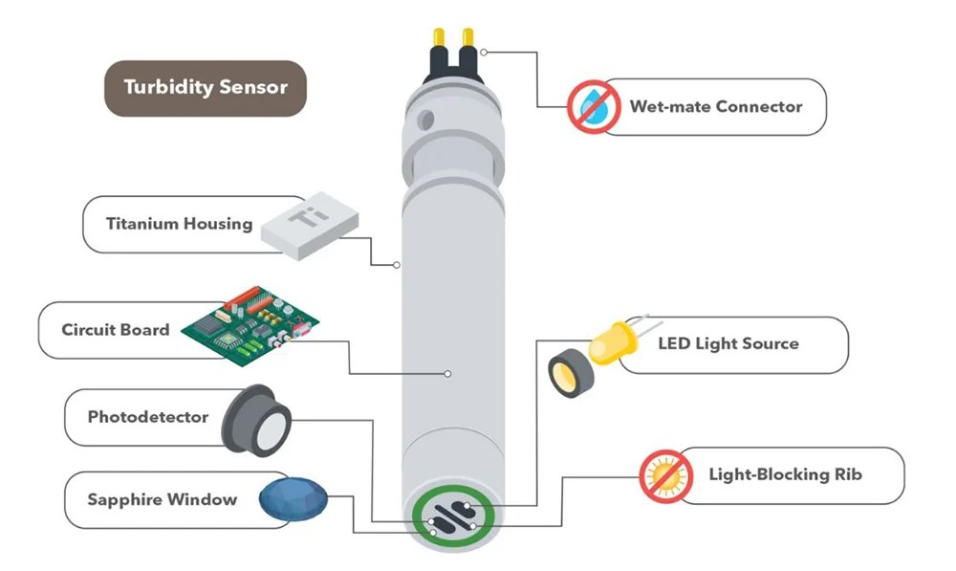

5.THERMOCOUPLE SENSOR

A **thermocouple** is a [sensor for measuring temperature](https://www.omega.co.uk/technical-learning/history-of-the-temperature-sensor.html). This sensor consists of two dissimilar metal wires, joined at one end, and connected to a thermocouple thermometer or other thermocouple-capable device at the other end. When properly configured, thermocouples can provide temperature measurements over wide range of temperatures.

This MAX6675 Module + K Type Thermocouple Sensor Measure 1024°C Temperature sensor makes use of the Maxim MAX6675 K-Thermocouple to digital converter IC to provide a microcontroller compatible digital serial interface (SPI compatible) for giving an accurate temperature compensated measurement of the supplied K-Type thermocouple sensor.

**It has a 12-bit resolution providing** [**temperature**](https://robu.in/product-category/sensors/temperature/) **readings from 0°C to 1024°C (max temperature of the supplied sensor is 450°C) with a resolution of 0.25°C.**

Screw terminals allow for connection to the thermocouples spade connectors and a 5 pin standard 0.1″ header provides an interface to a microcontroller such as an [Arduino](https://robu.in/product-category/arduino-2/arduino/) development board.

*Supplied thermocouple sensor has a diameter of 4.5mm with a 6mm threaded mounting bolt.* The total length of the sensor including cable and spade connectors is ~50cm.

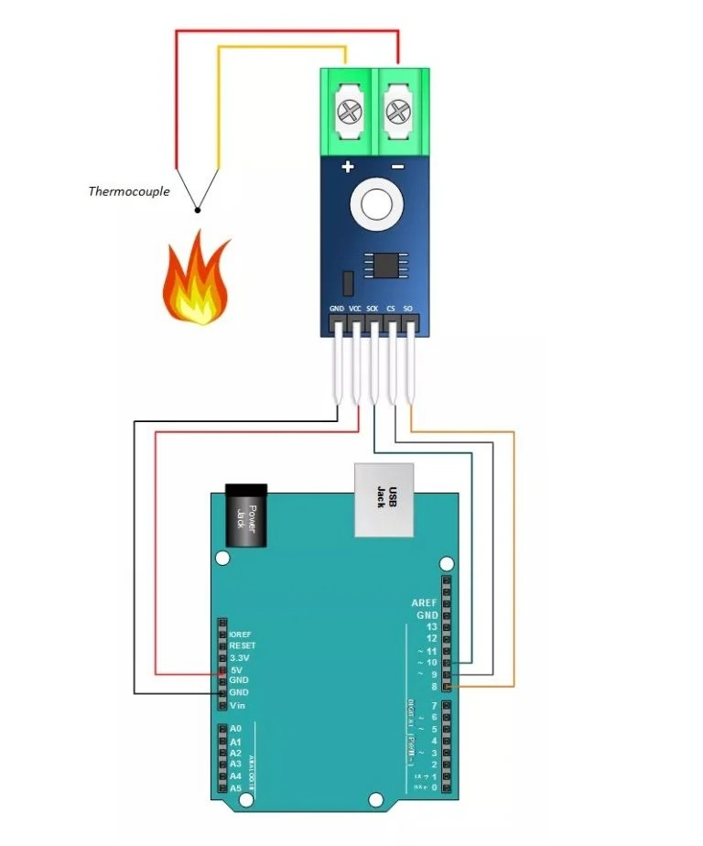

6.pH SENSOR

Water pollution is caused when many chemicals ,sewage,and fertilizers are dumped into riers.it must be prevented by measuring water quality beacause this harms human and aquatic health.The water pH sensor is a simple device that makes it easy to measure the quality of the water.

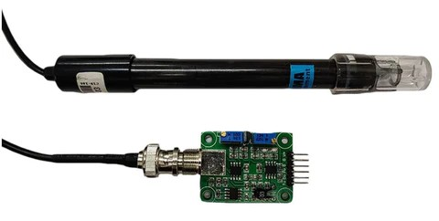

7.LAN

A local area network (LAN) is a collection of devices connected together in one physical location, such as a building, office, or home. A LAN can be small or large, ranging from a home network with one user to an enterprise network with thousands of users and devices in an office or school.

Regardless of size, a LAN's single defining characteristic is that it connects devices that are in a single, limited area. In contrast, a [wide area network](https://www.cisco.com/content/en/us/products/switches/what-is-a-wan-wide-area-network.html) (WAN) or metropolitan area network (MAN) covers larger geographic areas. Some WANs and MANs connect many LANs together.

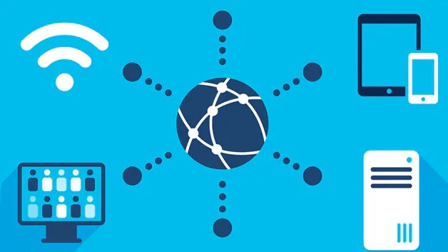

MODULES

GPRS and GSM modules are the two IoT devices: a water tank level sensor that sends data to the cloud for analysis and a motor that turns on and off automatically. Using an IoT-SWM system, the water level can be monitored and controlled while leaks in the tank are detected and an estimated measurement is provided.

GSM

A GSM module or a GPRS module is a chip or circuit that will be used to establish communication between a mobile device or a computing machine and a GSM or GPRS system. The modem (modulator-demodulator) is a critical part here.

GPRS

General Packet Radio Service (GPRS) is a packet-oriented mobile data service on the [2G and 3G cellular communication](https://www.electronicsforu.com/technology-trends/mobile-communication-1g-4g) system’s global system for mobile communications (GSM).

GPRS was originally standardized by European Telecommunications Standards Institute (ETSI) in response to the earlier CDPD and i-mode packet-switched cellular technologies. It is now maintained by the 3rd Generation Partnership Project (3GPP).

FEATURES OF SMART WATER MANAGEMENT

1. **Reduce wasting water** used in high volumes for agriculture, manufacturing, power production. It implies the introduction of high-tech practices like precision farming, smart irrigation, crop water management, real-time water metering and other applications of [Internet of Things in agriculture](https://www.digiteum.com/iot-agriculture/)..
2. **Improve water quality** and prevent contamination by chemical waste and natural pollution such as acidification. In order to improve and maintain the quality of water, companies use sensors and IoT technology for real-time monitoring and control.
3. **Enhance the efficiency of water systems** such as water collectors, treatment plants, distribution mains and wastewater recycling centers. Using IoT and data solutions for asset management, companies can keep important measurements such as water pressure, temperature, flow, etc. at hand, integrate predictive maintenance and avoid breakage and downtime of equipment.
4. **Implement leakage control** by using smart water management devices equipped with leak and moisture sensors. Given that almost $3 billion are spent on fixing the damage caused by leakage yearly, leakage control is essential to keep water resources and budgets safe.
5. **Practice consumption monitoring**via IoT-based water management systems. It helps to optimize and keep under control the usage of water resources at different levels — households, communities,  countries and the whole planet.

CONCLUSION

Smart water management can reduce the overflow of water in tanks and provide the usage of water in liter per hour in real time. This system is cost effective. This enables the efficient use of water.Thus it reduces the wastage of water. This project can be further enhanced by using the results of this present project. The turbidity sensor is placed in the water tank to know quality of water which is helpful to know that chemicals in the water. The PH sensor is also placed in water tank to know the nature of water in tanks in which is suitable for drinking or not for living beings in real time by using IOT

SUMMARY:

* The project works on Internet of things
* Project uses the sensors including ph sensor,Turbidity Sensor, Thermocouple,Ultrasonic Sensors.
* All the data from the sensors will be sent to the local server.
* The Hardware part took about 2-3 working days to build.
* The Arduino coding part took 3-5 working days to complete.