PROJECT OVERVIEW AND DESIGN

SMART WATER MANAGEMENT

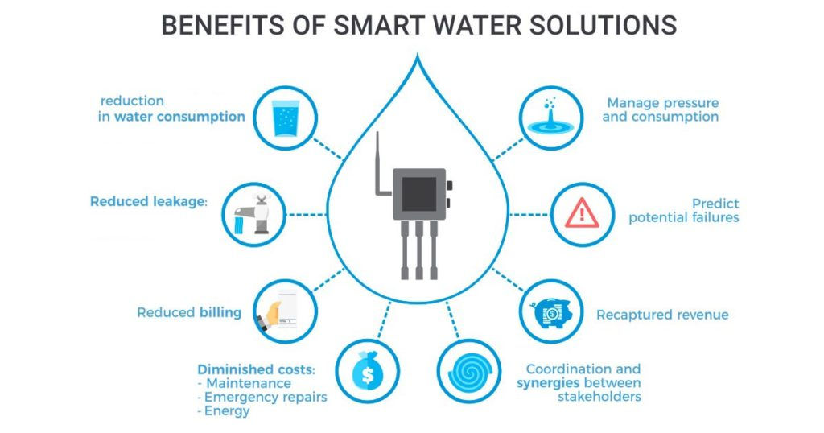

Water management is the control and movement of water resources to minimize damage to life and property and to maximize efficient beneficial use. Good water management of dams and levees reduces the risk of harm due to flooding. Irrigation water management systems make the most efficient use of limited water supplies for agriculture.

Drainage management involves water budgeting and analysis of surface and sub-surface drainage systems. Sometimes water management involves changing practices, such as groundwater withdrawal rates, or allocation of water to different purposes.

TEAM DETAILS

|  |  |
| --- | --- |
| Mentor: | Mrs.M.Maheswari |
| Leader: | Gayathri B |
| Members: | Anne PS  Boomika N  Danis Swetha A  Induja S |
| Problem Description: | IoT based water management system is a process of planning, allocating, and monitoring water resources and maintaining related equipment like pipes and pumps through IoT hardware and software |
| Phase: | Phase 1: Problem definition and Design thinking. |

PROJECT DETAILS ON PROBLEM AND SOLUTION

|  |
| --- |
| OBJECTIVE |

* Smart water management gives a greater understanding of the water system, including flaw detection, preservation, and water management.
* A comprehensive database of regions with water losses or unlawful connections can be built with the introduction of smart water system technology by public service corporations.
* Smart water grids can save costs by conserving water and energy while improving the quality of service to consumers. Wireless data transfer allows consumers to assess their water use to reduce water costs in other circumstances.

|  |
| --- |
| INTRODUCTION |

* Internet of Things has been associated with cities, smart homes and also to manage traffic system. A unknown fact that about internet of things technology is also application across many other fields in our everyday life.
* This work focuses on a solution for water management in colleges, building and commercial area with the help of IOT. Water is precious and supply the needs to be regulated.
* To maintain the water in a proper way, should prevent the overflow of water in tanks and usage of the water in proper manner
* The automated system is introduced which is used to save the human work and cost. In this system the motor is automatically ON/OFF by using level sensor. The usage of water is observed by the water flow sensor

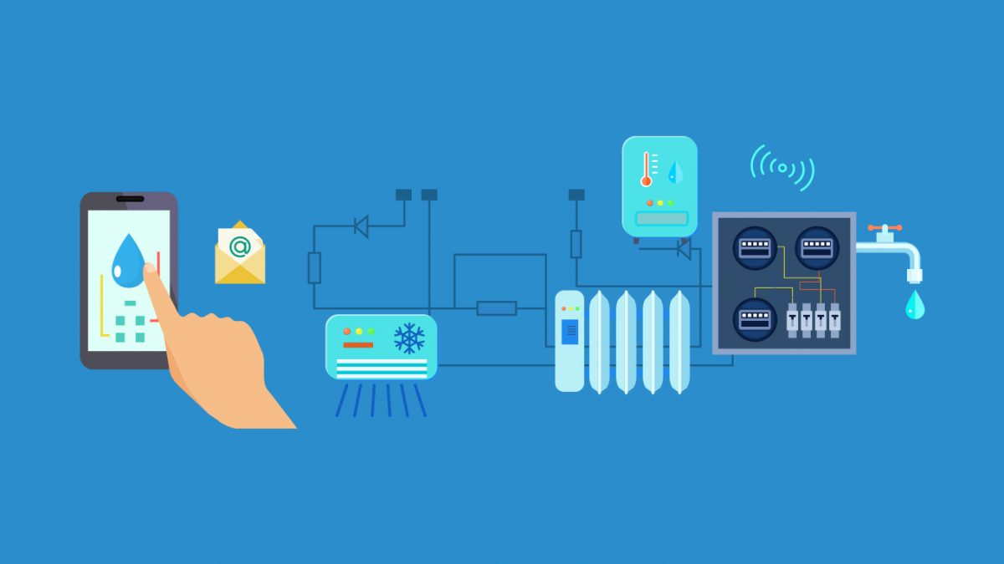

|  |
| --- |
| ABSTRACT |

Water is a precious resource that can be intelligently managed. Effective water usage demands computerized home water supply management in a culture where water tanks, motors, and pumps are ubiquitous. The issue is providing a constant, high-quality, low-cost water supply. This study introduces a smart water management (IoT-SWM) system that may be used in structures that do not have access to a constant water supply but instead have water stored in enormous tanks underneath. The GSM module collects water use data from each home in a community and transmits it to the cloud, where it is analyzed. A smart water grid is a hybrid application that uses an inspection mode to identify leaks and measure the resulting height differences to keep track of the tank’s water level. The system automatically deactivates the affected section after detecting any water shortage or malfunction in the system mechanism, such as broken valves, pumps, or pipes. It sends an emergency signal to building managers. It monitors essential water quality elements regularly, and if they fall below acceptable levels, it sends warning signals to the building management, who can take action. Over an extended period, the system monitored and recorded all water quality metrics. The system restarts when the water pump has been reconnected and sends an emergency alert.

|  |
| --- |
| PROJECT DETAILS |

|  |  |
| --- | --- |
| **Proposed Method:** | IoT-Based Smart Water Management Systems |
| **Hardware:** | The external power supply can be given by   * Connecting power source(7-12v DC) to DC power jack * Connecting a battery lead to Vin and Gnd. 5V and 3.3Vare used to provide power to sensors and module. * The temperature sensor LM35IC has been used for sensing the temperature * The temperature can be measured more accurately with it than using a thermistor. * A three terminal sensor used to measure the surrounding temperature ranging from -55 degree centigrade to 150 degree centigrade. |
| **Software:** | * The Arduino Uno is used as microcontroller in this structure , it has 14 propelled data/yield pins of which the user are using 6 pins for interfacing sensors-waterflow , Ultrasonic and temperature. * The ESP8266 wi-fi module is a free SOC with facilitated TCP/IP show stack that can give any microcontroller to access to the wi-fi range |

|  |
| --- |
| BLOCK DIAGRAM |

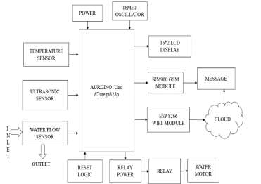

|  |
| --- |
| CONCLUSION |

According to this system, proposed architecture becomes more autonomous with quick transmission of data by using IOT. The main advantage in IOT is, even when clients are not in the node network, data will be sent, whenever a client is connected with that node, they can able to see the data which has been sent already. Smart water management can reduce the overflow of water in tanks and provide the usage of water in liter per hour in real time. This system is cost effective. This enables the efficient use of water.Thus it reduces the wastage of water. This project can be further enhanced by using the results of this present project. The turbidity sensor is placed in the water tank to know quality of water which is helpful to know that chemicals in the water. The PH sensor is also placed in water tank to know the nature of water in tanks in which is suitable for drinking or not for living beings in real time by using IOT.