SMART WATER MANAGEMENT

## Screenshot 2022-03-10 at 4.42.22 PM TEAM DETAILS

|  |  |
| --- | --- |
| Mentor: | Mrs.M.Maheswari |
| Leader: | Gayathri. B |
| Members: | Anne PS  Boomika N  Danis Swetha A  Induja S |
| Problem Description: | In this project we are going to use different sensors to manage the use of water and quality of the water.All the data from the sensors will be sent to local server using iot technology |
| Phase: | Phase 3: Design the innovation to solve a problem |
|  |  |

SIMULATION STEPS:

STEP 1:In wokwi environment add ESP32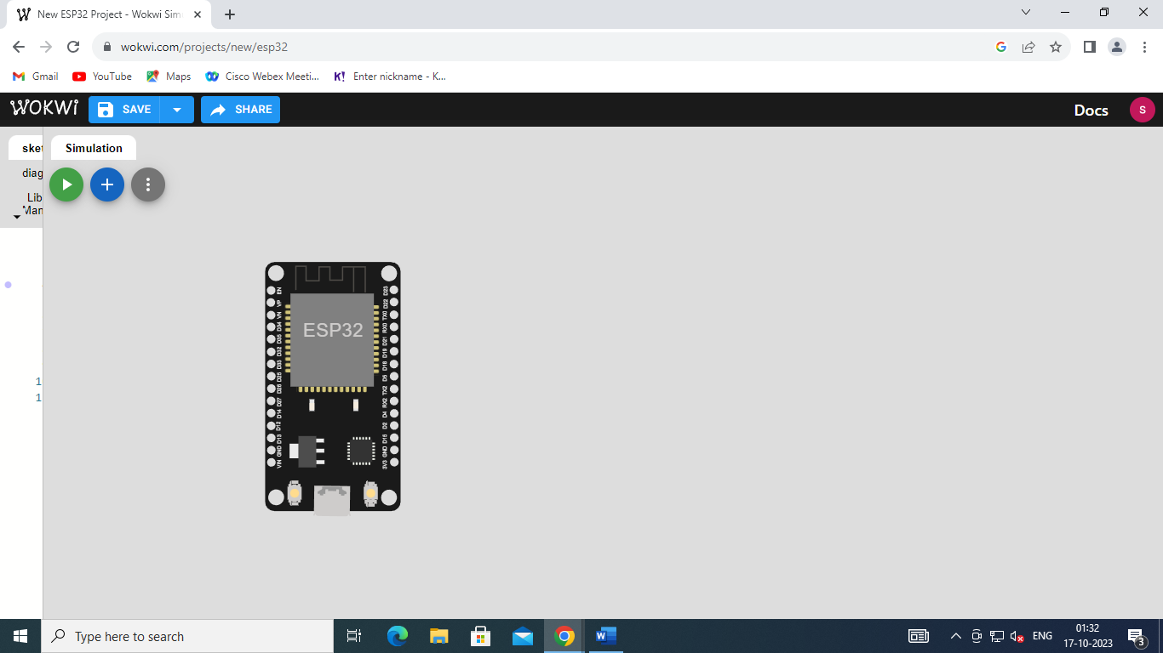

STEP 2:Now add ultrasonic distance sensor.

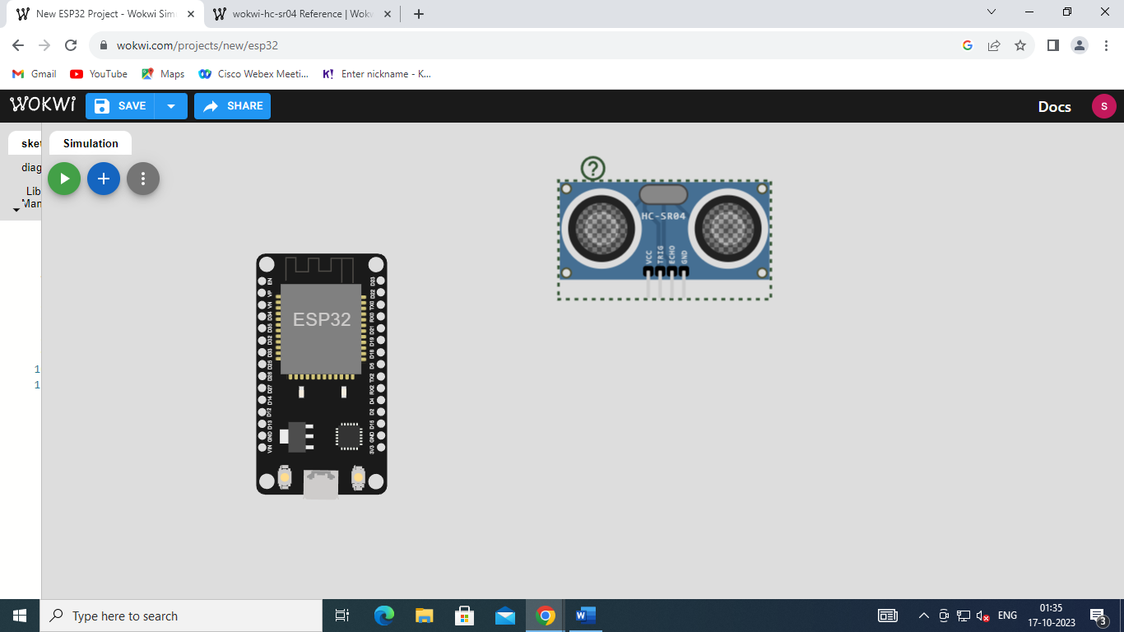

STEP 3:Add half bread board

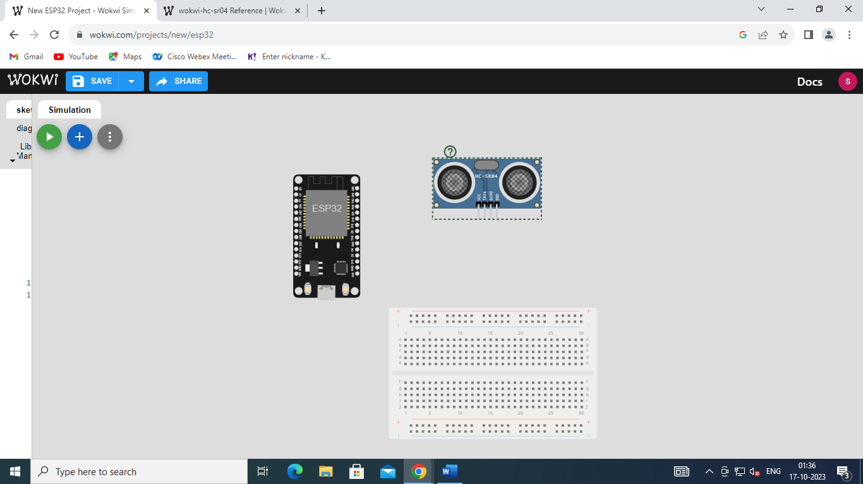

STEP 4:Add servo control signal

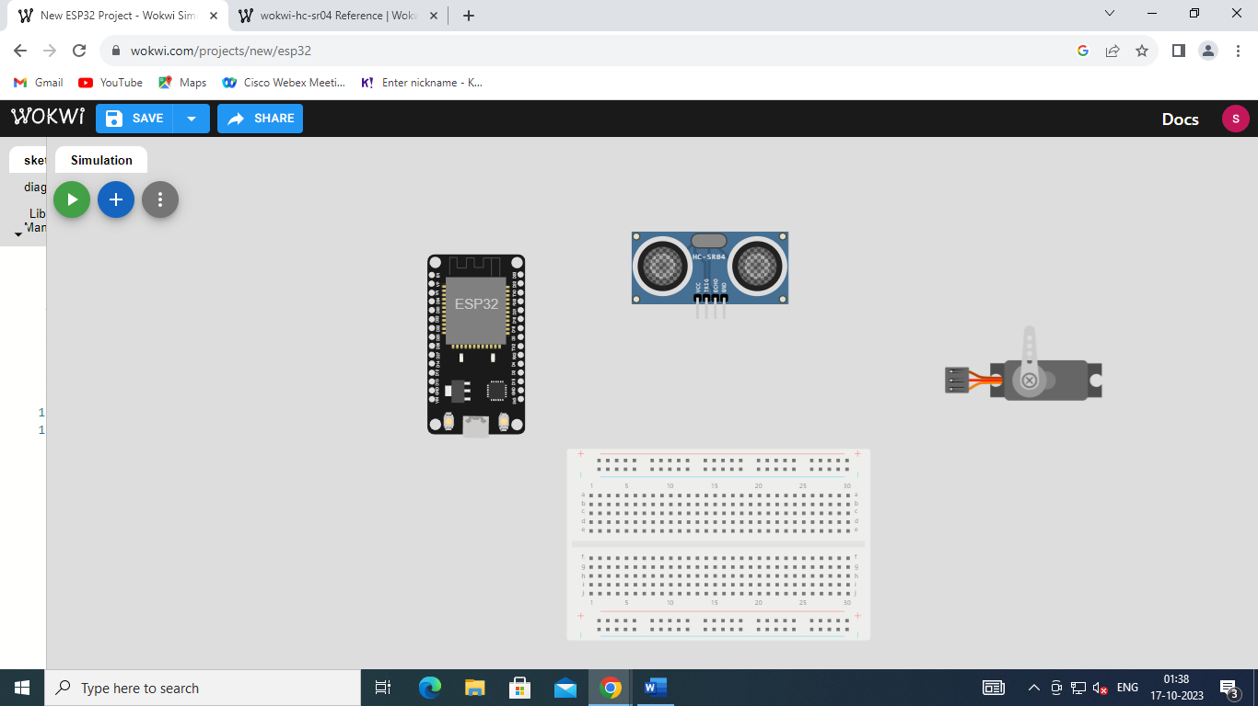

STEP 5:

ESP32 D18 is connected to Servo1:PWm

ESP D4 connected to ultrasonic1:ECHO

ESPD2 connected to ultrasonic1:TRIG

ESP GND1 connected to breadboard

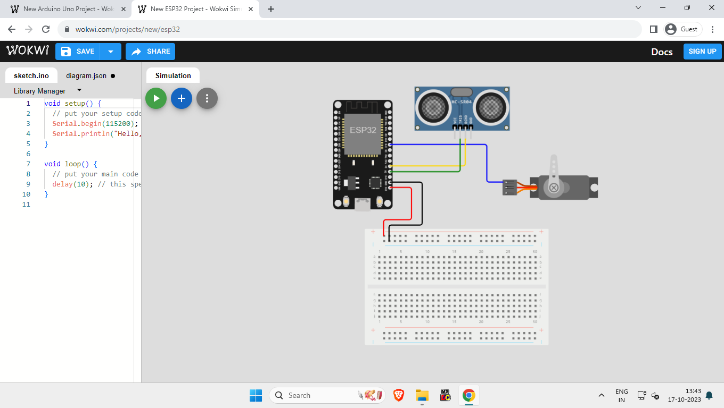

STEP 6:

Servo1: GND connected to bread board

Servo1:V+ connected to bread board

Ultrasonic1:GND connected to breadboard

Ultrasonic1:VCC connected to breadboard

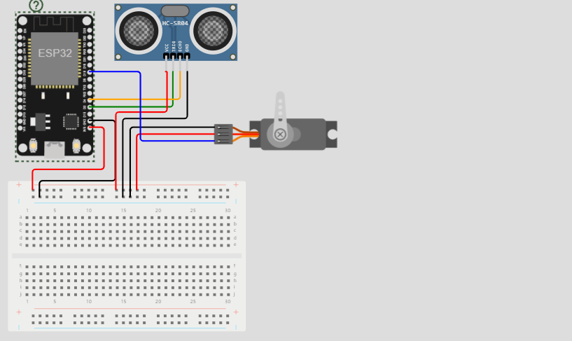

STEP 7:

The connection to wokwi environment is established and connection to wifi is also established.

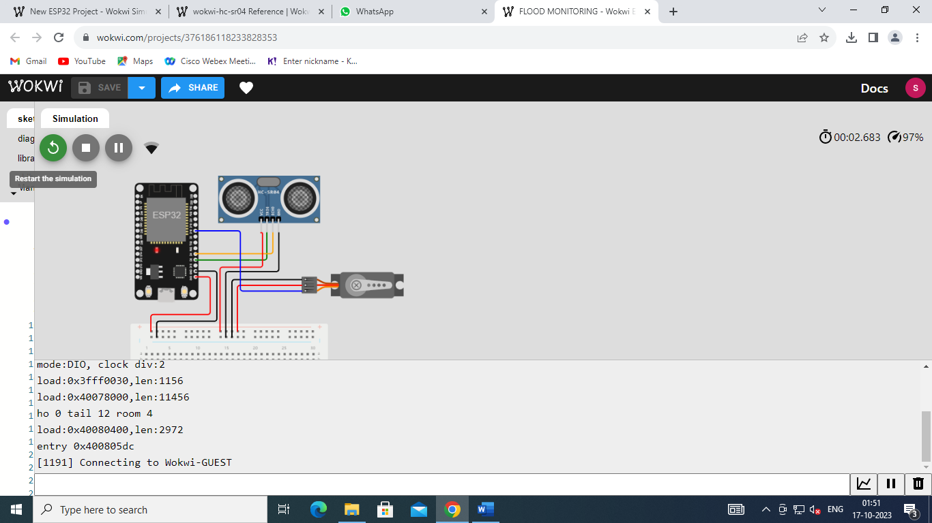

STEP 8:

The ESP32 red light sensor is activated and the leverage in servo control signal is rotated.



STEP 9:

The ESP32 blue light sensor is activated and leverage is rotated again.

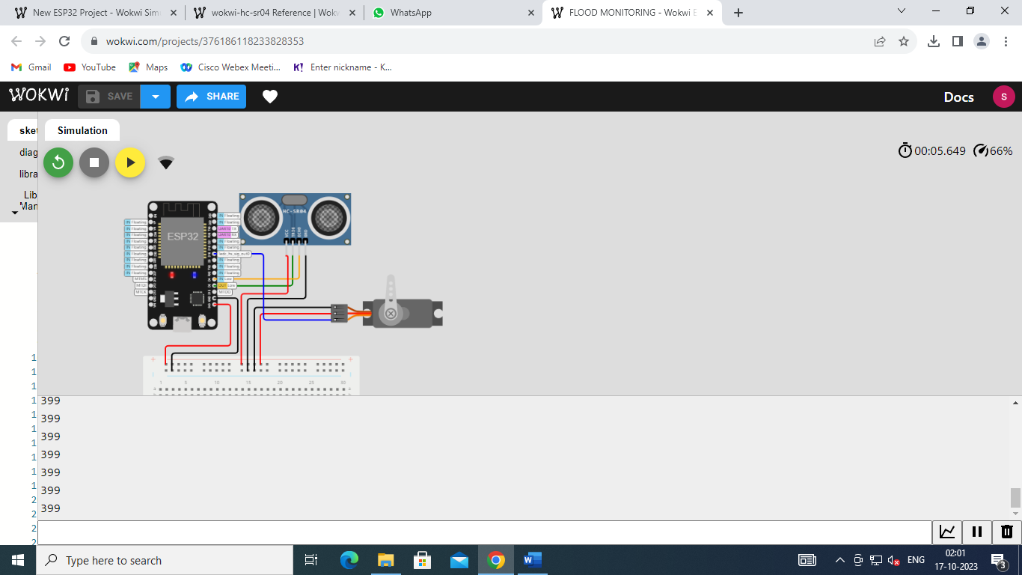

Coding for the above simulation:

#define BLYNK_TEMPLATE_ID "TMPL3tobBFjj-"

#define BLYNK_TEMPLATE_NAME "IOT SMART WATER MANAGEMENT"

#define BLYNK_AUTH_TOKEN "gy2bzR-i-RbPW3oWOpAiDgr6sSVzIHVZ"

char auth[] = BLYNK_AUTH_TOKEN;

char ssid[] = "member";

char pass[] = "";

#define BLYNK_PRINT **Serial**

#include <WiFi.h>

#include <WiFiClient.h>

#include <BlynkSimpleEsp32.h>

#include <ESP32Servo.h>

Servo gate;

const int trigPin=2;//d2

const int echoPin=4;//d4

const int servoPin = 18;//d18

long duration;

int distance;

void setup() {

**Serial**.begin(9600);

  Blynk.begin(auth, ssid, pass);

   pinMode(trigPin, OUTPUT);

   pinMode(echoPin, INPUT);

   gate.attach(servoPin, 500, 2400);

}

void loop()

{

 digitalWrite(trigPin, LOW);

 delay(2);

 digitalWrite(trigPin,HIGH);

 delay(10);

 digitalWrite(trigPin, LOW);

 duration=pulseIn(echoPin,HIGH);

 distance=duration*0.034/2;

**Serial**.println(distance);

 Blynk.virtualWrite(V0,distanceTECTED GATES OPENED");

});

if(distance<50)

{

  gate.write(90);

 Blynk.virtualWrite(V1,"FLOOD DE

else

{

  gate.write(0);

Blynk.virtualWrite(V1,"SAFE CONDITIONS GATES CLOSED");

}

}