Project Development Part 2

SMART WATER MANAGEMENT

## C:\Users\Administrator\Downloads\WhatsApp Image 2023-10-31 at 10.50.40 AM.jpeg TEAM DETAILS

|  |  |
| --- | --- |
| Mentor: | Mrs.M.Maheswari |
| Leader: | Gayathri. B |
| Members: | Anne PS  Boomika N  Danis Swetha A  Induja S |
| Problem Description: | In this project we are going to use different sensors to manage the use of water and quality of the water.All the data from the sensors will be sent to local server using iot technology |
| Phase: | Phase 4:To build IoT simulation of another part for smart water management. |
|  |  |

SIMULATION STEPS:

Step1: Access Wokwi

* Go to the websites(<https://wokwi.com>)

Step2: Create a project

* Click on the new project

Step3:Add component

* Search for Raspberry pi in the search panel.

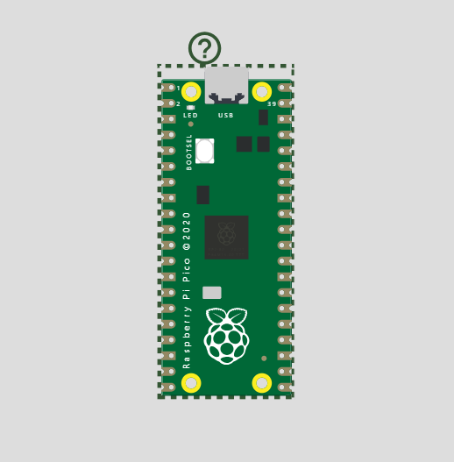

Step 4: Add components

* Search for DHT22 sensor
* Search for Ultrasonic distance sensor
* Search for buzzer reference
* Search for LED
* Search for resistor

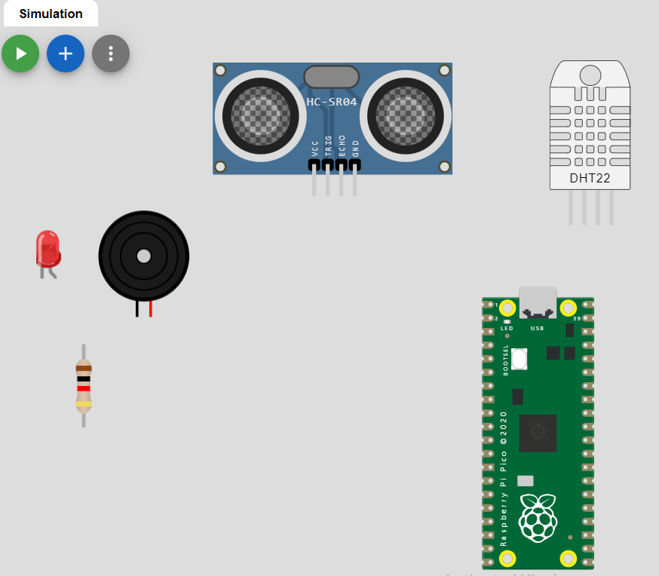

Step5:Connections from Raspberry pi to buzzer reference and LED

* pico:3V3 to led1:A through r1:2
* pico:GP6 to led1:C
* pico:GND.2 to bz1:1
* pico:GP4 to bz1:2

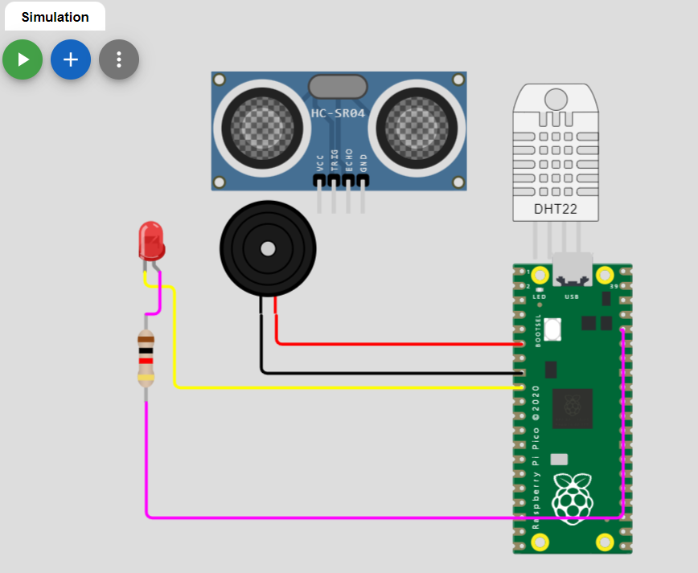

Step6:Connections form raspberry pi to DHT22 and HC-SR04

* pico:GP3 to ultrasonic1:ECHO
* pico:3V3_EN to ultrasonic1:VCC
* pico:GP2 to ultrasonic1:TRIG
* pico:GND.1 to ultrasonic1:GND
* pico:GP5 to dht1:SDA
* pico:3V3_EN to dht1:VCC
* pico:GND.8 to dht1:GND

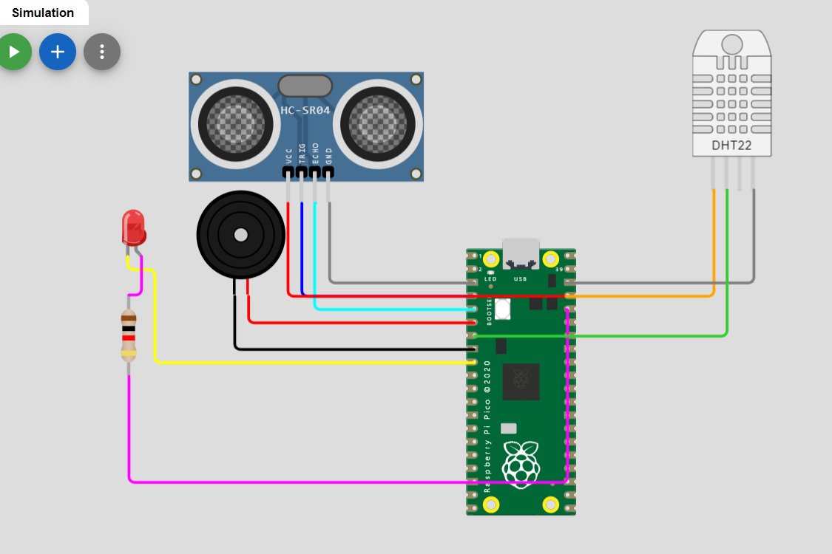

Step7:Source code for the above simulation.

import time

import machine

import dht

# Define GPIO pins

TRIG_PIN = machine.Pin(2, machine.Pin.OUT)

ECHO_PIN = machine.Pin(3, machine.Pin.IN)

BUZZER_PIN = machine.Pin(4, machine.Pin.OUT)

DHT_PIN = machine.Pin(5)

LED_PIN = machine.Pin(6, machine.Pin.OUT)

def distance_measurement():

    # Trigger ultrasonic sensor

    TRIG_PIN.on()

    time.sleep_us(10)

    TRIG_PIN.off()

    # Wait for echo to be HIGH (start time)

    while not ECHO_PIN.value():

        pass

    pulse_start = time.ticks_us()

    # Wait for echo to be LOW (end time)

    while ECHO_PIN.value():

        pass

    pulse_end = time.ticks_us()

    # Calculate distance

    pulse_duration = time.ticks_diff(pulse_end, pulse_start)

    distance = pulse_duration / 58  # Speed of sound (343 m/s) divided by 2

    return distance

def read_dht_sensor():

    d = dht.DHT22(DHT_PIN)

    d.measure()

    return d.temperature(), d.humidity()

buzz_start_time = None  # To track when the buzzer started

while True:

    dist = distance_measurement()

    temp, humidity = read_dht_sensor()

    # Check if the distance is less than a threshold (e.g., 50 cm)

    if dist < 50:

        # Turn on the buzzer and LED

        BUZZER_PIN.on()

        LED_PIN.on()

        status = "Flooding Detected"

        buzz_start_time = time.ticks_ms()

    elif buzz_start_time is not None and time.ticks_diff(time.ticks_ms(), buzz_start_time) >= 60000:  # 1 minute

        # Turn off the buzzer and LED after 1 minute

        BUZZER_PIN.off()

        LED_PIN.off()

        status = "No Flooding Detected"

    else:

        status = "No Flooding Detected"

    print(f"Distance: {dist:.2f} cm")

    print(f"Temperature: {temp:.2f}°C, Humidity: {humidity:.2f}%")

    print("Status:", status)

    time.sleep(2)

Step8: Result of the above simulation

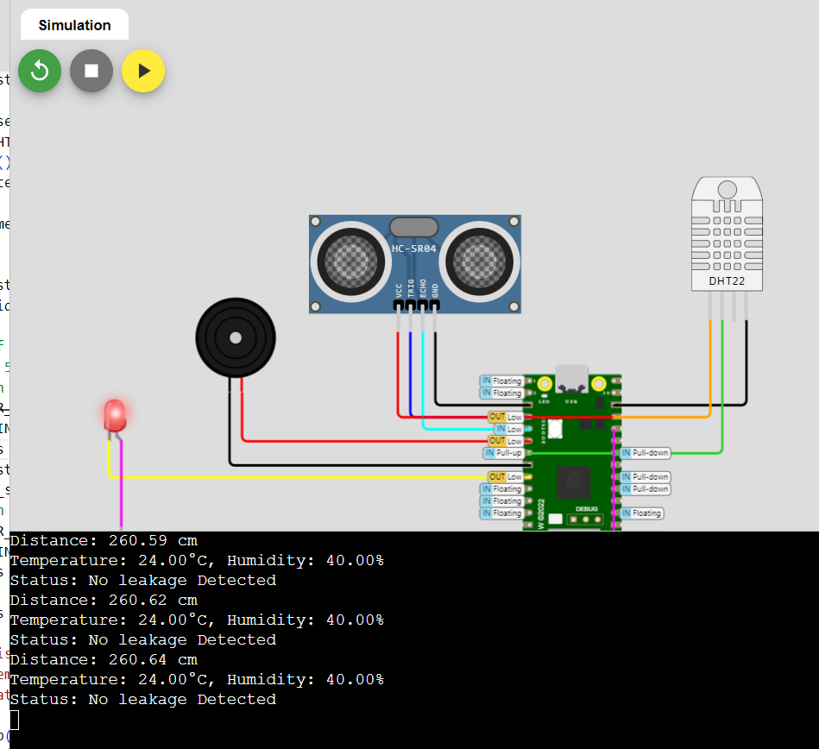

In the above simulation , the humidity and temperature are calculated using the DHT22 and the distance between the maximum and the current present capacity is calculated using the ultrasonic distance sensor.

Thus , the chances of leakage is determined beforehand.

In this case , there is no leakage.

WEB APPLICATION:

/*Water level monitoring system with the New Blynk app

https://srituhobby.com

*/

//Include the library files

#include <LiquidCrystal_I2C.h>

#define BLYNK_PRINT Serial

#include <ESP8266WiFi.h>

#include <BlynkSimpleEsp8266.h>

//Initialize the LCD display

LiquidCrystal_I2C lcd(0x27, 16, 2);

char auth[] = "5_Q6VTDFVGzauc0BBna2KVUNpn9RjMKL";//Enter your Auth token

char ssid[] = "";//Enter your WIFI name

char pass[] = "";//Enter your WIFI password

BlynkTimer timer;

// Define the component pins

#define trig D7

#define echo D8

#define LED1 D0

#define LED2 D3

#define LED3 D4

#define LED4 D5

#define LED5 D6

#define relay 3

//Enter your tank max value(CM)

int MaxLevel = 20;

int Level1 = (MaxLevel * 75) / 100;

int Level2 = (MaxLevel * 65) / 100;

int Level3 = (MaxLevel * 55) / 100;

int Level4 = (MaxLevel * 45) / 100;

int Level5 = (MaxLevel * 35) / 100;

void setup() {

Serial.begin(9600);

lcd.init();

lcd.backlight();

pinMode(trig, OUTPUT);

pinMode(echo, INPUT);

pinMode(LED1, OUTPUT);

pinMode(LED2, OUTPUT);

pinMode(LED3, OUTPUT);

pinMode(LED4, OUTPUT);

pinMode(LED5, OUTPUT);

pinMode(relay, OUTPUT);

digitalWrite(relay, HIGH);

Blynk.begin(auth, ssid, pass, "blynk.cloud", 80);

lcd.setCursor(0, 0);

lcd.print("Water level");

lcd.setCursor(4, 1);

lcd.print("Monitoring");

delay(4000);

lcd.clear();

//Call the functions

timer.setInterval(100L, ultrasonic);

}

//Get the ultrasonic sensor values

void ultrasonic() {

digitalWrite(trig, LOW);

delayMicroseconds(4);

digitalWrite(trig, HIGH);

delayMicroseconds(10);

digitalWrite(trig, LOW);

long t = pulseIn(echo, HIGH);

int distance = t / 29 / 2;

int blynkDistance = (distance - MaxLevel) * -1;

if (distance <= MaxLevel) {

Blynk.virtualWrite(V0, blynkDistance);

} else {

Blynk.virtualWrite(V0, 0);

}

lcd.setCursor(0, 0);

lcd.print("WLevel:");

if (Level1 <= distance) {

lcd.setCursor(8, 0);

lcd.print("Very Low");

digitalWrite(LED1, HIGH);

digitalWrite(LED2, LOW);

digitalWrite(LED3, LOW);

digitalWrite(LED4, LOW);

digitalWrite(LED5, LOW);

} else if (Level2 <= distance && Level1 > distance) {

lcd.setCursor(8, 0);

lcd.print("Low");

lcd.print(" ");

digitalWrite(LED1, HIGH);

digitalWrite(LED2, HIGH);

digitalWrite(LED3, LOW);

digitalWrite(LED4, LOW);

digitalWrite(LED5, LOW);

} else if (Level3 <= distance && Level2 > distance) {

lcd.setCursor(8, 0);

lcd.print("Medium");

lcd.print(" ");

digitalWrite(LED1, HIGH);

digitalWrite(LED2, HIGH);

digitalWrite(LED3, HIGH);

digitalWrite(LED4, LOW);

digitalWrite(LED5, LOW);

} else if (Level4 <= distance && Level3 > distance) {

lcd.setCursor(8, 0);

lcd.print("High");

lcd.print(" ");

digitalWrite(LED1, HIGH);

digitalWrite(LED2, HIGH);

digitalWrite(LED3, HIGH);

digitalWrite(LED4, HIGH);

digitalWrite(LED5, LOW);

} else if (Level5 >= distance) {

lcd.setCursor(8, 0);

lcd.print("Full");

lcd.print(" ");

digitalWrite(LED1, HIGH);

digitalWrite(LED2, HIGH);

digitalWrite(LED3, HIGH);

digitalWrite(LED4, HIGH);

digitalWrite(LED5, HIGH);

}

}

//Get the button value

BLYNK_WRITE(V1) {

bool Relay = param.asInt();

if (Relay == 1) {

digitalWrite(relay, LOW);

lcd.setCursor(0, 1);

lcd.print("Motor is ON ");

} else {

digitalWrite(relay, HIGH);

lcd.setCursor(0, 1);

lcd.print("Motor is OFF");

}

}

void loop() {

Blynk.run();//Run the Blynk library

timer.run();//Run the Blynk timer

}

OUTPUT:

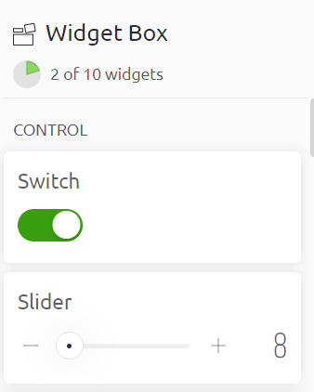

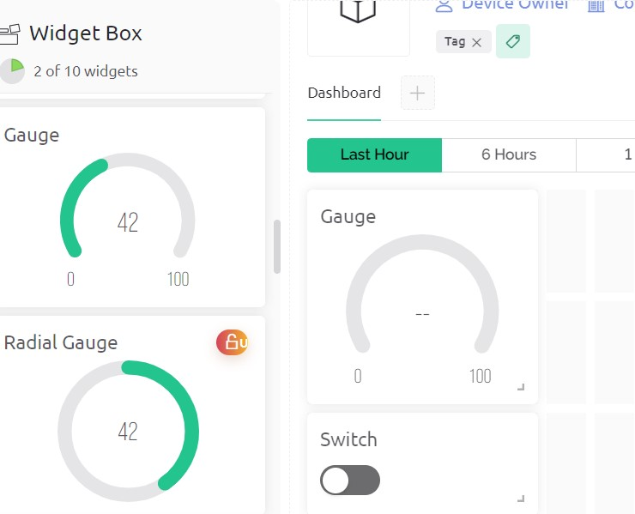

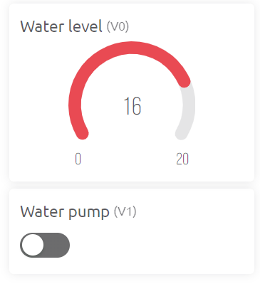

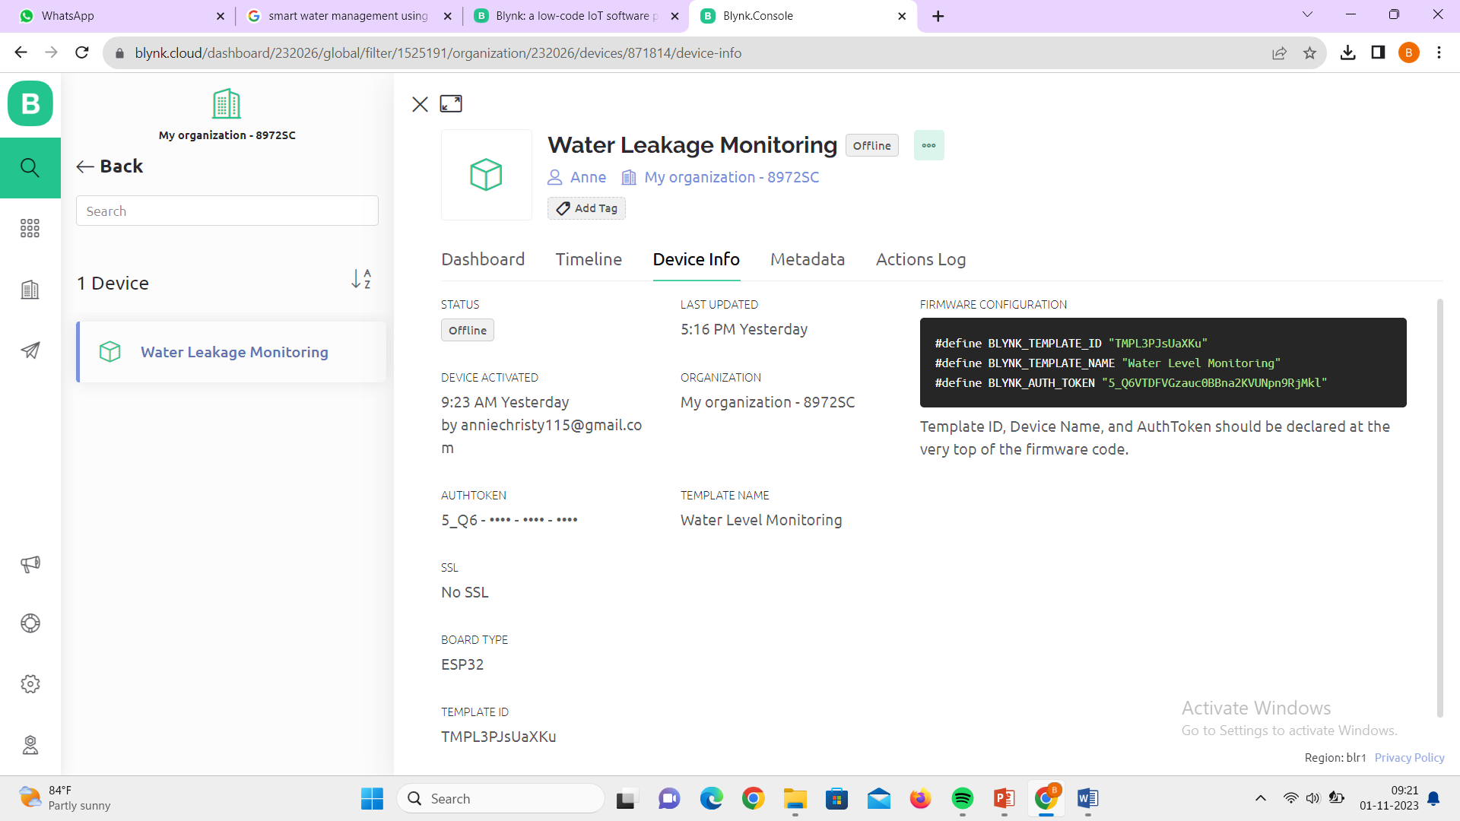

(application in mobile)

