Practical-1
Aim:-Design web pages for your college containing a description of the courses, departments, faculties, library etc. Use href, list tags.
Main.html
<html>
<head>
<title></title>
</head>
<body background="Background.jpg">
<marquee><font size="20%">WELCOME TO LDRP-ITR</marquee>
<center>
<p align="left">
<img height="15%" src="LDRP-logo-3.png"></p>
<hr size="1%"color="black">
<table height="50px"width="1200px" align="center">
<tr><h2><td align="center">"><a href="Main.html"><b>HOME</b></a></td>
<td align="center"><a href="department.html"><b>DEPARTMENTS</b></a></td>
<td align="center"><b>RESULTS<b/></td>
<td align="center"><b>GALLERY</b></td>
<td align="center"><b>ABOUT US</b></td></tr></h2>
</table>
</center>
<hr size="1%"color="black">
<font color="black">
<h2>Welcome to LDRP – ITR (A Constituent College of KSV)</h2>
<h2>LDRP Institute of Technology and Research</h2>
<font size="3%">
<p>LDRP INSTITUTE OF TECHNOLOGY AND RESEARCH, Gandhinagar was established in 2005 – 2006. The college has made steady progress during the past one year of its existence. Established as a pace setting Institute of Technical Education imparting undergraduate and postgraduate education, it has played a vital role in engineering colleges of Gujarat. In this mission today it has progressed to offering several B.E., M.B.A. and M.C.A. Programs and facilities.</p>
<p>LDRP INSTITUTE OF TECHNOLOGY AND RESEARCH, Gandhinagar is a constituent institute of Kadi Sarva Vishwavidyalaya.</p></font></font>
</body>
</html>
Department.html

<html>
<body background="Background.jpg">
<table height="50px"width="1200px" align="center">
<tr><h2><td align="center">"><a href="Main.html"><b>HOME</b></a></td>
<td align="center"><a href="department.html"><b>DEPARTMENTS</b></a></td>
<td align="center"><b>RESULTS<b/></td>
<td align="center"><b>GALLERY</b></td>
<td align="center"><b>ABOUT US</b></td></tr></h2>
</table>
<hr size="1%"color="black">
<h1>Departments</h1>
<h2><ul>
<li><font color=black><a href="ce.html">CE</a></li>
<li>IT</li>
<li>CIVIL</li>
<li>MECHANICAL</li>
<li>EC</li>
<li>ELECTRICAL</li>
</ul></h2>
</body>
</html>
IT.html
<html>
<body background="Background.jpg">
<table height="50px"width="1200px" align="center">
<tr><h2><td align="center">"><a href="Main.html"><b>HOME</b></a></td>
<td align="center"><a href="department.html"><b>DEPARTMENTS</b></a></td>
<td align="center"><b>RESULTS<b/></td>
<td align="center"><b>GALLERY</b></td>
<td align="center"><b>ABOUT US</b></td></tr></h2>
</table>
<hr size="1%"color="black">
<h1>Departments</h1>
<ul><h2><li>IT</h2></li>
<ul><h3><font color=black>
<li>Sem 1</li>
<li>Sem 2</li>
<li>Sem 3</li>
<li>Sem 4</li>
<li><a href="sem5.html">Sem 5</a></li>
<li>Sem 6</li>
<li>Sem 7</li>
<li>Sem 8</li>
</h3></ul></ul>
</body>
</html>

Sem5.html
<html>
<body background="Background.jpg">
<table height="50px"width="1200px" align="center">
<tr><h2><td align="center">"><a href="Main.html"><b>HOME</b></a></td>
<td align="center"><a href="department.html"><b>DEPARTMENTS</b></a></td>
<td align="center"><b>RESULTS<b/></td>
<td align="center"><b>GALLERY</b></td>
<td align="center"><b>ABOUT US</b></td></tr></h2>
</table>
<hr size="1%"color="black">
<h1>Departments</h1>
<ul><h2><li>CE</h2></li>
<ul><li><h3><font color=blue>Sem5</h3></li>
<h3><li><a href="http://ldrp.ac.in/images/syllabus/BE-Computer/CE506%20-%20Web%20Technology.pdf">Web Technology</a></li>
<li><a href="http://ldrp.ac.in/images/syllabus/BE-Computer/CE504%20-%20System%20Software.pdf">System Software</a></li>
<li><a href="http://ldrp.ac.in/images/syllabus/BE-Computer/CE503%20-%20Operating%20System.pdf">Operating System</a></li>
<li><a href="http://ldrp.ac.in/images/syllabus/BE-Computer/CE502%20-%20Advanced%20Processors.pdf">Advance Processor</a></li>
<li><a href="http://ldrp.ac.in/images/syllabus/BE-Computer/CC501%20-%20Principles%20Of%20Management.pdf">Principle Of Management</a></li>
<li><a href="http://ldrp.ac.in/images/syllabus/BE-Computer/CE505%20-%20Object%20Oriented%20Programming%20with%20JAVA.pdf">Object oriented programming with JAVA</a></li></ul>
</h3></ul>
</body>
</html>



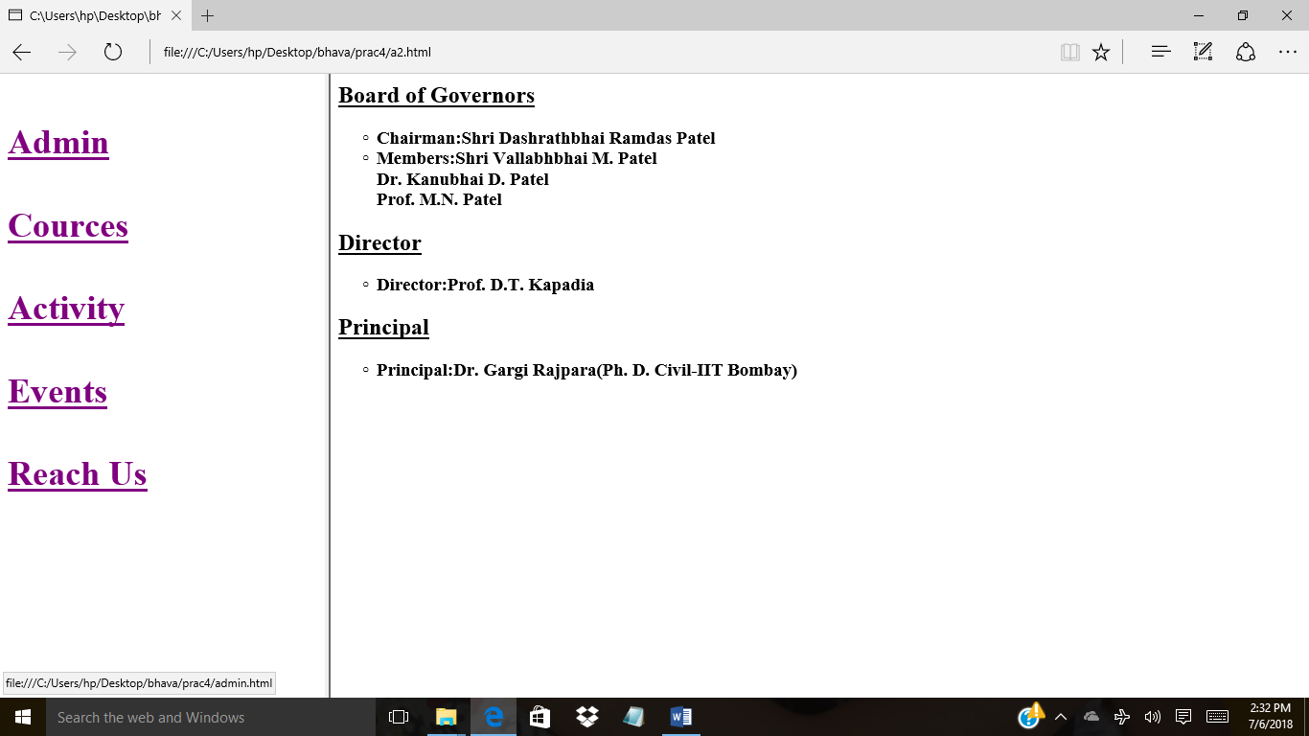

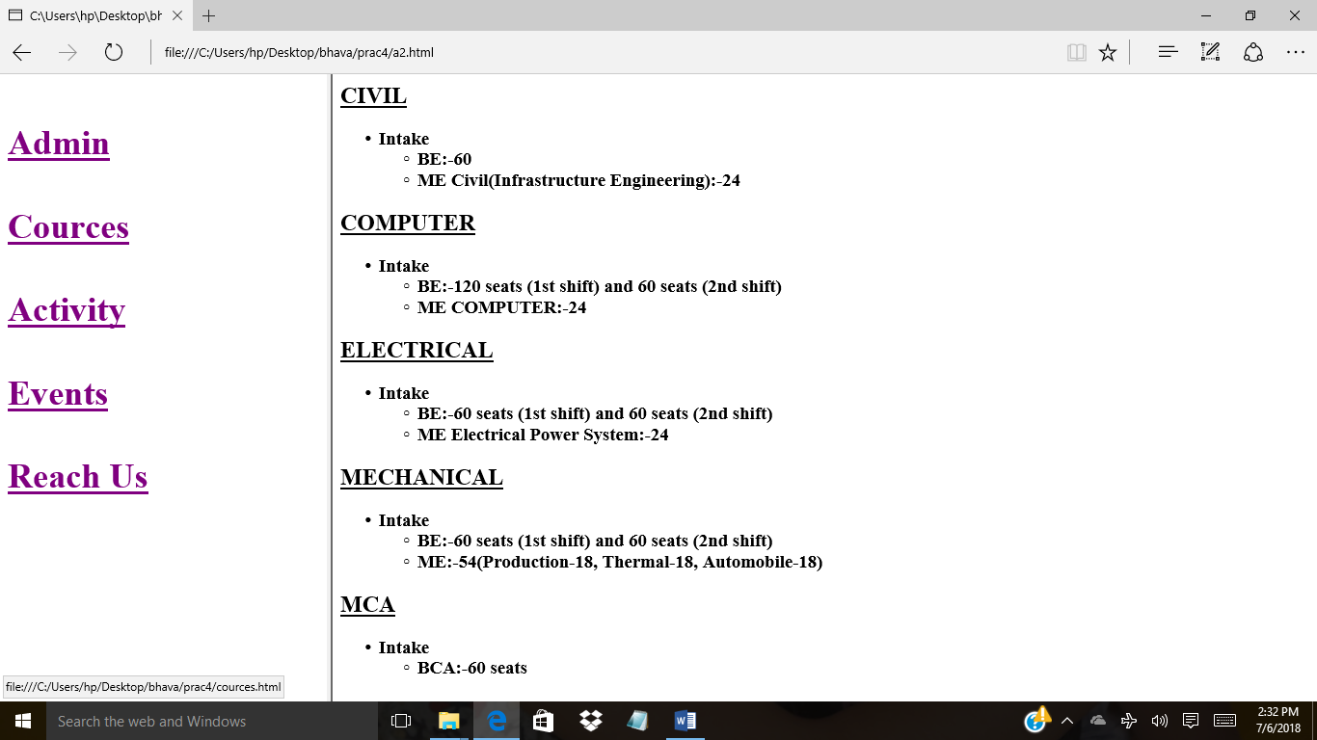

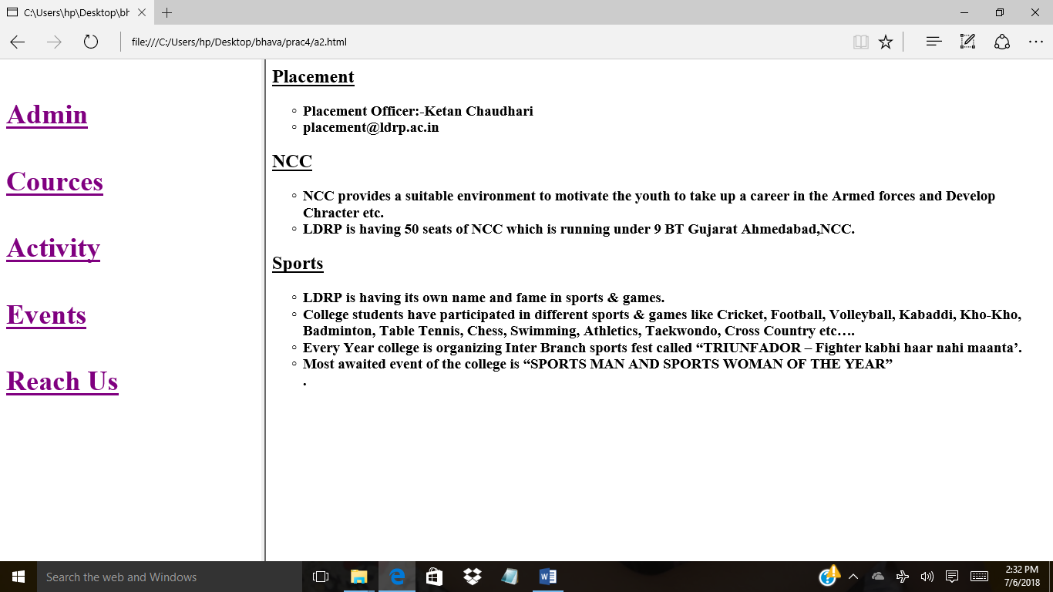

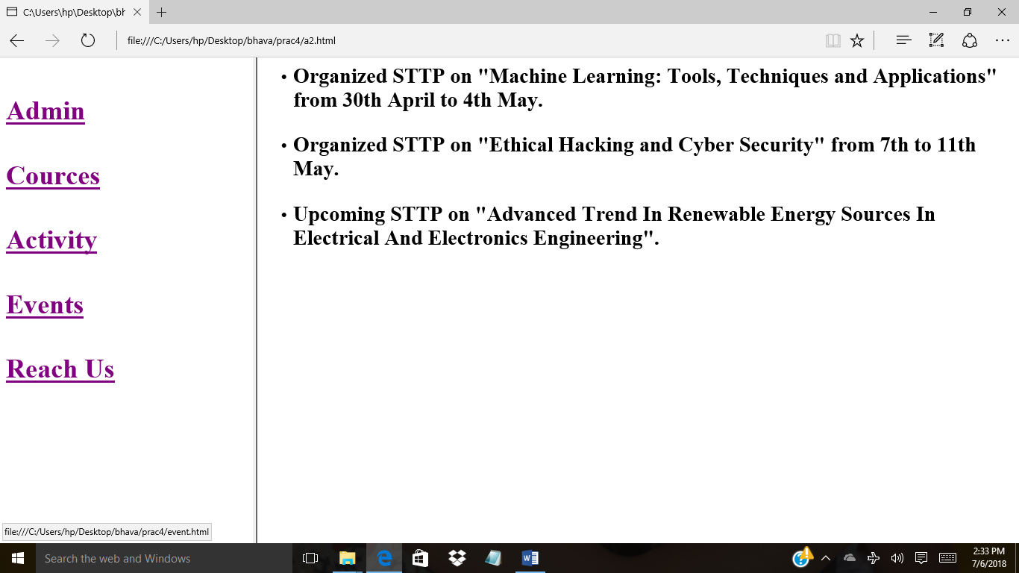

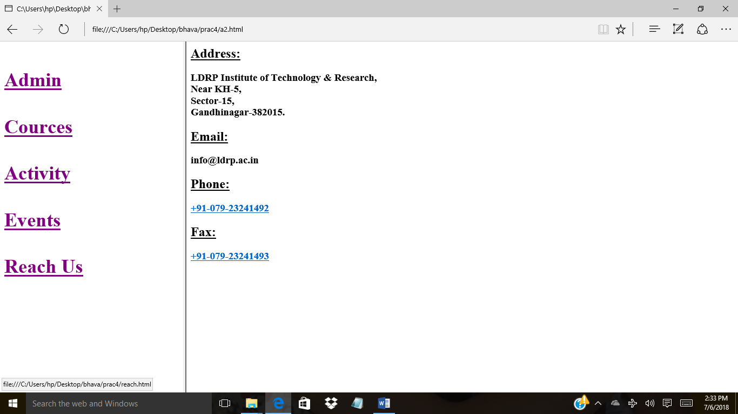

Practical:2
AIM: Create your class Timetable using table tag.
Code:
<html>
<head>

<h1><center>TIME TABLE OF DIVISION 5B B.E.(COMPUTER ENGINEERING)</center></h1>

</head>
<body>
<center>
<table border='1' width=50%>

<tr>
<th> SLOT</th>
<th> MONDAY</th>
<th> TUESDAY</th>
<th> WEDNESDAY</th>
<th> THURSDAY</th>
<th> FRIDAY</th>
<th> SATURDAY</th>
</tr>
<tr>
<td>1</td>
<td>OS(PP)</td>
<td>WT(VB)</td>
<td>OS(PP)</td>
<td>WT(VB)</td>
<td rowspan='2'><br>5B1 OS(PP)</br>
<br>5B2 WT(VB)</br>
<br>5B3 AP(OP)</br></td>
<td>OS(PP)</td>
</tr>
<tr>
<td>2</td>
<td>OS(PP)</td>
<td>WT(VB)</td>
<td>OS(PP)</td>
<td>WT(VB)</td>
<td>OS(PP)</td>
</tr>
<tr>
<td colspan='7' align='center'><b>LUNCH BREAK</b></td>
</tr>
<tr>
<td>3</td>
<td rowspan='2'><br>5B1 OS(PP)</br>
<br>5B2 WT(VB)</br>
<br>5B3 AP(OP)</br></td>

<td rowspan='2'><br>5B1 OS(PP)</br>
<br>5B2 WT(VB)</br>
<br>5B3 AP(OP)</br></td>

<td rowspan='2'><br>5B1 OS(PP)</br>
<br>5B2 WT(VB)</br>
<br>5B3 AP(OP)</br></td>

<td rowspan='2'><br>5B1 OS(PP)</br>
<br>5B2 WT(VB)</br>
<br>5B3 AP(OP)</br></td>

<td rowspan='2'><br>5B1 OS(PP)</br>
<br>5B2 WT(VB)</br>
<br>5B3 AP(OP)</br></td>

<td rowspan='2'><br>5B1 OS(PP)</br>
<br>5B2 WT(VB)</br>
<br>5B3 AP(OP)</br></td>
</tr>
<tr>
<td>4</td>
</tr>
<tr>
<td colspan='7' align='center'><b>BREAK</b></td>
</tr>
<tr>
<td>5</td>
<td>WT(VB)</td>
<td>OS(PP)</td>
<td>WT(VB)</td>
<td>WT(VB)</td>
<td>WT(VB)</td>
<td rowspan='2'><br></br>
<br></br>
<br></br></td>
</tr>

<tr>
<td>6</td>
<td>WT(VB)</td>
<td>OS(PP)</td>
<td>WT(VB)</td>
<td>WT(VB)</td>
<td>OS(PP)</td>

</tr>

</table>
</center>
</body>
</html>

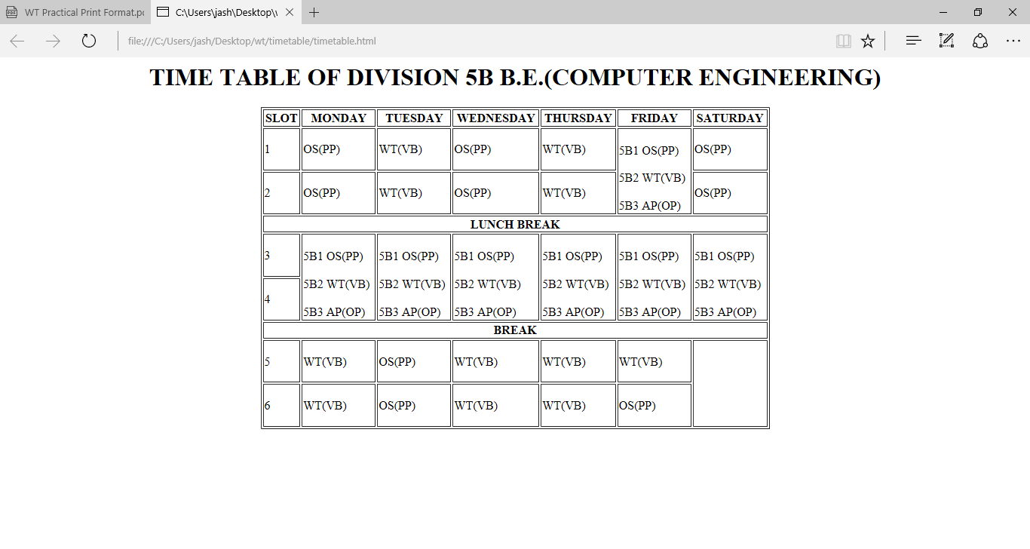

Practical:3
AIM: Create Student feedback form (use textbox, text area, checkbox, radio button, select box etc.)
Code:
<html>
<head>

<h1 align='center'> STUDENT FORM</h1>

</head>
<body>

<center>
<form action='xyz.html'>
<table>
<tr>
<td width='30%'>FIRST NAME</td>
<td width='50%'><input type="text"></td>
</tr>

<tr>
<td width='30%'>MIDDLE NAME</td>
<td width='50%'><input type="text"></td>
</tr>

<tr>
<td width='30%'>LAST NAME</td>
<td width='50%'><input type="text"></td>
</tr>

<tr>
<td width='30%'>E-MAIL</td>
<td width='50%'><input type="text" placeholder='example@xyz.com'></td>
</tr>

<tr>
<td width='30%'>DATE OF BIRTH</td>
<td width='50%'><input type="text" placeholder='dd/mm/yyyy'></td>
</tr>
<tr>
<td>REVIEW</td>
<td><input type="checkbox">EXCELLENT
<input type="checkbox">GOOD
<input type="checkbox">BAD
</tr>
<tr>
<td width='30%'>COMMENT</td>
<td width='50%'><textarea cols="20" rows="6"></textarea></td>
</tr>
<tr>
<td>CLASS</td>
<td><select>
<option>5A</option>
<option>5B</option>
<option>5C</option>
</select>
</td>
</tr>
<tr>
<td width='30%'>ENROLLMENT</td>
<td width='50%'><input type="text" placeholder='1620BECE30113'></td>
</tr>

<tr>
<td>GENDER</td>
<td><input type="radio" name="gender" valaue="male">M
<input type="radio" name="gender" value="female">F
<input type="radio" name="gender" value="other">OTHER</tr>
</tr>

</tr>
<tr>
<td width='30%'>LANGUAGE</td>
<td width='50%'><input type="checkbox">Gujrati
<input type="checkbox">English
<input type="checkbox">Hindi
<input type="checkbox">French
</td>
</tr>
<tr>
<td><input type="submit" value="Submit"></td>
<td><input type="reset" vlaue="Reset"></td>
</tr>
</table>
</center>
</body>
</html>

