Mapúa SOIT Student Portfolio Dashboard: Data Integration and Visualization

An OJT Project
Presented to the
School of Information Technology
Mapúa University

In Partial Fulfillment
of the Requirements for the Degree
Bachelor of Science in Data Science

by
Christine Julliane L. Reyes

July 2026

ABSTRACT
This practicum report details the 320-hour internal internship completed at Mapúa University’s School of Information Technology (SOIT) under the supervision of the BS Data Science Program Coordinator. The primary objective of the training was to conceptualize and develop a comprehensive Student Portfolio Project. Prior to this initiative, student academic data and project artifacts were stored in unstructured and disparate formats, creating administrative friction for faculty attempting to evaluate program effectiveness or showcase student capabilities. To address this opportunity, the internship focused on building a centralized data pipeline. The methodology involved extracting raw student data, executing rigorous data cleaning and structuring utilizing Python and SQL, and designing a robust relational database schema. The structured backend data was then seamlessly integrated into an interactive frontend visualization dashboard. The final output is a dynamic and user-friendly system that allows administrators to efficiently track and evaluate a student's holistic academic journey. Ultimately, the project successfully streamlined student data management for the department and demonstrated the critical importance of backend data integrity in developing reliable data science applications.

TABLE OF CONTENTS
Mapúa SOIT Student Portfolio Dashboard: Data Integration and Visualization i
ABSTRACT ii
TABLE OF CONTENTS iv
CHAPTER 1: COMPANY PROFILE 7
Company Background 7
Vision 7
Mission 7
Organizational Chart 8
Figure 1: A basic organizational chart of the School of IT (SOIT) department 8
CHAPTER 2: TRAINEE 9
Specific Department 9
Training Summary & Key Tasks Performed 9
Learnings 10
Overall Assessment 10
CHAPTER 3: PROJECT 11
Project Overview 11
Problem/Opportunity 11
Objectives 11
Significance 12
Scope and Limitations 12
Output Documentation 13
Figure 3.1: Public landing section of the Mapua Student Portfolio Registry 13
Figure 3.2: Public directory with search, filters, and student cards 14
Figure 3.3: Expanded student profile panel 15
Figure 3.4: Student publication request form 16
Figure 3.5: Private administration CMS and moderation workflow 17
APPENDICES 18

CHAPTER 1:
COMPANY PROFILE

Company Background
Founded on January 25, 1925, by Don Tomás Mapúa, the first registered Filipino architect and a graduate of Cornell University, Mapúa University (originally established as the Mapúa Institute of Technology) stands as a premier engineering and technological institution in the Philippines. Acquired by the Yuchengco Group of Companies in 2000, it officially attained its university status in 2017. The university operates its main campus in the historic district of Intramuros, Manila, with a prominent satellite campus in Makati City. Mapúa is widely recognized as a pioneer of outcomes-based education (OBE) in the country and holds the distinction of being the first university in Southeast Asia to receive accreditation from ABET. Today, Mapúa continues its legacy of academic excellence by maintaining international partnerships, integrating advanced AI and digital transformation into its pedagogy, and consistently producing top-tier professionals in engineering, architecture, information technology, business, and data science.

Vision
Mapúa University, a global leader in education, fosters sustainable socio-economic growth of society through innovation, digital transformation, and lifelong education.

Mission
The University is committed to:
- Providing a learning environment in order for its students to acquire the attributes that will make them globally competitive.
- Engaging in publishable and/or economically viable research, development, and innovation.
- Providing state-of-the-art solutions to the problems of industries and communities.

Organizational Chart
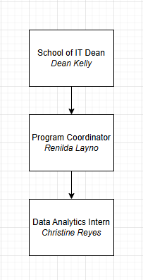

Figure 1: A basic organizational chart of the School of IT (SOIT) department

In the organizational setup relevant to the practicum, the trainee reported directly to Ms. Renilda Layno, Program Coordinator for BS Data Science, who served as the immediate supervisor for the Student Portfolio Dashboard project. The Program Coordinator operates within the School of Information Technology and reports to the SOIT Dean, Dean Kelly. This reporting structure provided the trainee with direct academic supervision while situating the project within the broader administrative and program-level priorities of the department.

CHAPTER 2:
TRAINEE

Specific Department
The trainee was assigned to the School of Information Technology (SOIT) under the direct supervision of Ms. Renilda Layno, Program Coordinator for BS Data Science. During the practicum, the trainee performed the role of lead developer and data analyst for the Student Portfolio Dashboard prototype. The work focused on structuring student portfolio information, designing a usable web-based dashboard, and preparing a private administrative workflow for managing profile submissions and published student records.

Training Summary & Key Tasks Performed
Over the course of 320 hours, the trainee developed a centralized Student Portfolio Dashboard prototype aligned with the needs of the School of Information Technology. The work began with the organization and modeling of student profile data into a structured format that could support search, filtering, profile expansion, and future database integration. The trainee then designed and implemented a public-facing portfolio registry using an institutional red, gold, and white visual direction appropriate for a Mapua University prototype.

The project also required the creation of an end-to-end profile management workflow. The public interface allows students or visitors to submit profile information for review, while the private administration route provides a fake-login CMS prototype where an administrator can add, edit, save, approve, return with comments, archive, restore, or delete records. The trainee also prepared a production-ready relational database schema and defense documentation covering the product requirements, system architecture, user flow, running instructions, and prototype limitations. Final work included QA testing, interface debugging, alignment with Chapter 3 project requirements, and updating the project documentation to reflect the actual implemented outcome.

Learnings
During the internship, I strengthened my technical understanding of data structuring, frontend development, database schema planning, and prototype documentation. The project reinforced the importance of transforming unstructured or scattered student information into a consistent data model before presenting it through a dashboard. I also gained practical experience in designing workflows that support both public users and administrators, particularly through profile submission, review, approval, revision, and archiving processes.

The work also improved my ability to connect data science concepts with software implementation. Instead of treating the dashboard only as a visual output, I learned to consider the full data lifecycle, from data preparation and schema design to interface behavior, persistence, moderation, and future production readiness. In terms of professional development, the practicum strengthened my independent problem-solving, documentation discipline, time management, and ability to translate academic project requirements into a working prototype.

Overall Assessment
The internal internship at Mapua University was a practical and rigorous experience that allowed me to apply data science, database design, and frontend development concepts in a realistic academic setting. By serving as the primary developer of the Student Portfolio Dashboard prototype, I gained an end-to-end understanding of how structured data supports reliable digital systems. The project demonstrated that a useful dashboard depends not only on visual design, but also on data integrity, workflow clarity, and maintainable system architecture.

Overall, the practicum strengthened my confidence in building systems that connect backend data requirements with user-facing interfaces. It also prepared me for future development work by requiring me to manage the full prototype cycle, including data modeling, UI/UX implementation, administrative workflow design, QA testing, and defense-ready documentation.

CHAPTER 3:
PROJECT

Project Overview
The project is a dynamic and interactive Student Portfolio Dashboard for the School of Information Technology that centralizes student achievements, academic standing, portfolio evidence, and project history in a single accessible interface. In its current prototype version, the system is presented as the Mapua Student Portfolio Registry, a web-based dashboard that allows public visitors to discover student profiles while providing a separate private administration workspace for profile review and data governance. The prototype contains thirty-three sample student profiles and demonstrates how structured student records can be transformed into a searchable and visually readable dashboard.

Problem/Opportunity
Prior to the proposed system, student information and portfolio artifacts were treated as scattered records rather than as a unified academic data resource. This made it difficult for faculty and administrators to assess a student's holistic academic journey, compare project evidence across program categories, or prepare student capabilities for institutional partners and accreditation-related presentations. The opportunity addressed by the project is the creation of a cleaned, structured, and moderated portfolio pipeline that turns unstructured student data into a reliable frontend dashboard supported by a production-ready relational schema.

Objectives
The first objective of the project is to convert unstructured student data into a dependable relational data model. The prototype demonstrates this objective through normalized student records, course classification, year-level status, portfolio evidence, skills, and moderation states. The supporting SQL schema documents how student identity, academic details, skills, projects, metrics, administrator users, and audit logs may be represented in a production database.

The second objective is to design a usable frontend dashboard that supports both discovery and academic administration. The public-facing interface allows visitors to search and filter student portfolios by year level, course category, availability, and keywords. The private administration interface, reached through the prototype's admin route, allows authorized users in a future production version to maintain data quality by reviewing, editing, approving, returning, archiving, restoring, and deleting records.

The third objective is to connect the data pipeline to an interface that reflects updates immediately. In the prototype, this is simulated through browser local storage, which persists submitted profiles, administrator edits, approval decisions, returned comments, archived records, and session state. Although the prototype is static, its data structures are intentionally designed so that a backend API and database can replace local storage without redesigning the user workflow.

Significance
The project reduces administrative friction by transforming student profiles into structured, searchable, and moderated records. Faculty and administrators can more easily inspect student capability, monitor the quality of submitted portfolio information, and prepare a more organized view of student work for external partners. The system also benefits students by providing a clearer publication process for presenting skills, projects, and availability in a professional format aligned with Mapua University's academic and institutional identity.

Scope and Limitations
The prototype is scoped to portfolio data for School of Information Technology programs and related computing, data, information systems, information technology, computer science, and media or design-oriented student work. It does not perform live synchronization with external Mapua systems such as Blackboard, nor does it use real cloud authentication, email verification, file uploads, or a hosted production database. For the purpose of the 320-hour deployment, these integrations remain outside the scope, while the prototype focuses on data structuring, dashboard interaction, administrative moderation, and defense-ready documentation.

Output Documentation
The final prototype is documented through the public interface, the private administration route, and the supporting product and database documents stored in the local documentation folder. The following figures describe the major screens and workflows that demonstrate the system from data presentation to administrative governance.

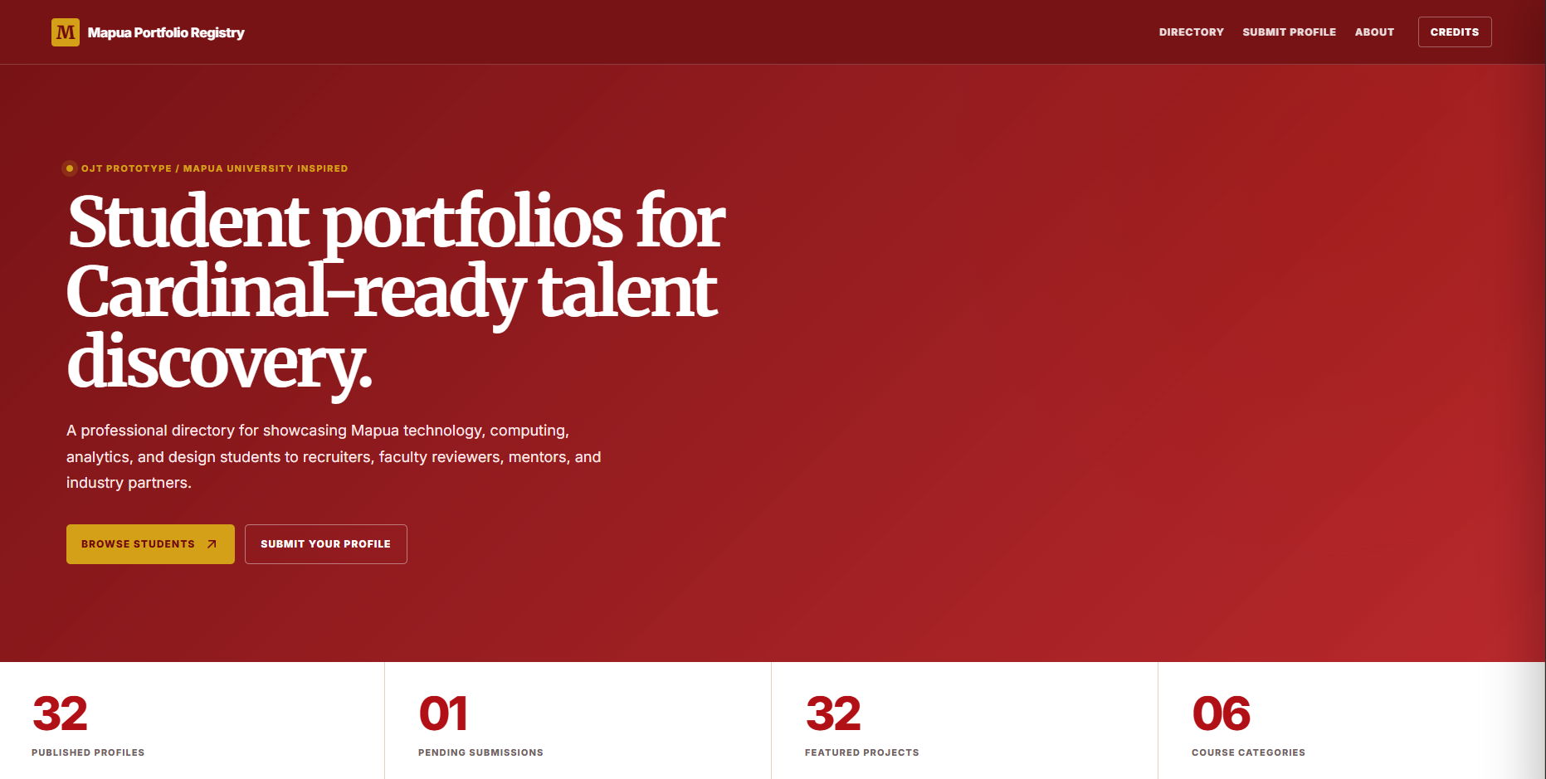

Figure 3.1: Public landing section of the Mapua Student Portfolio Registry

The landing section introduces the Student Portfolio Dashboard as a professional registry for Mapua student work. It uses a school-aligned red, gold, and white visual system and communicates the purpose of the site as a centralized discovery interface for student achievements, academic status, and project evidence. The summary metrics show the number of published profiles, pending submissions, featured projects, and course categories, giving administrators and visitors a quick overview of the current portfolio dataset.

This section also establishes the institutional tone of the prototype. Rather than functioning only as a decorative landing page, it immediately frames the website as a data-driven portfolio registry that can support faculty review, partner discovery, and OJT presentation requirements.
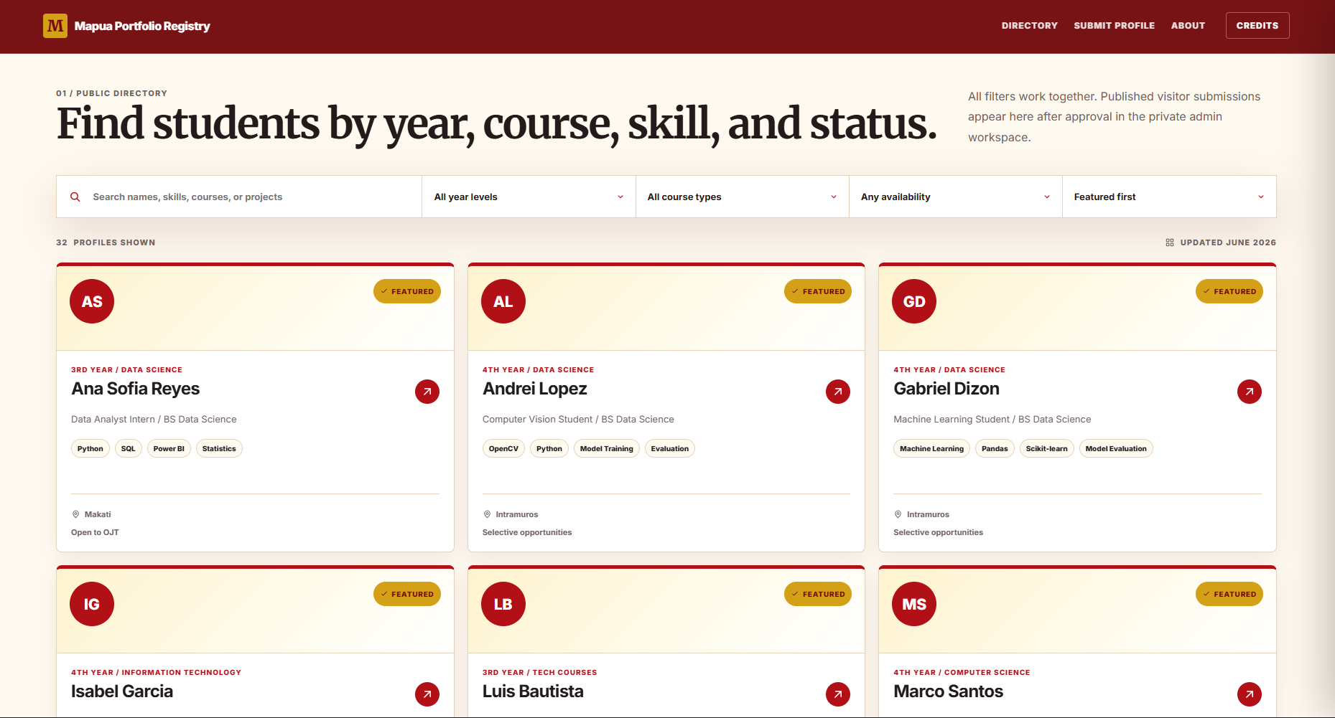

Figure 3.2: Public directory with search, filters, and student cards

The public directory contains the published student profiles and allows visitors to search by name, program, skills, project details, and other profile content. The directory includes filters for year level, course type, and availability, while sorting options allow records to be arranged by featured status, name, or year level. The current course-type filter focuses on Computer Science, Information Technology, Information Systems, Data Science, and Media and Design, while uncategorized or broader technology records remain visible through the All course types view.

Each card is generated from structured data rather than hard-coded profile markup. This supports the project's data-cleaning objective because the same rendering logic can display seed records, approved visitor submissions, or future records loaded from a database-backed API.

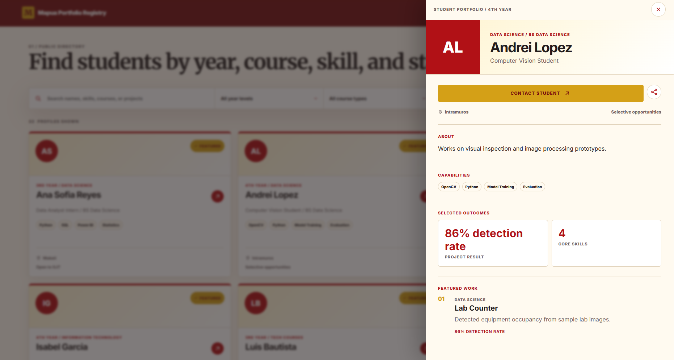

Figure 3.3: Expanded student profile panel

When a visitor selects a student card, the system opens an expanded profile panel that presents the student's name, course category, program, year-level status, role, location, availability, biography, skills, selected outcomes, and featured project work. This view demonstrates how a cleaned student record can be transformed into a readable portfolio summary for faculty, recruiters, mentors, or external partners.

The profile panel also includes contact and sharing actions. These actions support the project's purpose of making student capabilities easier to present and circulate while still keeping the profile structure consistent across all students.

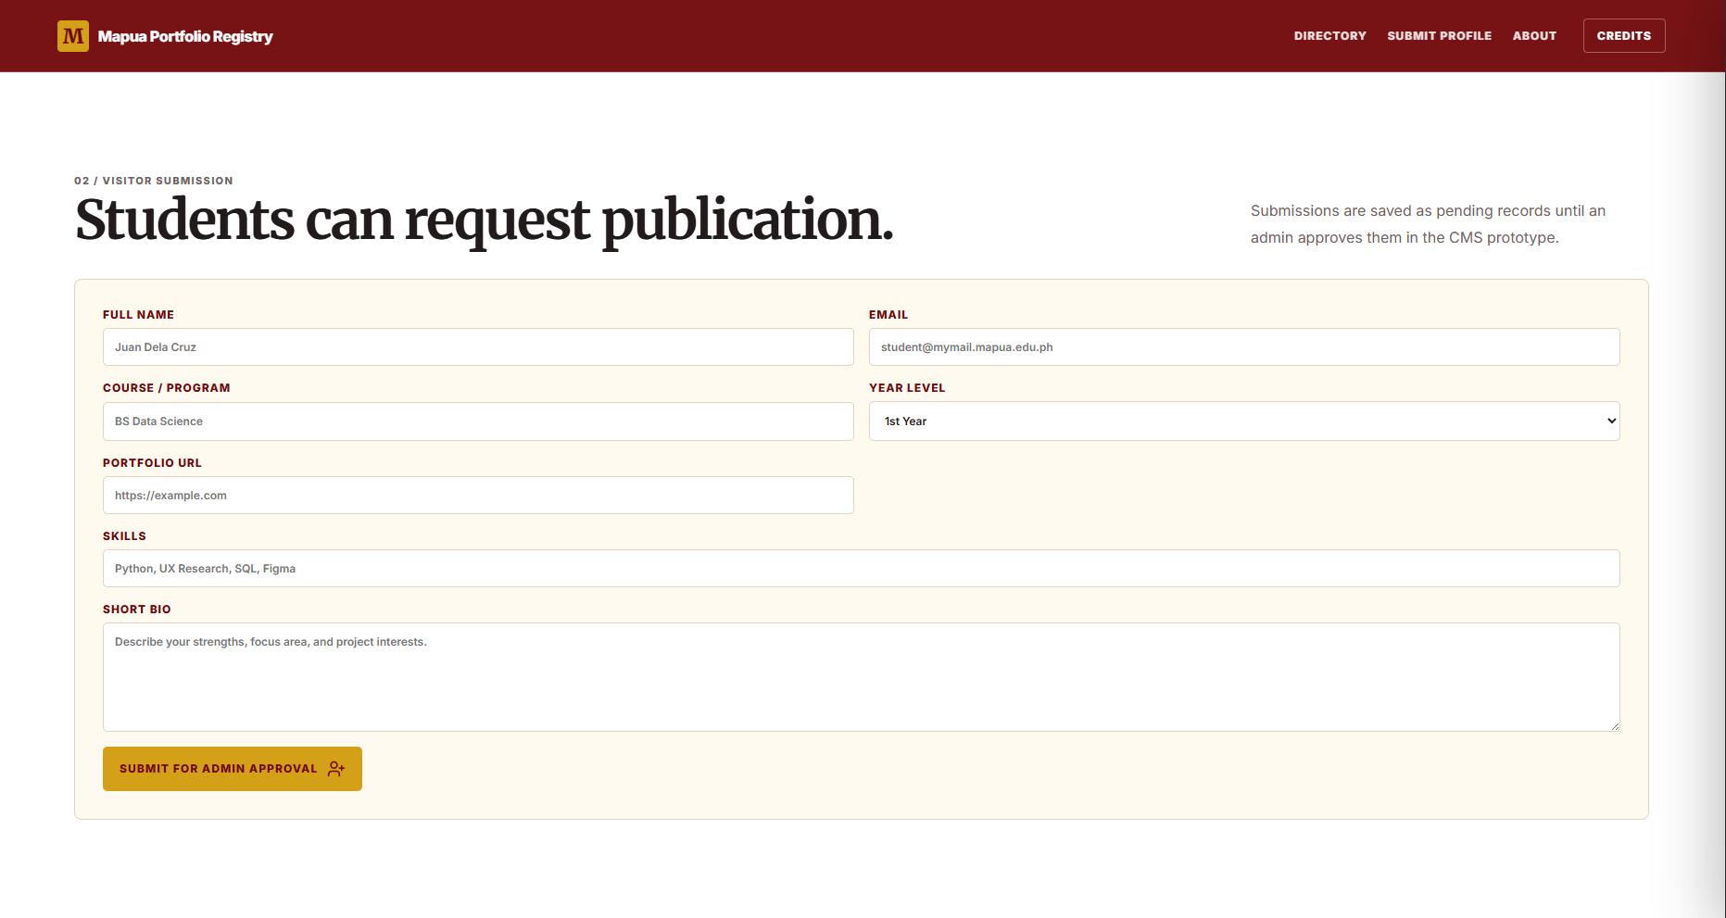

Figure 3.4: Student publication request form

The public-facing submission form allows students or visitors to request profile publication by entering their name, email, program, year level, portfolio URL, skills, and short biography. To avoid redundant input, the form no longer asks the submitter to choose a separate course-type dropdown. Instead, the prototype infers the course category from the program text and sends the record into the administration queue for review.

Submitted profiles are not published immediately. They are stored as pending records so that an administrator can verify, clean, classify, edit, and approve the information before it appears in the public directory. This reflects the need for data governance in an academic portfolio system.

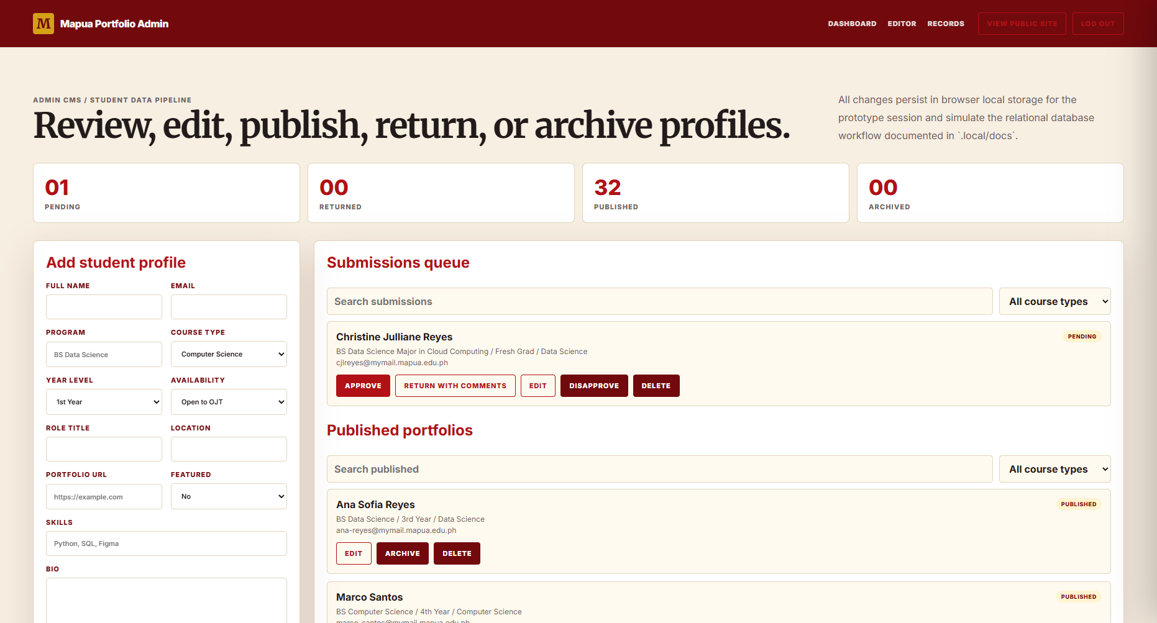

Figure 3.5: Private administration CMS and moderation workflow

The administration CMS is no longer displayed as a public page section. It is accessed through a private prototype route, such as index.html#/admin in local static mode or /admin when hosted with an appropriate rewrite rule. The route includes a fake login for demonstration purposes, where any email and password can start an admin session. This simulates authentication without requiring a live identity provider during the prototype defense.

Inside the private CMS, administrators can add new profiles, edit and save existing records, approve pending submissions, return submissions with comments, archive or disapprove records, restore archived profiles, and delete records from the prototype state. The system maintains separate administrative views for submission queues, published portfolios, and archived or disapproved records. Each category includes search and course filter controls and shows the top five records by default, with an option to see more when the list is longer.

The private CMS is intentionally backed by browser local storage in the prototype. This provides session persistence for defense demonstration while clearly separating prototype storage from the production design. In a deployed implementation, local storage should be replaced by the relational database schema, authenticated administrator accounts, server-side validation, and audit logging.

The system architecture separates the public interface, administrative workflow, structured data, and production database plan. The public interface is implemented in index.html and styled through styles.css, while app.js controls rendering, filtering, detail panels, visitor submission, admin routing, fake login, moderation actions, and local persistence. The production schema defines tables for students, skills, projects, metrics, admin users, and audit logs, allowing the prototype to be defended as a production-shaped system even though it remains dependency-free and locally runnable.

For the defense, the important point is that the prototype demonstrates the complete end-to-end process. A student profile can be submitted through the public website, held as pending data, reviewed in the private admin workspace, edited for quality, approved for publication, returned with comments, archived, restored, or deleted. This workflow directly supports the Chapter 3 objective of linking a cleaned backend data pipeline to a readable dashboard that can update portfolio information in real time within the prototype environment.

APPENDICES
None.

