SOLVING THE INVOICE PAYMENT PREDICTION PROBLEM (IPPP):
A MULTI-STAGE APPROACH

A Thesis Project
Presented to the
School of Information Technology
Mapúa University

In Partial Fulfillment
of the Requirements for the Degree
Bachelor of Science in Data Science

by
Rafael Joseph T. Beley
Christine Julliane L. Reyes

June 2026


TABLE OF CONTENTS
TABLE OF CONTENTS iii
LIST OF FIGURES vii
LIST OF TABLES viii
CHAPTER 1: INTRODUCTION 9
1.1 Context of the Study 12
1.2 The Problem, Gap, or Opportunity 13
1.3 Research Questions 14
1.4 Research Objectives 14
1.5 Significance of the Study 15
1.6 Alignment with United Nations Sustainable Development Goals 16
1.7 Scope and Limitations 17
CHAPTER 2: REVIEW OF RELATED LITERATURE & STUDIES 18
2.1 Introduction 18
2.2 Global and Cross-Sector Practices in Receivables and Debt Management 19
2.3 Tuition Collection Strategies in Educational Institutions Worldwide 20
2.4 Institutional Context: Philippine Schools and the Partner Institution 22
2.5 Machine Learning in Credit Default Risk Forecasting 23
2.6 Invoice Payment Prediction Models 25
2.7 Granular Feature Modeling and Student-Specific Variables 26
2.8 Socioeconomic and Behavioral Factors Affecting Payment 27
2.9 Intervention Strategies and Justification 28
2.9.1 Current Institutional Practices in Tuition Collection 28
2.9.2 Structural and Policy Constraints on Enforcement 28
2.9.3 Machine Learning as a Proactive Alternative 29
2.10 Ordinal Classification and Two-Stage Architectures 30
2.11 Survival Analysis in Accounts Receivable Prediction 31
2.12 Synthesis of Methods, Findings, and Gaps in Literature 32
2.13 Comparative Analysis of Existing Technologies 33
2.14 Theoretical Framework 36
CHAPTER 3: METHODOLOGY 38
3.1 Research Design 38
3.2 Data Acquisition and Preprocessing 39
3.3 Granular Feature Engineering 46
3.4 Survival-Analysis-Derived Features 47
3.5 Model Architectures 48
3.6 Experimental Design and Evaluation 56
3.7 Ethical Considerations 59
3.7.1 Data Privacy 59
3.7.2 Ethical Use of Predictions 60
CHAPTER 4: RESULTS AND DISCUSSION 61
4.1 RQ1 — Performance of Ensemble Architectures vs. Base Classifiers 62
4.2 RQ2 — Impact of Survival-Analysis-Derived Features 65
4.3 RQ3 — Effect of Class-Balancing Strategies on Model Performance 66
4.4 Metric Convergence and Model Selection Criteria 71
4.5 RQ4 — Granular Feature Contribution 75
4.6 Prototype Demonstration 78
4.7 Benchmark Dataset Generalizability 84
CHAPTER 5: CONCLUSION AND RECOMMENDATION 85
5.1 Summary of Findings 85
5.2 Implications for Practice 86
5.3 Recommendation for Continuous Calibration 86
5.4 Future Directions 86
5.5 Conclusion 88
APPENDICES 90
APPENDIX A: Days Sales Outstanding per Plan Type (calendar year 2023) 90
APPENDIX B: Days Sales Outstanding per Plan Type (calendar year 2024) 91
APPENDIX C: Days Sales Outstanding per Plan Type (calendar year 2025) 92
APPENDIX D: Feature importance from the paper titled “A MACHINE-LEARNING APPROACH TOWARDS SOLVING THE INVOICE PAYMENT PREDICTION PROBLEM” 93
APPENDIX E: Feature importance from the paper titled “A MACHINE-LEARNING APPROACH TOWARDS SOLVING THE INVOICE PAYMENT PREDICTION PROBLEM” 94
APPENDIX F: Correlation scores between features and the days to payment variable from the paper “A framework for modeling customer invoice payment prediction 95
APPENDIX G: Institutional Communication and Authorization Letter 96
APPENDIX H: Dataset Description and Variable Dictionary 97
APPENDIX I: Curriculum Vitae of Rafael Joseph T. Beley 103
APPENDIX J: Curriculum Vitae of Christine Julliane L. Reyes 105
REFERENCES 106

LIST OF FIGURES
Figure 2.1: Conceptual Framework. 37
Figure 3.1: Entity-relationship diagram (ERD) of the institutional dataset. 41
Figure 3.2: Level-1 DFD of the Pre-Processing component. 42
Figure 3.3: Level-1 DFD of the Modelling component. 49
Figure 3.4: Distribution of payment statuses. 57
Figure 3.5: Level-1 DFD of the Analysis component. 58
Figure 4.1: Ordinal & Two-Stage Variants vs. Base Classifiers (lift in F1 and AUC metrics). 63
Figure 4.2: F1 Macro by Model & Balance Strategy (enhanced features). 66
Figure 4.3: AUC Macro by Model & Balance Strategy (enhanced features). 68
Figure 4.4: F1 Macro by Model & Balance Strategy (baseline features). 69
Figure 4.5: ROC Curves for Top Models. 72
Figure 4.6: Confusion Matrices for Top 3 Models. 73
Figure 4.7: Feature Importance across Model Types (1 of 2). 75
Figure 4.8: Feature Importance across Model Types (2 of 2). 76
Figure 4.9: Multi-step initial setup wizard screen. 78
Figure 4.10: Main KPI dashboard screen. 79
Figure 4.11: Invoice prediction drilldown screen. 80
Figure 4.12: Comparative model dashboard screen. 81
Figure 4.13: Audit logs screen. 82
Figure 4.14: Settings screen. 83

LIST OF TABLES
Table 2.1. Trend of Bad Debts Expense (BDE), Student Balances, and Days Sales Outstanding (DSO), School Years 2019-2025. 22
Table 3.1. Entity data dictionary of the Transactions table. 43
Table 3.2. Entity data dictionary of the Categories table. 44
Table 3.3. Entity data dictionary of the Credit Sales Fact Table (FT). 45
Table 3.4. Hyperparameters used (Base Models). 51
Table 3.5. Hyperparameters used (Ordinal Models). 52
Table 3.6. Hyperparameters used (Two-Stage Models). 53
Table 3.7. List of the feature importance methods used per model. 54

CHAPTER 1:
INTRODUCTION
Machine learning (ML), as a branch of artificial intelligence, enables systems to discover patterns from historical data without explicit programming. In financial management, ML has been widely applied to credit scoring, default prediction, accounts-receivable optimization, and payment forecasting, consistently outperforming traditional statistical baselines [1, 2]. Its capacity to integrate heterogeneous, high-dimensional feature spaces makes it particularly suitable for the Invoice Payment Prediction Problem (IPPP), the task of predicting when a customer will settle an outstanding invoice and into which payment-delay class a transaction will fall [3, 4].
A substantial body of machine learning research has addressed the IPPP and adjacent receivables-prediction problems, employing models such as Logistic Regression, Random Forest, XGBoost, LightGBM, and neural networks. Schoonbee, Moore, and van Vuuren [5] applied a machine-learning decision-support approach to invoice payment prediction in an educational setting and reported classification accuracies of approximately 80–85% using tree-based ensembles, while Moore and van Vuuren [4] combined survival analysis with machine learning in their Modelling Invoice Payment Predictions (MIPP) framework to forecast the settlement timing of customer invoices. In the educational domain, Mugorobin et al. [3] developed an estimation system for late payment of school tuition fees, and Martikainen [6] demonstrated that statistical learning methods such as logistic regression can predict late payment of sales invoices with actionable discrimination. At the customer level, Cheong [7] and Appel et al. [8] showed that ensemble models trained on transaction histories can reduce unnecessary collection interventions, and Abbas and Hussein [9] confirmed that modern boosting algorithms such as XGBoost and LightGBM significantly outperform conventional statistical baselines in loan default prediction.
Despite these advances, existing approaches share three limitations: first, they model payment behavior using aggregate customer- or student-level features, discarding the line-item granularity at which invoices are actually issued; second, they treat payment delay as a binary or nominal multi-class target, ignoring the inherent ordering of delay brackets; and third, they benchmark only a narrow set of five to eight standard classifiers, leaving ordinal decompositions, hierarchical two-stage architectures, and survival-analysis-derived features systematically untested. This study addresses these gaps by introducing a multi-stage pipeline across 1,092 experimental configurations.

Table 1.1 summarizes the most directly comparable invoice payment prediction studies, the datasets and models they employed, their reported performance, and the principal limitation each leaves unaddressed.
Table 1.1. Summary of existing machine learning approaches to invoice payment prediction.
Study | Dataset Type | Models Used | Best  Accuracy / F1 | Key Limitation
Moore & van Vuuren (2020) [4] | Corporate customer invoices | Survival analysis + ML (MIPP framework) | Time-to-payment estimates; bracket-level F1 not reported | Aggregate customer features; no ordinal target
Schoonbee et al. (2021) [5] | Educational institution invoices (South Africa) | Logistic Regression, Random Forest, XGBoost, Neural Networks | Accuracy ≈ 80–85% | Broad student-level features; single-stage classifiers only
Mugorobin et al. (2020) [3] | School tuition fee records | Rule-based estimation with classification | Not reported on standardized metrics | Heuristic system; no ensemble benchmarking
Martikainen (2023) [6] | B2B sales invoices (Finland) | Logistic Regression, statistical learning | Moderate discrimination (AUC-based) | Few classifiers; no class-imbalance treatment
Cheong (2022) [7] | Corporate accounts receivable | Customer-level gradient boosting | Reduced intervention actions; per-class F1 not reported | Customer-level aggregation; no line-item granularity

Two patterns emerge from Table 1.1. Across studies, predictive accuracy clusters around 80–85% for binary or coarse multi-class formulations, yet none of the cited works decomposes performance across ordered delay brackets, and none operates at the granularity of individual fee categories. These omissions motivate the granular, ordinal, and multi-stage design benchmarked in this study.

Context of the Study
Existing IPPP research has largely focused on corporate trade credit and retail contexts [4, 6, 10], where the primary signal is aggregate invoice history, customer size, and industry classification. Educational institutions present a structurally distinct setting that has received comparatively little attention. In the Philippine private school sector, invoicing is shaped by installment plan selection (annual, semi-annual, quarterly, monthly), category-level subcategory charges (tuition, miscellaneous fees, course materials), and strong regulatory constraints that prevent service denial. Notably, the No Permit, No Exam Prohibition Act (Republic Act 11984) [11] bars schools from withholding examination privileges due to outstanding tuition, while DepEd and CHED memoranda further restrict collection enforcement. Schools must therefore continue instructional delivery regardless of receivable status, creating a structural vulnerability where cash flow management depends entirely on forecasting rather than enforcement.

The Problem, Gap, or Opportunity
Data from the partner institution, which is a private school in Montalban, Rizal, illustrate this challenge concretely. Over the 2019–2025 period, Bad Debts Expense rose from PHP 244,111 to PHP 469,102, the number of students in arrears climbed to 27, and Days Sales Outstanding reached 34 days. Despite flexible installment plans, reactive strategies like reminders, restructuring, and penalties have proven insufficient to preempt cash-flow shortfalls.
A proactive, predictive framework is operationally necessary. Prior work on IPPP in educational contexts has used broad student-level features without disaggregating by product or service category [3, 4, 5]. At the same time, methodological gaps persist in the general IPPP literature: existing benchmarks compare a small number of standard classifiers (typically 5–8 models) and rarely evaluate approaches that exploit the ordinal structure of payment-delay targets. Payment delay is inherently ordered: on-time, 1–30 days late, 31–60 days late, 61–90+ days late. Yet most classifiers treat it as a nominal multi-class problem, discarding the ranking information embedded in the label ordering. Ordinal classifiers [12] and two-stage ensemble architectures have demonstrated improvements in other ordered multi-class problems but have not been systematically evaluated in the IPPP context. Furthermore, the integration of survival-analysis techniques to model time-to-payment has not been benchmarked against standard resampling methods in this domain.

Research Questions
This study seeks to answer the following questions:
(1) How do advanced ensemble architectures, specifically two-stage and ordinal classifiers, compare against traditional single-stage base models in predicting granular payment brackets within a private educational context?
(2) How do survival-analysis-derived features (hazard rates, survival probabilities) improve the predictive performance of classification models?
(3) Which class-balancing strategies (SMOTE, hybrid undersampling, etc.) provide the most robust performance for educational accounts-receivable data characterized by extreme class imbalance?
(4) How do granular line-item features (product types, specific fees) influence payment timing compared to aggregate student-level variables?

1.4 Research Objectives
The primary goal of this research is to develop and benchmark a high-performance machine learning pipeline for educational IPPP. Specifically, the study aims to:
(1) Conduct a large-scale benchmarking over 1,092 experimental configurations to identify the optimal model/preprocessing combination.
(2) Develop a two-stage ensemble architecture that separates delinquent from on-time invoices before classifying delay severity.
(3) Evaluate the impact of survival-feature engineering on classifier sensitivity and recall for late-payment brackets.
(4) Provide an empirically grounded framework for private schools to transition from reactive to proactive receivable management.

1.5 Significance of the Study
This study offers direct operational value to the partner institution. As shown in Table 2.1, bad debts expense rose from PHP 248,650 in school year 2019 to PHP 352,075 in 2025, with Days Sales Outstanding persisting between 36 and 49 days in recent years — indicating that reactive collection practices have not sufficiently contained receivable risk. By predicting the payment bracket of every invoice at issuance, the system enables finance officers to anticipate cash shortfalls, target reminders and restructuring offers before due dates lapse, and reduce bad-debt exposure by shifting from reactive to proactive cash flow management. Beyond the partner school, the framework is transferable to Philippine private schools broadly: such institutions share substantially similar installment-billing structures and operate under the same enforcement constraints imposed by Republic Act 11984 [11], so any school capable of exporting standard revenue and enrollment records can retrain the pipeline on its own data without architectural modification.
For the academic community, this is the first study to benchmark ordinal classifiers and two-stage ensemble architectures specifically for the educational Invoice Payment Prediction Problem, directly addressing the methodological gaps identified in Schoonbee et al. [5] and Moore and van Vuuren [4]. For data science practice more generally, the study demonstrates that survival-analysis feature engineering has conditional rather than universal utility: Cox-derived hazard features improve distance-based and probabilistic learners while contributing redundant or noisy signal to high-capacity tree ensembles. This finding carries implications beyond the IPPP, suggesting that feature engineering effort should be allocated according to the inductive capacity of the downstream learner rather than applied uniformly across model families.

1.6 Alignment with United Nations Sustainable Development Goals
This research contributes to several of the United Nations Sustainable Development Goals (SDGs) articulated in the 2030 Agenda for Sustainable Development [13]. With respect to SDG 4 (Quality Education), the prediction system protects an institution's capacity to deliver quality education by helping it maintain financial sustainability: schools facing cash flow crises may be forced to cut staff, reduce learning resources, or close programs, so proactive receivables management directly protects educational continuity. With respect to SDG 8 (Decent Work and Economic Growth), predictive accounts-receivable management reduces financial uncertainty for small and medium-sized private educational institutions, supporting their role as employers and contributors to local economic activity.
The study likewise advances SDG 10 (Reduced Inequalities), because the model enables schools to identify at-risk families earlier and to offer targeted payment assistance — installment restructuring or referral for social welfare certification — rather than punitive enforcement, consistent with the equity-oriented intent of Republic Act 11984 [11]. With respect to SDG 16 (Peace, Justice, and Strong Institutions), the use of pseudonymized data, compliance with the Data Privacy Act of 2012, and a transparent, fully logged machine learning methodology demonstrate responsible institutional governance and data stewardship. Finally, in support of SDG 17 (Partnerships for the Goals), the open benchmarking framework and the accompanying web prototype are designed to be replicable by other institutions, supporting knowledge sharing and institutional capacity building across the sector.

1.7 Scope and Limitations
This study is focused on the Invoice Payment Prediction Problem within a single private educational institution in the Philippines. The dataset comprises 6,527 unique invoice records spanning three academic years (2022–2025). The research evaluates fifteen specific classifier types across seven resampling strategies and two feature regimes.
Several limitations bound the interpretation of these results. The study draws on data from a single institution, which may limit generalizability to schools with significantly different demographic or socioeconomic profiles. The predictive models are trained on historical journal entries and therefore cannot account for real-time external economic shocks, such as localized inflation or family-level crises, that are not captured in the pseudonymized financial records. Finally, the survival features are derived from a Cox Proportional Hazards model, which assumes a linear relationship between covariates and the log-hazard and may consequently miss non-linear temporal interactions.

CHAPTER 2:
REVIEW OF RELATED LITERATURE & STUDIES

2.1 Introduction
This chapter reviews the body of literature and studies relevant to the prediction of invoice payment behaviors using machine learning (ML), focusing on the unique challenges faced by educational institutions. It establishes the institutional and financial context of the partner school, compares invoicing and receivables practices across sectors, and examines the role of ML in financial forecasting and invoice payment prediction, highlighting the importance of granular, student- and product-specific variables in improving predictive accuracy.
The chapter subsequently discusses tuition debt collection in learning institutions, covering industry practices, school-level strategies, operational consequences of unpaid fees, and the socioeconomic and behavioral factors that influence payment behaviors. It then assesses existing intervention strategies and justifies the study's chosen approach, before reviewing methodological advances in ordinal classification, two-stage ensemble architectures, and survival analysis that inform this study's expanded model set, closing with a synthesis of findings and gaps to position this research within the academic discourse.
Through this structure, this chapter not only reviews existing knowledge but also clarifies the specific gaps this study addresses: the lack of granular, institution-specific features in predictive models; the absence of ordinal and two-stage classifiers in educational IPPP benchmarks; and the untested utility of survival-derived features as engineered inputs for payment-timing models.

2.2 Global and Cross-Sector Practices in Receivables and Debt Management
Invoicing and managing receivables vary depending on the sector, reflecting the various needs and differences in service delivery, customer expectations, and regulations. Restaurants and the retail industry follow a full-payment model; customers pay upfront before they receive goods or services, which minimizes the risk of unpaid bills. The healthcare industry, meanwhile, typically handles emergency services upfront but depends on insurance or post-care billing to manage receivables. In the education sector, however, access to learning is considered crucial, and withholding it would breach both legal rights and policy commitments. These differences show how schools face a unique challenge, requiring the need to balance accessibility with financial sustainability.
On the corporate finance side, companies often use smart, data-backed methods to manage their receivables. Peng and Tian [14] created an intelligent optimization model that showcases how predictive analytics can lessen financial pressure by foreseeing potential late payments. Similarly, Ramkumar and Karthick [15] found that machine learning techniques significantly outperform traditional methods in predicting how and when payments will be made. More recent studies, such as Abbas and Hussein [9], confirm that ML models like XGBoost and LightGBM significantly improve the accuracy of loan default prediction compared to conventional statistical approaches. These findings underscore the growing reliance on predictive modeling across industries to safeguard liquidity and reduce bad debt accumulation.
This challenge has become more pronounced in the Philippine context with the enactment of the No Permit, No Exam Prohibition Act (RA 11984) [11], which bars schools from denying students access to examinations due to unpaid tuition. While the law promotes educational equity, it also removes one of the primary reinforcement mechanisms schools previously relied on to ensure timely payments. Respicio and Co. Law [16] warned that this shift may lead to higher accounts receivable balances, delayed cash inflows, and increased risk of bad debts unless schools adopt proactive financial management strategies. The implementing guidelines further introduce administrative steps. Requiring students to submit social welfare certifications and promissory documents which lengthen collection cycles and extend credit exposure.
These cross-sector practices reveal two insights relevant to this study. First, industries that minimize receivable risk do so by requiring upfront payment or leveraging external systems like insurance; options unavailable to schools. Second, sectors that face higher receivable risks increasingly rely on predictive analytics and ML to anticipate defaults and prioritize interventions. These insights provide a foundation for examining how similar approaches can be adapted to the educational context, where financial sustainability must be balanced with accessibility. The following section examines how educational institutions worldwide have responded to this challenge through their tuition collection strategies.

2.3 Tuition Collection Strategies in Educational Institutions Worldwide
Educational institutions across the globe employ a variety of tuition collection strategies, shaped by their financial structures, regulatory environments, and commitments to accessibility. Unlike corporate sectors where upfront payment is the norm, schools often extend credit to students and families in the form of installment plans, deferred payments, or fee exemptions. These arrangements are designed to promote inclusivity but also expose institutions to heightened risks of delayed or non-payment.
In South Africa, Mestry [17] emphasized that non-payment or partial payment of school fees disrupts budget execution and undermines institutional goals, while Naicker [18] found that fluctuating fee payments complicate financial planning and threaten sustainability. The Education Policy and Data Center [19] similarly documented implementation gaps in fee collection policies, where unclear guidelines led to inconsistent and delayed payments. MRI Software TPN [20] also noted that unpaid fees force reductions in staff and infrastructure investment. Broader reports by the Associated Press [21] and the World Bank [22] confirm that unpredictable school-fee systems across Sub-Saharan Africa have caused both increased arrears and higher dropout rates, further destabilizing education systems.
In Asia, similar patterns emerge. Thuy et al. [23] compared machine learning and deep learning models in student credit scoring in Vietnam, highlighting the growing need for predictive approaches to manage tuition-related risks. Their findings suggest that data-driven models can help schools anticipate defaults and design targeted interventions. In the Philippines, Carvajal et al. [24] revealed that low levels of financial literacy contribute to poor debt management among students, while Mencias-Tabernilla [25] documented how teachers themselves often struggle with debt, indirectly affecting household capacity to meet tuition obligations.
These international experiences show two consistent themes. First, tuition-based institutions must balance their social mission of accessibility with the financial necessity of sustainability. Second, traditional collection mechanisms such as installment plans, promissory notes, or punitive restrictions are increasingly inadequate in volatile economic and policy environments. As a result, schools worldwide are beginning to explore more proactive and data-driven approaches to receivables management to anticipate defaults and mitigate their operational impact. These global pressures take a specific institutional form in the Philippines, where regulatory constraints further narrow the collection options available to private schools, as the next section details.

2.4 Institutional Context: Philippine Schools and the Partner Institution
The data for this study were drawn from a private Christian educational institution located in Montalban, Rizal, established in 2006. The school offers a comprehensive curriculum spanning pre-elementary (Nursery to Kinder 2), elementary (Grades 1-6), junior high school (Grades 7-10), and special education programs.
Table 2.1 summarizes the institution's bad debts expense, student balances, and Days Sales Outstanding across school years 2019–2025, documenting the receivables trend that motivates this study.
Table 2.1. Trend of Bad Debts Expense (BDE), Student Balances, and Days Sales Outstanding (DSO), School Years 2019-2025.
School year | Amount of BDE (in PH₱) | % (Bad Debts vs Gross Accounts Receivables) | No. Of Enrolled | No. Of Students with Balance Left | Days Sales Outstanding
2019 | 248,650 | 12.0% | 290 | 16 | 88
2020 | 7,850 | 0.8% | 150 | 1 | 134
2021 | 3,450 | 0.1% | 197 | 1 | 38
2022 | 51,172 | 0.8% | 446 | 7 | 53
2023 | 256,592 | 2.5% | 477 | 17 | 49
2024 | 347,824 | 3.2% | 441 | 18 | 38
2025 | 352,075 | 3.3% | 415 | 39 | 36
These patterns reveal that, despite offering flexible payment options, schools remain at risk when families fail to pay on time. The upward trend in bad debt expense lowers an institution's liquidity, challenging its ability to fund operations, invest in resources, and maintain educational quality. In contrast with other businesses that can vet clients for creditworthiness, Philippine educational institutions operate under laws that emphasize accessibility. The 1987 Philippine Constitution (Art. XIV, Sec. 1-2) and various DepEd Orders make clear that schools cannot turn families away based on financial situation. Recent legislation, RA 11984, further ensures that students cannot be barred from exams over unpaid tuition [11, 16, 26]. While these regulations promote fairness, they amplify the financial challenges faced by private schools, making receivable predictions all the more critical.
Taken together, the institutional record in Table 2.1 motivates the prediction problem at the center of this study. Bad debts expense has risen sharply since 2021, the number of students carrying unpaid balances has grown even as enrollment stabilized, and Days Sales Outstanding has remained in the 36–49 day range despite the availability of installment plans. Because the school can neither screen enrollees for creditworthiness nor enforce payment through academic sanctions, the only remaining managerial lever is anticipation: knowing, at the moment an invoice is issued, how likely it is to be paid late and by how much. That is precisely the granular forecasting capability this study develops.

2.5 Machine Learning in Credit Default Risk Forecasting
Machine learning (ML) is increasingly redefining the industry's approach to financial forecasting. Research shows it can sift through complex datasets, uncovering patterns that improve decision-making accuracy [1, 2]. Its greatest strength lies in handling vast amounts of data and revealing nonlinear patterns that traditional statistical methods often miss, making ML an indispensable asset in fields like risk assessment, credit scoring, and payment prediction.
Foundational research by Breiman (2001) [1] introduced random forests, an ensemble method that has become fundamental in risk assessment and payment prediction tasks. Lessman et al. (2015) [27] benchmarked leading classification algorithms for credit scoring and discovered that ML models, like gradient boosting and random forests, markedly enhance predictive accuracy compared to traditional methods such as logistic regression. Baesens et al. (2003) [28] highlighted the interpretability of neural networks when combined with rule extraction, bridging the gap between predictive power and decision transparency. Recent developments by Xu et al. (2024) [29] demonstrated how deep learning and big data can be leveraged to predict financial risk behaviors, underscoring the growing importance of contextual and behavioral variables in model performance.
Despite these advances, challenges remain. Feature selection and interpretability continue to be critical issues, especially in institutional contexts where decision-makers require not only accurate predictions but also transparent justifications for interventions. As Tsai, Huang, and Chen (2017) [30] noted in their study on hybrid ML techniques for credit rating, combining multiple algorithms can improve accuracy but often at the cost of interpretability. This tension between predictive performance and explainability is particularly relevant in education finance, where stakeholders must balance technical sophistication with accountability and trust. While these studies address credit risk in general, the same algorithmic advances form the technical foundation for the more specific task at hand, predicting when individual invoices will be paid, which the next section reviews.

2.6 Invoice Payment Prediction Models
A central theme in the invoice payment prediction literature is the continuous effort to refine models through improved variable selection and methodological approaches. Early studies applied ML to accounts receivable and customer-level data, demonstrating the potential of predictive analytics in managing cash flow. Appel et al. [8] developed ML models to predict account receivables, emphasizing the importance of transaction histories and customer segmentation. Cheong [7] introduced customer-level predictive modeling for receivables, showing how individualized features could reduce unnecessary interventions.
In the educational context, Moore and van Vuuren [4] proposed the Modelling Invoice Payment Predictions (MIPP) framework, which combined survival analysis with ML to forecast student payment behaviors. Their work demonstrated that historical payment patterns could improve accuracy, though the framework did not incorporate granular product or service categories. Extending this line of inquiry, Schoonbee, Moore, and van Vuuren [5] applied ML to South African educational data, creating a decision-support system that improved institutional forecasting. However, their models remained focused on broad student-level features rather than detailed, transaction-specific variables.
Other studies have explored statistical and hybrid approaches. Martikainen [6] applied statistical learning methods to predict late payment of sales invoices, providing evidence that even relatively simple models can yield actionable insights when applied to institutional data. In parallel, Mugorobin et al. [3] developed an estimation system for late tuition payments, underscoring the operational importance of predictive tools in schools. Khedr and Sheeja [10] reviewed ML applications in supply chain management, highlighting the role of digitization and transaction-level granularity in improving payment behavior analysis.
Across these studies, a specific methodological gap emerges: none of the cited works benchmarked ordinal classifiers or two-stage hierarchical architectures at scale for invoice payment prediction. Reported comparisons are limited to small sets of single-stage classifiers, typically five to eight models evaluated under one or two preprocessing regimes. This leaves open the question of whether architectures that explicitly exploit the ordered, heavily imbalanced structure of payment-delay targets can outperform conventional designs — the question this study answers across 1,092 experimental configurations.

2.7 Granular Feature Modeling and Student-Specific Variables
While existing invoice prediction models have demonstrated the value of historical payment data, recent research suggests that granularity — the inclusion of fine-grained, transaction-specific variables — can substantially improve predictive accuracy. In retail analytics, Wei et al. [31] introduced the Retail Product Checkout (RPC) dataset, which showed that distinguishing products at a detailed level significantly enhanced model performance.
To address this gap, this study integrates student-product categories into invoice prediction. Features identified from the literature include: (a) Demographic and socioeconomic variables: family income, household debt, financial literacy [24, 25]. (b) Academic and institutional variables: program type, year level, installment plan [11, 17, 18, 19, 20, 23]. (c) Behavioral and transactional variables: historical arrears, frequency of late payments [3, 11, 16]. (d) Policy and contextual variables: RA 11984 compliance, macroeconomic shocks [11, 21, 22, 26].

2.8 Socioeconomic and Behavioral Factors Affecting Payment
At the macro level, political and economic stressors directly affect household income and, consequently, tuition payment behavior. Voghouei et al. [32] demonstrated that political and economic instability can significantly affect financial development, reducing the capacity of households to meet recurring obligations. Legal and policy frameworks further shape payment dynamics. The 1987 Philippine Constitution (Art. XIV, Sec. 1-2) guarantees the right to education, while DepEd Orders prohibit schools from denying enrollment based on financial incapacity. Together, these factors explain why invoices in private schools often remain unpaid for extended periods, underscoring the need for predictive interventions.
Philippine evidence sharpens this picture at the household level. Carvajal et al. [24] surveyed financial literacy and debt management practices and found that low financial literacy is associated with poor debt management, a mechanism that translates directly into erratic tuition payment: families that do not budget for recurring obligations accumulate school balances even when income is nominally sufficient. Mencias-Tabernilla [25] documented the expenditure patterns and debt profiles of Filipino teachers, showing that chronic indebtedness extends even to salaried education professionals; if the households of stable wage earners struggle with recurring debt, tuition-paying families with irregular incomes are plausibly at greater risk. Finally, the implementing context of RA 11984 [11, 16, 26] shapes behavior on both sides of the transaction: students cannot be barred from examinations over unpaid fees, while schools must channel hardship cases through social welfare certification and restructuring procedures. These local realities make payment-timing prediction more valuable in the Philippine setting than in jurisdictions where enforcement remains available.

2.9 Intervention Strategies and Justification

2.9.1 Current Institutional Practices in Tuition Collection
Educational institutions typically employ a layered set of collection mechanisms. The most common first-line instrument is the administrative reminder campaign, ranging from printed statements of account to scheduled text-message and email reminders ahead of due dates, which practitioner literature identifies as the cheapest and most scalable intervention [33, 34]. When reminders fail, schools escalate to formal instruments: promissory notes that document a committed payment date, late-payment fees or surcharge schedules intended to price delinquency, and installment restructuring that converts an overdue lump sum into smaller scheduled payments [34, 35]. Some institutions complement these with incentives such as early-payment discounts or sibling rebates to reward timely settlement [33]. These practices, consistent with the tuition collection literature [33, 34, 35], remain the dominant standard operating procedures in many schools, including the partner institution. Their common weakness is that all of them, except early-payment incentives, are triggered only after an invoice has already become delinquent.

2.9.2 Structural and Policy Constraints on Enforcement
The effectiveness of these strategies is procedurally constrained by RA 11984 [11, 16, 26]. The law categorically prohibits schools from denying examinations to students with outstanding balances, removing the single strongest enforcement mechanism previously available to private institutions [11]. Its implementing guidelines add further procedural requirements: students invoking financial hardship must submit certifications from the Department of Social Welfare and Development (DSWD), and schools are in turn expected to provide installment restructuring or deferred payment arrangements rather than refuse service [16, 26]. Legal commentary has warned that this combination lengthens collection cycles, extends credit exposure, and may raise accounts receivable balances unless schools adopt proactive financial management [16]. As a result, institutions are structurally bound to continue providing instruction even as receivables accumulate, which converts collections from an enforcement problem into a forecasting problem.

2.9.3 Machine Learning as a Proactive Alternative
Given the limitations of traditional strategies, machine learning offers a structurally different alternative: rather than reacting to delinquency after a due date has lapsed, a predictive model assigns every invoice a payment-delay risk estimate at the moment it is issued. Studies in credit scoring and receivables management [7, 10, 27, 36] demonstrate that predictive models trained on granular behavioral features consistently outperform reactive heuristics, because they convert historical payment patterns into forward-looking early-warning signals.
The operational mechanism is straightforward. An invoice predicted to fall into a late bracket can be routed to a pre-due-date intervention, such as an earlier reminder, a proactive offer of installment restructuring, or a guidance conversation with the family, while invoices predicted to be paid on time require no action at all. This targeting matters under RA 11984: since post-due-date enforcement is legally restricted, the value of knowing which invoices are at risk before they become delinquent is amplified. Cheong [7] showed that customer-level prediction reduces unnecessary intervention actions, and Schoonbee et al. [5] demonstrated decision-support value in an educational context; this study extends that logic to category-level invoices in a Philippine private school.

2.10 Ordinal Classification and Two-Stage Architectures
A fundamental property of payment-delay targets is their inherent ordering, from on-time settlement through progressively later payment brackets. Frank and Hall [12] introduced a simple and influential approach to ordinal classification that decomposes a k-class ordinal problem into k-1 binary sub-problems: for the four payment brackets used in this study, three binary classifiers are trained to estimate P(target > on-time), P(target > 1–30 days), and P(target > 31–60 days), and the per-class probabilities are then recovered by differencing the cumulative estimates. Because each binary sub-problem preserves the ordering of the label space, the decomposition allows any probabilistic base classifier to exploit ranking information that a nominal multi-class formulation discards.
Two-stage architectures approach the same label structure from a different angle: where the Frank–Hall scheme is a decomposed view of one ordinal problem, a two-stage design is hierarchical. A first-stage binary classifier separates on-time from late invoices, directly attacking the dominant source of class imbalance, and a second-stage multi-class model, trained only on delinquent records, determines delay severity. The hierarchy mirrors institutional decision-making (first, will this invoice be late; second, how late) and allows each stage to specialize on a better-balanced sub-problem. Architectures of this kind have proven effective in credit risk [27], medical diagnosis [28], and receivables management [36], but had not previously been benchmarked at scale for the IPPP.

2.11 Survival Analysis in Accounts Receivable Prediction
Survival analysis provides a statistical framework for modeling the time until an event occurs — here, the time until an invoice is fully paid. Its defining advantage over standard classification is its treatment of censoring: at any observation cutoff, some invoices remain unpaid, and their eventual payment delay is unknown rather than missing. A conventional late/not-late variable must either discard these records or mislabel them, whereas survival methods retain censored invoices and extract partial information from the fact that they have survived unpaid up to the cutoff. The Cox Proportional Hazards model [37] formalizes this by expressing each invoice's hazard rate, the instantaneous probability of payment at time t given non-payment until t, as a baseline hazard scaled by an exponential function of the invoice's covariates. Each invoice therefore receives a continuous risk profile (partial hazard, expected settlement time, survival probability at reference horizons) rather than a single binary flag, a conceptually richer representation of payment timing.
Moore and van Vuuren [4] integrated survival analysis with machine learning in the MIPP framework, using time-to-payment modeling to inform invoice predictions. This study extends that work in a specific way: instead of using the survival model as the predictor, it uses Cox PH outputs (hazard rates, survival probabilities, expected settlement times) as engineered input features for downstream classifiers, and then measures their marginal value experimentally. Prior work in credit risk suggests such features help probabilistic models more than tree ensembles [28, 36], a hypothesis this study tests directly across feature regimes.

2.12 Synthesis of Methods, Findings, and Gaps in Literature
ML models outperform baseline statistical approaches in forecasting late payments and credit risk [7, 36]. Several gaps remain: (1) lack of granular student-product variables [3, 4, 5]; (2) limited application in private educational institutions [10, 31]; (3) few ordinal IPPP benchmarks; and (4) lack of two-stage architectures and systematic survival feature testing.
Each of these gaps maps directly onto the research objectives stated in Section 1.4. Gap (1), the lack of granular student-product variables, is directly addressed by Objective (4), which evaluates how line-item features derived from category-level invoices influence payment timing relative to aggregate student-level variables. Gap (2), the limited application of invoice prediction in private educational institutions, is addressed by Objective (1), which conducts the benchmarking on six years of records from a Philippine private school and by Objective (4)'s institution-specific feature set. Gap (3), the scarcity of ordinal IPPP benchmarks, and gap (4), the absence of two-stage architectures and systematic survival-feature testing, are addressed jointly by Objectives (1), (2), and (3): the 1,092-configuration benchmark includes three ordinal decompositions and six two-stage pipelines (Objective 2) and isolates the marginal contribution of survival-analysis-derived features across all model families (Objective 3). The synthesis of the literature thus leads directly to the methodology developed in Chapter 3.

2.13 Comparative Analysis of Existing Technologies
Before positioning this study's methodology, it is necessary to compare existing technologies for invoice payment prediction side by side. The studies reviewed differ in domain, feature granularity, algorithmic family, and evaluation protocol — differences easily lost in narrative form. A structured comparison serves three purposes: it reveals which methodological choices recur across unrelated domains, distinguishing genuine best practices from domain-specific conventions; it exposes evaluation gaps that limit the comparability of published results; and it establishes the baseline against which the present study's contribution can be judged. Table 2.2, presented across the next two pages, consolidates the eight studies most relevant to the IPPP, spanning educational, corporate, and consumer-credit domains.
Four patterns emerge from Table 2.2. First, tree-based ensembles and boosting algorithms are the consistent performance leaders across every domain tested, displacing both classical statistical models and deep learning alternatives on tabular financial data. Second, reported performance clusters in the 80–85% accuracy range for binary or coarse multi-class formulations, suggesting a practical ceiling for aggregate-feature approaches. Third, every study operates on aggregate customer- or student-level features; none model receivables at individual fee-category granularity, despite evidence that fine-grained features improve prediction. Fourth, and most consequentially, none evaluates ordinal decompositions, hierarchical two-stage architectures, or survival-derived features against resampling strategies. The present study fills this gap precisely, benchmarking fifteen architectures — three ordinal and six two-stage designs — across seven balancing strategies and two feature regimes on category-level educational invoices.
Table 2.2. Comparative analysis of existing invoice payment prediction and related studies.
Study | Year | Domain | Method | Features Used | Performance Metrics | Limitations
Schoonbee et al. [5] | 2021 | Educational invoices (South Africa) | LR, RF, XGBoost, NN decision support | Student-level payment history, demographics | Accuracy ≈ 80–85% | Aggregate features; nominal targets
Moore & van Vuuren [4] | 2020 | Customer invoices | Survival analysis + ML (MIPP) | Invoice history, customer attributes | Time-to-payment estimates | No ordinal brackets; no resampling study
Mugorobin et al. [3] | 2020 | School tuition (Indonesia) | Rule-based estimation with classification | Tuition payment timeliness records | Accuracy on small institutional sample | Heuristic; no ensemble benchmarking
Martikainen [6] | 2023 | B2B sales invoices (Finland) | Statistical learning, logistic regression | Invoice and customer attributes | Moderate AUC discrimination | Few classifiers; imbalance untreated
Cheong [7] | 2022 | Corporate accounts receivable | Customer-level gradient boosting | Customer payment history, segmentation | Reduction in unnecessary interventions | Customer aggregation; no line-item detail
Appel et al. [8] | 2021 | Corporate accounts receivable | Supervised ML on transaction histories | Transaction history, customer segmentation | Precision on overdue-account detection | Corporate context; binary target
Thuy et al. [23] | 2025 | Student credit scoring (Vietnam) | ML vs. deep learning comparison | Academic, demographic, financial features | ML ensembles competitive with deep learning | Credit scoring, not invoice-level prediction
Abbas & Hussein [9] | 2024 | Consumer loan default | XGBoost, LightGBM | Borrower financial attributes | Boosting outperforms statistical baselines | Default prediction; no payment-delay granularity

2.14 Theoretical Framework
Figure 2.1 presents the conceptual framework that integrates the four theoretical lenses guiding this study, tracing how raw institutional data flow through preprocessing, predictive modeling, and decision support to inform receivables management.
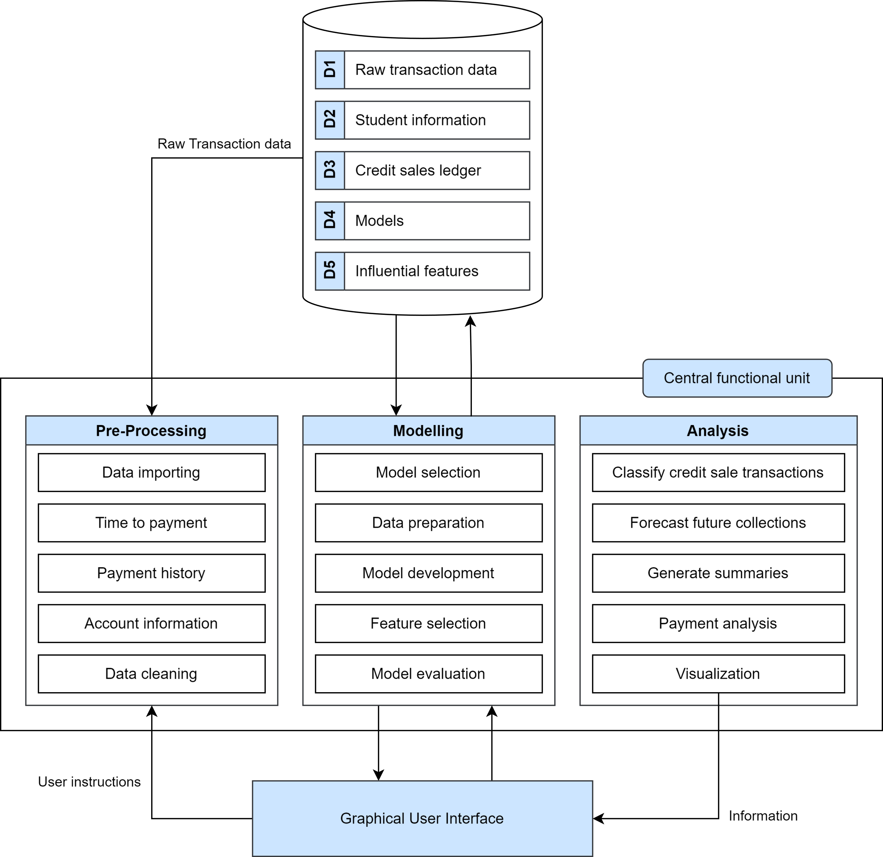
Figure 2.1: Conceptual Framework.
First, Information Processing Theory (IPT) [38] provides the foundation for data flow and preprocessing [1, 2]. Second, the Predictive Analytics and Machine Learning Paradigm (PA-MLP) supports the modeling stage [1, 2]. Third, Decision Support Systems (DSS) Theory [39, 40] justifies the analysis and interface components. Finally, Receivables Management Theory (RMT) [14, 41, 42] grounds the study in its financial context.

CHAPTER 3:
METHODOLOGY

3.1 Research Design
This study employs a quantitative, experimental research design. The research paradigm is a controlled benchmarking study: fifteen machine learning architectures are compared under identical data, split, and evaluation conditions, with the manipulated factors being model family, hyperparameter configuration, class-balancing strategy, and feature regime — a factorial space of 1,092 configurations. Experimental comparison of this kind is the standard methodology for evaluating machine learning systems, as established in large-scale credit-scoring benchmarks such as Lessmann et al. [27].
The data are observational institutional records rather than instruments administered to human subjects: the study draws on pseudonymized journal entries from a private school, so no surveys, interviews, or interventions on students were conducted. The design is therefore experimental with respect to model evaluation, not with respect to data collection. The data flow diagrams presented in Figures 3.1 through 3.5 illustrate the architecture of the developed system — its preprocessing, modeling, and analysis components — rather than the research design itself; the research design is the benchmarking protocol described in Section 3.6, which fixes the temporal train–test split, the evaluation metrics, and the experimental grid within which every architecture is assessed. The remainder of this chapter describes each component in the order data flows through the pipeline: data acquisition, granular feature engineering, survival analysis modeling, class balancing, and hierarchical ensemble classification.

3.2 Data Acquisition and Preprocessing
The primary dataset consists of 11,440 raw invoice records from a private school in Rizal, Philippines, spanning academic years 2019–2025 (with payment activity observed through March 31, 2026). The data originate from three Excel files manually exported from the school's internal enterprise resource planning (ERP) system. The revenues file contains itemized receivables — every billed amount with its due date, discounts, adjustments, and the dates and amounts of payments applied against it. The enrollees file records student enrollment per school year, including the installment plan selected, which allows enrollment streaks and plan-based features to be derived. The chart of accounts file maps every transaction category to its account classification and strategic business unit, enabling the category-level granularity central to this study. Each resulting record represents a discrete receivable item (e.g., Tuition, Miscellaneous Fee, E-Learning Platform) rather than an aggregate student-level balance.
Data were obtained with written institutional approval (Appendix G). All student identifiers were pseudonymized using a deterministic, irreversible hash prior to any analysis, implemented in a dedicated pseudonymization utility within the project codebase, and the original data files are excluded from the project's version-controlled repository. From the 11,440 raw records, 6,527 labeled records were retained after filtering for records with sufficient payment history to compute the days-to-payment (DTP) behavioral features; records lacking observable payment histories cannot support the lagged features the models require. The temporal train–test split is set at March 7, 2025: invoices due before this date form the training set, and invoices due on or after it form the test set.
Initial preprocessing involved three steps. First, student identifiers were pseudonymized as described above. Second, payment dates were temporally aligned against due dates to construct the target variable Days to Payment (DTP), computed as the number of days between an invoice's due date and the date its balance was fully settled, with negative or zero values denoting on-time settlement. Third, DTP was discretized into four ordinal brackets: Class 0 (On-Time, DTP <= 0), Class 1 (1–30 days late), Class 2 (31–60 days late), and Class 3 (61+ days late). Invoices still unpaid at the observation cutoff are flagged as censored and handled by the survival analysis described in Section 3.4.
Figure 3.1 presents the entity-relationship diagram (ERD) of the institutional dataset. Three core entities — Transactions, Categories, and Enrollees — are linked through foreign keys to form the basis for feature engineering. The Transactions table captures every discrete receivable item at category-level granularity, which is the primary innovation of this study's data model compared to aggregate student-level approaches in prior work.
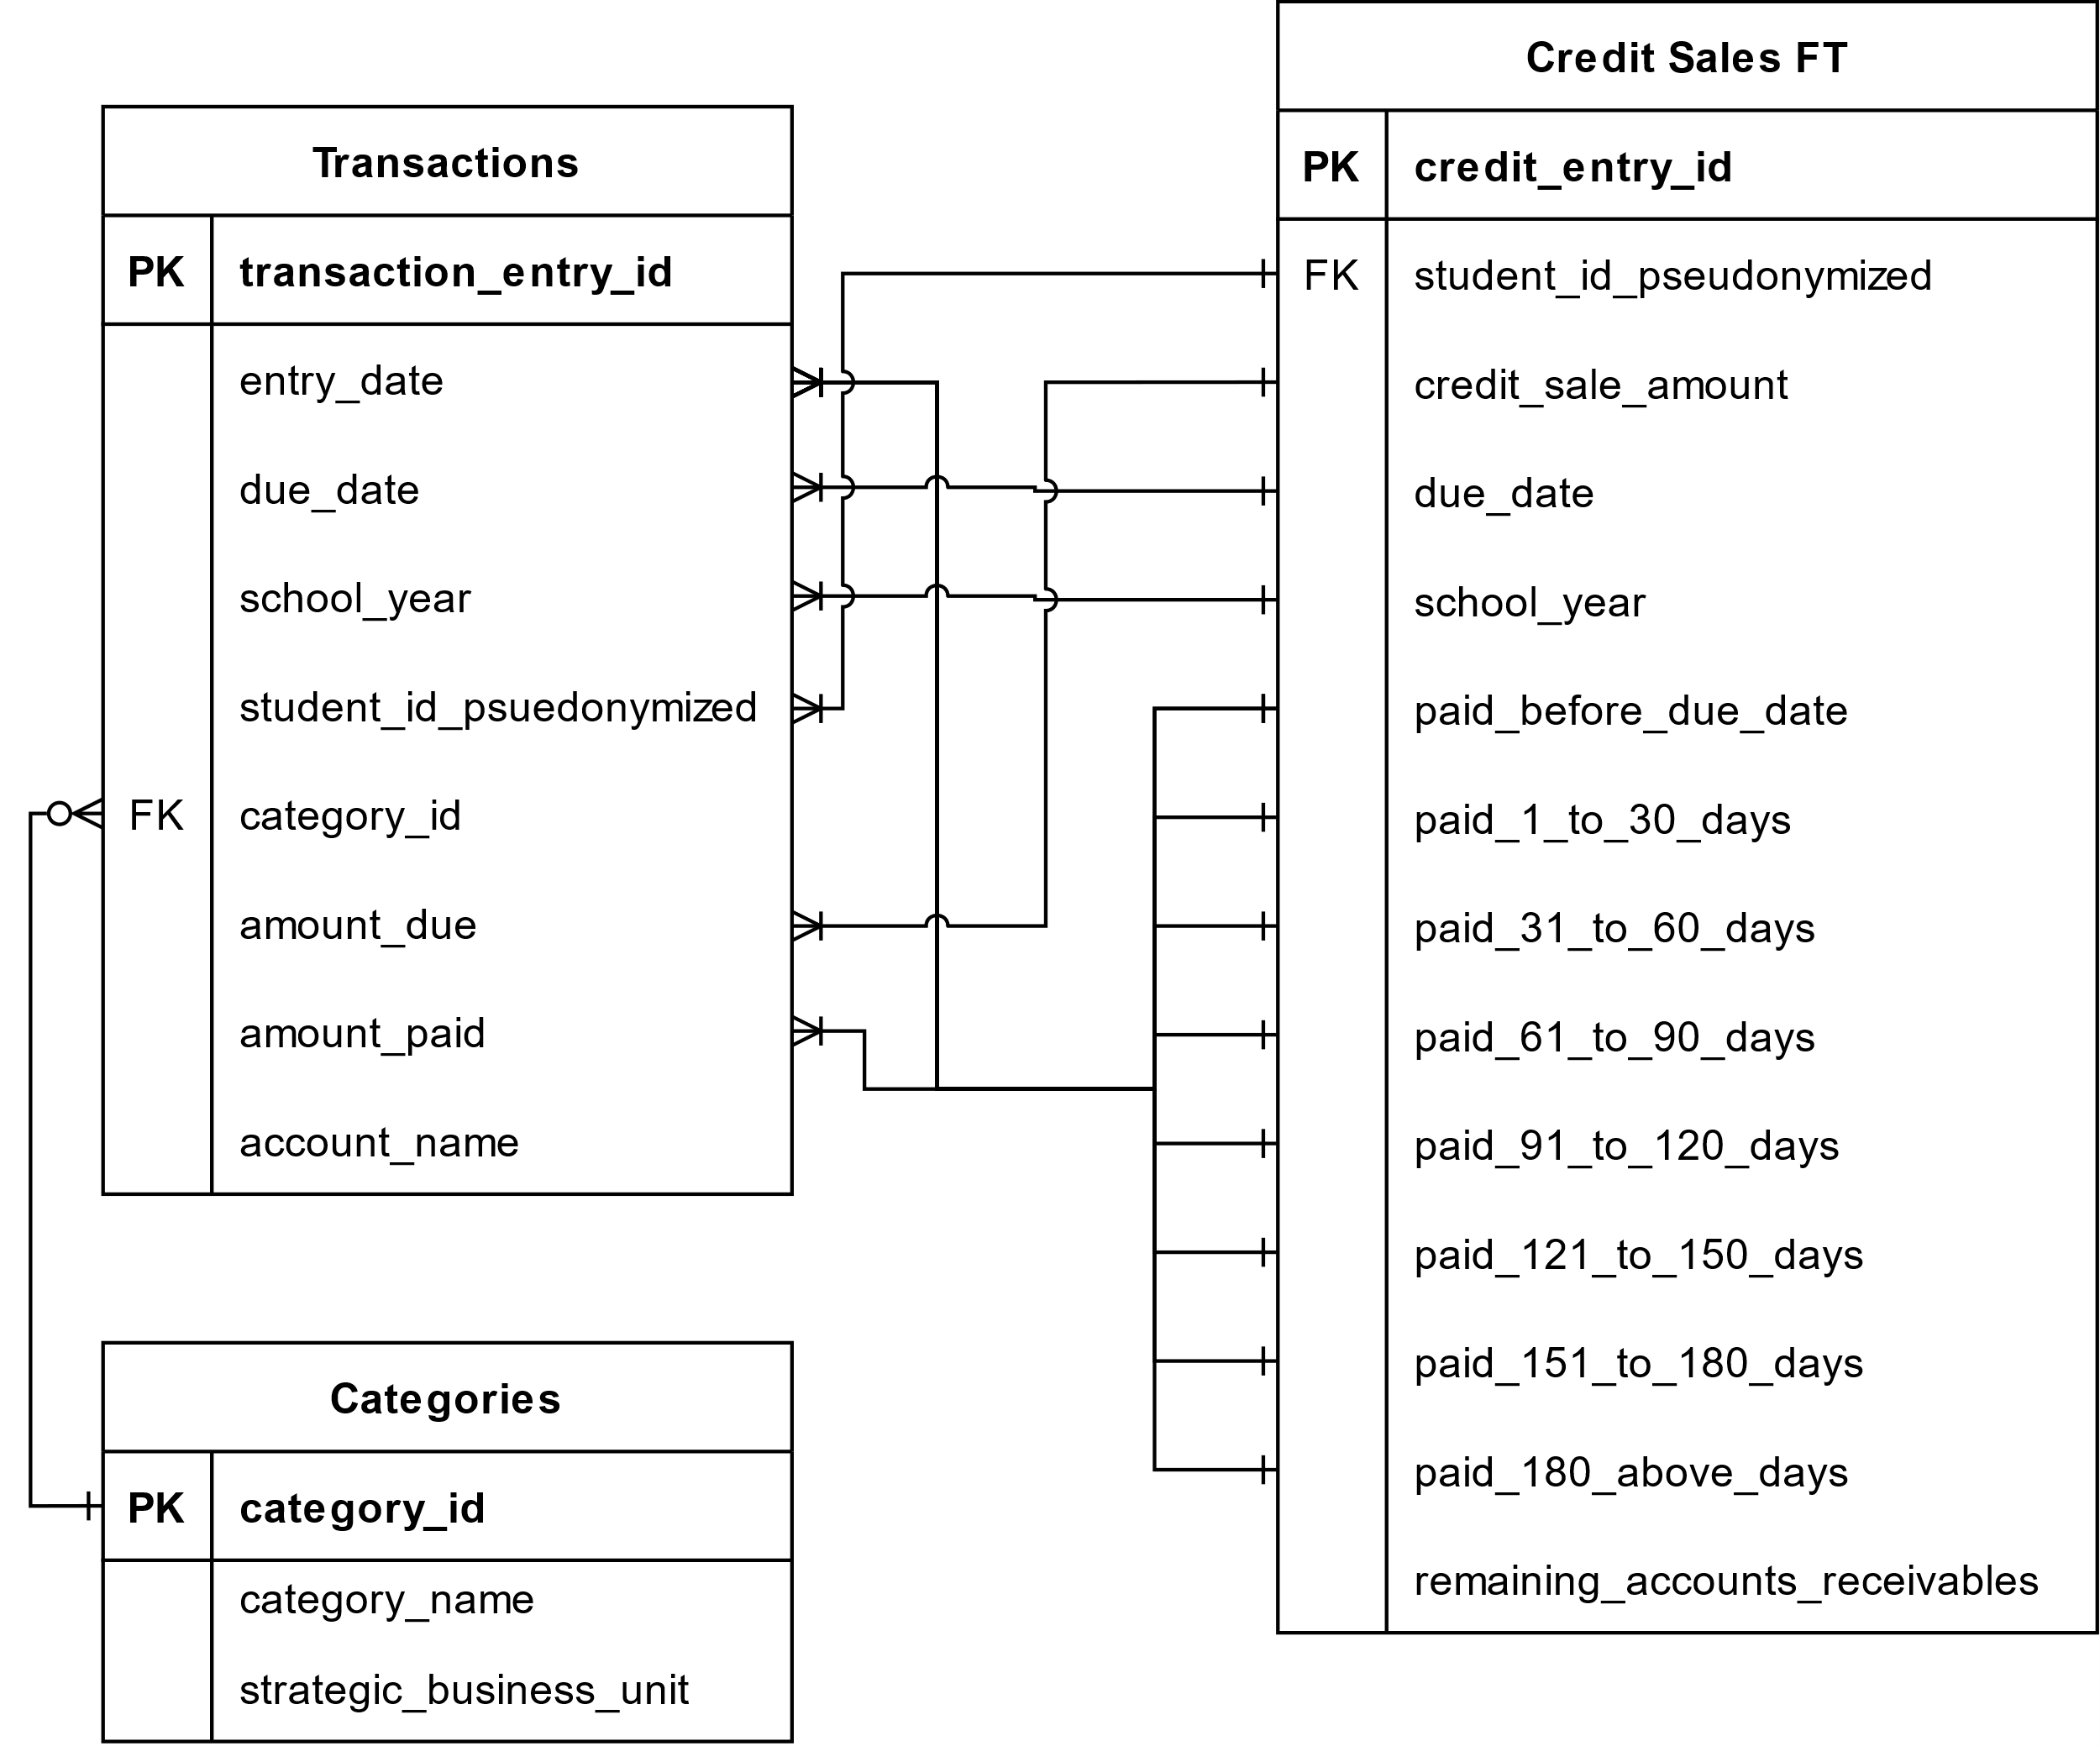
Figure 3.1: Entity-relationship diagram (ERD) of the institutional dataset.
The relationships visible in the ERD determine how the modeling dataset is assembled. Each transaction references a category through category_id, allowing every receivable line item to be typed (tuition, miscellaneous fees, course materials, other services), while the pseudonymized student identifier links transactions to enrollment records across school years. The due_date and amount_paid fields jointly define the target variable: the gap between the due date and the date the obligation is fully offset yields Days to Payment, from which the four ordinal payment brackets are derived. The Credit Sales Fact Table consolidates these joins into a single analysis-ready view per receivable.

Figure 3.2 presents the Level-1 data flow diagram (DFD) of the pre-processing component, which transforms the three raw institutional exports into the analysis-ready credit sales dataset.
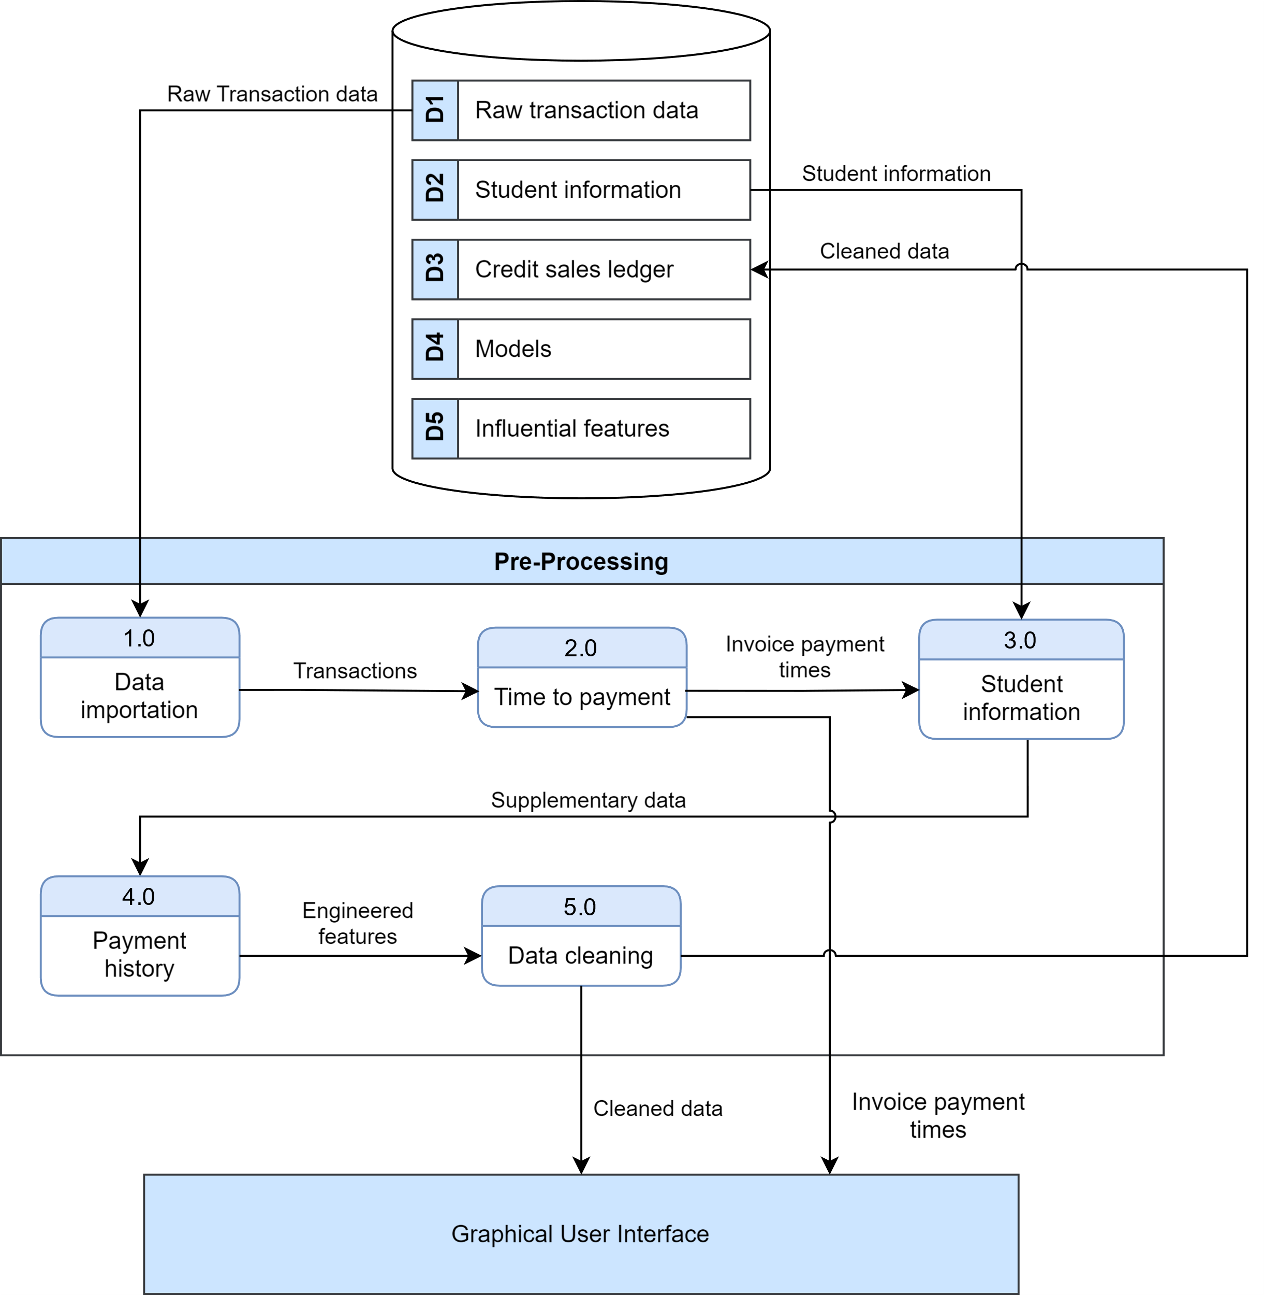
Figure 3.2: Level-1 DFD of the Pre-Processing component.
The diagram traces the main processing steps: the raw revenues, enrollees, and chart-of-accounts files are first validated and pseudonymized, then merged into category-level transactions; payment applications are temporally aligned against due dates to compute Days to Payment; and the engineered behavioral, financial, and temporal features described in Section 3.3 are appended before the labeled records are written to the modeling cache. Each module is deterministic, so the same raw exports always reproduce the same modeling dataset — a property that supports the auditability objectives discussed in Section 3.7.
Table 3.1 presents the data dictionary for the Transactions table, detailing each attribute's format and role in the preprocessing pipeline.
Table 3.1. Entity data dictionary of the Transactions table.
Attribute Name | Format | Description
transaction_entry_id | AutoNumber | Automatic numbering for a unique identifier
entry_date | Date | The date the journal entry was entered
due_date | Date | The date the specific product/service category is due to be paid
school_year | smallInt(4) | The school year the transaction is for
student_id_pseudonymized | mediumInt(6) | The identifier of the student the transaction is related to
category_id | smallInt(4) | The category of the transaction
amount_due | Float | The amount needed to be paid
amount_paid | Float | The amount paid to offset the amount due
account_name | Char(30) | The account the money was sent (e.g. Cash on Hand, Bank Transfer, or GCash)
Among these fields, due_date and amount_paid are the most consequential: together they are the source of the target variable, since Days to Payment is computed from the gap between an obligation's due date and the date it is fully offset. The category_id field is the link that enables granular line-item modeling — the central innovation of this study — while school_year and the pseudonymized student identifier allow behavioral features to be accumulated across a student's enrollment history.
Table 3.2 presents the data dictionary for the Categories table, detailing each attribute's format and role in the preprocessing pipeline.
Table 3.2. Entity data dictionary of the Categories table.
Attribute Name | Format | Description
category_id | smallInt(4) | Automatic numbering for a unique identifier
category_name | Char(60) | The name of the category
strategic_business_unit | Char(35) | The business unit the category is accounted in (e.g. Teaching, Goods, Other services, or Administrative)
Although structurally simple, this table is what gives the pipeline its granularity: category_name distinguishes tuition from miscellaneous and product-type charges, and strategic_business_unit groups categories into the operational units used for institutional reporting. Joining these attributes onto transactions is what allows the models to learn payment behavior per fee type rather than per aggregate balance.
Table 3.3 presents the data dictionary for the Credit Sales Fact Table, the consolidated analysis-ready view produced by the preprocessing pipeline.
Table 3.3. Entity data dictionary of the Credit Sales Fact Table (FT).
Attribute Name | Format | Description
credit_entry_id | autoNumber | Automatic numbering for a unique identifier
student_id_pseudonymized | mediumInt(6) | The pseudonymized identifier for the student number
credit_sale_amount | Currency | The amount payable for the respective student id
due_date | Date | The date when the obligation is due to be paid
school_year | smallInt(4) | The school year the credit sale occurred
paid_before_due_date | Currency | The amount paid in advance before the due date
paid_1_to_30_days |  | The amount paid after the due date, which is grouped from a span of [1 to 30], [31 to 60], etc. days.
paid_31_to_60_days
paid_61_to_90_days
paid_91_to_120_days
paid_121_to_150_days
paid_151_to_180_days
paid_180_above_days
remaining_accounts_receivables |  | The amount of accounts receivable left that needs to be paid as of generating this fact table
The fact table decomposes each receivable into payment-aging buckets (paid before the due date, 1–30 days, 31–60 days, and so on), which is the representation from which the four ordinal payment brackets are labeled. The remaining_accounts_receivables field identifies invoices still unpaid at the observation cutoff; these censored records are exactly the cases handled by the survival analysis described in Section 3.4.

3.3 Granular Feature Engineering
The feature space comprises 40 variables across six categories, derived from institutional journal entries and engineered to capture granular payment behaviors:
(a) Raw Financial: `gross_receivables`, `amount_discounted`, `adjustments`, `credit_sale_amount` (net receivable)
(b) Days-to-Payment (DTP) Historical: `dtp_1` through `dtp_4` (most recent 4 invoices), `dtp_avg`, `dtp_wavg` (weighted 0.4,0.3,0.2,0.1), `dtp_2_trend`, `dtp_3_trend`, `days_since_last_payment`, `dtp_rolling_std`, `dtp_max`
(c) Financial/Cumulative: `amount_due_cumsum`, `amount_paid_cumsum`, `opening_balance`, `opening_balance_flag`, `payment_ratio` (paid/due ratio)
(d) Behavioral/Historical: `prev_bracket` (most recent payment bracket), `early_payer_flag` (binary), `on_time_streak` (consecutive on-time payments)
(e) Payment Plan: One-hot encoded `plan_type_Plan-A` through `plan_type_Plan-E` and `plan_type_nan`, plus ordinal `plan_type_risk_score` (A=0→NaN=5)
(f) Temporal: `due_month` (1-12), `due_quarter` (1-4)
These features were generated via the `CreditSalesProcessor` pipeline, transforming raw transactional data into analysis-ready inputs. All features were retained for modeling.

3.4 Survival-Analysis-Derived Features
To capture the temporal risk of non-payment, the researchers’ applied survival analysis using a Cox Proportional Hazards (Cox PH) model via the `lifelines` library. The model was fitted on a censored training-set subset where the "event" is defined as full invoice settlement, preventing data leakage when applied to test splits. Five time-dependent hazard features were derived:
(1) `partial_hazard`: Exponentiated linear predictor (exp(coef)) from the Cox model
(2) `log_partial_hazard`: Natural log of the partial hazard
(3) `expected_survival_time`: Mean predicted days until full settlement under the Cox model
(4) `survival_probability`: Likelihood the invoice remains unpaid beyond a reference time point
(5) `cumulative_hazard`: Cumulative hazard at the reference time point
These features constitute the "Enhanced" feature regime, evaluated against the "Baseline" regime (all features except these five) to assess survival analysis' marginal utility in payment prediction.

3.5 Model Architectures
The researchers’ benchmarked 15 models categorized into three families:
(a) Base Classifiers: Six standard algorithms including AdaBoost, Random Forest, XGBoost, Decision Tree, Gaussian Naive Bayes, and K-Nearest Neighbors (KNN).
(b) Ordinal Classifiers: Three architectures (Ordinal AdaBoost, Ordinal RF, Ordinal XGBoost) utilizing a Frank and Hall decomposition [12] to exploit the ordered nature of the payment brackets.
(c) Two-Stage Ensemble Classifiers: Six hierarchical pipelines designed to mirror institutional decision-making.
- Stage 1 (Binary): A high-capacity learner (e.g., XGBoost) classifies an invoice as either "On-Time" (Class 0) or "Late" (Classes 1-3).
- Stage 2 (Multi-class): If an invoice is predicted "Late," it is passed to a second-stage model (e.g., AdaBoost) trained specifically on the subset of delinquent records to determine the severity (Class 1, 2, or 3).
Figure 3.3 presents the Level-1 DFD of the modelling component, covering class balancing, model training, and hyperparameter search across the three model families.
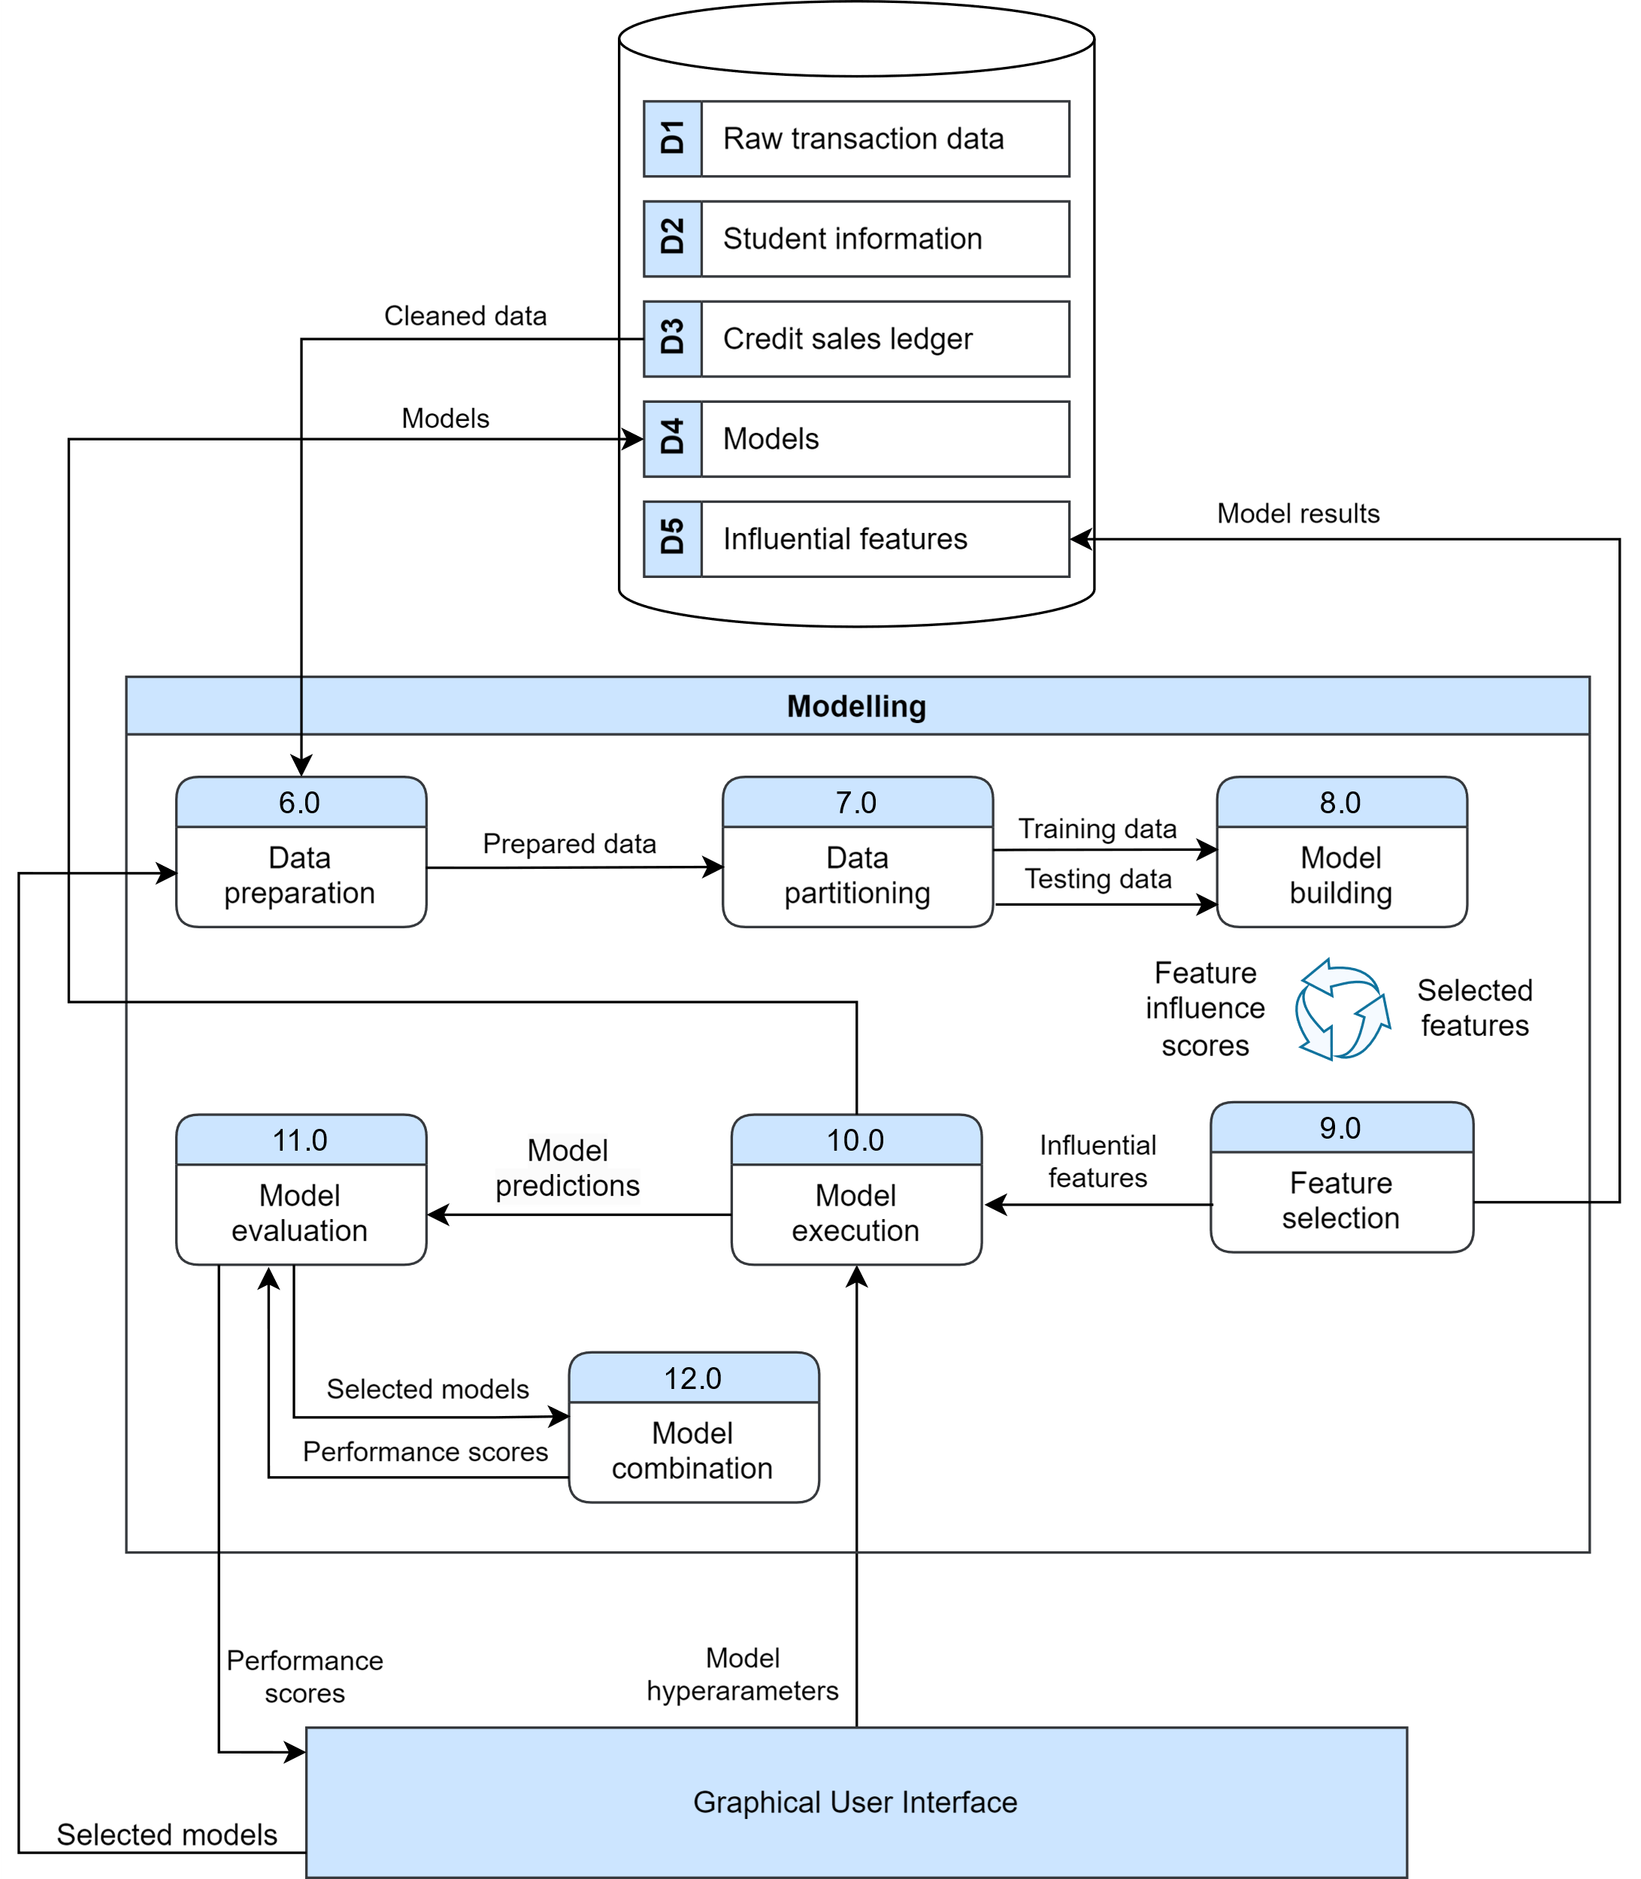
Figure 3.3: Level-1 DFD of the Modelling component.
The diagram shows the experimental loop at the heart of the benchmark: the labeled dataset is split temporally, the training partition is resampled under the selected balancing strategy, and each of the fifteen model architectures is trained across its hyperparameter grid before evaluation metrics and feature importance scores are logged to the results database. Because every configuration follows the same path through this loop, results are directly comparable across model families, balancing strategies, and feature regimes.
Grid search hyperparameter tuning was employed to identify the optimal model configurations. The specific parameter grids applied to each model type and family are presented in Tables 3.4, 3.5, and 3.6 found on the next pages, corresponding to the base, ordinal, and multi-step classifiers, respectively.
The following table presents the hyperparameter grid searched for the base classifier configurations.
Table 3.4. Hyperparameters used (Base Models).
Model | Tuned Parameters | Fixed Parameters | Configs
AdaBoost | learning_rate: {0.01, 0.1, 0.5, 1.0}  n_estimators: {50, 150} | algorithm: SAMME.R | 7
Decision Tree | max_depth: {10, 20}  min_samples_leaf: {1, 3, 5} | criterion: gini | 6
Gaussian Naive Bayes | var_smoothing: {1e-9, 1e-8, 1e-7, 1e-6, 1e-5, 1e-4, 1e-3, 1e-2} | — | 8
KNN | n_neighbors: {3, 5, 7}  weights: {uniform, distance} | metric: minkowski | 6
Random Forest | max_depth: {10, 20, 30}  min_samples_leaf: {1, 3, 5}  n_estimators: {100, 200, 300} | criterion: gini | 21
XGBoost | max_depth: {3, 5, 6}  learning_rate: {0.01, 0.05}  n_estimators: {300, 500}  subsample: {0.7, 0.8}  colsample_bytree: {0.7, 0.8} | min_child_weight: 3, reg_alpha: 0.0, reg_lambda: 1.0 | 11
Total |  |  | 59
The ranges reflect three constraints. The computational budget capped each grid at roughly ten configurations per model so that the full 1,092-experiment benchmark remained tractable; the specific values follow prior benchmarking literature, which finds diminishing returns beyond moderate tree depths and ensemble sizes [27]; and the XGBoost grid was additionally shaped by GPU memory constraints, favoring moderate depth with subsampling over exhaustive expansion.
The following table presents the hyperparameter grid searched for the ordinal classifier configurations.
Table 3.5. Hyperparameters used (Ordinal Models).
Model | Tuned Parameters | Fixed Parameters | Configs
Ordinal AdaBoost | learning_rate: {0.01, 0.1, 0.5, 1.0}  n_estimators: {50, 150} | scale_pos_weight: false | 7
Ordinal Random Forest | max_depth: {10, 20, 30}  min_samples_leaf: {1, 3, 5}  n_estimators: {100, 200, 300} | scale_pos_weight: false | 17
Ordinal XGBoost | max_depth: {3, 5, 6}  learning_rate: {0.01, 0.05}  n_estimators: {300, 500}  subsample: {0.7, 0.8}  colsample_bytree: {0.7, 0.8} | min_child_weight: 3, reg_alpha: 0.0, reg_lambda: 1.0, scale_pos_weight: true | 11
Total |  |  | 35
The ordinal wrappers reuse the grids of their underlying base learners so that any performance difference is attributable to the Frank–Hall decomposition itself rather than to differential tuning effort. The scale_pos_weight flag is the one ordinal-specific addition, compensating for the shifting class ratios within each binary sub-problem.

The table below shows the hyperparameter grids for the two-stage model (binary first stage and multi-class second stage).
Table 3.6. Hyperparameters used (Two-Stage Models).
Model | Stage 1 Parameters |  | Stage 2 Parameters |  | Configs
 | Tuned | Fixed | Tuned | Fixed
Two-Stage XGB → XGB | max_depth: {3}  lr: {0.01, 0.05}  n_estimators: {300, 500} | subsample: 0.8  colsample: 0.8  mcw: 3 | max_depth: {3, 5}  lr: {0.01, 0.05}  n_estimators: {300, 500} | subsample: 0.8  colsample: 0.8  mcw: 3 | 12
Two-Stage XGB → RF | max_depth: {3}  lr: {0.01, 0.05}  n_estimators: {300, 500} | subsample: 0.8  colsample: 0.8  mcw: 3 | max_depth: {10, 20}  min_samples_leaf: {1, 3}  n_estimators: {200, 300} | criterion: gini | 12
Two-Stage RF → RF | max_depth: {10, 20}  min_samples_leaf: {1, 3}  n_estimators: {200} | criterion: gini | max_depth: {10, 20}  min_samples_leaf: {1, 3}  n_estimators: {200, 300} | criterion: gini | 12
Two-Stage XGB → Ada | max_depth: {3, 5}  lr: {0.01, 0.05}  n_estimators: {300, 500} | subsample:0.8  colsample: 0.8  mcw: 3 | learning_rate: {0.01, 0.1}  n_estimators: {50, 150} | algorithm: SAMME.R | 10
Two-Stage RF → Ada | max_depth: {10, 20}  min_samples_leaf: {1, 3}  n_estimators: {200, 300} | criterion: gini | learning_rate: {0.01, 0.1}  n_estimators: {50, 150} | algorithm: SAMME.R | 10
Two-Stage Ada → XGB | learning_rate: {0.01, 0.1, 0.5}  n_estimators: {50, 150} | algorithm: SAMME.R | max_depth: {3, 5}  lr: {0.01, 0.05}  n_estimators: {300, 500} | subsample: 0.8  colsample: 0.8  mcw: 3 | 10
Total |  |  |  |  | 66

Because each two-stage pipeline trains two models, the per-stage grids were kept deliberately compact to contain combinatorial growth; the tuned values concentrate on the parameters with the largest observed effects (depth, learning rate, ensemble size), while secondary regularization parameters were fixed at the values established in the base-model grids.
These influence scores are then fed into a dedicated feature selection process in Module 9.0, where the most predictive variables are retained. Table 3.7 presents the feature importance method used for each model type.
Table 3.7. List of the feature importance methods used per model.
Model | Feature Importance Method
Decision Tree | Gini importance
Random Forest | Mean decrease in impurity (MDI) or Permutation importance
AdaBoost | Importance derived from the weighted sum of weak learners (decision stumps/trees).
XGBoost | Multiple metrics:  Gain (improvement in accuracy from splits),  Cover (number of samples affected), and  Frequency (split count).
Gaussian Naive Bayes | Feature influence comes from likelihoods (mean, variance per class).
KNN | Permutation importance

The methods differ because feature attribution must respect each model's internal structure: impurity-based measures suit tree learners, the gain/cover/frequency metrics decompose XGBoost's boosted splits, likelihood parameters expose Gaussian Naive Bayes' per-class evidence, and model-agnostic permutation importance covers learners such as KNN that lack intrinsic attribution. Normalizing these scores per experiment allows importance rankings to be compared across model families in Chapter 4.

3.6 Experimental Design and Evaluation
The benchmark encompasses 1,092 unique configurations (15 models × 7 balancing strategies × ~10 parameter sets × 2 feature regimes). Models were evaluated using a temporal 70/30 train–test split, where the training set comprised invoices with due dates prior to March 7, 2025, and the test set included invoices due on or after that date. Given the extreme class imbalance (Class 0 dominates at ~76%), macro-averaged F1-score was selected as the primary performance metric, supplemented by Area Under the Receiver Operating Characteristic Curve (ROC-AUC) and confusion matrix analysis to assess per-class recall.
The temporal split was chosen over random cross-validation deliberately: invoices are not exchangeable across time, and a random split would leak future payment behavior into training, inflating measured performance relative to deployment conditions. Training on all invoices due before March 7, 2025 and testing on those due afterward reproduces the situation the school faces in production — predicting forthcoming invoices from historical behavior — and exposes the models to any distribution drift across school years. The class imbalance statistics underline the metric choice: with Class 0 at roughly 76% of records, raw accuracy is dominated by the majority class, while the minority brackets that carry the greatest financial risk contribute least to it. Macro-averaged F1 corrects this by weighting all four classes equally, ROC-AUC complements it with a threshold-independent view of separability, and confusion matrices retain the per-class recall that a finance office ultimately acts on.
Figure 3.4 illustrates the distribution of the four payment brackets across the 6,527 training records used in this study.
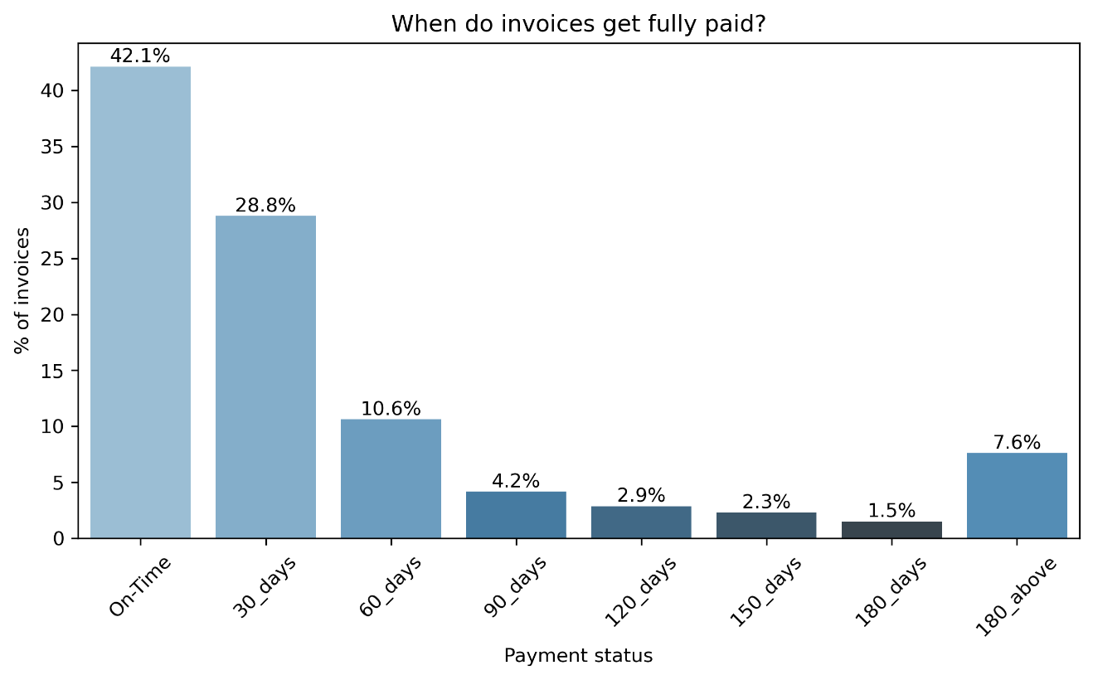
Figure 3.4: Distribution of payment statuses.
The distribution is extremely imbalanced: roughly 76% of invoices fall into Class 0 (on-time), while the three late brackets share the remainder, with the severest brackets the rarest. Left untreated, this imbalance lets a classifier achieve high accuracy by always predicting the majority class while failing entirely on the late invoices that matter operationally. It is this property that necessitates the resampling strategies evaluated in the benchmark — SMOTE [43], Borderline-SMOTE [44], SMOTE-Tomek [45], and threshold-based hybrid undersampling — and that motivates macro-averaged F1, which weights all four classes equally, as the primary evaluation metric, consistent with standard practice in imbalanced classification [46].
The last module of the framework is the analysis phase, presented in Figure 3.5. After the benchmark completes, the analysis component aggregates the logged experiments for evaluation and comparison.
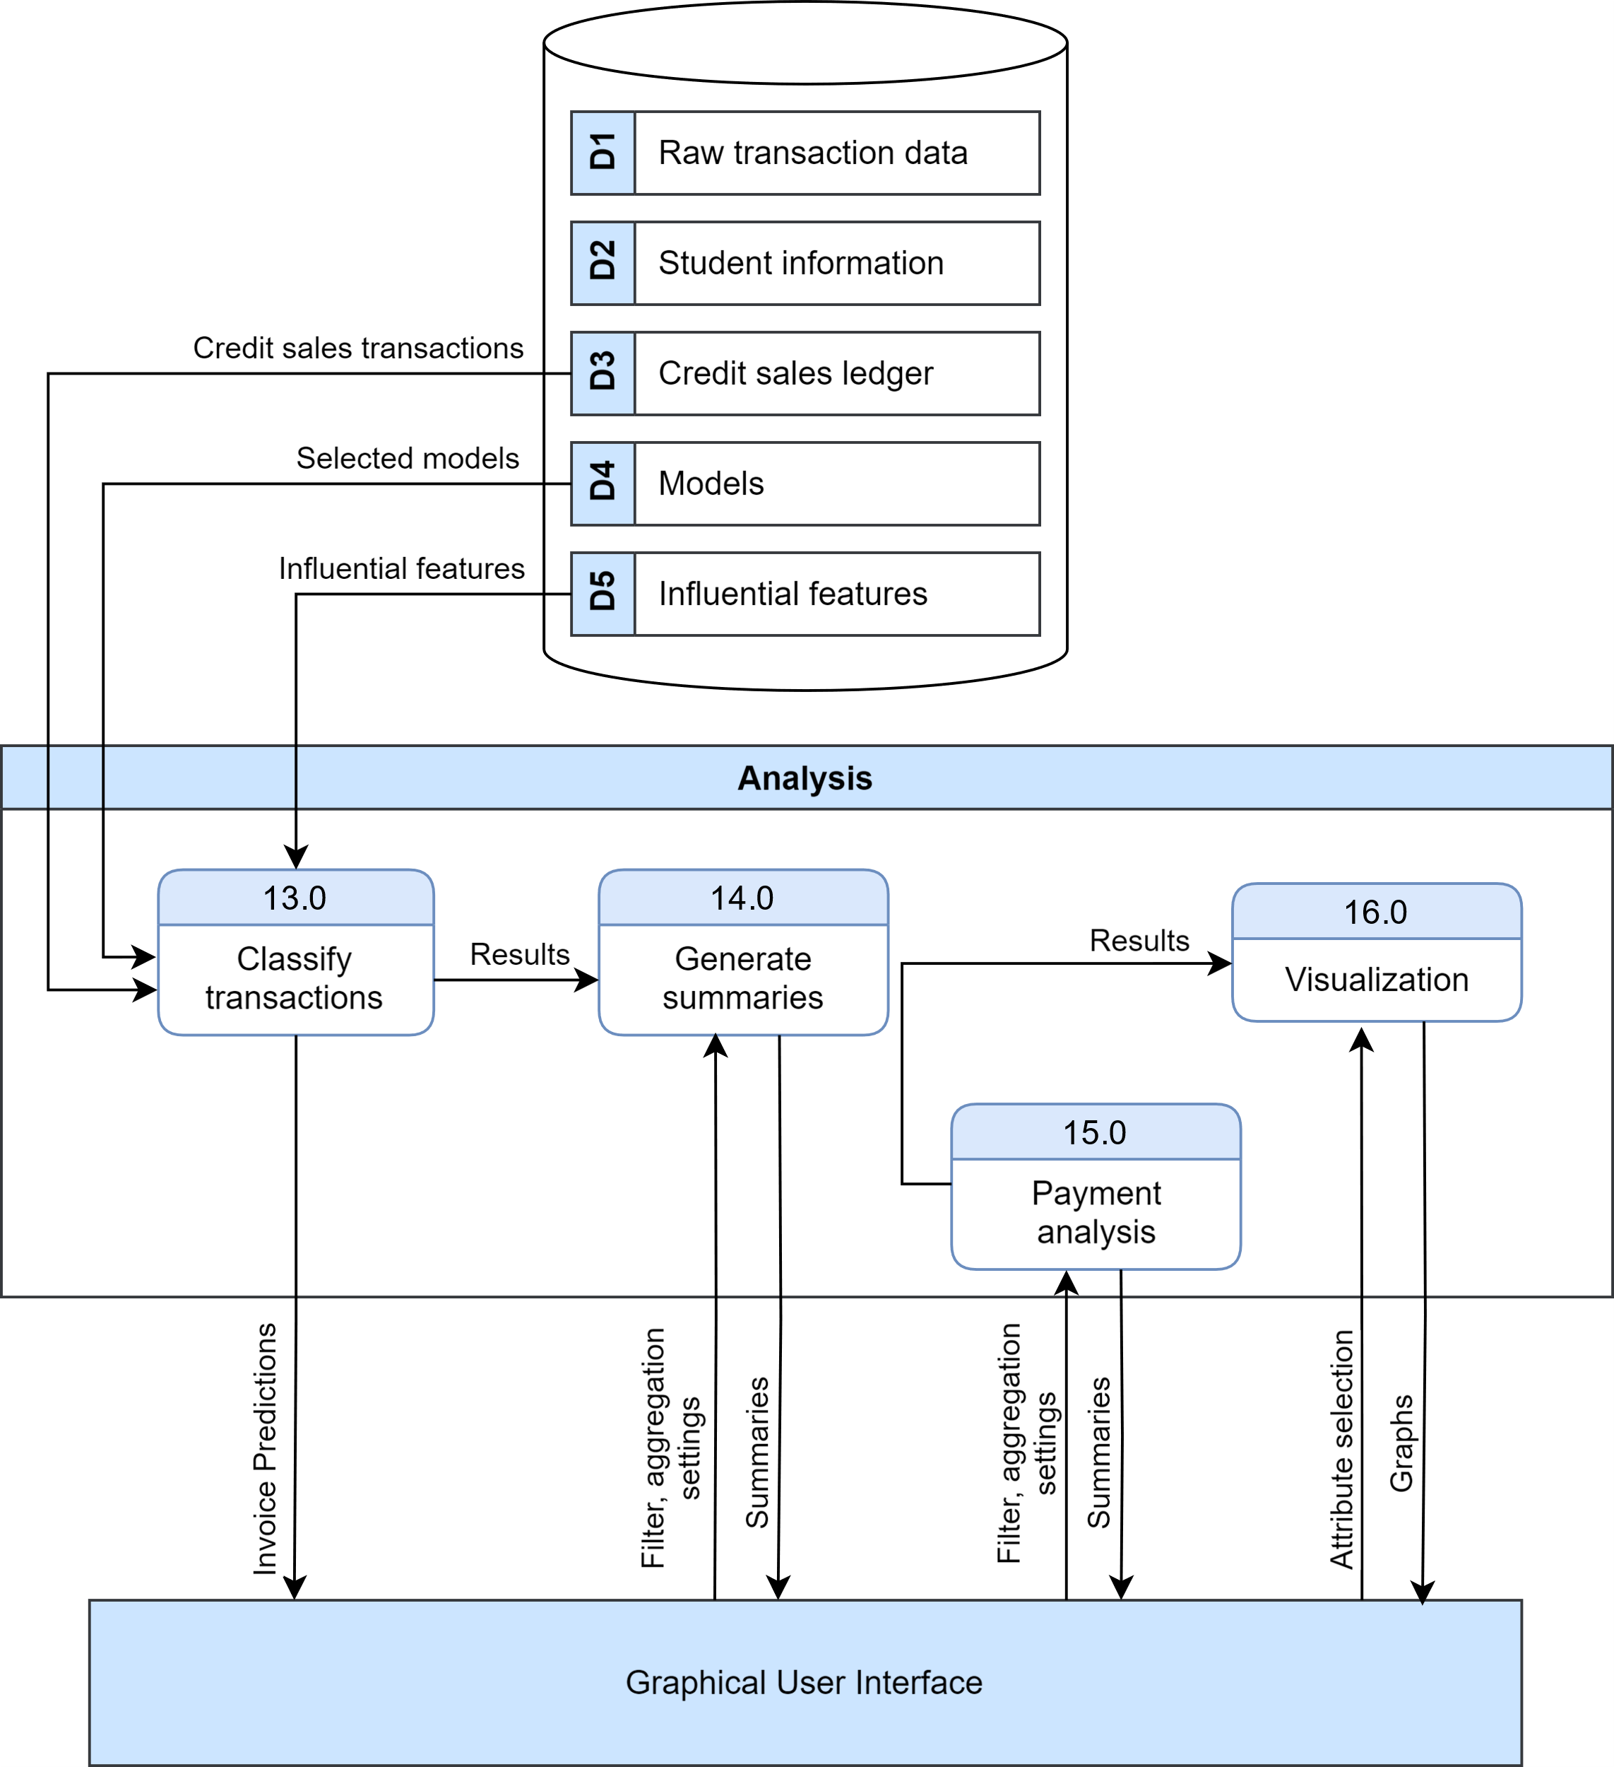

Figure 3.5: Level-1 DFD of the Analysis component.
The analysis component reads the per-experiment metrics, feature importance scores, and class mappings from the results database, ranks configurations by macro-F1 and ROC-AUC, and renders the comparative figures presented in Chapter 4. Keeping analysis decoupled from training means new experiments extend the same results store without rerunning prior configurations, and every figure in Chapter 4 is reproducible from the 1,092 logged experiments.

3.7 Ethical Considerations
Because the study processes sensitive student financial records and produces predictions about identifiable behavior, two ethical dimensions require explicit treatment: the privacy of the data used to train the models, and the manner in which the resulting predictions may be used.

3.7.1 Data Privacy
The dataset contains sensitive student financial records, and privacy was addressed before any analysis took place. All student identifiers were pseudonymized using a deterministic, irreversible hash implemented in a dedicated pseudonymization utility in the project codebase; no real names or student numbers appear in any processed file, and the mapping cannot be reversed from the published artifacts. Raw data files are never committed to version control — their exclusion is enforced through the repository's ignore rules — so the source records exist only within the institution's systems and the researchers' controlled working environment. These measures place the study in compliance with the Data Privacy Act of 2012 (Republic Act 10173) [47], which governs the processing of personal information in the Philippines and requires that processing be limited to declared, legitimate purposes with proportionate safeguards. Data access was granted under written institutional authorization, reproduced as Appendix G, which defines the scope of data access and the restrictions on its use. Finally, the predictive model outputs are intended for institutional receivables management only; they are not designed or released for individual student profiling for any public purpose.

3.7.2 Ethical Use of Predictions
There is an inherent risk that machine learning predictions of payment delinquency could be used to discriminate against students from families with poor payment histories, and the researchers acknowledge this risk explicitly. Three mitigations are recommended wherever the system is deployed. First, predictions should inform early outreach and support — earlier reminders, proactive installment restructuring, or referral to social welfare assistance — and never punitive action against the student. Second, any intervention workflow built on the model must comply with Republic Act 11984 [11], which prohibits academic penalties, including examination denial, for outstanding balances; the system's outputs therefore cannot lawfully gate any academic activity. Third, the model should be audited periodically for demographic bias, comparing error rates across student segments, and retrained where disparities emerge. The study's framing is deliberately supportive rather than punitive: the goal is to enable schools to offer targeted payment assistance earlier, not to flag students for enforcement, and this orientation is embedded in the recommendations of Chapter 5.

CHAPTER 4:
RESULTS AND DISCUSSION
The experimental results from 1,092 benchmark configurations reveal significant performance variances across model families, resampling strategies, and feature regimes. Performance is primarily ranked by macro-averaged F1-score to account for the severe class imbalance.
This chapter is organized around the four research questions posed in Section 1.3. Section 4.1 addresses RQ1 by comparing two-stage and ordinal ensemble architectures against single-stage base classifiers. Section 4.2 addresses RQ2, isolating the marginal contribution of survival-analysis-derived features. Section 4.3 addresses RQ3, evaluating seven class-balancing strategies across all model families. Section 4.4 examines the convergence of the two headline metrics and the resulting model selection criteria, and Section 4.5 addresses RQ4 by analyzing which granular features most consistently drive payment-bracket predictions. The chapter closes with a demonstration of the prototype system that operationalizes the best-performing model (Section 4.6) and an assessment of the pipeline's generalizability to public benchmark datasets (Section 4.7).

4.1 RQ1 — Performance of Ensemble Architectures vs. Base Classifiers
Table 4.1 presents the peak macro-F1 and ROC-AUC scores for each model family under the enhanced feature regime, identifying the best individual model and resampling strategy per family.
Table 4.1. Peak performance per model family (Enhanced Feature Regime).
Family | Peak F1 | Peak ROC-AUC | Best Individual Model | Best Strategy
Two-Stage | 0.6003 | 0.8919 | two_stage_xgb_ada | BORDERLINE_SMOTE
Ordinal | 0.5621 | 0.8205 | ordinal_ada_boost | Hybrid (t=0.5)
Base | 0.5589 | 0.8607 | Ada_boost | Hybrid (t=0.5)
The two-stage family leads on both headline metrics: its best configuration (two_stage_xgb_ada under Borderline-SMOTE) reaches a macro-F1 of 0.6003 and ROC-AUC of 0.8919, exceeding the best ordinal model by approximately 0.038 F1 and the best base classifier by approximately 0.041 F1. With respect to RQ1, this gap indicates that architectural decomposition — separating the on-time/late decision from delay-severity classification — yields a larger improvement than either exploiting class ordering alone (the ordinal family) or tuning strong single-stage learners, though the modest margins also show that base ensembles remain competitive when paired with well-chosen resampling.
Figure 4.1 visualizes the full F1 and AUC lift of ordinal and two-stage variants over their corresponding base classifiers under the enhanced feature regime, making both the gains and the exceptions visible at a glance.
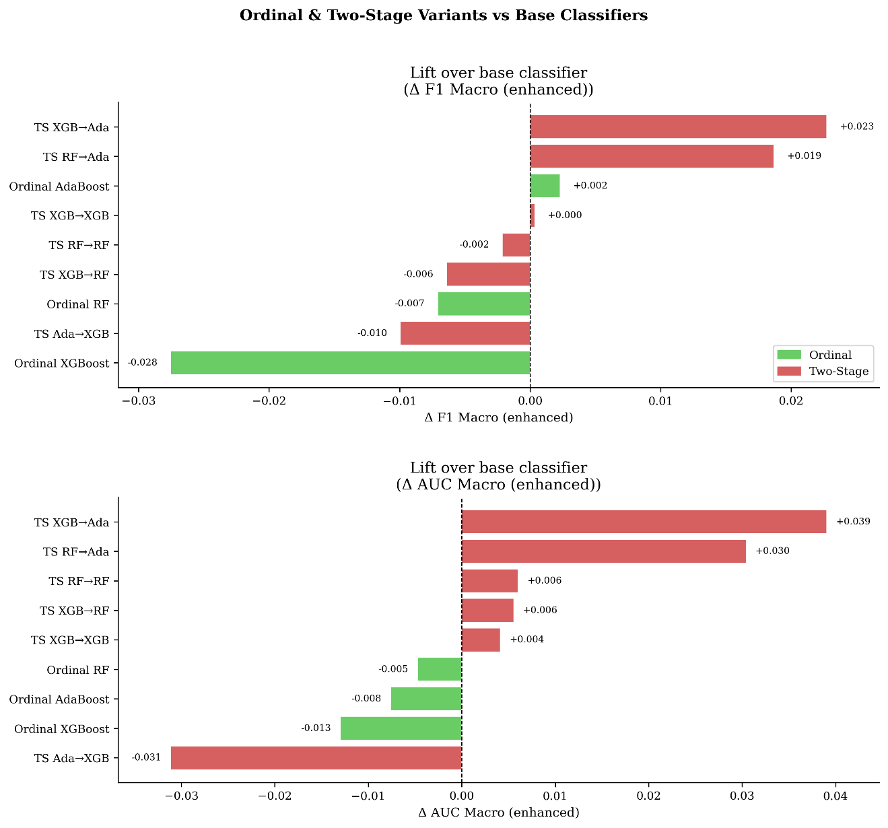
Figure 4.1: Ordinal & Two-Stage Variants vs. Base Classifiers (lift in F1 and AUC metrics).
The two-stage ensemble family demonstrates clear dominance at the top of the overall performance ranking (Figure 4.1). The best configuration, which is a Two-Stage XGBoost-to-AdaBoost pipeline with SMOTE resampling achieves a macro-F1 of 0.6003 and ROC-AUC of 0.8819. However, performance is highly sensitive to the choice of second-stage classifier: two-stage pipelines that route into AdaBoost yield the largest gains, while those routing into XGBoost (TS XGB→XGB, TS Ada→XGB) underperform their base classifiers. This suggests that hierarchical decomposition is most effective when paired with a complementary learner in Stage 2, rather than being universally beneficial.
Ordinal classifiers provide modest and inconsistent gains over standard base models, confirming that while exploiting class ordering is beneficial, the benefit is secondary to the architectural decomposition provided by well-configured multi-stage pipelines. Among ordinal models, Ordinal AdaBoost (F1 = 0.5621) under hybrid resampling was the strongest performer.

4.2 RQ2 — Impact of Survival-Analysis-Derived Features
The inclusion of survival-derived features produced a differential impact highly dependent on the base learner's architecture:
(a) Positive Lift: Distance-based (KNN) and probabilistic (Gaussian Naive Bayes) models showed the highest mean F1 lifts (+0.0050 to +0.0061). These learners lack internal mechanisms to capture non-linear temporal interactions, making pre-computed survival statistics like the partial hazard and survival probability highly informative.
(b) Negligible-to-Negative Lift: High-capacity tree-based ensembles (Random Forest, XGBoost, AdaBoost) exhibited neutral or weakly negative results. These models can independently approximate survival patterns through complex branch splits and feature interactions, rendering the Cox PH-derived features redundant or, in cases of small class sizes, noisy.
This finding suggests a conditional feature engineering strategy: survival features should be prioritized for simpler, faster models but may be omitted for high-capacity ensembles to reduce computational overhead. The magnitude of the contribution is quantified visually by comparing the baseline-regime distributions in Figure 4.4 against their enhanced-regime counterparts in Figure 4.2, and the feature importance analysis presented in Section 4.5 (Figures 4.5 and 4.6) confirms the relative weight of survival features across model types.

4.3 RQ3 — Effect of Class-Balancing Strategies on Model Performance
Figure 4.2 presents macro-F1 distributions across all model types and balancing strategies under the enhanced feature regime.
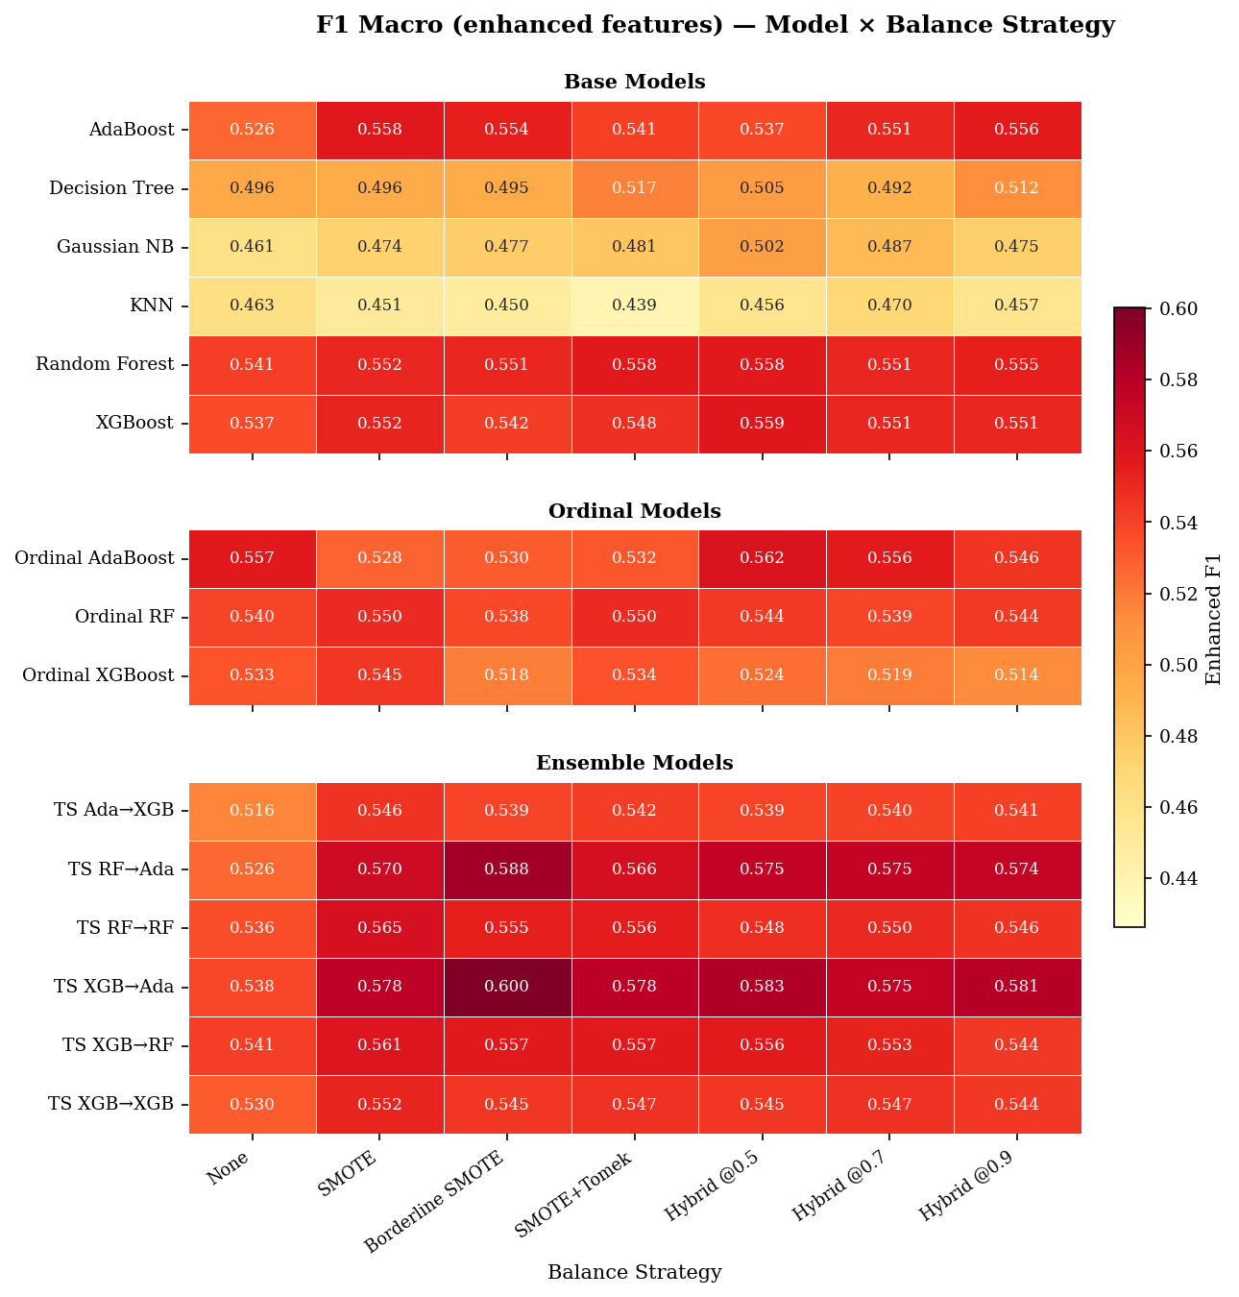
Figure 4.2: F1 Macro by Model & Balance Strategy (enhanced features).
Borderline-SMOTE wins most consistently across model types, matching or exceeding vanilla SMOTE in nearly every column, while configurations without resampling trail for all but the strongest ensembles. The variance across strategies is itself informative: high-capacity ensembles are relatively robust to the choice of strategy, whereas KNN and Gaussian Naive Bayes swing substantially — strategy selection matters most for precisely the models least able to compensate internally.
Figure 4.3 presents ROC-AUC distributions across all model types and balancing strategies under the enhanced feature regime.
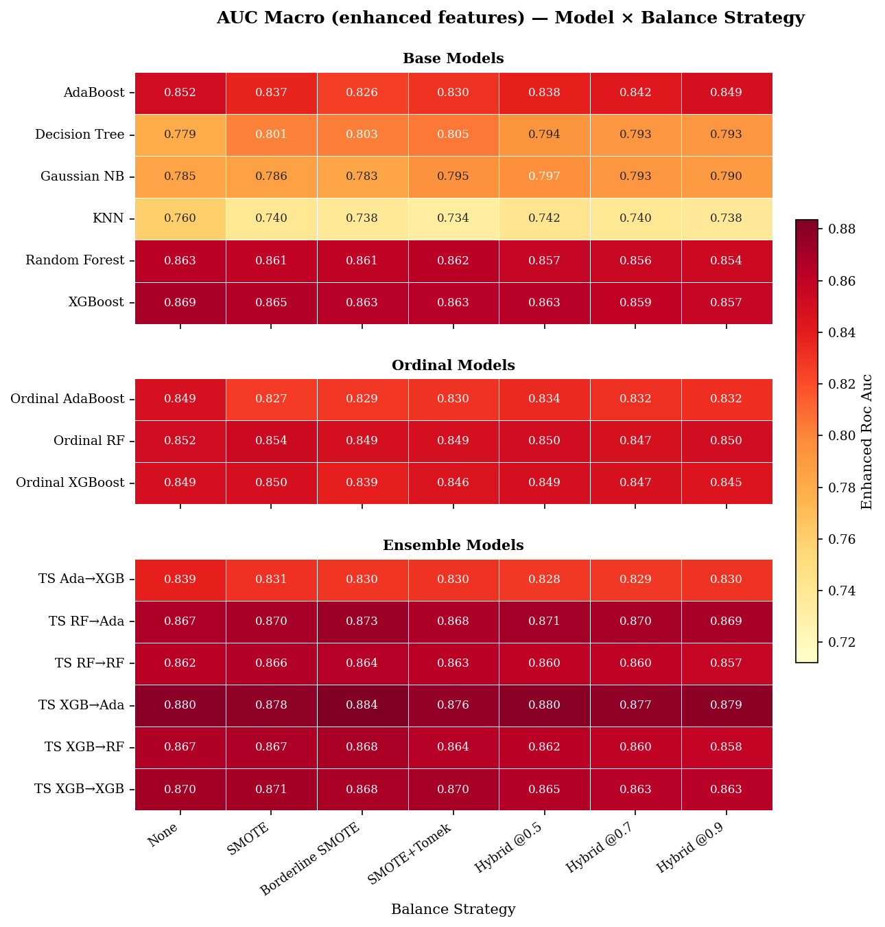
Figure 4.3: AUC Macro by Model & Balance Strategy (enhanced features).
The AUC view largely mirrors the F1 ranking — the same two-stage configurations top both charts, with the best AUC of 0.882 achieved by the two-stage XGBoost-to-AdaBoost pipeline under Borderline-SMOTE — but the spread between strategies is narrower than under F1. This indicates that resampling primarily improves the placement of the decision threshold rather than the underlying separability of the classes.
Figure 4.4 presents macro-F1 distributions by model and balancing strategy under the baseline feature regime, that is, without the five survival-analysis-derived features.
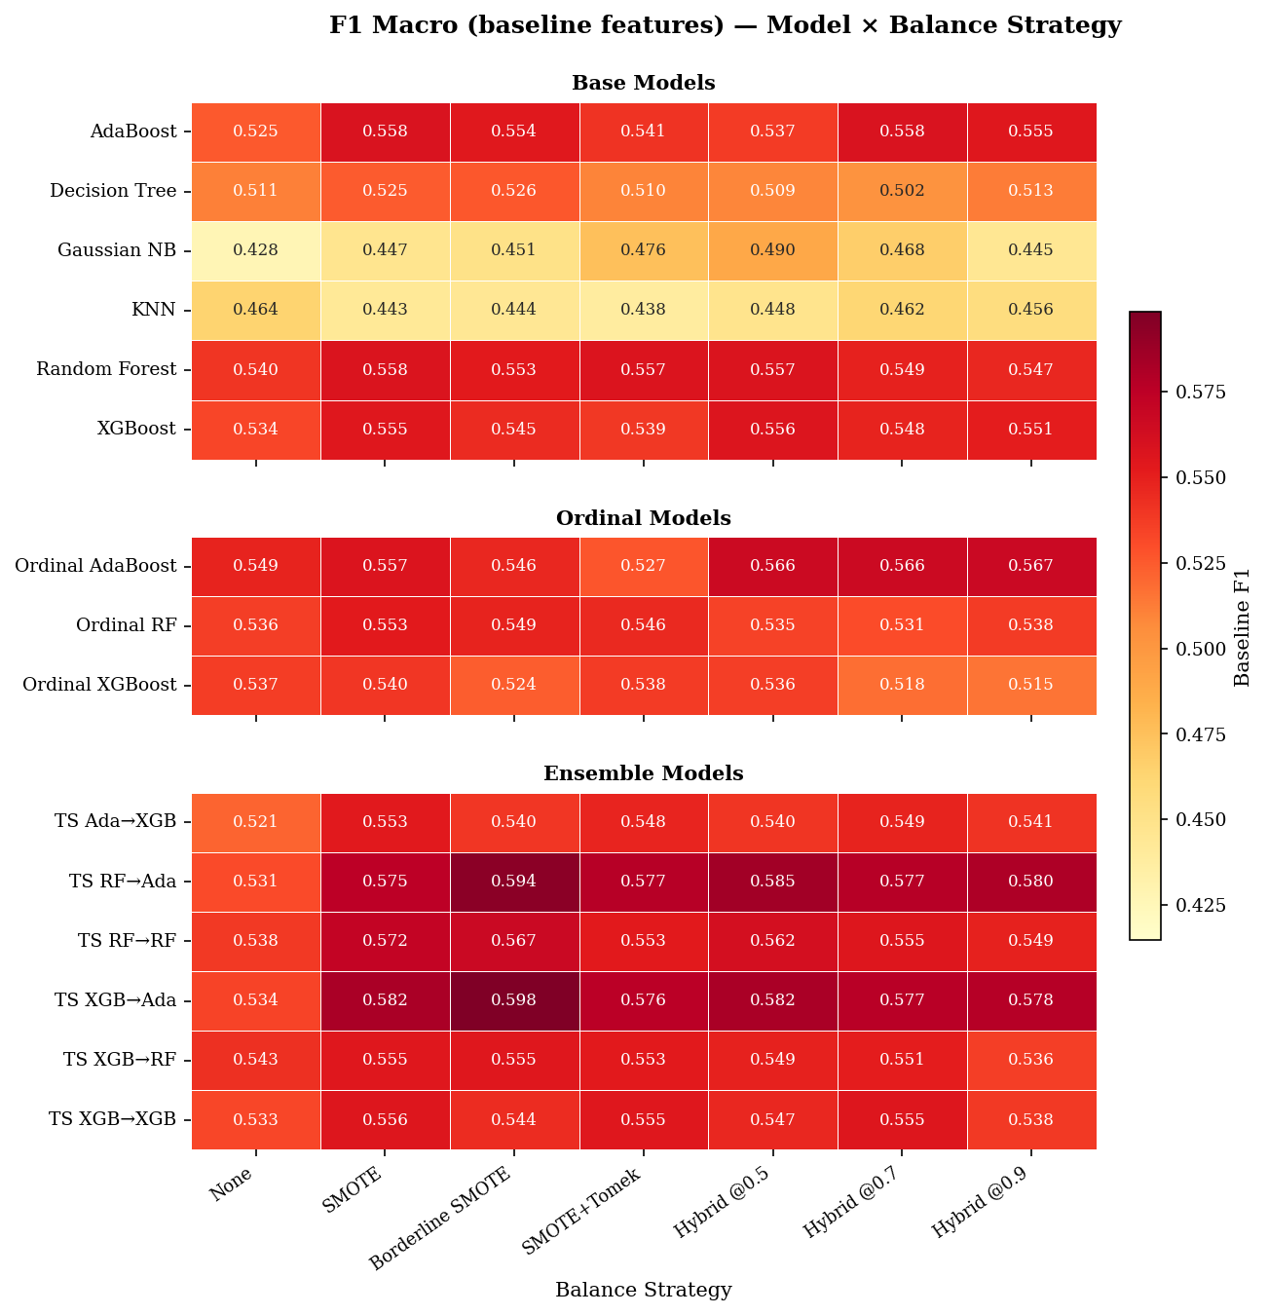
Figure 4.4: F1 Macro by Model & Balance Strategy (baseline features).
Comparing Figure 4.4 against Figure 4.2 quantifies the survival-feature contribution discussed in Section 4.2: the distributions shift upward modestly under the enhanced regime for distance-based and probabilistic models (mean F1 lifts of +0.0050 to +0.0061 for KNN and Gaussian Naive Bayes), while tree-based ensembles are essentially unchanged. The strategy rankings, however, are stable across the two regimes — Borderline-SMOTE leads in both — indicating that resampling choice and feature regime act as largely independent levers.
Resampling is confirmed as the most critical preprocessing step. Borderline-SMOTE consistently outperforms or matches Vanilla SMOTE across most model–strategy combinations, with the peak F1 difference reaching approximately 0.022 for top-performing ensembles (e.g., TS XGB→Ada: 0.600 vs. 0.578 in Figure 4.2). Borderline-SMOTE also yields the highest observed ROC-AUC at 0.882 (TS XGB→Ada, Figure 4.3). Hybrid undersampling strategies offer a moderate but stable alternative, with mean F1 values clustering around 0.58–0.54; however, their variance across model types remains notable — weaker classifiers like KNN and Gaussian NB still lag substantially under hybrid strategies, limiting the claim that they are uniformly reliable when the classifier is not pre-selected.
The impact of different balancing strategies on model performance is visualized in Figure 4.2 and Figure 4.3, which show F1-score and ROC-AUC distributions across models and strategies using the enhanced feature set. Configurations without resampling tend to underperform resampled counterparts, particularly for weaker classifiers, though certain ensemble models (e.g., Ordinal AdaBoost at 0.557 and TS RF→RF at 0.536) show competitive F1 scores even without resampling, suggesting that the magnitude of improvement is model-dependent. Baseline performance without feature engineering is shown in Figure 4.4 for comparison, where similar patterns hold but with generally lower absolute scores for base and ordinal models.

4.4 Metric Convergence and Model Selection Criteria
Analysis of the Spearman rank correlation between macro-F1 and ROC-AUC (rho = 0.732, p < 0.001) confirms a strong agreement between the two metrics. Models that excel at maximizing the harmonic mean of precision and recall also tend to provide superior class separation, validating macro-F1 as a reliable primary criterion for model selection in school finance applications.
Figure 4.5 shown on the next page presents ROC curves for the top-performing models, plotting the trade-off between true positive rate and false positive rate across classification thresholds.
The curves separate cleanly from the diagonal chance line, with the two-stage XGBoost-to-AdaBoost configuration achieving the largest area under the curve (approximately 0.89). Its advantage is most pronounced in the low-false-positive region, which is operationally the relevant regime: a finance office acting on predictions wants high recall of late invoices while contacting as few on-time payers as possible.
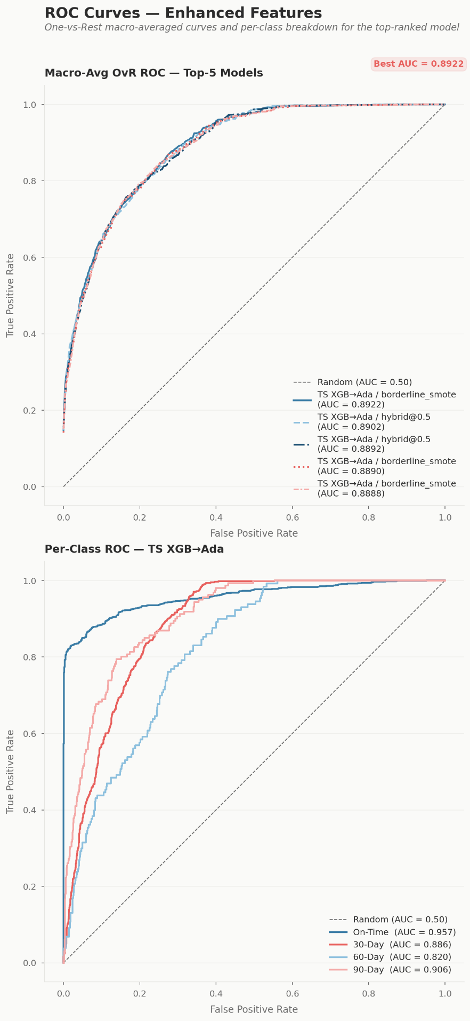
Figure 4.5: ROC Curves for Top Models.
Figure 4.6 presents the confusion matrices of the top three models, detailing classification performance per payment bracket.
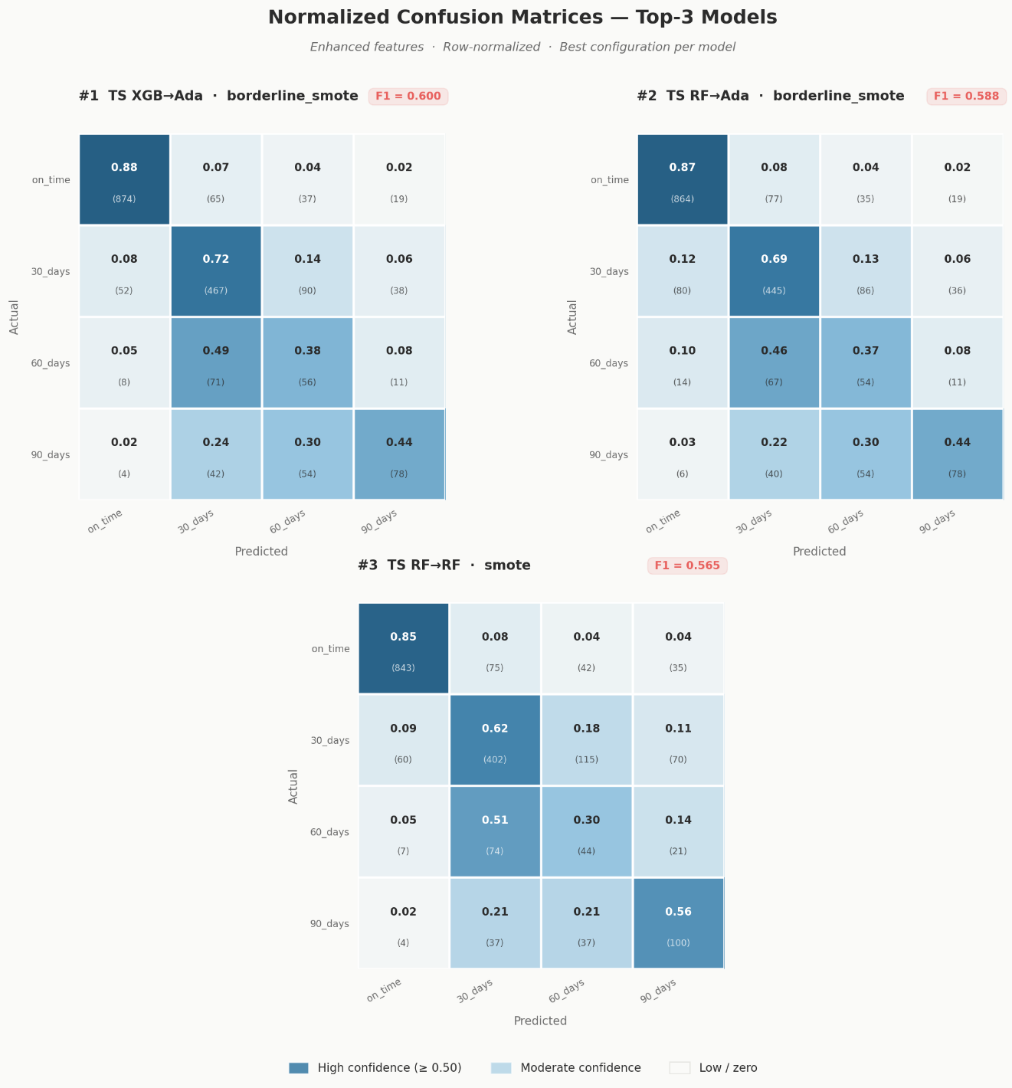
Figure 4.6: Confusion Matrices for Top 3 Models.

The matrices reveal a consistent class-level pattern: Class 0 (on-time) recall is uniformly high and Class 1 (1–30 days late) is recovered reasonably well, but Classes 2 and 3 remain difficult under every strategy, with a substantial share of 31–60 day invoices absorbed into neighboring brackets. The errors are predominantly ordinal-adjacent — misclassifications land one bracket away rather than at the opposite extreme — which moderates their operational cost, since an invoice flagged one bracket early still receives an intervention.
The relationship between F1-score and ROC-AUC is further illustrated in Figure 4.5 (ROC Curves for Top Models), showing the trade-off between true positive rate and false positive rate at various threshold settings. Confusion matrices for the top-performing models are presented in Figure 4.6 to detail classification performance per payment bracket.

4.5 RQ4 — Granular Feature Contribution
Figures 4.7 and 4.8 present feature importance scores aggregated across model types, revealing which variables most consistently drive payment bracket predictions.
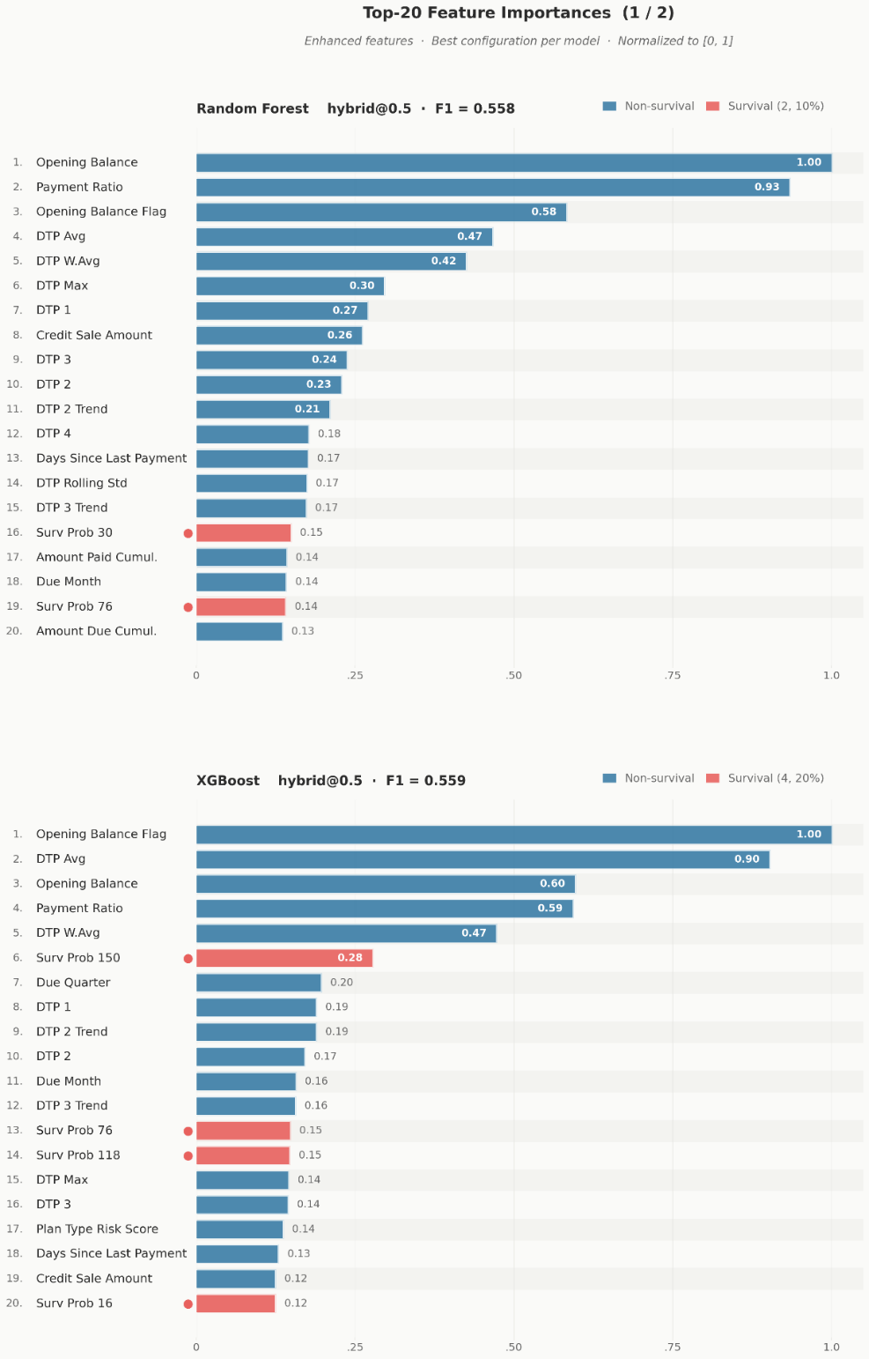
Figure 4.7: Feature Importance across Model Types (1 of 2).
Figure 4.7 covers the first half of the model types, where the same small set of behavioral variables heads every ranking. Figure 4.8 continues the ranking with the remaining model types, allowing the cross-family comparison discussed on the next page.
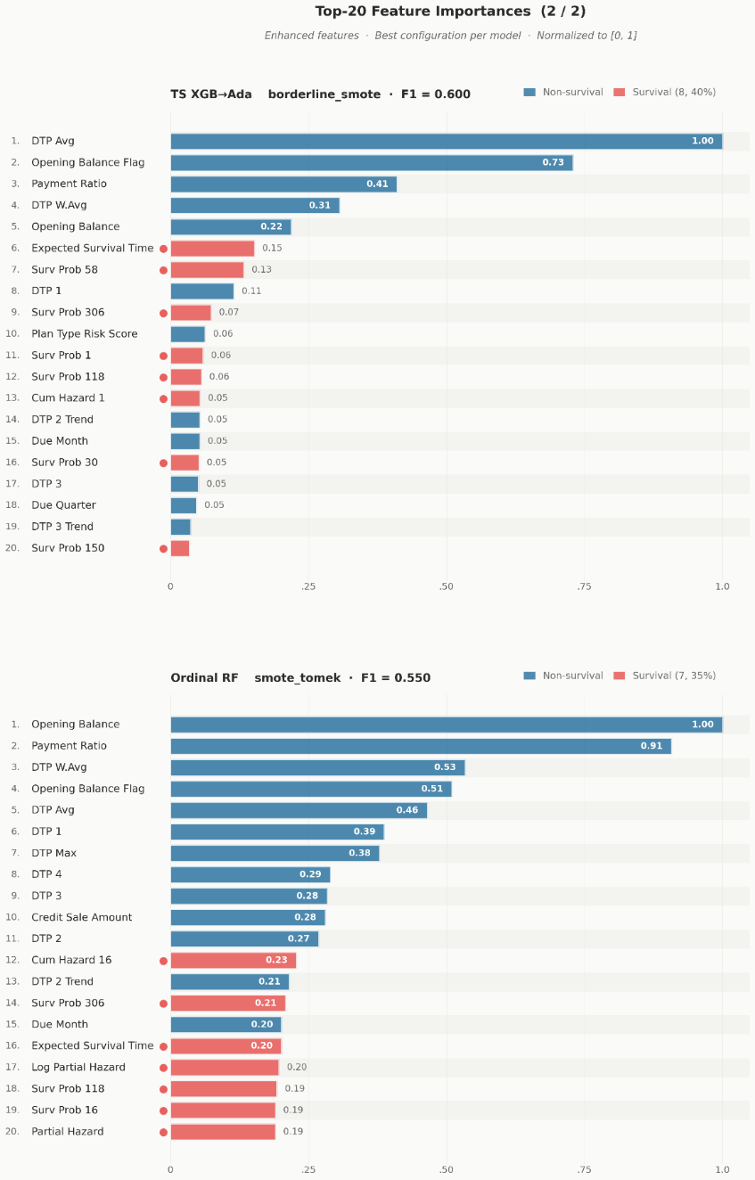
Figure 4.8: Feature Importance across Model Types (2 of 2).
Three features dominate across model families: prev_bracket, the payment bracket of the student's most recent invoice; dtp_wavg, the recency-weighted average of historical days-to-payment; and opening_balance_flag, indicating whether the student carried an unpaid balance into the period. All three are behavioral-historical features engineered at the granular, line-item level described in Chapter 3, confirming the study's central design rationale with respect to RQ4: a student's payment future is best predicted by a compact summary of their payment past, and that summary is only available when invoices are tracked at category-level granularity rather than as aggregate balances.
The exploratory linear discriminant analysis corroborates this ranking from a different angle. A four-class LDA on the training set finds that the first discriminant axis (LD1) explains 79.5% of between-class separation variance, and the features loading most heavily on it are opening_balance_flag, the log-transformed opening_balance, prev_bracket, and dtp_wavg — essentially the same compact behavioral set identified by the supervised importances. When the analysis is restricted to the three delinquent classes, LD1 explains 95.9% of separation, indicating that delay severity behaves as a nearly one-dimensional behavioral construct. The agreement between this projection-based view and the supervised importance rankings strengthens confidence that these variables capture genuine structure rather than model-specific artifacts.

4.6 Prototype Demonstration
The benchmarking results are operationalized in a working prototype: a Dash (Python/Plotly) web application that serves as the study's delivery vehicle for institutional users. The prototype is best characterized as a Minimum Viable Product (MVP): a functional, working system that demonstrates the core workflow end to end — from raw data upload through model training to invoice-level prediction — while deferring selected non-core integrations to future development. An administrator interacts with five principal screens, described below.
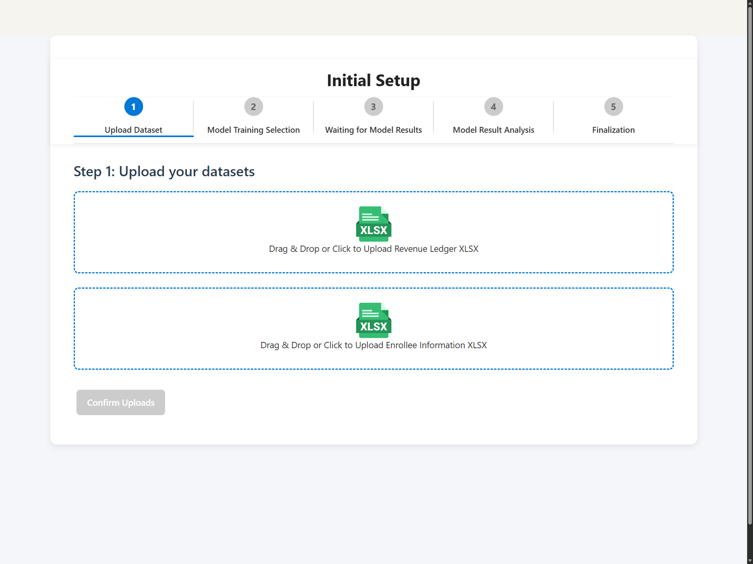
Figure 4.9: Multi-step initial setup wizard screen.
The entry point is a multi-step Initial Setup Wizard that guides the administrator through uploading the two institutional source files (revenues and enrollees) and triggering the training pipeline, removing any need to interact with code or notebooks.
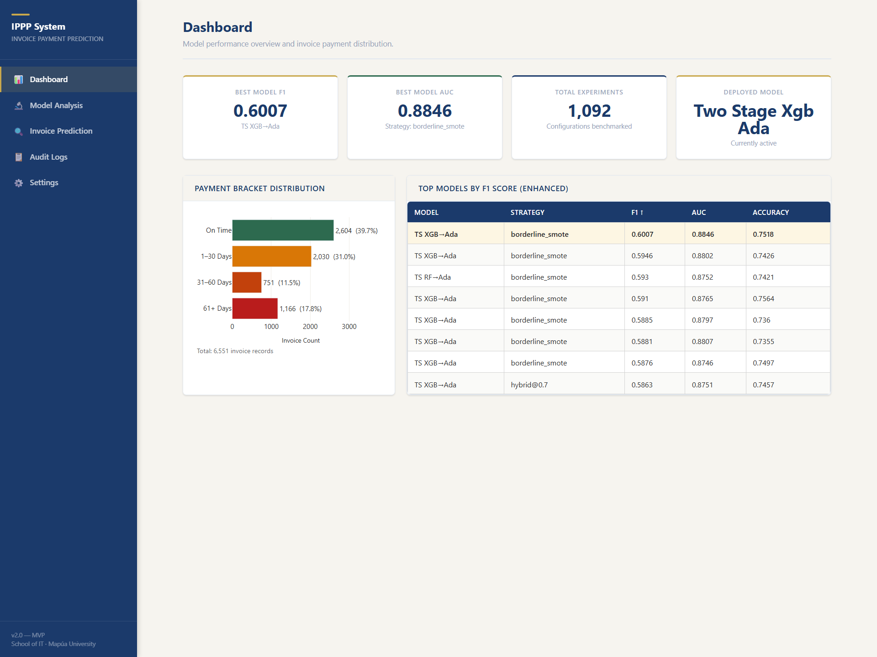
Figure 4.10: Main KPI dashboard screen.
Once training has been run, the KPI Dashboard loads live data from the results database on mount: four indicator cards report the best model's macro-F1, its ROC-AUC, the total number of logged experiments, and the name of the currently deployed model, alongside a payment-bracket distribution chart built from the processed invoice cache and a table of top models sorted by enhanced-regime F1. The screen falls back gracefully to an empty state when no training has yet been performed. For a school administrator, this view answers the first operational question — how reliable is the deployed model and what does the receivables mix look like — at a glance.
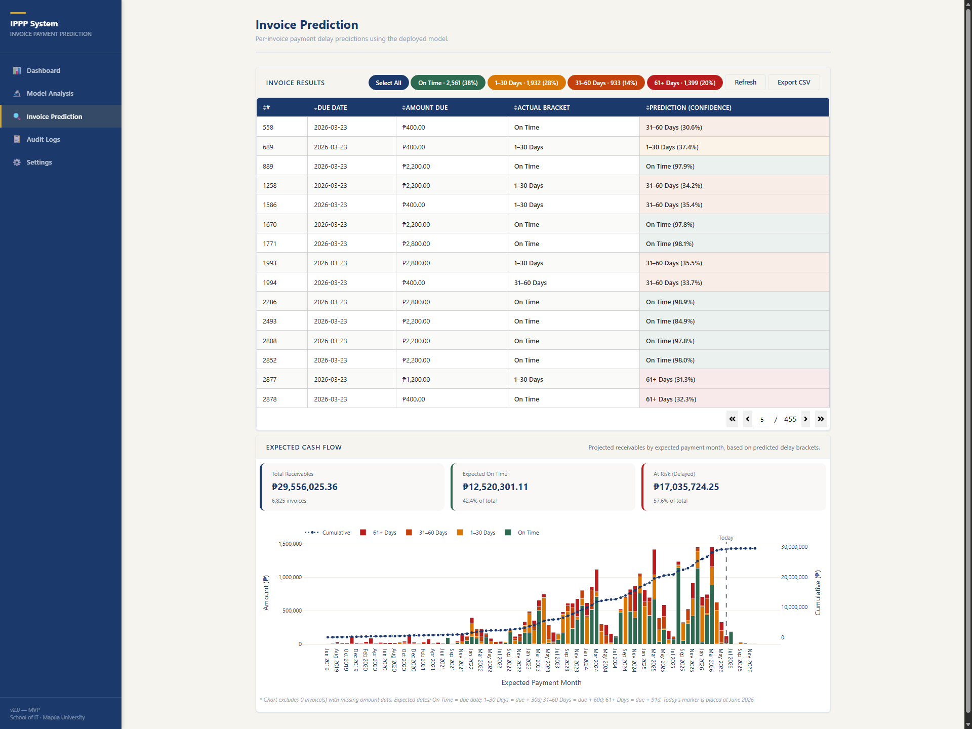
Figure 4.11: Invoice prediction drilldown screen.
The Invoice Prediction Drilldown is the screen where predictions become actionable. It loads the processed credit sales cache, runs the deployed inference pipeline's class and probability predictions across all invoice records, and displays a paginated table of invoice number, due date, amount, predicted payment bracket, prediction confidence, and the actual bracket where known. The administrator can filter the table by predicted bracket — isolating, for example, all invoices expected to fall 61 or more days late — and export the result to CSV for use in collection workflows; every prediction run is recorded in the audit log.
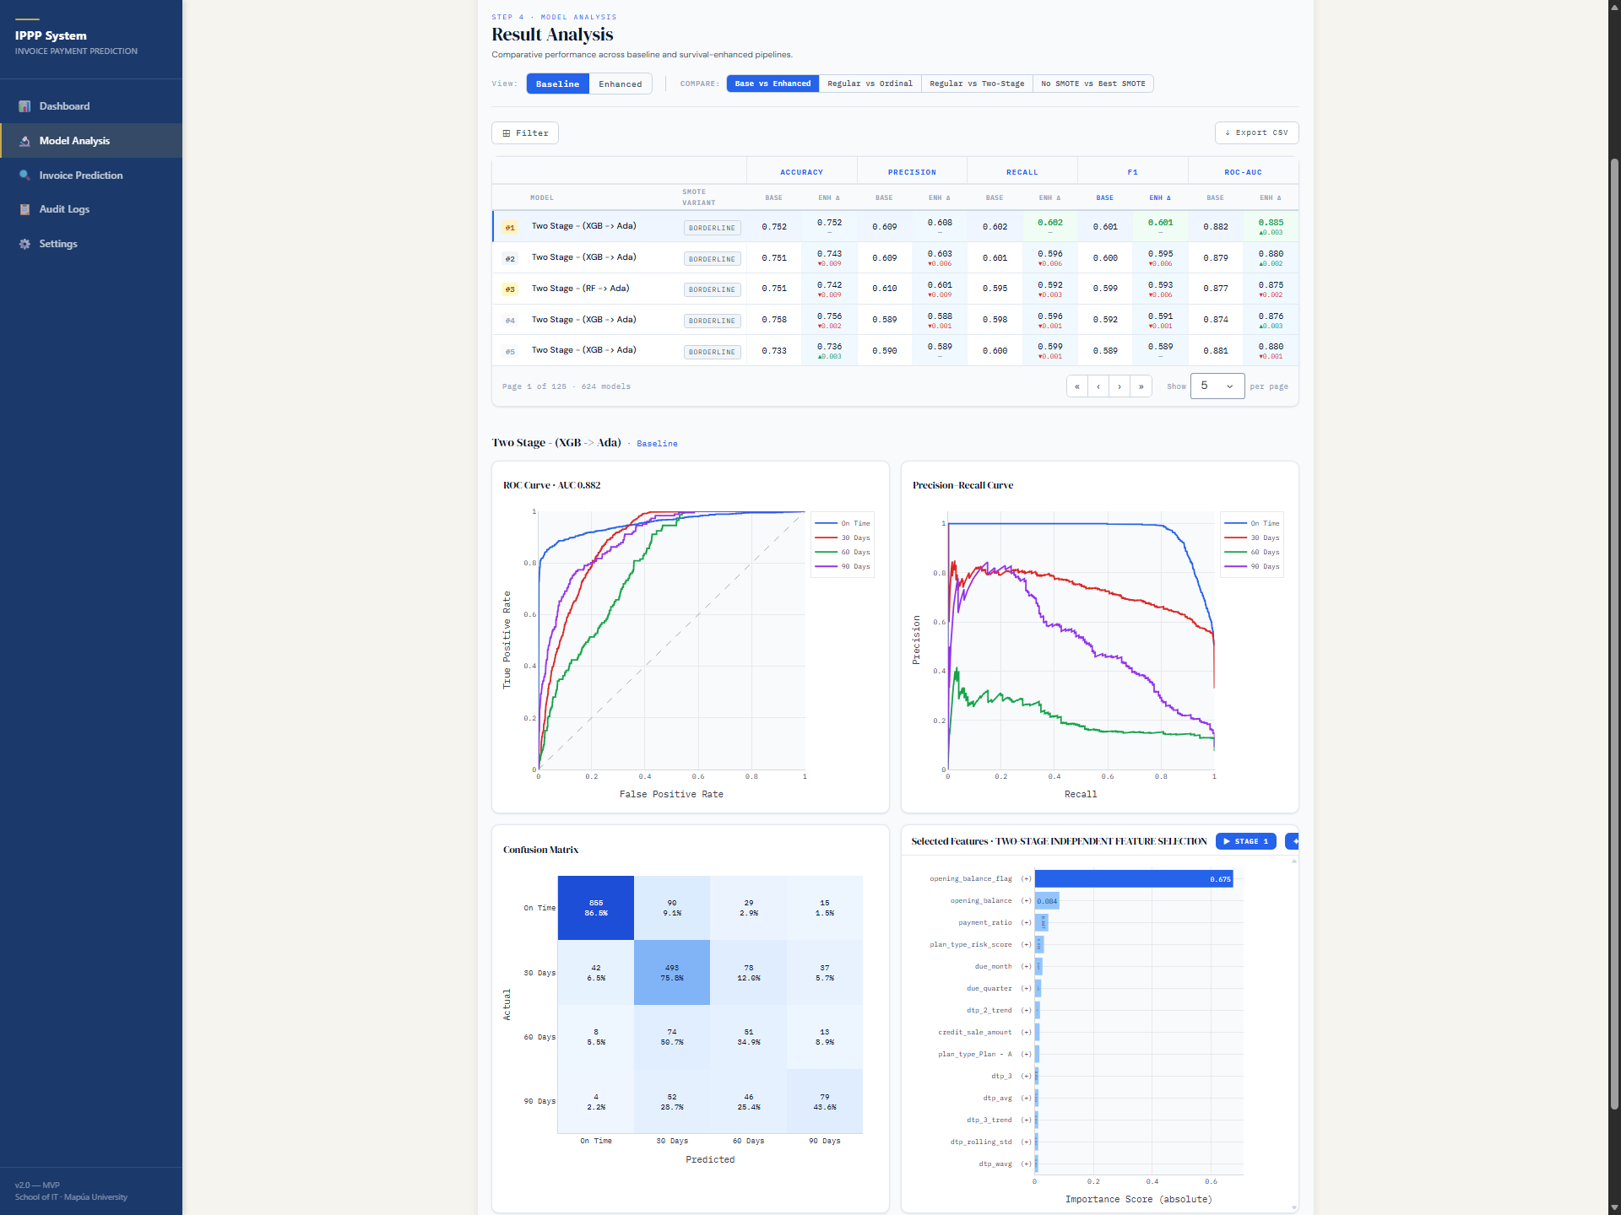
Figure 4.12: Comparative model dashboard screen.
The Comparative Model Dashboard provides the analytical depth behind the deployment choice, allowing filtering by model type and balance strategy and rendering ROC curves, confusion matrices, and F1/AUC comparison charts across all 1,092 experiment configurations.
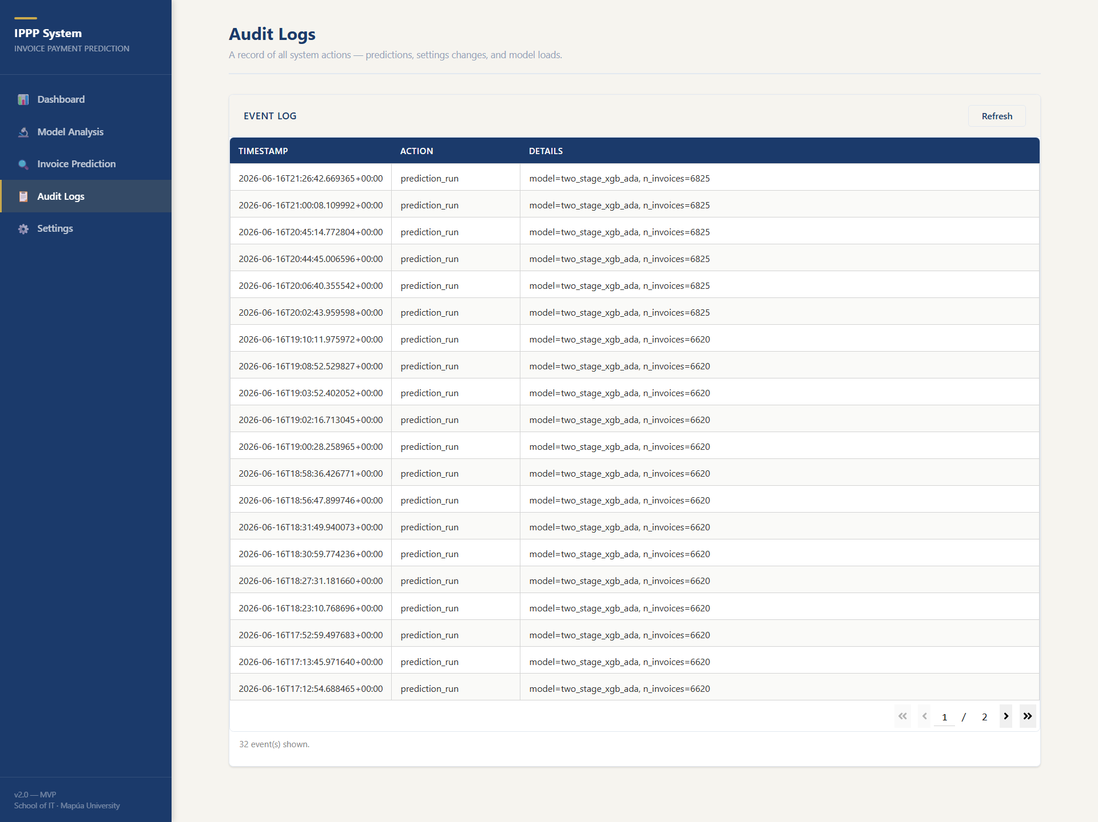
Figure 4.13: Audit logs screen.
Two supporting screens round out the MVP. The Audit Logs screen lists all system events — predictions run, settings saved, models loaded — with timestamp, action, and details, refreshing automatically every 30 seconds; this provides the accountability trail required for responsible institutional use (Section 3.7).
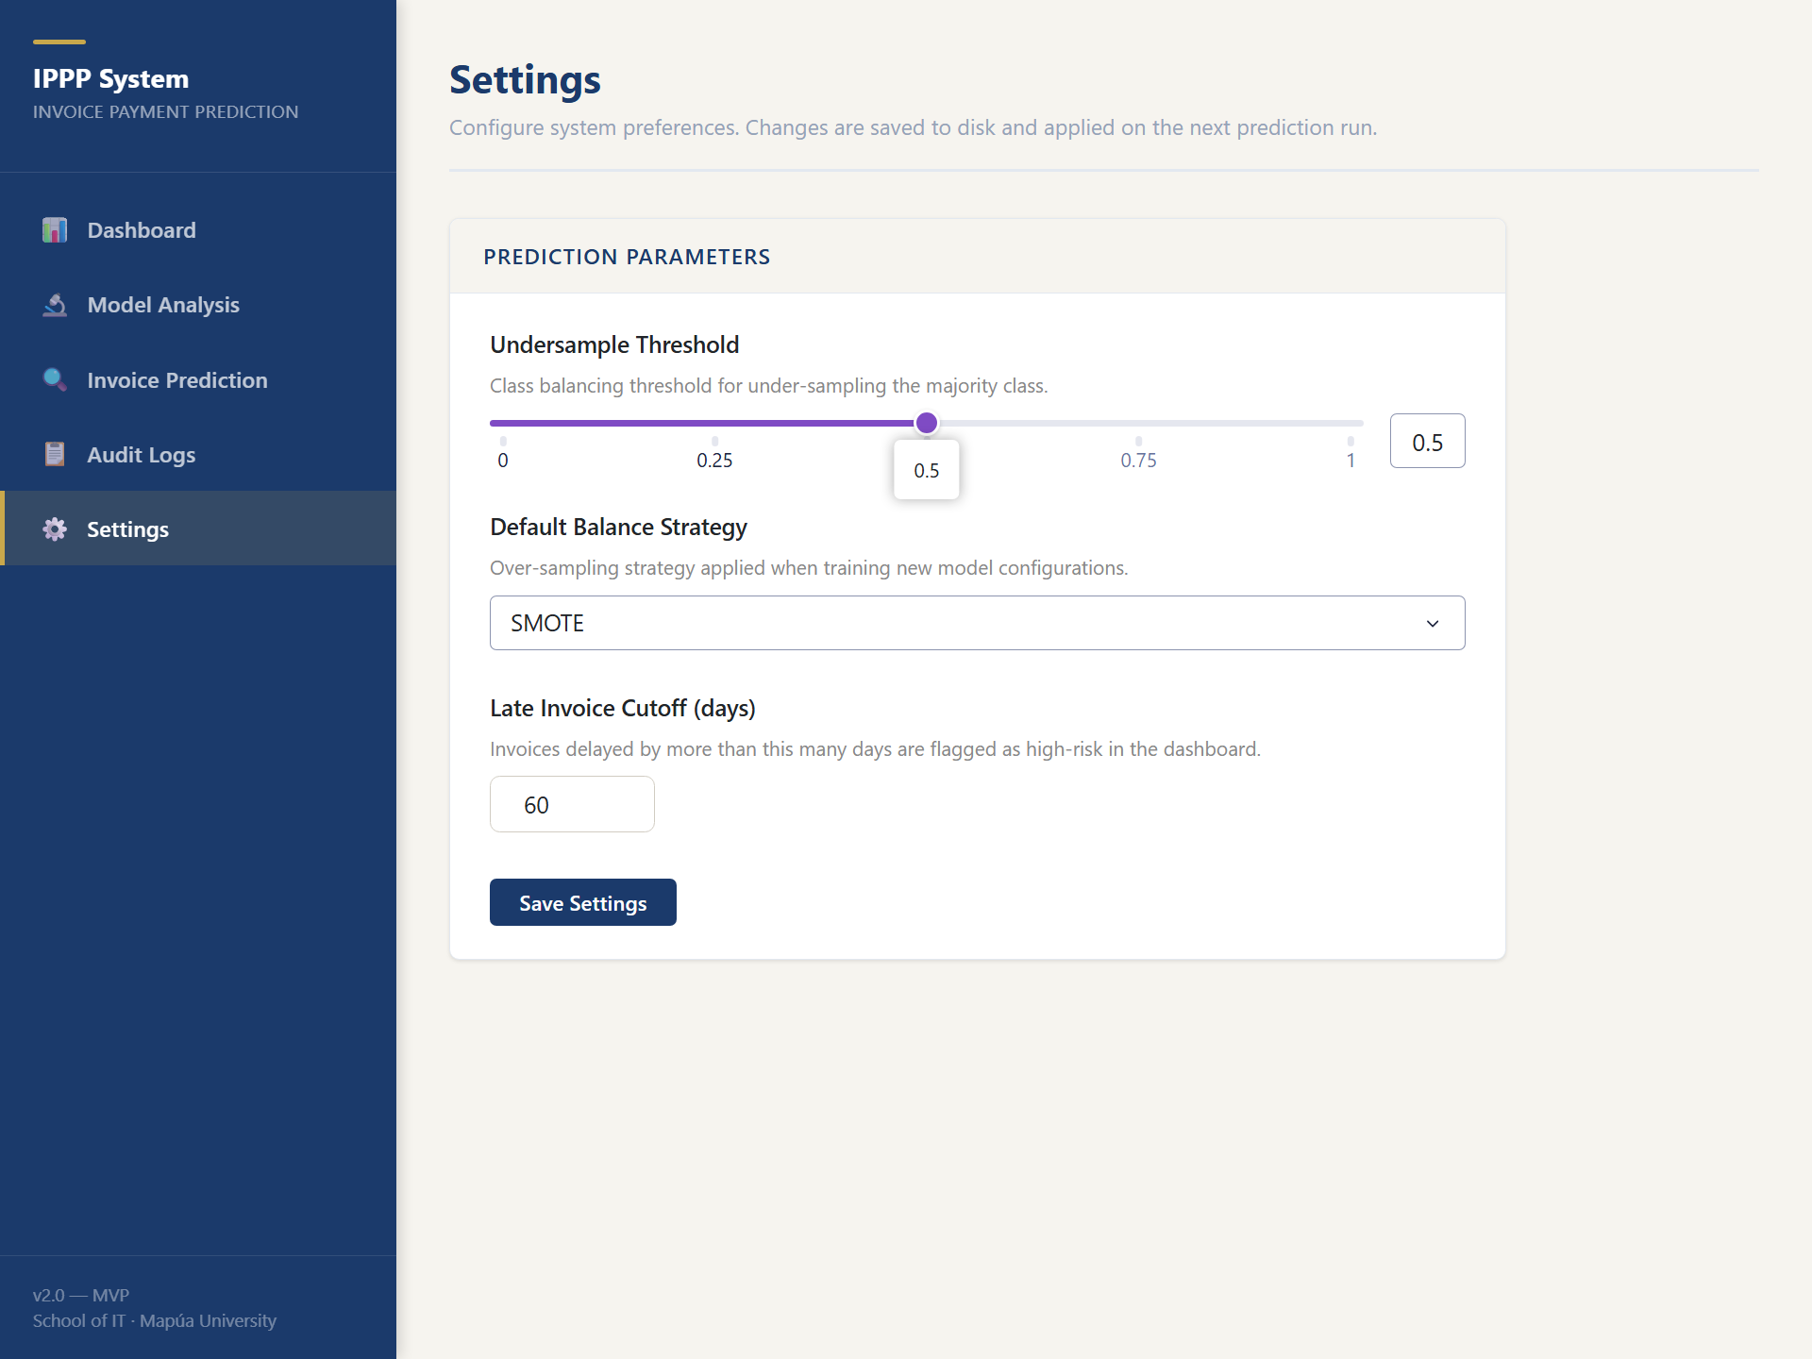
Figure 4.14: Settings screen.
The Settings screen exposes the undersample threshold, the default balance strategy, and the late-invoice cutoff, persisting preferences to a configuration file and logging each change. All five screens are implemented and functional in the MVP. One integration is deliberately deferred: a compatibility adapter that would map external dataset schemas — such as public Kaggle invoice datasets with columns like invoice_date, due_date, amount, customer_id, and paid_date — onto the input schema expected by the feature engineering pipeline. At present only the proprietary three-file institutional schema is supported; the adapter and additional data source integrations are planned for future development (Section 5.4).

4.7 Benchmark Dataset Generalizability
The pipeline as implemented is designed around a specific institutional schema: the three Excel exports (revenues, enrollees, chart of accounts) described in Section 3.2. Its strong results therefore demonstrate effectiveness for the partner institution's data model, but not yet generalizability beyond it. The natural validation step is to benchmark the pipeline against publicly available invoice and accounts-receivable datasets, such as those published on Kaggle under searches for "B2B invoice payment prediction," "accounts receivable dataset," or "customer payment behavior." Doing so requires the compatibility adapter described in Section 4.6: a mapping layer that translates external columns onto the schema expected by the feature engineering pipeline and degrades gracefully where institution-specific variables — installment plan types, enrollment streaks, category-level fee structure — have no external equivalent. Because several of the study's strongest features are institution-specific, such benchmarking would also reveal how much of the measured performance derives from the granular school data model itself, which is an informative result in either direction. This evaluation is explicitly flagged as planned future work rather than a completed contribution of this study (Section 5.4).

CHAPTER 5:
CONCLUSION AND RECOMMENDATION

5.1 Summary of Findings
This study benchmarked 1,092 experimental configurations to address the Invoice Payment Prediction Problem (IPPP) within a private educational context. By evaluating fifteen machine learning architectures across multiple resampling and feature engineering regimes, four conclusions emerge:
(1) Hierarchical architectures dominate: Two-stage ensemble classifiers, which separate the discrimination of on-time from late invoices before determining delay severity, consistently outperform single-stage and ordinal benchmarks. The two_stage_xgb_ada configuration represents the state-of-the-art for this task (F1 = 0.6002).
(2) Resampling is indispensable: Given the heavy concentration of on-time payments, synthetic oversampling via SMOTE or Borderline-SMOTE is necessary to achieve meaningful recall for late-payment brackets.
(3) Ordinal structure yields modest utility: While exploiting the ordered nature of payment delay provides consistent gains under hybrid resampling, these improvements are marginal compared to the gains from multi-stage ensemble architectures.
(4) Survival feature impact is model-specific: Survival-analysis-derived features provide significant informative lift for distance-based and probabilistic models but offer redundant signals for high-capacity tree-ensembles that can independently model temporal interactions.

5.2 Implications for Practice
For private educational institutions, these findings provide a directly deployable framework to shift from reactive collections to proactive cash flow management. The recommended production pipeline is a Two-Stage XGBoost-to-AdaBoost architecture trained with SMOTE resampling. Institutional administrators can leverage model outputs to identify high-risk accounts at the start of billing cycles and prioritize tailored interventions (e.g., early reminders for Class 1 vs. installment restructuring for Class 3).

5.3 Recommendation for Continuous Calibration
To account for temporal drift in payment behaviors caused by shifting socioeconomic conditions or changes in institutional policies, the researchers’ recommend that schools re-fit the Cox PH model and retrain the downstream classifiers annually. This ensures that the survival probabilities and partial hazard features remain calibrated to the latest student cohorts.

5.4 Future Directions
Future research and development should proceed along six directions. First, explainable AI integration: a SHAP value layer over the deployed two-stage model would let administrators see why an individual invoice is flagged as high risk, increasing the administrative trust on which adoption depends. Second, time-varying covariates within the Cox model would allow hazard estimates to update as partial payments arrive during the term, rather than fixing survival features at invoice issuance. Third, multi-institution federated learning would improve model generalizability while preserving student data privacy, since schools could train shared models without exchanging raw records. Fourth, the Dash prototype should be extended beyond its MVP scope — most notably through the Kaggle dataset compatibility adapter described in Sections 4.6 and 4.7, a mapping layer that would translate external invoice schemas onto the input format expected by the feature engineering pipeline, together with additional data source integrations beyond the three-file institutional export. Fifth, and enabled by that adapter, the pipeline should be tested on publicly available accounts-receivable and invoice datasets to establish generalizability beyond the partner institution. Finally, deployments should adopt the retraining cadence recommended in Section 5.3: an annual recalibration of the Cox PH model and downstream classifiers, so that survival features and decision thresholds continue to track each new cohort's payment behavior.

5.5 Conclusion
This study demonstrated that hierarchical ensemble decomposition is a viable architectural paradigm for the Invoice Payment Prediction Problem, outperforming both ordinal classifiers and single-stage baselines across the majority of resampling and feature regimes tested. Across 1,092 controlled configurations, the two-stage XGBoost-to-AdaBoost pipeline established the performance ceiling at a macro-F1 of 0.6003 and ROC-AUC of 0.8919, and the experiments further demonstrated two structural results: that granular, line-item behavioral features — a student's previous bracket, weighted payment history, and carried balance — are the dominant predictive signal, and that survival-analysis feature engineering has conditional rather than universal utility, helping probabilistic and distance-based learners while adding little to high-capacity tree ensembles.
These numbers have a concrete operational meaning for the partner school, connecting back to the significance articulated in Section 1.5. A macro-F1 of 0.60 on a four-class, heavily imbalanced problem means that if one hundred invoices fall due next month, the model places roughly sixty of the eventually-late ones in their correct delay bracket, and the confusion analysis in Section 4.4 shows that most of its remaining errors land in adjacent brackets rather than at the opposite extreme. Measured against the status quo — no forward visibility into receivables at all — this allows the finance office to concentrate outreach on the highest-risk invoices before due dates lapse: earlier reminders, proactive restructuring offers, and social welfare referrals, in place of after-the-fact collection that RA 11984 has rendered largely unenforceable. Prediction, in other words, converts bad-debt exposure into earlier and gentler intervention.
Beyond the single institution, the contribution is methodological. The study leaves behind a replicable benchmarking framework — a factorial protocol over model families, balancing strategies, and feature regimes, with every experiment logged to a queryable results store — together with a working prototype that operationalizes the winning configuration. Any institution facing the IPPP, educational or otherwise, can rerun the same protocol on its own records and obtain a defensible, evidence-based model selection rather than an imported assumption about what works.
Predictive receivables management, finally, should be read as an instrument of institutional responsibility rather than financial surveillance. A school that can see payment difficulty coming can keep its programs funded without leaning on enforcement mechanisms the law has rightly removed, and can direct assistance to the families who need it while there is still time to help. In aligning financial sustainability with educational equity, this study argues, predictive analytics becomes part of responsible governance — and the gap between what schools can know and what they currently act on is precisely where data science has the most to offer.

APPENDICES

APPENDIX A: Days Sales Outstanding per Plan Type (calendar year 2023)
Appendix A presents the Days Sales Outstanding (DSO) per payment plan type for calendar year 2023. DSO is computed as the average number of days between invoice due date and full settlement, segmented by the student's chosen installment plan (A through E, or none).
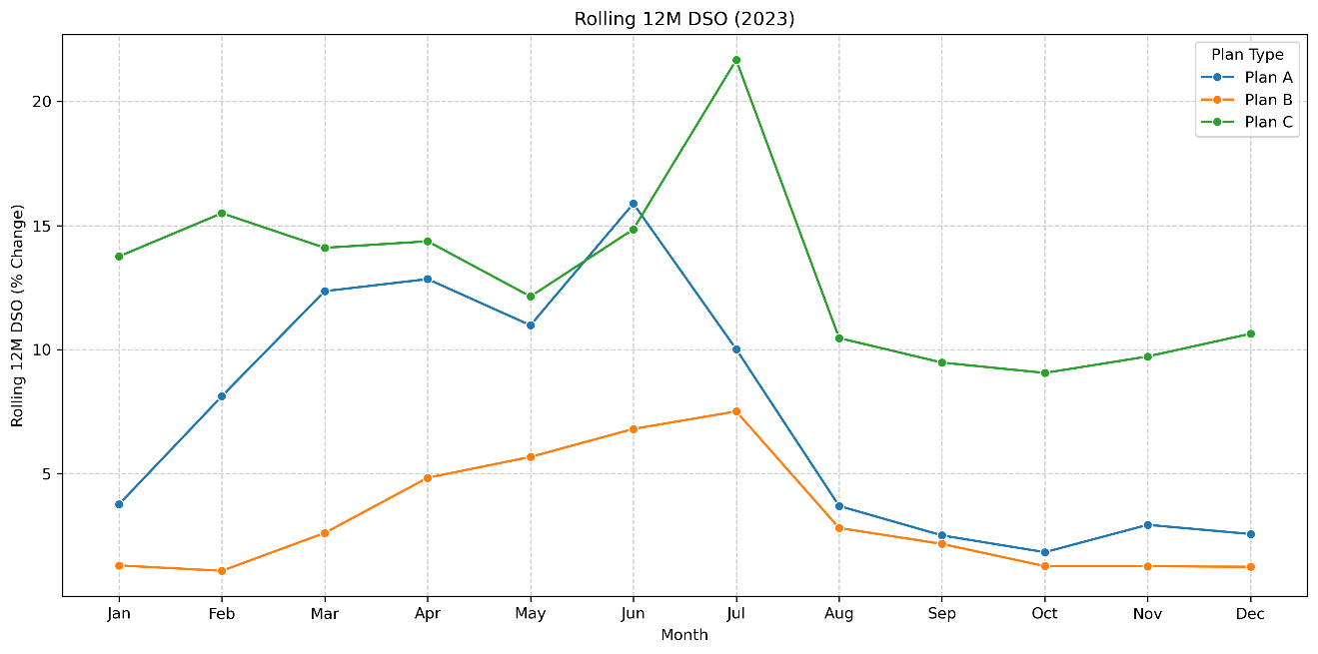
The figure shows the same plan-level ordering observed across all three reported years: longer credit windows correspond to higher DSO. A consolidated observation across Appendices A–C follows the final figure in Appendix C.

APPENDIX B: Days Sales Outstanding per Plan Type (calendar year 2024)
Appendix B presents the Days Sales Outstanding (DSO) per payment plan type for calendar year 2024. DSO is computed as the average number of days between invoice due date and full settlement, segmented by the student's chosen installment plan (A through E, or none).
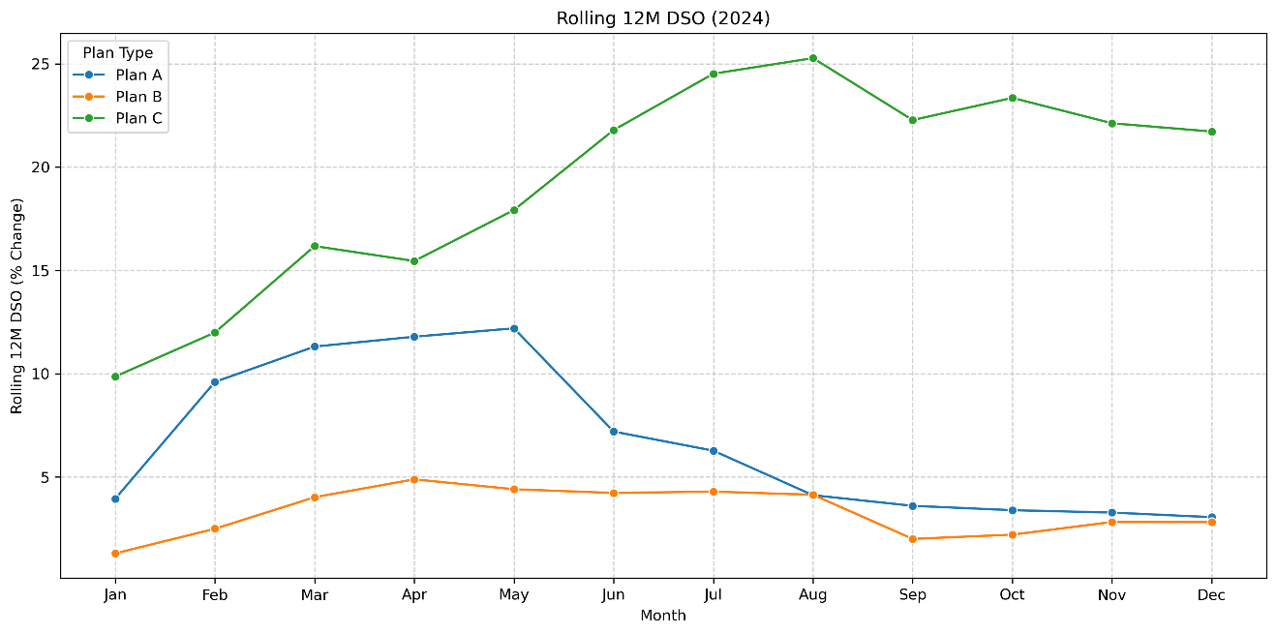
The figure shows the same plan-level ordering observed across all three reported years: longer credit windows correspond to higher DSO. A consolidated observation across Appendices A–C follows the final figure in Appendix C.

APPENDIX C: Days Sales Outstanding per Plan Type (calendar year 2025)
Appendix C presents the Days Sales Outstanding (DSO) per payment plan type for calendar year 2025. DSO is computed as the average number of days between invoice due date and full settlement, segmented by the student's chosen installment plan (A through E, or none).
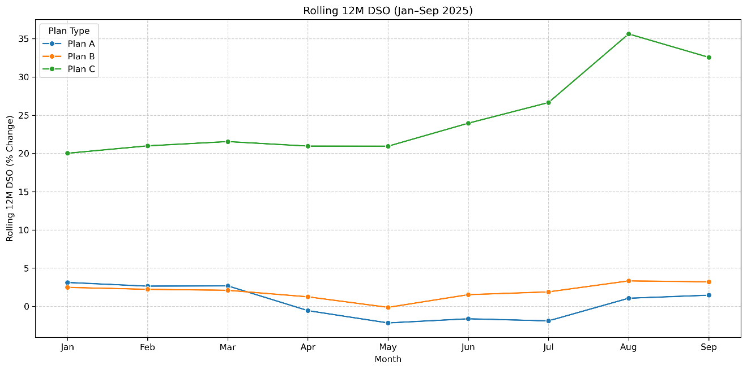
Across the three years presented in Appendices A through C, the plan types that extend the longest credit windows — the extended monthly installment arrangements and invoices with no assigned plan — consistently exhibit the highest DSO, while Plan A (full upfront payment) settles fastest. The implication is that settlement speed tracks the length of the credit window a plan extends: the more payment is deferred, the longer receivables remain outstanding. This ordering is consistent with the ordinal plan-risk encoding used as a model feature (Section 3.3), and it explains why plan-type variables carry predictive signal in the payment-bracket models.

APPENDIX D: Feature importance from the paper titled “A MACHINE-LEARNING APPROACH TOWARDS SOLVING THE INVOICE PAYMENT PREDICTION PROBLEM”
Appendix D reproduces the first set of feature importance rankings reported by Schoonbee et al. [5], included as the principal point of comparison for the importance analysis in Section 4.5.
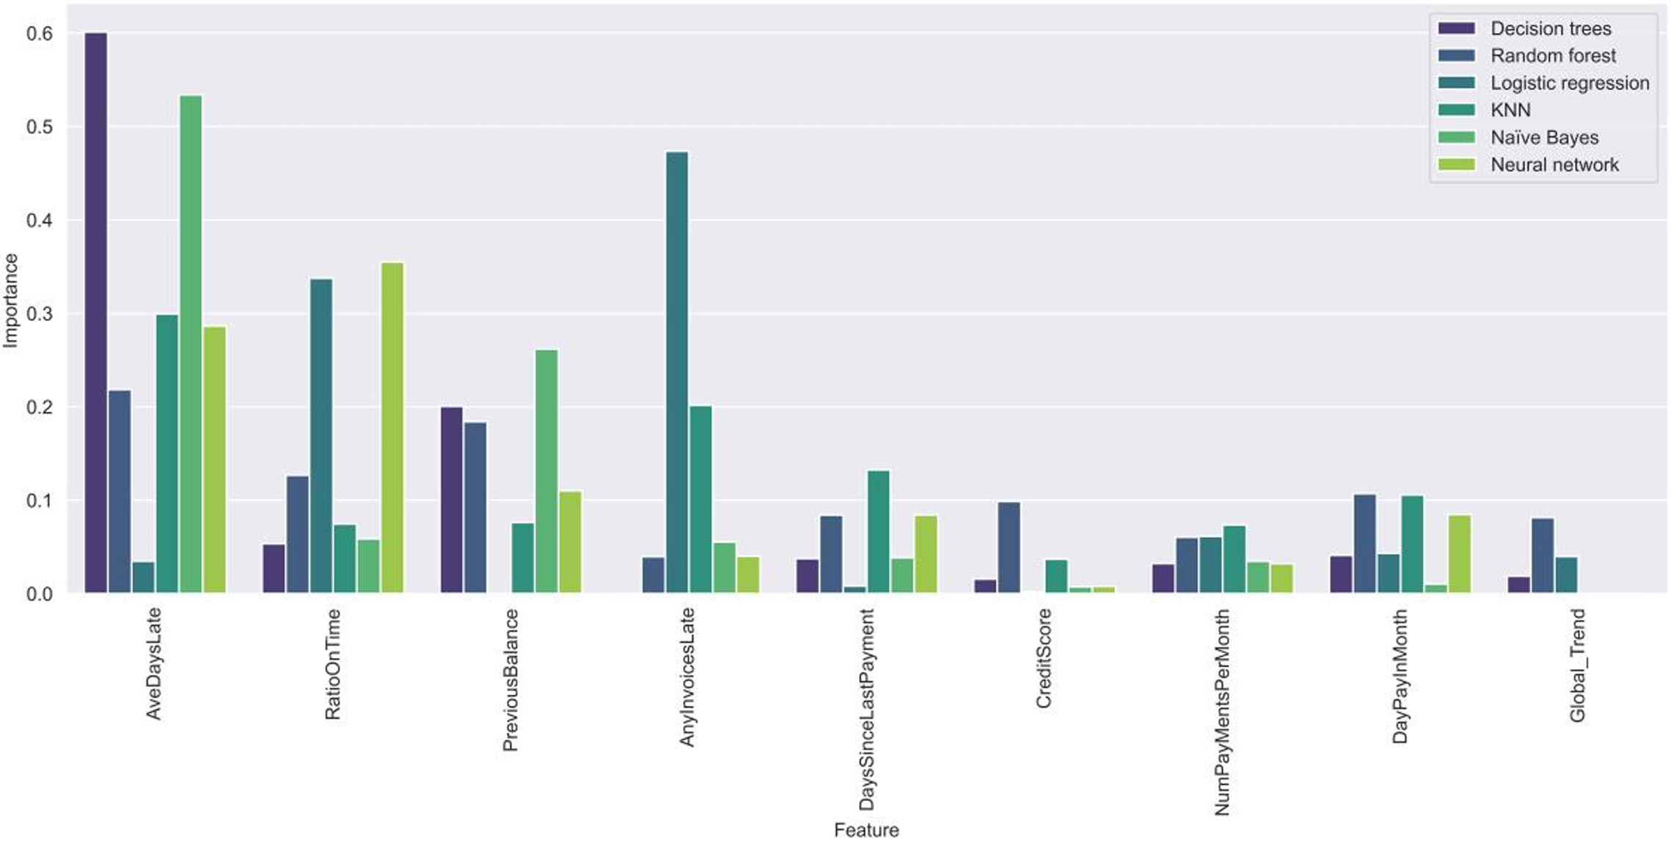
Their top-ranked variables are aggregate, student-level payment history features, which is consistent with this study's finding that behavioral payment history dominates prediction — while lacking the category-level granularity and engineered survival features introduced here.

APPENDIX E: Feature importance from the paper titled “A MACHINE-LEARNING APPROACH TOWARDS SOLVING THE INVOICE PAYMENT PREDICTION PROBLEM”
Appendix E reproduces the second set of feature importance rankings from Schoonbee et al. [5], complementing Appendix D.
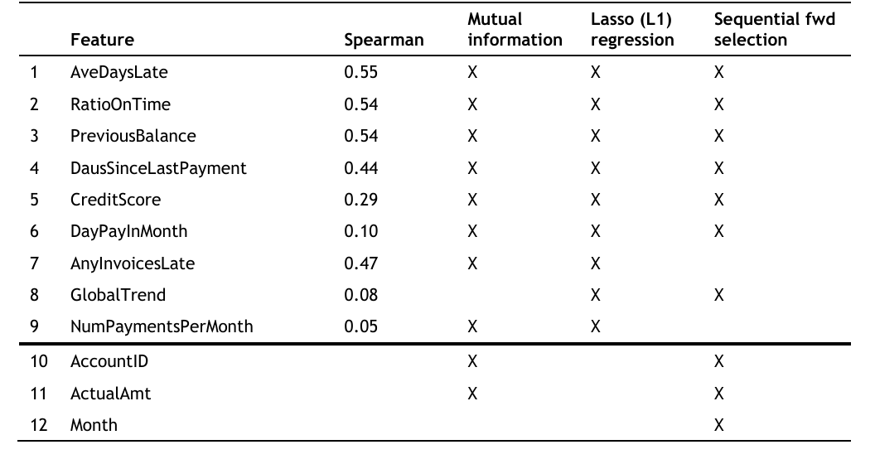
Together, Appendices D and E show that prior educational IPPP work concentrated its predictive signal in a small set of aggregate history variables, supporting this study's design decision to expand the feature space at line-item granularity (Section 3.3).

APPENDIX F: Correlation scores between features and the days to payment variable from the paper “A framework for modeling customer invoice payment prediction
Appendix F reproduces the correlation scores between candidate features and the days-to-payment variable reported by Moore and van Vuuren [4].
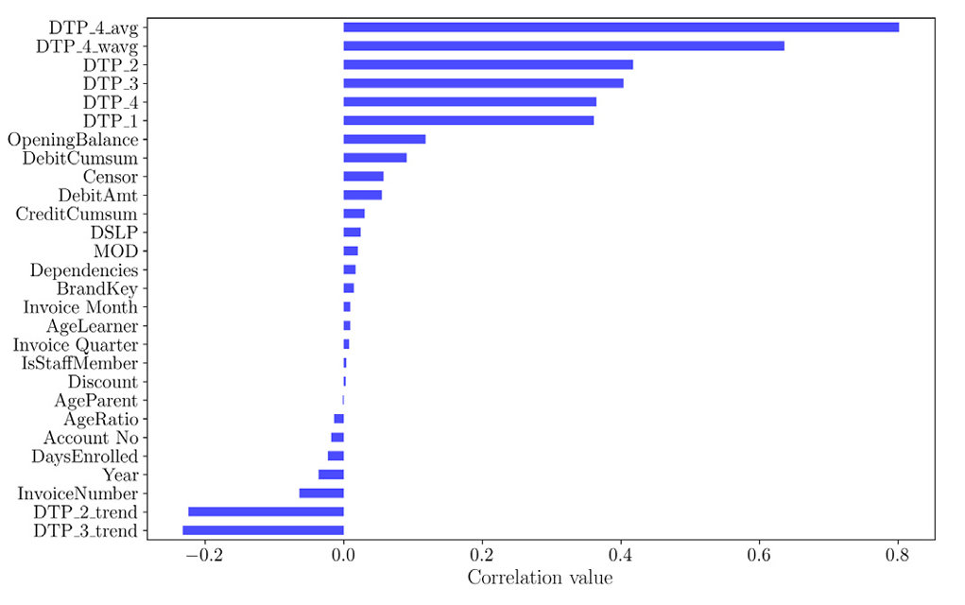
The strongest correlates in their framework are historical payment-delay aggregates, anticipating the dominance of dtp-derived features observed in this study's importance rankings (Figures 4.5 and 4.6).

APPENDIX G: Institutional Communication and Authorization Letter
Letter on file — co-author to provide. This appendix contains the written authorization from the partner institution permitting the research team to access and process student financial records for the purposes of this study, subject to the conditions described in Section 3.7.1. The letter is issued on the school's letterhead and signed by an authorized signatory, and it specifies the scope of data access granted, the restrictions on data use (research purposes only, mandatory pseudonymization, and no public release of raw records), and the date of authorization. This communication is distinct from any non-disclosure agreement: it constitutes the school's formal authorization to use its data for research.

APPENDIX H: Dataset Description and Variable Dictionary
The pseudonymized dataset comprises 11,440 raw invoice records exported from the partner institution's ERP system, of which 6,527 labeled records were retained for modeling after filtering for sufficient payment history. Records span academic years 2019–2025, with payment activity observed through March 31, 2026, and originate from three source tables: revenues (itemized receivables and payments), enrollees (per-year enrollment and installment plan), and the chart of accounts (category classifications). The table below lists every variable used in the machine learning pipeline, its category, type, description, and source.
Feature Name | Category | Type | Description | Source
school_year | Identity (not a model input) | Categorical | Academic year of the invoice | Revenues
student_id_pseudonymized | Identity (not a model input) | Integer | Anonymized student identifier | Revenues (pseudonymized)
category_name | Identity (not a model input) | Categorical | Fee category (e.g., tuition, miscellaneous) | Chart of accounts
gross_receivables | Raw financial | Numeric | Total billed amount before deductions | Revenues
amount_discounted | Raw financial | Numeric | Discount applied to the invoice | Revenues
adjustments | Raw financial | Numeric | Post-billing adjustments (credit or debit) | Revenues
credit_sale_amount | Raw financial | Numeric | Net receivable after discount and adjustments | Derived
due_date | Raw financial | Date | Contractual payment due date | Revenues
date_fully_paid | Raw financial | Date | Date the invoice was fully settled (empty if unpaid) | Revenues
dtp_1 | Days-to-payment history | Numeric | Days to full payment, most recent prior invoice | Derived
dtp_2 | Days-to-payment history | Numeric | Days to full payment, 2nd most recent prior invoice | Derived
dtp_3 | Days-to-payment history | Numeric | Days to full payment, 3rd most recent prior invoice | Derived
dtp_4 | Days-to-payment history | Numeric | Days to full payment, 4th most recent prior invoice | Derived
dtp_avg | Days-to-payment history | Numeric | Simple average of available DTP values | Derived
dtp_wavg | Days-to-payment history | Numeric | Weighted average of DTP values (recent invoices weighted higher) | Derived
dtp_2_trend | Days-to-payment history | Numeric | Slope of DTP across the 2 most recent invoices | Derived
dtp_3_trend | Days-to-payment history | Numeric | Slope of DTP across the 3 most recent invoices | Derived
days_since_last_payment | Days-to-payment history | Numeric | Calendar days since the student's last full payment | Derived
dtp_rolling_std | Days-to-payment history | Numeric | Rolling standard deviation of recent DTP values | Derived
dtp_max | Days-to-payment history | Numeric | Maximum DTP observed across recent invoices | Derived
amount_due_cumsum | Financial / cumulative | Numeric | Cumulative total billed to the student to date | Derived
amount_paid_cumsum | Financial / cumulative | Numeric | Cumulative total paid by the student to date | Derived
opening_balance | Financial / cumulative | Numeric | Unpaid balance carried over from prior periods | Derived
opening_balance_flag | Financial / cumulative | Binary | 1 if the current invoice has a non-zero opening balance | Derived
payment_ratio | Financial / cumulative | Numeric | Ratio of cumulative paid to cumulative billed | Derived
prev_bracket | Behavioral / historical | Ordinal | Payment bracket of the most recent prior invoice | Derived
early_payer_flag | Behavioral / historical | Binary | 1 if the previous invoice was paid before the due date | Derived
on_time_streak | Behavioral / historical | Integer | Consecutive on-time payments preceding the current invoice | Derived
plan_type_Plan - A | Payment plan | Binary (one-hot) | Full payment upfront | Enrollees
plan_type_Plan - B | Payment plan | Binary (one-hot) | Installment plan with 3 payment periods | Enrollees
plan_type_Plan - C | Payment plan | Binary (one-hot) | Installment plan with 6 payments periods | Enrollees
plan_type_Plan - D | Payment plan | Binary (one-hot) | Monthly installment plan | Enrollees
plan_type_Plan - E | Payment plan | Binary (one-hot) | Special COVID-era plan (one school year only) | Enrollees
plan_type_nan | Payment plan | Binary (one-hot) | No plan assigned; student not enrolled | Enrollees
plan_type_risk_score | Payment plan | Ordinal | Plan type encoded by associated payment risk (A=0 … none=5) | Derived
due_month | Temporal | Integer (1–12) | Calendar month of the due date | Derived
due_quarter | Temporal | Integer (1–4) | Fiscal quarter of the due date | Derived
partial_hazard | Survival analysis | Numeric | Exponentiated linear predictor from the Cox PH model | Cox PH model
log_partial_hazard | Survival analysis | Numeric | Natural log of the partial hazard | Cox PH model
expected_survival_time | Survival analysis | Numeric | Expected days to full payment under the Cox model | Cox PH model
survival_probability | Survival analysis | Numeric | Probability of remaining unpaid beyond a reference time point | Cox PH model
cumulative_hazard | Survival analysis | Numeric | Cumulative hazard at the reference time point | Cox PH model
dtp_bracket | Target variable | Ordinal (4 classes) | Payment bracket label: on-time, 1–30, 31–60, or 61+ days late | Derived
censor | Target variable | Binary | 1 if the invoice was still unpaid at the observation cutoff | Derived

The raw data files underlying these variables are not publicly available due to the privacy constraints described in Section 3.7.1; access may be requested through institutional channels, subject to the authorization conditions documented in Appendix G.

APPENDIX I: Curriculum Vitae of Rafael Joseph T. Beley



APPENDIX J: Curriculum Vitae of Christine Julliane L. Reyes

REFERENCES
[1] L. Breiman. 2001. Random forests. Machine Learning 45, 1 (2001), 5-32. https://doi.org/10.1023/A:1010933404324
[2] H. Wasserbacher and M. Spindler. 2022. Machine learning for financial forecasting, planning, and analysis: Recent developments and pitfalls. Digital Finance 4 (2022), 63-88. https://doi.org/10.1007/s42521-021-00046-2
[3] K. Mugorobin, S. Kusrini, S. Rokhmah, and I. Muslibah. 2020. Estimation system for late payment of school tuition fees. International Journal of Computer and Information System 1, 1 (2020).
[4] W. Moore and J. H. van Vuuren. 2020. A framework for modelling customer invoice payment predictions. Financial Analytics Journal 12, 4 (2020), 55-70. https://doi.org/10.1016/j.mlwa.2024.100578
[5] L. Schoonbee, W. R. Moore, and J. H. van Vuuren. 2021. A machine-learning approach towards solving the invoice payment prediction problem. Journal of Computational Finance 14, 3 (2021), 101-118.
[6] M. Martikainen. 2023. Predicting late payment of sales invoices with statistical learning methods. Lappeenranta-Lahti University of Technology LUT, School of Engineering Science: Computational Engineering.
[7] M. Cheong. 2022. Customer level predictive modeling for accounts receivable to reduce intervention actions. Journal of Business Analytics 15, 3 (2022), 45-60.
[8] A. P. Appel, G. L. Malfatti, R. Cunha, B. Lima, and R. de Paula. 2021. Predicting account receivables with machine learning. Journal of Financial Technology 10, 2 (2021), 88-102.
[9] A. Abbas and A. Hussein. 2024. Data-driven loan default prediction: A machine learning approach. Systems 13, 7 (2024), 581. MDPI. https://doi.org/10.3390/systems13070581
[10] A. M. Khedr and R. S. Sheeja. 2024. Enhancing supply chain management with deep learning and machine learning techniques: A review. Journal of Open Innovation: Technology, Market and Complexity (2024). https://doi.org/10.1016/j.joitmc.2024.100379
[11] Republic of the Philippines. 2024. Republic Act No. 11984: An Act Providing for the Free College Entrance Examinations Act. (Also known as No Permit, No Exam Prohibition Act). Official Gazette of the Republic of the Philippines.
[12] E. Frank and M. Hall. 2001. A simple approach to ordinal classification. In Proceedings of the 12th European Conference on Machine Learning (ECML 2001), Lecture Notes in Computer Science 2167, 145-156. Springer. https://doi.org/10.1007/3-540-44795-4_13
[13] United Nations. 2015. Transforming our world: The 2030 agenda for sustainable development. United Nations General Assembly.
[14] Y. Peng and G. Tian. 2021. Intelligent optimization model of enterprise financial account receivable management. International Journal of Management Science 18, 1 (2021), 112-128. https://doi.org/10.1155/2024/4961081
[15] M. Ramkumar and R. Karthick. 2023. Finance forecasting using machine learning: A data-driven approach. International Journal of Data Science and Machine Learning 4, 2 (2023), 540-558.
[16] Respicio & Co. Law. 2025. No permit, no exam policy for unpaid tuition in Philippine schools. Respicio.ph.
[17] R. Mestry. 2020. The effective and efficient management of school fees. South African Journal of Education 40, 4 (2020).
[18] I. Naicker. 2020. Responding to school funding challenges in no-fee and fee-paying schools: Lessons from South African principals. South African Journal of Education 40, 1 (2020).
[19] Education Policy and Data Center. 2012. School fees in South Africa (Case study). EPDC.
[20] MRI Software TPN Credit Bureau. 2024. The legal consequences of unpaid school fees in South Africa. MRI Software TPN.
[21] The Associated Press. 2024. Parents in Africa struggle with unpredictable school fees that force children to drop out. Associated Press.
[22] World Bank. 2024. Urgent education reform key to unlocking faster, more inclusive growth in Africa. World Bank.
[23] N.T.H. Thuy, N.T.V. Ha, N.N. Trung, V.T.T. Binh, N.T. Hang, and V.T. Binh. 2025. Comparing the effectiveness of machine learning and deep learning models in student credit scoring: A case study in Vietnam. Risks 13, 5 (2025), 99. https://doi.org/10.3390/risks13050099
[24] W.C. Carvajal, C.M. Baltonado, M.G. Gocela, L.J. Pajes, A.J. Soliman, H. Bankas, C.K.F. Lubon, and M.E. Albano. 2025. Level of financial literacy and debt management: Basis for personal financial management program. Psychology and Education: A Multidisciplinary Journal 41, 2 (2025), 206-215.
[25] M.C.L. Mencias-Tabernilla. 2023. Exploring teachers' expenditure patterns and debt profile. PhilArchive.
[26] Presidential Communications Office. 2024. PBBM signs "No Permit, No Exam Prohibition Act" allowing students with unpaid tuition fees to take exam. PCO.
[27] S. Lessmann, B. Baesens, H. V. Seow, and L. C. Thomas. 2015. Benchmarking state-of-the-art classification algorithms for credit scoring: An update of research. European Journal of Operational Research 247, 1 (2015), 124-136. https://doi.org/10.1016/j.ejor.2015.05.030
[28] B. Baesens, R. Setiono, C. Mues, and J. Vanthienen. 2003. Using neural network rule extraction and decision tables for credit-risk evaluation. Management Science 49, 3 (2003), 312-329.
[29] K. Xu, Y. Wu, Z. Li, R. Zhang, and Z. Feng. 2024. Investigating financial risk behavior prediction using deep learning and big data. International Journal of Innovative Research in Engineering and Management 11, 3 (2024).
[30] C. F. Tsai, C. W. Huang, and C. W. Chen. 2017. Credit rating by hybrid machine learning techniques. Applied Soft Computing 26 (2017), 170-182.
[31] X.-S. Wei, Q. Cui, L. Yang, P. Wang, L. Liu, and J. Yang. 2022. RPC: A large-scale and fine-grained retail product checkout dataset. Science China Information Sciences 65, 197101 (2022).
[32] H. Voghouei, M. A. Jamali, and S. B. Pormehr. 2020. The effect of political factors on financial development. IOSR Journal of Economics and Finance 11, 3 (2020), 41-55.
[33] Varthana. 2023. 5 Ways to Improve School Fee Collections. Varthana School Finance.
[34] Finalsite. 2023. 5 Ways to Increase Your School's Tuition Collection Rates. Finalsite Blog.
[35] Frontline Collections. 2024. Debt Collection in the Education Sector: Tuition Fee Recovery Strategies. Frontline Collections.
[36] J. Olamijuwon and S. J. C. Zouo. 2024. Machine learning in budget forecasting for corporate finance: A conceptual model for improving financial planning. Open Access Research Journal of Multidisciplinary Studies 8, 2 (2024).
[37] D. R. Cox. 1972. Regression models and life-tables. Journal of the Royal Statistical Society. Series B (Methodological) 34, 2 (1972), 187-202.
[38] I. Goldstein, A. Ozdenoren, and K. Yuan. 2013. Trading frenzies and their impact on real investment. Journal of Financial Economics 109, 2 (2013), 566-582.
[39] FasterCapital. 2023. Decision Support Systems: Empowering Financial Decisions with AI-Driven Support Systems. FasterCapital.
[40] Caine & Weiner. 2023. Accounts Receivable Management in Education: Key Aspects and Strategies. Caine & Weiner.
[41] Higher Ed Dive. 2023. 3 Reasons Accounts Receivable Management in Higher Education Suffers -- and How to Fix It. Higher Ed Dive.
[42] A. Caparros. 2023. Effects of Students Extracurricular Activities to Schools Internal Efficiency: Basis for School Improvement Management Plan. Psychology and Education: A Multidisciplinary Journal 7, 10 (2023), 1-1.
[43] N. V. Chawla, K. W. Bowyer, L. O. Hall, and W. P. Kegelmeyer. 2002. SMOTE: Synthetic minority over-sampling technique. Journal of Artificial Intelligence Research 16 (2002), 321-357. https://doi.org/10.1613/jair.953
[44] H. Han, W.-Y. Wang, and B.-H. Mao. 2005. Borderline-SMOTE: A new over-sampling method in imbalanced data sets learning. In Advances in Intelligent Computing (ICIC 2005), Lecture Notes in Computer Science 3644, 878-887. Springer. https://doi.org/10.1007/11538059_91
[45] G. E. A. P. A. Batista, R. C. Prati, and M. C. Monard. 2004. A study of the behavior of several methods for balancing machine learning training data. ACM SIGKDD Explorations Newsletter 6, 1 (2004), 20-29. https://doi.org/10.1145/1007730.1007735
[46] H. He and E. A. Garcia. 2009. Learning from imbalanced data. IEEE Transactions on Knowledge and Data Engineering 21, 9 (2009), 1263-1284. https://doi.org/10.1109/TKDE.2008.239
[47] Republic of the Philippines. 2012. Republic Act No. 10173: Data Privacy Act of 2012. Official Gazette of the Republic of the Philippines.

