Slide 1

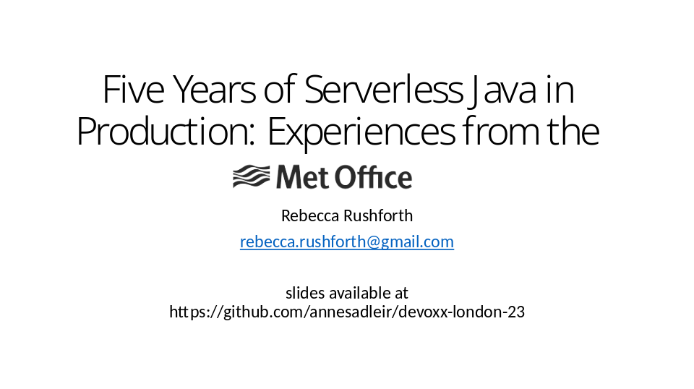

Hi I’m Rebecca Rushforth, I’m going to be talking about “Five Years of Serverless Java in Production: Experiences from the Met Office”

Slide 2

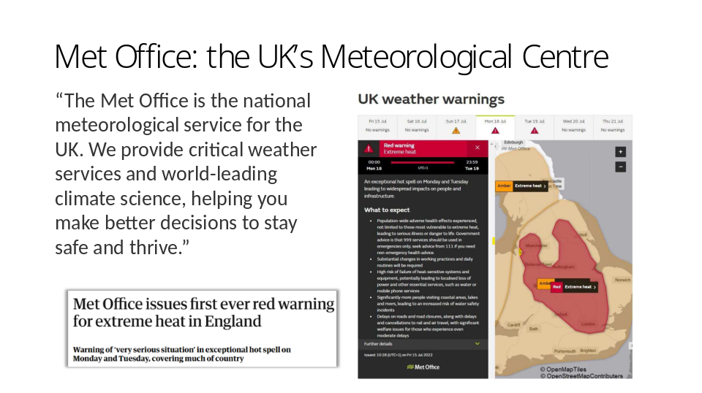

The Met Office is the UK’s national weather forecasting centre. We do lots of different things to do with weather and climate – including Aviation services, Space Weather, education outreach, and research – but if you’re based in the UK hopefully you know us from our daily forecasts and our Weather Warnings. (Advance) There’s a weather warning for the extreme UK heatwave last summer.
I work in an area of Technology called Hazards and Resilience, where we get information about possible weather issues out to people who need to know about them for safety reasons.

We’ve been running Java serverless for about five years now. It works well for us, so what I want to do is share some information about how we do it and what the challenges have been. It’s really easy to love a new technology, when it hasn’t yet had a chance to cause you pain. After a few years’ use you gain a better understanding of its pros and cons. So I thought therefore that our longer-term experiences might be useful for people to hear about.

So why did we go serverless?
In around 2017 a decision was taken for the Met Office to move to Amazon Web Services. Up to then we’d been using on-prem servers running JBoss with Spring services, mostly Spring Boot. The first impulse was to do something similar on AWS, using Elastic Cloud Compute, aka EC2 – which meant devs configuring our own VPCs, load balancers, network interfaces, etc. But some of the services we needed to redo at this time seemed particularly fitting for serverless

Slide 3

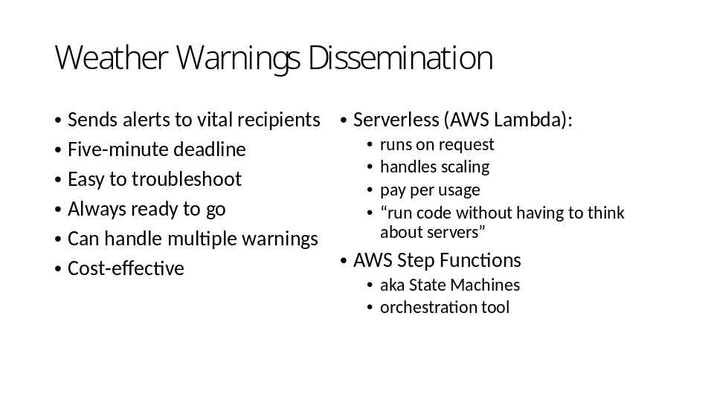

For example, the first service we went serverless on was the National Severe Weather Warnings Dissemination Service. (ADVANCE) When a weather warning is issued, it sends an alert via SMS and email to recipients in the emergency services and people responsible for national infrastructure. (ADVANCE) There is a five minute deadline to get the messages sent, and that’s a target agreed with the government. (ADVANCE) If something goes wrong, it’s vital that this can be understood by someone unfamiliar with the service, and if possible remedied. An emergency warning could be issued in the middle of the night. At the Met Office there are people on duty 24/7 and they can do basic support for us as long as we have given them clear instructions. (ADVANCE) And there might not be a weather warning for weeks on end, but the service still has to be ready to go at any moment. (ADVANCE) It must be able to handle multiple warnings at once, though there aren’t often more than a handful issued in one session. (ADVANCE) And although all those points are more important, still we want to keep costs down because this is all tax payers’ money.
Serverless has many features that are a good fit for this. (ADVANCE) It runs on request so it can quickly scale from zero to one to many. That helps with readiness and cost-effectiveness, and with our five-minute deadline. The concept of serverless, that you don’t have to think about servers, helps with cost-effectiveness by making the developers’ lives easier – we can concentrate on the business logic in our code. It also makes things a bit easier to trouble-shoot.
(ADVANCE) However it’s been using Lambdas with another AWS service that’s been especially successful for us – this is AWS Step Functions. We use these to orchestrate the interactions between different lambdas.

Slide 4

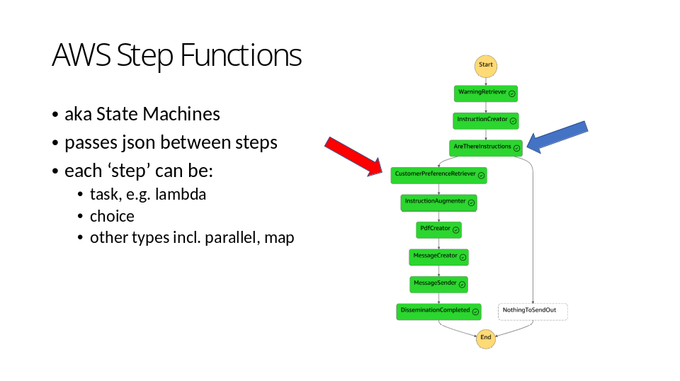

Step Functions are a way of linking together a series of ‘steps’. The diagram on the right shows the step function for handling a new weather warning. The Step Function passes JSON between the steps, so the output of one step becomes the input of the next step. Most of the steps in this example are lambdas, but there is a choice here (ADVANCE), which looks at the output of the previous lambda and skips to the end if there’s nothing that needs sending out.

Now, Step Functions can do much fancier things this. They can manipulate the json that gets passed around, for example. On the whole we decided to stick with more straightforward execution. We’ve mostly used them a bit like the Actor pattern, with immutable messages passed between separate bits of code.

Step Functions give a very clear way to orchestrate the interactions of our lambdas. That in turn makes it easy to split our code up into lots of small self-contained pieces of work, each of which is one lambda. So we can take advantage of the microservices concept of “code that fits in your head”. (ADVANCE) For example, I don’t know if you can see that this step is called “Customer Preference Retriever”. The step is a lambda, and it’s only responsible for working out a recipient list, based on which areas of the UK the warning affects. So each lambda in the chain is responsible for a small clearly defined piece of work.

One small task per lambda makes it easier to test them, to understand and maintain them. It also means we’ve been able to reuse some lambdas where they fit into other workflows, or even completely replace a lambda when functionality has needed changing.

Slide 5

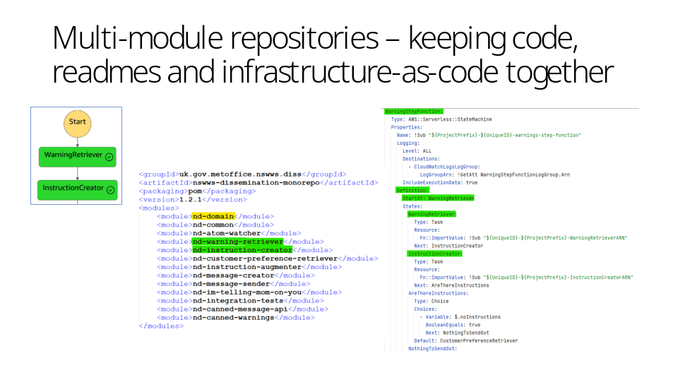

So if we look at the first two steps, the output of the warning retriever gets passed down to be the input of the instruction creator.
The obvious way to handle this is to define a POJO, a simple object, to make sure the two match up – taking advantage of Java’s type safety.
All those POJOs can then live together in a domain library, to be used by all the lambdas and control the format of their communications.
We organise our code in a single repository as a multi-module project. (ADVANCE) There’s an extract from the maven pom.
This is actually something we changed over time – originally every lambda was in a separate github repository.
We tried having multi-module repositories on some of our other services and then went back and changed this.
Bringing them together has worked much better – it’s made building and deploying easier and it’s made it easier to introduce new devs to the system.
We can have one main readme for the project. Also we can keep the infrastructure as code in the same repository.
(ADVANCE) For example, here’s the yml that defines the step function, that is defining the connections between the lambdas.
If you look at the old world of monoliths in one huge codebase, they could certainly be hard to understand; but something it’s too easy to lose when you split it up into lots of smaller services, is the connections between those different bits of code. So keeping the infrastructure as code and all the code together in one place makes it much easier to keep track of what’s supposed to be going on in the system as a whole.

Slide 6

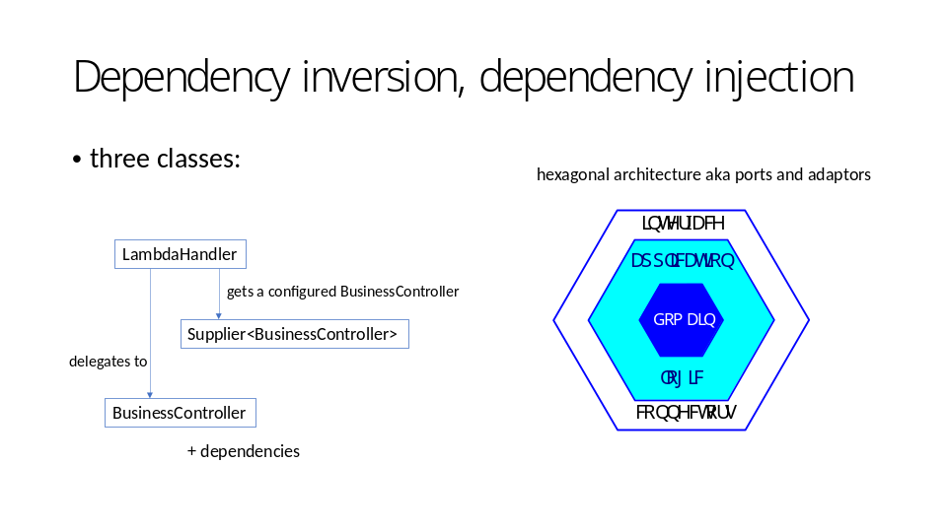

Dependency inversion is the D in the SOLID design principles. It’s a pretty standard practice, but if you’ve worked on a codebase that doesn’t have it, then you’ve probably really noticed its benefits…
To recap in brief, it’s about making your code depend on abstractions not on concrete implementations. This also requires separating out creation of dependencies from their use.
There are quite a few dependency injection frameworks out there, perhaps most famously Spring. Before we went serverless we were using Spring Boot.

We decided for our serverless code to implement do-it-yourself dependency injection, instead of using Spring or another framework.
The lambdas vary quite a bit in how much code they contain, but the most basic only contain a handful of classes. A full-on framework seemed excessive for this.
It also enables the lambdas to start up more quickly. On AWS Lambda you deploy a fat jar containing all the required libraries, and when the lambda task is assigned to a server it has to copy that fat jar down to where it is run. So you want to keep your deployable small in size.
I also think that the DIY dependency injection is more readable, and it’s easy to adapt if a lambda is being reused.

So we do this with a simple pattern with three classes. (ADVANCE) Every lambda has a class which is responsible for the business logic of the lambda. The idea is that this class and its dependencies shouldn’t care where they’re running -- they don’t need to know that they’re deployed as an AWS lambda.
(ADVANCE) Then there is the class which satisfies AWS’s API for being deployed as a lambda. When AWS starts the lambda, it calls the no-args constructor of this class, and then its specified handler method. (ADVANCE) The LambdaHandler has a Supplier of a BusinessController, which can give it a fully-configured BusinessController, with concrete implementations for all the BusinessController’s dependencies. The BusinessController Supplier is where all the object creation in the application happens. (ADVANCE) So the Lambda Handler is responsible for getting a configured BusinessController and then delegating to it.

Although doing our own dependency injection is something we introduced when we moved to serverless, this design is carrying on what we were doing before. (ADVANCE) This is using what’s known as the hexagonal architecture, aka ports and adaptors, or onion architecture, which also has a lot in common with the design that Bob Martin has called “clean architecture”. In this pattern, there’s a thin layer of code on the outside of the application which deals with its interface or interfaces with the outside world, and the application logic lives inside, isolated from outside requirements. This worked well for us in our previous code so we’ve carried the concepts over to serverless code.

Slide 7

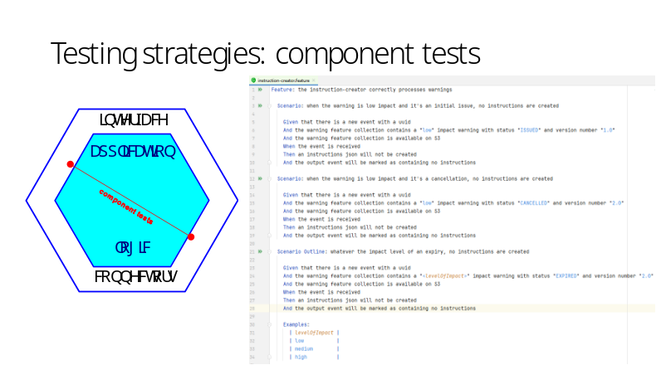

These decisions have also helped a lot with testing. People often talk about serverless code being harder to test, but I don’t think we’ve found that to be especially the case. Obviously we have lots of unit tests – writing unit tests can be a very good exercise for improving your code, as well as verifying it. Then we have tests at two other levels: component tests, and end-to-end or integration tests.

We have component tests for each lambda. (ADVANCE) They cover the whole of the application except for the thin outer layer that connects with the outside world. They use mocks for anything external to the application, and this means that like the unit tests, they can run as part of the build. So the unit and component tests can be run very easily and frequently by the developer, and we also have a barrier set up with GitHub actions so that if any tests fail a branch cannot be merged.
(ADVANCE) We also like to define those component tests using Behaviour-Driven Development, using Cucumber and Gherkin. If you haven’t come across this style of testing, it allows you to define the behaviour you want in a sort of English, in the form of Given, When, and Then statements. You write step definitions to translate the English into code. You can then reuse those step definitions in other tests. There are two big advantages to using it here: it helps make these tests more sharable with non-devs, particularly product managers and other stakeholders. And they also act as a sort of executable documentation, which is intrinsically cool. There was an occasion when a service manager asked me some tricky questions about business behaviour in one of the lambdas that I hadn’t looked at for literally years, and I was able to send her the definition in Cucumber to answer her questions precisely. But even more importantly, I was able to run the cucumber first just to check that the behaviour hadn’t been changed… This is a perennial problem with documentation, that it can get out of date, so executable documentation is especially pleasing. You might forget to update the docs if you’re in a rush, but that’s less of a risk if they’re making your build fail.

Slide 8
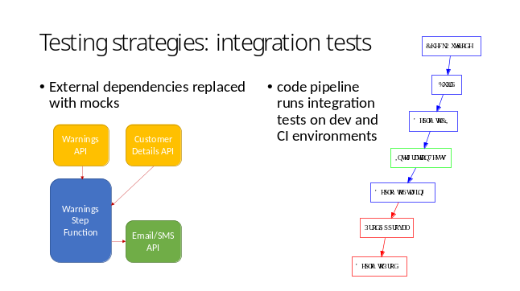
We also have automated tests for the deployed system. These are both end-to-end tests, in that they test the standard pathways through the system, and integration tests, because they test the integrations between components and integrations with other AWS services.

We keep these in their own module in the codebase and run them with maven as integration tests.
(ADVANCE) They start by running setup which replaces the external dependencies with mocks. For this service, there are two APIs which supply information: one for warnings information, and one for the customer contact details. And it send output to one place, the API that handles sending out emails and SMSs. The tests change some environment variables so that the inputs are replaced by mocks controlled by the tests, and the output is replaced with a service that captures the information sent to it. The tests run by changing the inputs and checking that the expected outputs appear. These tests are also written in Cucumber, for all the benefits I mentioned about the component tests.

We run the integration tests as part of our deployment pipelines. We use AWS CloudFormation to define all our infrastructure, including our deployment pipelines, which run on AWS-specific services, CodePipeline and CodeBuild.
(ADVANCE) The integrations tests are always run as part of a deployment to a dev environment, and they fit into our main deployment pipeline as shown in this diagram – they are run on a CI environment before the code is deployed to a staging environment, from where the code is approved for Prod.

When I was writing this I tried to think of where we’ve made our worst mistakes. There have definitely been times when writing these integration tests has been pushed by time constraints and deadlines and ended up sitting on a backlog instead of getting done at the same time as the system is written. The problem with this is that the tests are so much easier to write at the time. And all maintenance tasks are vastly easier if you have these tests. Small things like changing the build configuration, or updating dependencies, are much more straightforward if you can easily check that the system’s essential behaviour has not been changed. They’re also really useful for people who don’t know the system well. So I would really recommend having these sorts of tests because although they take time to set up, they will increase your efficiency in future, and contribute to the reliability of the system.

Slide 9

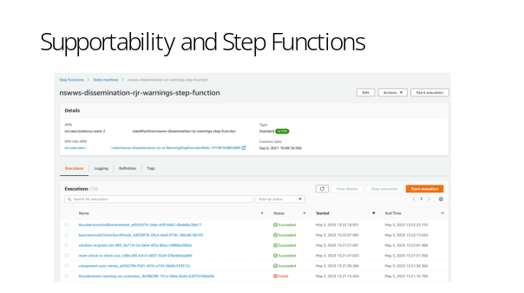

A huge bonus of using AWS Step Functions is that they have a really good GUI, which is extremely helpful when devving, as well as for troubleshooting and support tasks. Here’s a screenshot of a step function on a dev environment which has run the integration tests. You can see that it lists all recent runs with their status. You can click on a run to get details about that specific execution

Slide 10

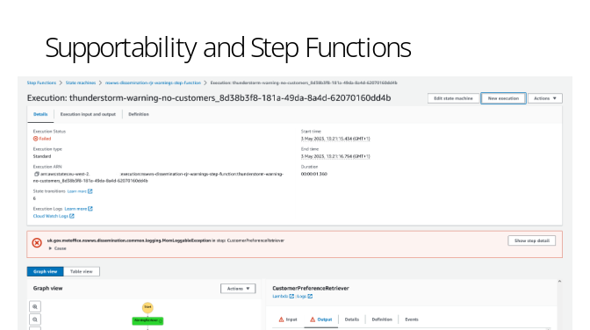

So here is a specific execution with its details … I want to show you what’s a bit further down the page…

Slide 11

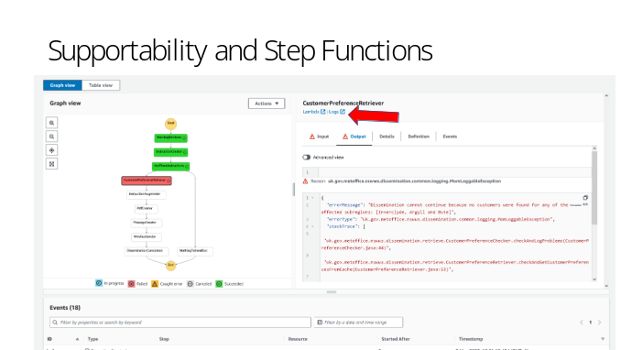

You get a diagram of the execution, with each step colour-coded. You can click on any step to see its input and output, and if it failed, as here, you can see the error details. Particularly useful for further investigation are these options here, (ADVANCE) which will take you straight to the details for that lambda, or better still, to its logs. If you’ve used AWS’s Cloudwatch logging facility, you’ll know how much of a boon it is to be able to go straight to the right log group.

Slide 12

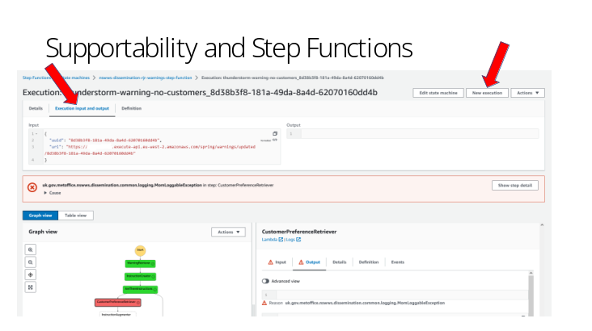

This is also very very useful for writing support playbooks. Here’s the top of the execution summary again, (ADVANCE) this time with the tab selected that shows the input and output to the whole run. If you click the New execution button at the top right (ADVANCE) it gives you the option to start a new run using the same input json.

Slide 13

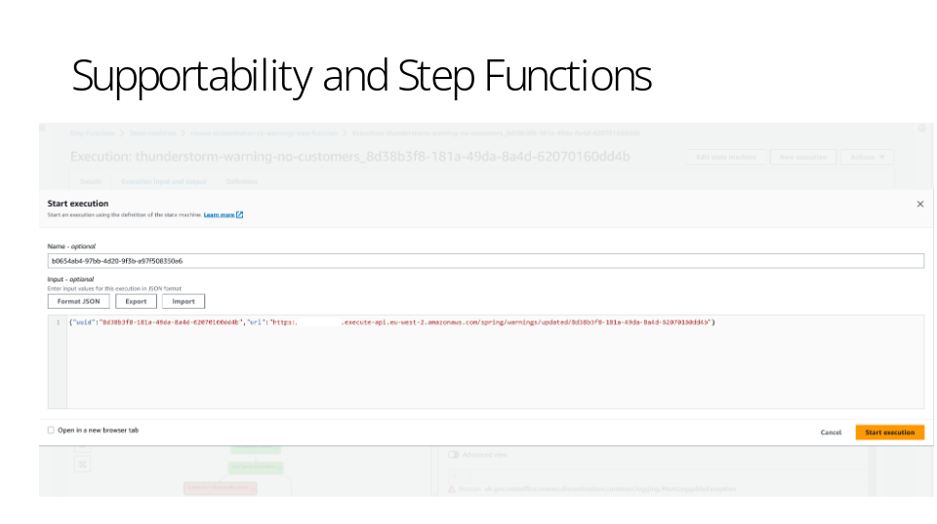

But you can also edit the input and name before triggering the run. So you can see how this makes it really easy to write straight-forward support documentation for out-of-hours workers who may not know the system at all. We can tell them that a specific error means it’s worth retrying the run, and we can give very clear instructions for how to restart the run with the same input. And this supportability aspect is massively helpful for us. People get stressed when things go wrong, especially when things go wrong with a service which makes a difference to people’s actual safety, so anything that makes things clearer and simpler in those stressful moments is very valuable.

Slide 14

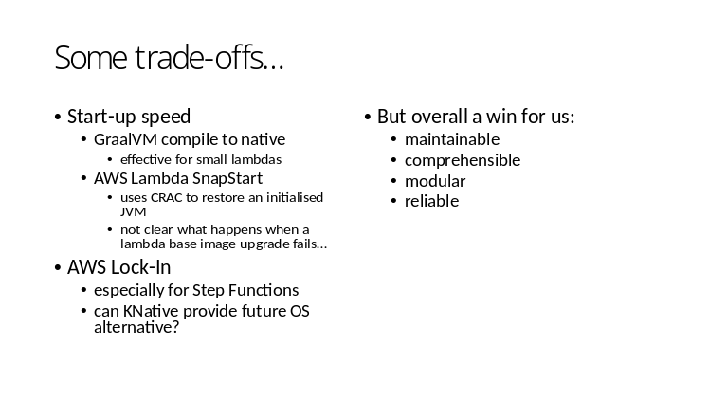

I’ve only really had time to talk about one of our services here. Most of our others are very similar. (ADVANCE) You’ll notice that start-up time for lambdas is not an issue for us in these event-driven systems. This is different from if they were serving a RESTful API, for example. However there are some possibilities for decreasing start-up time. I’ve experimented with these and they look promising.
GraalVM compile to native will hugely reduce latency though if your lambda is doing a lot of work it might not decrease overall time. Lambda Snapstart uses Coordinated Restore at Checkpoint and is interesting but it might need more work on the error reporting.
(ADVANCE) There’s also the issue of vendor lock-in. This is especially the case for Step Functions.
(ADVANCE) But in summary, this architecture has worked very well for us, giving us services we can maintain, understand, support and adapt as required.

Slide 15


Thanks!
Slide 16

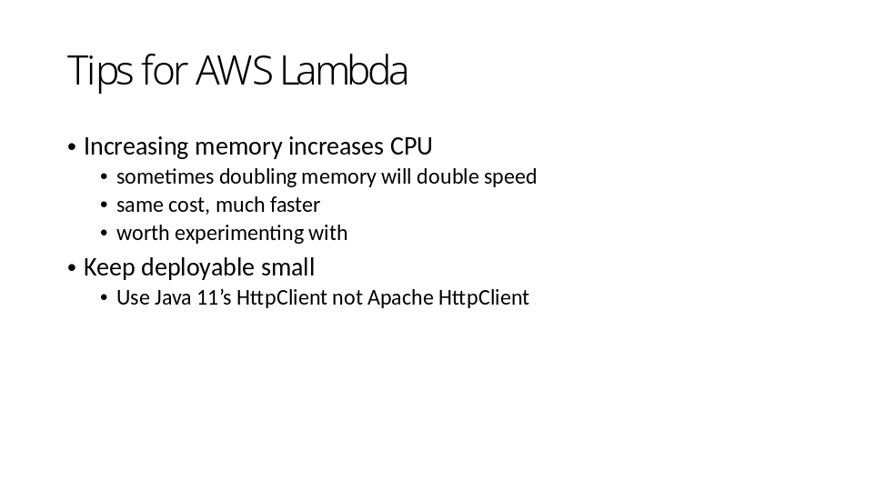

Memory increase == CPU increase == networking capacity increase

