Tenorio, Anne Marie S.

BS Information Technology 102

Data Structure & Algorithm LAB

Act 11.CS

|  |  |
| --- | --- |
| CODE:  using System;    public class Program  {  public static void Main()  {  Console.Write("Enter Temperature in Fahrenheit: ");  float f = float.Parse(Console.ReadLine());    float c = (float) ((5.0 / 9.0) * (f - 32));    Console.WriteLine("Equivalent Temperature in Celcsius: " + c);    Console.ReadLine();  }  } | OUTPUT: |

FLOWCHART:

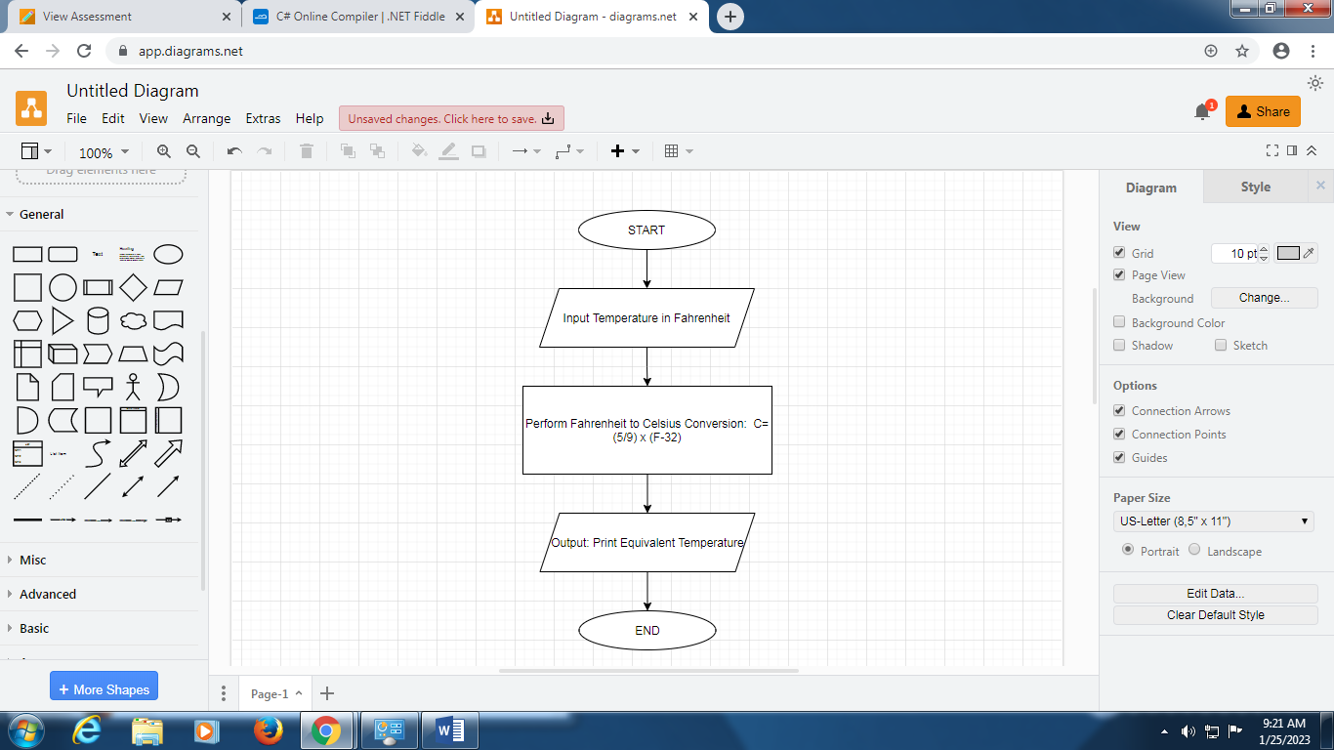

Act 12.CS

|  |  |
| --- | --- |
| CODE:  using System;    public class Program  {  public static void Main()  {  int a, b;    Console.Write("Enter Number A: ");  a = Convert.ToInt32(Console.ReadLine());    Console.WriteLine("Enter Number B: ");  b = Convert.ToInt32(Console.ReadLine());    if (a > b)  {  Console.WriteLine("Number A is HIGHER than Number B");  }    else  {  Console.WriteLine("Number B is HIGHER than Number A");  }  }  } | OUTPUT: |

FLOWCHART:

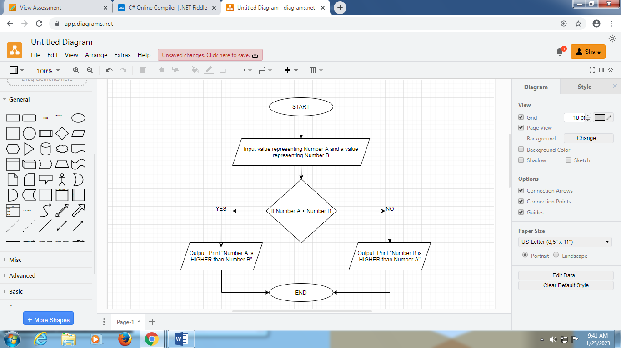

Act 13.CS