Change in Head by Aquifer System

Annette Hilton

2023-06-05

## Attach Packages

# Attach packages   
  
library(tidyverse)

## Warning: package 'tidyverse' was built under R version 4.2.1

## ── Attaching packages ─────────────────────────────────────── tidyverse 1.3.2 ──  
## ✔ ggplot2 3.3.6 ✔ purrr 0.3.4  
## ✔ tibble 3.1.7 ✔ dplyr 1.0.9  
## ✔ tidyr 1.2.0 ✔ stringr 1.4.0  
## ✔ readr 2.1.2 ✔ forcats 0.5.1  
## ── Conflicts ────────────────────────────────────────── tidyverse_conflicts() ──  
## ✖ dplyr::filter() masks stats::filter()  
## ✖ dplyr::lag() masks stats::lag()

library(here)

## Warning: package 'here' was built under R version 4.2.1

## here() starts at C:/Users/aeliz/Dropbox/Documents/github/chapter1_vhg

library(janitor)

## Warning: package 'janitor' was built under R version 4.2.1

##   
## Attaching package: 'janitor'  
##   
## The following objects are masked from 'package:stats':  
##   
## chisq.test, fisher.test

library(dplyr)  
library(knitr)  
  
  
# Disable scientific notation   
  
options(scipen=999)

# Read in data

* By each regional aquifer system that you can analyze based on criteria (n=25 samples)
* Data that has already been sorted in aquifer unit, contains DEM information
* Regional aquifer systems include:
  + Mississippi Embayment
  + North Atlantic Coastal Plain
  + Central Valley
  + Dakota Aquifer System
  + Floridan
  + Houston-Gulf Coast
  + Roswell

## Criteria for analysis

Regional systems will be examined by aquifer unit. Each aquifer unit must have at least n=25 wells in both the pre-1910 and post-2010 time periods

### Mississippi Embayment

# Pre-1910 clean file   
  
early1900s_me <- read_tsv(here::here("change_head", "data", "1900s_me.txt"))

## Rows: 579 Columns: 22  
## ── Column specification ────────────────────────────────────────────────────────  
## Delimiter: "\t"  
## chr (4): id, keep, aquifer, status  
## dbl (18): oid, ned10m_bilinear_cusa_albers102003, latitude, longitude, well_...  
##   
## ℹ Use `spec()` to retrieve the full column specification for this data.  
## ℹ Specify the column types or set `show_col_types = FALSE` to quiet this message.

# Modern 2010-2022 clean file   
  
modern_me <- read_tsv(here::here("change_head", "data", "modern_me.txt"))

## Rows: 4013 Columns: 29  
## ── Column specification ────────────────────────────────────────────────────────  
## Delimiter: "\t"  
## chr (8): site_no, id_x, national_aquifer_x, local_aquifer_x, code, keep, a...  
## dbl (20): oid, dec_lat_va_x, dec_long_va_x, well_depth_va, median, level_ye...  
## dttm (1): level_date  
##   
## ℹ Use `spec()` to retrieve the full column specification for this data.  
## ℹ Specify the column types or set `show_col_types = FALSE` to quiet this message.

##### Aquifer units to analyze in ME:

* Middle Claiborne aquifer
* Lower Claiborne confining unit

#### Middle Claiborne Aquifer

Post-2010 data

# Subtract median water level from topography to get the real water level   
  
modern_head_me <- modern_me %>%   
 mutate(head = topo_ft - median)  
  
# Keep only records in the mcaq, that are confined, and what we used in our regional analysis   
  
mca_mod <- modern_head_me %>%   
 filter(aquifer == "mcaq") %>%   
 filter(status == "confined") %>%   
 filter(!grepl("Unconfined single aquifer", code))  
  
# Final summaries   
  
mca_mod_head <- mca_mod %>%   
 group_by(aquifer) %>%   
 dplyr::summarise(  
 min = min(head),   
 max = max(head),   
 quantile = quantile(head),  
 mean = mean(head),   
 median = median(head),  
 standard_deviation = sd(head)  
 )

## `summarise()` has grouped output by 'aquifer'. You can override using the  
## `.groups` argument.

Table 1. Mississippi Embayment, head of Middle Claiborne aquifer summary statistics for Post-2010

| aquifer | min | max | quantile | mean | median | standard_deviation |
| --- | --- | --- | --- | --- | --- | --- |
| mcaq | -186.789 | 387.9793 | -186.78900 | 97.78385 | 83.14224 | 98.14278 |
| mcaq | -186.789 | 387.9793 | 35.18334 | 97.78385 | 83.14224 | 98.14278 |
| mcaq | -186.789 | 387.9793 | 83.14224 | 97.78385 | 83.14224 | 98.14278 |
| mcaq | -186.789 | 387.9793 | 172.20810 | 97.78385 | 83.14224 | 98.14278 |
| mcaq | -186.789 | 387.9793 | 387.97928 | 97.78385 | 83.14224 | 98.14278 |

# Histogram   
  
Head_2010 <- mca_mod$head  
  
hist(Head_2010,  
 main="Hydraulic Head Post-2010",  
 xlab="Hydraulic Head (ft)",  
 xlim=c(-200, 400))

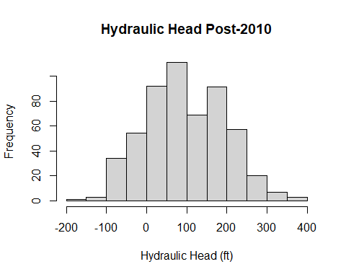

Pre-1910 data

# The DEM of the artesian flowing wells will be used as minimum head   
  
# Keep only records in the mcaq, that are confined, artesian, and what we used in our regional analysis  
  
mca_1900s <- early1900s_me %>%   
 filter(aquifer == "mcaq") %>%   
 filter(status == "confined") %>%  
 filter(artesian == 1)  
  
  
# Final summaries   
  
mca_1900_head <- mca_1900s %>%   
 dplyr::summarise(  
 min = min(topo_ft),   
 max = max(topo_ft),   
 quantile = quantile(topo_ft),  
 mean = mean(topo_ft),   
 median = median(topo_ft),  
 standard_deviation = sd(topo_ft)  
 )

Table 1. Mississippi Embayment, head of Middle Claiborne aquifer summary statistics for Pre-1910 (artesian values only), n=47

| min | max | quantile | mean | median | standard_deviation |
| --- | --- | --- | --- | --- | --- |
| 63.04988 | 378.6241 | 63.04988 | 128.5041 | 110.6407 | 73.93757 |
| 63.04988 | 378.6241 | 75.91588 | 128.5041 | 110.6407 | 73.93757 |
| 63.04988 | 378.6241 | 110.64070 | 128.5041 | 110.6407 | 73.93757 |
| 63.04988 | 378.6241 | 141.90125 | 128.5041 | 110.6407 | 73.93757 |
| 63.04988 | 378.6241 | 378.62406 | 128.5041 | 110.6407 | 73.93757 |

# Histogram   
  
Head_1900s <- mca_1900s$topo_ft  
  
hist(Head_1900s,   
 main="Head Pre-1910 (Topography Proxy/Artesian Only)",  
 xlab="Hydraulic Head (ft)",  
 xlim=c(-200, 400))

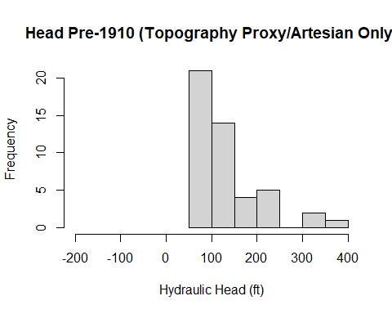

TEST–use all water levels (if available)

# The DEM of the artesian flowing wells will be used as minimum head   
  
allmca_1900s <- early1900s_me %>%   
 filter(aquifer == "mcaq") %>%   
 filter(status == "confined") %>%   
 mutate(non_art_head = topo_ft - abs(water_level_ft)) %>%   
 mutate(head = ifelse(artesian == 1, topo_ft, non_art_head)) %>%   
 select(-vkbg_surf_1:-mdwy_surf_1)  
  
# Final summaries   
  
all_mca_1900_head <- allmca_1900s %>%   
 dplyr::summarise(  
 min = min(head),   
 max = max(head),   
 quantile = quantile(head),  
 mean = mean(head),   
 median = median(head),  
 standard_deviation = sd(head)  
 )

Table 1. Mississippi Embayment, head of Middle Claiborne aquifer summary statistics for Pre-1910 (All values), n=136

| min | max | quantile | mean | median | standard_deviation |
| --- | --- | --- | --- | --- | --- |
| -7.819158 | 383.6952 | -7.819158 | 168.693 | 172.6863 | 80.19713 |
| -7.819158 | 383.6952 | 110.640705 | 168.693 | 172.6863 | 80.19713 |
| -7.819158 | 383.6952 | 172.686270 | 168.693 | 172.6863 | 80.19713 |
| -7.819158 | 383.6952 | 218.239880 | 168.693 | 172.6863 | 80.19713 |
| -7.819158 | 383.6952 | 383.695154 | 168.693 | 172.6863 | 80.19713 |

# Histogram   
  
Head_1900s_all <- allmca_1900s$head  
  
hist(Head_1900s_all,   
 main="Hydraulic Head Pre-1910 (All Values)",  
 xlab="Hydraulic Head (ft)",  
 xlim=c(-200, 400))

