**Scholarly Activities Committee Award Contract**

Your proposal to the College of Science Scholarly Activities Committee for faculty mentored research has been approved for funding. By accepting this award, you agree to abide by the proposed budget, the general SAC Guidelines, and the requirements listed in the SAC award notification email.

If awarded funds include travel for research, please coordinate travel arrangements with your faculty mentor. If your faculty mentor is not traveling and is unable to assist, or you have questions, please contact Veronica Augustine:

Phone: 801-863-6441

email: veronica.augustine@uvu.edu

office: SB 241

Students are expected to provide a written summary of the project. Details of the requirements for the summary were given in the SAC Award Notification email.

**Funds will become available upon return of this signed contract. All purchases must be made by December 15th, 2023. Any funds not used by the deadline will be forfeited.**

**Please use the account number listed below on all purchases and other communication regarding this award.**

Recipient: **Geoff Zahn, Annette Lewis, Kendall Holcomb, Barbara Schincariol, & Joshua Stubbs**

Grant Proposal Title: **“Does Higher Phylogenetic Diversity in Fungal Communities Lead to Faster Decomposition?”**

Supplies Awarded Amount: **$746**

SAC Account Number: **DTRS04**

Ac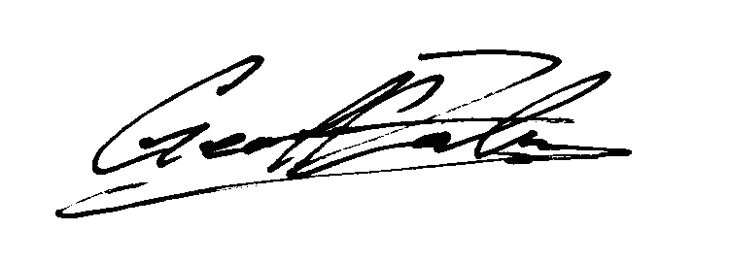knowledgment of Award:

Sep 16, 2023

Dr. Geoff Zahn (Signature) Date

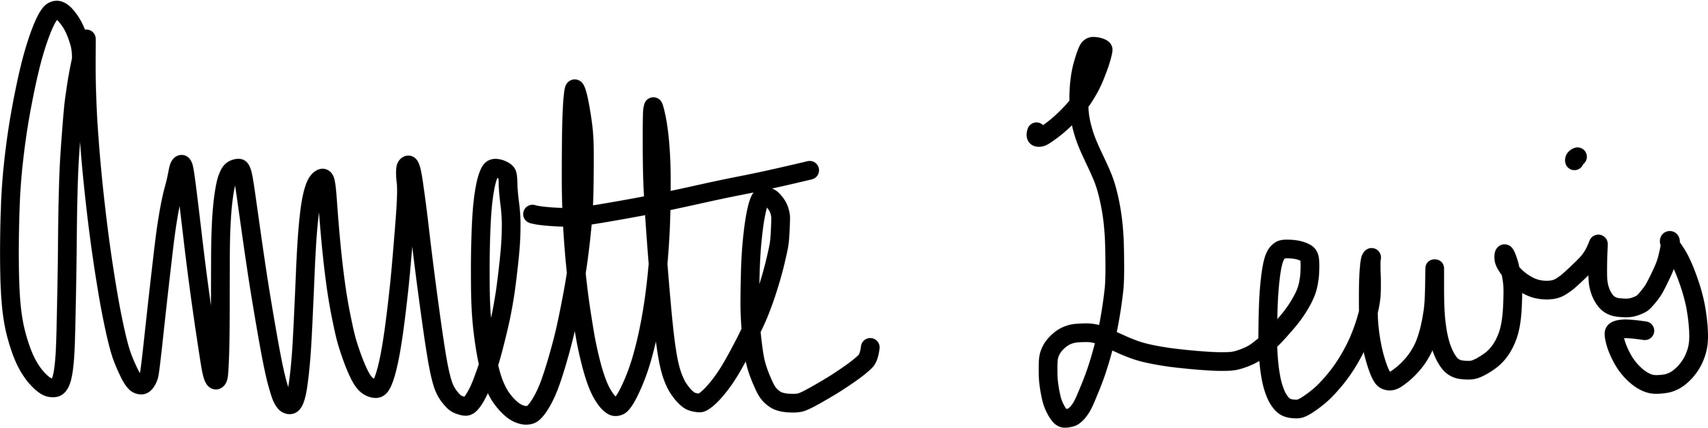 Sep 19, 2023

Annette Lewis (Signature) Date

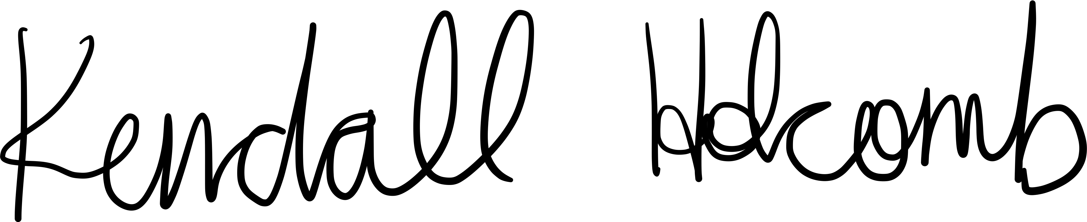

Sep 19, 2023

Kendall Holcomb (Signature) Date

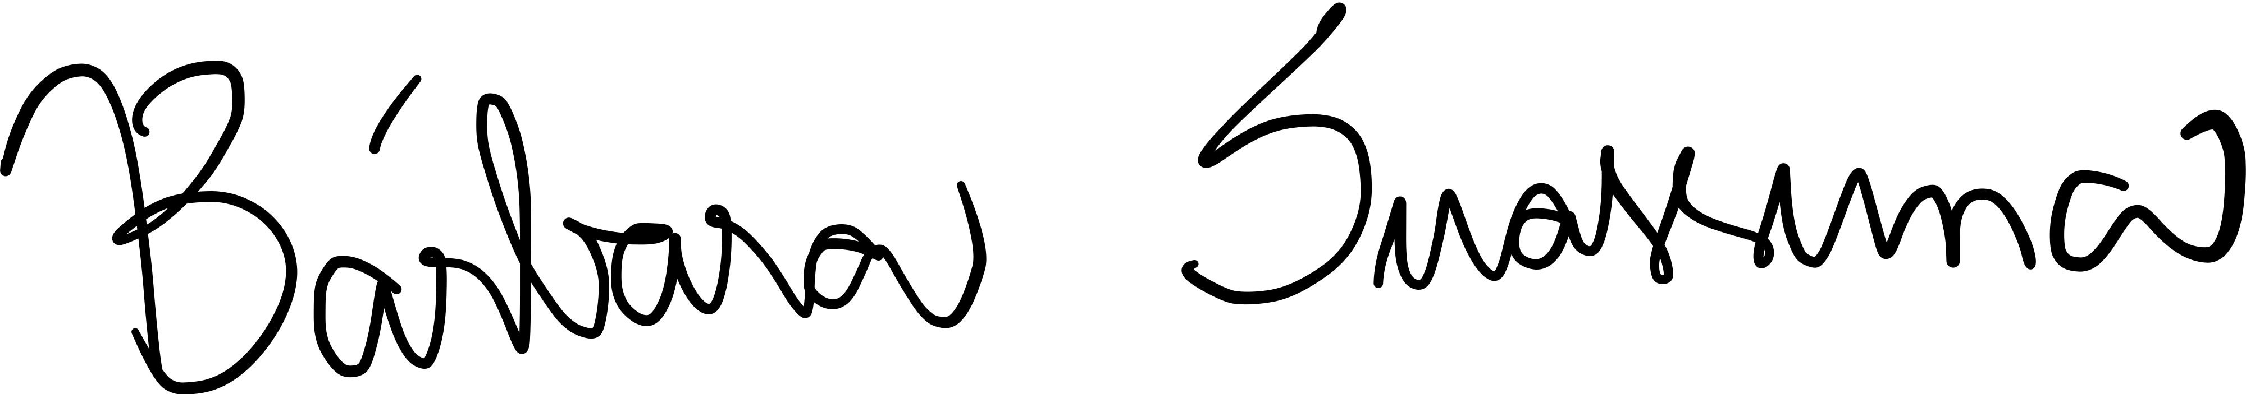

Sep 18, 2023

Barbara Schincariol (Signature) Date

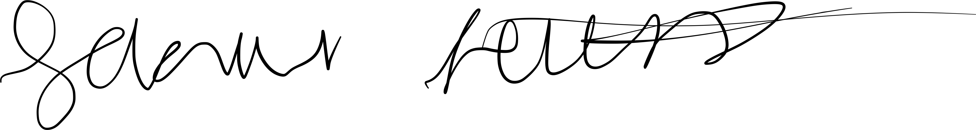

Sep 19, 2023

Joshua Stubbs (Signature) Date