# UVU COLLEGE OF SCIENCE

# Scholarly Activities Committee (SAC)

# 2023 STUDENT PROPOSAL FOR FACULTY MENTORED RESEARCH

Students working with a faculty or staff mentor may submit this proposal to obtain funds for research supplies or travel to conduct research. The proposal should be written by the student with guidance from the faculty mentor. The completed form will be submitted electronically as a Word document to the Department Chair or Department SAC representative of the faculty/staff mentor’s department. Upon review and approval, the signed form should be emailed by the Chair or Department SAC representative to the COS Associated Dean SAC representative for final approval.

**Criteria for submission:**

**The proposal and budget must be written and developed by the student(s),** with guidance from the mentor. Students must be directly involved in the research in a significant way and demonstrate a thorough knowledge of the research project and budget. See last page for Guidelines and Limitations. *

1. **Title of project:**

Does Higher Phylogenetic Diversity in Fungal Communities Lead to Faster Decomposition?

1. **Is this project considered biochemical research?**

Yes

1. **Faculty/staff mentor**:

Dr. Geoffrey Zahn

1. **Lead student information**:
   * 1. Name: Annette Lewis
     2. Email: annette.lewis@gmail.com
     3. UVID: 10856752
     4. Credit hours earned: # total credits = 143; # of UVU credits = 128; # transfer credits = 15;
     5. Anticipated date of graduation: 12/2023
     6. Major: Biology
     7. Plans after graduation: PhD in Biomedical Informatics
2. **Other student researcher information (repeat 4) for each student:**

i) Name: Kendall Holcomb

ii) Email: kendallade@gmail.com

iii) UVID: 10959968

iv) Credit hours earned: # total credits = 87; # of UVU credits = 57; # transfer credits = 30

v) Anticipated date of graduation: 12/2025

vi) Major: Biology; Minor: Spanish

vii) Plans after graduation: PhD in Biology

i) Name: Joshua Stubbs

ii) Email: js40620@gmail.com

iii) UVID:10698325

iv) Credit hours earned: # total credits = 173; # of UVU credits = 173; # transfer credits = 0;

v) Anticipated date of graduation: 12/2023

vi) Major: Biology minor in Chemistry

vii) Plans after graduation: Pharmacy School

i) Barbara Suassuna Schincariol

ii) UVID: 11030042

iii) Email: 11030042@uvu.edu

iv) Credit Hours Earned: # total credits = 76; # of UVU credits = 0; # transfer credits = 76

v) Anticipated Graduation: 05/2026

vi) Major: Biology

vii) Plans after graduation: I plan to enter the workforce and earn a PhD in Biology.

1. **Start/Stop dates of project (a project summary will be due by the stop date of the project)**:

08/23/2023 - 12/08/2023

1. **Have any students involved in this project received funding prior SAC funding for this or any other project?** If so, list name(s) of students, titles of previously funded project(s), date(s) of funding, and amount(s) of funding received for each student.

N/A

1. **If this is a continuation of a project that was previously funded by SAC,** please describe what work related to the project has been completed and what are the results of that work. *(Please attach any papers, abstracts, etc.)*

N/A

1. **List any other UVU or off-campus funding sources you have applied to for this project** (e.g., URSCA, Teels, Department funds, NSF, NIH, etc.):

N/A

1. **List other sources of funding, including amount, already received for this project, if any** *(Please note that priority is given to projects that seek funding from sources other than SAC).*

N/A

1. **Do you require funding from both SAC and other source(s) in order for your proposed project to proceed?**

No

1. **Is any part of this proposal redundant with the proposal submitted to any other funding source (e.g., are you seeking funds for the same supplies from both SAC and the other source)?** Yes or No

*(If yes, and if you are successful in obtaining funds from the other source, the SAC award may be reduced.)*

No

1. **Is the proposed project part of a course? If so, what is the course number?**

Yes. This project is part of BOT 3500.

1. **Is the proposed project required for graduation? If so, please describe why.**

This proposed project is not required for graduation.

1. **Description of the proposed work/project (1-2 pages)**. Read evaluation criteria listed in the proposal writing guidelines at the end of this form for guidance.

**Introduction**

For over a billion years, fungi have played a crucial role on Earth for their unique diversity and decomposing ability. Within the last few decades, fungi have become a focal point for industrial applications and research, contributing to the body of knowledge on the kingdom of Fungi (Lange, 2014). Furthermore, saprotrophic fungi consist of saprophytes, which break down any dead and decaying matter into simpler substances for plants to uptake. Fungal decomposition allows the soil in any plant life to be filled with essential nutrients and minerals. If plant life did not exist, humans would not be able to live as we rely on trees for oxygen and plants for consumption to provide our bodies with essential necessities. Phylogenetic trees are often used to visualize the relationship between species, as many species have multiple branches. Exploring the diversity of fungi provides a glimpse of success between which specific fungal species are the best at decomposing.

Researchers over the years have hypothesized and tested various ways to increase fungal decomposition. It was discovered that when establishing the relationship between moisture tolerance and decomposition rate time, there indeed was a linear relationship between the two factors (An et al., 2021). Ongoing research on ways to increase fungal decomposition allows answers to be given on how to increase the amount of nutrients and minerals provided for plant life and the rate at which plants grow.

The role of phylogenetic relatedness in fungal decomposition rates has not received much attention in research. With this being said, a study has looked into the effect of compost amendment on the promotion of fungal community composition and phylogenetic relatedness, such that decomposition by *Dothidiomycetes* was accelerated (Miao et al., 2022).

Our research intends to compare four different kinds of fungi (two from the same genus, one from a different family, and one from a different phylum) and their ability to decompose. We will compile data analytics in order to report our findings. Additionally, we intend to observe and record any fungal interactions and their decomposition benefits individually and collectively. We can use the scientific method process and increase our lab technique skills through our research.

**Benefits**

* **Impact on UVU**

This experiment will allow for research to be conducted on fungi and their ability to interact with one another. It is important to study fungi that are related and fungi that are not related to determine if they decompose better together or separate. Our group will collaborate with faculty members and learn more about research in their respective disciplines. This research project will provide information to the university to improve future experiments that deal with phylogeny families and fungal communities.

Our group will be able to work with faculty members to learn their specialties and seek their knowledge on research methods. This will better the faculty connection with students and improve the campus connection between students and faculty members. The faculty may also be able to learn from our experiment and apply the results to their personal experiments.

* **Impact on Students**

This research experiment would better the understanding of fungal decomposition for mycology research projects and allow them to understand the decomposition rate for application in other fungal growth experiments. This would also impact our education and ability to improve our research knowledge. Understanding the research process will provide an essential experience for our group of students and provide the opportunity to improve our graduate program applications. It is very important for students to understand how research is conducted and reported to prevent misinformation from being spread.

* **Impact on Program**

This would improve the biology program by helping students understand the textbook knowledge and have hands-on training and lab practice for lab or research based careers. Employers want to be able to access well rounded students who can jump into their tasks with enough knowledge to get started and work through the project with previously learned knowledge.

* **Impact on Community**

It is important for students to learn and understand how to publish results and conduct experiments in a repeatable and proper way. Without research experience, there is a higher likelihood that false studies or misinformation will be reported to the public. It is also important for a community to understand fungi's effect and ability to break down materials. This research could provide insights into using related or unrelated fungi to contribute to agricultural nutrient cycling.

**Methods**

We will use four saprophytic fungal species *Aspergillus niger* van Tieghem, *Aspergillus fumigatus* Fresenius, and *Fusarium solani* (Martius) Saccardo. These specimens will be purchased from [ATCC.org](http://atcc.org) as freeze-dried and frozen samples. We also will use *Pleurotus ostreatus,* already available from Dr. Zahn’s laboratory. The selected fungal species were chosen so that they would include two species in the same genus (*Aspergillus*), one species in a different family (*Fusarium*), and an outgroup (*Pleurotus*). These fungal species will then be cultured in cellulose agar and grown to a splitting stage for further testing.

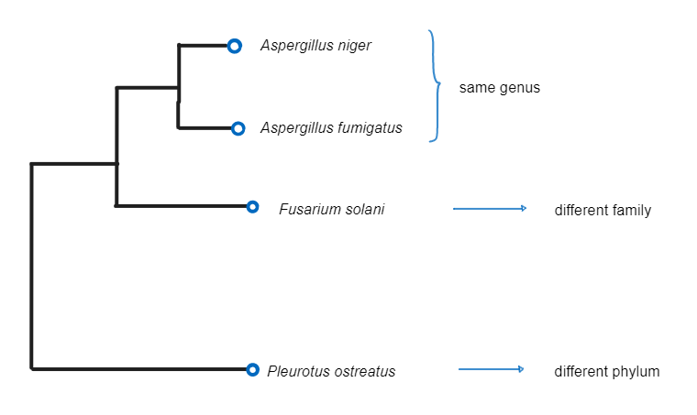

The cultured fungal samples will be placed in **15 combinations** to test their ability to decompose as individual fungi populations and combined communities. For each of the combinations, there will be six replicates. The combinations of fungi will be used to assess each of the four individual species of fungi on their own, alongside how they work with another species of fungi in groups of two, three, and finally, all four. In every combination, all species of fungi will be introduced to the petri dish with cellophane at a similar measurable weight and at the same time. Each petri dish will have five milliliters of water added.

These combinations of fungi (e.g., A+B, A+B+C, A+B+C+D, B+C, ...) will be assessed after a month of growth on how well they can decompose the sheet of cellophane they are placed on. Each replicate will be destructively sampled by stripping the cellophane sheets from fungi and agar residue using alcohol. The sheets of decomposed cellophane will then be dehydrated and compared to their initial starting weights.

Alongside our results, we will obtain genetic information based on the ITS1 gene in GenBank and construct a phylogenetic tree. We will calculate the phylogenetic relatedness of our species via branch length distance, using ape 5.0 in R. This portion of the research will be conducted to observe species' phylogenetic diversity and decomposition abilities. 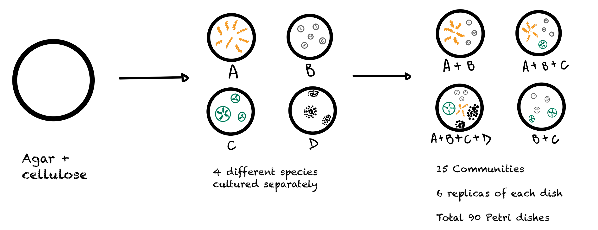

**References**

An, Q., Xu, J., Hu, X., & Gao, X. (2021). Fungal decomposition model. *2021 International Conference on Intelligent Computing, Automation and Applications (ICAA)*. https://doi.org/10.1109/icaa53760.2021.00150

Lange, L. (2014). The importance of fungi and mycology for addressing major global challenges. *IMA Fungus*, *5*(2), 463–471. https://doi.org/10.5598/imafungus.2014.05.02.10

Miao, Y., Li, J., Li, Y., Niu, Y., He, T., Liu, D., & Ding, W. (2022). Long-term compost amendment spurs cellulose decomposition by driving shifts in fungal community composition and promoting fungal diversity and phylogenetic relatedness. *mBio*, *13*(3). https://doi.org/10.1128/mbio.00323-22

1. **Outcomes:**

Our research project will enlighten the scientific community on whether close phylogenetic relatedness in fungal communities helps fungi to decompose organic matter at an accelerated rate. The data we find in this project could be used in future research that is trying to answer a similar question to ours – if phylogenetic diversity leads to faster decomposition. What we find might not be useful to the general public, but in the long run, as more and more scientists arise and perform research, they might gather all this information and transform it into something that can be applied to human society. There is a lot of research out there about fungi helping decompose wood and other substrates, which brings many of the nutrients back to the soil. What if that can be done at an accelerated rate? It can be beneficial to our community.

Another outcome of this project will be involvement in research. This experience will teach students how to develop an experiment design, follow the steps of the scientific method, and just learn from a practical view. Most of the time, students have a lecture-based class where no practical experience is acquired. Being in the lab doing all this work will resemble the daily life of a scientist. Furthermore, students will present their final project poster at the Science Building Atrium to all the faculty and students at UVU in December, which will also benefit students when they practice communicating with a larger public. Our group will also be presenting this project at UCUR in February 2024.

1. **Budget:**

**Budget Table:**

| **Materials/Supplies (add additional rows as needed)** | **Cost** |
| --- | --- |
| 3 mm Cellophane Roll | $20.00 |
| *Aspergillus niger* van Tighem (#16888) freeze-dried sample | $72.00 |
| *Aspergillus fumigatus* Fresenius (#1022) freeze-dried sample | $252.00 |
| *Fusarium solani* (Martius) Saccardo (#201839) frozen sample | $402.00 |
| Culture plates and growth media | Provided |
| Shipping costs: | $0.00 |
| Material/Supplies /Shipping Total: | $746.00 |

| **Research-Related Travel Expenses** | **Cost** |
| --- | --- |
| Transportation | $0.00 |
| Lodging fees | $0.00 |
| Other | $0.00 |
| Travel Total: | $0.00 |

| **Total requested budget (material/supply + research travel):** | $746.00 |
| --- | --- |

**Budget Narrative**

\****Aspergillus niger*, *Aspergillus fumigatus*, and *Fusarium solani* freeze-dried and frozen samples →** These fungi species were chosen based on relatedness such that two are within the same genus and one is within a different family. We were able to find these samples on ATCC.org at a reasonable price. A list of all the buyable fungi was compiled with the goal of collecting species within the same genus (*Aspergillus*) and in a different family (*Fusarium solani*). Buying the fungi instead of going out and finding them will save this project time and money, alongside the mistakes that come with doing PCR to find out what each species is and then see how closely related they are.

**\*Cellophane →** The cellophane will be the substrate used to test for fungal decomposition. Cellophane is a polymeric cellulose film made from wood, hemp, or cotton. This medium will allow for fungal growth and be strong enough to allow for decomposition analysis.

**Travel Narrative**

No traveling will be required for this project.

**Signature Page**

**Typed signatures are acceptable**

1) Title of project: Does Higher Phylogenetic Diversity in Fungal Communities Lead to Faster Decomposition?

2) Lead Student Name and UVID: Annette Lewis 10856752

3) Faculty/Staff Mentor: Geoffrey Zahn

By signing this form, we agree that:

This proposal was written by the student(s), with guidance from the faculty mentor.

A summary of the results of the project will be submitted to the faculty mentor and then COS Associate Dean SAC representative by the date indicated in the award notification. Failure to provide a summary may result in suspension of further funding for the student(s) and faculty mentor.

If awarded, all stipulations in the award notification and contract will be followed.

The SAC Guidelines** applicable for student participation in a faculty mentored research have been read and understood.

Annette Lewis 09/12/2023

Lead Student Applicant Date

Geoffrey Zahn 09/12/2023

Faculty Mentor Date

**Chair or Department SAC representative:**

Please meet with the student(s) on the proposal to review and discuss the application thoroughly. Ensure they understand the project and that the request makes appropriate use of existing department/college resources and funds.

I have met with the students. I have reviewed and support the proposal. The proposed research makes appropriate use of existing department and/or college resources and is appropriate in scope.

_____________________________________ _______

Department Chair/Dept. SAC Representative Date

This signed form should be forwarded via email from the Department Chair or Department SAC Representative to the Associate Dean SAC Representative.