Bulletin Board Announcement Form
To request an event announcement be placed on the Stow TV Bulletin Board,
mail completed form to Stow TV, Stow Town Building, 380 Great Road, Stow, MA 01775;
or FAX to 978-897-4553 or deliver to the Stow TV mailbox in Town Building.
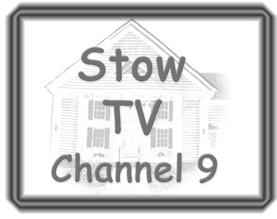
978-897-7732
stowtv@stow-ma.gov
Requester’s Name(s):
Phone Number: (Day) (Eve)
Address:
Email:
Organization (if applicable):
Announcement start date: Announcement end date:
Announcement (please print or type – Limited to 7 rows, 30 characters/row)
Bulletin Board
- Use of the bulletin board is subject to the policies and procedures contained in the Stow TV Handbook.
- Any Stow community, government, or school member or group may submit messages. Announcements for events outside of Stow must be sponsored by a Stow citizen or group.
- Messages may not include: any obscene or profane material in accordance with applicable law and FCC Regulations; any lottery or lottery information; any advertisements of for-profit commercial services or advertisements for political candidate campaigns or ballot referenda questions; any direct or indirect solicitation of money except for charitable and not-for-profit organizations; any material which constitutes libel, slander, invasion of privacy or publicity rights, violation of trademark or copyright, or which might violate any local, state or federal law, regulation or rule .
- Message requests should be submitted 14 days prior to the desired starting date for cablecast.
- Additional copies of this form are available at the Town Building, Randall Library, and www.stow-ma.gov.
- Stow TV is not responsible for any errors that appear in the announcements either because of information provided by the submitter or because of processing by the Stow TV Coordinator or his or her designee.
- I agree to indemnify and hold harmless the Town of Stow, its elected and appointed officials, Stow TV and their agents and servants from any liability or legal fees and expenses incurred either by the Town of Stow or the Requester as a result of cablecasting this message and accompanying visual material.
Requester’s Signature: Date:
If under 18, Form must be signed by a parent or legal guardian.

For Stow TV Use
Date: Accepted: Rejected: Received By:
Comments:
Form V. 041110

