



int_annexcloud_v1

Share & Save, Loyalty Program, Visual Commerce, Refer A Friend, Sale Tracking

Cartridge Integration Document

Version 18.1.0

**Contents**

1. Summary: 1

2. Component Overview: 1

2.1. Functional Overview: 1

2.2. Use Cases: 2

Use case for Share and save 2

Use Cases for Loyalty Program: 2

Use Cases for Visual Commerce: 2

The use case for Refer a Friend 3

The use case for Sale Tracking 3

2.3. Limitations: 3

2.4. Compatibility: 3

2.5. Privacy, Payment: 3

3. Implementation Guide: 4

3.1. Setup: 4

To set up Annex Cloud cartridge: 4

Upload the metadata file: 4

Import the metadata: 4

Upload the services file from services/services.zip: 4

Add the below isml tag on specific pages, where you want to add the Annex Cloud modules: 4

Setup for adding Share & Save: 4

Setup for Loyalty Program: 6

Setup for Displaying Loyalty dashboard: 6

Setup for assigning the loyalty points for specific action: 6

Setup for Visual Commerce: 7

Display photo gallery on the gallery page: 8

Display photo slider on the product page: 8

Display gallery in slider, view gallery link on home page: 8

Setup for adding Refer a Friend widget: 9

Setup for Sale Tracking script: 10

3.2. Configuration: 10

To show the modules on the website, follow the below steps: 10

Extra fields to be set for the Loyalty Program: 11

Extra fields to be set for Visual Commerce: 11

Extra fields to be set for the Refer a Friend: 12

3.3. Custom Code: 12

3.4. External Interfaces: 12

3.5. Firewall Requirements: 13

4. Operations, Maintenance: 13

4.1. Data Storage: 13

4.2. Availability: 13

4.3. Support: 13

5. User Guide: 13

5.1. Roles, Responsibilities: 13

5.2. Business Manager: 13

5.3. Storefront Functionality: 14

6. Known Issue: 14

7. Release History: 14

1. Summary:

* Annex Cloud is a one-stop solution for everything.
* The Annex Cloud’s cartridge contains the Share & Save, Loyalty Program, Visual Commerce, and Refer a Friends program module.
* The Share & Save is an Annex Cloud module which provides shoppers the ability to share the products, on the retail site, with friends across their social networks, and get rewarded by the retail site for their advocacy.
* The Loyalty Program module provides the feature for the end user to earn the loyalty points based on the specific actions which are performed on the client’s website and use that loyalty points on featured purchase to get discount or gift cards.
* The Visual Commerce module provides the feature to the end user to upload their photos on the retailer’s website using their social networking accounts (i.e. Facebook, Twitter, Instagram, and Flickr) & by using the hard drive. The user will see the uploaded photos on the retailer’s homepage image slider & on gallery page after gets approval from the site admin.
* Refer a Friend module is used for referring the friends to buy some product or brand from an e-commerce website. This tool provides a very easy way to utilize social media for the promotion of a product through the customers.
* The sale tracking script is Annex Cloud’s script which is used to track the orders being placed by the users, who have interacted with the Annex Cloud’s modules.
* No known dependency on any 3rd party product.
* The integration for this cartridge encompasses, the deployment of a generic cartridge combined with minor modification of templates inside the storefront code for the cartridge to be fully functional.

1. Component Overview:
   1. Functional Overview:

From a user’s standpoint, the Annex Cloud cartridge is a combination of several different features enabled by using different templates available inside this one cartridge. For example, Annex Cloud cartridge provides the user the ability to share the merchant site, or a specific product or a specific category and get rewarded for it and logged into the e-commerce sites by using their social networks credentials. From a merchant’s standpoint, it comes off as a tool which rewards the loyal customers who share and promote their site or a product and hence direct traffic towards the site.

While sale tracking script doesn’t provide any additional functionality to a user but it goes along with other modules which use the data captured by sale tracking script.

* 1. Use Cases:

Use case for Share and save

1. The widget appears on the site for a user.
2. User clicks on the widget and the pop up appear.
3. This pop-up shows the promotion and user have the choice to share through different social networks or through email.
4. Once the user has shared through the desired mode, the friend or person with whom the link is shared may click on the given shared link.
5. Upon clicking on the shared link by the friend, the original sharer should get the reward or discount coupon code, whichever is applicable, in the email.

Use Cases for Loyalty Program:

1. The user can see the Enroll or Sign Up link for Loyalty Program on client’s website.
2. Upon clicking on the Enroll or Sign Up link, client’s registration or create an account page will appear.
3. After completion of the registration process, the user will see the dashboard of the Loyalty Program.
4. Loyalty dashboard has three main sections i.e. Earn Points, Manage Rewards & Activity.
5. In Earn points tab they will see the actions from which they can earn the points.
6. The user will perform those actions and according to the specific actions, they will get the loyalty points.
7. In Manage reward tab user will see the active rewards, and there will be the claim reward link to redeem the active rewards.
8. In the Activity tab, the user will see the actions performed by him.
9. The user will see the Lifetime points which user has earned from the enrollment date & Available points which user actually has after reward redemption.

Use Cases for Visual Commerce:

* + - 1. The user can see the upload button from the gallery page of the website.
      2. The user can also see the other photos which are uploaded by another user.
      3. After click on the upload button, the user will get the option to upload their photos using their social networks.
      4. Then the user will choose the photos which he wants to upload, the thank you popup will display after submitting the photos.
      5. The user can share the photos which are in the gallery on their social networks (Facebook, Twitter, and Pinterest).
      6. When the user clicks on “Buy Now” button at image details popup then the user will redirect to the specific product page.

The use case for Refer a Friend

1. Refer a Friend link will appear in the footer section of e-commerce website’s homepage.
2. User clicks on the Refer a Friend link & it will redirect to the Refer a Friend registration page.
3. On this page, the user needs to enter his name & mail address.
4. After entering the required details click on start sharing button to refer the friends on an e-commerce website.
5. After that, Refer a Friend’s sharing section will open.
6. In that, the user needs to select the specific social networking site to share the referral program information.
7. Once the user has shared through the desired mode, the friend or person with whom the link is shared may click on the shared link.
8. Upon clicking on the shared link by the friend, he will be redirected to the specific e-commerce website & will get the coupon code pop up.
9. By using that coupon code user’s friend may avail discount on the Purchase.
10. Once User’s friend made a purchase on e-commerce website through the User’s referral, User will get the reward in terms of Credit or Discount on an e-commerce website.

The use case for Sale Tracking

1. Sale tracking is used to track sales and provide reporting and analytics on Annex Cloud.
   1. Limitations:

No known limitations or constraints associated with 3rd party offerings.

* 1. Compatibility:

Built on Version 18.10 (Compatibility Mode: 16.2)

* 1. Privacy, Payment:

1. For Annex Cloud’s widget, once the user chooses to interact with Annex Cloud’s widgets appearing on the site, the widgets asks for the user’s permission to access their relevant profile data. The profile data is stored on the Annex Cloud’s database servers.
2. For Annex Cloud’s sale tracking script, once a sale tracking script is in place and a user makes a purchase on the site, the order details of the user get passed on to the Annex Cloud’s tracking script which captures that information for reporting purposes.
3. For more privacy policy details please visit

<https://www.annexcloud.com/privacy-policy>

1. Implementation Guide:
   1. Setup:

NOTE:First step for the Annex Cloud cartridge to become usable is to contact SocialAnnex for them to initiate the setup. Once the setup is done on Annex Cloud’s side, one can follow the following instructions to enable the desired module of the Annex Cloud cartridge. Please check the support section for contact details.

To set up Annex Cloud cartridge:

* Add the cartridge to the site cartridge path as int_annexcloud_v1.

Upload the metadata file:

* To upload the file, navigate to Administration 🡺 Site Development 🡺 Import & Export 🡺 Import & Export Files 🡺 uploaded

Import the metadata:

* To Import the metadata, navigate to Administration 🡺 Site Development 🡺 Import & Export 🡺 Meta Data 🡺 Import

Upload the services file from services/services.zip:

* To upload the file, navigate to Administration 🡺 Site Development 🡺 Site Import & Export 🡺 Choose file and Upload
* Select the uploaded file and click on Import button.
* Now, you can see all the services at Administration 🡺 Operations 🡺 Services

Add the below isml tag on specific pages, where you want to add the Annex Cloud modules:

Setup for adding Share & Save:

* To display the Share & Save tool, insert the following code at the end of the **homepage.isml** file as shown in the following image (Fig. 1).

Code:

|  |
| --- |
| <iscomment>Share & Save Tool</iscomment>  <isinclude template=*"util/modules_annexcloud"*/>  <issnsv2universal incentiveid=*"1"* siteid=*"${dw.system.Site.getCurrent().getCustomPreferenceValue('acSiteId')}"*/> |

**File Path:** storefront_core/cartridge/templates/default/content/home/homepage.isml

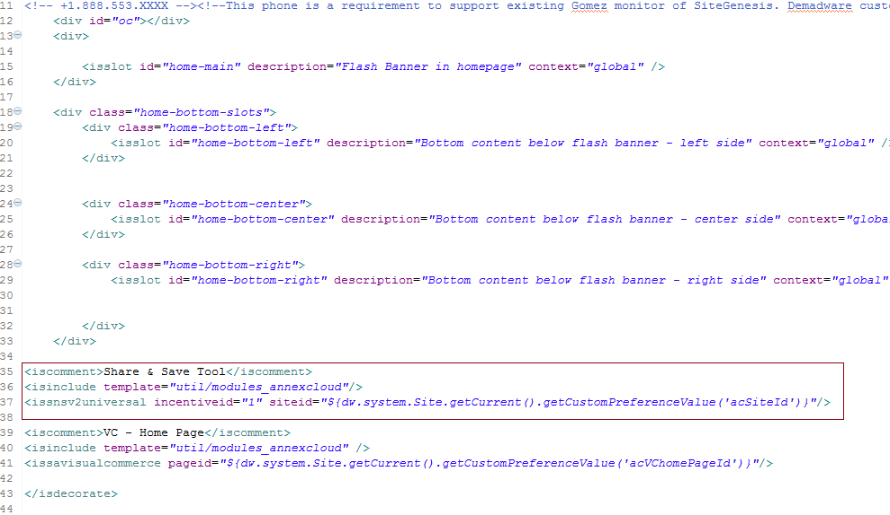

**Fig. 1: homepage.isml file**

* The meaning of attributes included in the above code is as follows:
* incentiveid: Please pass the incentive id which is provided to you. The incentive id may be different for the General page, Category Page, product page, Confirmation page.
* siteid: Annex Cloud will provide the unique site id, which needs to be passed in every request.
* You can enable/disable the Share and Save widget on the web page by unchecking “Enable Share and Save” checkbox in the Storefront configuration section.
* To visit the Storefront configuration section, follow below path:

Site Genesis 🡺 Site Preferences 🡺 Custom Preferences 🡺 Storefront Configuration

Setup for Loyalty Program:

* First, we need to activate the Loyalty Program flag from the site preferences.
* To activate the Loyalty Program flag, follow below steps.

Navigate to Merchant Tools 🡺 Site Preferences 🡺 Custom Site Preferences

Select Annex Cloud Main Configuration Option

Check the checkbox “Activate Loyalty Program”, to activate the module.

* Loyalty Program setup has been divided into the following two parts:
* To display the Loyalty Dashboard.
* Assign the points for specific action.

Setup for Displaying Loyalty dashboard:

* Navigate to **Merchant Tools 🡺 Content 🡺 Content Assets**.
* Click on **account-nav-registered**
* Select **General tab** and add the below code in **Content Body** area.

|  |
| --- |
| <li><a title="Your Loyalty Dashboard" href="$httpsUrl(LoyaltyProgram-ShowDashboard)$">Loyalty Dashboard</a></li> |

Note: When user will log in/Register then it will redirect to My Account page, now the user can see the **Loyalty Dashboard** link in left side.

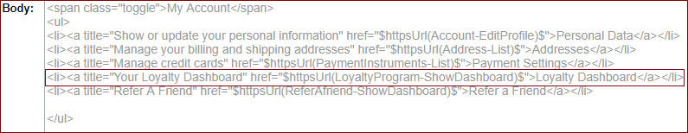 **Fig. 2: Content Body Area**

Setup for assigning the loyalty points for specific action:

* To assign the points for user registration action, insert below code at the ending of **accountoverview.isml** file.

Code:

|  |
| --- |
| <isif condition=*"${pdict.CurrentHttpParameterMap.registration.value=='true'}"*>  <isinclude url=*"${URLUtils.url('LoyaltyProgram-GivePoints','actionId',109,'emailId',pdict.CurrentCustomer.profile.email,'firstName',pdict.CurrentCustomer.profile.firstName,'lastName',pdict.CurrentCustomer.profile.lastName)}"*/>  </isif> |

* The meaning of attributes included above is as follows :
  + actionId: Insert the action id provided by the Annex Cloud.
  + emailId: Please pass the email id of the user who is performing the specific action.
  + firstName: Please pass the first name of the user who is performing the specific action.
  + lastName: Please pass the last name of the user who is performing the specific action.

Note: Action ID will be provided by Annex Cloud.

Path of file:storefront_core/cartridge/templates/default/account/accountoverview.isml

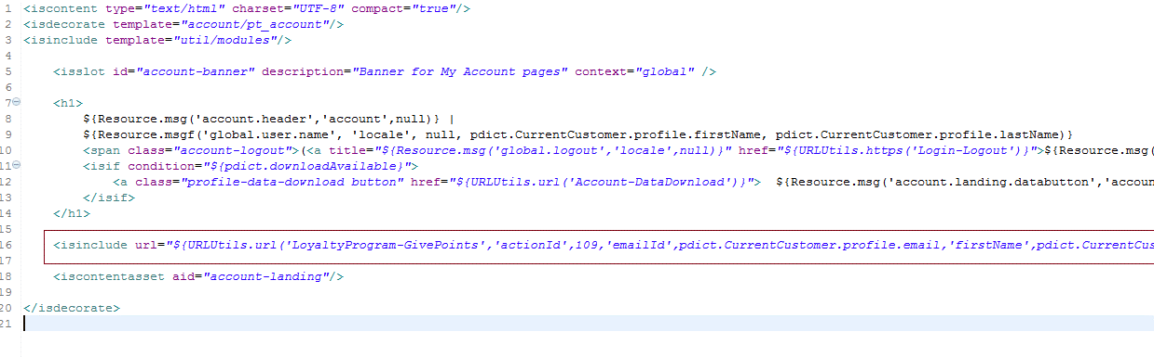

**Fig. 3: accountoverview.isml file**

Setup for Visual Commerce:

* First, we need to activate the Visual Commerce flag from site preferences.
* To activate the Visual Commerce flag, follow below steps.

Go to **Merchant Tools 🡺 Site Preferences 🡺 Custom Site Preferences**

Select Annex Cloud Main Configuration Option

Checked the checkbox **Activate Visual Commerce** to active the module.

* Setup for Visual Commerce tool has been divided into following parts:

Display photo gallery on gallery page with upload photo functionality.

Display photo gallery in the slider on the product page.

Display photo gallery in the slider, view gallery link on home page.

Display photo gallery on the gallery page:

* To display the only gallery on the site, you have to create view gallery link on anywhere in the site and add the following code in the href tag to call the gallery pipeline.

|  |
| --- |
| <isinclude template=*"util/modules_annexcloud"*>  <issavisualcommerce pageid=*"${dw.system.Site.getCurrent().getPreferences().getCustom()['acVCgalleryPageId']}"*/> |

Display photo slider on the product page:

* To display photo slider on the product page, add below code at the end of **productdetail.isml** file.

Code:

|  |
| --- |
| <isinclude template=*"util/modules_annexcloud"*>  <issavisualcommerce pageid=*"${dw.system.Site.getCurrent().getCustomPreferenceValue('acVCproductPageId')}"* productid=*"${pdict.Product.ID}"*/> |

Path of File**:** storefront_core/cartridge/templates/default/product/productdetail.isml

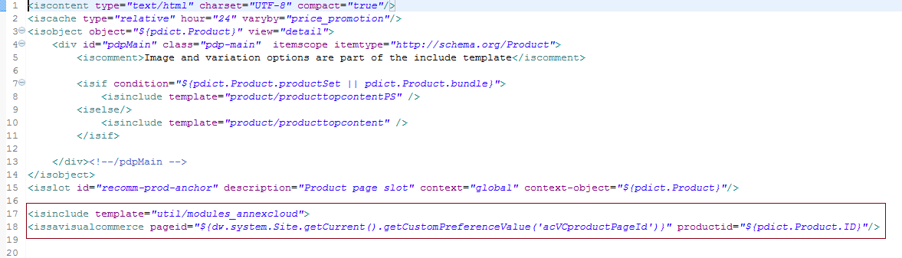

**Fig. 4: productdetail.isml file**

Note: Client needs to provide the product feed to Annex Cloud. Product feed contains Product name, id, image URL, category name, attribute etc. So it will associate with related products.

Display gallery in slider, view gallery link on home page:

* To display photo on home page, you need to add below code at the end of **homepage.isml** file

Code:

|  |
| --- |
| <iscomment>VC - Home Page</iscomment>  <isinclude template=*"util/modules_annexcloud"* />  <issavisualcommerce pageid=*"${dw.system.Site.getCurrent().getCustomPreferenceValue('acVChomePageId')}"*/> |

File path**:** storefront_core/cartridge/templates/default/content/home/homepage.isml

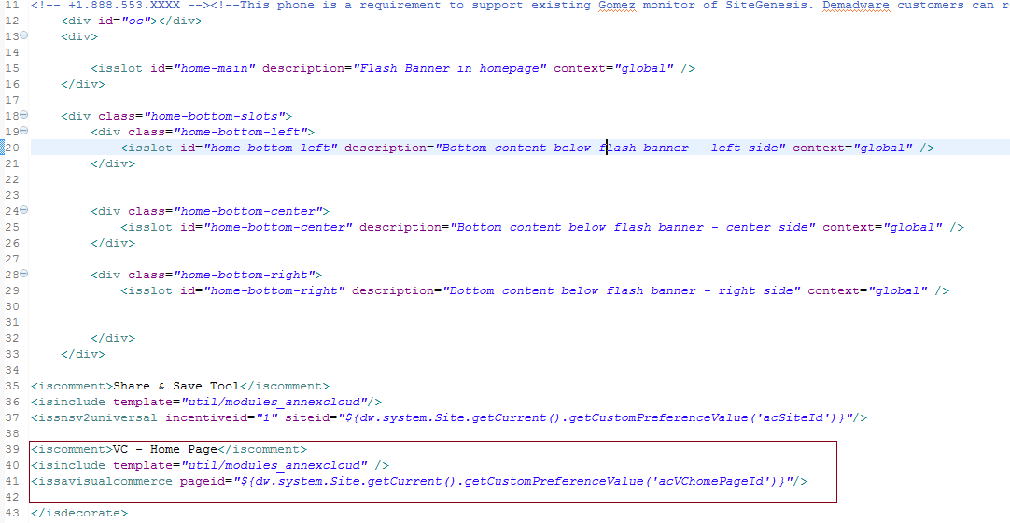

**Fig. 5: homepage.isml file**

Setup for adding Refer a Friend widget:

* First, activate the Refer a Friend flag from site preferences. For that follow the following steps.
  + - 1. Go to **Merchant Tools 🡺 Site Preferences 🡺 Custom Site Preferences**
      2. Select Annex Cloud Main Configuration Option.
      3. Checked the checkbox **Activate Refer a Friend** to active the module.
* To display Refer a Friend Dashboard, Please follow the below steps.

1. Go to **Merchant Tools 🡺 Content 🡺 Content Assets**.
2. Click on **account-nav-registered**
3. Select the **General tab** and add below code in **Content Body** area.

Code:

|  |
| --- |
| <li><a title="Refer A Friend" href="$httpsUrl(ReferAfriend-ShowDashboard)$">Refer A Friend</a></li> |

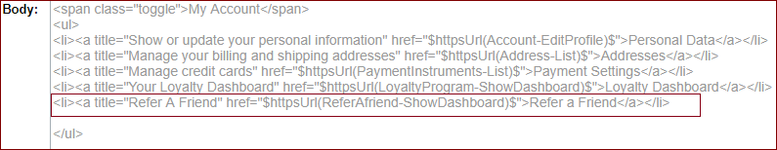

**Fig. 6: Content Body Area**

Setup for Sale Tracking script:

* Insert the following code at the ending of **ReportOrder.isml** file.

Code:

|  |
| --- |
| <isif condition=*"${dw.system.Site.getCurrent().getPreferences().getCustom()['acEnableSaleTrack']}"*>  <isinclude template=*"util/modules_annexcloud"*/>  <issaletracker sadebug=*"0"*/>  </isif> |

File path**:** storefront_core/cartridge/templates/default/util/reporting/ReportOrder.isml

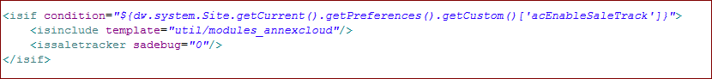

**Fig. 7: ReportOrder.isml file**

* 1. Configuration:

To show the modules on the website, follow the below steps:

* Merchant Tools 🡺 Site Preferences 🡺 Custom Preferences 🡺 Annex Cloud Configuration
* After clicking on Annex Cloud Main Configuration you have to fill the following fields
* **Site ID:** Enter the site id provided by SocialAnnex.
* **Activate Share and Save:** To activate Share and Save, check Share and Save checkbox.
* **Activate Loyalty Program:** To activate the Loyalty Program, check the Activate Loyalty Program checkbox.
* **Activate Visual Commerce:** To activate Visual Commerce, check the Activate Visual Commerce checkbox.
* **Activate Refer a Friend:** To activate Refer a Friend, check the Refer a Friend checkbox.  
  Refer A Friend Dashboard Page ID: Enter the Page ID which is provided by SocialAnnex, This will use in RAF tool.

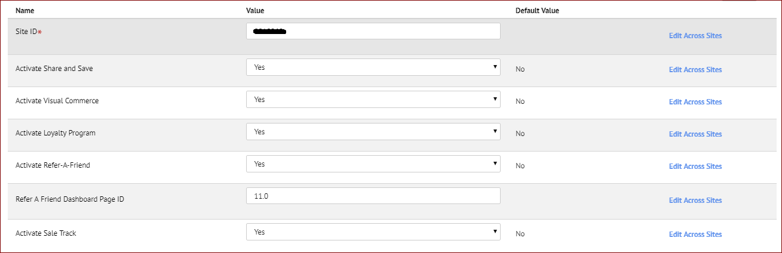

**Fig. 8: Configuration fields**

Extra fields to be set for the Loyalty Program:

* After activating Loyalty Program, following extra fields need to be set:
* Merchant Tools 🡺 Site Preferences 🡺 Custom Preferences 🡺 Loyalty Program Config
* Now you have to fill the following fields
* **Access Token:** Here you enter the Token number provided by Annex Cloud.
* **Dashboard Page ID:** Enter the Page ID which is provided by SocialAnnex.

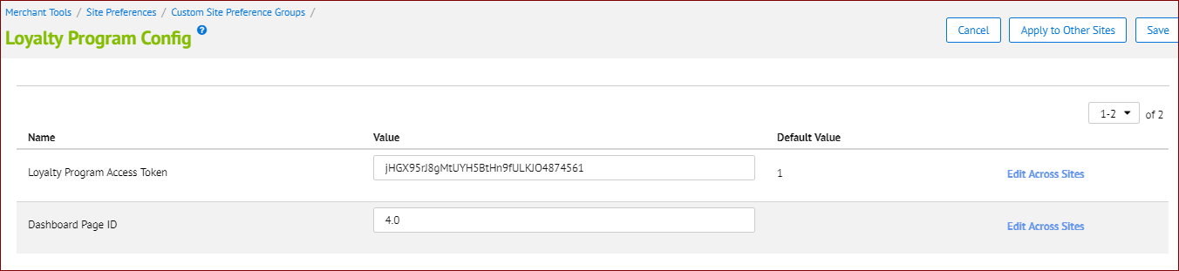  
**Fig. 9: Loyalty Program Config. Page**

Extra fields to be set for Visual Commerce:

* After activating Visual Commerce, following extra fields need to be set:
* Merchant Tools 🡺 Site Preferences 🡺 Custom Preferences 🡺 Visual Commerce Config
* Now you have to fill the following fields
* **VC Home page Id, Product Page Id, Gallery page Id & Category page Id:** Here you have to enter the page Id for a specific page. This page Id’s will be provided by Annex Cloud.
* **Visual Commerce Category Page Type:** Here, you have to enter the page type as ‘Category‘.

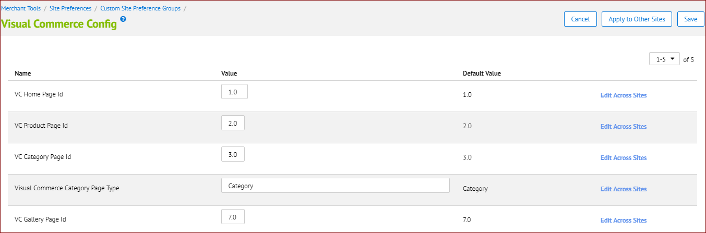

**Fig. 10: Visual Commerce Config. Page**

Extra fields to be set for the Refer a Friend:

* After activating Refer a Friend, following extra fields need to be set:
* Merchant Tools 🡺 Site Preferences 🡺 Custom Preferences 🡺 Annex Cloud Configuration
* Now you have to fill the following fields
* **Refer A Friend Dashboard Page ID:** Here you have to enter the page Id for Refer A Friend dashboard page, which is provided by Annex Cloud.



**Fig. 11: Refer A Friend Config. Page**

* 1. Custom Code:

// Same as the setup

* 1. External Interfaces:

No exposed external interfaces for this cartridge.

* 1. Firewall Requirements:

The outbound requests will be made through port 80 and 443.

1. Operations, Maintenance:
   1. Data Storage:

* No data storage applicable.
  1. Availability:
* The Annex Cloud widgets, being asynchronous, gracefully degrades and doesn’t block loading of any page element.
  1. Support:
* Please contact Annex Cloud at [info@socialannex.com](mailto:info@socialannex.com) or 866-802-8806.

1. User Guide:
   1. Roles, Responsibilities:

* There are no recurring tasks that need to be fulfilled to get the full potential of Annex Cloud. As long as the confirmation details are correct in your Site Preferences that is all you’ll need to do.
  1. Business Manager:

Within the Business Manager under Custom Site Preferences, there will now be modules of SocialAnnex. The merchant must enter information for the following attributes:

* Site ID: Site id which is provided by Annex Cloud.
* Share & Save checkbox: Check the Share & Save checkbox to enable Share and Save on site.
* Activate Loyalty Program checkbox: Check the Activate Loyalty Program checkbox to enable the Loyalty Program on site.
* After checking the checkbox set the following fields in the Loyalty Program Configure section.
* Access Token: Enter the Loyalty Access Token provided by Annex Cloud.
* Dashboard Page ID: Enter the loyalty dashboard page id provided by Annex Cloud.
* Activate Visual Commerce: Check the Visual Commerce checkbox to enable the Visual Commerce module.
* After checking the checkbox set the following extra field in Visual Commerce Configure, which are
* Home, Product, Category, Gallery Page ID, which Annex Cloud will provide you.
* Category page type as Category.
* Refer a Friend Checkbox: Check the Refer a Friend checkbox to enable the module on an e-commerce website.
  1. Storefront Functionality:

NA

1. Known Issue:

No known issues.

1. Release History:

|  |  |  |
| --- | --- | --- |
| **Version** | **Date** | **Changes** |
| 18.1.0 | 10/23/2018 | Initial release – Share and Save, Refer-A-Friend, Visual Commerce, Loyalty Program. |