# Analyzing and Visualizing Report

By: Ayodele Anuoluwa

This report describe four insights regarding analyzing WeRateDogs project and each insights have its own visualizations.

**1. 10 Most Popular Dog Names**

After removing all the erroneous dog names starting with lowercase characters (e.g. a, an, actually, by) the 10 most popular names are Penny, Charlie, Oliver, Tucker, Sadie, Cooper, Winston, Lucy, Bo and Lola.

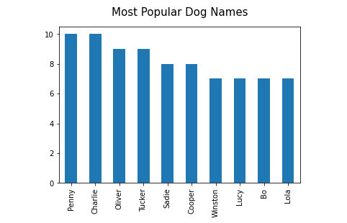

The visualization shows the 10 most popular names for dogs in the datasets.

**2. The Major Source used for the Tweets**

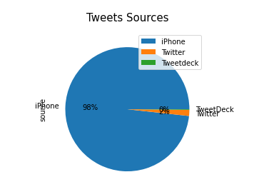

It is interesting to note that most popular source of tweets for we_rate_dogs is tweets from **iphone** with about 98% of all the sources. This shows that most of the users that rates their dogs are iphone users.

**3. Dog Stages**

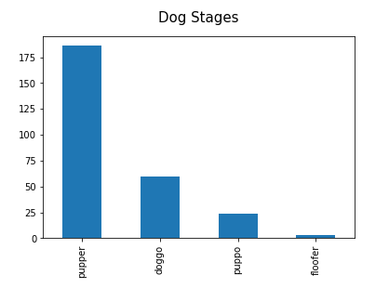

Although most of the stages of the dogs are unknown with Null values but the Most Common Dog Stages in the dataset as shown in the visualization is **pupper**

**4. Correlation between Retweets and Favourites**

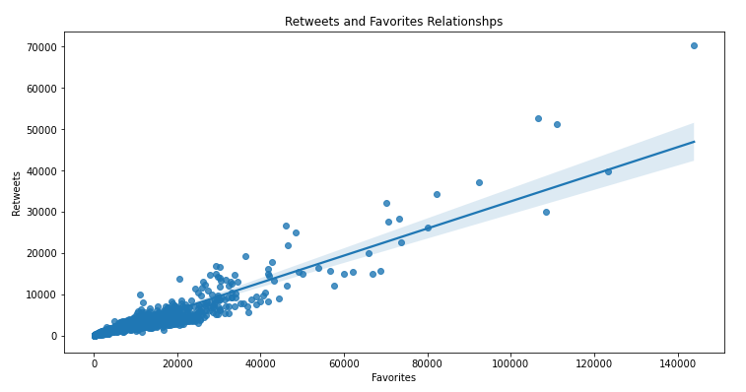

The visualization shows that there is a positive correlation between retweets and favourites i.e. the higher the number of retweets, the higher the number of favourites