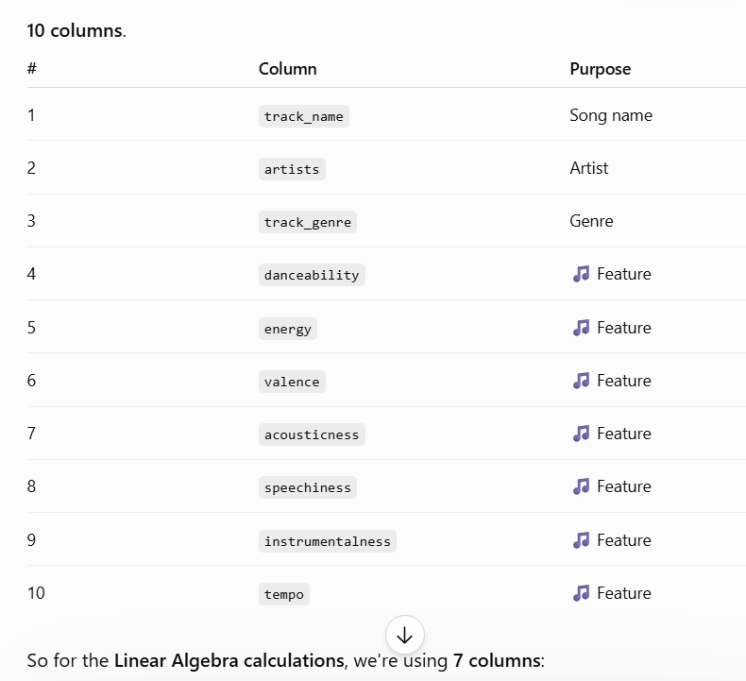Because our 7 features have different numerical scales, and we don't want the scale itself to affect our Linear Algebra calculations.
For example, imagine two songs:
Feature | Song A | Song B
Danceability | 0.8 | 0.6
Energy | 0.9 | 0.7
Valence | 0.8 | 0.5
Tempo | 140 | 100
Without normalization, our vector is something like:
$$\left[0.8 , , 0.9 , , 0.8…140\right]$$
The 140 is numerically much larger than values like 0.8.
When we calculate things such as:
- distances
- dot products
- projections
- angles
- similarity
- SVD/principal angles
the tempo dimension can have a disproportionately large influence.
Normalization fixes that
We convert each feature to:
$$z=\frac{x-μ}{σ}$$
So instead of saying:
"Tempo is important because its numbers are bigger."
we're effectively saying:
"Each feature should contribute according to how much it differs relative to its own variation."
In our project specifically
This matters a lot because later we're going to compare two people's taste geometrically.
We're asking:
"Are User A's and User B's taste directions similar?"
We want that answer to reflect their musical characteristics, not the fact that tempo happens to be measured in BPM while danceability is measured from 0 to 1.
So normalization isn't just a random preprocessing step — it makes our vector-space geometry meaningful.
And don't worry: normalization itself is also easy to explain in your Linear Algebra presentation.

