MISSILE DEFENSE INTEGRATION AND OPERATIONS CENTER

JNIC Research and Development Contract



JRDC Writing Style Guide

Rev A

24 June 2016

|  |  |
| --- | --- |
| Prepared for:  Missile Defense Integration and Operations Center  730 Irwin Avenue  Schriever AFB, CO 80912-7300 | Prepared by:  Northrop Grumman Systems Corporation  730 Irwin Avenue, Room 270  Schriever AFB, CO 80912-7300 |

Distribution authorized to U.S. Government agencies and their contractors due to this publication containing technical or operational information for official Government use only, effective 24 June 2016. Other requests for this document shall be referred to MDA/IC.

**DESTRUCTION NOTICE** - For classified documents, follow the procedures in DoD 5220.22-M, National Industrial Security Program Operating Manual or DoDM 5200.01 Vol 3, Protection of Classified Information. For unclassified, limited documents, destroy by any method that will prevent disclosure of contents or reconstruction of the document.

This page intentionally left blank.

JRDC Writing Style Guide

Rev A

24 June 2016

Approved by:

NNA HAIAR

Technical Writer Lead

This page intentionally left blank.

REVISION/CHANGE RECORD

|  |  |  |  |  |
| --- | --- | --- | --- | --- |
| Symbol | Date | Authorization | Revision/Change Description | Pages Affected |
| NC | 31 December 2015 | See title page | Initial draft | All |
| A | 24 June 2016 | JRDC Style Guide IPT | Quarterly updates | All |
|  |  |  |  |  |
|  |  |  |  |  |
|  |  |  |  |  |
|  |  |  |  |  |
|  |  |  |  |  |
|  |  |  |  |  |
|  |  |  |  |  |
|  |  |  |  |  |
|  |  |  |  |  |
|  |  |  |  |  |
|  |  |  |  |  |
|  |  |  |  |  |
|  |  |  |  |  |
|  |  |  |  |  |
|  |  |  |  |  |
|  |  |  |  |  |
|  |  |  |  |  |
|  |  |  |  |  |
|  |  |  |  |  |
|  |  |  |  |  |
|  |  |  |  |  |
|  |  |  |  |  |
|  |  |  |  |  |
|  |  |  |  |  |
|  |  |  |  |  |
|  |  |  |  |  |
|  |  |  |  |  |
|  |  |  |  |  |
|  |  |  |  |  |
|  |  |  |  |  |

This page intentionally left blank.

TABLE OF CONTENTS

1. Introduction 1

1.1 Purpose 1

1.2 Scope 1

1.3 Style References 1

1.4 Marking References 1

1.5 Exceptions to the JRDC Writing Style Guide 2

2. Formatting guidelines 3

2.1 Template 3

2.2 Spacing 3

2.3 Document Titles 3

2.4 Numbered and Bulleted Lists 3

2.5 Margins 4

2.6 Font and Size 4

2.7 Headers 4

2.8 Footers 4

2.9 Page Numbering and Special Pagination 4

2.10 Page Breaks and Section Breaks 4

2.11 Line Breaks 5

2.12 Block Quotes 5

2.13 Computer Instructions 5

2.14 Phone Numbers 5

2.15 Time 5

2.16 Figures 5

2.16.1 Figure Captions 6

2.17 Tables 6

2.17.1 Table Captions 6

2.17.2 Horizontal Alignment 7

2.17.3 Vertical Alignment 7

2.18 Glossaries 7

3. EDITING GUIDELINES 8

3.1 Active Voice 8

3.2 Numbers in Text 8

3.3 Hyperlinks 8

3.4 Dates 8

3.5 Capitalization 9

3.6 City and State References 9

3.7 References 9

3.8 Appendices 10

3.9 Attachments 10

3.10 Annexes 11

3.11 Distribution Statements 11

4. Marking For official use only Documents 12

4.1 FOUO Page Markings 12

4.2 FOUO Portion Markings 12

5. Marking Classified Documents 14

5.1 Classified Page Markings 14

5.2 Classified Portion Markings 14

6. Acronyms and Abbreviations 16

6.1 Acronym Appendix 17

6.2 Article Usage with Abbreviations and Acronyms 17

6.3 Military Ranks 17

7. Document revisions and the Revision/Change Record 18

7.1 Internal Reviews/Revisions 18

7.2 DAL Revisions 18

7.3 CDRL Revisions 18

LIST OF Figures

Figure 4–1 FOUO Marking Example 13

Figure 5–1 Classification Authority Block 14

Figure 5–2 Classified Marking Example 15

Figure 7–1 CDRL Revision/Change Record 18

LIST OF Tables

Table 3–1 Example Reference Table 9

LIST OF APPENDICES

Appendix A CDRL Distribution Statements A-1

Appendix B List of Common Acronyms B-1

Appendix C U.S. Military Rank Abbreviations C-1

Appendix D Tech Writing Resources D-1

LIST OF ATTACHMENTS

Attachment 1 JRDC Document Templates 1-1

Attachment 2 Standard Terms 2-1

# Introduction

This *JRDC Writing Style Guide* serves as the governing document for writing across the JRDC.

## Purpose

This *JRDC Writing Style Guide* provides the preferred writing style to ensure high quality and consistency in all JRDC products. Follow this guide when preparing, editing, and reviewing documents to ensure consistency.

## Scope

This *JRDC Writing Style Guide* defines and prescribes the preferred writing style of documents and applies to all functional areas and organizations across the JRDC. This guide does not review grammar; when necessary, consult the *Chicago Manual of Style* for grammar rules.

## Style References

For style issues not addressed in this *JRDC Writing Style Guide*, follow additional references (in order of hierarchy):

1. JRDC document templates (located at <https://mko.mda.mil/sites/ic/JRDC%20Resources%20Homepage/PAL/default.aspx>)
2. *DoD Manual 5110.04: Correspondence Management*, 26 October 2010 (located at [*http://www.dtic.mil/whs/directives/corres/pdf/511004m_v1.pdf*](http://www.dtic.mil/whs/directives/corres/pdf/511004m_v1.pdf))
3. *Chicago Manual of Style* (latest online version at [*http://www.chicagomanualofstyle.org*](http://www.chicagomanualofstyle.org))
4. *MDA Instruction 5025.01-INS, Issuance Program*, 14 August 2012 (located at [*https://mko.mda.mil/sites/ds/sgs/charters/Templates/5025.01-INS%20Issuance%20Program-14Aug2012-Admin%20update.pdf*](https://mko.mda.mil/sites/ds/sgs/charters/Templates/5025.01-INS%20Issuance%20Program-14Aug2012-Admin%20update.pdf))
5. *Missile Defense Agency Correspondence Guide*, 17 June 2011 (located at [*https://mko.mda.mil/sites/ds/sgs/SiteCollectionDocuments/MDA%20Correspondence%20Guide-with%20Change%201%20Incorporated.pdf*](https://mko.mda.mil/sites/ds/sgs/SiteCollectionDocuments/MDA%20Correspondence%20Guide-with%20Change%201%20Incorporated.pdf))
6. *Merriam-Webster Dictionary* (latest online version at [http://www.merriam-webster.com/](http://www.merriam-webster.com/%20))

## Marking References

1. MDA 5200.01 Volume 2, *DoD Information Security Program: Marking of Classified Information*
2. MDA 5200.01 Volume 4, *DoD Information Security Program: Controlled Unclassified Information*

## Exceptions to the JRDC Writing Style Guide

Exceptions do exist. When conformance with the Data Item Description (DID) conflicts with this *JRDC Writing Style Guide*, the DID takes precedence. When conformance with the Government customer’s direction conflicts with this *JRDC Writing Style Guide*, Government customer direction takes precedence. In the event a customer requires a format that conflicts with the *JRDC Writing Style Guide* (for example, no contractor markings on the document), one of the following documents is required:

* A statement of CDRL tailoring in the active Technical Requirements Document (TRD)
* An email or other form of documentation from the Government PM indicating his/her agreement and approval
* A formal notification from the MDA/IC Contracts office to the JRDC Contracts office indicating Government approval

# Formatting guidelines

The following subsections provide guidance for the format of JRDC documents.

## Template

* Base the document on the appropriate current JRDC document template, located in the Process Asset Library (PAL), to ensure correct formatting and styles are used.
* Use the styles provided in the JRDC template to align all bullets, numbered lists, and indents for consistency throughout the document.

## Spacing

* Use one space between sentences. .
* Single-space body text. Double space between unnumbered paragraphs; and before and after each numbered heading, table or figure title.
* Use proper spacing between paragraphs, tables, figures, and equations in accordance with (IAW) the current master document template.
* Use one space after a colon.
* Do not use a space before and after a backslash (e.g., ‘TCP/IP’ not ‘TCP / IP’)

## Document Titles

* Italicize specific document titles in body text (e.g., *JRDC Program Management Plan*).
* Do not italicize generic document titles (e.g., test directive).
* Do not abbreviate document titles in body text with the document acronym unless the document title includes the acronym (e.g., *GTD-04d Detailed Test Plan*, not *GTD-04d DTP*).
* Include appendix letter and attachment number separated with an em dash for attachment and appendix titles (e.g., *Appendix E—List of Acronyms and Abbreviations, Attachment 1—TIR Forms*).

## Numbered and Bulleted Lists

* Use a numbered list to indicate a sequence or order of importance.
* Use a bulleted list if the order has no particular significance.
* Use periods after long phrases or complete sentences in a list. Do not use periods after short phrases unless the phrases are essential to the grammatical completeness of the statement introducing the list.
* Be consistent with use of periods *within* a set of bullets.
* If a list contains only one item, try to rewrite the list and lead-in statement to be one sentence. If this is not possible, use the appropriate body text indent style.
* Check for parallelism in lists.

## Margins

Top, bottom, left, and right margins should each be one inch (follow the master document template.)

## Font and Size

When preparing document text, use the 12-point Times New Roman (*Body Text* style). Figure and table font size should be 10-point and may not be smaller than 8-point.

* Use bold text on numbered headings, figure titles, table titles, and appendix titles.
* Left-justify text.
* Use bold for notes (i.e., ‘**Note:** Do not bold the text after the colon.’).
* Begin the sentence following ‘**Note:**’ with an uppercase.

## Headers

Place headers on all document pages, beginning with the table of contents (TOC) page. The header consists of the document title, document number, revision number, and date.

The date appearing in the header is the same as the date on the cover and title page.

The Northrop Grumman logo appears only on the Rev/Change Record page.

Document number and date are flush right in the header, and the document title is flush left in the header. The document header should be included in any appendix, but is not included in an attachment to the main document. Attachments are standalone documents that carry their own identifiers/headers. When in doubt, check with JRDC Data Management.

## Footers

Document footers contain only the page number beginning with the TOC. An exception to this rule is if the page is part of a change or a revision, in which case the existing style and format will be retained.

## Page Numbering and Special Pagination

Page numbering begins with the Revision/Change Record. The front matter pages are numbered with lowercase Roman numerals. The main body text pages are numbered beginning with ‘1’ using 10-point, Times New Roman Arabic numerals.

## Page Breaks and Section Breaks

* Ensure section breaks have not caused issues with the header and footer information   
  (e.g., incorrect page numbering).
* Start a large section (more than one page long) on a new page.
* Avoid unnecessary white space in documents with multiple short *Heading 1* sections by keeping *Heading 1* sections on the same page.
* Do not use hard returns within sections. Use the *Keep with Next* feature instead of using hard returns.

## Line Breaks

* Use line breaks rather than hard returns to force lines to break at specific locations, either in text or inside tables. Line breaks preserve the internal spacing in paragraphs or other blocks of text; hard returns insert the spacing normally used between paragraphs. Line breaks are also called soft returns (i.e., Shift + Enter).
* Ensure test event names, dates, personnel names, phone numbers, email addresses, URLs, and file or folder names are not split between lines by adding manual line breaks.

## Block Quotes

Use the Block Quote style for three or more lines of text quoted from another source. If the quoted material is fewer than three lines, use the Body Text style and quotation marks. Do NOT use quotation marks in block quotes.

## Computer Instructions

* Use the *Computer Action* style for an action being taken on something. (e.g., “Click the Submit button”)
* Use italics for the names of tabs, dialog boxes, windows, and spreadsheets (e.g., “Click OK in the *Print* dialog box”)
* Separate paths appearing in a series, such as portal paths, with vertical bars (e.g., My MKO Toolbar | My Communities | GT-04 Campaign | GTD-06 Part 1 | Documents | DTP ; Start | Programs | Microsoft Word)
* Use ‘select’ for drop-down menu choices and ‘click’ for buttons (e.g., “Click OK”, not “Select OK”)

## Phone Numbers

Format phone numbers as follows: (719) 721-9500

## Time

Express time in military format (e.g., ‘1600’ not ‘4pm’).

Avoid expressing time zones as daylight or standard (e.g., ‘1630 Mountain Time (MT)’, not ‘1630 Mountain Daylight Time’).

## Figures

* Use legends to define symbols, test cases, etc.
* Ensure abundant white space does not surround a figure. Add text to the page to avoid white space.
* Group multiple figures on a single page if space allows.
* Place figures vertically (portrait) on the page whenever possible.
* Outline figures in a ½ point black border.
* Horizontally center figures on the page.
* Introduce figures with a cross-reference (e.g., ‘Figure 1–1 illustrates the test architecture’).
* Do not use directional terms or phrases (e.g., ‘above’ or ‘below’); use a cross-reference when referring to a table.

### Figure Captions

* Use the *Caption Figure* style to ensure figure captions appear centered below figures and on the same pages as figures.
* Ensure related text (including the required figure lead-in statement) appears above figures and, if possible, on the same pages as figures.
* Ensure figure captions are short and concise but provide enough information so the reader understands what the figures represent.
* Assign figure numbers sequentially within the document section (e.g., Figure 2–1,   
  Figure 2–2, Figure 3–1, Figure 3–2). Use an en-dash between the chapter number and figure number.
* Figures in appendices should be numbered sequentially within the appendix section (e.g., Figure A–1, Figure B–1, Figure B–2).
* Figures in attachments should be numbered sequentially within the attachment section e.g., Figure 2–1, Figure 2–2, Figure 3–1, Figure 3–2).

## Tables

* If a table continues across multiple pages, repeat the header row and ensure no rows break across the page.
* Use 10-point Arial (*Table 10pt* style). *Table 9pt* and *Table 8pt* styles are available, but make every effort to use the largest font size possible.
* Use 10-point bold Arial (*Table Heading 10pt* style) in header rows. Fill header rows with 15 percent grey.
* In general, do not use colored text or fills in table cells; if there is a compelling reason for doing so, ensure a key or legend is provided to explain the usage to the reader (e.g., Event Cybersecurity Plan [ECsP] uses green, yellow, and red cells to indicate readiness status).
* Place tables vertically (portrait) on the page whenever possible.
* Horizontally center tables on the page and ensure the table borders do not extend into the page margins.
* Introduce tables with a cross-reference (e.g., ‘Table 2–2 lists the event POCs’).
* Do not use directional terms or phrases (e.g., ‘above’ or ‘below’); use a cross-reference when referring to a table.

### Table Captions

* Use the *Caption Table* style to ensure table captions appear centered above tables and on the same pages as tables.
* Ensure related text (including the required table lead-in statement) appears above tables and, if possible, on the same pages as tables.
* Ensure table captions and column headings describe concisely what the table represents.
* Assign table numbers sequentially within the section (for example, Table 1–1, 1–2, 2–1, 2–2, 3–1, 3–2). Use an en-dash between the chapter number and table number.
* Tables in appendices should be numbered sequentially within the appendix section (e.g., Table A–1, Table B–1, Table B–2).
* Tables in attachments should be numbered sequentially within the attachment section e.g., Table 2–1, Table 2–2, Table 3–1, Table 3–2).

### Horizontal Alignment

* In general, left-align text in tables
* Center the header rows
* In general, center text with three characters or less
* Right-align numerals containing decimals, so the decimal points line up

### Vertical Alignment

* Middle-align text unless the text/numbers need to align with other items in the row or if borders are not displayed.
* Top-align text if borders are not displayed (e.g., in the List of Acronyms and Abbreviations).

## Glossaries

If a glossary appears in a document, place the contents in a table.

# EDITING GUIDELINES

The following subsections provide guidance for creation and editing of JRDC documents.

## Active Voice

Use active voice whenever possible. Passive voice may be used when replacing direct commands (e.g., ‘The scenario list is placed under control of the test event CCB’ instead of ‘Place scenario list under control of the test event CCB’).

## Numbers in Text

* Express numbers from zero through ten as words.
* Express numbers 11 and above as numerals. Exceptions to this rule include:
* Numbers in figures, tables, and proper nouns (e.g., Scenario 1, Test Case 1, FTX-01).
* Percentages, units of measurement, time, and dollar amounts
  + **Note:** Spell out ‘percent’ in body text; use % in tables and figures
* If a sentence contains some numbers less than 10 and some greater than 10, use numerals for all numbers within the sentence for consistency
* Ensure statistical numbers are consistently represented to the same decimal point throughout.
* Spell out numbers at the beginning of sentences. When possible, re-write the sentence so it does not start with a number.

## Hyperlinks

* Use default formatting (i.e., blue, italic, underlined link) if a hyperlink is necessary.

**Note:** If a user is thought to want to click on hyperlinks and actually use them or if the Government requests hyperlinks to be used, then hyperlinks are necessary.

* Ensure email addresses have the mailto: function enabled.
* MS Word will frequently auto-format links and email addresses to function as described above. To manually set links and email addresses, perform the following steps:
* Right-click
* Select Hyperlink… from the pop-up menu
* In the Link to: menu on the left, select Existing File or Webpage or Email Address.
* For a hyperlink, paste the URL in the Address: text field
* For an email address, fill out the Email address: text field

## Dates

* Include dates in military format (Day Month YYYY) with no commas. Do not abbreviate months in body text; abbreviations are allowed in tables and figures (three-letter abbreviations are preferred [e.g., APR, JUN, AUG]).
* Do not add a zero before a single-digit date (e.g., 1 June 2015 not 01 June 2015).

## Capitalization

* Capitalize proper nouns only (e.g., ‘There are 30 test cases in the event,’ ‘C2BMC will not participate in Test Case 1’).
* Capitalize Government when referring to the Government customer.
* Capitalize acronyms and abbreviations IAW the master JRDC Acronyms Database.
* In general, capitalize both words in a hyphenated phrase if the words are of equal value, but do not capitalize element(s) of lesser value (e.g., ‘Non-Event’ and ‘Hardware-in-the-Loop’).
* Capitalize specific personnel titles and do not capitalize general personnel titles (e.g., ‘This capability provides communications between the Test Conductor, operators in the OPR TEC, BMDS component operators at each of the element sites, Mission Test Director, test stakeholder POCs, MDA/EET [JAT], and Warfighter.’)
* Capitalize a personnel title when it follows an individual’s name (e.g., ‘Mr. Jim Smith, Sr. Systems Engineer’).
* Only capitalize proper nouns.
* Use all caps for names of ships (e.g., ‘USS AGILE,’ not ‘USS Agile’) and military exercises (e.g., ‘Operation SHARP SENTRY,’ not ‘Operation Sharp Sentry’).

## City and State References

Use postal abbreviations for states after spelling out on first use. Once a city has been referenced, use only the city name (without the state) on subsequent references. COS, HSV, DLG, and NCR are valid abbreviations for Colorado Springs, Huntsville, Dahlgren, and National Capital Region.

## References

References listed in the Reference Section of the document should appear in a table including the document number and document title. References should be listed in alphabetical order by document title. See Table 3–1 for an example reference table.

Table 3–1 Example Reference Table

| Document ID | Title |
| --- | --- |
| Externally Issued Documents | |
| H95001-10-D-0001 | Joint National Integration Center (JNIC) Research and Development Contract  (JRDC) Statement of Work |
| JRDC Issued Documents | |
| JRDC-Plan-311B | JRDC Data Management Plan |
| JRDC-Procedure-355A | JRDC Proposal Procedure |
| A015-8001-0013 | JRDC Program Management Plan |
| Other Applicable Standards and References | |
| JRDC document templates | <https://mko.mda.mil/sites/ic/JRDC%20Resources%20Homepage/PAL/default.aspx> |
| MDA Instruction 5025.01-INS, Issuance Program, 14 August 2012 | <https://mko.mda.mil/sites/ds/sgs/charters/Templates/5025.01-INS%20Issuance%20Program-14Aug2012-Admin%20update.pdf> |
| Missile Defense Agency Correspondence Guide, 17 June 2011 | <https://mko.mda.mil/sites/ds/sgs/SiteCollectionDocuments/MDA%20Correspondence%20Guide-with%20Change%201%20Incorporated.pdf> |
| Merriam-Webster Dictionary | <http://www.merriam-webster.com/> |

Technical writers should make every attempt to locate the document number. If the document number is not known, leave the information blank.

When referring to a reference document within the body of the text, include only the document title (in italics) for JRDC and external documents. For military and DoD-issued documents, include the document number followed by the document title.

## Appendices

Appendices contain information to support data in the document but are not an integral part of the text. Use an appendix for explanations that are too long or detailed for notes but which could be helpful to the reader seeking further assistance or to clarify points made in the document. Appendices should be referenced in the main document. Ensure references are correct (stating exact name of appendix title).

Generally, each appendix contains only one type of information. The contents of each appendix should be identifiable without the reader having to refer to the body of the document. If the document contains more than one appendix, arrange the appendices in the same order in which they are referenced in the text.

Appendices are designated with an alpha character (e.g., Appendix A, Appendix B).

Since appendices are a continuation of information found in the main document, there is no need to re-define acronyms already found in the main document.

If section headings, tables, or figures appear in an appendix, do not reference them in the main document’s TOC.

Preface appendix table and figure numbers with the appendix letter (e.g., Table A–1).

Preface appendix page numbers with the appendix letter (e.g., A–1).

Ensure the List of Acronyms and Abbreviations is the last appendix if multiple appendices are in the document.

## Attachments

Attachments are standalone documents that carry their own identifiers/headers, TOCs, and acronym lists separate from the main document, and are reviewed and delivered concurrently with the main document. Attachment files are separate from the parent document. Though they are treated as separate documents, attachments are not assigned a separate control number.

Attachments are designated with a numeral (e.g., Attachment 1, Attachment 2).

Do not alter attachment table and figure numbers.

Preface attachment page numbers with the attachment number (e.g., 1-1). **Note**: Do NOT use ‘Attch’ or any other abbreviation before the page number).

When referring to attachments in body text, separate the attachment label and name with an em dash and italicize the attachment title (e.g., *Attachment 1—JRDC Document Templates)*.

## Annexes

Annexes are standalone documents that are developed, reviewed, and delivered separately from the referencing document. Annexes have a control number and are archived as separate documents.

## Distribution Statements

Refer to *Appendix A—CDRL Distribution Statements* for a list of distribution statements used in CDRLs.

# Marking For official use only Documents

This *JRDC Writing Style Guide* is not meant to give comprehensive instructions for marking For Official Use Only (FOUO) information and documents; refer to MDA 5200.01 Volume 4, *DoD Information Security Program: Controlled Unclassified Information* for detailed guidance. This section includes general, high-level marking information.

FOUO is not a classification marking; it is a dissemination control.

## FOUO Page Markings

FOUO documents must be marked at the bottom of each page (use the *Header/Footer Class Marking* style).

JRDC style does not require marking only the pages that contain FOUO information.

## FOUO Portion Markings

FOUO information must be portion marked. Paragraphs may use the FOUO abbreviation, but figures and tables must use the full FOR OFFICIAL USE ONLY designation.

In SECRET documents, FOUO information must be marked U//FOUO or UNCLASSIFIED//FOR OFFICIAL USE ONLY.

Insert a line break and the ‘FOUO’ portion marking before the first line on the new page when a paragraph breaks between pages in an FOUO document.

See Figure 4–1 for an example of markings on an FOUO document.

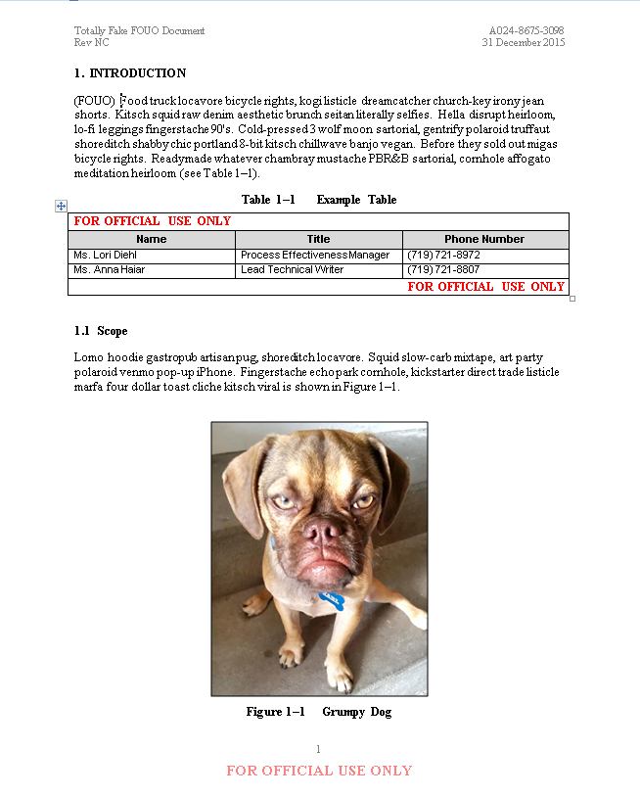

Figure 4–1 FOUO Marking Example

# Marking Classified Documents

This *JRDC Writing Style Guide* is not meant to give comprehensive instructions for marking classified information and documents; refer to MDA 5200.01 Volume 2, *DoD Information Security Program: Marking of Classified Information* for detailed guidance*.*

Classified documents (including classified emails) must have a classification authority block on the cover page, which includes who classified the information, the source, and the declassify on date (see Figure 5–1).

|  |
| --- |
|  |

Figure 5–1 Classification Authority Block

## Classified Page Markings

Classified documents must be page marked at the top and bottom of each page (use the *Header/Footer Class Marking* style).

The DoD recommends marking individual pages with the highest classification appearing on that page, making it easier to extract information for use in other documents. However, it is often impractical to follow this guideline with lengthy Word documents. Therefore, the JRDC style is to mark every page of Word documents with the overall document classification (that is, the highest classification appearing in the document). In PowerPoint files, the use of master slides makes this per-page marking guideline easier to follow. Use master slides to mark PowerPoint presentations with the highest classification per individual slide.

## Classified Portion Markings

All titles, headers, paragraphs, tables, and figures in a classified document must be portion marked, regardless of classification.

Insert a line break and the appropriate portion marking before the first line on the new page when a paragraph breaks between pages in a classified document.

See Figure 5–2 for an example of markings on a classified document.

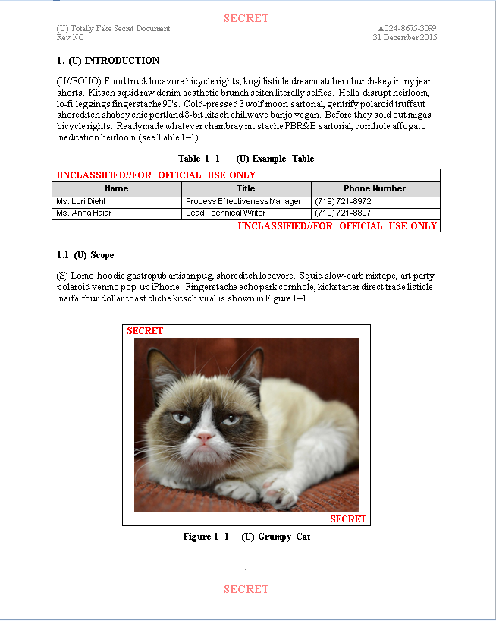

Figure 5–2 Classified Marking Example

# Acronyms and Abbreviations

* Define acronyms and abbreviations at first use within each ‘part’ of a document   
  (e.g., Executive Summary, main body with appendices). Include acronyms contained in the front matter, main body, and appendices in the List of Acronyms and Abbreviations.
* **Note:** The main body with the appendices is treated as one part, so acronyms and abbreviations are not re-defined in the appendices (e.g., an acronym that appears both in the main body and Appendix A is only defined at first use in the main body).
* Exceptions:
* Do not define ‘common’ acronyms and MDA office symbols. Refer to   
  *Appendix B—List of Common Acronyms* for a full list of common acronyms.
* Do not define MDA office symbols at first use or spell them out in body text (e.g., MDA/SS). Always include full MDA office symbol when referring to the office (e.g., MDA/DDW).
* Do not define acronyms and abbreviations in section headings, tables, or figures; define the acronyms and abbreviations at first use in the body text as necessary.
* Do not define acronyms used in a cover page, title page, header, table, or figure
* Do not define units of measure (e.g., KM, s [seconds], mg, nmi, F, C) within the document. Include abbreviations for units of measure in the List of Acronyms and Abbreviations appendix.
* Include MDA office symbols and common acronyms and abbreviations in the List of Acronyms and Abbreviations.
* Terms used only once in a document do not require the use of an acronym. The term is spelled out with no acronym or abbreviation included.
* Do not re-define each acronym at each use if the same acronym has two different, valid definitions used in a document (e.g., CTI for Critical Test Incident and CTI for Common Threat Interface). When two of the same acronyms are used in a document, only use one as an acronym and fully define the other term.
* Do not define acronyms already established as part of a previous acronym (e.g., if ‘JFCC IMD’ has already been defined, it is not necessary to define a subsequent use of ‘IMD’)
* For test event names containing numbers, do not include the number as part of the acronym definition. E.g., use ‘Ulchi Freedom Guardian (UFG)-15’, not ‘Ulchi Freedom Guardian-15 (UFG-15)’.
* Use ‘U.S.’, not ‘US’. Use ‘U.S.’ in adjective form only. Spell out ‘United States’ when using the noun form.  
  **Note**: Use periods when abbreviating ‘U.K'.
* If the first instance of an acronym is a plural, add an ‘s’ to the end of the acronym. E.g., use ‘…all System Mission Managers (SMMs)’, not ‘…all System Mission Managers (SMM)’. Do NOT put the ‘s’ outside the closing parenthesis.
* Do not refer to a parent document by an acronym (e.g., in a Detailed Test Plan, use ‘Future updates to this *GTI-06 Part 2 Detailed Test Plan* will be produced as needed’, not ‘Future updates to the DTP will be produced as needed’).

## Acronym Appendix

* Include a List of Acronyms and Abbreviations as the final appendix of a document. In the case of attachments, the attachment contains its own List of Acronyms and Abbreviations appendix.

**Note**: The ECsPs do not include an acronym appendix at the direction of the Government customer.

* Include acronyms and abbreviations found in tables and figures in the List of Acronyms and Abbreviations.
* Insert a blank row for each alphabet break/grouping in the List of Acronyms and Abbreviations.
* In general, do not provide an acronym list or define acronyms in briefs. If the document author requests an exception, apply the rules outlined in this section.

## Article Usage with Abbreviations and Acronyms

* Use the articles ‘the,’ ‘a,’ and ‘an’ before abbreviations and acronyms according to basic rules of grammar. If an article would appear before the term if it were spelled out, then it most likely will be used before the acronym.
* The use of ‘a’ and ‘an’ depends on the sound of the acronym that follows, not on the first letter. For example, the vowel sound at the beginning of the acronym ‘MDA’ (pronounced ‘em-dee-ay’) requires that ‘an’ be used. However, ‘a’ is used before “MOOTW,” since the acronym is pronounced ‘moo-twah.’

## Military Ranks

Refer to *Appendix C—U.S. Military Rank Abbreviations* to ensure use of the proper abbreviation for ranks. **Note:** There are sometimes branch-specific abbreviations for ranks (e.g., a U.S. Marine Lieutenant Colonel is abbreviated ‘LtCol’ and a U.S. Army Lieutenant Colonel is abbreviated ‘LTC’).

# Document revisions and the Revision/Change Record

Use the revision/change record to track significant updates and responsible parties. Use letters for **formal revisions of an already-published document** to indicate revisions/redeliveries.

## Internal Reviews/Revisions

If a document is in the internal review phase, use numbers in the Symbol column. Internal review revision numbering is not required for documents, but may be useful for tracking multiple internal reviews/revisions on a document. When a document is initially released (as a DAL, CDRL, or process document), delete the revision tracking information prior to delivery.

## DAL Revisions

If a published DAL is revised, use a **new** DAL number and indicate the revision letter in the Rev No field on the signature page. In the title, use the original title and indicate the revision. For example: *System Requirements Specification (SRS) for the SMC Open Systems Architecture Sensor Models (OSM) Build 5.1, Revision A*. Change the headers to update the document title to reflect the revision.

## CDRL Revisions

The initial release of a CDRL is Rev NC. Follow the format in Figure 7–1.

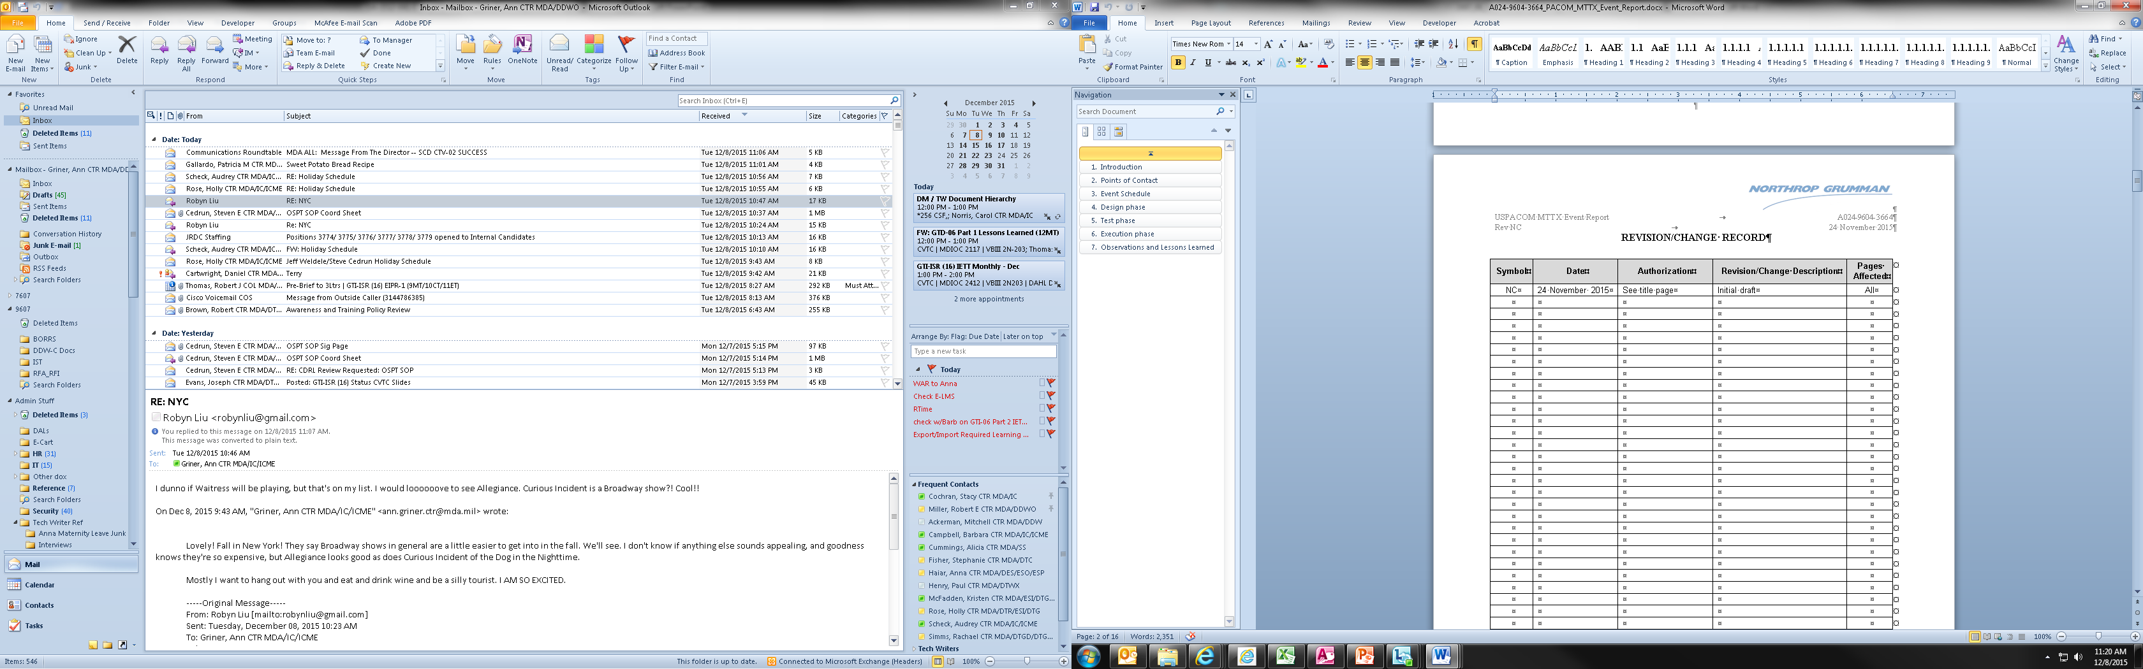

Figure 7–1 CDRL Revision/Change Record

If the Government customer requires the re-delivery of a CDRL, append the CDRL number with an ‘A’ for the first delivery, ‘B’ for the second, etc. (e.g., ‘A024-9604-3664A’). Add an entry to the Revision/Change Record to reflect the re-delivery.

Appendix A

CDRL Distribution Statements

Block 9 of the CDRL tailoring section of the applicable TRD specifies the distribution statement to be used for each CDRL deliverable.

[DISTRIBUTION STATEMENT A.](http://www.dtic.mil/dtic/submit/distribution_limitations_and_statements.html#one) Approved for public release; distribution is unlimited.

[DISTRIBUTION STATEMENT B.](http://www.dtic.mil/dtic/submit/distribution_limitations_and_statements.html#two) Distribution authorized to U.S. Government agencies only (fill in reason) (date of determination). Other requests for this document shall be referred to MDA/IC.

[DISTRIBUTION STATEMENT C.](http://www.dtic.mil/dtic/submit/distribution_limitations_and_statements.html#three) Distribution authorized to U.S. Government Agencies and their contractors (fill in reason) (date of determination). Other requests for this document shall be referred to MDA/IC.

[DISTRIBUTION STATEMENT D.](http://www.dtic.mil/dtic/submit/distribution_limitations_and_statements.html#four) Distribution authorized to the Department of Defense and U.S. DoD contractors only (fill in reason) (date of determination). Other requests shall be referred to MDA/IC.

[DISTRIBUTION STATEMENT E.](http://www.dtic.mil/dtic/submit/distribution_limitations_and_statements.html#five) Distribution authorized to DoD Components only (fill in reason) (date of determination). Other requests shall be referred to MDA/IC.

**Note**: Distribution Statement F is widely limited in its use. See DoDI 5230.24, “Distribution Statements on Technical Documents,” Dated 23 August 2012, Incorporating Change 1, Effective 28 April 2016.

Appendix B

LIst of Common Acronyms

The following is a list of common acronyms that do not need to be established upon first use. Include common acronyms in the list of acronyms and abbreviations appendix.

* BMD
* BMDS
* CD
* DoD
* DVD
* GIF
* ID
* IT

**Note:** IT may be used as a common acronym for Information Technology. If ‘IT’ is used as an acronym for a different term, it is not considered to be a common acronym and must be defined at first use.

* JNIC
* JPG/JPEG
* JRDC
* LCD
* MDA
* MDIOC
* N/A
* PC
* PDA
* PDF
* PNG
* POC
* TBD
* TIFF
* URL
* U.S.

**Note:** Use ‘U.S.’, not ‘US’. Use ‘U.S.’ in adjective form only. Spell out ‘United States’ when using the noun form.

Appendix C

U.S. Military Rank Abbreviations

Table C–1 U.S. Army Ranks

|  |  |  |
| --- | --- | --- |
| Pay Grade | Title | Abbreviation |
| O-1 | Second Lieutenant | 2LT |
| O-2 | First Lieutenant | 1LT |
| O-3 | Captain | CPT |
| O-4 | Major | MAJ |
| O-5 | Lieutenant Colonel | LTC |
| O-6 | Colonel | COL |
| O-7 | Brigadier General | BG |
| O-8 | Major General | MG |
| O-9 | Lieutenant General | LTG |
| O-10 | General | GEN |

Table C–2 U.S. Air Force Ranks

|  |  |  |
| --- | --- | --- |
| Pay Grade | Title | Abbreviation |
| O-1 | Second Lieutenant | 2nd Lt |
| O-2 | First Lieutenant | 1st Lt |
| O-3 | Captain | Capt |
| O-4 | Major | Maj |
| O-5 | Lieutenant Colonel | Lt Col |
| O-6 | Colonel | Col |
| O-7 | Brigadier General | Brig Gen |
| O-8 | Major General | Maj Gen |
| O-9 | Lieutenant General | Lt Gen |
| O-10 | General | Gen |

Table C–3 U.S. Marine Corps Ranks

|  |  |  |
| --- | --- | --- |
| Pay Grade | Title | Abbreviation |
| O-1 | Second Lieutenant | 2ndLt |
| O-2 | First Lieutenant | 1stLt |
| O-3 | Captain | Capt |
| O-4 | Major | Maj |
| O-5 | Lieutenant Colonel | LtCol |
| O-6 | Colonel | Col |
| O-7 | Brigadier General | BGen |
| O-8 | Major General | MajGen |
| O-9 | Lieutenant General | LtGen |
| O-10 | General | Gen |

Table C–4 U.S. Navy Ranks

|  |  |  |
| --- | --- | --- |
| Pay Grade | Title | Abbreviation |
| O-1 | Ensign | ENS |
| O-2 | Lieutenant Junior Grade | LTJG |
| O-3 | Lieutenant | LT |
| O-4 | Lieutenant Commander | LCDR |
| O-5 | Commander | CDR |
| O-6 | Captain | CAPT |
| O-7 | Rear Admiral (Lower Half) | RDML |
| O-8 | Rear Admiral (Upper Half) | RADM |
| O-9 | Vice Admiral | VADM |
| O-10 | Admiral | ADM |
| O-11 | Fleet Admiral | FADM |

Appendix D

Tech Writing Resources

Table D-1 Tech Writing Resources

|  |  |
| --- | --- |
| Resource | Link |
| Process Asset Library | <https://mko.mda.mil/sites/ic/JRDC%20Resources%20Homepage/PAL/default.aspx> |
| JRDC Data Management Database | <https://caswebapps2.mda.mil/DM/> |
| E-CaRT DAL Folder | <https://ecart.mda.mil/ContentServer/livelink.exe?func=ll&objId=2783779&objAction=browse&viewType=1> |
| JRDC Org Charts  (located in the left column towards the bottom of the page) | <https://mko.mda.mil/sites/ic/JRDC%20Resources%20Homepage/default.aspx> |