In the R project, the loop statements used can be divided into three groups [1]:

- For loop: iterate a part of the code within a definite number of loops by using a definite number of items in a Sequence – which the last item in Sequence notify loop ending.
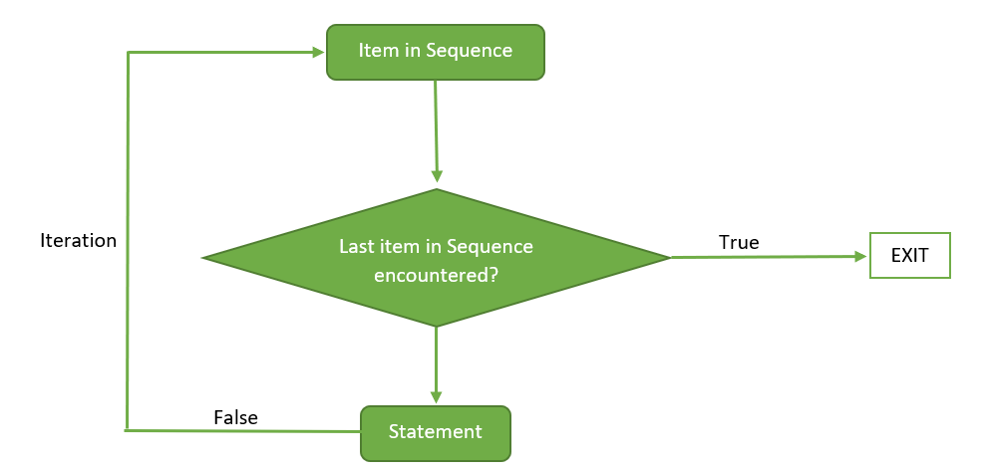
- While loop: iterate the code if the condition for the while loop remained True, if the condition is False, the loop will end
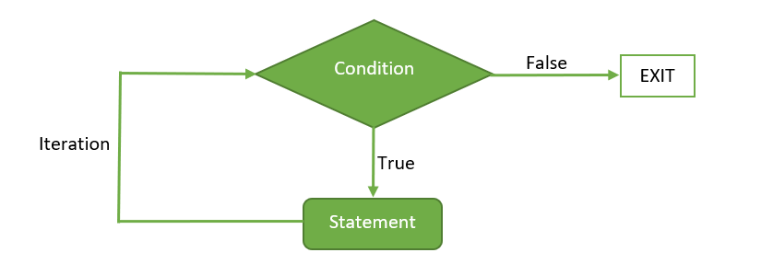
- Repeat loop: iterate the code if the condition for the repeat loop remained False, if the condition is True, the loop will end ( This is the reverted version of the While loop)

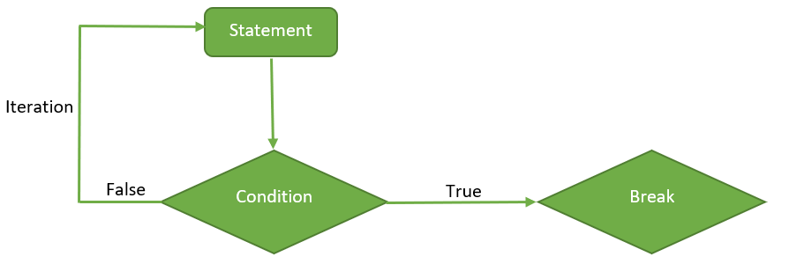

- A break statement can be thrown to stop a loop within a conditional statement.

The detailed examples and applications of loops in R can be found within the examples R files.

The R Project has the basic construction syntax of a function as followed:

- function (arglist) {body}

In which it could be constructed by the users with the following format:
- function.name ← function (arglist) {body – to compute the arguments}

In order to implement and execute the code, users only need to implement function.name (arglist) where the output of a function can also be referred to an object or it can also be use to print out values onto the compiler. [2] In order for the code to be executed, the function statements should be implemented before it is called upon [2]. Recursion loops are also supported within the R project [3].

Functions in the R project can adopt one or multiple objects from different types, or to be more precise, the type (or class) is not usually defined within the parameter of a function. Furthermore, it can even take other functions to be a parameter for the function [4].

Functions in R can only be return as one individual object, however if the user wants to print out multiple results, they can put the outputs into a List and extract the data out of the List later on [5].

R is also a language where the objects passed into a function is pass-by value and that the function would not modify the object if we do not explicitly associate it with the function [6].

[1] “Loops in R (for, while, repeat),” GeeksforGeeks, Apr. 02, 2020. https://www.geeksforgeeks.org/loops-in-r-for-while-repeat/ (accessed Apr. 11, 2022).
[2] “A Tutorial on Using Functions in R! (and their scoping),” DataCamp Community, Feb. 01, 2019. https://www.datacamp.com/community/tutorials/functions-in-r-a-tutorial (accessed Apr. 11, 2022).
[3] “Recursive Functions in R Programming,” GeeksforGeeks, May 01, 2020. https://www.geeksforgeeks.org/recursive-functions-in-r-programming/ (accessed Apr. 11, 2022).
[4] “Function Arguments in R Programming,” GeeksforGeeks, May 29, 2020. https://www.geeksforgeeks.org/function-arguments-in-r-programming/ (accessed Apr. 11, 2022).
[5] “Returning multiple objects in an R function - Intellipaat Community.” https://intellipaat.com/community/10247/returning-multiple-objects-in-an-r-function (accessed Apr. 11, 2022).
[6] “R passes arguments by value | R.” https://campus.datacamp.com/courses/intermediate-r/chapter-3-functions?ex=13 (accessed Apr. 11, 2022).

