Energy Consumption Evaluation
based on Personalized Driver-Vehicle Model
Thomas Wilhelem, Hiroyuki Okuda, Blaine Levedahl, Tatsuya Suzuki, Member, IEEE
Abstract—A new approach to evaluate personalized energy consumption is presented in this article. The method consists of identifying driver-vehicle dynamics using probability weighted autoregressive (PrARX) model, which is one of the multi-mode ARX models, and then of reproducing driver-vehicle behavior in vehicle-following task. The energy consumption of the vehicle is estimated from the velocity profile calculated by using the driver-vehicle model. In this study, driving simulator and real world driving data were recorded to identify the driver-vehicle model in various situations. As a result, real-world energy consumption could be reproduced in a variety of situations with an average error of 1.9% and a standard deviation within a 1.5%. Several promising applications of the energy consumption evaluation are introduced in this paper, such as an online energy consumption prediction, a powertrain choice assistance system for car buyers, and a solution to estimate the macroscopic energy consumption of aggregated vehicles in a traffic flow.

Index Terms—Driving behavior reproduction, energy consumption evaluation, hybrid systems, Probability-Weighted ARX

INTRODUCTION
T
HE modeling and reproduction of driving behavior have been studied since the 50’s from various viewpoints [1]-[3]. These studies were used for numerous applications such as modeling of traffic flows, optimization of road infrastructures, prediction of traffic jams, creation of advanced personalized driver assistance systems, and for the design of automated driving vehicles.
Analysis and evaluation of mobility solutions’ energy consumption is one of the key issues to realize environment-aware transportations. Numerous studies have been dedicated to energy consumption analysis of road and rail vehicles, at microscopic and macroscopic scales, in order to reduce energy losses [5]-[16]. The optimization theory have been applied by many researchers and developers to establish the control method to realize vehicle motion controls which minimizes the energy consumption of single or networked vehicles.
Although these works could successfully estimate the energy consumption in each application domain, the accuracy of road vehicles energy optimization was limited due to the lack of precise information on the driving characteristics of each driver. In order to improve the modeling and estimation accuracy of the energy consumption, driving characteristics of each individual driver must be explicitly represented.
Paper submitted for 3rd review on the 2nd of September 2016.
The authors are with Nagoya University, Nagoya 464-8603, Japan
(e-mail: wilhelem@nuem.nagoya-u.ac.jp).
Paper ID: T-ITS-16-02-0086
From these considerations, this paper develops a novel energy consumption estimation method, explicitly based on personalized driver-vehicle dynamics in vehicle-following task.
Numerous models have been developed to reproduce the driver-vehicle personalized behavior in a vehicle-following task. Some behavior models and most of traffic car-following models are based on system-oriented methods [1]-[4], [17]-[20]. These methods are robust, and model parameters are comprehensive. However, mathematical structure of these models tend to be complicated. To improve the modeling accuracy, another broadly studied approach is machine learning. With machine learning techniques, the human is usually regarded as a controller. Typical driving behavior models for this context are linear or non-linear controller model [21]-[22], hybrid dynamical models [24]-[26], stochastic models [23], neural networks or hidden Markov chains [27]-[29]. In this paper, the integrated driver-vehicle system is considered as a single entity, and its reaction to the leading vehicle is modeled by using the probability weighted autoregressive exogenous model, PrARX model [31]. PrARX model is one of the hybrid dynamical (multi-mode) models. This model enables us to reproduce human behavior by probabilistically overlapping multiple ARX models. The PrARX model has a comprehensive set of parameters which represent not only motion control aspects but also mode switching in the driving behavior. PrARX model has better precision than a simple ARX model without the drawback of output discontinuity inherent to other piecewise ARX models. Moreover the PrARX model benefits from a method to identify the parameters online.
This paper proposes a novel approach to driver behavior personalized vehicle energy consumption estimation. A new framework and closed-loop implementation of the PrARX model is proposed. The hybrid model inputs selection is detailed, and the simulation energy consumption results are compared with driving simulator and real-world data.
The paper is organized as follows: In section II, the developed energy consumption evaluation structure is explained. In section III, the implementation of the PrARX model to represent the driver-vehicle dynamics is described in detail. Modeling method, inputs, output, and the identification process are explained. Section IV introduces the experimental setups to collect the driving data. Section V describes the energy consumption evaluation method in detail, and in section VI, results of the energy consumption evaluations are discussed for various situations. Section VII is dedicated to application proposals.

Personalized Energy Consumption Evaluation
Energy consumption (EC) optimization is a major topic in vehicle development. In order to correctly dimension components and to optimize control systems, realistic driving of a virtual vehicle in a variety of environments is a key feature. Figure 1 depicts the overall architecture of the proposed energy consumption evaluation system. The proposed system explicitly includes the driver-vehicle model which has two main inputs: a specific set of parameters depending on the driver, and a velocity pattern of the leading vehicle. Definition of the driver-vehicle model is described in section III-B. The ego-vehicle velocity profile is calculated as the output of the driver-vehicle model. Finally, the vehicle energy consumption is estimated by using a detailed car model (in this work, IPG Carmaker is used).
As shown in Figure 1, the driver-vehicle model is validated by comparing experimental energy consumption to simulated driver-vehicle energy consumption. Thus, the proposed framework enables us to evaluate the energy consumption of different drivers, depending on the choice of the leading vehicle velocity pattern and depending on a vehicle powertrain.

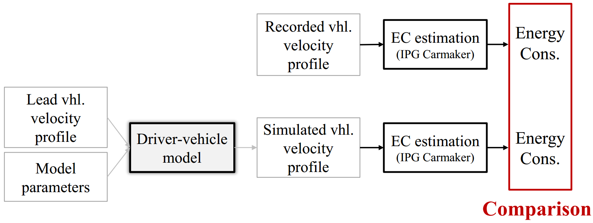
Figure 1: Driver personalized vehicle energy consumption evaluation framework. Comparison of the estimation of the energy consumption of a vehicle based on a recorded vehicle velocity profile and a simulated vehicle velocity profile.
Obviously, careful selection of the driver-vehicle model is a central issue in this framework. The driver- model should be simple enough to be used in optimization procedures, and precise enough to realize accurate reproduction of the driver-vehicle behavior. Model selection, definition and implementation are detailed in the following section.

Definition of Driver-vehicle model
The personalized driver-vehicle model is developed in this paper based on the probability weighted autoregressive exogenous (PrARX) model [31]. PrARX model is a modified version of piecewise autoregressive exogenous (PWARX) model, which is one of the well-known identification models of hybrid dynamical systems. The main difference between these two ARX models is the definition of mode switching mechanism. Although the PWARX model has discrete (discontinuous) mode switching, the PrARX model has soft (continuous) mode switching defined by a probabilistic softmax function. The soft switching mechanism avoids to have discontinuity in the model output during mode transition. The PrARX model also allows adaptive parameter estimation, which implies the possibility of the progressive revision of the model parameters depending on the change of the driving characteristics and/or the driving environment. Although the PrARX model has some advantages described above, it has some drawbacks, such as difficulty in initial parameters setting, and instability observed when the model is embedded in the closed loop analysis. This study focuses on the analysis of a single following vehicle. Vehicle platooning modeling would require more in-depth analysis of information propagation on the modeled string. The following sections describe the detail of the definition of the model and the identification procedure, which is updated from the one in [27] to embed the PrARX model in the energy consumption system.

Definition of PrARX model
This section briefly reviews the PrARX model. The PrARX model is a hybrid model composed of several ARX sub-models, named modes. The output is defined by weighted summation of the output of each ARX model. The weighting function expresses the probability of the region to be in each mode. Thus the PrARX model is defined by the set of ARX model parameters, and by the weighting function parameters. PrARX model are formally defined by:

 | $${y_{k}=f}_{PrARX}\left(r_{k}\right)=\sum_{i=1}^{s}{P_{i}θ_{i}^{T}φ_{k}}$$ | (1)

where $r_{k}∈R^{n}$ defines the regressor vector (input vector) with $k∈N$ the time index, $φ_{k}={[r_{k}^{T} 1]}^{T}∈R^{n+1}$,$y_{k}∈R^{q}$, $θ_{i}^{T}∈R^{q*\left(n+1\right)} (i=1,…,s)$ is the parameter vectors defining the $i^{th}$ ARX modes, $s$ defines the number of modes, and $P_{i}∈R^{q}$ is the weighting function expressing the probability of the $q$ outputs. $P_{i}$ is defined by the following softmax function:

 | $$P_{i}=\frac{exp⁡(η_{i}^{T}φ_{k})}{\sum_{j=1}^{s}{exp⁡(η_{j}^{T}φ_{k})}}$$  $η_{s}=0$ | (2)

where $η_{i} (i=1,…,s-1)$ is the parameter vectors specifying the probabilistic (soft) partition between modes.

PrARX model for vehicle-following task
The goal of this study is to reproduce personalized vehicle behavior in vehicle-following task. The PrARX model is used to model the integrated behavior of the driver and vehicle dynamics. The measured data of leading vehicle and the model output are used to create the regressor vector (see Figure 2). The PrARX model is used to predict the outputs of the integrated behavior at $k+τ$ based on the current input at time $k$. A delay $τ$ is applied to the model input to represent the drivers' cognitive reaction time (300ms [1], [4]). Then, the output of each ARX model and the mode probabilities (weighting parameters) are calculated by using the PrARX model. The PrARX model with input-delay is given by:

 | $$i_{k}=f_{inputs}\left(s_{k},y_{k}\right)$$  $$r_{k}=i_{k-τ}$$  $$y_{k}=f_{PrARX}\left(r_{k}\right)$$ | (3)

where $i_{k}$ is the regressor vector without delay, $f_{inputs}(∙,∙)$ is the function to calculate the PrARX model inputs without delay based on the sensor information $s_{k}$ and on the model output $y_{k}$. $r_{k}$ is the regressor vector for the PrARX model, and $y_{k}$ represents the input-delay PrARX model output.

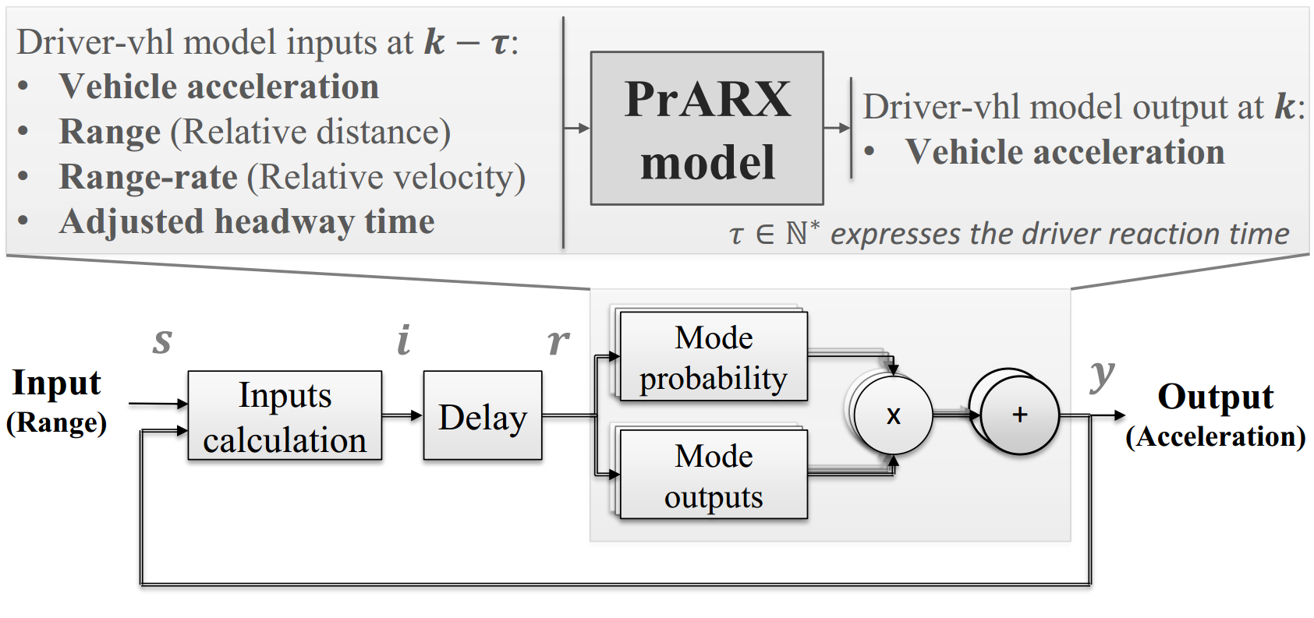
Figure 2: Driver-vehicle model, expressed as the feed-back implementation of a PrARX model with input-delay. Relation between inputs and outputs.
Definition of the driver-vehicle model is given as follows:

 | $i_{k}=f_{inputs}\left(s_{k},y_{k}\right)$ with  $$f_{inputs}\left(s_{k},y_{k}\right)=\left\{\begin{matrix}\begin{matrix}Acceleration_{k} \\ Range_{k}\end{matrix} \\ \begin{matrix}RangeRate_{k} \\ \frac{1}{HT_{k}+1}\end{matrix}\end{matrix}\right.$$  $$=\left\{\begin{matrix}\begin{matrix}y_{k} \\ s_{k}\end{matrix} \\ \begin{matrix}{\dot{s}}_{k} \\ \frac{\sum_{t=0}^{k}{y_{t}}}{s_{k}+\sum_{t=0}^{k}{y_{t}}}\end{matrix}\end{matrix}\right.$$  $$r_{k}=i_{k-τ}$$  $$y_{k}=f_{PrARX}\left(r_{k}\right)$$  $$HT_{k}=\frac{Range_{k}}{Velocity_{k}}=\frac{s_{k}}{\sum_{t=0}^{k}{y_{t}}}$$ | (4)

where $HT$ refers to the headway time.
The choice of variables in (4) is discussed in III-C.

Parameter identification
Parameter identification of the PrARX model is based on a steepest descent method [31]. The cost function is defined by the Euclid norm of the output error in the identification scheme in [31]. Although both parameters in the ARX model and the softmax function can be identified simultaneously by a single algorithm, this identification scheme is a non-convex optimization problem. In order to increase the level of reliability and accuracy of the identified of the PrARX model, a two-stage identification process is newly developed in this work. In the first stage, a classification technique is applied to the data, and PrARX hyperplans parameters are identified. The set of data is separated into subsets depending on the preferable mode separation, and the mode separation parameters $η$ are identified with a multinomial logistic regression method. In the second stage, the parameters of the ARX models $θ$ are identified using a steepest descend method. The advantage of using classification over clustering in the case of applying a multi-mode model to analyze realistic driving data lies in the nature of the observed data. If constancy in the physical understanding of the modes parameter is desired, data clusters must have high margin hyperplanes separation, enabling similar data clusters formation for every identification. Unfortunately, the available data does not show clear separation pattern. Thus, in this work, subjective prior-knowledge about the data classification is assumed, based on the vehicle acceleration, to describe the following driving situations: acceleration, deceleration, and constant speed.

Choice of regressor vector
Reproduction of the driving behavior depends not only on the structure of the model, but also on the selection of explanatory variables of the model. The regressor vector must have strong relation with the output of the ARX models. In addition, the regressor vector must be able to distinguish the driving modes, i.e., to represent the partition between modes.
In this work, the output of the model is set to be the longitudinal acceleration of the vehicle because our goal is the evaluation of the energy consumption. Generally, it seems natural to select the range between leading vehicle, and range-rate as elements of regressor vector in the case of vehicle following task. In addition, some indices have also been considered as variable, which express the feeling of the driver [1] (KDB [32], PRE (Perceptual Risk Estimate) [33]). These indices are commonly used to trigger emergency systems (e.g. emergency braking), however, it is difficult to use them for behavior reproduction. In this work, we tried to find the explanatory variables that can be linked as simply as possible to the output of the system (vehicle acceleration). To understand the necessary input variables for ARX models, multivariable linear regression statistical test was performed in each mode based on real world recorded data. According to the values of the standard error of the coefficient estimate and on the p-values, it was observed that the past acceleration and range-rate were the two most significant variables to estimate the current acceleration value. The range-rate is a fundamental variable to calculate the output acceleration of the vehicle (consistent p-value lower than ${10}^{-8}$). This result is also reported in the Gazis-Herman-Rothery (GHR) model [3]. The past acceleration is obviously linked to the current acceleration due to the low dynamics of the car (lower than 0.5Hz), and the fact that the model is running at 10Hz. Headway time (time to collision) also has shown strong importance. The range was not directly linked to the model output, but is used in the mode determination process. Note that the magnitude of the linkage between some variables and output highly depends on driver and on the driving mode.
Thus, the selected inputs are the acceleration of the driven vehicle [m/s²], distance between the driver and leading vehicles (“range” [m]), relative velocity between the vehicles (“range-rate” [m/s]), and an adjusted inverse of the headway time ((velocity+1)/range) [1/s] [34]-[35]. The inverse of the headway time was adjusted to provide information even when the vehicle is stopped. Headway time provides an improved stability to the output model response as stated later. The identified parameters of the corresponding variable can be interpreted to represent the driving characteristics of each driver. For example, aggressive drivers tend to base their judgement on the range and the range-rate, while soft drivers rely mostly on the headway time.
To provide more information about the effectiveness of the selected input parameters, Figure 3 shows the verification results of the driver-vehicle model with input delay in the cases of different regressor vector choice. The regressor vectors definition are in TABLE I:

TABLE I
Regressor Vectors Definition for Figure 3
 | Vectors components
wo RR | $$Acc$$ | $$Range$$ | $$adj HT^{-1}$$
wo R | $$Acc$$ | $$RangeRate$$ | $$adj HT^{-1}$$
wo HT | $$Acc$$ | $$Range$$ | $$RangeRate$$
RegV | $$Acc$$ | $$Range$$ | $$RangeRate$$ | $$adj HT^{-1}$$
“wo” stands for “without”, “RR” for “range-rate”, R for “range”, “$adj HT^{-1}$” for adjusted inverse of headway-time, and “RegV” for the final regressor vector.

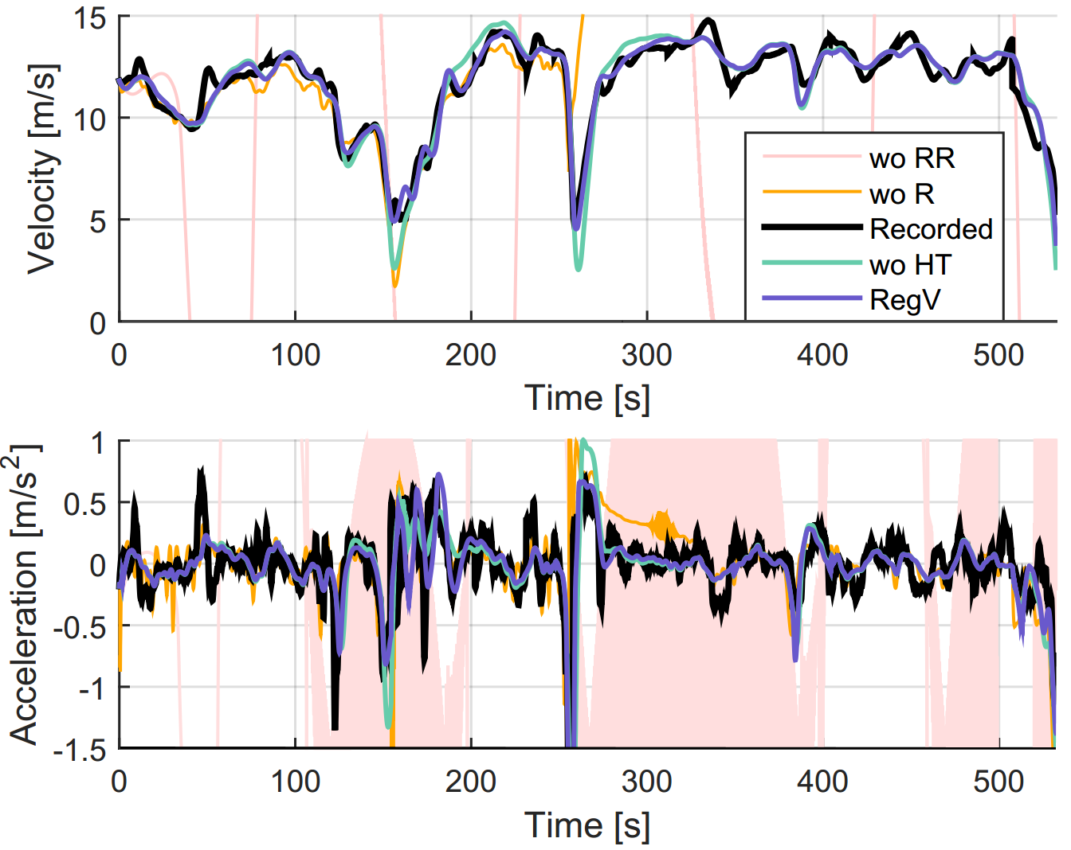
Figure 3: 3 modes PrARX input-delay model output depending on the selected learning regressor vector. The label “Recorded” represents the reference recorded vehicle following profile. Definition of the labels is in Table 1.
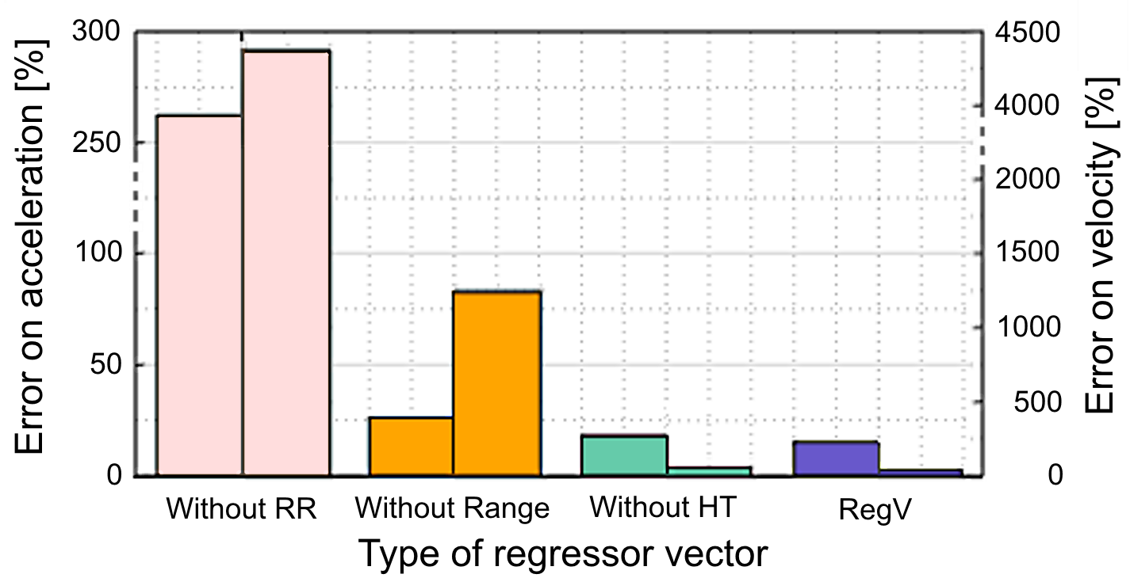
Figure 4: Acceleration error of the input-delay model output on the left, and velocity error on the right, depending on the type of regressor vector. The error is the Euclid norm of the difference between the reference data and the identified 3 modes PrARX input-delay model output.

Data classification for mode definition
Classification is used to determine the modes of the PrARX model. According to the distribution of the recorded driving data and to the energy estimation error of the resulting model, we decided to classify the data into three clusters based on the vehicle acceleration. The defined mode definition is shown in Table II. This segmentation implies to differentiate low-band dynamical driving mode and high-band dynamical driving modes. High-band dynamical driving modes are representative of the acceleration and deceleration phases. To avoid sudden mode changes and take advantage of the smooth mode switching of the PrARX model, overlapping between the simple clusters is considered on a 0.1 m/s² range of the acceleration data.

TABLE II
Learning Data Clusters Definition
Acceleration [m/s²] | Cluster name | Mode number
$$(-∞ , -0.35]$$ | Deceleration cluster (high-band) | 1
$$\left[-0.45 , 0.45\right]$$ | Low-band dynamics cluster | 2
$$[0.35 ,+∞)$$ | Acceleration cluster (high-band) | 3

Figure 14 shows the velocity and acceleration profile of the output of simulation using the 3-modes PrARX model with input-delay, which is identified from real-world data. It can be observed that the behavior reproduction is successfully made, and it is expected to play a key role for precise energy consumption evaluation. The “Mode probability” graph in Figure 14 illustrates the instantaneous mode probability which is used as a weighting factor for the calculation of PrARX model output.
Without range or range-rate, the driver-vehicle behavior becomes unstable particularly in high-band dynamics domain. The headway time helps to stabilize the behavior. To get more information about the precision of the reproduced vehicle dynamics, Figure 4 shows the error in terms of reproduced accelerations and reproduced velocities, that is Euclid norm of the difference between the recorded vehicle data and the output of the simulation using driver-vehicle model. According to the error bar graphs, we can see that the selected regressor vector (i.e., RegV) provides the best acceleration and velocity reproduction performance among the considered set. Since the selected regressor vector does not depend on the absolute velocity of the vehicle, different driver models can be identified depending on various velocity spans, congestion states or road types.

Learning data decimation
The data used for this study has been recorded from a driving simulator and from real world experiments. Due to the amount of data (30 minutes at 10Hz) and the distribution of the data, a simple technique has been developed to remove possible redundant data, and thus to reduce the computational burden for the identification of the model parameters while realizing more homogeneous data repartition.
The process consists in placing the regressor data into cells based on acceleration. Width of the cells in constant, thus only the number of elements in the cells vary. Then the data of each cell is independently decimated based on two factors: a global maximal decimation factor, and the average number of data in the decimated cell.
Figures 5 and 6 illustrate the increase of the data repartition homogeneity thanks to the dynamical data decimation, and the reduction of computation time of this technique. As observed in Figure 6, the calculation time decreases according to the increase of the decimation factor. A minimum amount of data in each identified mode is set as a threshold to select the appropriate decimation factor during the PrARX parameters identification process. The only drawback of this method is the fact that outliers in high dynamical bands have low chance to be removed and thus become significantly important in the identification process. Careful prior learning data processing is required.

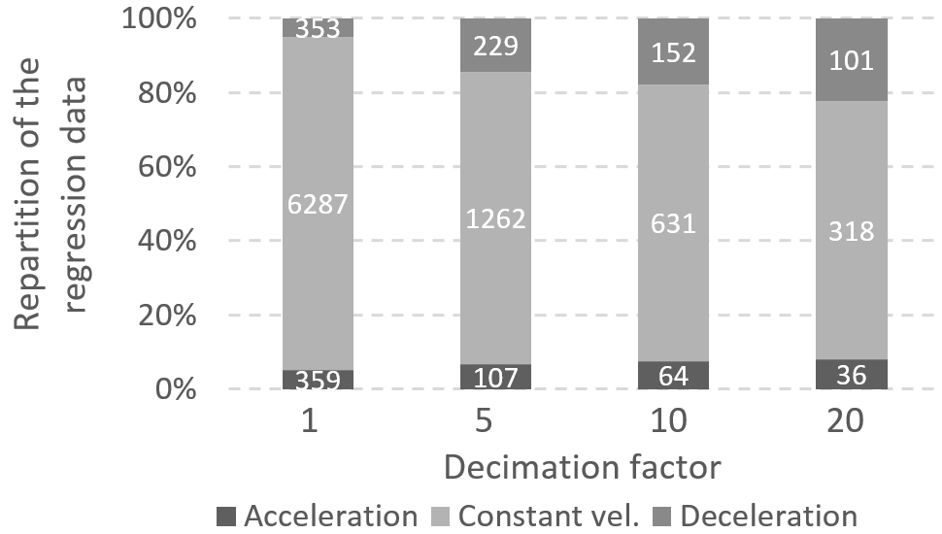
Figure 5: Influence of the selected decimation factor on the proportion of learning data in the classification modes. Number of data vectors in each cluster is specified.

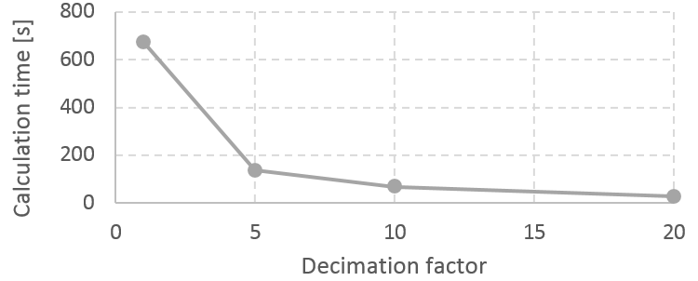
Figure 6: Influence of the selected maximal decimation factor on the model parameters identification duration.

Overall flowchart of identification process

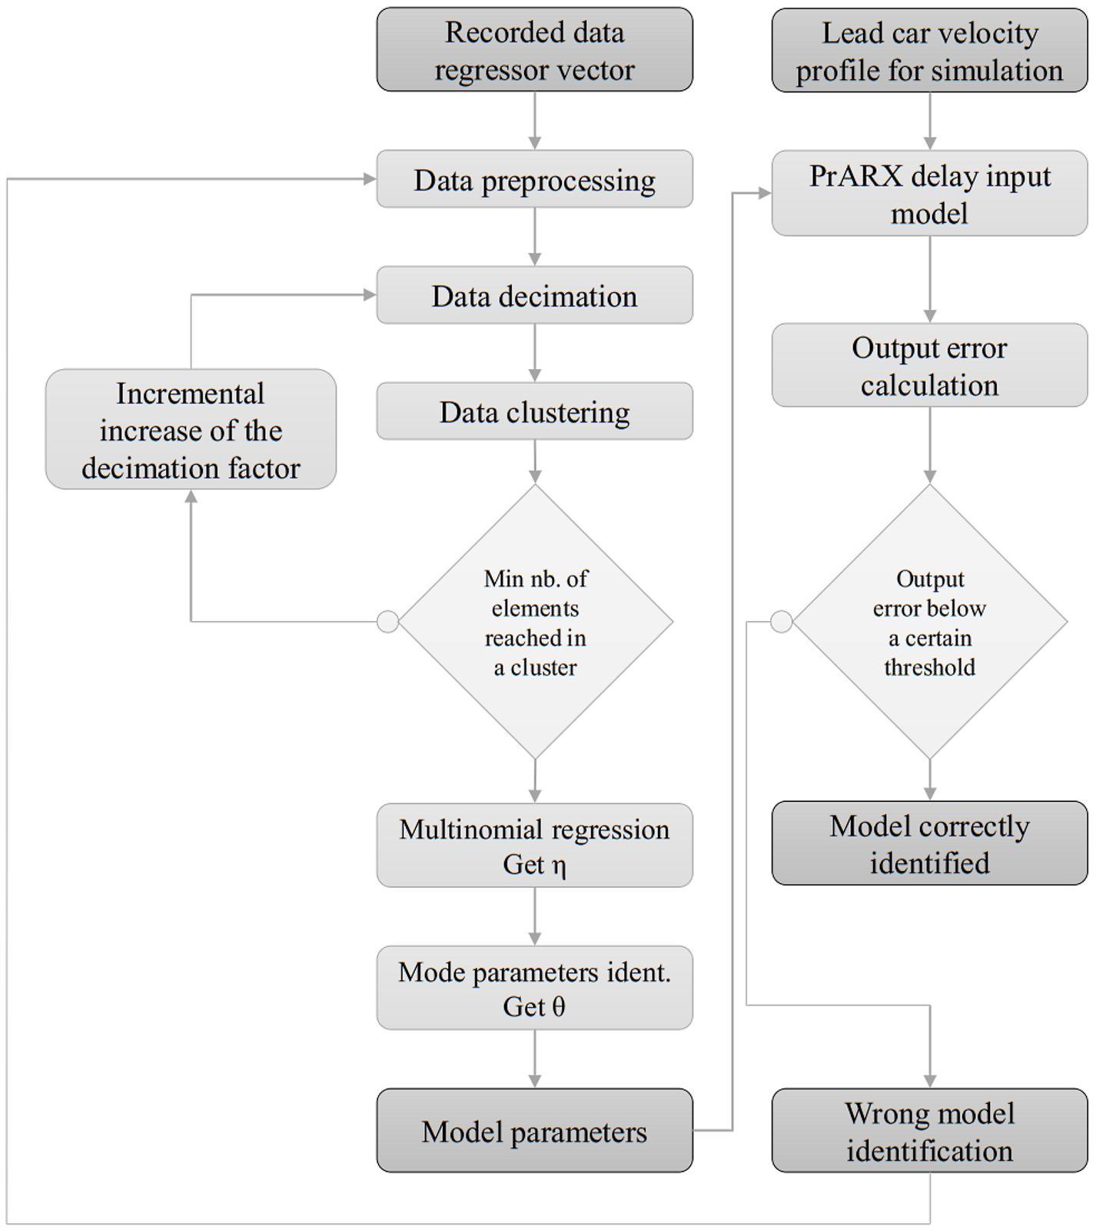
Figure 7: Flowchart of the PrARX input-delay model identification process.
Overall flowchart of the identification process is depicted in Figure 7. Two types of data sets are used during the identification process. The first one is for the parameter identification, and the other one is for the model verification (simulation). The first data set contains as much information as possible. This data set is manually preprocessed to remove noise and outliers. Then data is decimated to reduce the computation burden of the identification process, while ensuring to have enough data in each cluster. The identification step takes about 3 minutes on a personal computer (CPU i7 870, RAM 8Gb). The second data set (velocity profile of leading vehicle) is used to run the simulation using PrARX model with input-delay. The velocity profile of the leading vehicle used for verification can be any velocity profile, as long as the underlying dynamics are coherent with the first data set.

Experimental setup for data collection
In order to get data from different driving styles in various situations, two types of experimental setups were used for data collection. At first, data was collected by using a driving simulator, which enabled us to control all the environmental parameters. Then a real world experiment was executed to get realistic driver-vehicle dynamics.

Data collection by using driving simulator
In order to exactly control the velocity pattern of the leading vehicle, i.e., to realize a broad variety of driving situations, data collection was executed by using a driving simulator (DS) shown in Figure 8. The DS is composed of a real vehicle interior and HMI devices, and the visualized image is projected on three wide screens. This configuration provides 180 degree vision and good driver immersion.

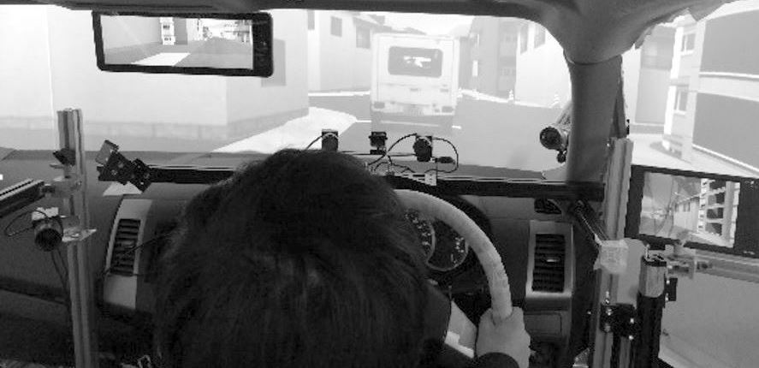
Figure 8: View from the examinee in the DS.
The created environments are: a typical residential area from real-world map, and a 4-lane oval-loop highway. Different velocity profiles of leading vehicle have been implemented to reproduce the different driving situations.
Four non-professional examinees executed the following task with different levels of aggressiveness. The leading vehicle ran according to three different velocity patterns designed in-house to represent typical driving scenarios (See Figure 9):
- 30 to 70 km/h pattern: representing city use.
- 80 to 110 km/h pattern: representing extra-urban/Japan highways.
- 100 to 150 km/h pattern: representing European highways.
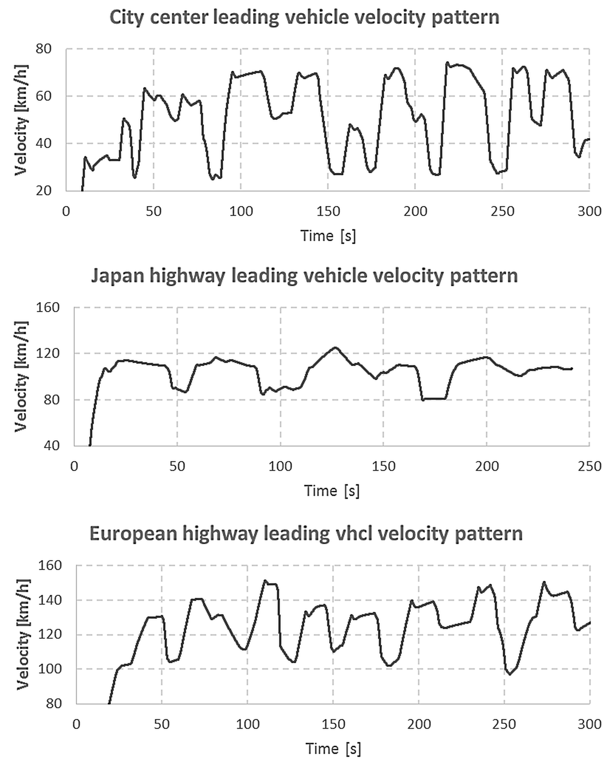
Figure 9: Velocity patterns of the leading vehicles used in the DS experiments.

Data collection from real-world driving
In order to get more realistic driver-vehicle dynamics, experiments were executed in real-world. Three different examinees drove on a highway following a leading vehicle. Each driver repeated the experiment twice. The leading vehicle was equipped with a GPS based reference velocity profile display system which showed a predefined velocity pattern on a smartphone (see Figure 10). The ego-vehicle was equipped with a CAN bus acquisition tool, and a millimeter-wave radar. The CAN bus acquisition tool was used to record the GPS position, and the velocity and acceleration at the wheel of the vehicle. The millimeter-wave radar was used to get precise information on the distance to the leading vehicle, and to calculate the relative velocity.

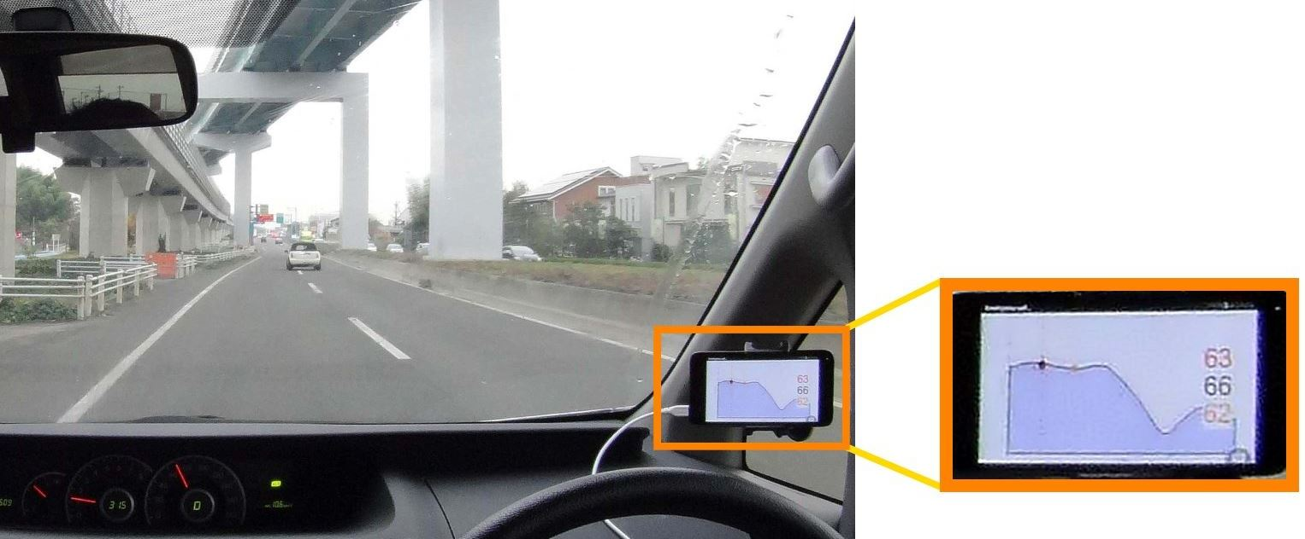
Figure 10: View from the driver of the leading vehicle. The velocity profile display system is squared and zoomed on the right. Current velocity, future velocity and desired velocity plots are displayed.
A velocity profile reference shown in Figure 11 was created. This velocity profile included a wide range of accelerations and decelerations in order to include all the possible driving situations. Emergency braking was not performed in this experiment since the model was not designed for such a situation. Low velocity under 5 m/s were excluded from the identification data since the driving behavior changes significantly in traffic jams and in creeping situations.

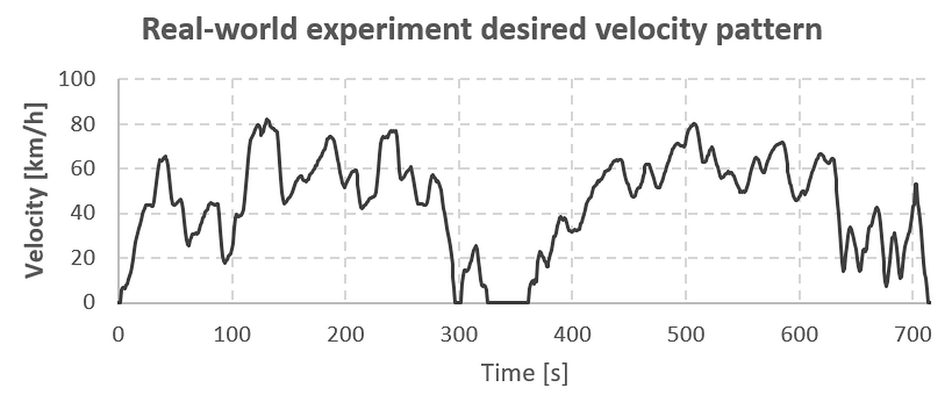
Figure 11: Reference velocity profile of the leading vehicle used for real world experiment.

Energy consumption evaluation
The energy consumption of the vehicle is estimated by inputting a vehicle velocity pattern, which is calculated by using the driver-vehicle model, to the car dynamics simulation software Carmaker (IPG Automotive), as shown in Figure 1. Carmaker is known to be able to calculate the fuel consumption with high accuracy based on the different car losses, including the engine efficiency mapping of the vehicle. This software is industry standard, and it is used by the biggest manufacturers to model car dynamics and powertrains.
The fuel consumption volume flow $\dot{{vol}_{f}}$ is calculated by

 | $$\dot{{vol}_{f}}=\frac{\dot{m_{F}}\left(ω_{Eng},{Trq}_{Eng}\right)*\left|P_{Eng}\right|}{ζ_{F}*3.6*{10}^{9}}$$ | (5)

where $\dot{m_{F}}\left(ω_{Eng},{Trq}_{Eng}\right)$ is the specific mass flow extracted from the engine mapping (see Figure 12),$ω_{Eng}$ the engine frequency of rotation, and ${Trq}_{Eng}$ the torque load at the crank shaft. $ζ_{F}$ is the petrol density (0.75 kg/L), and $P_{Eng}$ is the engine output power. Eq.5 is provided by IPG Carmaker.

The speed profile tracking function of Carmaker can realize very precise reproduction of any velocity pattern. The simulated environment is a flat straight line, and the selected powertrain are 250hp and 130hp petrol engines for the DS and real-world driving, respectively. The average velocity difference between the evaluated pattern and the reproduced pattern is 0.3km/h and the median absolute deviation is 0.1km/h.

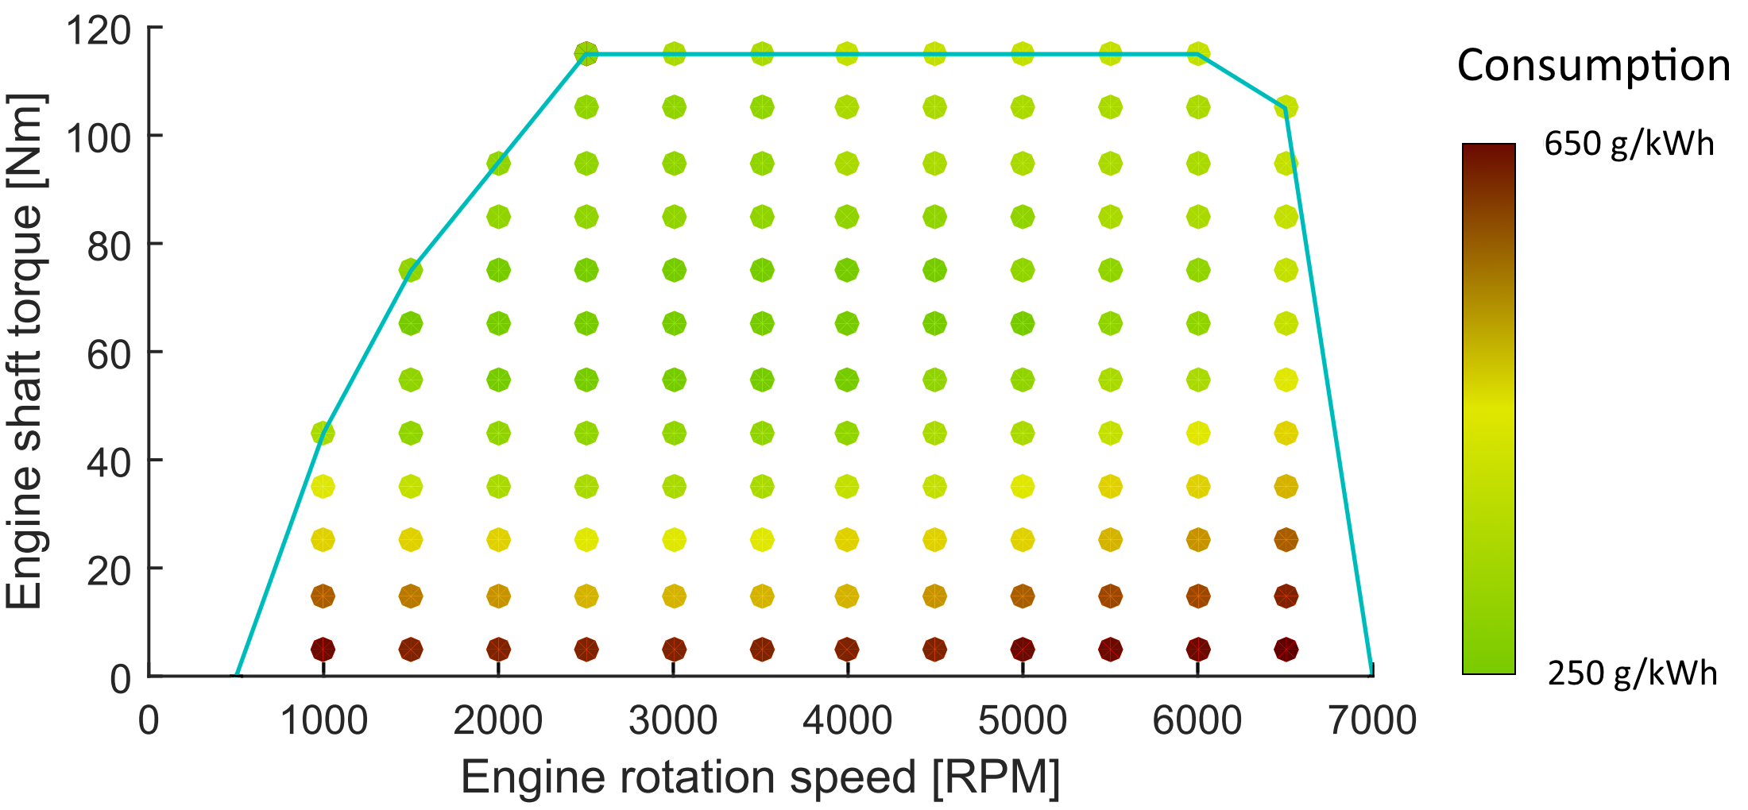
Figure 12: Engine mapping of the 130hp petrol powertrain (IPG Carmaker). The blue line represents the torque at full load, and colored dots the specific fuel consumption.
Using the energy consumption evaluation scheme shown in Figure 1, the fuel consumption of the different vehicles can be assessed and compared, considering the variety of driving characteristics.

Results and analysis
In this section, results of fuel consumption analysis are shown and discussed.
Fuel consumption modeling error is calculated by comparing the fuel consumption estimated from the driver-vehicle model, and the fuel consumption estimated from the reference velocity profile used to train the driver-vehicle model. The formula is detailed in equation (6).

 | $${error}_{FC} [\%]=\frac{{FC}_{estimate}-{FC}_{reference}}{{FC}_{reference}}*100$$ | (6)
Here, FC stands for fuel consumption.

Results using data from DS
Tables III and IV show the fuel consumption estimation values and their estimation errors, respectively.

TABLE III
DS Experiment Fuel Consumption Values [l/100km]
 | Recorded vehicle | Simulated vehicle
City center  Aggressive driver | 10.12 | 9.81
City center  Soft driver | 8.63 | 8.11
Extra-urban  Aggressive driver | 9.76 | 8.71
Extra-urban  Soft driver | 7.45 | 7.15
European highway  Aggressive driver | 10.75 | 10.46
European highway  Soft driver | 8.37 | 8.24

TABLE IV
DS Experiment Fuel Consumption Estimation Error [%]
 | Aggressive driver | Soft driver
City center | - 3.1 | - 5.9
Extra-urban | - 10.7 | - 4.1
European highway | - 2.7 | - 1.6

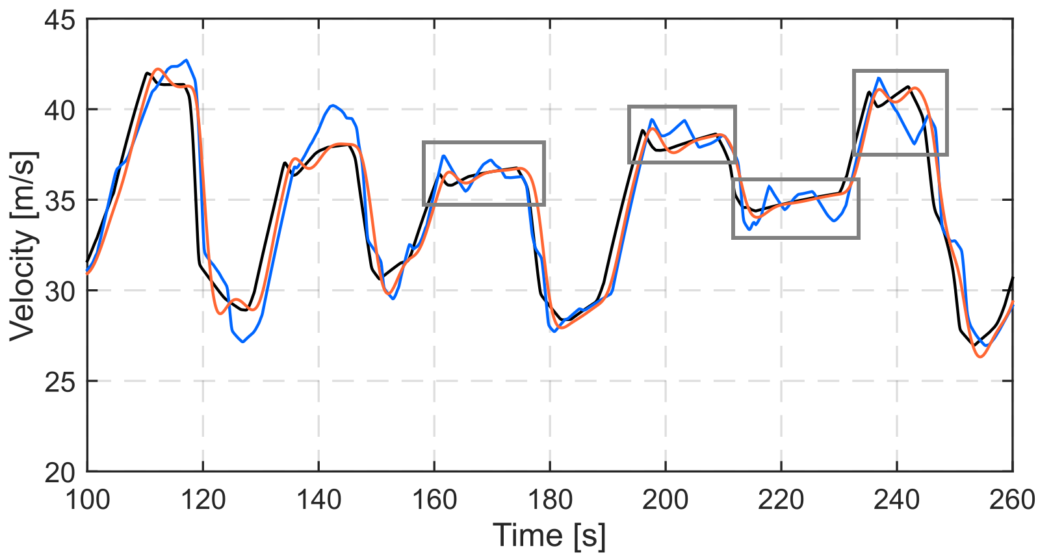
Figure 13: Velocity of the driver-vehicle model output. DS European highway profile with aggressive following. In black the leading vehicle, in blue the recorded ego vehicle, in orange the driver-vehicle model simulated ego vehicle. The oscillatory behavior of the aggressive driver during constant velocity phases is squared in grey.
The estimation error of the fuel consumption varies from -10.7% to -1.6%, with an average error of -4.6% and an absolute standard deviation of 3.4%. The energy consumption value is underestimated due to the low-pass characteristics of ARX models. The lack of acceleration feeling of vehicle in the DS makes the driver act quite aggressively, and examinees struggled to follow the leading car with creating acceleration oscillations in usual low dynamical band. Figure 13 shows these oscillations squared in black. This behavior cannot be correctly modeled by the PrARX input-delay model, due to the absence of direct path between the input and the output.

Results using data from real-world driving
Table V shows the fuel consumption evaluation values for three drivers on real-world measurement. “Lead vehicle” represents the fuel-consumption of the leading car. Due to the impossibility to exactly realize the desired leading vehicle velocity profile (shown in Figure 11), leading vehicle energy consumption is calculated for each driver-vehicle model using realized velocity profile. “Follow recorded” represents the fuel consumption of the vehicle used for driver-vehicle model identification, and “PrARX input-delay” represents the fuel consumption of the simulated driver-vehicle model.

TABLE V
Real World Experiment Fuel Consumption Evaluation
 | Driver 1 | Driver 2 | Driver 3
Lead vehicle [L/100lm] | 5.59 | 5.19 | 5.87
Follow recorded [L/100lm] | 6.02 | 5.59 | 5.81
PrARX input-delay [L/100lm] | 6.02 | 5.48 | 5.59
Error values [%] | -0.06 | -1.8 | -3.8

In Table V, we can observe good results in energy consumption estimation. The average estimation error is -1.9%, and the absolute standard deviation 1.5%. The energy estimation error is much lower in real-world environment than in the driving simulator experiment.
Figure 14 illustrates the driver-vehicle model dynamics reproduction ability based on real-world recorded data. The low estimation error of energy consumption in real-world experiment is due to the fact that examinees seem to drive the vehicle with lower frequency dynamics in real world, so that the recorded and reproduced signals are no more limited by the low pass behavior of the PrARX input-delay model. Moreover the observed correlation between the leading vehicle and ego-vehicle is much better than in the driving simulator.

Application examples
It could be observed in the previous sections that the PrARX input-delay model is able to provide ego-vehicle dynamics with enough precision to evaluate first order energy consumption of the vehicle. The computation cost of the PrARX input-delay model being very low, online use in a vehicle is possible. Although the parameter identification process requires high computational cost, thanks to the increase of V2X communication in recent years [36], parameter identification can be done remotely on most cars without any implementation on the vehicle computer system. Based on this information, two in-vehicle and one traffic flow model oriented applications are proposed in this section. The first application can be described as a customer decision assistance system for the choice of an appropriate powertrain in buying new vehicle. The second application aims to help the driver to reduce his fuel or electricity consumption by challenging his behavior with somebody else’s. The last application is a method to evaluate energy consumption of vehicles embedded in a traffic flow model.

Customer decision assistance for powertrain choice
The first application of the developed driver-vehicle model with energy consumption estimation is based on the ability of the model to reproduce a user’s behavior on a variety of lead velocity patterns, as long as driving situation is equivalent. Each different vehicle powertrain has specific high and low efficient zones. Depending on the human driving manner, different types of powertrains will be adapted to different users. The goal of this application is to help customers to select an appropriate vehicle powertrain depending on their individual driving habits.
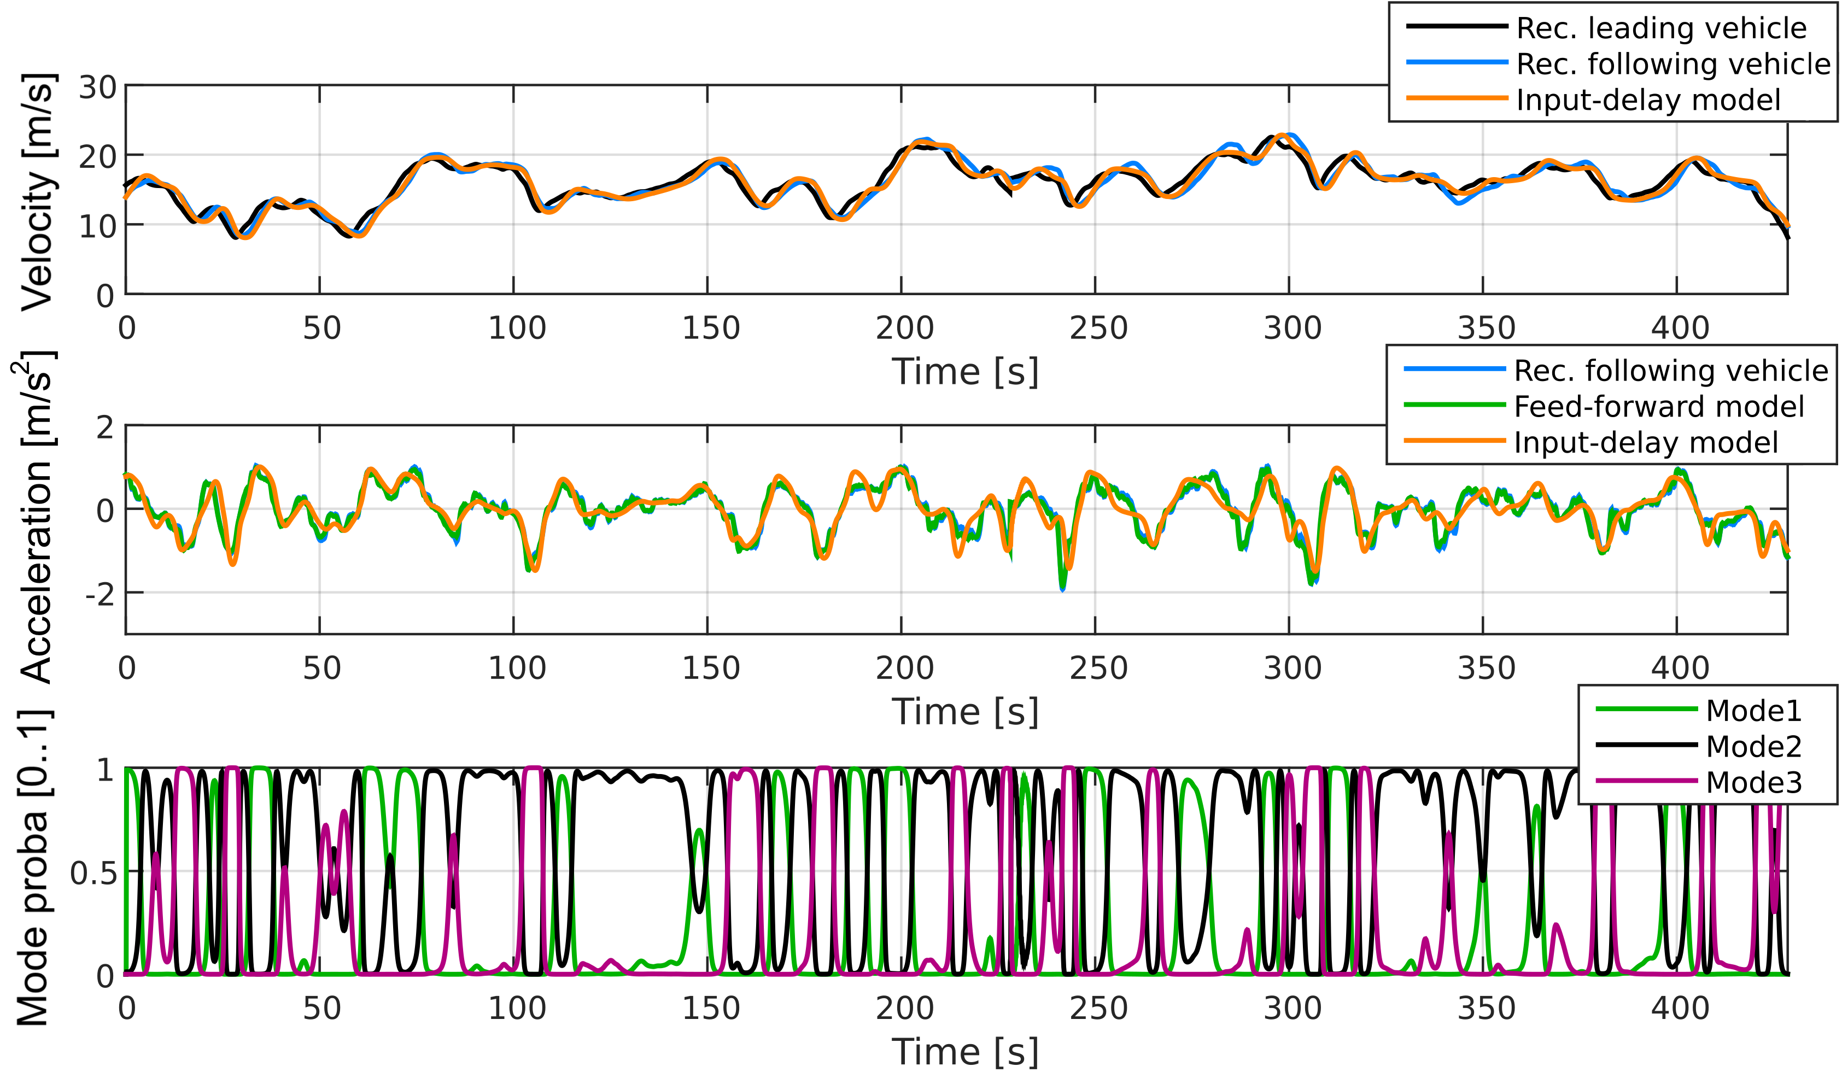
The typical situation places a customer comparing some possible new vehicles. The parameters of customer’s vehicle-following behavior model have already been identified during daily driving. These parameters can then be applied to classic homologation cycles or any usual velocity pattern. Knowing that every manufacturer is able to provide the powertrain performance map of their vehicles, the customer will be able to receive a personalized estimation of the energy consumption of the vehicle depending on his personal behavior.
Figure 14: Velocity, acceleration, and modes probability weight of an identified 3 modes PrARX input-delay model. “Rec. leading vehicle” represents the recorded leading vehicle used for simulation, “Rec. following vehicle” represents a section of the recorded ego vehicle of the learning phase, “Feed-forward model” is the output of the PrARX model when using pre-calculated learning data regressor vector, without feedback loop, “Input-delay model” is the output of the driver-vehicle model by using “Rec. leading vehicle” for the lead vehicle.

Social eco-driving challenge
The second proposed application of the behavior personalized energy consumption estimation model is based on the ability of the driver-vehicle model to reproduce different driving behaviors under identical lead velocity pattern. The idea behind social eco-driving challenge is based on the concept of social games [34]. The aim of this application is to get people interested in eco-driving by challenging them to outperform others. Setting goals to reach their best results in the form of eco-indicators is the main focus to obtain good efficiency results [30]. Thus the combination of goal reaching and the interest of social game could assist the development of a platform which proposes advice to help drivers to reduced energy consumption.

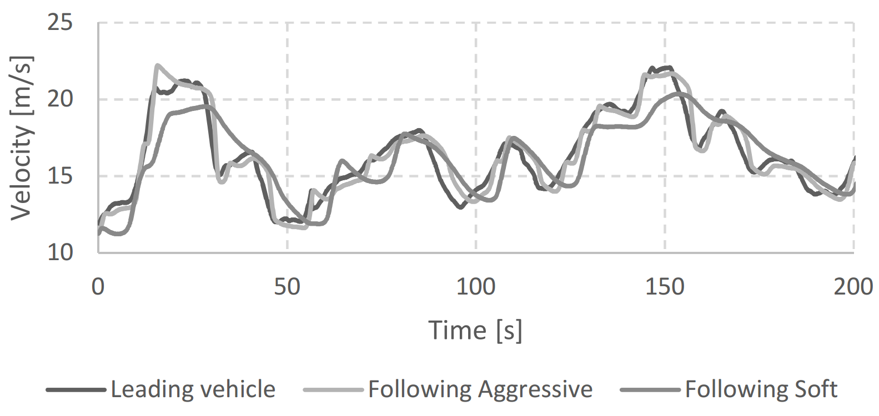
Figure 15: A leading vehicle from real-world, followed by two different PrARX input-delay models. The PrARX input-delay models are representative of an aggressive and a soft driver. These models have been identified from distinctive driving measurements.
The PrARX input-delay model can be used to calculate the reaction of different drivers online, and thus compare in real time the energy consumption of virtual drivers. As an example, comparison of behavior in the cases of using aggressive driver model and soft driver model is shown in Figure 15. The estimated energy consumption are simulated and compared based on two leading vehicle velocity patterns. The driver-vehicle parameters have been identified from city-center driving situation in section VI. The selected leading vehicle velocity patterns are: a DS recorded velocity profile, and a velocity pattern measured in real-world (R-W) experiment.
Tables VI and VII show the relative difference of fuel consumption between the two driver-vehicle models (D-VMs) with different leading vehicle velocity patterns.
The fuel consumption comparisons in Tables VI and VII show that the driver models keep their own relative energy consumption behavior independently on the leading vehicle velocity profile. The soft D-VM is consistently 17% more energy efficient than the aggressive D-VM. Therefore, the PrARX input-delay model is a good candidate to compare drivers based on a selected driving situation.

Estimation of vehicle energy consumption in traffic flow model
Traffic flow models enable users to analyze wide road networks dynamical behavior depending on the road topology, the traffic flow density, the basic vehicle characteristics and other macroscopic parameters [7],[20],[38]-[39]. Nevertheless, conventional driver-vehicle models used in traffic flow simulation cannot provide realistic microscopic behavior due to the lack of personalized driving characterization.
PrARX input-delay model can be used as an adaptive cruise control model when implemented with the Virtual Leading Vehicle (Vlv-ACC) system [40]. Vlv-ACC system is based on the philosophy of action-point microscopic traffic flow models. Thus, by embedding the developed driver-vehicle model in the Vlv-ACC system, an interesting traffic flow model can be developed. This model can provide more precise and user personalized driver-vehicle dynamics of certain road sections, and as the results, energy consumption of particular vehicles can be assessed in the context of traffic flow.

Conclusion

This paper propose a new method to accurately estimate energy consumption in vehicle-following task by using a personalized driver-vehicle behavior model. The driver-vehicle behavior model is a PrARX model, which is one of the hybrid dynamical system models, with an input time-delay integration. In particular, careful selection of the regressor vector and dynamical input decimation enabled us to realize robust identification with small computational cost. Then the vehicle energy consumption was calculated based on the model output signals. The proposed driver-vehicle model leads to average fuel consumption estimation error of 1.9% and 1.5% standard deviation in real-world measurement cases. Based on this method, possible application domains are: a powertrain choice assistance system for car buyers, an online energy consumption evaluation system based on driver models, and a method to estimate energy consumption of vehicles in a traffic flow modeling. The realization of these applications and extension to the different driving situations are our future works.

TABLE VI
Comparison of FC of D-VMs Following DS Recorded Vehicle 1
Evaluated\Reference | Aggressive | Soft
Aggressive | --- | 20.9 %
Soft | -17.3 % | ---

TABLE VII
Comparison of FC of D-VMs Following R-W Recorded Vehicle 2
Evaluated\Reference | Aggressive | Soft
Aggressive | --- | 20.0 %
Soft | -16.7 | ---

References
- Charles C.MacADAM, “Understanding and Modeling the Human Driver”, Swets & Zeitlinger, Vehicle System Dyn., Vol. 40, No. 1-3, pp. 101-134, 2003
- J. Bengtsson, “Adaptive Cruise Control and Driver Modeling”, PhD dissertation, Automatic Control Dept., Lund Institude of Technology, Sweden, Nov. 2001
- M. Brackstone, M. McDonald, “Car-following: a historical review”, Transportation research part F, pp.181-196
- P.G. Gipps, “A behavioural Car-Following Model For Computer Simulation”, Trans. Res. Part B, Vol. 15, No. 2, 1981, pp 105-111
- M. Bottero, B. Dalla Chiara, F. Deflorio, G. Franco, E. Spessa, “Model-based approach for estimating energy used by traffic flows on motorways with ITS”, IEEE Intel. Trans. Systems, Vol 8, Issue 7, Nov. 2014
- P.W.G. Newman, J.R. Kenworthy, “The transport energy trade-off: Fuel-efficient traffic versus fuel-efficient cities”, Transportation Research Part A: General, Vol 22, Issue 3, pp. 162-174, May 1988
- J.J. Olstam, A. Tapani, “Comparison of Car-following models”, VTI meddelande 960A, Swedish Nat. Road and Trans. Res. Institute, 2004
- A. Kostikj, M. Kjosevski. L. Kocarev, “Impact of Mixed Traffic in Urban Environment with Different Percentage Rates of Adaptive stop&go Cruise Control Equipped Vehicles on the Traffic Flow, Travel Time, Energy Demand and Emission”, IEEE 18th International Conference on Intel. Trans. Systems, Sept. 2015
- S. Stockar, V. Marano, M. Canova, G. Rizzoni, L. Guzzella, “Energy-Optimal Control of Plug-in Hybrid Electric Vehicles for Real-World Driving Cycles”, IEEE Trans. on Vehicular Tech., Vol. 60, Issue 7, June 2011.
- M. Schori, T.J. Boehme, B. Frank, B.P. Lampe, “Optimal Calibration of Map-Based Energy Management for Plug-In Parallel Hybrid Configurations: A Hybrid Optimal Control Approach”, IEEE Trans. On Vehicular Tech., Vol. 64, Issue 9, Oct. 2014
- H. Khayyam, “Stochastic Models of Road Geometry and Wind Condition for Vehicle Energy Management and Control”, IEEE Trans. On Vehicular Tech., Vol. 62, Issue 1, Sept 2012
- R. Shankar, J. Marco, “Method for estimating the energy consumption of electric vehicles and plug-in hybrid electric vehicles under real-world driving conditions”, Intel. Trans. Systems, Vol 7, Issue 1, March 2013
- P.G. Howlett, P.J. Pudney, “Energy-Efficient Train Control”, Springer, 1995
- P.G. Howlett, P.J. Pudney, X. Vu, “Local energy, minization in optimal tain control”, Automatica, Vol. 45, Issue 11, Nov. 2009
- Y. Huang, L. Yang, T. Cao, Z. Gao, “Saving Energy and Improving Service Quality: Bicriteria Tain Scheduling in Urban Rail Transit Systems”, IEEE Trans. On Intel. Trans. Systems, In press, http://dx.doi.org/10.1109/TITS.2016.2549282
- J. Yin, T. Tang, L. Yang, Z. Gao, B. Ran, “EnerEnergy-efficient metro train rescheduling with uncertain time-variant passenger demands: An approximate dynamic programming approach”, Transportation Research Part B: Methodological, Vol. 91, Sept. 2016, pp. 178-210
- R. Wiedemann, “Simulation des Strassenverkehrsflusses. Schriftenreihe des Instituts für Verkehrswesen der Universität Karlsruhe”, Band 8, Karlsruhe, Germany, 1974
- B. Higgs, MM. Abbas, A Medina, "Analysis of the Wiedemann Car Following Model over Different Speeds using Naturalistic Data", 3rd Int. Conf. on Road Safety and Sim., 2011
- S. Glaser, B. Vanholme, S. Mammar, D. Gruyer, L. Nouveliere, “Maneuver-Based Trajectory Planning for Highly Autonomous Vehicles on Real Road With Traffic and Driver Interaction” , IEEE Trans. on Intel. Trans. Systems, Vol. 11, No. 3, Sept. 2010
- S. Panwai, H. Dai, “Comparative Evaluation of Microscopic Car-Following Behavior”, IEEE Trans. on Intel. Trans. Systems, Vol. 6, No. 3, Sept. 2005
- Charles C.MacADAM, “Application of an Optimal Preview Control for Simulation of Closed-Loop Automobile Driving”, IEEE Trans. on Systems and Cybernetics, Vol. SMC-11, No. 6, June 1981
- J. Ackermann, J. Guldner, W. Sienel, R. Steinhauser, “Linear and nonlinear controller design for robust automatic steering”, IEEE Control Syst. Society, March 1995
- S. Sekizawa, S. Inagaki, T. Suzuki, S. Hayakawa, N. Tsuchida, T. Tsuda, H. Fujinami, “Modeling and recognition of Driving Behavior Based on Stochastic Switched ARX model”, IEEE Trans. on Intel. Trans. Systems, Dec 2007
- Y. Hui, A.N. Michel, H. Lui, “Stability theory for hybrid dynamical systems”, IEEE Trans. On Automatic Control, April 1998
- A. Bemporad, A. Garulli, S. Paoletti, and A. Vicino, “A bounded-error approach to piecewise affine system identification,” IEEE Trans. Autom. Control, vol. 50, no. 10, pp. 1567–1580, Oct. 2005.
- R. Tarada, H. Okuda, T. Suzuki, K. Isaji, N. Tsuru, “Multi-scale Driving Behavior Modeling using Hierarchical PWARX Model”, IEEE Cong. on Intel. Trans. Systems, Sept. 2010
- P. Angkititrakul, C. Miyajima, K. Takeda, “Modeling and adaptation of stochastic driver-behavior model with application to car following”, IEEE Intelligent Vhl. Symposium (IV), pp. 814-819, 2011
- J. Sjöberg, Q. Zhang, L. Ljung, A. Benveniste, B. Delyon, P.Y. Glorennec, H. Hjalmarsson, A. Juditsky, "Nonlinear black-box modeling in system identification: A unified overview”, Automatica, vol. 31, no. 12, pp. 1691–1724, Dec. 1995.
- K.S. Narendra and K. Pathasarathy, “Identification and control of dynamical systems using neural networks”, IEEE Trans. Neural Networks, Vol. 1, No. 1, pp. 4–27, March 1990
- T. Stillwater, K. S. Kurani, “Drivers discuss ecodriving feedback: Goal setting, framing, and anchoring motivate new behaviors”, Transportation Research Part F: Traffic Psychology and Behaviour, Vol. 19, July 2013
- H. Okuda, N. Ikami, T. Suzuki, Y. Tazaki, K. Takeda, "Modeling and Analysis of Driving Behavior Based on a Probability-Weighted ARX Model", IEEE Trans. on Intel. Trans. Systems, Vol. 14, No. 1, March 2013
- T. Wada, S. Doi, K. Imai, N. Tsuru, et al., “Analysis of drivers’ behaviors in car following based on a performance index for approach and alienation”, SAE Tech. Paper 2007-01-0440, 2007
- H. Aoki, H. Yasuda, Van Q. H. Nguyen, "Perceptual Risk Estimate (PRE)": Development of an index of the longitudinal risk estimate, Proceedings of the 22nd International Technical Conference on the Enhanced Safety of Vehicles Conference, Paper No. 11-0121-O 2011
- L. Yan, W. Dianhai, “Minimum time headway model by using safety space headway”, IEEE World Automation Congress, June 2012
- T.J. Ayres, L. Li, D. Schleuning, D. Young, “Preferred time-headway of highway drivers”, IEEE Intel. Trans. Systems, August 2001
- L. Zhou, “The Advance of Intelligent Mobility and Co-Creation of Ecosystems”, Connected Car Japan Keynote, Automotive World, 2015
- D. Y. Wohln, C. Lampe, R. Wash, N. E llison, J. Vitak, “The S in Social Network Games: Initiating, Maintaining, and Enhancing Relationships”, Hawaii Int. Conference on System Sciences, Proceeding of the 44th, 2001
- L. Elefteriadou, “An introduction to traffic flow theory”, Springer, 2014
- A. Schnadschneider, “The Nagel-Schreckenberg model revisited”, The European Physical Journal B, pp.573-582, 1999
- T. Wilhelem, H. Okuda, B. Levedahl, T. Suzui, T. Haraguchi, “Behavior personalized Adaptive Cruise Control using Probability-Weighted ARX model”, 22nd ITS World Congress, Oct. 2015
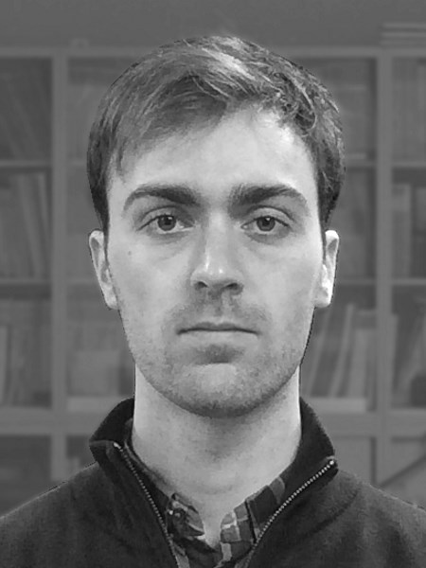
Thomas Wilhelem was born in Paris, France, in 1990. He received a Master’s degree in Solid Mechanics and Automobile and Railway transportation from ENSTA ParisTech, Palaiseau, France. He is currently pursuing the Ph.D degree with the department of Mechanical Science and Engineering of Nagoya University, Nagoya, Japan.
His research interests include modeling and analysis of human driving behavior, focused on the ability to reproduce personalized fuel consumption.

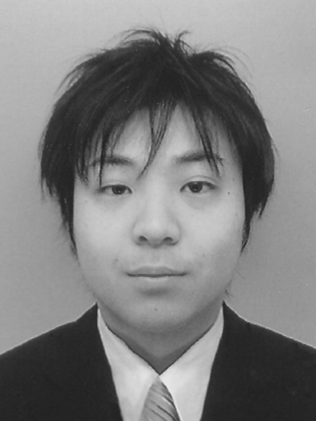
Hiroyuki Okuda was born in JAPAN, in 1982. He received the B.E. and M.E. degrees in Advanced Science and Technology from Toyota Technological Institute, JAPAN in 2005 and 2007, respectively, and he received the Ph.D degree in Mechanical Science and Engineering from Nagoya University, JAPAN in 2010.
From 2010 to 2012, he was a post doctoral researcher with the CREST, JST. Currently, he is an assistant professor of the Green Mobility Collaborative Research Center in Nagoya University. His research interests are in the areas of system identification of hybrid dynamical system and its application to modeling of human behavior, design of human centered mechatronics and biological signal processing.
Dr.Okuda is a member of the IEEJ, SICE and JSME.


Blaine Levedahl was born in 1976 in Manchester Conneticutt. He earned his BS, MS, and PhD in Aerospace Engineering as well as an MS in Electrical Engineering in 2001, 2003, 2007, and 2010, respectively.
During his academic career he had the opportunity to work on biologically-inspired flight vehicles at NASA Langley Research Center and on underwater vehicles with Northrop Grumman Newport News. Starting his professional career in 2007, he had the pleasure of working on autopilot development and integration testing at Honda Aircraft Company. In 2012, he took an appointment as a Designated Associate Professor at Nagoya University which he held until 2015. Since 2015, he has been working with various researchers on various modeling and control problems.


Tatsuya Suzuki was born in Aichi, JAPAN, in 1964. He recieved the B.S., M.S. and PhD degrees in Electronic Mechanical Engineering from Nagoya University, JAPAN in 1986, 1988 and 1991, respectively.
From 1998 to 1999, he was a visiting researcher of the Mechanical Engineering Department of U.C.Berkeley. Currently, he is a Professor of the Department of Mechanical Science and Engineering of Nagoya University, Vice Director of Green Mobility Collaborative Research Center in Nagoya University and Principal Investigator in JST-CREST. He won the best paper award in International Conference on Advanced Mechatronic Systems 2013 and the outstanding paper award in International Conference on Control Automation and Systems 2008. He also won the journal paper award from IEEJ, SICE and JSAE in 1995, 2009 and 2010, respectively. His current research interests are in the areas of analysis and design of hybrid dynamical systems and discrete event systems particularly focusing on the human-centric mobility systems and energy management systems.
Dr.Suzuki is a member of the SICE, ISCIE, IEICE, JSAE, RSJ, JSME, IEEJ and IEEE.

